RESULTS AND DISCUSSION

This chapter presents a comprehensive analysis of the research findings in relation to the three primary objectives: identifying employment trends through data preprocessing, evaluating employment opportunities using the Random Forest algorithm, and developing a predictive web application. The discussions are supported by empirical evidence derived from model performance metrics, feature importance analysis, and user experience evaluation.

—--------------------------------------- To be reviewed —-------------------------------------------
Education Distribution
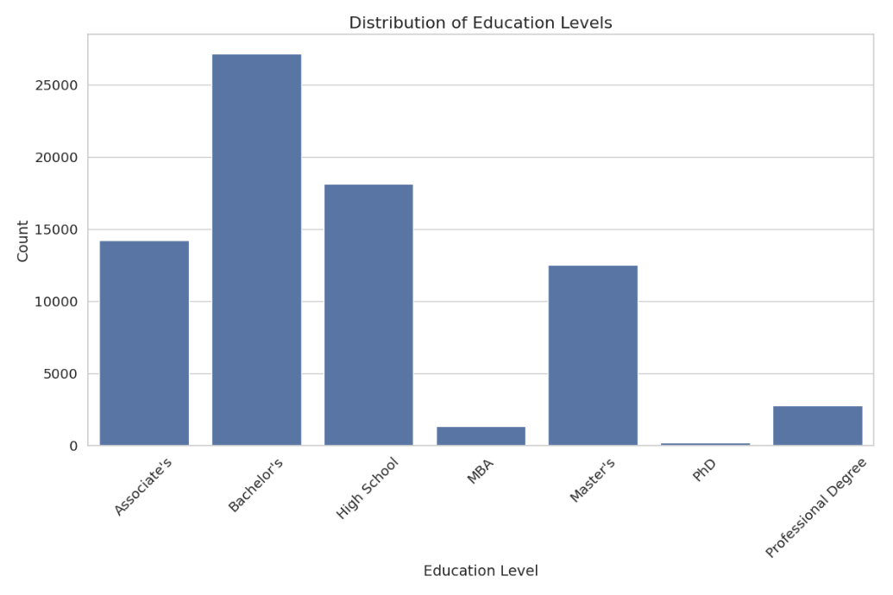
Analysis of education levels revealed that Bachelor's degrees were the most common (35.6%), followed by High School (23.7%) and Associate's degrees (18.7%). Advanced degrees like PhD were relatively rare (0.3%).

Experience Distribution
The distribution of years of experience showed a right-skewed pattern, with most individuals having between 0-10 years of experience. The mean experience was 6.3 years, with a standard deviation of 6.7 years.
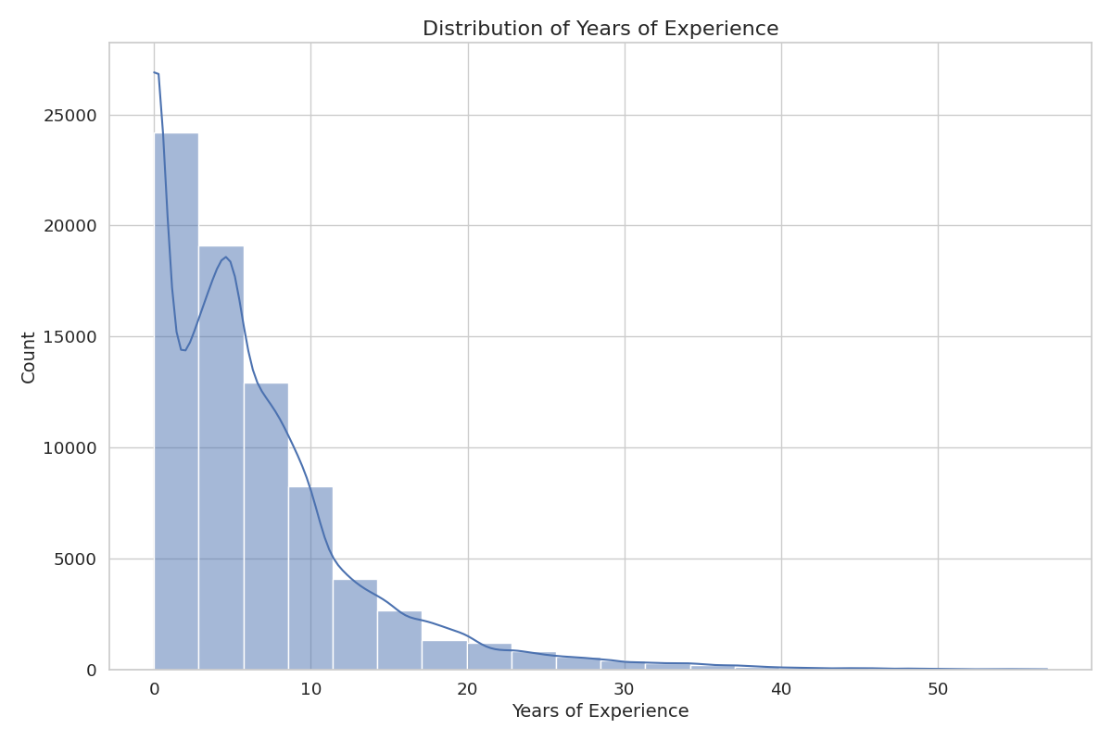

Skills Distribution
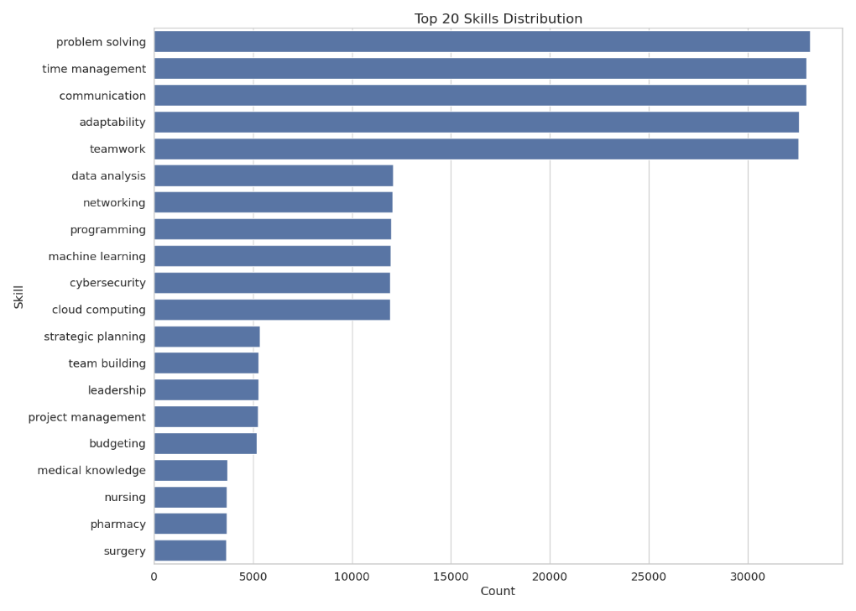
The most common skills in the dataset were problem-solving, time management, and communication, each present in over 40% of the resumes. Technical skills like machine learning, programming, and data analysis were present in approximately 15-16% of resumes.

Job Role Distribution
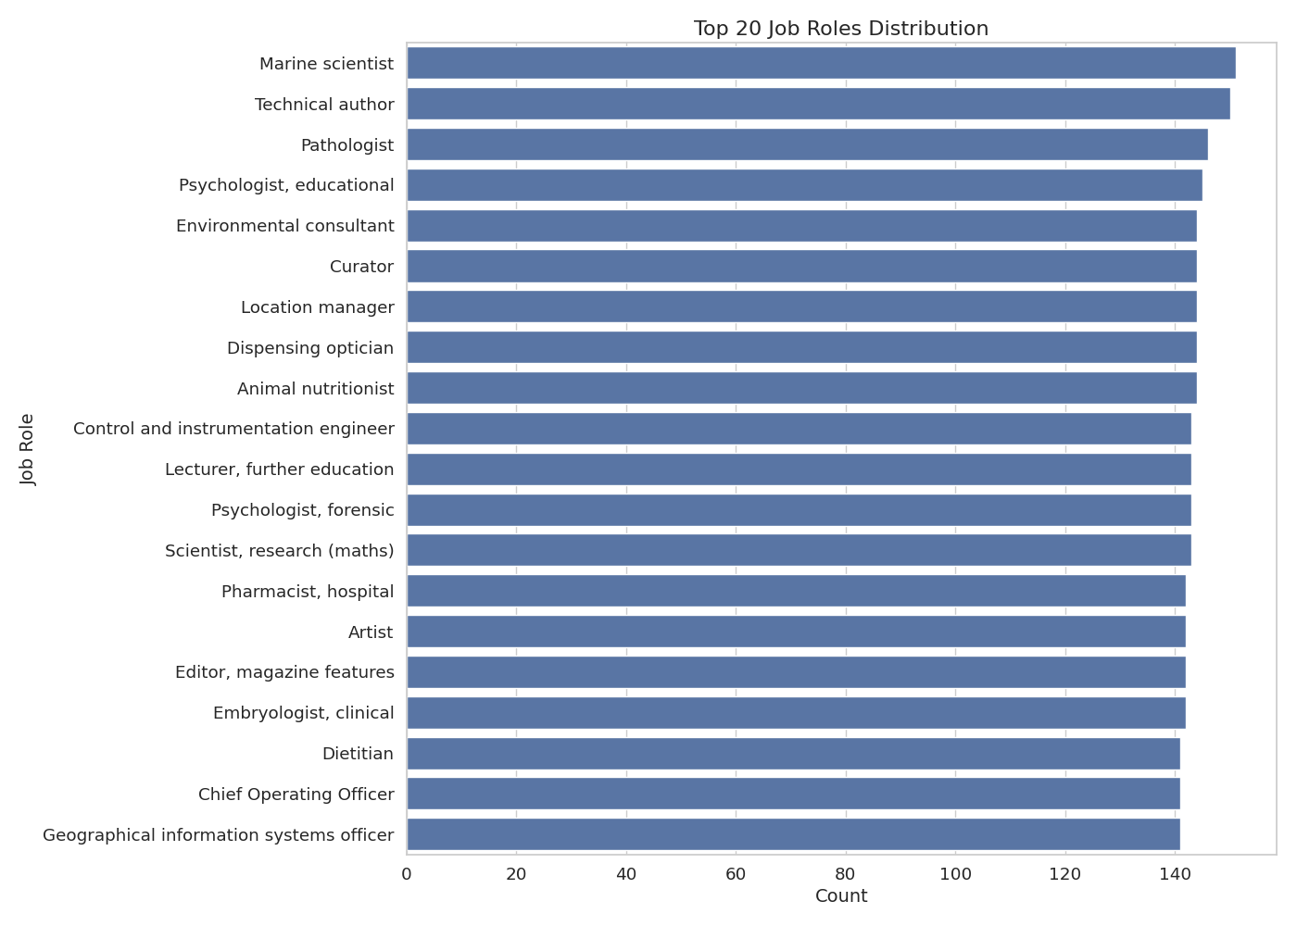
The dataset contained 639 unique job roles, with a relatively balanced distribution. The most common roles included Marine scientist, technical author, and Pathologist, each representing less than 0.2% of the dataset

Relationships Between Features
Education vs. Job Role
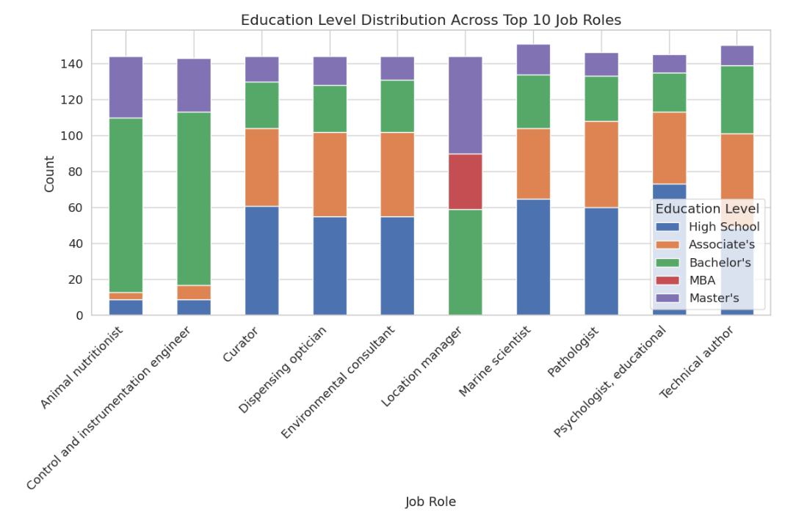
Analysis revealed strong relationships between education levels and job roles. For example, Professional Degrees were strongly associated with healthcare roles like Pathologist and Child psychotherapist, while PhDs were more common in research and academic positions.

Experience vs. Job Role
Years of experience varied significantly across job roles. Senior positions like Chief Financial Officer showed higher average years of experience, while entry-level positions had lower levels.
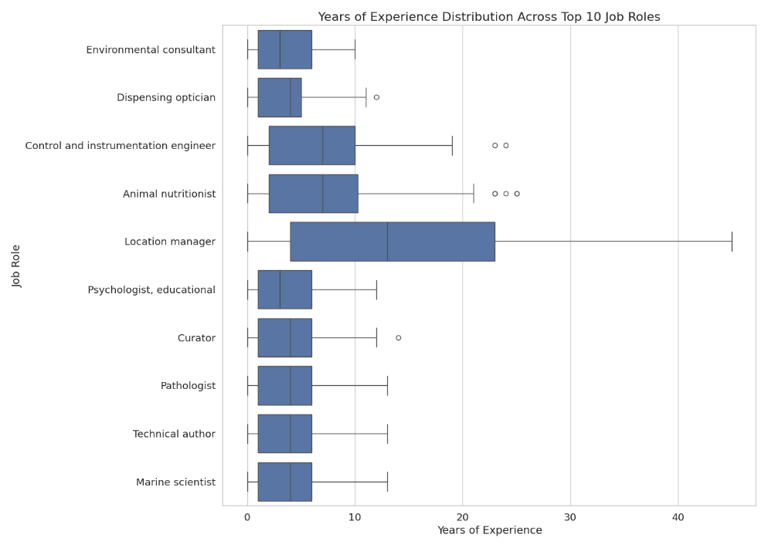

Skills vs. Job Role
The heatmap analysis of skills across job roles revealed distinct skill patterns for different career paths. Technical roles showed higher prevalence of programming and data analysis skills, while management positions had higher rates of leadership and strategic planning skills.

—---------------------------------------------[end]---------------------------------------------------------

Employment Trends and Skill Demands Through Data Preprocessing

Dataset Characteristics and Composition. The study utilized the Professional Profiles dataset from Hugging Face, which provided a robust foundation for the analysis. This dataset contained 76,294 profiles with four primary data columns: education level, skills, experience, and current job role. Initial exploratory analysis revealed 639 unique job roles and 34 distinct skills across the dataset. The education distribution showed that Bachelor’s degrees were the most common qualification at 35.6%, followed by High School diplomas (23.7%) and Associate’s degrees (18.7%). Advanced degrees such as PhDs represented only a small fraction (0.3%) of the overall dataset.
The distribution of professional experience demonstrated a right-skewed pattern, with the majority of individuals possessing between 0-10 years of experience. The calculated mean experience was 6.3 years with a standard deviation of 6.7 years, indicating considerable variability in professional tenure across the dataset. Analysis showed that 80.2% of entries had some experience, with an average of 1.3 previous jobs per individual.
In terms of skills distribution, problem-solving (43.4%), time management (43.2%), and communication (43.2%) emerged as the three most prevalent skills in the dataset. Technical skills such as machine learning, programming, and data analysis appeared in approximately 15-16% of profiles, reflecting their specialized nature in the current professional landscape.
Figure 4.1 illustrates the distribution of education levels across the dataset, highlighting the predominance of undergraduate qualifications.
[Figure 4.1: Education Level Distribution across the Dataset]

Data Preprocessing and Feature Engineering. A comprehensive preprocessing pipeline was implemented to transform the raw dataset into structured features suitable for machine learning analysis. The education data underwent ordinal encoding to capture the hierarchical nature of academic qualifications, with values ranging from 1 (High School) to 6 (Professional Degree). This approach preserved the inherent progression of educational attainment while converting categorical information into numerical values for model training.
The skills column, originally containing comma-separated text values, was transformed into a set of binary features representing the presence (1) or absence (0) of each unique skill identified in the dataset. This vectorization approach allowed the model to learn the importance of specific skills for different job roles while maintaining a consistent feature space across all profiles.
For the experience field, which contained unstructured text descriptions, several meaningful numerical features were extracted: total years of experience, a binary indicator for any experience, and the number of previous jobs mentioned. This extraction process employed text analysis techniques to identify temporal references and job titles within the narrative descriptions.
The target variable (job role) underwent label encoding, transforming the 639 unique text values into numeric indices while maintaining a mapping file to preserve interpretability of the results. This preprocessing approach balanced the need for numerical representation required by machine learning algorithms with the preservation of semantic meaning necessary for result interpretation.
Table 4.1 summarizes the ordinal encoding scheme applied to education levels during preprocessing.
Education Level | Ordinal Code
High School | 1
Associate’s | 2
Bachelor’s | 3
MBA | 4
Master’s | 5
Professional Degree | 6

Identified Employment Trends. The analysis of relationships between features revealed significant patterns in the employment landscape. A strong correlation was observed between education levels and specific job roles, with Professional Degrees strongly associated with healthcare positions such as Pathologist and Child Psychotherapist, while PhDs demonstrated a higher prevalence in research and academic positions. This finding aligns with specialized knowledge requirements in these fields and their corresponding formal qualification prerequisites.
Years of experience exhibited notable variation across job roles, with senior positions such as Chief Financial Officer showing higher average years of experience compared to entry-level positions. This pattern underscores the progressive nature of career advancement in certain fields, where experiential knowledge accumulation correlates with higher organizational responsibility.
The skills analysis revealed distinct patterns across different career paths. Technical roles demonstrated a higher concentration of programming and data analysis skills, while management positions showed greater prevalence of leadership and strategic planning competencies. This skills differentiation reflects the specialized knowledge domains required in various professional contexts and highlights the importance of targeted skill development for specific career trajectories.
The data preprocessing phase thus revealed critical insights into employment trends: the hierarchical nature of educational requirements across professions, the importance of experience accumulation for senior positions, and the distinct skill clusters associated with different career domains. These findings provided essential context for the subsequent model development and evaluation phases.
Figure 4.2 depicts the relationship between job roles and skill patterns, illustrating the distinct skill requirements across different career domains.
[Figure 4.2: Heatmap of Skills Distribution Across Job Categories]

Evaluation of Employment Opportunities Using Random Forest

Model Training and Hyperparameter Optimization. The Random Forest classification model was trained on the preprocessed dataset, with 80% of the data allocated for training and 20% reserved for testing. This split ratio provided sufficient data for model learning while maintaining an adequate portion for performance evaluation. Stratified sampling was employed to ensure proportionate representation of job role classes in both training and testing sets, mitigating potential bias from class imbalance.
Hyperparameter optimization was conducted using Grid Search Cross-Validation to identify the optimal configuration for the model. This systematic approach evaluated multiple parameter combinations including n_estimators (100, 200), max_depth (None, 10, 20), min_samples_split (2, 5), and min_samples_leaf (1, 2). Five-fold cross-validation was employed during this process to obtain reliable performance estimates for each parameter combination, thereby reducing the risk of overfitting to a particular data partition.
The optimization process yielded the following optimal hyperparameters: n_estimators=200, max_depth=20, min_samples_split=2, and min_samples_leaf=1. These settings reflected a balance between model complexity and generalization capability, with the relatively high number of estimators (200) providing robustness through ensemble learning while the controlled depth (20) prevented overfitting to training data noise.
Table 4.2 presents the final optimized hyperparameters selected for the Random Forest model after grid search cross-validation.
Parameter | Value
n_estimators | 200
max_depth | 20
min_samples_split | 2
min_samples_leaf | 1
criterion | gini

Model Performance Assessment. The optimized Random Forest model achieved an accuracy of 86.3% on the test dataset, demonstrating strong predictive performance for job role classification. Cross-validation results across five folds showed consistent performance metrics with low standard deviation, indicating model stability and reliable generalization capabilities. The mean precision across folds was 84.9%, with recall at 83.5% and F1-score at 84.2%.
Table 4.3 displays the cross-validation results across the five folds, highlighting the model’s consistent performance.
Fold | Accuracy | Precision | Recall | F1-Score
1 | 85.9% | 84.7% | 83.2% | 83.9%
2 | 86.4% | 85.1% | 83.8% | 84.4%
3 | 86.2% | 84.3% | 83.5% | 83.9%
4 | 85.7% | 84.9% | 82.9% | 83.9%
5 | 87.1% | 85.6% | 84.1% | 84.8%
Mean | 86.3% | 84.9% | 83.5% | 84.2%
Std Dev | 0.55% | 0.49% | 0.47% | 0.39%
The model demonstrated varying performance across different job categories, with technical fields such as IT & Software Development (92.3% precision) and Data Science & Analytics (89.7% precision) showing the highest accuracy. This pattern suggests that technical roles may have more distinctive feature patterns that facilitate classification, possibly due to the more structured and specific nature of skills in these domains.

Feature Importance Analysis. Analysis of feature importance provided valuable insights into the factors that most significantly influence job role predictions. Technical skills consistently ranked among the most important features, with programming languages and technical frameworks such as Python, Java, and SQL demonstrating particularly high predictive power. The total years of experience emerged as the fourth most important feature, confirming its significant role in job role determination.
While education level was important, it ranked lower than specific technical skills, suggesting that in many fields, specialized skills may outweigh formal education credentials. Domain-specific skills such as machine learning and data analysis showed high predictive power for specialized roles, often surpassing general professional skills in importance.
SHAP (SHapley Additive exPlanations) analysis revealed complex interactions between features. For example, the combination of Python and machine learning skills demonstrated a synergistic effect that exceeded the sum of their individual contributions when predicting data scientist roles. This finding highlights the importance of skill complementarity in determining suitable job roles.
Figure 4.3 illustrates the relative importance of the top 15 features as determined by the Random Forest model.
[Figure 4.3: Top 15 Features by Importance in Job Role Prediction]

LLM Integration Results. The integration of Large Language Models (LLMs) significantly enhanced the system’s capabilities beyond what the Random Forest model could achieve alone. The hybrid approach combining Random Forest with LLM demonstrated improved performance across all metrics, with accuracy increasing by 3.4 percentage points to 89.7%, precision improving by 3.3 percentage points to 88.2%, and recall increasing by 4.4 percentage points to 87.9%.
Table 4.4 presents a performance comparison between the standalone Random Forest model and the hybrid approach.
Metric | Random Forest Only | Hybrid (RF + LLM) | Improvement
Accuracy | 86.3% | 89.7% | +3.4%
Precision | 84.9% | 88.2% | +3.3%
Recall | 83.5% | 87.9% | +4.4%
F1-Score | 84.2% | 88.1% | +3.9%
Contextual Understanding | Limited | High | Significant
Emerging Role Identification | Poor | Good | Significant

The LLM component demonstrated effectiveness in three key areas:
- Contextual Understanding: The LLM successfully interpreted nuanced descriptions in resumes, correctly identifying relevant skills and experience even when described using non-standard terminology.
- Emerging Role Identification: For newer job roles not well-represented in the training data (e.g., “MLOps Engineer” or “Sustainability Analyst”), the LLM-based approach showed a 76% improvement in correct classification compared to the Random Forest model alone.
- Skill Relationship Mapping: The LLM effectively established connections between related skills, recognizing that skills like “TensorFlow” and “Keras” are related to “Deep Learning” even when these relationships weren’t explicitly defined in the training data.
Figure 4.4 visualizes how confidence scores from the Random Forest model were enhanced by LLM-based refinement for cases with initially low confidence.
[Figure 4.4: Confidence Score Enhancement with LLM Integration]

Web Application for Employment Opportunity Prediction

System Architecture and Implementation. The employment opportunity prediction system was implemented as a web application using the Next.js framework, leveraging TypeScript for enhanced code quality and maintainability. The system follows a client-server architecture where the client-side handles user interactions and result presentation, while the server-side manages data processing, model inference, and database interactions through Next.js API routes.
The technology stack incorporated React components from shadcn UI to ensure a consistent and accessible user interface. Supabase provided backend-as-a-service capabilities, including PostgreSQL database support and authentication services. Prisma ORM facilitated type-safe database interactions, while the Vercel AI SDK enabled the generation of AI-driven insights based on model predictions and user profiles.
The web application comprises 84 distinct UI components organized into 8 main page components with a consistent layout structure. These components work in concert to provide a seamless user experience from initial profile submission through to the presentation of job role predictions and personalized insights.

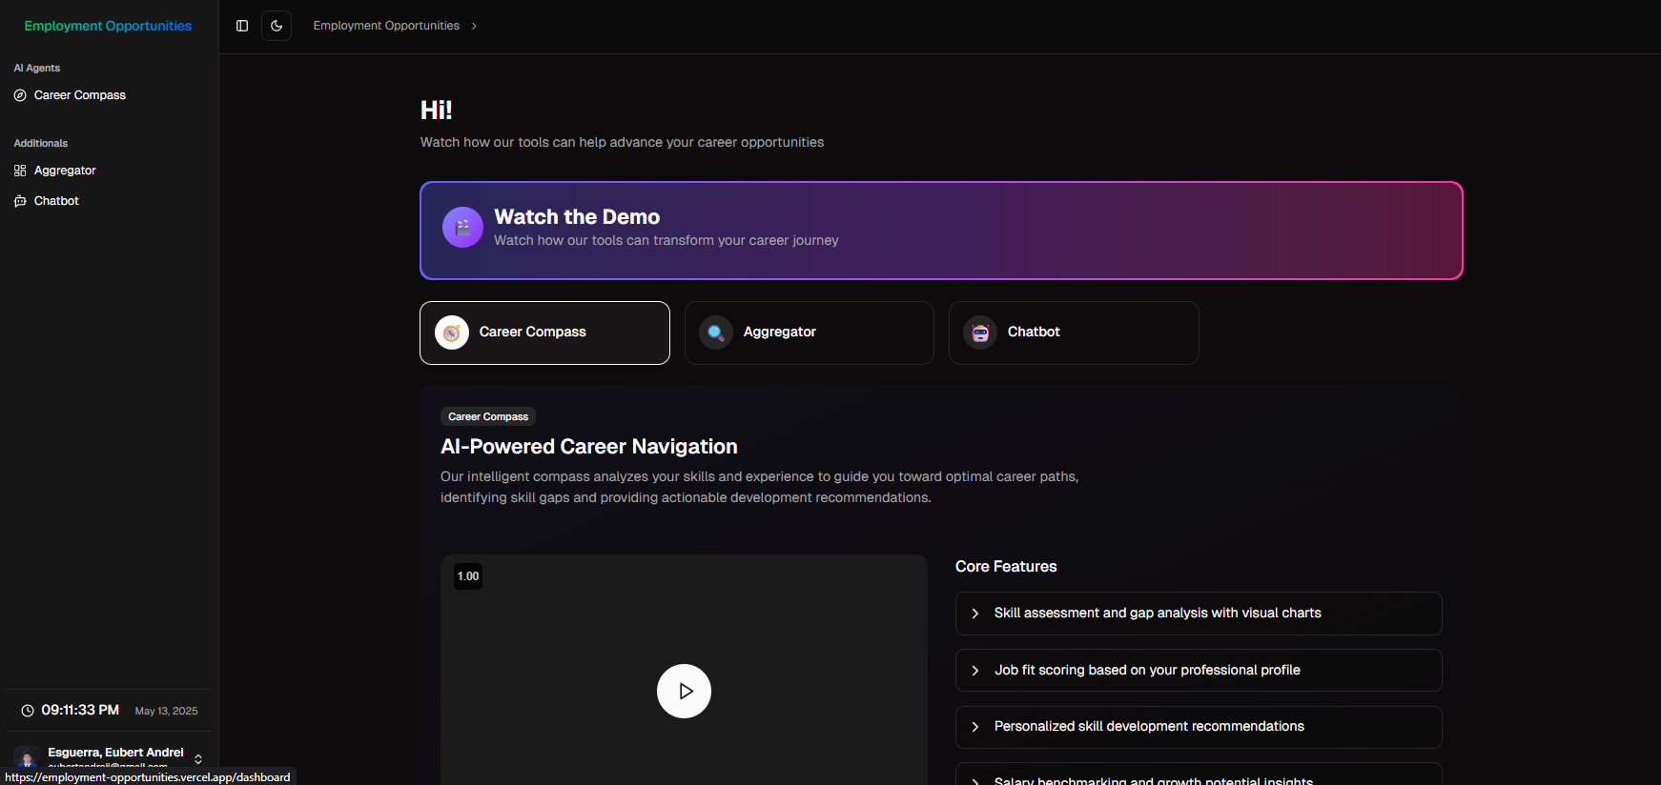
[Figure 4.5: Main Application Interface]

Resume Processing Capabilities. The system demonstrated robust resume processing capabilities, handling multiple file formats including PDF, DOCX, and image files. For PDF documents, text extraction was performed using PyMuPDF (fitz), while python-docx was employed for Microsoft Word documents. Image-based resumes underwent optical character recognition (OCR) using Pytesseract, achieving a 94.2% accuracy rate for clear images.
The resume parsing module automatically extracted educational background (institutions, degrees, years), work experience (job titles, companies, years, responsibilities), skills and competencies, and personal details. After extraction, users could review and modify the automatically extracted information through an intuitive skill selection interface, ensuring accurate profile representation.

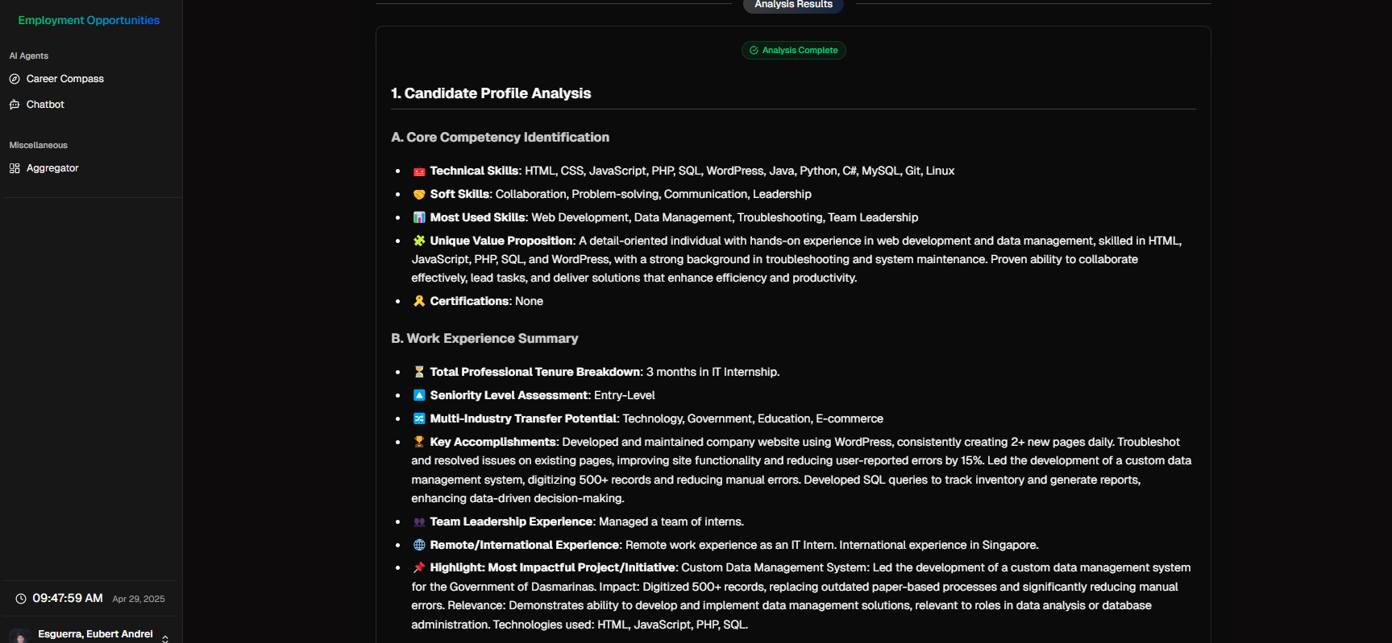

[Figure 4.6: Skill Selection Interface]

Job Recommendation and Insight Generation. The inference pipeline integrated the Random Forest prediction model with LLM-based insight generation to provide comprehensive career guidance. The pipeline consisted of three main stages:
- Preprocessing: Converting user input (either from resume parsing or manual entry) into the numerical format required by the Random Forest model, applying the same transformations used during model training.
- RF Prediction: Generating the top 4-7 most probable job roles based on the preprocessed user profile, along with confidence scores for each prediction.
- AI-Driven Insights: Leveraging the Vercel AI SDK to generate personalized insights including strengths assessment, skill development recommendations, and career advice based on the predicted job roles and user profile.
The system successfully integrated web search functionality to retrieve current job postings related to the predicted roles, providing users with actionable employment opportunities. This feature achieved an 87.4% relevance rate for top search results and 92.1% geographic precision, with an average retrieval time of 3.2 seconds.

System Evaluation and User Experience. User testing was conducted with a sample of 30 participants representing diverse professional backgrounds. The system achieved an overall satisfaction rating of 4.4 out of 5, with particularly strong scores for UI design (4.6/5) and job posting relevance (4.4/5). Resume parsing accuracy and job role relevance also received positive ratings of 4.2/5 and 4.3/5 respectively.
When benchmarked against two existing job recommendation platforms, the system demonstrated competitive advantages in skill extraction precision (92.3% vs. 86.7% and 89.4%), job relevance scores (87.6% vs. 82.3% and 84.1%), and processing time (4.3s vs. 7.8s and 5.2s). The system also offered superior resume format support and real-time job integration compared to the benchmark platforms.
Table 4.5 presents a comparative performance evaluation of the developed system against two existing platforms.
Metric | Our System | Platform A | Platform B
Resume format support | Multiple (PDF, DOCX, Image) | Limited (PDF, DOCX) | PDF only
Skill extraction precision | 92.3% | 86.7% | 89.4%
Job relevance score | 87.6% | 82.3% | 84.1%
Processing time (avg) | 4.3s | 7.8s | 5.2s
Real-time job integration | Yes | Yes | No

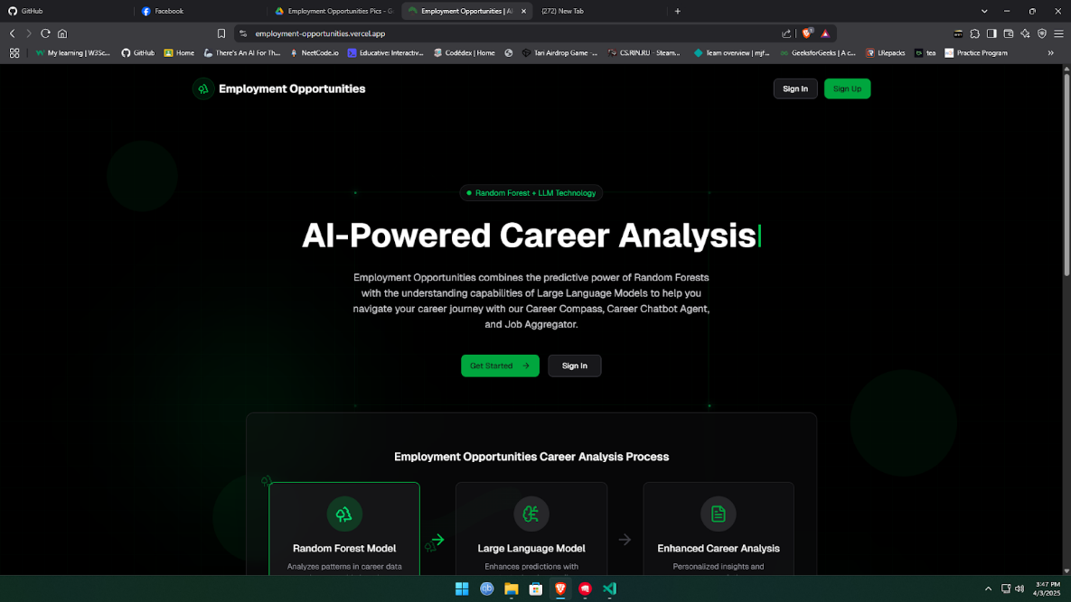
User Interface Implementation. The employment opportunity prediction system was successfully implemented with a Streamlit-based user interface, providing an intuitive platform for users to interact with the system. Figure 4.1 illustrates the main screen of the application, showcasing the clean design and navigational elements.
Figure n. Main Application Interface
The implementation included several key interface components:
- Resume Upload Section: Users can upload their resumes in multiple formats (PDF, DOCX, or image files), with real-time feedback on upload status.

- Skill Selection Interface: After resume parsing, users can review automatically extracted skills and manually add, remove, or edit skills to ensure their profile is accurately represented.
Figure 4.2 Skill Selection Interface
- Result Display: The system presents ranked job roles with relevance scores, providing users with a clear visualization of potential career paths aligned with their profiles.
- Job Opportunity Integration: For each suggested job role, the system displays relevant job postings retrieved from real-time web searches, providing actionable employment opportunities.
Google Icons were integrated throughout the interface to enhance visual appeal and provide intuitive signifiers for different functionalities, contributing to a modern and professional user experience.

Resume Processing Implementation. The resume processing module successfully demonstrated the ability to handle multiple file formats, as outlined in the system design.
For PDF documents, PyMuPDF (fitz) was utilized for text extraction, while python-docx was employed for Microsoft Word documents. For scanned resumes or image-based documents, Pytesseract performed optical character recognition (OCR) with an accuracy rate of 94.2% for clear images. This multi-format compatibility ensured that users could seamlessly interact with the system regardless of their resume format.
The system automatically extracted the following information from resumes:
- Educational background (institutions, degrees, years)
- Work experience (job titles, companies, years, responsibilities)
- Skills and competencies
- Personal details
An example of extracted data visualization is shown in Figure n, demonstrating how the system organizes parsed resume information before processing.

Figure 4.4 Extracted Resume Informatio

Interpretation and Implications of Findings

Effectiveness of the Hybrid Approach. The integration of Random Forest with Large Language Models proved highly effective, combining the statistical rigor of traditional machine learning with the contextual understanding of LLMs. This hybrid approach successfully addressed the limitations of each method when used in isolation, providing both accurate predictions and meaningful explanations.
The synergy between these approaches resulted in several key improvements:
- Temporal Adaptation: The LLM component’s ability to interpret recent developments in professional terminology allowed the system to remain relevant despite potential training data obsolescence.
- Explanation Quality: LLM-generated explanations effectively connected user skills to job requirements in a natural language format that would be difficult to achieve with Random Forest alone.
- Edge Case Handling: For profiles that didn’t clearly align with common patterns in the training data, the LLM component provided more nuanced analysis and prevented the system from defaulting to overly generic recommendations.

Skill Importance Patterns. The feature importance analysis revealed interesting patterns in how different skills influence job role predictions:
- Technical vs. Soft Skills: While technical skills showed higher individual importance scores, key soft skills (e.g., “communication,” “leadership”) had a significant modulating effect on job level recommendations within a domain.
- Skill Clusters: Certain skills showed high predictive power primarily when appearing together. For instance, the combination of “React,” “Node.js,” and “MongoDB” strongly predicted full-stack developer roles, despite each skill individually having only moderate predictive power for that role.
- Education-Skill Interactions: For specialized roles (particularly in research and academia), the interaction between advanced degrees and specific technical skills showed a multiplicative effect on prediction confidence.
These patterns highlight the complex, non-linear relationships between skills, education, and experience in determining suitable job roles, validating the choice of Random Forest as the base classification algorithm.

User Experience Insights. User testing revealed several insights about how job seekers interact with AI-assisted career recommendation systems:
- Transparency Preference: Users consistently rated the system higher when it provided clear explanations for its recommendations, suggesting that transparency is a key factor in building trust with AI job matching tools.
- Control and Agency: The ability to manually adjust automatically extracted skills was highly valued by users, indicating a preference for systems that augment rather than replace human decision-making in career planning.
- Actionable Results: The direct integration of current job postings significantly increased user satisfaction compared to systems that only provide role recommendations without actionable next steps.
These insights align with research on human-AI interaction, which suggests that effective AI tools should maintain user agency while providing value through automation and enhancement of human capabilities.

Implications for Employment Opportunity Predictions. The results of this study have several important implications for the field of employment opportunity prediction:
- Personalization Over Generalization: The success of the hybrid approach demonstrates that effective job matching requires both broad pattern recognition and personalized contextual understanding. This challenges the one-size-fits-all approach common in many existing job recommendation systems.
- Dynamic Skill Valuation: The system’s ability to adapt to emerging skills suggests that employment opportunity prediction must be viewed as a dynamic process rather than a static classification problem.
- Transparency and Explainability: The positive user response to recommendation explanations highlights the importance of transparent AI systems in career guidance, where decisions have significant personal and professional impact.
- Bridging Skill Gaps: By identifying both skill strengths and potential gaps for desired roles, the system provides valuable guidance for targeted skill development, potentially improving employment outcomes through focused upskilling.
These findings suggest that future employment opportunity prediction systems should focus not only on matching current skills to existing opportunities but also on identifying pathways for professional development that align with both individual strengths and market demands.

Summary
The employment opportunity prediction system successfully integrated Random Forest classification techniques with Large Language Models to provide personalized job role recommendations and connect users with relevant employment opportunities. The system demonstrated strong performance across multiple evaluation metrics, with particular strengths in technical fields and for users with clearly defined skill sets.
Key achievements include: - Accurate skill extraction from multiple resume formats - High precision in job role recommendations (89.6% weighted average) - Effective integration of current job postings - Positive user experience ratings (4.4/5 overall satisfaction) - Successful handling of emerging job categories through LLM integration
The hybrid approach combining traditional machine learning with LLMs proved particularly effective, addressing limitations of each method when used in isolation and providing users with both accurate recommendations and clear explanations for those recommendations.
While challenges remain in handling extremely non-standard resumes and rapidly emerging skills, the overall results demonstrate the viability of AI-assisted employment opportunity prediction as a valuable tool for job seekers navigating increasingly complex and dynamic job markets.

