# Objetivos:

-Crear web estática

-Crawler

-Scrapper

-subir a MongoDB la base de datos

# 1. Descripción técnica:

## a. Arquitectura de la aplicación y tecnologías utilizadas [doc]

## b. Diagrama de componentes. [doc]

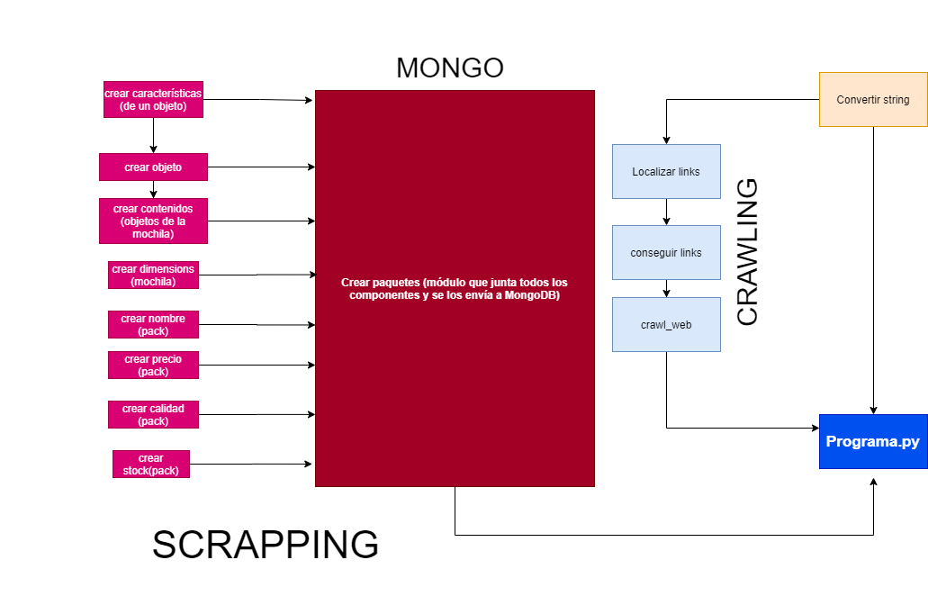

## C. Fichero XML y Schema.

{

    "title": "Amenities",

    "description": "Amenities Project DAW DUAL",

    "default": {},

    "examples": [{

        "id": 1,

        "bag_type": "premium",

        "name": "Morty's Style",

        "dimensions": {

            "width": 5,

            "height": 10

        },

        "contents": {

            "quantity": 2,

            "flying_party_hat": {

                "color": "blue",

                "quantity": 1,

                "materials": "gold"

            },

            "teleporter_pill": {

                "quantity": 3,

                "quality": "premium"

            }

        }

    }],

    "required": [

        "id",

        "bag_type",

        "dimensions",

        "contents"

    ],

    "properties": {

        "id": {

            "$id": "#/properties/id",

            "type": "integer",

            "title": "The id schema",

            "description": "Identificator for the bag",

            "default": 0,

            "examples": [

                1

            ]

        },

        "bag_type": {

            "$id": "#/properties/bag_type",

            "type": "string",

            "title": "The bag_type schema",

            "description": "Bag type, from super good, to trash, as desired",

            "default": "",

            "examples": [

                "premium",

                "i_don't_like_u_bag"

            ]

        },

        "name": {

            "$id": "#/properties/name",

            "type": "string",

            "title": "The name schema",

            "description": "Name you want to give to the bag",

            "default": "none",

            "examples": [

                "Morty's Style"

            ]

        },

        "dimensions": {

            "$id": "#/properties/dimensions",

            "type": "object",

            "title": "The dimensions schema",

            "description": "Every type of bag has to be the same size.",

            "default": {},

            "examples": [{

                "width": 5,

                "height": 10

            }],

            "required": [

                "width",

                "height"

            ],

            "properties": {

                "width": {

                    "$id": "#/properties/dimensions/properties/width",

                    "type": "integer",

                    "title": "The width schema",

                    "description": "width, anchura.",

                    "default": 0,

                    "examples": [

                        5

                    ]

                },

                "height": {

                    "$id": "#/properties/dimensions/properties/height",

                    "type": "integer",

                    "title": "The height schema",

                    "description": "height, altura.",

                    "default": 0,

                    "examples": [

                        10

                    ]

                }

            },

            "additionalProperties": true

        },

        "contents": {

            "$id": "#/properties/contents",

            "type": "object",

            "title": "The contents schema",

            "description": "Contents of the bag.",

            "default": {},

            "examples": [{

                "quantity": 2,

                "flying_party_hat": {

                    "color": "blue",

                    "quantity": 1,

                    "materials": "gold"

                },

                "teleporter_pill": {

                    "quantity": 3,

                    "quality": "premium"

                }

            }],

            "required": [

                "quantity",

                "an_item"

            ],

            "properties": {

                "quantity": {

                    "$id": "#/properties/contents/properties/quantity",

                    "type": "integer",

                    "title": "The quantity schema",

                    "description": "An explanation about the purpose of this instance.",

                    "default": 1,

                    "examples": [

                        2

                    ]

                },

                "item": {

                    "$id": "#/properties/contents/properties/Item",

                    "type": "object",

                    "title": "Item schema",

                    "description": "An item of your choice",

                    "default": {},

                    "examples": [{

                        "color": "blue",

                        "quantity": 1,

                        "materials": "gold"

                    }],

                    "required": [

                        "none"

                    ],

                    "properties": {

                        "color": {

                            "$id": "#/properties/contents/properties/item/properties/color",

                            "type": "string",

                            "title": "The color schema",

                            "description": "Color.",

                            "default": "",

                            "examples": [

                                "blue"

                            ]

                        },

                        "quantity": {

                            "$id": "#/properties/contents/properties/item/properties/quantity",

                            "type": "integer",

                            "title": "The quantity schema",

                            "description": "Quantity.",

                            "default": 1,

                            "examples": [

                                1

                            ]

                        },

                        "materials": {

                            "$id": "#/properties/contents/properties/item/properties/materials",

                            "type": "string",

                            "title": "The materials schema",

                            "description": "Material made of.",

                            "default": "",

                            "examples": [

                                "gold"

                            ]

                        }

                    },

                    "additionalProperties": true

                }

            },

            "additionalProperties": true

        }

    },

    "additionalProperties": true

}

# Metodología de desarrollo utilizada (sin invents).

# 3.Clockify del desarrollo de la app.

## a. Un diagrama (circular, barras, etc.) donde se presente el tiempo invertido por componente y/o asignaturas. [doc]

## b. Análisis y justificación del tiempo invertido.

# 4. Conclusiones.

## a. Posibles mejoras.

-nombres funciones y variables

-interdependencia de módulos (que haya menos dependencia)

-web con más recursos gráficos

-metodología

## b. Principales dificultades encontradas.

-gestión del tiempo

-gestión del trabajo en equipo

# 5. Tiempo para preguntas de los compañeros/as: