GBHS GAROUA – GEOGRAPHY DEPARTMENT
UPPER SIXTH ARTS – GEOGRAPHY – MODULE 1
FURTHER STUDY 1
TROPICAL WEATHER DISTURBANCES
Topic: Climates Sub-topic: Air Mass Interactions at Fronts and Convergence Zones
Teacher: Mr KAMDEM Emmanuel – Copy this lesson in your notebook, with the illustrations.

DEFINITIONS

Thunderstorm: It is a local storm from a cumulonimbus cloud, with lightning, thunder, strong winds and heavy rain or hail.
Tornado: It is a violently rotating narrow column of air extending from a thunderstorm to the ground.
Tropical cyclone: It is a very large rotating storm system with a low-pressure centre, strong winds and heavy rain, formed over warm tropical seas.
Storm surge: It is an abnormal rise of the sea level caused by a storm.

1. Thunderstorms

A) Meaning and Distribution
Thunderstorms are explained as follows:
Meaning: A thunderstorm is a local storm produced by a cumulonimbus cloud. It brings lightning, thunder, strong gusts of wind and heavy rain or hail, usually for one or two hours.
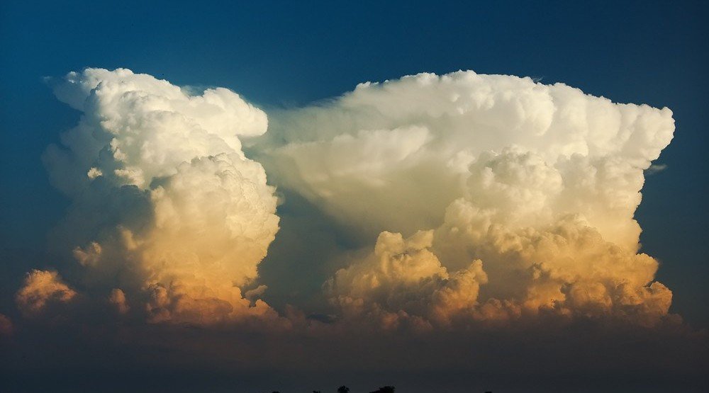
Illustration: A cumulonimbus cloud, the cloud that produces a thunderstorm
Distribution: Thunderstorms are most frequent in hot, humid regions near the Equator, such as the Congo Basin, where they occur on more than 100 days a year. In Garoua, they are common in the rainy season, especially at its start and end.
B) Causes
Thunderstorms are caused by the following factors:
Strong heating of the ground: Strong heating of the ground makes moist, unstable air rise quickly by convection. In the tropics, this happens mostly in the afternoon.
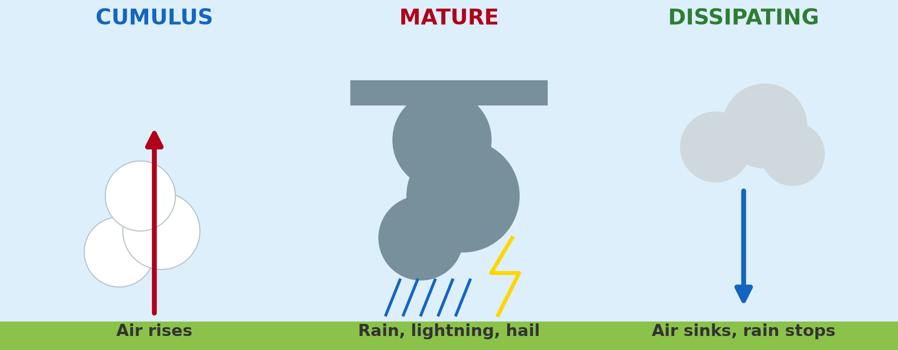
Illustration: The three stages of a thunderstorm: cumulus, mature and dissipating
Lifting by fronts and mountains: Fronts and mountains can also force moist air to rise. The rising air cools, and its water vapour condenses into clouds.
Release of latent heat: As the vapour condenses, it releases latent heat that warms the air and makes it rise even faster. The cloud grows into a tall cumulonimbus that reaches the tropopause.
Separation of electric charges: Collisions between ice particles and water drops separate electric charges inside the cloud. When these charges are discharged, they produce lightning and thunder.
C) Consequences
Thunderstorms have the following consequences:
Lightning: Lightning kills people and animals and starts fires. It also damages buildings and electrical equipment.
Strong winds: Strong gusts tear off roofs and break trees. Fallen power lines cause power cuts.
Flash floods: Intense rain over a short time cannot soak into the ground. Streets and small rivers overflow suddenly.
Hail: Hailstones destroy crops and damage roofs and vehicles. A single storm can ruin the harvest of a whole village.

2. Tornadoes

A) Meaning and Distribution
Tornadoes are explained as follows:
Meaning: A tornado is a narrow column of air that rotates violently and hangs from the base of a thunderstorm down to the ground. It looks like a dark funnel and usually lasts only a few minutes.
Distribution: Tornadoes occur in many parts of the world but are most frequent and violent in the central United States, called Tornado Alley, with more than 1,000 a year. They also occur in Bangladesh, Argentina and sometimes in West Africa.
B) Causes
Tornadoes are caused by the following factors:
Supercell thunderstorms: Tornadoes form in the most severe thunderstorms, called supercells. These storms have very strong and long-lasting rising currents of air.
Meeting of contrasting air masses: Warm, moist air meets cold, dry air, as in the central USA in spring. This contrast makes the air very unstable.
Wind shear: Changes of wind speed and direction with height make the rising air rotate. The rotation then tightens into a narrow funnel that reaches the ground.
C) Consequences
Tornadoes have the following consequences:
Destruction of buildings: Winds can exceed 400 km/h and destroy houses, vehicles and trees. Debris carried by the wind becomes dangerous missiles.
Loss of life: People are killed or injured by flying debris and collapsing buildings. Deaths are highest where there is no warning or shelter.
A narrow path of damage: The damage is very severe but limited to a path usually less than 1 to 2 km wide. Houses a short distance away may remain untouched.

3. Tropical Cyclones

A) Meaning and Distribution
Tropical cyclones are explained as follows:
Meaning: A tropical cyclone is a huge rotating storm, 500 to 1,000 km wide, around a calm centre called the eye, with winds above 119 km/h. It is called a hurricane in the Atlantic, a typhoon in the north-west Pacific and a cyclone in the Indian Ocean.
Distribution: Tropical cyclones form over warm oceans between about 5° and 20° N and S, and then move westwards and towards the poles. They are almost absent from the South Atlantic, so the coast of Cameroon is rarely affected.
B) Causes
Tropical cyclones are caused by the following factors:
Warm sea water: Sea water warmer than 26.5 °C supplies heat and moisture to the air above it. The warm, moist air rises and forms a deep low pressure.
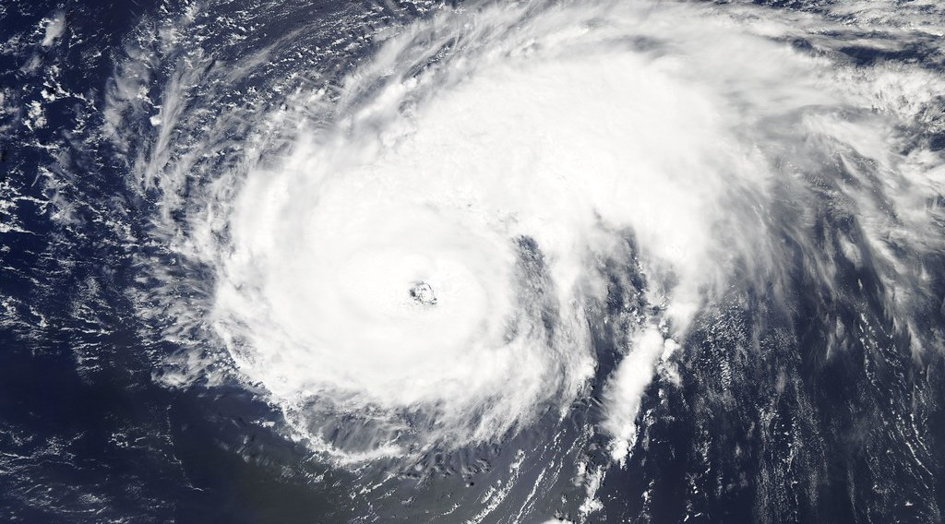
Illustration: A tropical cyclone seen from space: the calm eye is at the centre
The Coriolis effect: The Coriolis effect makes the air spin around the low pressure. It is absent at the Equator, so cyclones do not form between about 0° and 5° of latitude.
Release of latent heat: The vapour condenses in tall clouds around the eye and releases latent heat. This heat feeds the storm and makes it stronger.
C) Consequences
Tropical cyclones have the following consequences:
Violent winds: Winds above 119 km/h destroy buildings, crops and power lines over hundreds of kilometres. Whole towns can be damaged.
Storm surges: The strong winds and the low pressure raise the level of the sea and push it onto the coast. These storm surges flood coastal areas and cause most of the deaths.
Torrential rain: Days of very heavy rain cause floods and landslides inland. Roads, bridges and farms are destroyed.

4. Hazards and Control Measures

The hazards of these disturbances are reduced by the following measures:
Early warning: Radars and satellites follow storms, and weather services send alerts by radio, television and telephone. People then have time to take shelter or to leave threatened areas.
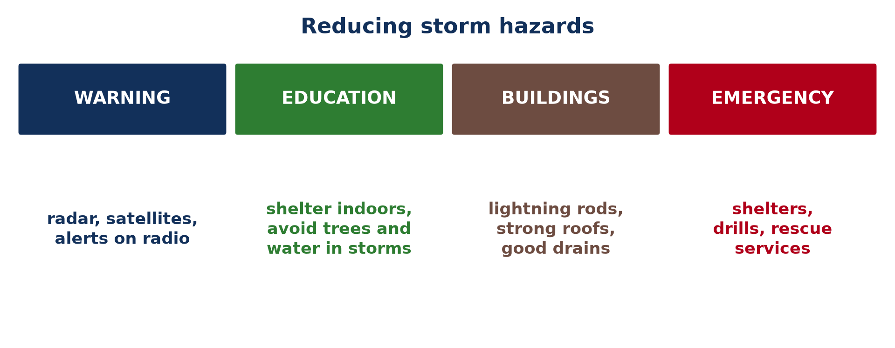
Illustration: Ways of reducing the hazards of storms
Public education: People learn to shelter indoors during storms and to avoid trees, open fields, water and metal objects when there is lightning. Drills teach them what to do when a warning is given.
Protection of buildings: Lightning rods, strong roofs and building codes that resist wind reduce damage. Good drains reduce the floods caused by heavy rain.
Emergency preparedness: Governments build storm shelters, plan evacuation routes and train rescue services. After a disaster, they provide water, food, shelter and medical care.

5. SUMMARY TABLE: THE THREE DISTURBANCES COMPARED

 | Thunderstorm | Tornado | Tropical cyclone
Size | A few kilometres wide | Less than 1 to 2 km wide | Hundreds of kilometres wide
Where it occurs | In the tropics (e.g. Garoua), over land | Mainly in the central USA | Over warm seas, between 5° and 20° N and S
Main cause | Convection and unstable air | Wind shear in supercell storms | Sea water above 26.5 °C and the Coriolis effect
Main danger | Lightning, floods and hail | Violent winds and flying debris | Storm surges, violent winds and floods

HOMEWORK

Define a micro-climate.
Our next lesson will be on: Lesson 20: Micro-climates.

