GOVERNMENT BILINGUAL HIGH SCHOOL GAROUA  P.O. BOX: 301 GAROUA TEL: (+237) 674 23 91 99 | 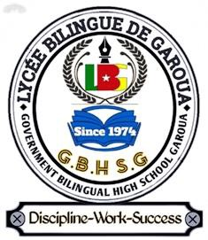 | SCHOOL ACADEMIC YEAR:  2026-2027
INDIVIDUAL TIMETABLE
SUBJECT: GEOGRAPHY
TEACHER'S NAMES: …………………… PERMANENT TEACHER / PART-TIMER: ……………………
FUNCTION: …………………… GRADE: …………………… MATRICULE: ……………………
LONGEVITY: …………………… PHONE NUMBER(S): ……………………
HOURS DUE: …………………… HOURS DONE: …………………… CLASSES TAUGHT: ……………………

PERIODS  DAYS | 7:30  8:30 | 8:30  9:30 | 9:30  10:30 | 10:30  10:45 | 10:45  11:45 | 11:45  12:45 | 12:45  13:15 | 13:15  14:15 | 14:15  15:15 | 15:15  16:15 | 16:15  18:00
MONDAY |  |  |  | B  R  E  A  K |  |  | B  R  E  A  K
TUESDAY |  |  |  | B  R  E  A  K |  |  | B  R  E  A  K
WEDNESDAY |  |  |  | B  R  E  A  K |  |  | B  R  E  A  K
THURSDAY |  |  |  | B  R  E  A  K |  |  | B  R  E  A  K
FRIDAY |  |  |  | B  R  E  A  K |  |  | B  R  E  A  K
SUBJECTS / TOPICS TO BE TAUGHT  ……………………………………………………………………………………………………………  …………………………………………………………………………………………………………… | Done in Garoua, on the ……………………………  The Vice Principal

