GBHS GAROUA – GEOGRAPHY DEPARTMENT
LOWER SIXTH ARTS – GEOGRAPHY – MODULE 2: GEOMORPHOLOGY
LESSON 4
LANDFORMS AT CONSTRUCTIVE OR DIVERGENT MARGINS
Topic: The Development of the Earth's Structure Sub-topic: Theories of Earth Structure and Resultant Landforms
Teacher: Mr KAMDEM Emmanuel – Copy this lesson in your notebook, with the illustrations.

DEFINITIONS

Constructive (divergent) margin: It is a boundary where two plates move apart and new crust is formed.
Faulting: It is the breaking of rocks of the crust under stress, with movement of blocks along the fractures.
Fault: It is a fracture in the crust along which rocks have moved.
Folding: It is the bending of layers of rock under compression.

1. Divergence and Faulting

At constructive margins, faulting takes place as follows:
Tension: At a constructive margin, the plates move apart and the crust is stretched by tension. The brittle rocks of the crust cannot bend much, so they break.
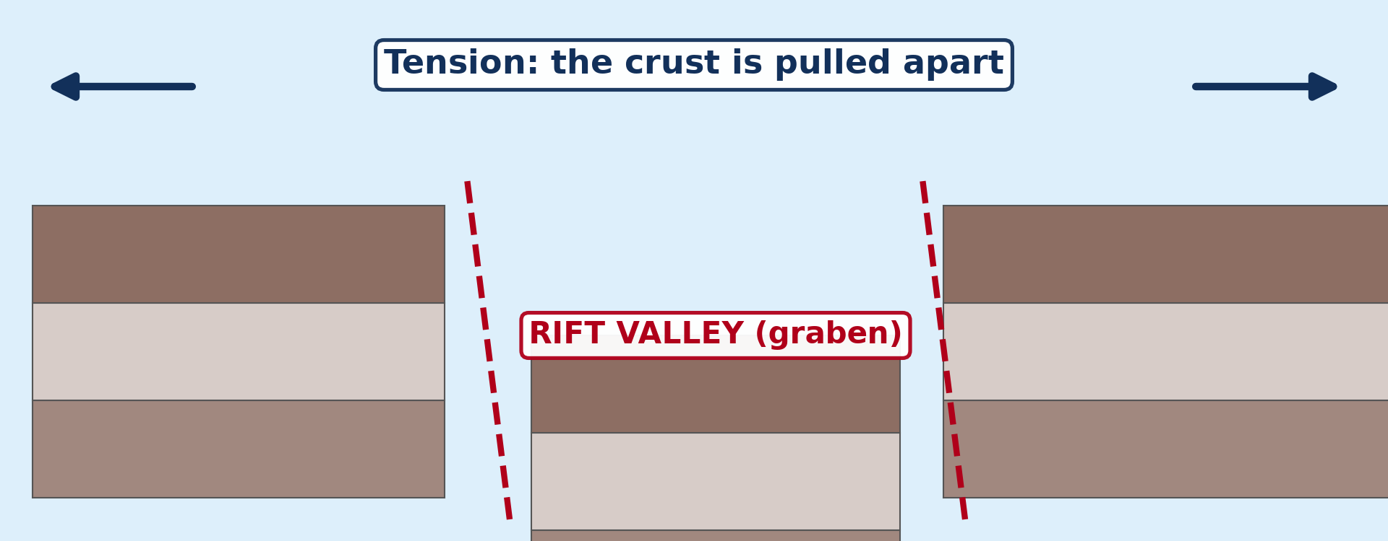
Illustration: Horst and graben: tension pulls the crust apart and a block sinks to form a rift valley
Normal faults: Tension produces normal faults, in which one block slides down along a sloping fracture. Parallel faults divide the crust into blocks that move up or down.
Result on the relief: Faulting creates rift valleys, block mountains and escarpments on the continents. On the ocean floor, it creates the central rift of the mid-ocean ridges.

2. Major Landforms

A) Ridges, Rift Valleys and Shield Volcanoes
Divergence creates the following major landforms:
Mid-ocean ridges: Where two oceanic plates move apart, rising magma builds long underwater mountain chains, like the Mid-Atlantic Ridge. They are cut by a central rift and by many transform faults.
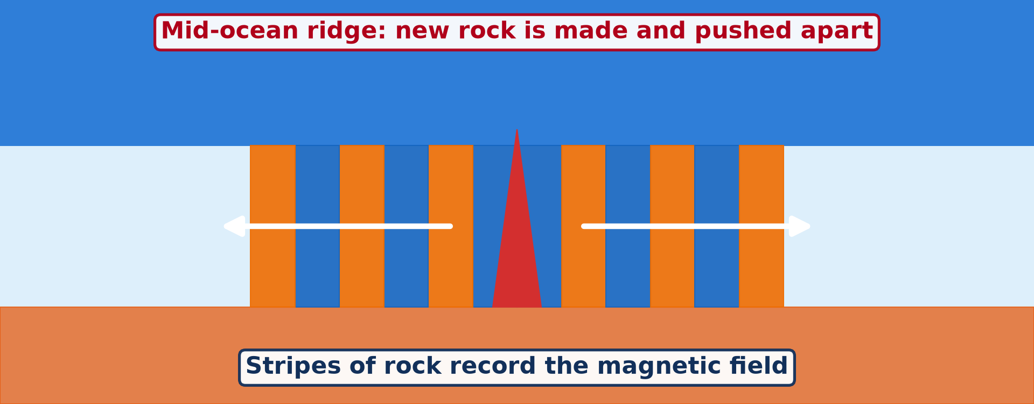
Illustration: A mid-ocean ridge, where new rock is made and pushed apart
Rift valleys: Where a continent is pulled apart, a long block sinks between two parallel faults and forms a rift valley (graben), like the Great Rift Valley of East Africa. The Benue Trough, in which the Benue flows past Garoua, is an old rift formed when Africa and South America separated.
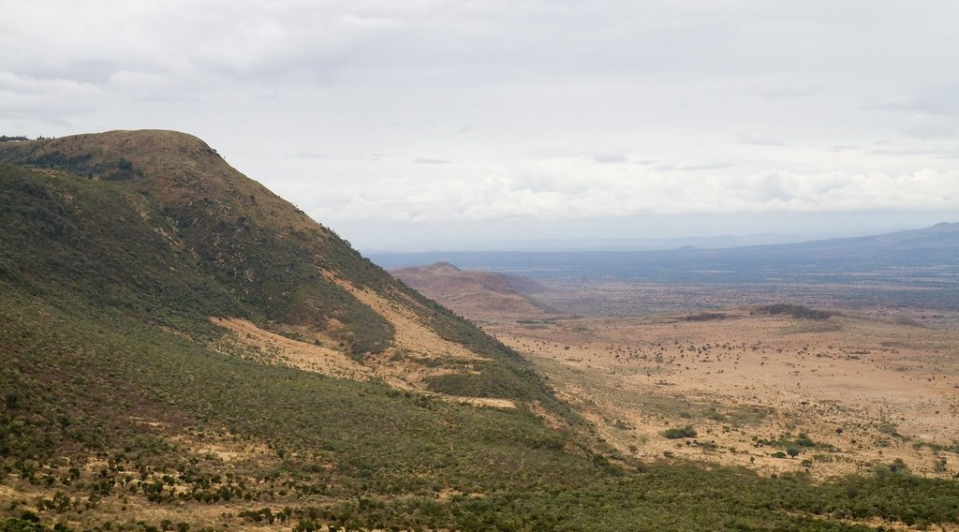
Illustration: A rift valley
Shield volcanoes: Magma at divergent margins is basic and runny, so lava flows far before it cools. It builds broad volcanoes with gentle slopes, as in Iceland and along the East African Rift.

Illustration: A shield volcano
B) Faulted Landforms
Faulting at divergent margins creates the following landforms:
Block mountains (horsts): A block of land left standing high between two faults, or pushed up, forms a block mountain with a flat top. The Ruwenzori Mountains, between Uganda and the Democratic Republic of Congo, are an example.
Plateaux: Where large blocks are uplifted as a whole, they form high, flat plateaux bounded by faults. Parts of the East African plateau were formed in this way.
Escarpments (fault scarps): An escarpment is the steep slope along the edge of a horst or a rift valley, which marks the line of the fault. Its steepness shows that the fault is recent or active.
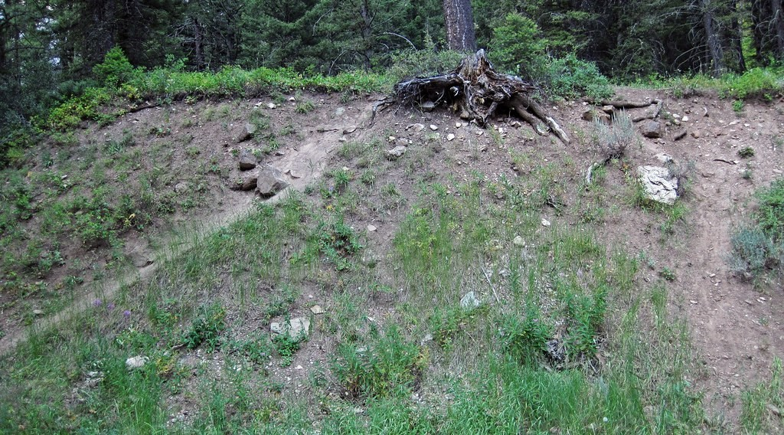
Illustration: An escarpment (fault scarp)
Basin and range landscape: Where the crust is stretched over a wide area, many parallel faults form alternating horsts (ranges) and grabens (basins). This landscape is found in Nevada and Utah in the United States.

3. Volcanic Eruptions and Earthquakes

Constructive margins have the following types of eruptions and earthquakes:
Fissure (Icelandic) eruptions: Runny basaltic lava pours quietly out of long cracks in the ground. These eruptions build lava plateaux and give people time to move away.
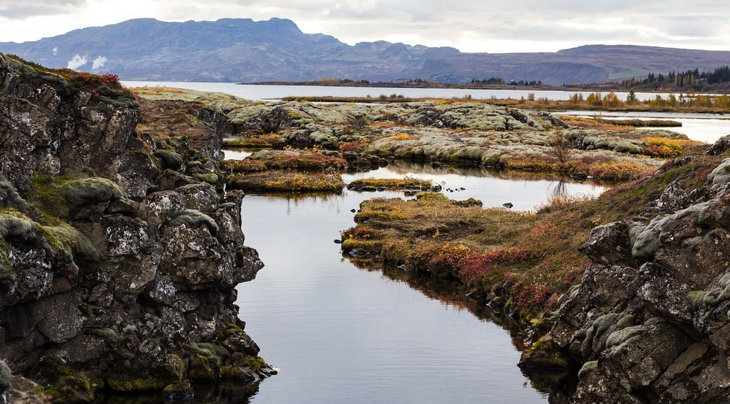
Illustration: A fissure in Iceland
Hawaiian-type eruptions: Lava flows out of a central vent with fountains of red-hot lava but few explosions, because the magma contains little gas. They build shield volcanoes.
Shallow earthquakes: Movements along the faults cause frequent earthquakes, with a focus less than about 70 km deep. They are usually weaker than those of destructive and conservative margins.

HOMEWORK

Name one range of fold mountains.
Our next lesson will be on: Lesson 5: Landforms at Destructive and Conservative Margins.

