REPUBLIQUE DU CAMEROUN  Paix – Travail – Patrie  ****  MINISTERE DES ENSEIGNEMENTS SECONDAIRES  ****  DELEGATION REGIONALE DU NORD  ****  DELEGATION DEPARTEMENTALE DE LA BENOUE  ****  DIVINE GRACE COLLEGE OF ARTS, SCIENCE AND TECHNOLOGY  (DGCAST) – GAROUA |  | REPUBLIC OF CAMEROON  Peace – Work – Fatherland  ****  MINISTRY OF SECONDARY EDUCATION  ****  NORTH REGIONAL DELEGATION  ****  BENOUE DIVISIONAL DELEGATION  ****  DIVINE GRACE COLLEGE OF ARTS, SCIENCE AND TECHNOLOGY  (DGCAST) – GAROUA

Student’s names: | F | M | Class: FORM ONE
SEQ N° 1 | Assessment of module N°: 1 | Date: | Discipline: Geography | Duration: 1 hour
Evaluated competence: Learners are able to use maps and their knowledge of the Earth to locate places.
Student performance: | Remarks
Mark/20: | Grade: | CVWA | CWA | CA | CAA | CNA
Seal of the school  HARDWORK – DILIGENCE – SUCCESS | Signature, name and comments of the teacher: | Signature and name of parent/guardian:
FIRST SEQUENCE EVALUATION – SCHOOL YEAR 2026-2027
GEOGRAPHY DEPARTMENT
INSTRUCTIONS TO CANDIDATES
Answer ALL questions on this question paper.
In Section I, mark an (X) on the letter of the correct answer.

PART ONE: VERIFICATION OF RESOURCES (9 marks)
Section I: Multiple Choice Questions (10 × 0.5 = 5 marks)
1. The study of the Earth, its physical features and the activities of the people who live on it is called:  A. History  B. Geography  C. Geology  D. Biology | 6. Water covers about … of the Earth’s surface.  A. 29 %  B. 50 %  C. 71 %  D. 90 %
2. The branch of geography that studies relief, climate, rivers and soils is:  A. Human geography  B. Practical geography  C. Physical geography  D. Economic geography | 7. The largest ocean in the world is the:  A. Atlantic Ocean  B. Indian Ocean  C. Pacific Ocean  D. Arctic Ocean
3. Population geography and settlement geography belong to:  A. Physical geography  B. Human geography  C. Practical geography  D. Climatology | 8. A round model of the Earth is called a:  A. Map  B. Globe  C. Projection  D. Atlas
4. Which method do geographers use to collect information directly from people?  A. Questionnaires and interviews  B. Satellite images  C. Map projections  D. Contour lines | 9. The part of a map that explains the signs and colours used on it is the:  A. Title  B. Scale  C. Key (legend)  D. North arrow
5. From the Sun, the Earth is the:  A. First planet  B. Second planet  C. Third planet  D. Fourth planet | 10. The latitude and the longitude of a place are called its:  A. Cardinal points  B. Geographical coordinates  C. Scale  D. Key
Section II: Structural Questions (4 marks)
1. On a map with a scale of 1 cm to 20 km, two towns are 7 cm apart. Calculate the real distance between them. (2 marks)

2. Give two differences between a globe and a map. (2 marks)

PART TWO: VERIFICATION OF COMPETENCES (9 marks)
Situation:
Aïcha has just arrived in Garoua from Douala. She wants to visit her aunt in Maroua, but she does not know where Maroua is, nor how far it is from Garoua. She opens a map of Cameroon, but she does not understand the signs, the colours and the numbers written on it. She asks you, a Form One geography student, for help.

Document 1: The marginal information of a map  Every good map has marginal information. The title tells what the map shows. The key explains the signs and colours. The scale helps to calculate real distances. The north arrow shows the directions, and the lines of latitude and longitude help to locate places. | Document 2  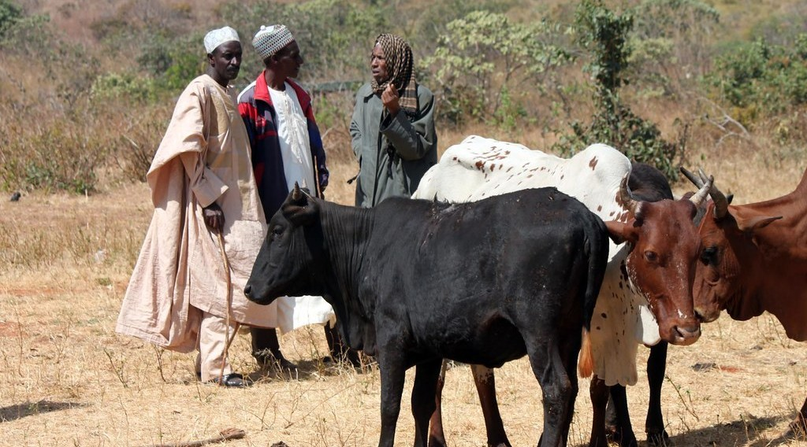  A cattle market
Perform the following tasks:
1. What is the problem raised in the situation above? (3 marks)

2. Using Document 1, name three elements of a map that can help Aïcha and say what each one is used for. (3 marks)
i)

ii)

iii)

3. Propose three things Aïcha can do to find Maroua on the map and to know its distance from Garoua. (3 marks)
i)

ii)

iii)

Presentation: 2 marks
FACILITATOR: Mr KAMDEM Emmanuel

