REPUBLIQUE DU CAMEROUN  Paix – Travail – Patrie  ****  MINISTERE DES ENSEIGNEMENTS SECONDAIRES  ****  DELEGATION REGIONALE DU NORD  ****  DELEGATION DEPARTEMENTALE DE LA BENOUE  ****  DIVINE GRACE COLLEGE OF ARTS, SCIENCE AND TECHNOLOGY  (DGCAST) – GAROUA |  | REPUBLIC OF CAMEROON  Peace – Work – Fatherland  ****  MINISTRY OF SECONDARY EDUCATION  ****  NORTH REGIONAL DELEGATION  ****  BENOUE DIVISIONAL DELEGATION  ****  DIVINE GRACE COLLEGE OF ARTS, SCIENCE AND TECHNOLOGY  (DGCAST) – GAROUA

Student’s names: | F | M | Class: FORM TWO TECHNICAL
SEQ N° 1 | Assessment of module N°: 1 | Date: | Discipline: Geography | Duration: 1 hour
Evaluated competence: Learners are able to protect the resources of the equatorial region.
Student performance: | Remarks
Mark/20: | Grade: | CVWA | CWA | CA | CAA | CNA
Seal of the school  HARDWORK – DILIGENCE – SUCCESS | Signature, name and comments of the teacher: | Signature and name of parent/guardian:
FIRST SEQUENCE EVALUATION – SCHOOL YEAR 2026-2027
GEOGRAPHY DEPARTMENT
INSTRUCTIONS TO CANDIDATES
Answer ALL questions on this question paper.
In Section I, mark an (X) on the letter of the correct answer.

PART ONE: VERIFICATION OF RESOURCES (9 marks)
Section I: Multiple Choice Questions (10 × 0.5 = 5 marks)
1. The equatorial region lies between about:  A. 5° N and 5° S of the Equator  B. 10° N and 20° N  C. 23½° N and 66½° N  D. 66½° N and 90° N | 6. The washing down of soil nutrients by heavy rain is called:  A. Leaching  B. Evaporation  C. Irrigation  D. Transpiration
2. Which of the following is an equatorial region?  A. The Sahara  B. The Congo Basin  C. The Sahel  D. The Mediterranean | 7. The equatorial forest is evergreen because:  A. Its trees shed their leaves at different times  B. Its trees have no leaves  C. It rains only in summer  D. Its trees are very short
3. The average temperature of the equatorial region is about:  A. 10 °C  B. 18 °C  C. 27 °C  D. 40 °C | 8. Which of the following is a hardwood of the equatorial forest?  A. Pine  B. Mahogany  C. Eucalyptus  D. Baobab
4. The annual rainfall of the equatorial region is generally:  A. Below 250 mm  B. About 500 mm  C. Above 1,500 mm  D. Nil | 9. Which of the following is a human activity of the equatorial region?  A. Lumbering  B. Camel herding  C. Ice fishing  D. Reindeer herding
5. The annual range of temperature of the equatorial climate is:  A. Very small (2 to 3 °C)  B. About 15 °C  C. About 20 °C  D. About 30 °C | 10. Which of the following is a problem of the equatorial region?  A. Deforestation  B. Desertification  C. Frost  D. Snowstorms
Section II: Structural Questions (4 marks)
Study the climate data of Yaoundé below and answer the questions.
Month | J | F | M | A | M | J | J | A | S | O | N | D
Temperature (°C) | 24 | 25 | 25 | 24 | 24 | 23 | 22 | 22 | 23 | 23 | 24 | 24
Rainfall (mm) | 15 | 50 | 140 | 180 | 200 | 150 | 50 | 80 | 220 | 290 | 120 | 20
Climate data of Yaoundé (approximate values)
a) Calculate the annual range of temperature. (1 mark) | b) Calculate the total annual rainfall. (1 mark)
c) Name the wettest month. (1 mark) | d) State one characteristic of the equatorial climate shown by these figures. (1 mark)
PART TWO: VERIFICATION OF COMPETENCES (9 marks)
Situation:
During the holidays, Paul visits his uncle in Bertoua, in the East Region. Every day, he sees many lorries carrying huge logs, and large areas of forest cleared for farms. His uncle tells him that animals and medicinal plants are becoming rare and that the rains are no longer regular. Paul asks you, a Form Two Technical student, to explain what is happening.

Document 1: The forest in danger  The equatorial forest is cut for timber, which is sold abroad, for new farms, for firewood and charcoal, and to open roads and mines.  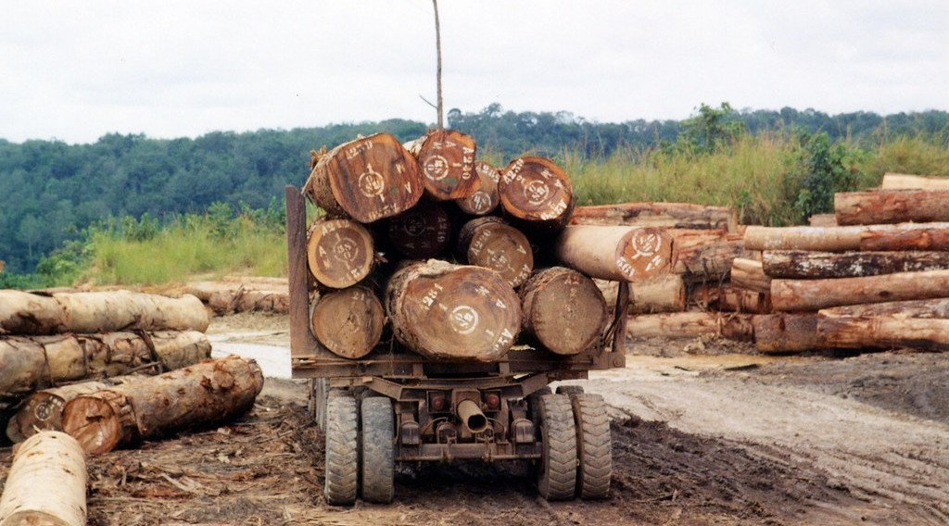  Logs leaving the equatorial forest | Document 2  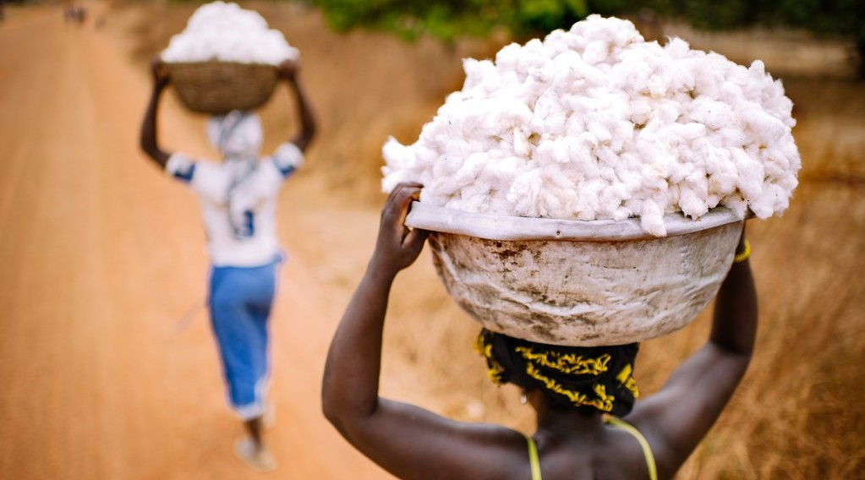  A cotton harvest
Perform the following tasks:
1. What is the problem raised in the situation above? (3 marks)

2. Using Document 1, give three causes of the destruction of the equatorial forest. (3 marks)
i)

ii)

iii)

3. Propose three measures to protect the equatorial forest. (3 marks)
i)

ii)

iii)

Presentation: 2 marks
FACILITATOR: Mr KAMDEM Emmanuel

