REPUBLIQUE DU CAMEROUN  Paix – Travail – Patrie  ****  MINISTERE DES ENSEIGNEMENTS SECONDAIRES  ****  DELEGATION REGIONALE DU NORD  ****  DELEGATION DEPARTEMENTALE DE LA BENOUE  ****  DIVINE GRACE COLLEGE OF ARTS, SCIENCE AND TECHNOLOGY  (DGCAST) – GAROUA |  | REPUBLIC OF CAMEROON  Peace – Work – Fatherland  ****  MINISTRY OF SECONDARY EDUCATION  ****  NORTH REGIONAL DELEGATION  ****  BENOUE DIVISIONAL DELEGATION  ****  DIVINE GRACE COLLEGE OF ARTS, SCIENCE AND TECHNOLOGY  (DGCAST) – GAROUA

Student’s names: | F | M | Class: FORM THREE
SEQ N° 1 | Assessment of module N°: 1 | Date: | Discipline: Geography | Duration: 1 hour
Evaluated competence: Learners are able to describe the planet Earth and to locate places on its surface.
Student performance: | Remarks
Mark/20: | Grade: | CVWA | CWA | CA | CAA | CNA
Seal of the school  HARDWORK – DILIGENCE – SUCCESS | Signature, name and comments of the teacher: | Signature and name of parent/guardian:
FIRST SEQUENCE EVALUATION – SCHOOL YEAR 2026-2027
GEOGRAPHY DEPARTMENT
INSTRUCTIONS TO CANDIDATES
Answer ALL questions on this question paper. Calculators are allowed.
In Section I, mark an (X) on the letter of the correct answer.

PART ONE: VERIFICATION OF RESOURCES (9 marks)
Section I: Multiple Choice Questions (10 × 0.5 = 5 marks)
1. From the Sun, the Earth is the:  A. First planet  B. Second planet  C. Third planet  D. Fourth planet | 6. Which of the following is a proof that the Earth is spherical?  A. Ships disappear gradually below the horizon  B. The Sun gives heat  C. Rivers flow to the sea  D. Trees grow upwards
2. The natural satellite of the Earth is:  A. The Sun  B. The Moon  C. Mars  D. The Milky Way | 7. The line of latitude 0° is called the:  A. Greenwich Meridian  B. Equator  C. Tropic of Cancer  D. Arctic Circle
3. The phase of the Moon in which its whole lit face can be seen from the Earth is called the:  A. New Moon  B. First quarter  C. Full Moon  D. Last quarter | 8. The line of longitude 0° is called the:  A. Equator  B. International Date Line  C. Greenwich (Prime) Meridian  D. Tropic of Capricorn
4. The circumference of the Earth at the Equator is about:  A. 12,700 km  B. 20,000 km  C. 40,000 km  D. 510 million km | 9. The Tropic of Cancer is at latitude:  A. 0°  B. 23½° N  C. 23½° S  D. 66½° N
5. The shape of the Earth is best described as:  A. A flat disc  B. A cube  C. A sphere slightly flattened at the poles  D. A cylinder | 10. Lines of longitude are also called:  A. Parallels  B. Meridians  C. Tropics  D. Polar circles
Section II: Structural Questions (4 marks)
1. Town A is on latitude 8° N and town B is on latitude 2° S, on the same meridian. Taking 1° of latitude = 111 km, calculate the distance between the two towns. (2 marks)

2. Give two differences between lines of latitude and lines of longitude. (2 marks)

PART TWO: VERIFICATION OF COMPETENCES (9 marks)
Situation:
One night, the engine of a fishing canoe breaks down in the middle of Lake Lagdo. The fishermen call the rescue team with a mobile phone, but they cannot say exactly where they are. The rescuers ask them to give their position, but the fishermen do not know what latitude and longitude are. You, a Form Three geography student, are asked to help them.

Document 1: Giving the position of a place  The exact position of a place is given by its geographical coordinates. Its latitude is its distance north or south of the Equator, and its longitude is its distance east or west of the Greenwich Meridian; both are measured in degrees. A mobile phone with GPS shows the coordinates of the place where it is, for example about 9° 03′ N, 13° 44′ E near the Lagdo dam. | Document 2  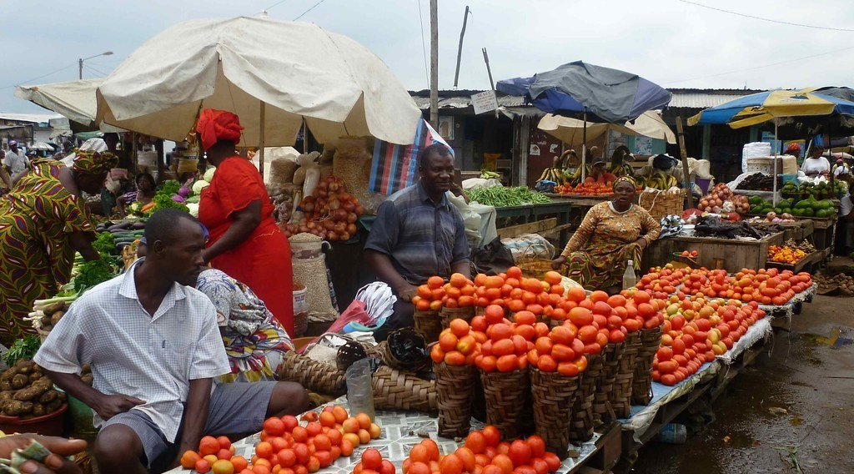  A market day
Perform the following tasks:
1. What is the problem raised in the situation above? (3 marks)

2. Using Document 1, explain how the fishermen can give their exact position to the rescuers. (3 marks)

3. Propose three things the fishermen can do so that they can be located easily in the future. (3 marks)
i)

ii)

iii)

Presentation: 2 marks
FACILITATOR: Mr KAMDEM Emmanuel

