GBHS GAROUA – GEOGRAPHY DEPARTMENT
UPPER SIXTH ARTS – GEOGRAPHY – MODULE 1
LESSON 20
MICRO-CLIMATES
Topic: Climates Sub-topic: Concept of Micro-climate
Teacher: Mr KAMDEM Emmanuel – Copy this lesson in your notebook, with the illustrations.

DEFINITIONS

Micro-climate: It is the climate of a small area that differs from the climate of the surrounding region.
Meso-climate: It is the climate of a medium-sized area, such as a town, a valley or a lake shore, a few kilometres to tens of kilometres wide.
Heat island: It is the higher temperature of a town compared with the surrounding countryside.
Anthropogenic heat: It is the heat released by human activities (vehicles, machines, air conditioners).

1. Meaning of Micro-climates

Micro-climates are explained as follows:
Micro-climate: A micro-climate is the special climate of a small area, from a few metres to a few kilometres, such as a garden, a forest clearing or a street. It differs from the regional climate because of local surfaces, relief, water or vegetation.
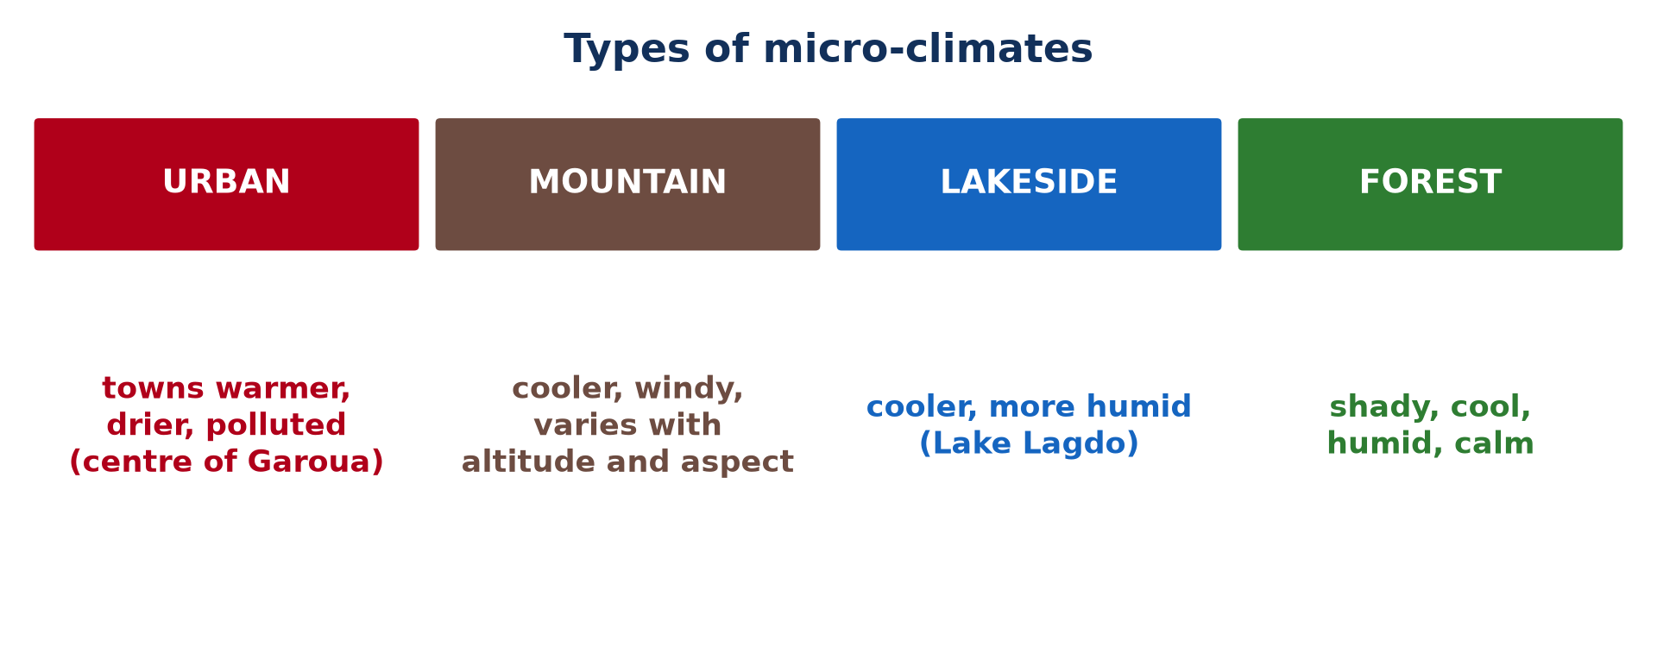
Illustration: Types of micro-climates
Micro- and meso-climates: The climate of a larger area, such as a whole town or a valley, is called a meso-climate. In practice, both are studied together as local climates, different from the macro-climate of a region.

2. Classification of Micro-climates

Micro-climates are classified into the following types:
Urban climate: The climate of a town is warmer, drier and more polluted than that of the surrounding countryside. It is created by buildings, roads, vehicles and industries.
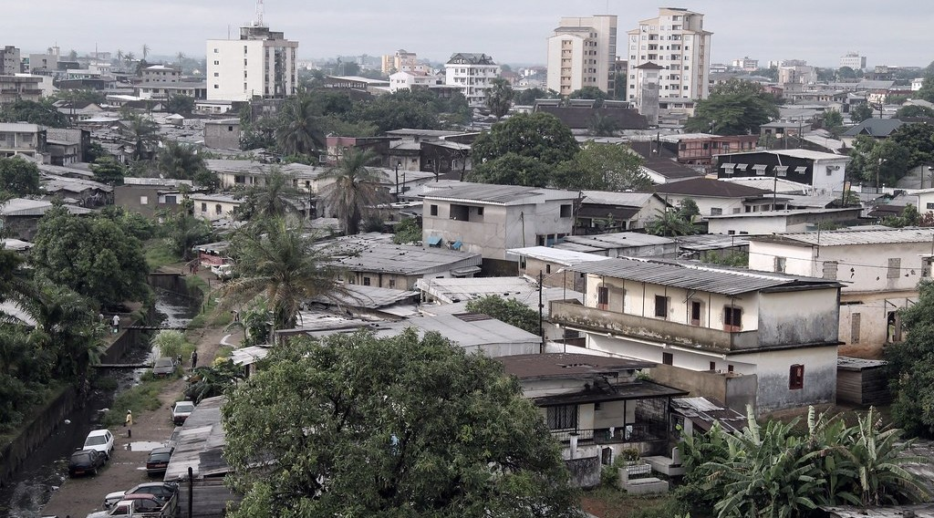
Illustration: Douala, a large city with its own urban climate
Mountain climate: On a mountain, temperature and rainfall change with altitude and with the side of the slope. Each level therefore has its own climate and vegetation.
Lakeside climate: Along a large lake, such as Lake Lagdo or Lake Chad, the water keeps the air cooler by day and more humid. Lake breezes blow onto the shore in the afternoon.
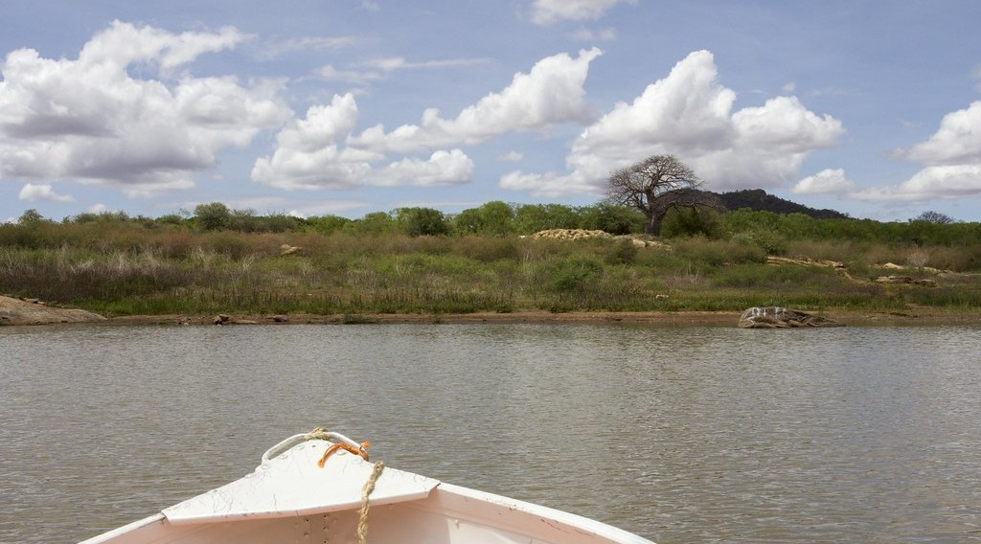
Illustration: A lake shore: the lakeside climate
Forest climate: Inside a forest, the trees block the sun and the wind and release water vapour. The air is therefore shady, cool, humid and calm, with a small daily range of temperature.
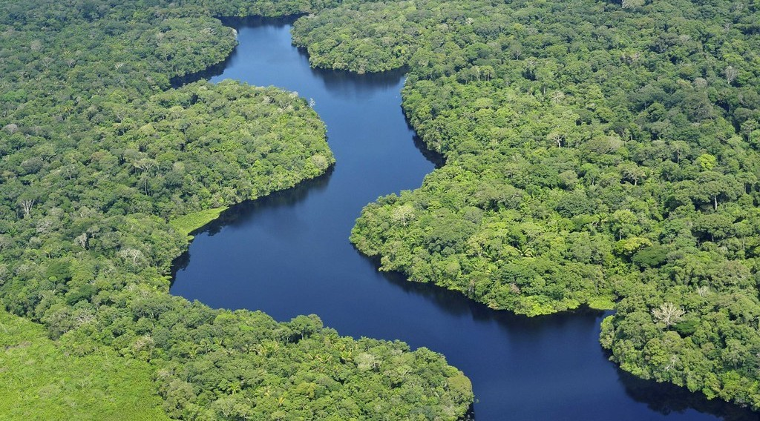
Illustration: A forest: the forest climate

3. Characteristics of Urban Climates

Compared with the countryside, towns have the following climatic characteristics:
Higher temperatures: Towns are warmer than the countryside, especially at night, by 2 to 5 °C in large cities. This is the urban heat island, strongest in the town centre.
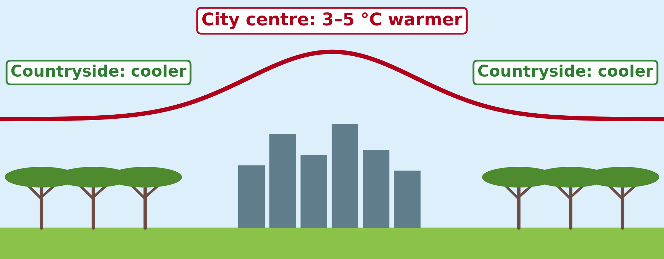
Illustration: The urban heat island: the town is warmer than the countryside
Lower humidity: Rainwater runs quickly into drains, and there are few plants and little open water. As a result, there is less evapotranspiration and the air is drier.
Modified winds: Buildings slow down the wind, so towns are generally calmer. However, wind can be channelled and strengthened in narrow streets between tall buildings.
More pollution and more rain: Dust, smoke and gases from vehicles, generators and factories are concentrated over towns. These particles and the extra heat can trigger more convectional storms over and downwind of large cities.
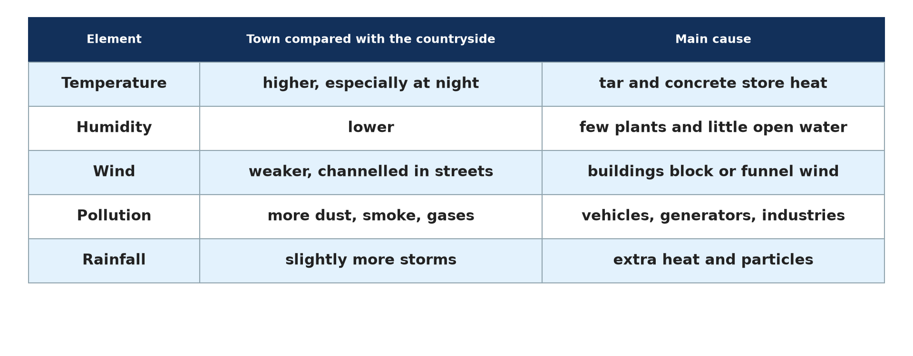
Illustration: The urban climate compared with the countryside

4. Factors of Urban Climates

The urban climate is explained by the following factors:
Artificial surfaces: Tarred roads, concrete and bricks absorb much solar energy by day and release it slowly at night. They also make rainwater run off quickly, so less water is available for evaporation.
Anthropogenic heat: Cars, moto-taxis, generators, air conditioners, factories and crowds all release heat. In big cities, this heat can equal a large part of the energy received from the sun in winter.
Reduced evapotranspiration: Towns have few trees, gardens and open soils. The energy that would be used to evaporate water is used instead to warm the air.
Urban geometry: Tall buildings and narrow streets form urban canyons that trap the heat radiated by walls and roads. They also block the wind that could carry this heat away.

HOMEWORK

State how temperature changes with altitude.
Our next lesson will be on: Lesson 21: Mountain Climates

