GBHS GAROUA – GEOGRAPHY DEPARTMENT
LOWER SIXTH ARTS – GEOGRAPHY – MODULE 2: GEOMORPHOLOGY
LESSON 5
LANDFORMS AT DESTRUCTIVE AND CONSERVATIVE MARGINS
Topic: The Development of the Earth's Structure Sub-topic: Theories of Earth Structure and Resultant Landforms
Teacher: Mr KAMDEM Emmanuel – Copy this lesson in your notebook, with the illustrations.

DEFINITIONS

Destructive (convergent) margin: It is a boundary where two plates move towards each other and crust is destroyed.
Conservative margin: It is a boundary where two plates slide past each other without creating or destroying crust.
Benioff zone: It is the sloping zone of earthquakes along a sinking plate.
Anticline and syncline: An anticline is an upward fold of rock layers and a syncline is a downward fold.
Tear (transform) fault: It is a fault along which two blocks slide past each other horizontally.

1. Destructive (Convergent) Margins

A) Folding and Fold Mountains
Fold mountains are formed as follows:
Compression and folding: When two plates collide, the layers of sedimentary rock between them are squeezed and bend into folds. Upward folds are called anticlines and downward folds synclines.
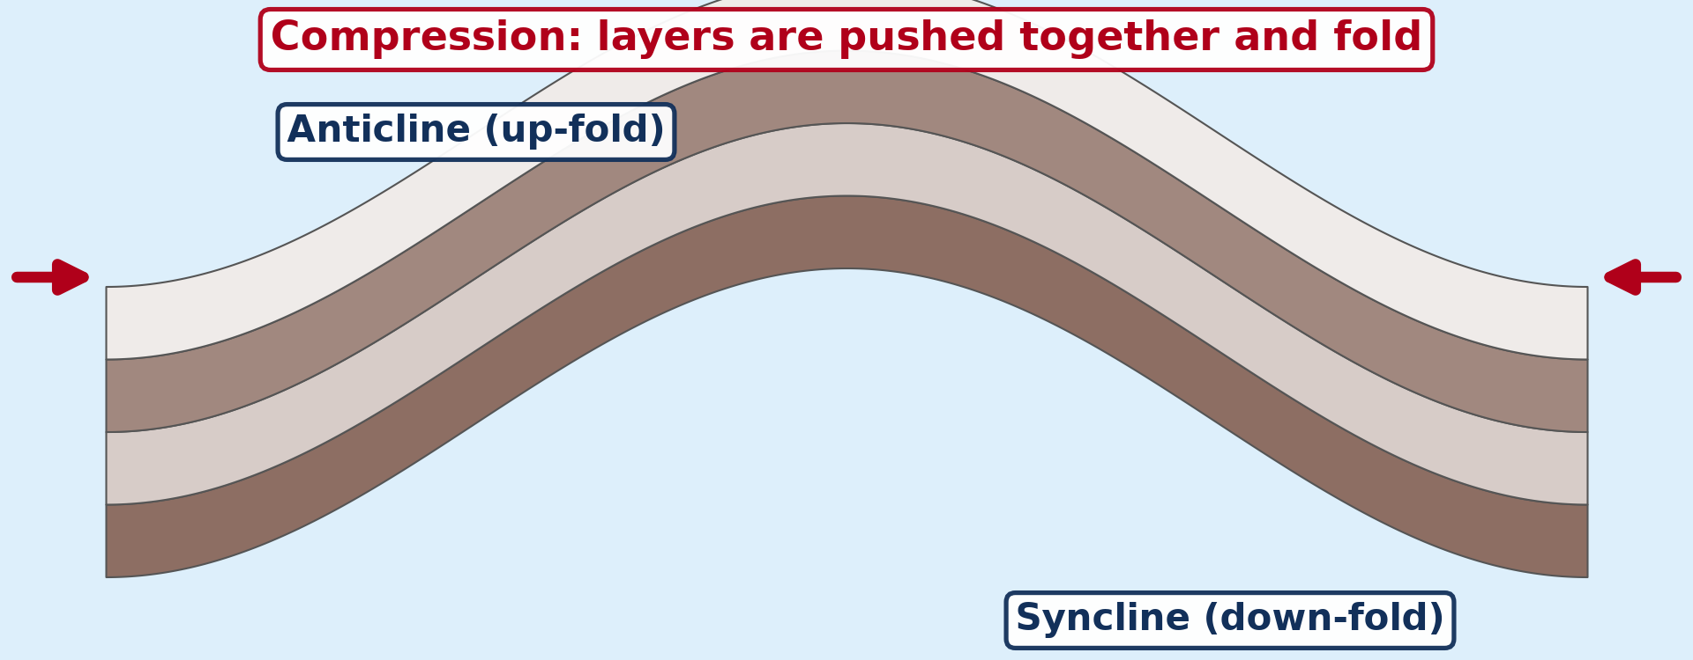
Illustration: Folding: compression crumples the layers of rock into anticlines and synclines
Types of folds: Gentle pressure forms simple, symmetrical folds, while stronger pressure forms asymmetrical and overturned folds. Very strong pressure lays the folds flat (recumbent folds) and can push them far forward as nappes, as in the Alps.
Continent against continent: When two continental plates collide, neither sinks, so the crust is crumpled and thickened into very high mountains. The Himalayas rose where the Indian plate pushes into the Eurasian plate.
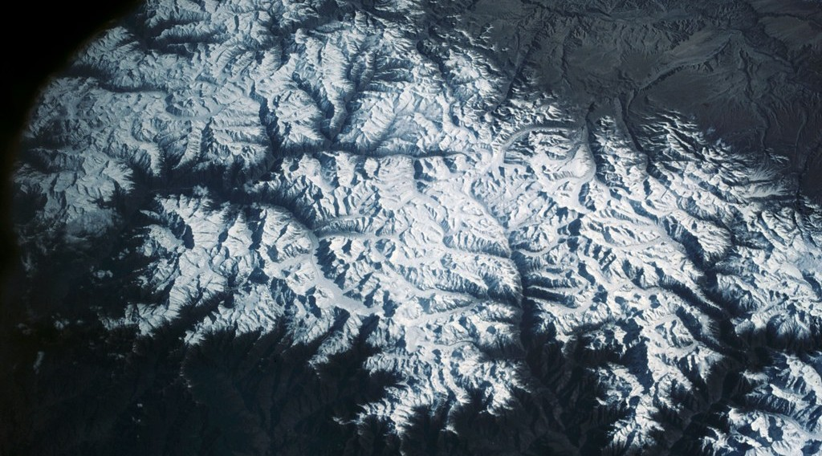
Illustration: The Himalayas, fold mountains formed where two continental plates collided
Ocean against continent: When an oceanic plate sinks under a continental plate, the edge of the continent is folded and uplifted. The Andes rose in this way where the Nazca plate sinks under the South American plate.
B) Trenches and the Benioff Zone
Subduction forms the following features:
Ocean trenches: Where a dense oceanic plate bends down into the mantle, a very deep, narrow trench forms on the ocean floor. The Mariana Trench in the Pacific is about 11,000 m deep, the deepest point on Earth.
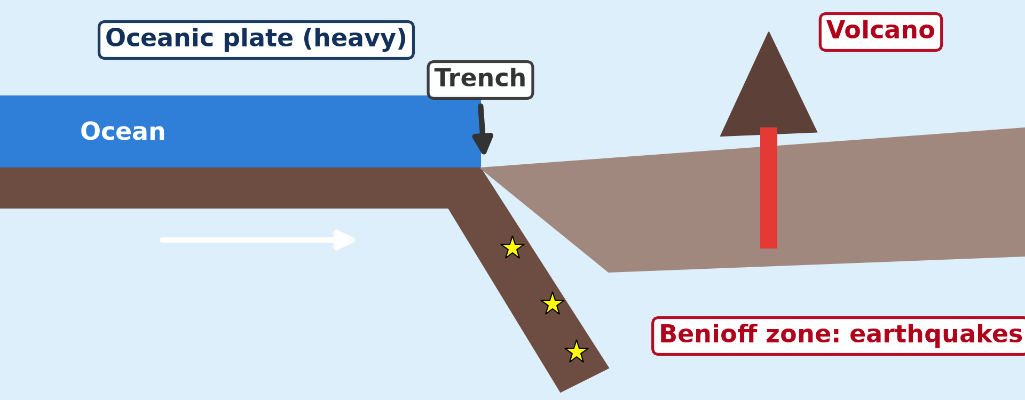
Illustration: Subduction: an oceanic plate sinks under another plate and forms a trench and volcanoes
The Benioff zone: As the plate sinks, friction and breaking of rocks cause earthquakes along a sloping zone that goes down to about 700 km. This zone, called the Benioff zone, shows the path of the sinking plate.
C) Island Arcs, Volcanoes and Earthquakes
Destructive margins also have the following features and activities:
Island arcs: When two oceanic plates meet, one sinks and melts, and the rising magma builds a curved chain of volcanic islands. Japan, the Philippines and the Aleutian Islands are island arcs.
Explosive volcanoes: The melting of the sinking plate produces thick, sticky magma rich in silica and gas. It causes violent eruptions, as at Mount St Helens in 1980 and Mount Pinatubo in 1991.
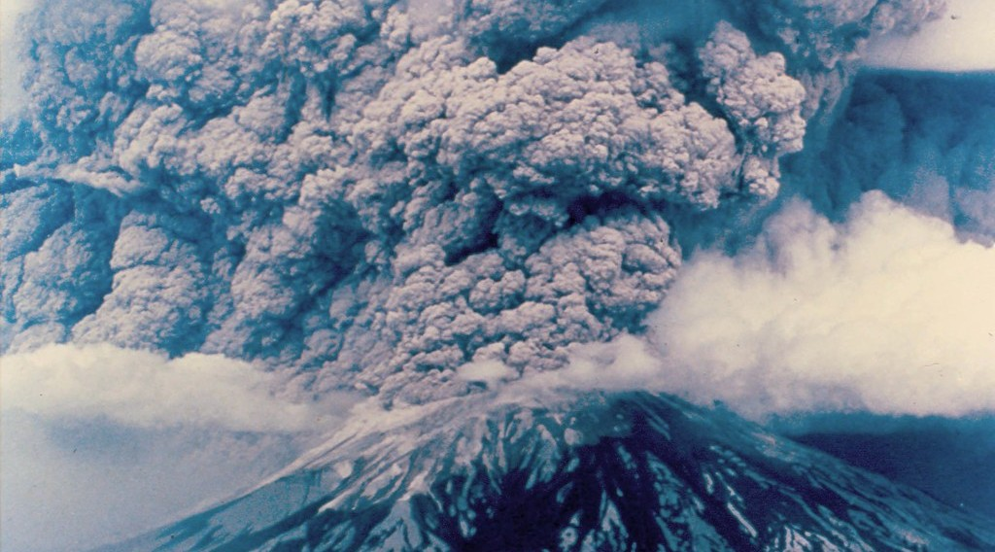
Illustration: Mount St Helens, an explosive volcano at a destructive margin
Powerful earthquakes: Earthquakes occur at all depths: shallow near the trench, intermediate and deep along the Benioff zone. The shallow ones are the strongest on Earth, like the Chile earthquake of 1960 (magnitude 9.5).
D) Location on a Global Scale
These features and processes are located in the following zones:
The Pacific Ring of Fire: It surrounds the Pacific Ocean, from the Andes to Japan and New Zealand, and contains about 75 % of the active volcanoes of the world. About 80 % of the largest earthquakes of the world occur along it.
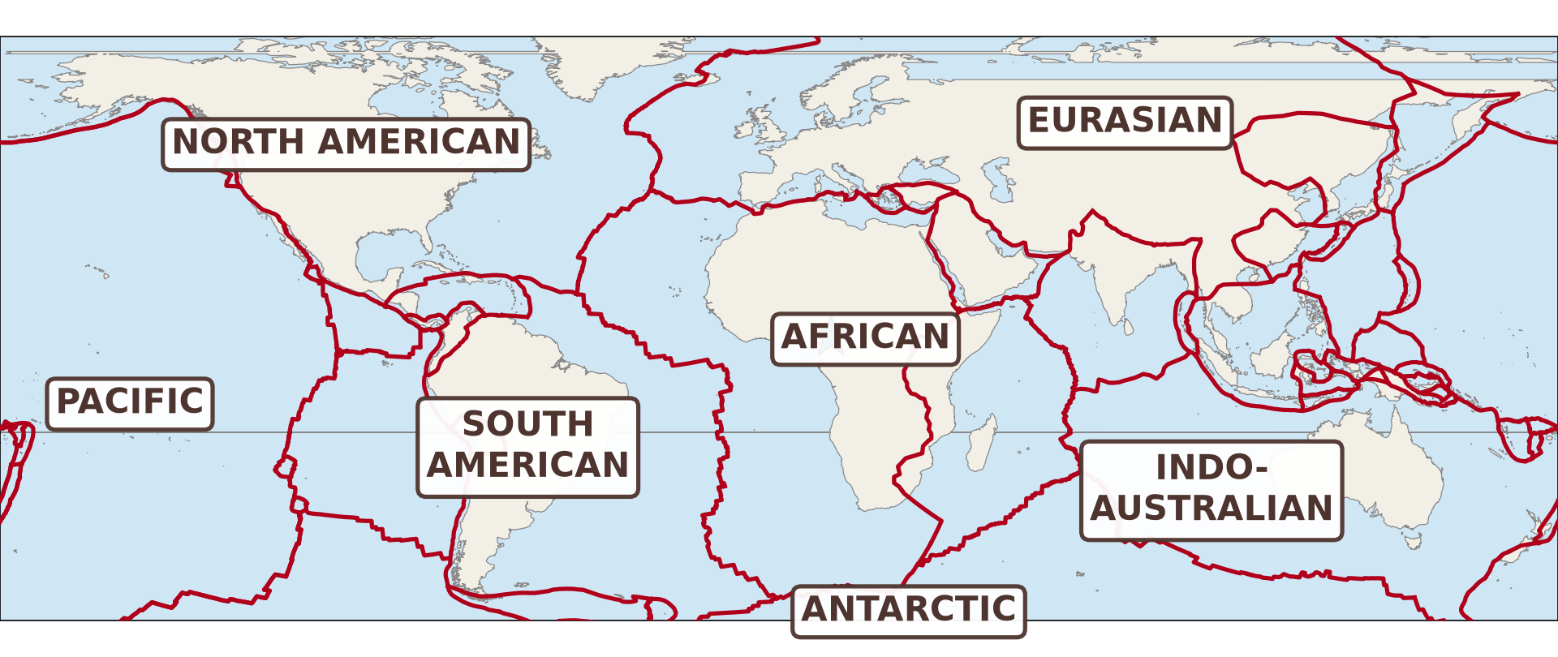
Illustration: Location of the main destructive margins around the world
The Alpine–Himalayan belt: It runs from the Atlas Mountains through the Alps, Turkey and Iran to the Himalayas. It is a zone of collision with young fold mountains and frequent earthquakes.

2. Conservative (Neutral) Margins

Conservative margins have the following processes:
By-passing of plates: The plates slide past each other in opposite directions, or in the same direction at different speeds. Crust is neither created nor destroyed, so there are no volcanoes.
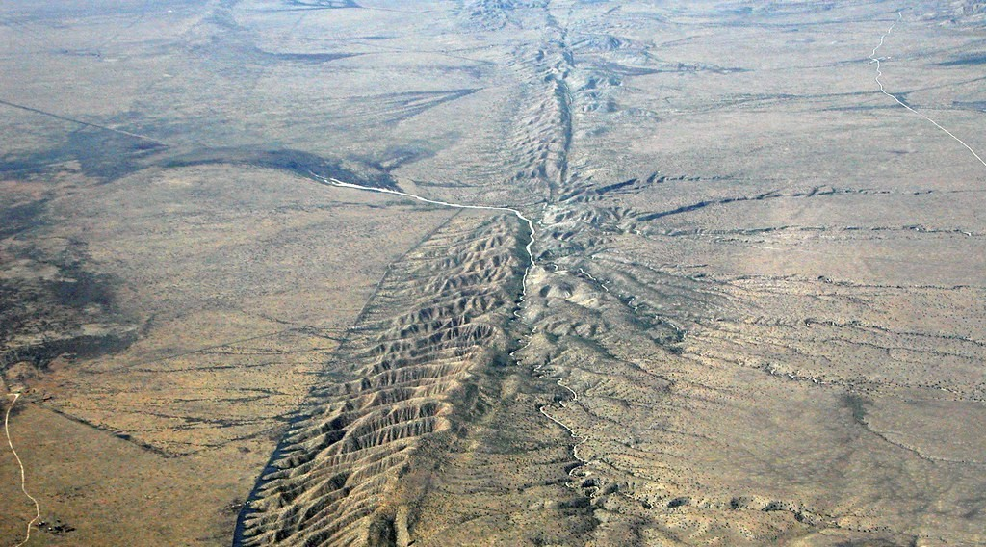
Illustration: The San Andreas Fault, a conservative margin in California
Tear (transform) faulting: The movement tears the crust along a long vertical fault, and the land on each side is offset. Rivers, roads and fences that cross the fault are displaced, as along the San Andreas Fault in California.
Earthquakes: The plates lock together by friction, and stress builds up for many years. When the rocks suddenly slip, a strong shallow earthquake occurs, like the San Francisco earthquake of 1906.

HOMEWORK

Distinguish magma from lava.
Our next lesson will be on: Lesson 6: Volcanism

