REPUBLIQUE DU CAMEROUN  Paix – Travail – Patrie  ****  MINISTERE DES ENSEIGNEMENTS SECONDAIRES  ****  DELEGATION REGIONALE DU NORD  ****  DELEGATION DEPARTEMENTALE DE LA BENOUE  ****  LYCEE BILINGUE DE GAROUA  BP : 301 GAROUA – TEL : 222 27 30 51  E-mail : lybilgaroua@yahoo.fr  N° Immatriculation : 1CK1GSFD110910109 | 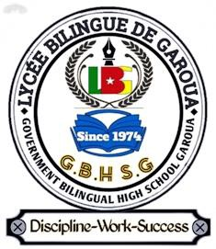 | REPUBLIC OF CAMEROON  Peace – Work – Fatherland  ****  MINISTRY OF SECONDARY EDUCATION  ****  NORTH REGIONAL DELEGATION  ****  BENOUE DIVISIONAL DELEGATION  ****  GOVERNMENT BILINGUAL HIGH SCHOOL GAROUA  P.O. BOX: 301 GAROUA – TEL: 222 27 30 51  E-mail: lybilgaroua@yahoo.fr  Registration N°: 1CK1GSFD110910109

Student’s names: | F | M | Class: FORM ONE BIL A / B
SEQ N° 1 | Assessment of module N°: 1 | Date: | Discipline: Geography | Duration: 1 hour
Evaluated competence: Learners are able to adapt to cosmic changes.
Student performance: | Remarks
Mark/20: | Grade: | CVWA | CWA | CA | CAA | CNA
Seal of the school  DISCIPLINE – WORK – SUCCESS | Signature, name and comments of the teacher: | Signature and name of parent/guardian:
FIRST SEQUENCE EVALUATION – SCHOOL YEAR 2026-2027
GEOGRAPHY DEPARTMENT
INSTRUCTIONS TO CANDIDATES
Answer ALL questions on this question paper.
In Section I, mark an (X) on the letter of the correct answer.

PART ONE: VERIFICATION OF RESOURCES (9 marks)
Section I: Multiple Choice Questions (1 × 5 = 5 marks)
1. Imaginary lines that divide the Earth into two equal halves are called:  A. Great circles  B. Latitudes  C. Longitudes  D. Cardinal points  2. Large masses of land on the Earth’s surface separated by oceans are called:  A. Oceans  B. Continents  C. Islands  D. The Equator  3. Because about 71 % of its surface is covered by water, the Earth is also called:  A. The red planet  B. The Greenwich Meridian  C. The blue planet  D. The world map | 4. The spinning movement of the Earth on its axis is called:  A. A year  B. The seasons  C. Revolution  D. Rotation  5. Which of the following is at the centre of the solar system?  A. The Sun  B. The Moon  C. The stars  D. The galaxies
Section II: Structural Question (4 marks)
The circle below represents the Earth. On it, draw and label the Equator, the Tropic of Cancer, the Tropic of Capricorn and the Arctic Circle. (4 × 1 = 4 marks)
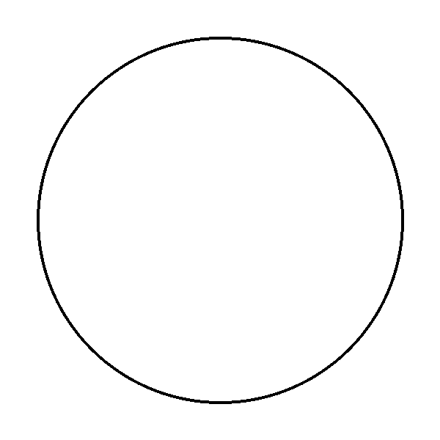
PART TWO: VERIFICATION OF COMPETENCES (9 marks)
Situation:
Your family is travelling by car to the village. On the way, your little brother Samy looks out of the window and says that the trees along the road are moving. The driver laughs and tells him that, in the same way, the Sun seems to “move” across the sky every day, from the east to the west. Samy does not understand, and he asks you, a Form One geography student, to explain what is really moving.
Perform the following tasks:
1. Present the problem raised in the situation above. (3 marks)

2. Give two effects of the rotation of the Earth on its axis. (3 marks)
i)

ii)

3. Give three proofs to convince Samy that it is the Earth that moves and not the Sun. (3 marks)
i)

ii)

iii)

Presentation: 2 marks
FACILITATOR:
Mme ASTHA Noura

