ONK Deployment Modeller – Gruppe 14

## Deployment Model Local:

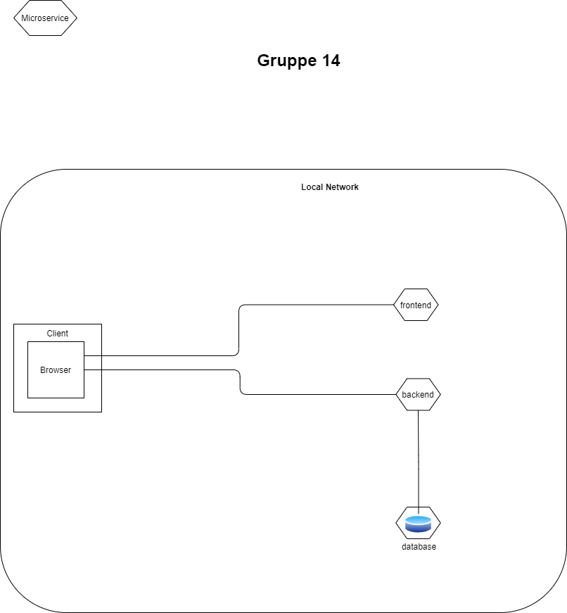

Deployment Model Local Container:  
  
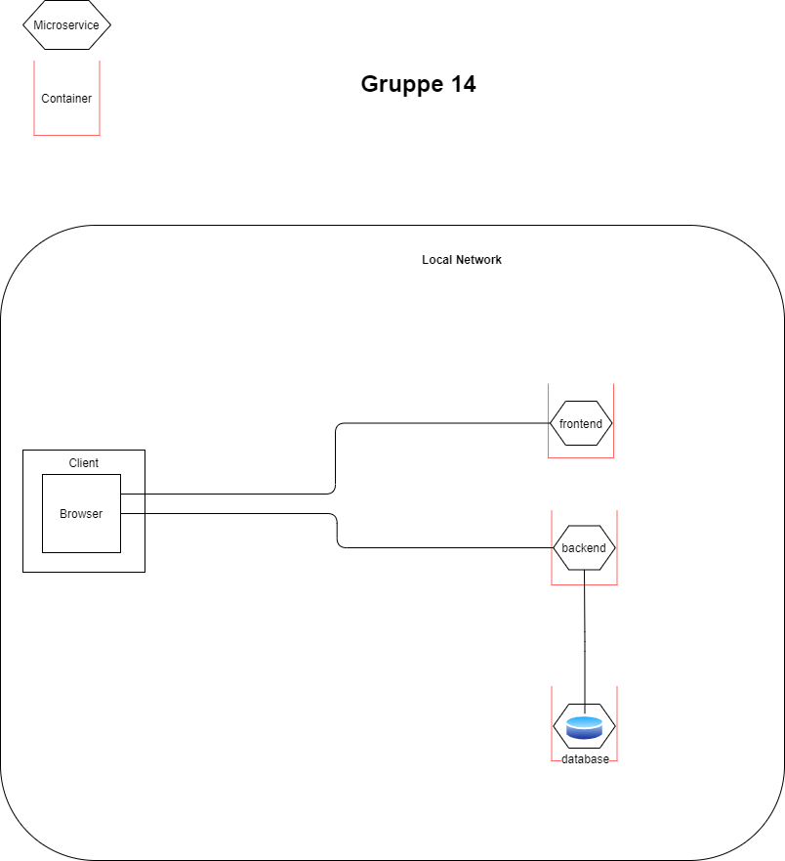

## Deplotment Model Cluster:

