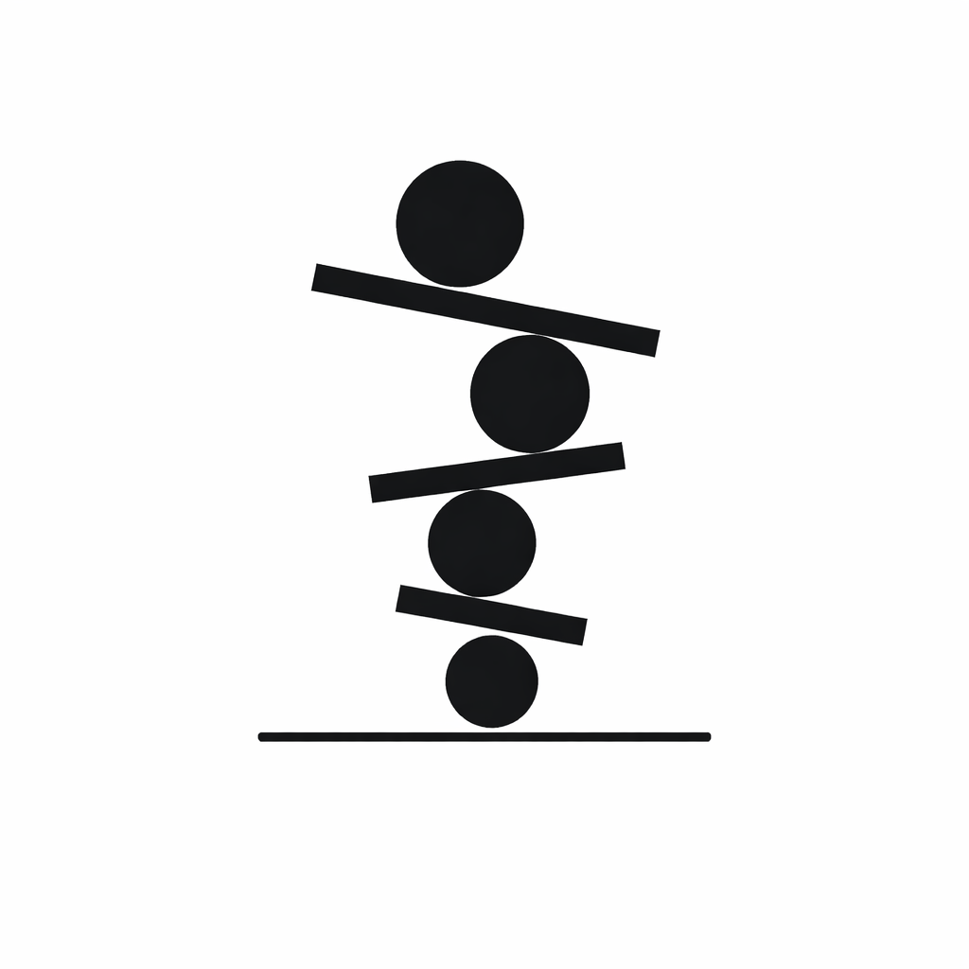

Project Proposal
Unitas System
Version 1.0
Prepared by Limbo Software Development

Rodrigo Alejandro Hurtado Cortés - A01713854

Alexis Yaocalli Berthou Haas - A01713458

Ana Camila Cuevas González - A01412609

Alejandro Contreras Magallanes - A01662743

February 13th, 2026
Table of Contents

1. Organizational Scope 1
1.1. Institution 1
1.2. Project Specific Area 1
1.3. System Impact 1
2. Problem Description 1
2.1. Current Working Procedures 1
2.2. Identified problems 1
2.3. Employee's Impact 1
2.4. Organization's Impact 1
3. Information Requirements 2
Figure 1. UML for information requirements 8
4. Work Plan 8
5. Communication Channel 8

Table of Figures

Figure 1. UML for information requirements 8
Figure 2. Gantt Chart - Decomposition of Project Proposal (present document). 8

Organizational Scope

Institution
Change.org is the greatest platform of social change around the world () where people can start campaigns, mobilize citizens, and collaborate with the decision makers that can create change and provide solutions.

Project Specific Area
The current project proposal will be developed for the team behind change.org who is made up of various groups specializing in different careers who give support, maintenance, and develop new features for the platform; looking to increase the impact of each campaign by providing refined software tools.

System Impact
The impact of the system proposed will influence directly to reduce lost hours of employees during quarterly assessments, centralize information, facilitate the work of project leaders, and overall increase the productivity of the team by including summary's and highlighting automatic obtention.

Problem Description

Current Working Procedures
At present, Change.org employees rely on a self-review system to track the progress of their work projects. On a daily basis, they complete forms to record completed tasks, pending activities, and the impact of their contributions.
In addition, Slack is used for general communication, while Jira serves as the primary platform for visualizing projects, goals, tasks, and subtasks.

Identified problems
The information recorded across these platforms becomes dispersed and difficult to retrieve from all employees. As a result, effectively tracking the progress of a project, or monitoring the tasks performed by an individual employee or team, becomes highly challenging.

Employee's Impact
Moreover, the current system fails to capture the full scope of employees' work. Important activities such as documentation, research, and meetings are frequently left unregistered.

Organization's Impact
The lack of structured information management leads to an estimated loss of approximately two-four hours per day per employee every self-review period, ultimately reducing overall productivity. Additionally, this fragmented system may create inaccurate perceptions of individual performance, potentially affecting employees' opportunities for recognition or performance-based bonuses.
Additionally, the dispersion of information hinders collaborative learning, limits effective knowledge sharing, and restricts opportunities for constructive feedback within teams.

Information Requirements
The system requires a structured set of data entities to support team organization, project tracking, daily activity logging, collaboration visibility, achievement monitoring, and report generation. The following data catalogs define the core information required for the system.
After the meetings and information obtained from the senior software engineer Bernardo Laing, the following information requirements are proposed from the developer team:
Team
Stores organizational teams and their leadership roles.
Fields
- team_id (UUID)
- name (varchar)
- description (varchar)
- team_manager_id (UUID, references Employee)
- product_manager_id (UUID, references Employee)
- design_manager_id (UUID, references Employee)
- created_at (datetime)
Purpose
Represents engineering or product teams and identifies leadership roles without enforcing strict hierarchy.

Employee
Stores internal users who log work, contribute to projects, and generate reports.
Fields
- employee_id (UUID)
- full_name (varchar)
- email (varchar)
- timezone (varchar)
- is_active (boolean)
- created_at (datetime)
Purpose
Represents system users and serves as the central entity for activities, entries, achievements, and reports.

Membership
Represents the association between employees and teams, including historical tracking.
Fields
- membership_id (UUID, primary key)
- employee_id (UUID, foreign key → Employee)
- team_id (UUID, foreign key → Team)
- joined_at (datetime)
- left_at (datetime, nullable)
- role (varchar)
Purpose
Allows employees to belong to one or more teams over time and preserves historical membership data for reporting and evaluations.

Project
Stores internal projects and their lifecycle information.
Fields
- project_id (UUID)
- name (varchar)
- description (varchar)
- status (ProjectStatus enum)
- owner_employee_id (UUID, references Employee)
- start_date (date)
- end_date (date, nullable)
- created_at (datetime)
Purpose
Represents work initiatives that group goals, activities, collaborations, and achievements.
ProjectTeam
Represents the association between projects and teams.
Fields
- team_id (UUID, foreign key → Team)
- project_id (UUID, foreign key → Project)
- team_role (varchar)
- joined_at (date)
Purpose
Allows multiple teams to participate in a project and defines their role within it.

Collaboration
Stores cross-project or cross-team contributions that may not be captured in formal ticketing systems.
Fields
- collaboration_id (UUID, primary key)
- project_id (UUID, foreign key → Project)
- employee_id (UUID, foreign key → Employee)
- description (varchar)
- started_at (datetime)
- ended_at (datetime, nullable)
Purpose
Captures invisible work such as mentoring, technical assistance, or temporary collaboration efforts that impact evaluations.

Goal
Stores measurable objectives associated with a project.
Fields
- goal_id (UUID)
- project_id (UUID, foreign key → Project)
- title (varchar)
- description (varchar)
- metric_target (varchar, nullable)
- due_date (date, nullable)
- status (GoalStatus enum)
- created_at (datetime)
Purpose
Defines what a project aims to achieve and allows monitoring of progress toward objectives.

DailyEntry
Stores daily standup entries, typically originating from Slack.
Fields
- entry_id (UUID)
- employee_id (UUID, foreign key → Employee)
- entry_date (date)
- work_today (varchar)
- work_tomorrow (varchar)
- blockers (varchar)
- slack_standup_url (varchar, nullable)
Purpose
Preserves daily progress logs that would otherwise be lost in messaging channels and enables structured reporting.

Activity
Represents a concrete unit of work performed by an employee.
Fields
- activity_id (UUID, primary key)
- title (varchar)
- description (varchar)
- employee_id (UUID, foreign key → Employee)
- project_id (UUID, foreign key → Project)
- entry_id (UUID, foreign key → DailyEntry, nullable)
- completed_at (date, nullable)
Purpose
Tracks specific work actions. Activities may be linked to daily entries and projects to enable traceability and aggregation.

Achievement
Stores notable accomplishments associated with a project.
Fields
- achievement_id (UUID)
- project_id (UUID, foreign key → Project)
- created_by_pm_id (UUID, references Employee)
- title (varchar)
- description (varchar)
- achievement_date (date)
- evidence_link (varchar, nullable)
Purpose
Highlights meaningful outcomes for communication across teams and for use in evaluation processes.
Report
Stores generated reports for employees, projects, or teams.
Fields
- report_id (UUID)
- generated_by_employee_id (UUID, foreign key → Employee)
- period_start (date)
- period_end (date)
- content_json (varchar)
- file_url (varchar, nullable)
- created_at (datetime)
Purpose
Supports generation of self reviews, team reviews, and project summaries for defined time periods.

EmployeeReport
Associates a report with an employee.
Fields
- report_id (UUID, foreign key → Report)
- employee_id (UUID, foreign key → Employee)

ProjectReport
Associate a report with a project.
Fields
- report_id (UUID, foreign key → Report)
- project_id (UUID, foreign key → Project)

TeamReport
Associates a report with a team.
Fields
- report_id (UUID, foreign key → Report)
- team_id (UUID, foreign key → Team)

Core Relationships
- A Team has many Membership records.
- An Employee can belong to multiple Teams over time.
- A Project has many Goals and Achievements.
- An Employee logs many DailyEntries.
- A DailyEntry can generate multiple Activities.
- An Employee performs multiple Activities.
- A Project contains multiple Activities.
- Multiple Teams can participate in a Project.
- Employees can participate in multiple Collaborations.
- Employees generate Reports.
- Each Report is associated with exactly one subject type through EmployeeReport, ProjectReport, or TeamReport.
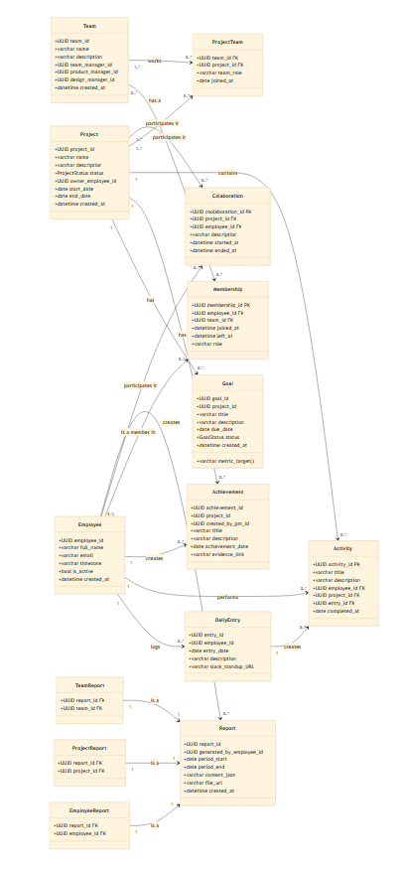

Figure 1. UML for information requirements

Work Plan
The following Gantt Chart has been designed by the developer team based on the Course Calendar of the Software Construction & Decision Making class which coordinates the continuous minimum progress required to achieve a successful project.
Modifications and the emergence of subtasks for each of the tasks assigned are based on the inner team's considerations, priorities, time availability, and relevance.

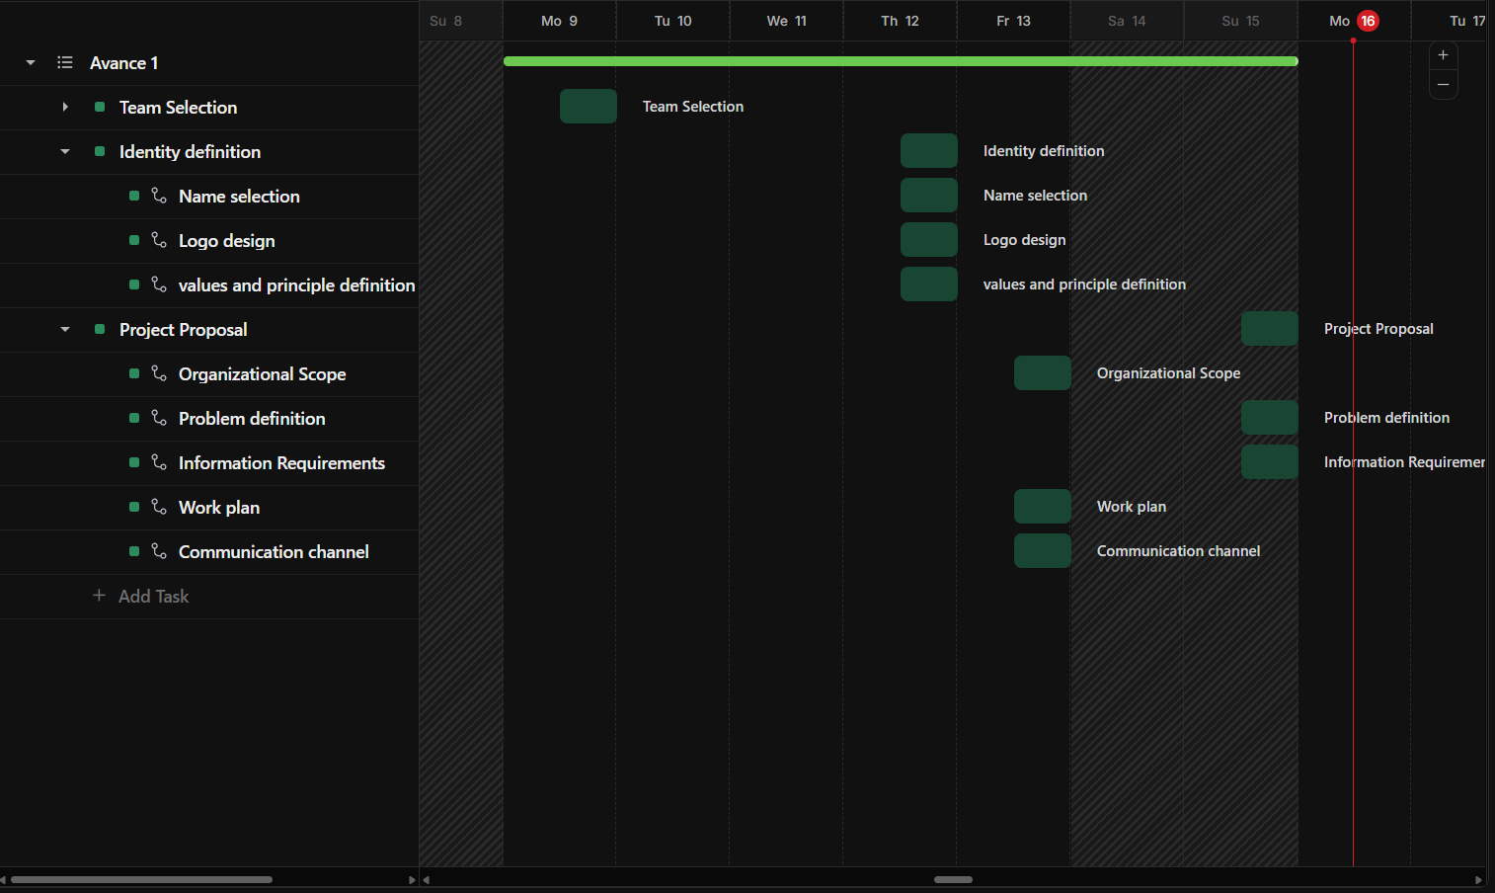

Figure 2. Gantt Chart - Decomposition of Project Proposal (present document).

Each of the presented tasks and subtasks are assigned to a member of the team, with its relevance and due date with enough time to develop them.

Communication Channel
The developer team has established the following communication channels and working environments for increasing efficiency and collecting the project information and documentation in a common place where updates are seen simultaneously.

- Slack Channel:
  - tc2005b_limbo7
Communication channel among members of the group where contact is formally referent to the project.
https://edjuarezp.slack.com/archives/C0AEMC5FRRC
- WhatsApp Group:
  - Limbo Software Dev
Communication channel focused on informal communication and fast member reach.

- ClickUp Environment:
  - Limbo Software Dev
Working environment where actively developers of the team share and collaborate over documentation, brainstorming, and task delegation.
https://app.clickup.com/9017890496/v/g/8cr45p0-297

