Software Requirements Specification

for

All-About-Pools System
Version 1.0 approved
Prepared by Rodrigo Alejandro Hurtado Cortés - A01713854

Alexis Yaocalli Berthou Haas - A01713458

Ana Camila Cuevas González - A01412609

Alejandro Contreras Magallanes - A01662743

Software Construction & Decision Making Group 402
February 11, 2026
Table of Contents
1. Introduction 1
1.1. Purpose 1
1.2. Document Conventions 1
1.3. Intended Audience and Reading Suggestions 1
1.4. Product Scope 2
1.5. References 2
2. Overall Description 3
2.1. Product Perspective 3
2.2. Product Functions 3
3. External Interface Requirements 5
3.1. User Interfaces 5
3.1.1. Non-authenticated User Interfaces 5
3.1.2. Client User Interfaces 6
3.1.3. Service Worker User Interfaces 11
3.1.4. Supervisor User Interfaces 12
3.1.5. Administrator User Interfaces 13
3.2. Communications Interfaces 18
4. System Features 19
4.1. Functional Requirements 19
4.2. Information Requirements 25
5. Other Nonfunctional Requirements 26
5.1. Performance Requirements 26
5.2. Safety Requirements 26
5.3. Security Requirements 26
5.4. Software Quality Attributes 26
5.4.1. Responsiveness 26
5.4.2. Compatibility 26
5.4.3. Scalability 26
5.4.4. Accessibility 26
5.4.5. Availability 26
5.5. Business Rules 27
Service's Terms 27
Client's Terms and Benefits 27
Employee's Responsibilities 28
Supervisor's Responsibilities 28
Administrator's Responsibilities and Privileges 28
6. Other Requirements 29
Appendix A: Glossary 29
Appendix B: Generative AI Use 29
7. References 30

Table of Figures

Figure 1. Roles and Privileges of the System (RBAC) 4
Figure 2. Login / Register Interface 5
Figure 3. Additional information page / user manual Interface 6
Figure 4. Client User Interfaces Interface 7
Figure 5. Profile settings page Interface 7
Figure 6. Pool registration, deregistration and editing page Interface 8
Figure 7. Service history page Interface 9
Figure 8. Service information page Interface 9
Figure 9. Reports, incidents and recommendations page Interface 10
Figure 10. Page of employees related to a service Interface 10
Figure 11. Service Request Page Interface 11
Figure 12. Page for recording supervisions, budgets and billings Interface 11
Figure 13. Customer search page Interface 12
Figure 14. Customer information inquiry page Interface 12
Figure 15. Service request inquiry page Interface 13
Figure 16. Customer service history inquiry page Interface 13
Figure 17. Invoice generation page Interface 14
Figure 18. Service report inquiry page and incident feedback Interface 14
Figure 19. Service report inquiry page and incident feedback Interface 15
Figure 20. Job search page for workers/supervisors Interface 15
Figure 21. querying information and registering and deregistering staff Interface 16
Figure 22. Table of Priority Functional Requirements 18
Figure 23. UML Role Inheritance Diagram 19
Figure 24. UML Non-authenticated User - User Case Diagram 19
Figure 25. UML Client User - User Case Diagram 20
Figure 26. UML Service Worker User - User Case Diagram 21
Figure 27. UML Supervisor User - User Case Diagram 21
Figure 28. UML Administrator User - User Case Diagram 22
Figure 29. Entity Relationship Model 23

Introduction

Purpose
All-about-Pools is a Spanish enterprise specializing in pool maintenance, cleaning, and lifeguarding services, currently experiencing significant growth across Spain. Each day, they receive numerous requests for different addresses, requirements, dates and other specifications.

This volume of requests is overwhelming the staff responsible for logistics and service coordination, placing a strain on human resources and increasing the risk of customer dissatisfaction or lost clients due to slow processes or human mistakes. Standardizing processes and controlling information efficiently have become critical needs.

Consequently, an information system represents a process automation solution that reduces the need to hire additional personnel, streamlines operations, and ensures consistent service quality. Implementing such a system not only helps retain existing clients but also enables the enterprise to expand its customer base effectively.

Document Conventions
The following requirements declared in section 3. will not be ordered by priority level, instead these will have a concrete priority label declared as one of the following options:

- Critical
- High
- Medium
- Low
- Lowest

Intended Audience and Reading Suggestions
The presented document below has been developed for the client, project managers and developers to have a clear, transparent and precise declaration of requirements in the system, a guide during the project development and a reference for modifications; keeping always the functionality to the final user and the client problem solving as the optimal priority.

Product Scope
The presented product consists of an information system managed by All-about-Pools, with different user roles including clients, service workers, supervisors, administrators, and non-authenticated users. The system allows non-authenticated users to access public information, register as clients, and log in to the system. Clients can submit and manage service requests, consult budgets, track service history, and provide or review feedback on incidents. Service workers can consult schedules and inspections, submit reports, and manage personal information, while additionally, supervisors create assessment reports, assign materials, and monitor inspections. Administrators manage budgets, assign personnel, consult and update information, handle incidents, and generate reports.
The system applies workflow optimization by automating processes, standardizing request management, and improving information control. This reduces the need for additional personnel, ensures consistent service quality, enhances client satisfaction, and supports scalable growth for the enterprise.

References
The present document follow the guidelines and standards established in:

- IEEE Std. 830-1998 sponsored by the Software Engineering Standard Committee developed on October 20th, 1998; reaffirmed on December 9, 2009. Which can be consulted at https://standards.ieee.org/ieee/830/1222.

For details about the use of generative AI during the creation of the present document Appendix B has been created.

Overall Description

Product Perspective
The presented product works under the regulation and supervision of All-about-pools, relying on its internal databases to store, track, and manage information about clients, service requests, employees, supervisors, and maintenance tasks; effectively becoming an integrated extension of the company’s operational network.

Some of the remarkable features of the system include role-based access to functionalities, automated assignment of employees to service requests, management and consultation of service budgets, tracking of maintenance and service history, submission and feedback of incidents, and control of personal and pool information.

Product Functions
The application functionality changes drastically depending on the role of the user as its architecture is created over symmetric Role Based Access Control (RBAC). The following table presents the functionalities of each user in a hierarchical structure where the first users have the least privileges (Non Authenticated User) while the last one controls the overall roles of them (Administrator).

Roles | Privileges
Non-authenticated user | - FR-01 Access the system through the web interface.  - FR-02 Consult public information available on the website.  - FR-03 Register as a client in the system.  - FR-04 Log in to the system.
Client | - FR-05 Submit company's service request.  - FR-06 Register pool.  - FR-07 Modifies pool's data.  - FR-08 Eliminates pool.  - FR-09 Consult submitted service requests.  - FR-10 Cancel submitted service requests.  - FR-11 Consult maintenance reports created by supervisors.  - FR-12 Consult generated service's budget.  - FR-13 Authorize generated service's budget.  - FR-14 Consult issued receipts.  - FR-15 Submit incidents related to received services.  - FR-16 Consult feedback related to submitted incidents.  - FR-17 Consult service history.  - FR-18 Consult information about assigned employees.  - FR-19 Consult personal information.  - FR-20 Modify personal information.
Service worker (Maintenance, Cleaning, lifeguard) | - FR-21 Consult assigned work schedules.  - FR-22 Submit service reports.  - FR-23 Consult personal information.  - FR-24 Modify personal information.
Supervisor | - FR-25 Consult assigned maintenance inspections.  - FR-26 Create maintenance assessment reports.  - FR-27 Assign required materials for repairs.
Administrator | - FR-28 Consult submitted service requests.  - FR-29 Assign service request budgets.  - FR-30 Assign employees to service requests.  - FR-31 Consult client information.  - FR-32 Consult worker information.  - FR-33 Modify worker information.  - FR-34 Consult supervisor information.  - FR-35 Modify supervisor information.  - FR-36 Consult reported incidents.  - FR-37 Give feedback to reported incidents.  - FR-38 Generate service request reports.  - FR-39 Generate client lists.  - FR-40 Generate invoice reports.  - FR-41 Generate service reports.  - FR-42 Generate client revenue reports.

Figure 1. Roles and Privileges of the System (RBAC)

Additionally, the User Cases Diagram presented in Figure ## of the present document can give a greater understanding of the RBAC presented.

External Interface Requirements

User Interfaces

Non-authenticated User Interfaces
      - Login / register
- Request email and password
- Display the company name and logo

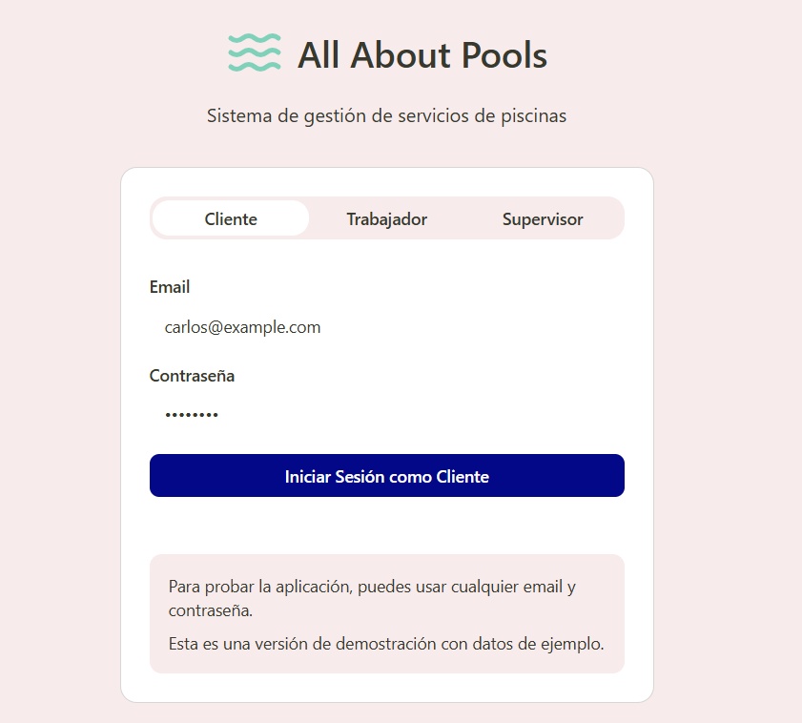
Figure 2. Login / Register Interface

      - Additional information page / user manual
- Website description
- General use of the page as a user role
- Company contact information

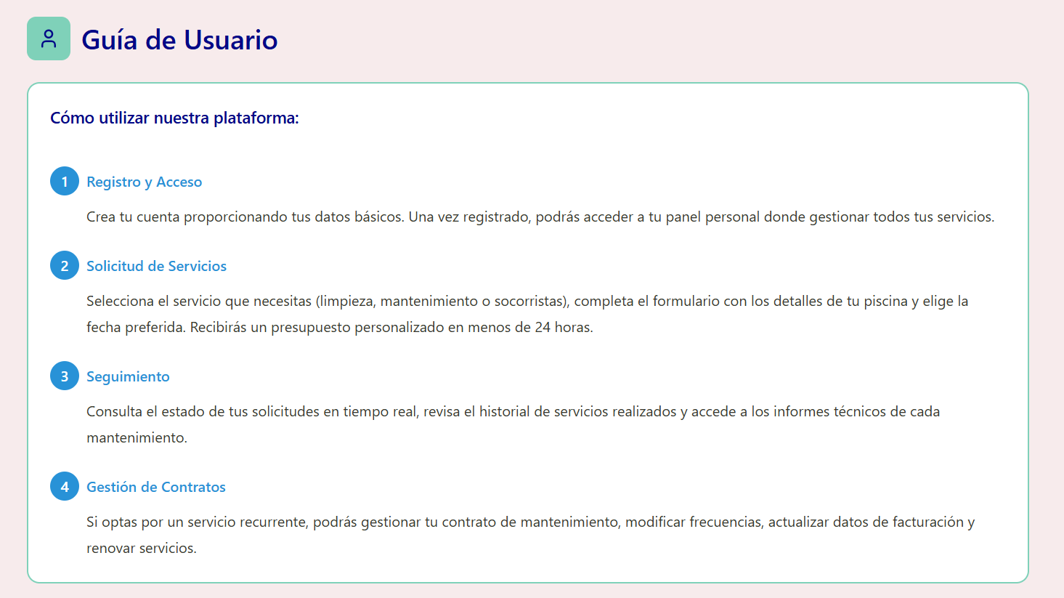
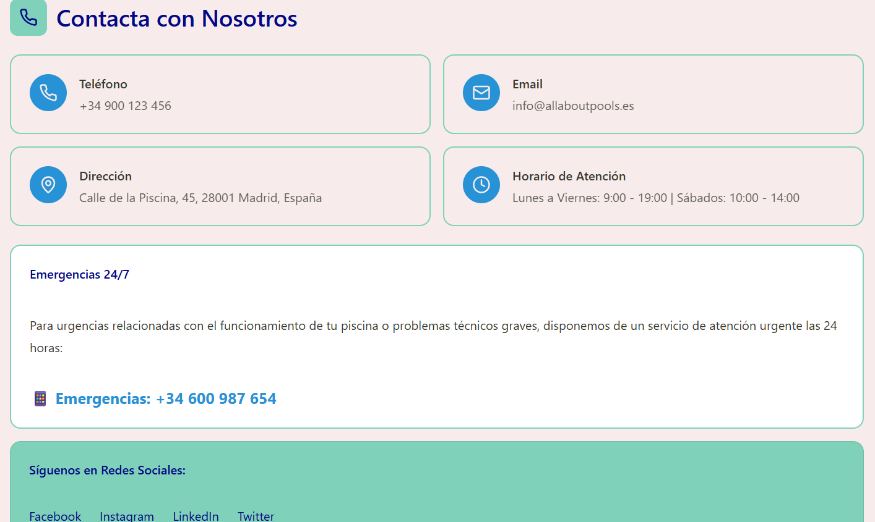
Figure 3. Additional information page / user manual Interface

Client User Interfaces
      - News and updates page
- Presenting discounts, services, achievements, news and updates relevant to users in the form of a "post" like a bubble
- Access to consult news information (to external pages)
- Word matching search tool

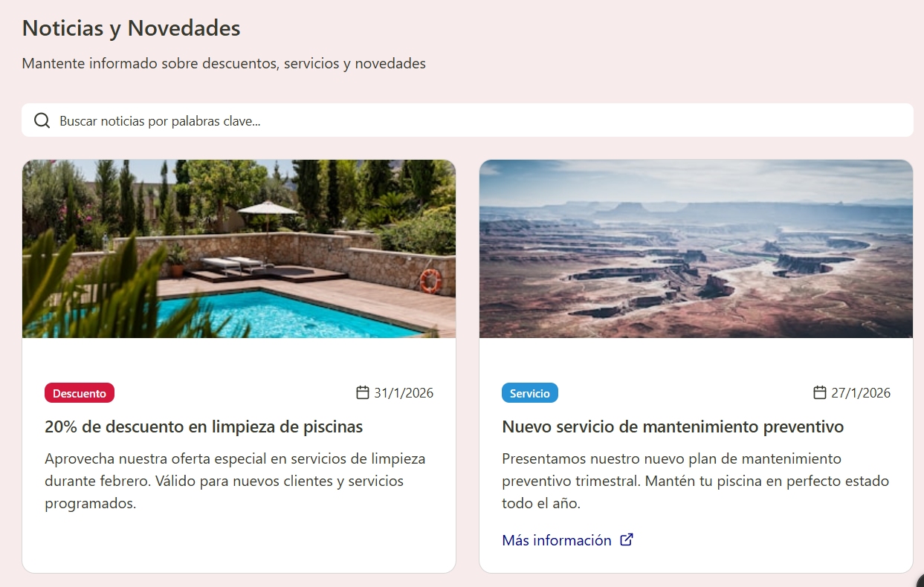
Figure 4. Client User Interfaces Interface

      - Profile settings page
- Access to name, email, password, pools, profile picture, notifications, language, and address
- Direct presentation and list format
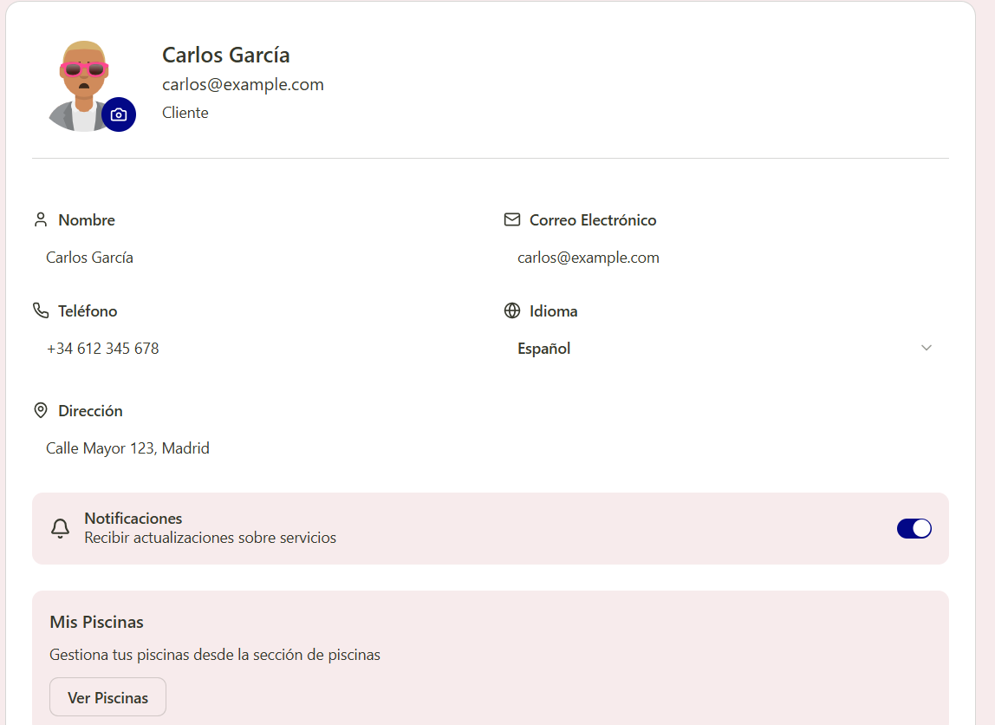

Figure 5. Profile settings page Interface

      - Pool registration, deregistration and editing page
- Display of swimming pools by name in list format
- access and editing of pools
- Edit name, dimensions, address and description
- removal and addition of swimming pools
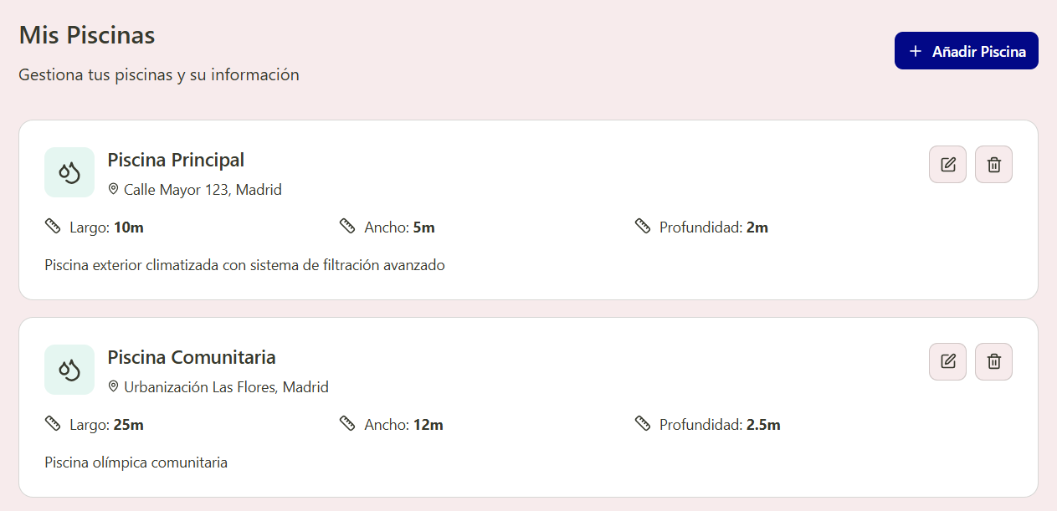

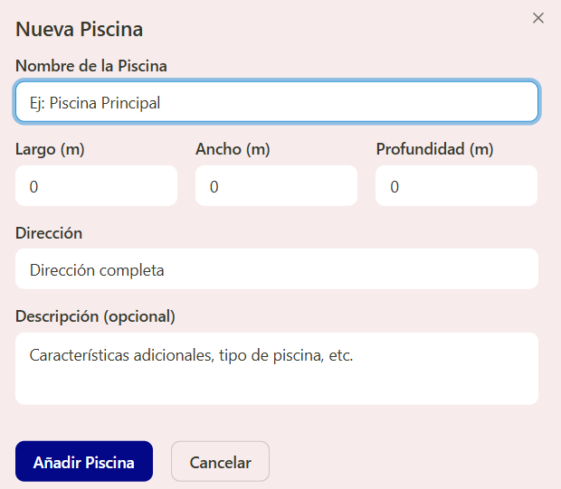
Figure 6. Pool registration, deregistration and editing page Interface

      - Service history page
- Viewing and accessing services by status, name, type, and date in list format.

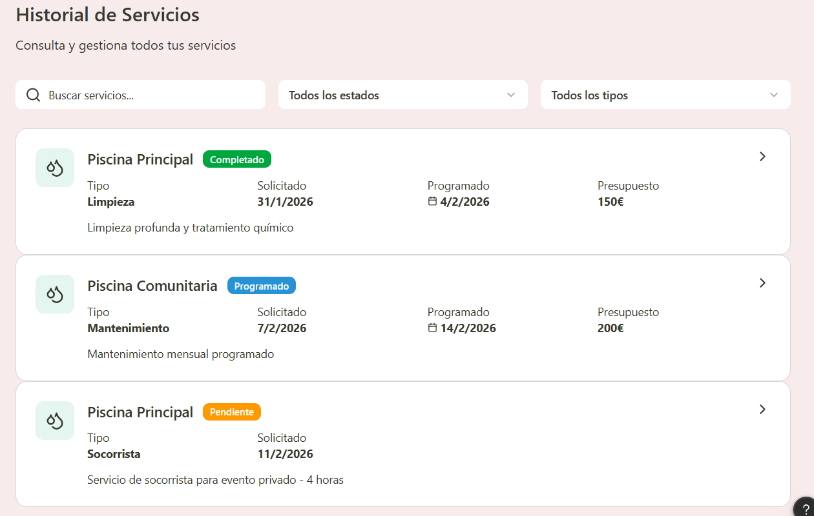
Figure 7. Service history page Interface

      - Service information page
- View and query a specific service with status, name, pool, type, related workers, date, budget, invoice and partial description/incidents/recommendations.

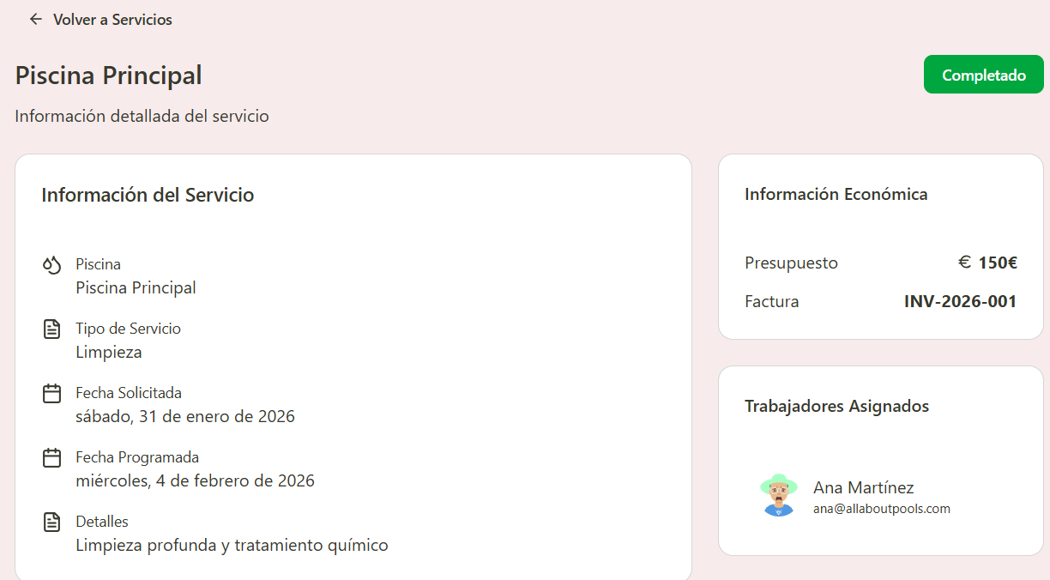
Figure 8. Service information page Interface

      - Reports, incidents and recommendations page
- Edition (depending on the time frame) on incidents
- Consultation and acceptance (depending on the time frame) of budgets
- Contact with supervisors/administrators

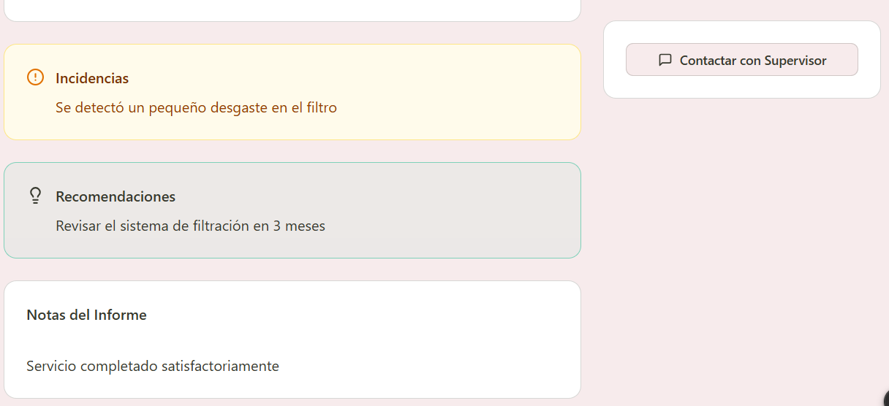
Figure 9. Reports, incidents and recommendations page Interface
      - Page of employees related to a service
- Viewing employee profile related to a service
- Displaying profile data (similar to a user profile)

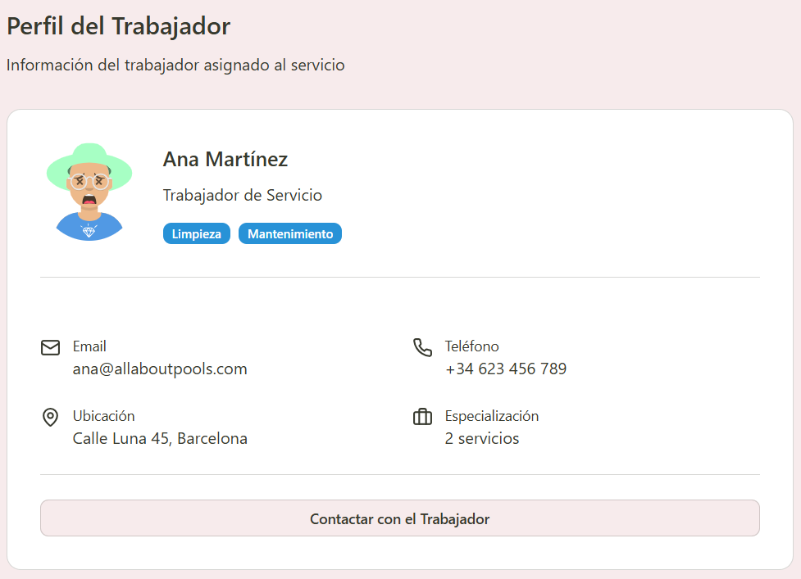
Figure 10. Page of employees related to a service Interface

      - Service Request Page
- Page for creating a service request based on pool, service type, requested date and time, details
- Viewing user profile
- Format type "forms"

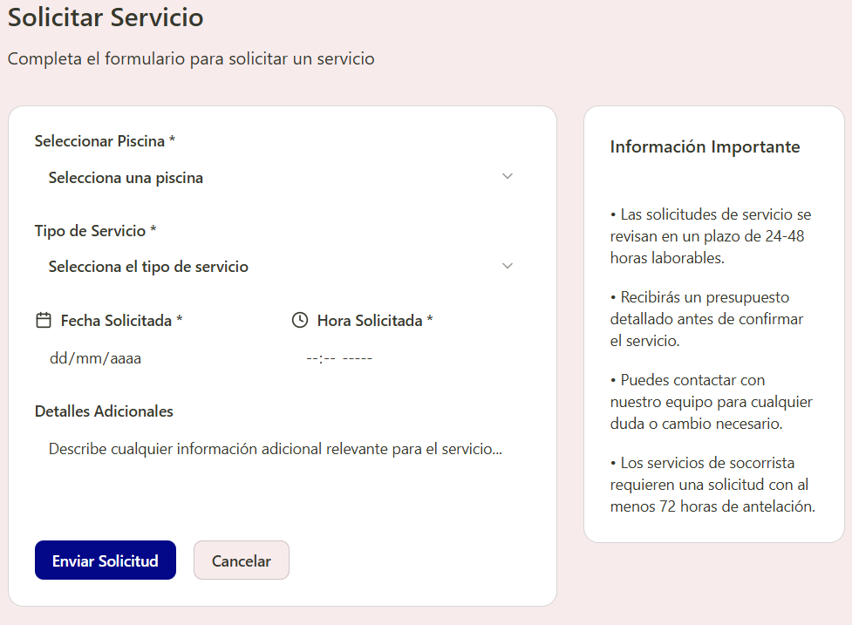
Figure 11. Service Request Page Interface

Service Worker User Interfaces
      - Page for querying assigned services
- Display of user, schedule, address, pool specifications and assigned collaborators.
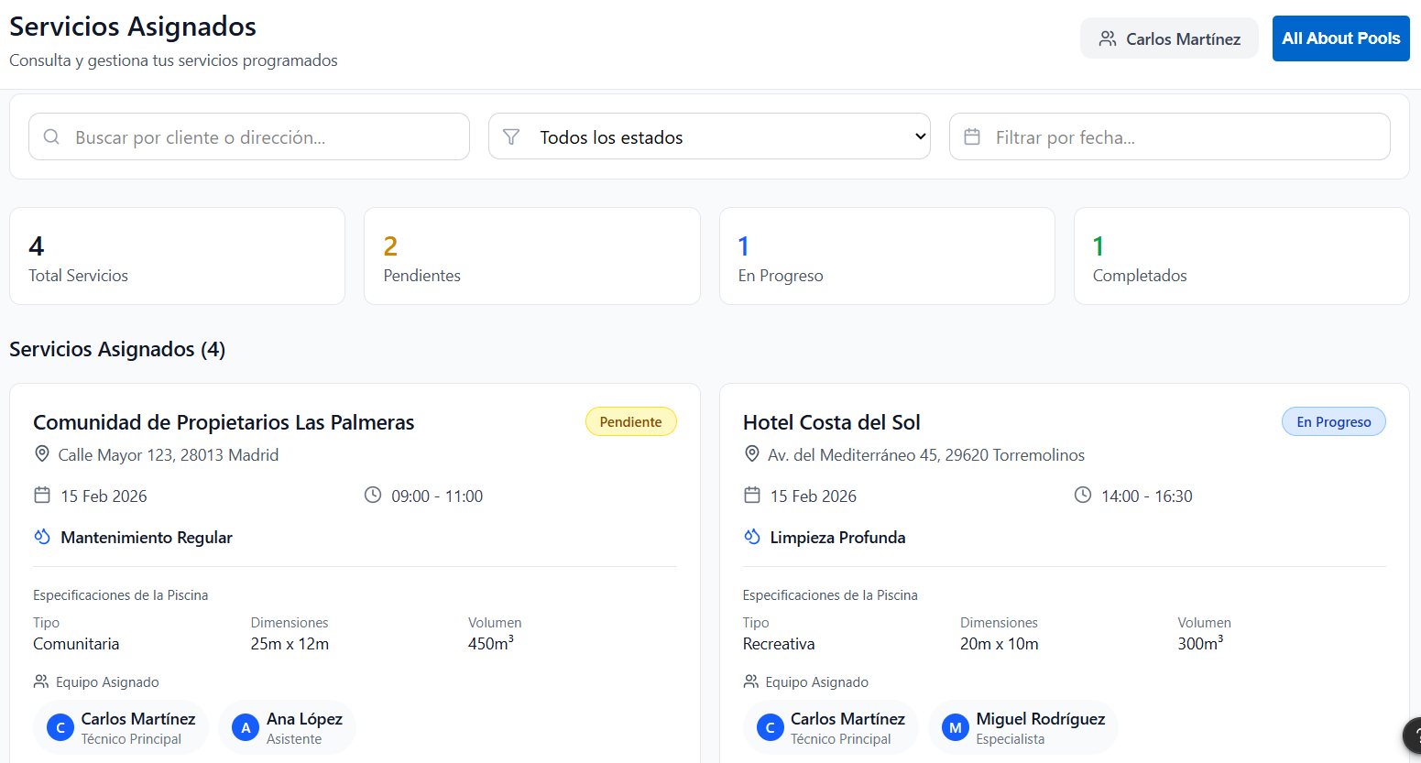
Figure 12. Page for querying assigned services Interface
      - Service report registration page
- Service completion documentation
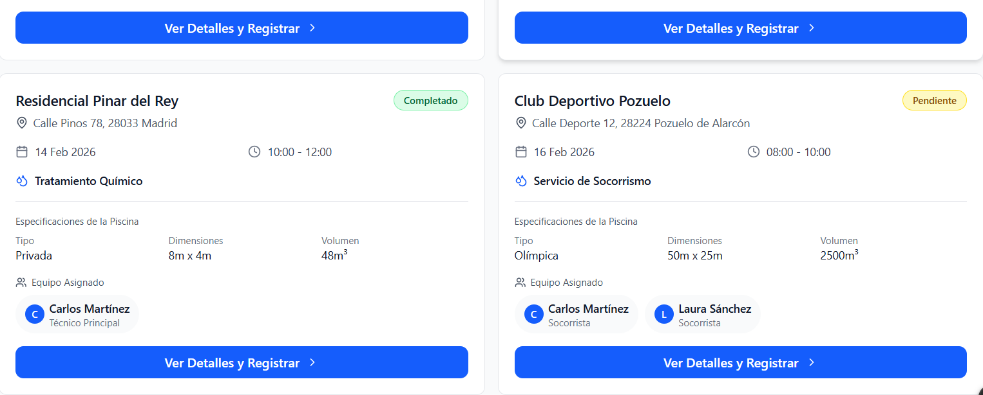
Figure 12. Service report registration page Interface

Supervisor User Interfaces
      - Page for recording supervisions, budgets and billings.
- Service completion and documentation: possible schedule, supervisor in charge, billing.
- Viewing user profile.

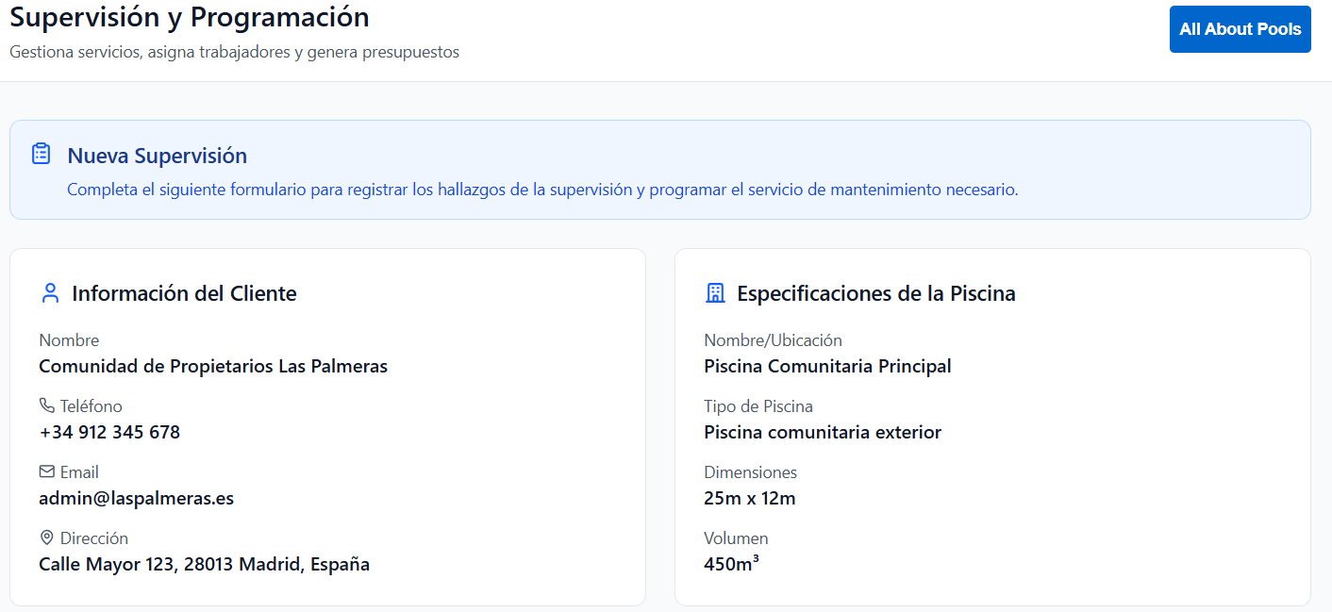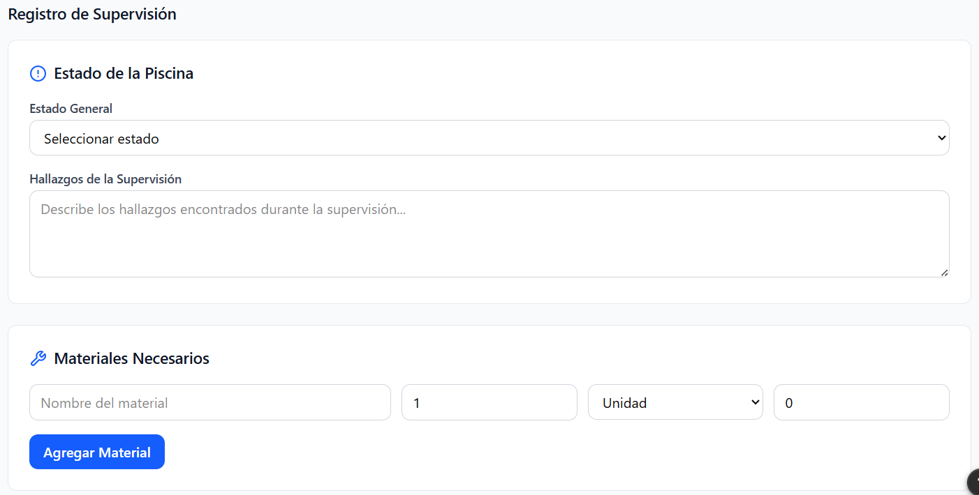

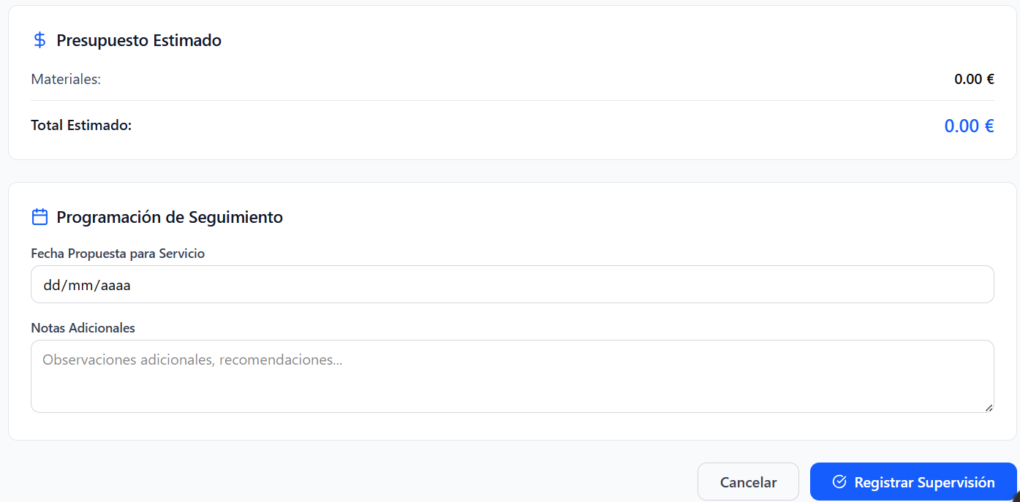
Figure 12. Page for recording supervisions, budgets and billings Interface

Administrator User Interfaces
      - Customer search page
- Search based on user name, email, or address
- Displaying users by name and profile picture based on matching characteristics

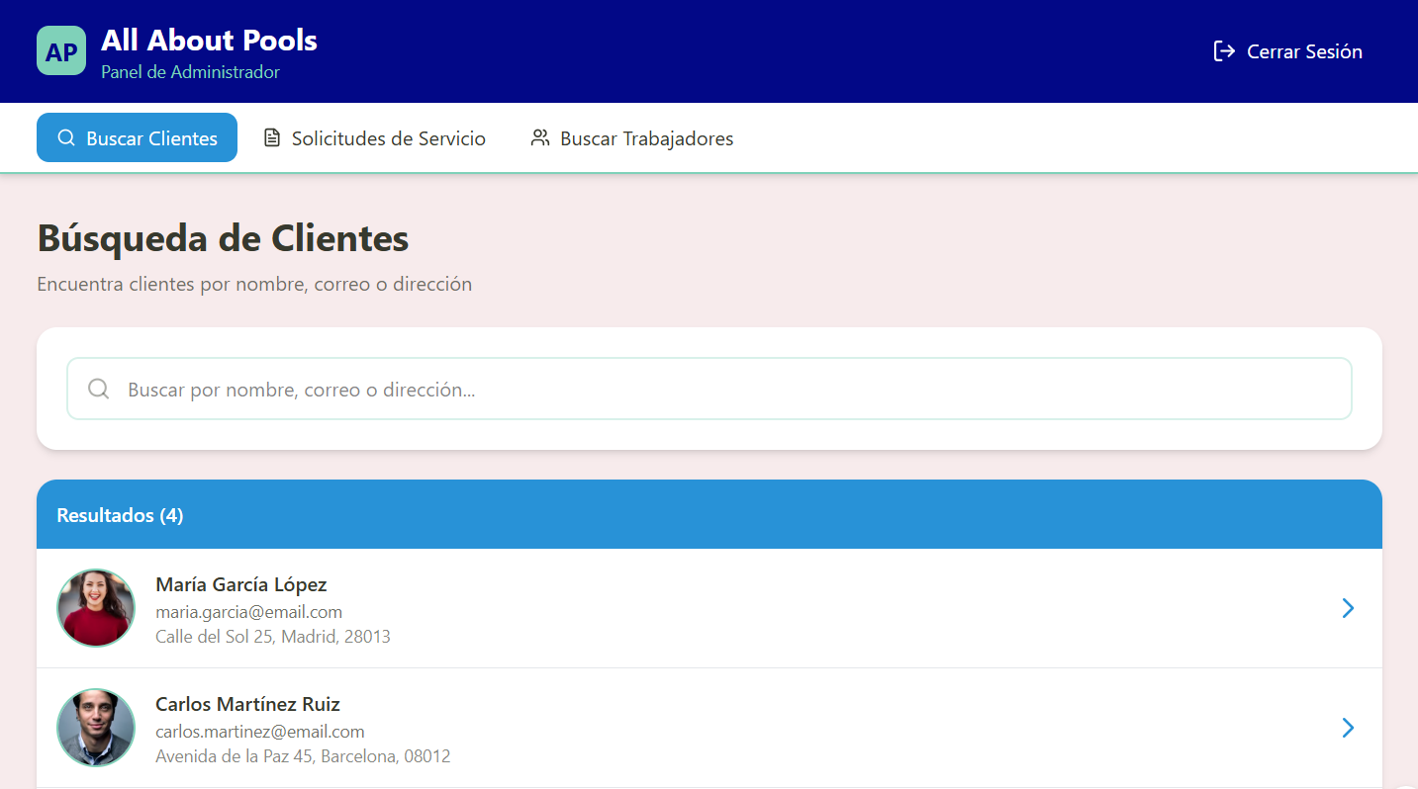
Figure 13. Customer search page Interface

      - Customer information inquiry page
- Viewing the selected user's profile
- Display of your data page

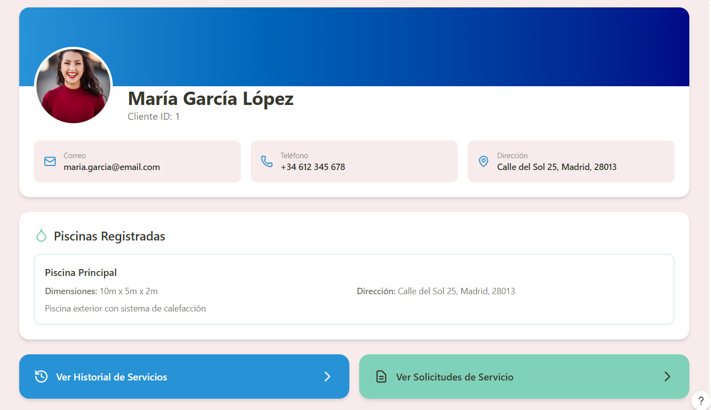
Figure 14. Customer information inquiry page Interface

      - Service request inquiry page
- Displaying queries from different users and of different types
- Display of the same features as in the section for requesting a consultation from the user
- Link to the section on the allocation and deployment of competent workers in the area for said service
- Link to invoice generation page

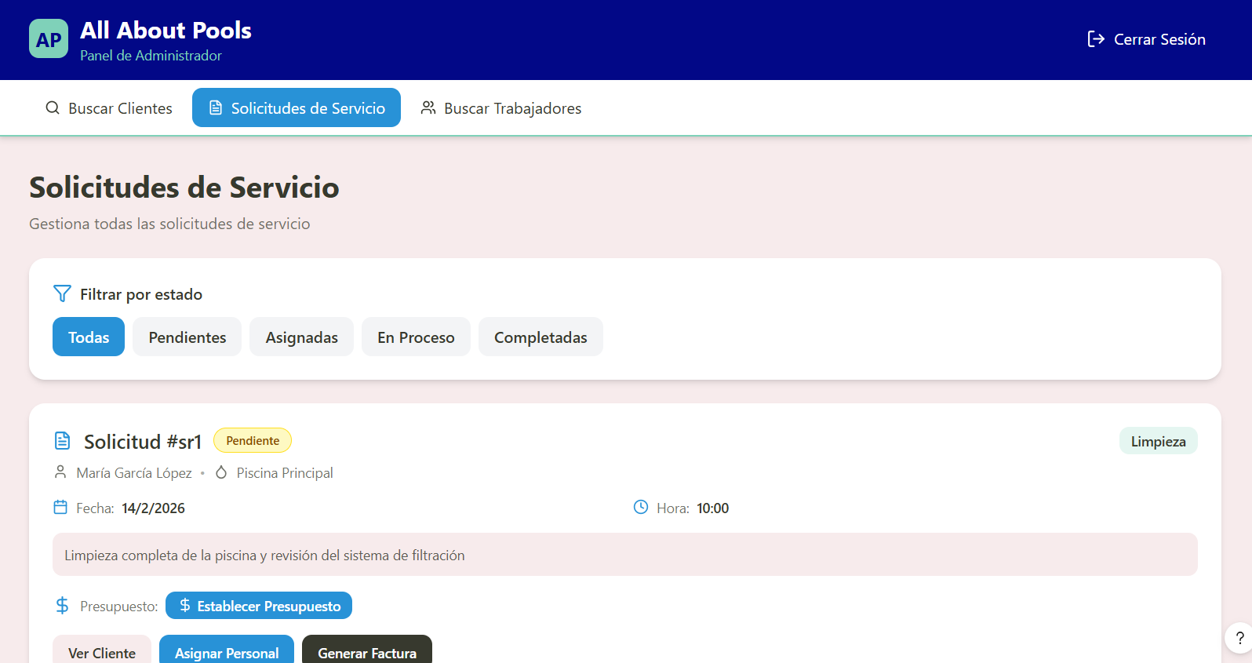
Figure 15. Service request inquiry page Interface

      - Customer service history inquiry page
- Viewing the service history of a selected client
- Same display as user history in your own account

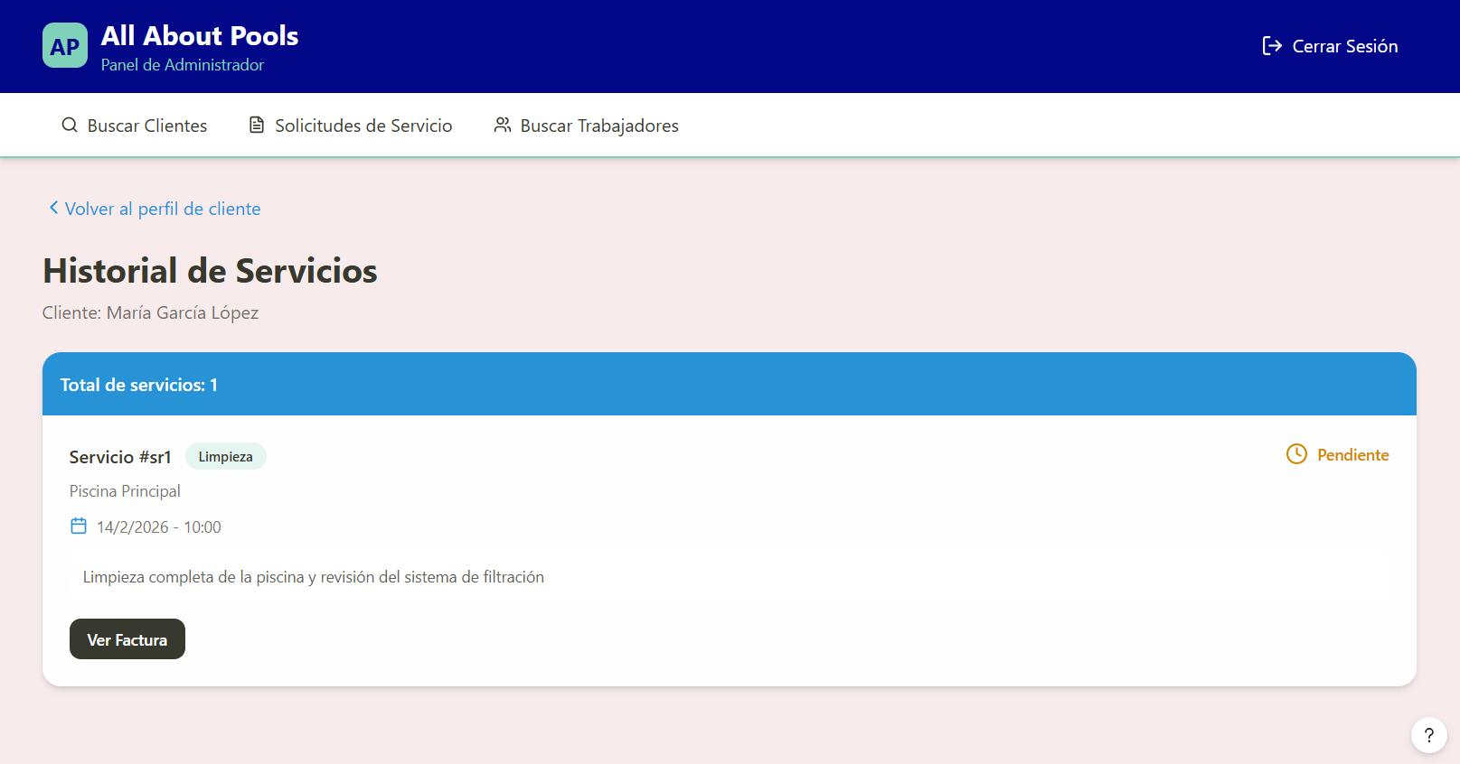
Figure 16. Customer service history inquiry page Interface

      - Invoice generation page
- Space for publishing and/or editing invoices regarding the requesting service

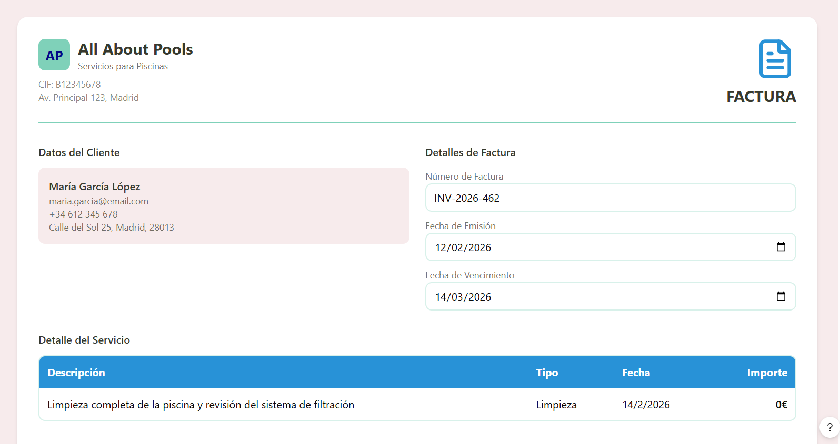
Figure 17. Invoice generation page Interface

      - Staff assignment page
- Section for assigning competent personnel to the requesting service
- Display with profile icon of competent workers
- Selection of one or more workers
- Limited to workers related to the type of service

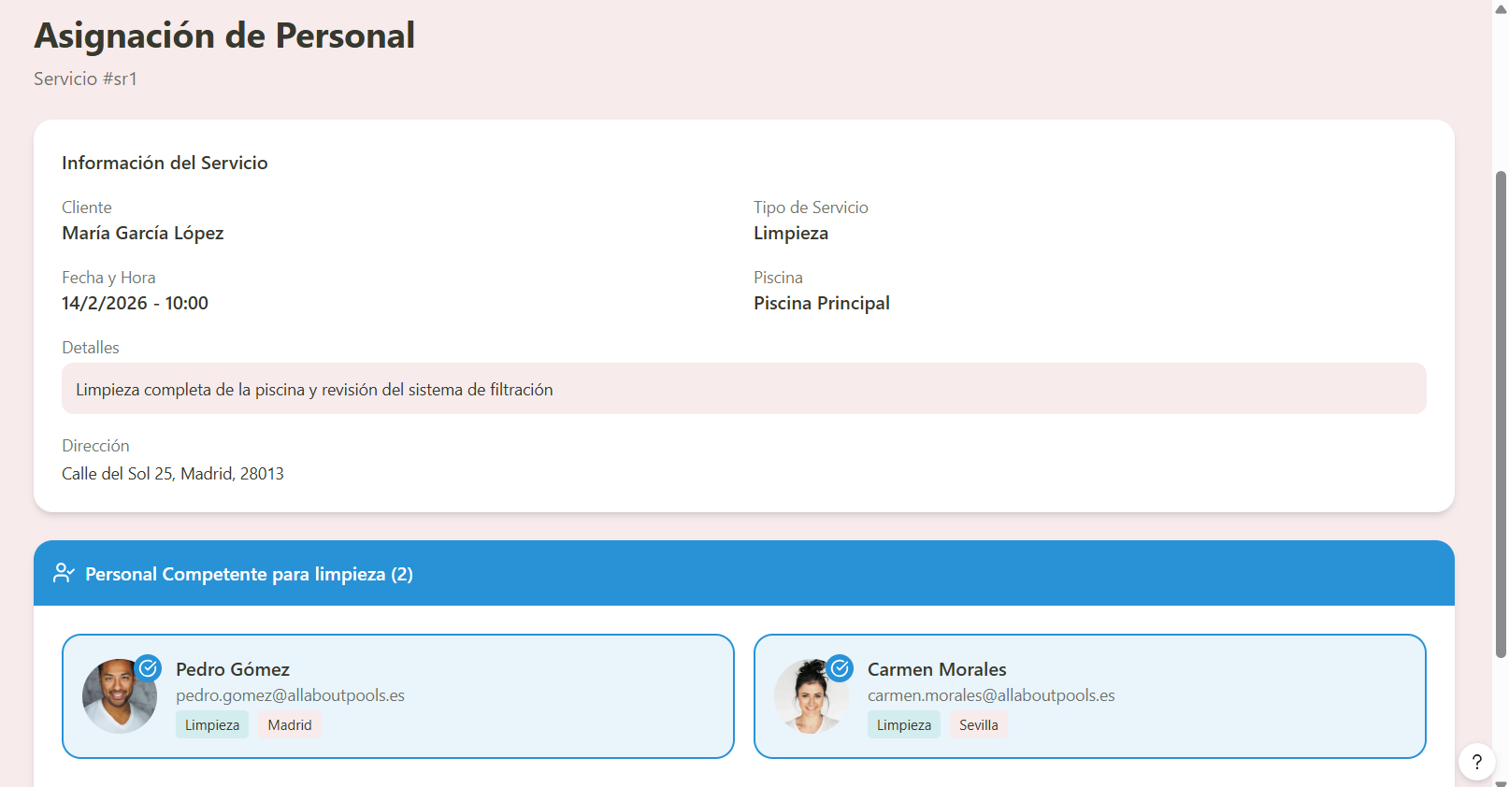
Figure 18. Service report inquiry page and incident feedback Interface

      - Service report inquiry page and incident feedback
- Editing and consultation of service reports, feedback and incidents for selected service

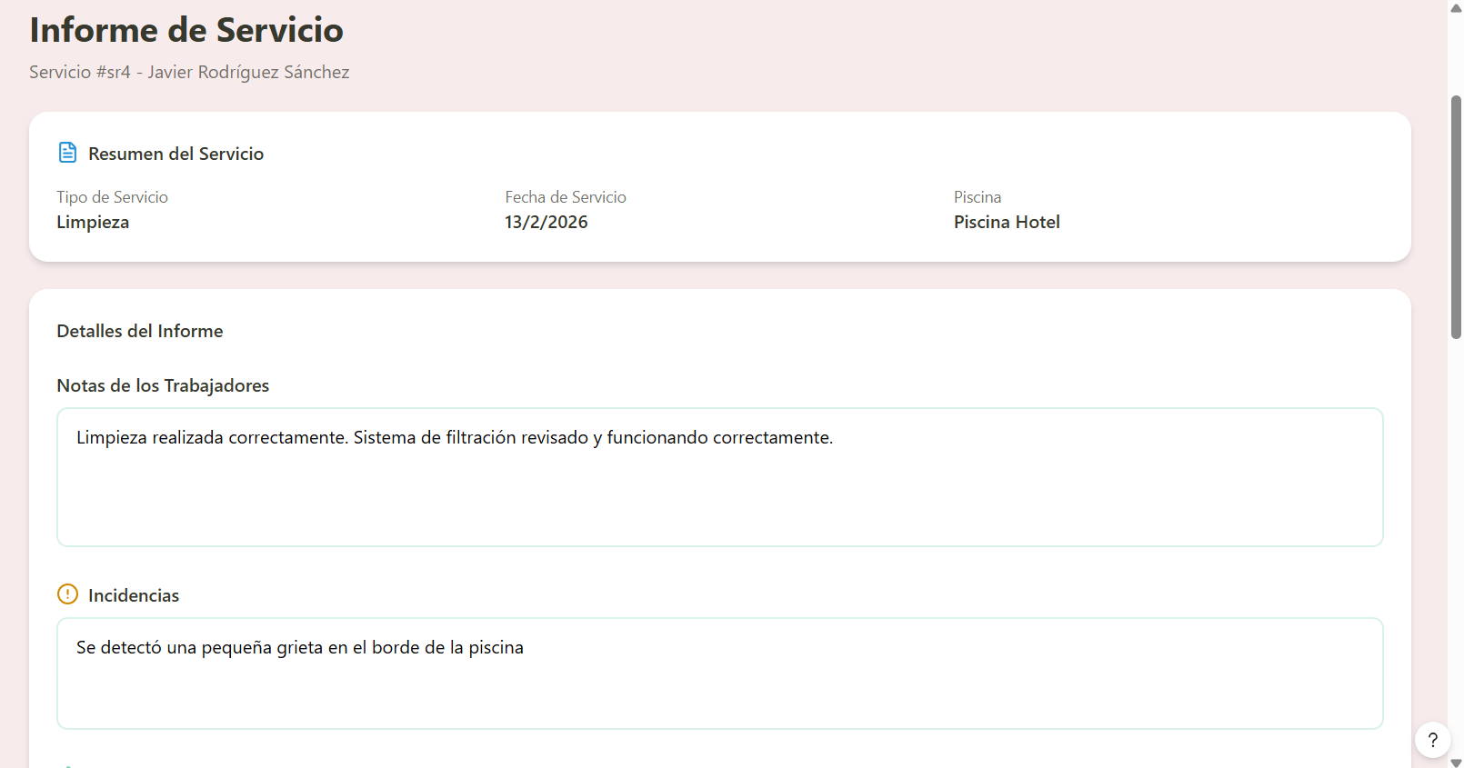
Figure 19. Service report inquiry page and incident feedback Interface

      - Job search page for workers/supervisors
- Search based on user name, email, or address
- Displaying users by name and profile picture based on matching characteristics
- Filter by type, area, or other

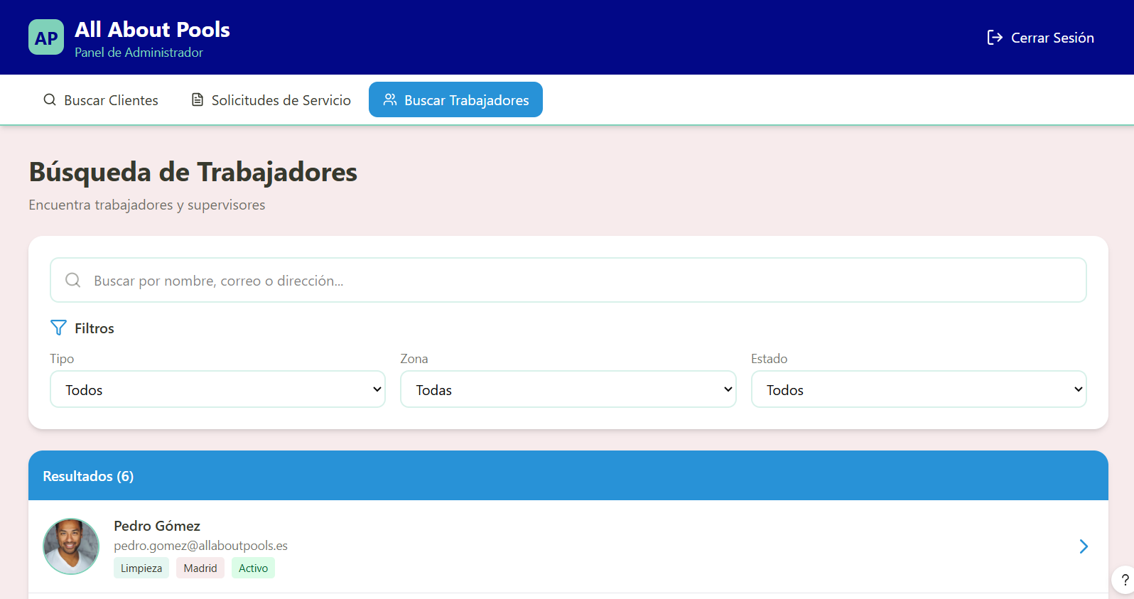
Figure 20. Job search page for workers/supervisors Interface
      - Page for querying information and registering and deregistering staff
- Section for adding or removing subordinates, along with displaying employee profiles

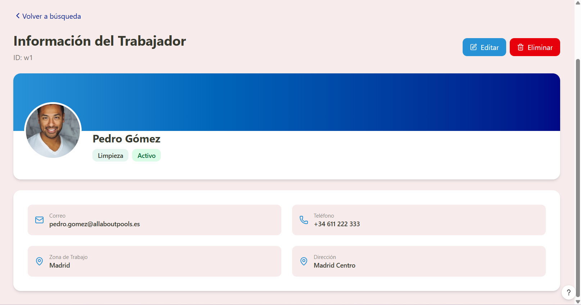
Figure 21. querying information and registering and deregistering staff Interface

Communications Interfaces
The following section are descriptions of the connections the web application will require to be able to perform the functionalities declared in the previous section.

    - Connection to its specific database through its API to store the company's data.
    - Connection with the Google Maps API in order to obtain locations and compare distances over employee's assignment suggestions.
    - Connection to an open source created calendar in order to assign specific services to employees' and supervisors' schedules.

System Features

Functional Requirements
The following functional requirements are shown in two ways: first, the requirements will be ordered in a table from the highest to the lowest priority, such classification was obtained through a comparison of the functionalities value for the developer team based on risk of the project to fail without that functionality, long term stability and implementation difficulty; on the other hand a UML User Cases Diagram is integrated below to give a further understanding of the functionalities of each role.

Index | User | Requisitos | Prioridad | Dificultad | Riesgo | Estabilidad | Total
4 | Non-authenticated user | Log in to the system. | Critical | Medium | Critical | Critical | 18
21 | Service worker | Consult assigned work schedules. | Critical | High | Critical | Medium | 17
28 | Administrator | Consult submitted service requests. | Critical | Low | Critical | Critical | 17
29 | Administrator | Assign service request budgets. | Critical | Low | Critical | Critical | 17
30 | Administrator | Assign employees to service requests. | Critical | Critical | Critical | Low | 17
1 | Non-authenticated user | Access the system through the web interface. | Critical | Lowest | Critical | Critical | 16
5 | Client | Submit company's service request. | Critical | Medium | Critical | Medium | 16
26 | Supervisor | Create maintenance assessment reports. | Critical | High | High | Medium | 16
27 | Supervisor | Assign required materials for repairs. | Critical | High | High | Medium | 16
3 | Non-authenticated user | Register as a client in the system. | High | Low | High | Critical | 15
12 | Client | Consult generated service's budget. | Critical | Medium | Critical | Low | 15
13 | Client | Authorize generated service's budget. | Critical | Lowest | High | Critical | 15
9 | Client | Consult submitted service requests. | High | Low | High | High | 14
14 | Client | Consult issued receipts. | High | Low | High | High | 14
32 | Administrator | Consult worker information. | High | Low | Medium | High | 13
34 | Administrator | Consult supervisor information. | High | Low | Medium | High | 13
38 | Administrator | Generate service request reports. | High | Medium | Medium | Medium | 13
40 | Administrator | Generate invoice reports. | High | Medium | Medium | Medium | 13
42 | Administrator | Generate client revenue reports. | High | Medium | Medium | Medium | 13
6 | Client | Register pool. | High | Lowest | Medium | High | 12
10 | Client | Cancel submitted service requests. | Medium | Lowest | High | High | 12
11 | Client | Consult maintenance reports created by supervisors. | Medium | Low | Low | Critical | 12
18 | Client | Consult information about assigned employees. | Low | Medium | Low | Critical | 12
31 | Administrator | Consult client information. | Medium | Low | Medium | High | 12
33 | Administrator | Modify worker information. | Medium | Low | Medium | High | 12
35 | Administrator | Modify supervisor information. | Medium | Low | Medium | High | 12
41 | Administrator | Generate service reports. | Medium | Medium | Medium | Medium | 12
2 | Non-authenticated user | Consult public information available on the website. | Medium | Lowest | Low | Critical | 11
20 | Client | Modify personal information. | Low | Low | Low | Critical | 11
22 | Service worker | Submit service reports. | Medium | Low | Low | High | 11
24 | Service worker | Modify personal information. | Low | Low | Low | Critical | 11
25 | Supervisor | Consult assigned maintenance inspections. | Medium | Low | Low | High | 11
36 | Administrator | Consult reported incidents. | Medium | Medium | Low | Medium | 11
37 | Administrator | Give feedback to reported incidents. | Medium | Medium | Low | Medium | 11
15 | Client | Submit incidents related to received services. | Low | Medium | Low | Medium | 10
16 | Client | Consult feedback related to submitted incidents. | Low | Medium | Low | Medium | 10
19 | Client | Consult personal information. | Low | Lowest | Low | Critical | 10
23 | Service worker | Consult personal information. | Low | Lowest | Low | Critical | 10
39 | Administrator | Generate client lists. | Low | Low | Low | High | 10
7 | Client | Modify pool's data. | Lowest | Low | Lowest | Critical | 9
17 | Client | Consult service history. | Lowest | Low | Low | High | 9
8 | Client | Delete pool. | Lowest | Lowest | Lowest | Critical | 8

Figure 22. Table of Priority Functional Requirements

Additionally the All-about-pools System UML - User Cases Diagram is presented in the following page.

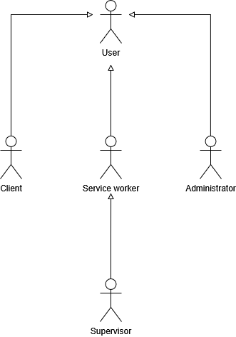

Figure 23. UML Role Inheritance Diagram

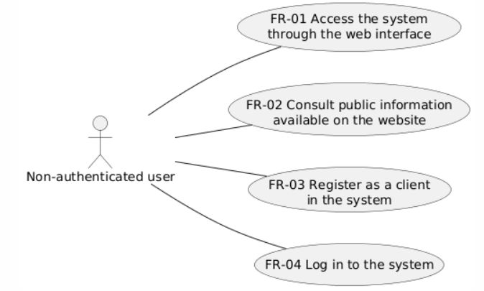

Figure 24. UML Non-authenticated User - User Case Diagram

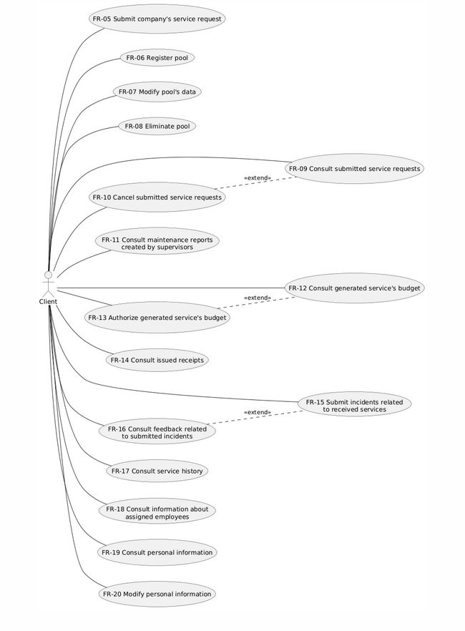

Figure 25. UML Client User - User Case Diagram

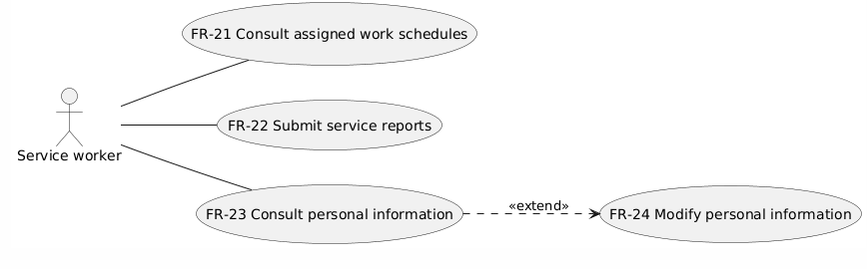

Figure 26. UML Service Worker User - User Case Diagram

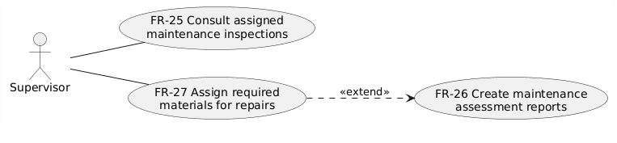

Figure 27. UML Supervisor User - User Case Diagram

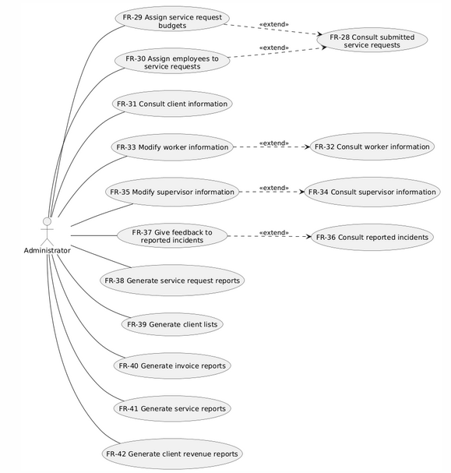

Figure 28. UML Administrator User - User Case Diagram

Information Requirements
The following section contains the Entity Relationship Diagram (ERD) of the designed relational database proposed to store the company's information. Its design process was carefully constructed to be persistent over time and facilitate simple queries to obtain the desired information between entities and their connections.

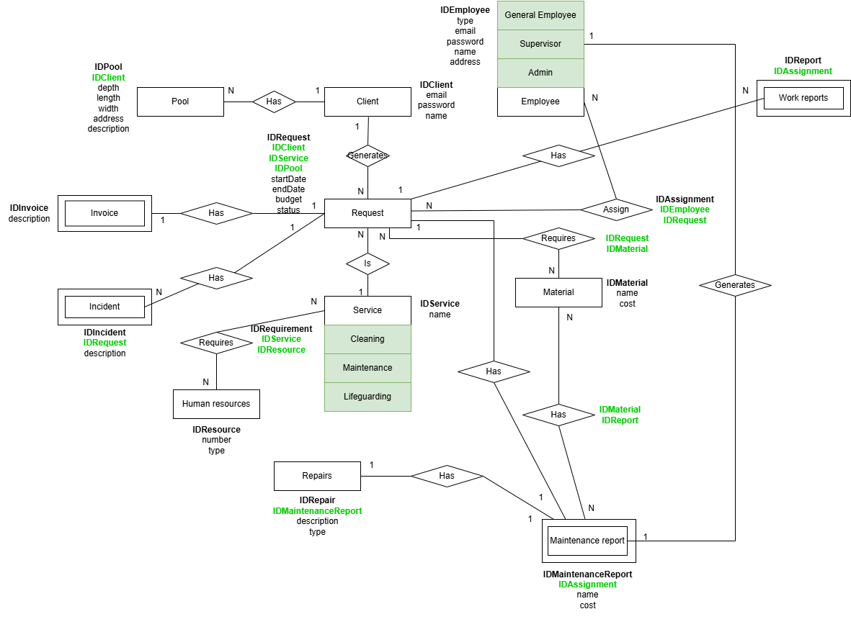

Figure 29. Entity Relationship Model

Other Nonfunctional Requirements

Performance Requirements
    - The app supports 2000 concurrent users giving response times < 1 second.

Safety Requirements
    - The presented product does not represent any safety hazard to the final user or any individual involved in its use or management.

Security Requirements
    - The system implements secure authentication of the user by implementing (encrypted
password & institutional email validation).
    - The encryption algorithm to store user passwords is Argon2 (Hash with salt algorithm resistant to multiple threats).
    - Encrypted database.
    - The information and functionality of the users will be regulated under a symmetric Role Based Access Control (RBAC).
    - Roles and privileges are managed under the Administrator user.
    - Automatic database backup every 24 hours.

Software Quality Attributes

Responsiveness
      - The app is completely responsive for devices with screen’s width smaller or equal to 768px (Mobile - Small Tablets).

Compatibility
      - The app runs in both operating systems Android and iOS being available at Play Store and App Store respectively.

Scalability
      - The system allows the implementation of multiple student plans working and giving their graduation requirements simultaneously, development of new roles, addition of subjects and individual requirement modifications.

Accessibility
      - The app implements color contrast, modifiable text size and screen reader.

Availability
      - The app will be available 24/7 for users excluding maintenance programmed periods.

Business Rules
The following Business Rules have been generated from the detailed lecture of the Study Case "All-about-pools System" obtained through the Monterrey Institute of Technology and Higher Education (ITEMS). Despite not having specific sections, the Business Rules will be classified based on the actor who is being charged with the responsibilities or obtaining the benefits.

Service's Terms
- All-about-pools' business model starts with a service request from the client.
- Each service has a different procedure, requires a different type of specialist employee and varies in cost depending on the size and condition of the pool treated.
  - Cleaning:
One visit (1 day).
Human resources:
- Two workers
Materials:
- Requires materials depending on the dimensions of the pool.
  - Maintenance:
Two visits (2 separate days)
Human resources (1st Visit):
- Supervisor
Human resources (2nd Visit):
- 3 workers
Materials:
- Those established and approved by the client and the supervisor's revision.
  - Aquatic lifeguarding:
Range of days
Human resources:
- Lifeguard

- Employee assignments will be done after a service's budget has been approved.
- The employees assigned to a service request will be selected based on their speciality and location.
- A client's payment must be received after performing any service.

Client's Terms and Benefits
- The client has the facility to suggest a date for his/her service request.
- During the registration of the client, he/she must provide his/her pool's dimensions in order to obtain a correct service budget.
- The client has access to employee's information before and during the performance of their Service Request.
- The client has the right to report incidents and receive personalized feedback from the company's administrator.
- The client can approve or dismiss the offered budget for his/her service request, which will determine the actual performance of the service.
- The client can access bank invoices after an approved budget; information about his/her pool's condition; and receipts from previously completed services.

Employee's Responsibilities
- Each employee must produce reports of the services performed.
- Each employee must present to the assigned Service Request as assigned by the Administrator.

Supervisor's Responsibilities
- Each supervisor must produce a detailed inform after the 1st Visit of a Maintenance Request. Such inform must include repairs cataloged in one of the two following categories:
  - Pool Rehabilitation.
  - Maintenance and Replacement of Accessories.
And include the required materials to perform the maintenance in order to obtain a budget for the second visit.

Administrator's Responsibilities and Privileges
- The administrator has access to the information of clients, employees and supervisors registered under the company's web application.
- The administrator is responsible for assigning and sending a budget for a service request to the client for approval.
- The administrator is responsible for assigning specialized workers to client approved service requests over an agreed date within a considerable distance from its permanent location.
- The administrator is responsible for managing the system's master data.
- The administrator is able to generate reports over: requests, clients, assessments, receipts, and total income.

Other Requirements

Appendix A: Glossary
- Company: It makes reference to the "All-about-pools" company who is the main beneficiary and owner of the requested software.
- Non-authenticated User: It makes reference to those web users who access the web application before login in or being registered.
- Client User: Web users who accessed the web application and are able to request services from the company, review previous services, report incidents, receive feedback, and access information related to their requests, among other functions.
- Service Worker User: Employees of the company that are able to review their schedules and create reports.
- Supervisor User: Employees responsible for making maintenance assessment reports and declaring necessary materials for repairs.
- Administrator User: User responsible for managing and coordinating the requirements of services, making use of employees, submitting budgets and being able to generate reports based on the information of requests, receipts, employees, clients and assessments.
- Symmetric Role Based Access Control (RBAC): Makes reference to the information and functionality security control established in access before being able to perform any actions within a system. Depending on the privileges assigned to the specific role of an account, the user may possess more or less functionality, access and control within the app. The symmetric model allows the Administrator to create and modify roles depending on the needs of the Institution.
- Role: Series of privileges assigned under a name, determined and assigned by the Administrator and by the system automatically due to Institution credentials; that allow the user to have certain functionalities and responsibilities.
- Privilege: Specific credentials assigned to one or many roles at the same time that allow access to a specific functionality.

Appendix B: Generative AI Use
For ethical reasons, the detailed description of the use of generative AI is provided below. It is important to recall that the developer team only and only used these sets of tools to accelerate the creation of certain sections of the present document from information, descriptions and designs previously developed and carefully planned.
- Claude: General research related to standard non-functional requirements for web applications.
- Figma: Generation of the User Interfaces from the descriptions of each screen and the detailed connection between them.
- OpenAI: Generation of the UML User Case Diagram from the detailed table of the functional requirements divided by role.

References

AltexSoft Editorial Team. (2023, 30 december). Nonfunctional Requirements in Software
Engineering: Examples, Types, Best Practices. AltexSoft.https://www.altexsoft.com/blog/non-functional-requirements

Anthropic. (2024). Claude [Sonnet 4.5]. https://claude.ai/

Grinschgl, S., Papenmeier, F., & Meyerhoff, H. S. (2021b). Consequences of cognitive offloading:
Boosting performance but diminishing memory. *Quarterly Journal Of Experimental Psychology*, *74*(9), 1477-1496. https://doi.org/10.1177/17470218211008060
Figma, Inc. (2024). Figma AI [Artificial intelligence design tool]. https://www.figma.com/
OpenAI. (2025). ChatGPT (GPT-5) [GPT-5.2]. https://chat.openai.com/

