

Project Progress No. 3
Unitas System
Version 1.0
Prepared by Limbo Software Development

Rodrigo Alejandro Hurtado Cortés - A01713854

Alexis Yaocalli Berthou Haas - A01713458

Ana Camila Cuevas González - A01412609

Alejandro Contreras Magallanes - A01662743

March 6th, 2026
Table of Contents

1. Encabezado 1 1
1.1. Encabezado 2 1
1.1.1. Encabezado 3 1
2. Other Requirements 2
Appendix A: Glossary 2
Appendix B: Generative AI Use 2
3. References 2

Table of Figures

Figure 1. Figure Title. Figure Description 1

Database: unitas_system

Entity Model Diagram
The Entity-Relationship Model used for the design of the Unitas System database is presented below, but can be also found at a higher definition in the following link:

Lucidchart document

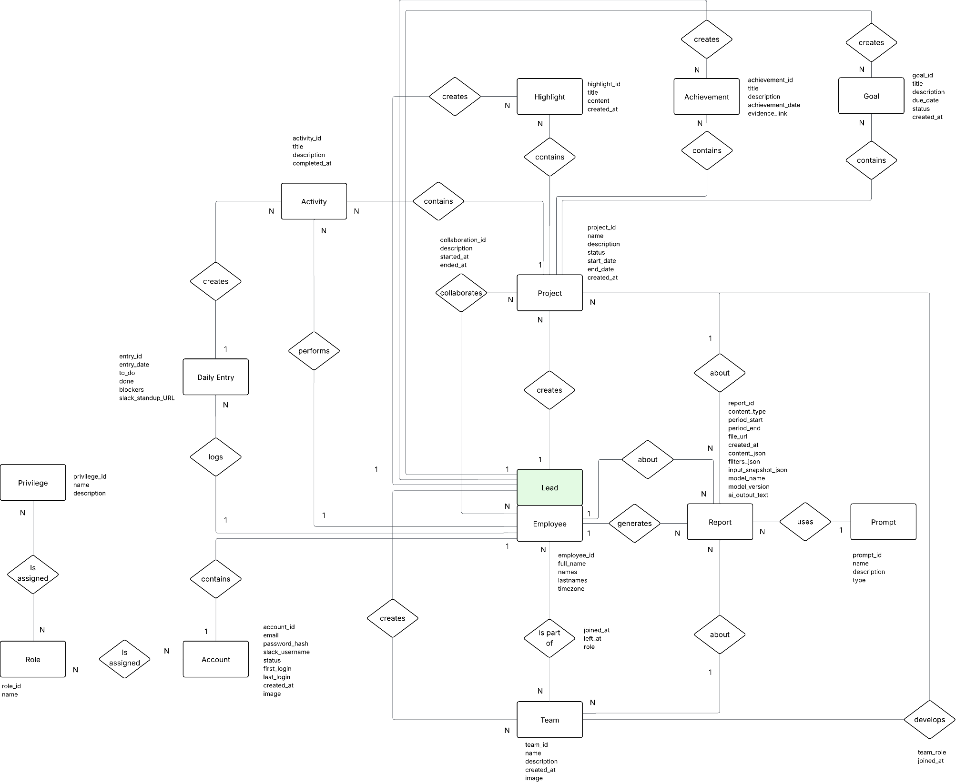

Figure 1. Entity Relationship Model - Unitas System

Relational Model (RM) [Design]
The translation of the previously presented Entity-Relational Model into the Relational Model is presented below following the same order as the Data Dictionary of the following section:

Team(team_id, employee_responsible_id, name, description, created_at, image)
PK(team_id)
FK(employee_responsible_id) references Employee(employee_id)

Employee(employee_id, full_name, names, lastnames, timezone)
PK(employee_id)

EmployeeTeam(employee_id, team_id, joined_at, left_at, role)
PK(employee_id, team_id)
FK(employee_id) references Employee(employee_id)
FK(team_id) references Team(team_id)

Project(project_id, employee_responsible_id, name, description, status, start_date, end_date, created_at)
PK(project_id)
FK(employee_responsible_id) references Employee(employee_id)

ProjectTeam(team_id, project_id, team_role, joined_at)
PK(team_id, project_id)
FK(team_id) references Team(team_id)
FK(project_id) references Project(project_id)

Collaboration(collaboration_id, project_id, employee_id, description, started_at, ended_at)
PK(collaboration_id)
FK(project_id) references Project(project_id)
FK(employee_id) references Employee(employee_id)

Goal(goal_id, project_id, employee_responsible_id, title, description, due_date, status, created_at)
PK(goal_id)
FK(project_id) references Project(project_id)
FK(employee_responsible_id) references Employee(employee_id)

Activity(activity_id, project_id, employee_id, entry_id, title, description, completed_at)
PK(activity_id)
FK(project_id) references Project(project_id)
FK(employee_id) references Employee(employee_id)

DailyEntry(entry_id, employee_id, entry_date, to_do, done, blockers, slack_standup_URL)
PK(entry_id)
FK(employee_id) references Employee(employee_id)

Achievement(achievement_id, project_id, employee_responsible_id, title, description, achievement_date, evidence_link)
PK(achievement_id)
FK(project_id) references Project(project_id)
FK(employee_responsible_id) references Employee(employee_id)

Prompt(prompt_id, name, description, type)
PK(prompt_id)

Report(report_id, generated_by_employee_id, content_id, content_type, prompt_id, period_start, period_end, file_url, created_at, content_json, filters_json, input_snapshot_json, model_name, model_version, ai_output_text)
PK(report_id)
FK(prompt_id) references Prompt(prompt_id)

Account(account_id, employee_id, email, password_hash, slack_username, status, first_login, last_login, image, created_at)
PK(account_id)
FK(employee_id) references Employee(employee_id)

Role(role_id, name)
PK(role_id)

AccountRole(account_id, role_id)
PK(account_id, role_id)
FK(account_id) references Account(account_id)
FK(role_id) references Role(role_id)

Privilege(privilege_id, name, description)
PK(privilege_id)

RolePrivilege(role_id, privilege_id)
PK(role_id, privilege_id)
FK(role_id) references Role(role_id)
FK(privilege_id) references Privilege(privilege_id)

Highlight(highlight_id, employee_id, project_id, title, content, created_at)
PK(highlight_id)
FK(employee_id) references Employee(employee_id)
FK(project_id) references Project(project_id)

Additionally, the enumerators mentioned in the previous fields of tables TeamEmployee, Account, Report, Prompt, Project, and Goal are presented below:

Status (ENUM){PLANNED, IN_PROGRESS, ON_HOLD, COMPLETED, CANCELLED}
ReportType (ENUM){EMPLOYEE, TEAM, PROJECT}
EmployeeRole (ENUM){EMPLOYEE,LEAD}
AccountStatus (ENUM){ACTIVE,DISABLED}

Data Dictionary
The respective Data Dictionary for the previous tables can be found in the following link:

Data Dictionary - Unitas System - Limbo Software.xlsx

Additional Restrictions
The present section corresponds to any additional logical or business rule based restriction that is attached to a specific field of a table in the previously presented database diagrams:

      - Employee - time_zone: Must be in UTC standard.
      - Project - start_date <= end_date.
      - Collaboration - started_at <= ended_at.
      - Goal - created_at <= due_date.
      - Report - content_id gets the UUID of either an Employee, Team or Project depending on the content of the generated report. This content_id will be consistent with the ENUM field content_type.
      - Report - period_start<=period_end.
      - Account - created_at<=last_login.

Any additional specification as ENUMS for a concrete field, nullable fields and the distinction of PK (Primary Keys) and FK (Foreign Keys) is declared in the system’s data dictionary.

Database Script
The script of the database can be accessed at our github branch = “develop” in “sql/unitas_system.sql”.

The mock data created for the unitas_system database was developed with AI following the MER diagrams in order to perform valuable queries for specific sections of our project.

Both the queries and the data fulfillment and tables creation in the following commit:

https://github.com/Berthou05/LimboSoftwareDevelopment_Change.org/commit/f0592b13294549e29e7235cbe39bb771def6e639

Acquired Learning
- Mastered the translation of logical business requirements and functional requirements into physical database structures through the creation of relational tables.
- Applied Relational Algebra concepts to design and optimize complex data queries and structures.
- Gained experience in population and management of datasets to ensure data integrity during the "Database Fill" phase.
- Developed interactive and navigable prototypes to validate user experience and system flows before final implementation.
- Performed technical peer reviews (Merge Request reviews) to maintain high-quality standards in collaborative development environments.
- Refined the structural design of reports to ensure that processed data meets the specific needs of end-users.
- Managed project timelines and task hierarchies by updating and maintaining a Work Breakdown Structure (WBS).
- Identified and categorized activity keys to streamline the tracking of essential software requirements.
- Engaged in co-evaluation processes to critically analyze team performance and project outcomes.
- Implemented schema definitions and data designs that align with the overall architectural goals of the software.

Work Plan

Completed activities for this delivery
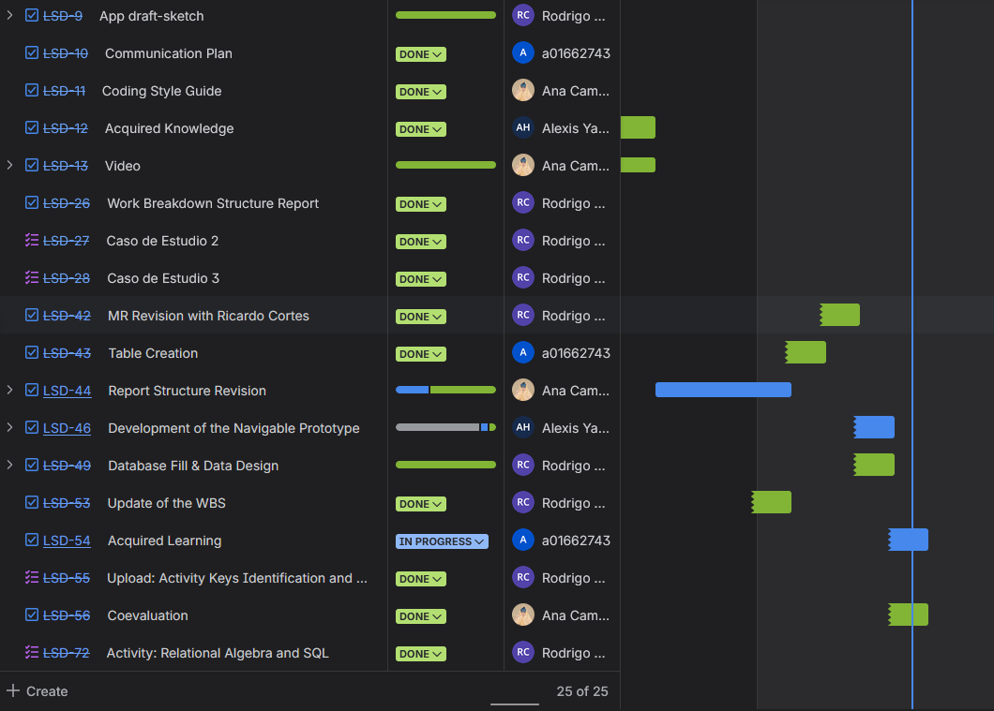

Figure 2. Advance 3 Work Plan- Unitas System

Estimated time compared to real time

Activity | Estimated Hours | Actual Hours | Difference
Relational Model Final Validation | 3 | 3 | 0
Database Structure Script (estructura.sql) | 2 | 4 | 2
Data Population Script Development | 4 | 6 | 2
Primary and Foreign Key Constraints Implementation | 1 | 1 | 0
Navigable Web Prototype Refinement | 20 | 30 | 10
Navigation Flow Validation | 2 | 3 | 1
Documentation Updates and Alignment | 4 | 4 | 0
Repository Organization and Validation | 4 | 8 | 4

Figure 3. Advance 3 Estimated vs Actual effort- Unitas System

Main Reasons for Deviation

- Table insertion planning took longer than expected.
- Prototype development had many adjustments.
- Git control version fixes were required.

Pending Project Activities and Timeline
The following activities remain pending and will be executed during Advancement 3:
- Final revision of functional requirements based on professor and client feedback.
- Initial definition of the system software architecture.
  - Documentation of how the architecture supports non functional requirements.
- Decomposition of the application into functional components.
- Implementation of approximately 30 percent of the functional requirements.
  - Design of test cases derived from the defined use cases.
  - Execution of approximately 30 percent of the planned system tests.
  - Correction of issues detected during testing.
- Usability improvements based on the Eight Golden Rules of interface design.
  - Implementation of at least three interface improvements based on peer heuristic evaluation.
- Definition of the structure and contents of system reports, including:
  - Report headers
  - Data fields and detailed information
  - Expected charts or visual elements
  - Report summary or footer
- Identification of the production environment for system deployment, including:
  - Hosting provider compatible with Node.js and MySQL
  - Secure communication through HTTPS
  - SSL certificate configuration
- Final adjustments and validation of project documentation.
- Preparation and publication of the project progress demonstration video.
- Completion and submission of the team co evaluation form.

Activities for the Next Advancement (Advancement 4)
Estimated execution period: March 9 – March 27 , 2026
Functional Requirements Analysis (90%)
- Responsible: Team
- Date: March 9 - March 17
- Estimated effort: 54 hours
Software Architecture Description
- Responsible: Camila
- Date: March 9 - 11
- Estimated effort: 3–4 hours
Design and implementation of Functional Requirements (30%)
- Responsible: Team
- Date: March 18 - 24
- Estimated effort: 30 hours
Test Design and showcase
- Responsible: Team
- Date: March 20 - 24
- Estimated effort: 15 hours
Usability
- Responsible: Alejandro
- Date: March 25 – 26
- Estimated effort: 2 – 3 hours

Reports
- Responsible: Alexis
- Date: March 24 – 26
- Estimated effort: 2 – 3 hours
Production environment
- Responsible: Team
- Date: March 24 – 26
- Estimated effort: 10 hours

