BERTINITY Whitepaper

v0.9.8.2

Toward Decentralization, Equity and Balance

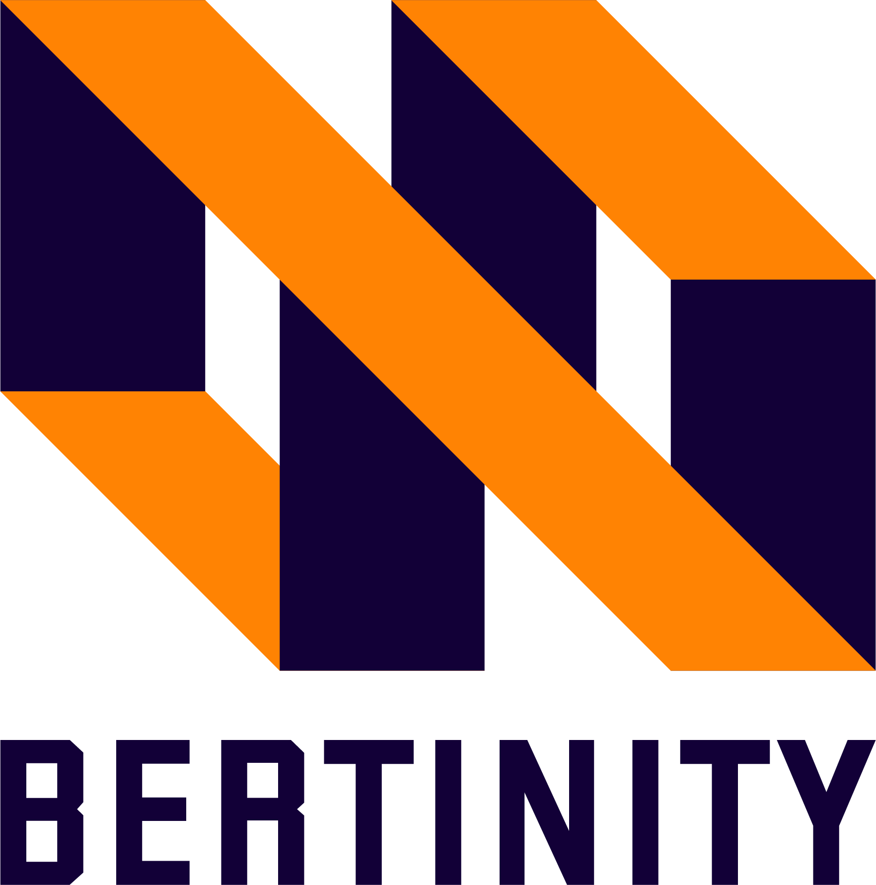

OCT 2021

Contents

1. Description 5
2. Introduction 5
3. Why us 6
3.1. Bertinity moves towards direct democracy 6
3.2. Consensus decision-making 8
3.2.1. Benefits of consensus decision-making 8
3.3 Problems and Solutions 9
4. Product 12
4.1. Crypto Payment Gateway (CPG) 14
4.2. Centralized Exchange (CX) 14
4.2.1. No-KYC 15
4.2.2. Device Compatibility 15
4.3. ICO Launchpad 15
4.4. Decentralized Exchange (DEX) 15
4.5. Decentralized Worldwide Stock Marketplace (DWSM) 16
4.5.1. Bertinity Decentralized World-wide Stock Market opportunities 17
4.6. Main-net 18
4.7. Wallet 18
4.8. Native token 18
4.9. Bertinity ecosystem opportunities 19
5. How it works 19
5.1. Crypto Payment Gateway 20
5.2. Centralized Exchange 20
5.3. Decentralized Exchange 21
5.4. Coin 21
5.5. Wallet 22
5.6. Security Token 22
6. Supply and ICO (Tokenomics) 22
6.1. Overall 23
6.2. Sale events 24
6.3. Ecosystem 24
6.4. Rewards 24
6.5. Multi Phase Initial Coin Offering (ICO) Mechanism 25
6.6. Anti whale mechanism 27
6.7. Anti dump mechanism 27
6.8. Vesting period 27
6.9. Distribution plan 28
6.10. Important addresses 28
7. Technical Details 29
7.1. BERTINITY Main-net 29
7.1.1. Consensus Algorithm 30
7.1.2. Max divisibility number 30
7.1.3. Smart contracts 30
7.1.4. Validators and block rewards 30
7.1.5. Native Tokens/Coins 30
7.1.6. Security tokens 31
7.1.7. Anti-fraud labeling system 31
7.1.8. Swap system 31
7.2. Cryptocurrency Payment Gateway (CPG) 31
7.2.1. REST API 32
7.2.2. Control Panel 33
7.2.3. Coin support 33
7.2.4. Bertinity Cryptocurrency Payment Gateway for Merchants 33
7.3. Centralized Cryptocurrency Exchange (CEX) 36
7.3.1. CPG API 36
7.3.2. Internal wallets 36
7.3.3. Trading zone 37
7.3.4. No-KYC 37
7.3.5. Premium API 37
7.3.6. Multilingual support 37
7.3.7. Apps 38
7.3.8. Support 38
7.3.9. Announcements and News 38
7.4. Decentralized Cryptocurrency Exchange (DEX) 38
7.5. Wallet 39
8. Roadmap 39
9. Risks 42
9.1. Software security 43
9.1.1. Application-based security issues 43
9.1.2. Blockchain-based security issues 43
9.2. Regulation 44
9.3. Long term development 44
10. Channels 44
11. Definition 45
11. Legal Disclaimer and Disclosures 46

1. Description
BERTINITY is a disruptive innovation and a fully anonymous and No KYC blockchain financial ecosystem.

2. Introduction
BERTINITY ecosystem includes:

• Cryptocurrency Payment Gateway (CPG)
• Centralized cryptocurrency Exchange (CX)
• ICO Launchpad
• Decentralized Cryptocurrency Exchange (DEX)
• Decentralized Worldwide Stock Market (DWSM)
• Public Blockchain Network (Main Net)
• Native tokens/coins
• Wallet (Crypto Wallet)
• Other utilities:
o Crypto Forex Services
o DeFi Lending (No KYC Lending)
o Tokenizing assets
o NFTs
o Escrow service for P2P trades
o Smart Contracts

In the BERTINITY ecosystem, you can use our crypto payment gateway on your website to provide an alternative payment method for your customers. with our centralized exchange, you can trade easily and anonymously in a safe way while with our decentralized exchange you can even launch your exchange and trade in a fully decentralized and peer-to-peer way. Decentralized Worldwide Stock Market is another platform that is provided by us to facilitate fundraising events to our customers, which makes the fundraising and investment process inclusive and accessible based on decentralized listing & delisting by blockchain consensus.

3. Why us

The world of central decision-makers is coming to an end and decisions must be made by consensus and freely. we are against governments, banks, and stock exchanges.
We strongly believe in crypto-anarchism in which cryptographically protected anonymization technologies, digital pseudonyms, and digital money are employed to circumvent state control - surveillance, censorship, and taxation. Thus we are Crypto‐​anarchists aiming at providing conditions for getting rid of state interference.

To this end, we are going toward balance and equity with access to modern global financial services by decentralizing and eliminating cumbersome, slowing, and restrictive governments, banks, and stock exchanges rules.

We should not wait for the wave of change. we do not want to wait for the wave of changes to pass over us; we want to be Mainstream.

Indeed, we are a startup that wants to create an anonymous ecosystem over a blockchain to utilize blockchain technology as a financial tool in our life.

We are here to solve some of the problems that exist in blockchain-based projects.

3.1. Bertinity moves towards direct democracy
Democracy literally means rule by the people. it falls into two categories, indirect and direct. The concept of “indirect democracy” (also called representative democracy) refers to the fact that the people choose others to represent them and make important decisions on their behalf. In this regard, representative democracy is completely different from “direct democracy”, in which the people, all members of a group, are given the right to vote. Representative democracy is typically employed in the countries where the population is too large to be constantly engaged in decision making. It's not always reliable because the votes of elected individuals may not provide faithful and accurate reflection of people’s will. these individuals may distort the peoples’ demands. Moreover, indirect democracy can lead to massive bureaucracies, which are too slow to take action, especially on momentous issues.
However, each person’s point of view is taken into account in a direct democracy providing free, fair, regular and competitive elections. it offers the people greater opportunities for participation in which they can exercise their sovereignty within the decision-making process in the most direct manner.
blockchain technology paved the way for bringing democracy back to full circle. So, by means of this technology, a paradigm shift is taking place from centralization to decentralization.
Centralization refers to the fact that the power of planning and decision making are exclusively in the hands of few people. It means that the systematic and consistent concentration of all the powers is at central points. Regulatory capture, corruption, rent-seeking efforts, government intervention in markets, and monopolies are the perfect examples of centralization.
the scenario, however, has been changed completely. Decentralization is growing in popularity due to rise in demand for transferring supervision and decision-making from a centralized association (individual, corporation, or group of people) to a dispersed network where corruption and monopoly are prevented and transparency, free economy, free markets and fair competition are provided.

To this end, BERTINITY, a financial blockchain ecosystem, has been developed. It is aimed at achieving equity, meaning that the income and opportunity among people can be evenly distributed. In other words, the absence of equity creates a scope of inequality in the market. For example, in a monopoly market where there is only a single buyer, the other people sell their labor at a very cheaper rate as compared to a competitive market where there is a lot to buy and wages are very competitive too. As a result, Income difference is one of the most common problem areas which an economy must face when there is no equity in the economy. In this case, equity, as a goal, can be reached through true decentralization achieved by Bertinity.

As a result, doing business, the people can enjoy the benefits of a decentralized world in which they are able to make decisions freely without central decision makers.

All mentioned benefits are mainly facilitated through consensus decision-making process.

3.2. Consensus decision-making
Consensus decision-making is a creative and dynamic way of reaching to an agreement among all members of group. The group using consensus is committed to finding solutions that everyone actively supports. In this regard, all opinions, ideas, and concerns are taken into account.

In other words, consensus decision-making is a process that builds trust and creates ownership and commitment. An effective consensus process is inclusive and engages all participants.
Consensus decisions can lead to better quality outcomes that empower the community to move forward to create their future together.

Blockchain consensus decision-making principles behind BERTINITY ecosystem
- Before voting in a public space, everyone can comment and express their opposition and agreement.
- Bertinity acts as a facilitator to make the process of reaching a consensus decision easier.
- As many stakeholders as possible should be involved in the consensus decision-making process to protect from attacks.
- Rewards are anticipated for maximum stakeholder participation.
- Proof of Importance Consensus is employed, which is based on time and stake. In the proof of importance consensus mechanism, nodes receive a rating dependent on the stake they own (i.e. the number of coins owned) and the length of time the node had those coins.

3.2.1. Benefits of consensus decision-making
- Inclusive participation engages and empowers the community.
- It requires a commitment to work together and increases cooperation.
- Distribution of power and resource in a community is equalized.
- It facilitates better decisions that are more representative of the larger community.
- More ownership and commitment are achieved.

3.3 Problems and Solutions
Government agents act as individuals responding to incentives, much as actors within a market. This reduces the effectiveness of indirect democratic systems. Currency is a creature of law and government control over money can be a form of oppression. Bitcoin is nothing less than a fundamental assault on the idea that a law of currency is a necessary prerequisite of modern monetary order.

The people in power would have us believe that this system is natural and inevitable, but better alternatives to the current system are already here. Despite the increasing progress of blockchain-based projects, payment services, and financial ecosystems, there are still many problems, some of which are mentioned below.

• Unbanked people don't use traditional financial services such as credit cards and bank accounts; instead, they rely on alternative financial services, which are often expensive. Those who are underbanked have some type of bank account, but they still use cash and alternative financial services to make purchases. There are More than 2bn Unbanked or Underbanked in 140 countries including 1/3 of US and more than 2.7mn in UK housewives, youth, immigrants, and many more. They cannot use saving accounts to build emergency funds. Furthermore, they are not able to turn to time-saving tools for transactions such as paying bills and transferring money.

• Because blockchain utilities are not yet truly decentralized, governments can intervene and impose restrictions on them. there are still lots of centralized decision-makers and financial monopolies held by the administrations and banks.

• There are so many cross-border payments restrictions, limitations, and costs for foreign merchants, foreign labor remittances, tourists, freelancers, remote workers, and SMEs. There are many limitations in exterritorial payments with fiats, and limitations of using services and international online payments for anyone, anywhere. In all financial and payment processes we have to trust third parties that means we can’t directly control our assets, which may lead to fraud and scams. Furthermore, companies and banks are charging massive fees and taking multiple days to clear transfers. in addition, they can limit our transactions and control our financial accounts.

• You can buy the crypto of your choice from PayPal as well. While it is not a crypto-focused company, the platform has a feature to buy, sell and hold crypto coins. So, there is a need for crypto exchanges to enable people to even trade cryptocurrencies. Most of the nowadays crypto exchanges need KYC or they have withdrawal limitations and are not accessible to anyone from anywhere. Furthermore, if you want to trade security tokens in these types of
exchanges you must be authenticated that causes some privacy problems and geographic limitations.

• Cryptocurrencies are more assets rather than payment tools

• Most fund and capital raising processes are exclusive, expensive, and extremely difficult for startups and small businesses. further, they are not open to anyone, anywhere. the capital raising process for companies is not streamlined and they can’t use all potential of their offering capability. They also have lots of limitations. There are also lots of cross-border stock investment restrictions.

We are here to solve these types of problems with our services. Here are some of our solutions:

• Anyone from across the globe can use the crypto payment gateway to pay the merchants with cryptocurrencies without any concern of time, fee and fiat payment limitation with our NO-KYC CPG services. We are providing easy, fast and reliable cross-border payment solutions and global financial services in a decentralized world to more than 2bn Unbanked and Underbanked in Bertinity financial ecosystem without traditional financial system limitations.

• We are going to increase the number of crypto payment gateways by providing easy and fast payment gateway services for SMEs at a lower cost than traditional payment gateways to convert cryptocurrencies to payment tools.

• One of our solutions is providing decentralized and P2P services with No third parties and no centralized decision making as a paradigm and price is not controlled by anyone. Decentralized platforms are more secure because there’s no possibility of multiple users losing their funds and every user’s money will be in their hands alone.

• Simplified fund and capital raising, investment, decentralized cross-border stock market and security token crowdfunding marketplace. We facilitate asset trading by streamlining liquidity and allow people around the world to invest, trade, and connect in a peer-to-peer blockchain-based network. It protects investors through blockchain technology and a smart contract system, and it makes it easy to unlock the blockchain to tokenize and trade traditional assets. our network makes the fundraising process inclusive and accessible, fair and flexible, innovative and easy, and open to anyone, anywhere.

• Disruptive innovation increases user satisfaction by eliminating local laws and going beyond national borders.

• With our no KYC platform, nobody has to reveal their identity and because of that, we don’t have any geographical limitations. merchants benefit from crypto payment and instant solutions for liquidity enabling them to receive new income streams.

4. Product

BERTINITY ecosystem contains 5 main parts, including crypto payment gateway, centralized exchange, ICO launchpad, decentralized worldwide security token stock market & native coin
All Products list:
- Cryptocurrency Payment Gateway (CPG)
- Centralized cryptocurrency Exchange (CX)
- ICO Launchpad
- Decentralized Cryptocurrency Exchange (DEX)
- Decentralized Worldwide Stock Market (DWSM)
- Public Blockchain Network (MainNet)
- Native tokens/coins
- Wallet
- Crypto Forex Services
- DeFi Lending (No KYC Lending)
- Tokenizing assets
- NFTs
- Escrow service for P2P trades
- Smart Contracts

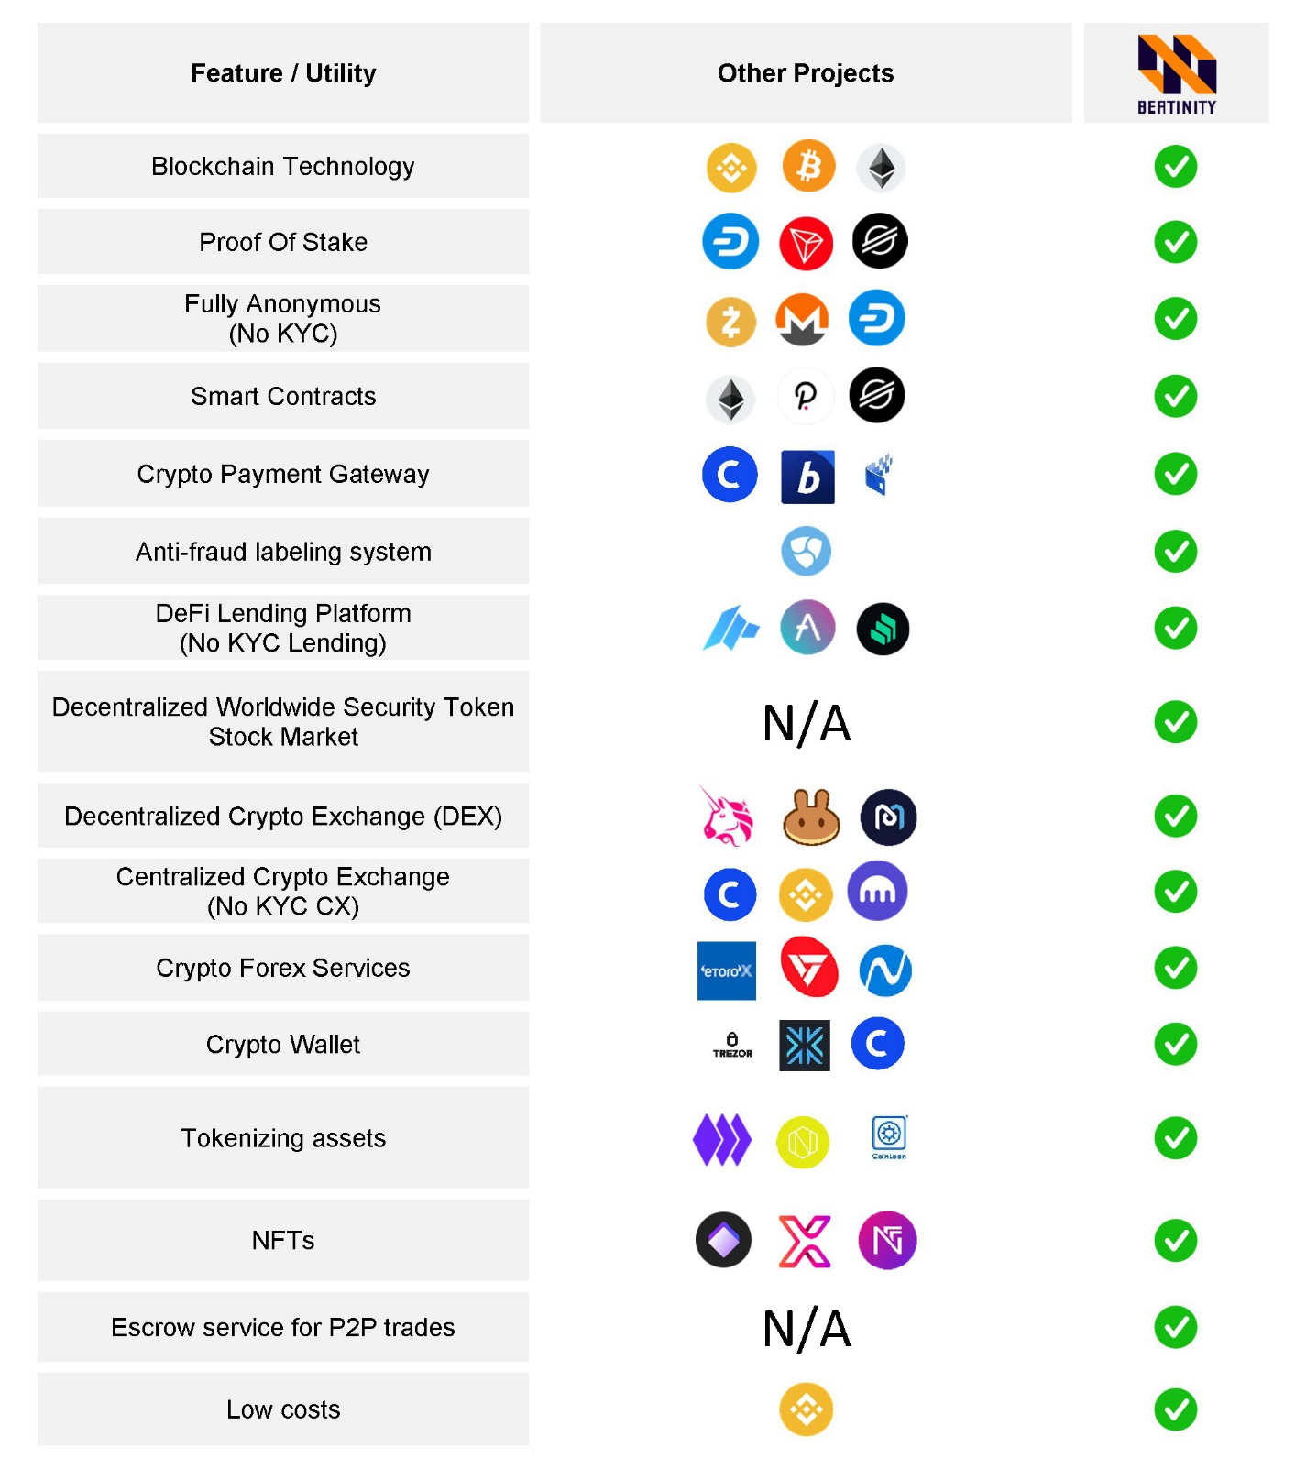

Bertinity Ecosystem Comparison Table

4.1. Crypto Payment Gateway (CPG)
A crypto payment gateway is a platform for online transactions that helps companies accept payments in cryptocurrencies. As we mentioned earlier for problems of cross-border payments, etc., we offer our NO-KYC CPG services. In our ecosystem, everyone can use our Crypto Payment Gateway (CPG) on their website to provide an alternative payment method to their customers. And anyone from across the globe can use the crypto payment gateway to pay the merchants with cryptocurrencies without any concern of time and fee and fiat payment limitation without any KYC. Also, you can track in real-time with our CPG API & plugins and connect the transaction systems with our e-commerce solutions. Our crypto payment gateway will remove cross-border restrictions and it is accessible for anyone, anywhere.

4.2. Centralized Exchange (CX)
Centralized cryptocurrency exchanges (CX) are online platforms used to buy and sell cryptocurrencies. Decentralized platforms are slower than
centralized ones. According to an analysis, centralized crypto exchanges
take an average of 10 milliseconds to execute orders whereas a decentralized exchange takes a minimum of 15 seconds to match and fill an order. To
work with the decentralized exchanges, some nodes are needed to to be launched, which not possible for everyone. So, they are the most common means that investors use to buy and sell cryptocurrency. We will support spot, futures, margin, and demo trading. Our CX will be a NO-KYC platform. we have two options for traders: crypto trading and security token trading, so everyone can trade in cryptocurrencies and security tokens that we will offer. We immediately connect buyers with sellers by streamlining liquidity. by our user-friendly exchange, you can trade 24/7 with a small fee as fast as possible.

The coins we will firstly support as trading pairs are Bitcoin, Litecoin, Bitcoin Cash, Ethereum, Tether, Binance coin, and XRP.

4.2.1. No-KYC
To respect user’s privacy, there is no KYC procedure on the CX platform. All customers may sign-up without providing additional personal information about themselves.

4.2.2. Device Compatibility
Our goal is to bring our platform into the variant devices and operating systems such as:
▪ Web-based client
▪ Android client
▪ IOS client

4.3. ICO Launchpad
A blockchain crowdfunding platform on which users can buy ICO tokens and coins with fiat or other cryptocurrencies. This platform supports automatic distribution mechanisms and crypto payment gateways.

4.4. Decentralized Exchange (DEX)
A decentralized exchange (DEX) is a peer-to-peer (P2P) marketplace that connects cryptocurrency buyers and sellers. In contrast to centralized exchanges (CCEs), decentralized platforms are non-custodial, meaning that a user remains in control of their private keys when transacting on a DEX platform. By our CCE, everyone can trade easily and anonymously. you can trade 24/7 with a small fee as fast as possible while by DEX you can even launch your exchange and every user’s money will be in their hand. The transactions are highly secure and wallet-to-wallet. Also, third parties can’t access your data. With our No-KYC decentralized exchange, all third parties are eliminated and everything is established on the blockchain, thereby helping people gain a better trading experience.

4.5. Decentralized Worldwide Stock Marketplace (DWSM)
Security tokens are essentially digital, liquid contracts for fractions of any asset that already has value, like real estate, a car, or corporate stock. Using security tokens means investors can expect that their ownership stake is preserved on the blockchain ledger. Our security token platform is another platform that makes the fundraising process inclusive and accessible, fair and flexible, innovative and easy, and open to anyone, anywhere. We create a digital global investment marketplace with a P2P network that makes processes more streamlined for investors which makes the fundraising and investment process inclusive and accessible and a built-in exchange is provided to allow global trade of securities. Because our p2p network is to be fully decentralized, the price is not controlled by anyone. Furthermore, since it is a no-KYC platform, nobody has to reveal their identity. Accordingly, we don’t have any geographical limitations. We create a digital investment marketplace with a P2P network that makes processes more streamlined for investors and a built-in exchange to allow global trade of securities.

Here are three levels for each project/security token to get listed on:

➢ Basic Level Market (BLM), For those who wish not to pay, there is no need to pay to apply. it might be highly risky to get rejected while there is no control over the admission process. this plan is proper for small-size projects/businesses.
➢ Rapid Entry Market (REM), For those who want to lower the risk by
paying which is between $10000 to $50000. although there is still no control on the admission process, this plan is useful for medium-sized projects/businesses.
➢ Premium Enterprise Market (PEM), For those who want to lower the
risk and increase the chance of success. This plan is proper for medium-large size projects/businesses. the admission process will be
held on the blockchain.

 | Basic Level | Rapid Entry | Premium Enterprise
 | Market (BLM) | Market (REM) | Market (PEM)
Initial due diligence | No | Yes | Yes
Admission | No Control | No Control | Blockchain  Consensus
Risk | Medium to High | Medium | Low
Initial due diligence fee | No | $10000-$50000 | $10000-$50000

4.5.1. Bertinity Decentralized World-wide Stock Market opportunities

Why token publishers love Bertinity:
- They don't like local markets, because of their cumbersome, slowing, and restrictive rules
- Bertinity facilitates fundraising from a multi-billion market is facilitated
- They can have access to a global market instead of a local market
- Local markets have low capacities and potentials, but Bertinity Uses international marketing capacity
- Bertinity provides high liquidity while the liquidity of local markets is low

Why investors and participants love us:
- They have been exiled from the global markets
- Bertinity facilitates investment across borders (Capital knows no borders)
- They are enabled to invest in a variety of projects around the world
- More investment opportunities are given
- They can get rid of a variety of annoying local taxes
- They have equal rights to invest
- Privacy is protected by Bertinity

4.6. Main-net
Main-net is the term used to describe when a blockchain protocol is fully developed and deployed, meaning that cryptocurrency transactions are being broadcasted, verified, and recorded on a distributed ledger technology (blockchain). Our main-net is a dedicated network to keep all transaction records. Our Main-net will be a p2p network to act as a distributed ledger to keep track of assets, transactions and provide a lot of features for users, and may tokenize any asset on the blockchain. Any companies and startups can tokenize their securities with our platform and we give them the services oftokenizing, whitepaper and business plan advice, and implementation of tokenizing their assets.

4.7. Wallet
A cryptocurrency wallet is an app that allows cryptocurrency users to store and retrieve their digital assets. When a user acquires cryptocurrency, such as bitcoins, they can store it on a cryptocurrency wallet and from there use it to make transactions. Our wallet is a multi-platform wallet (Windows, Mac, Linux, Android, IOS) to create and manage the accounts, transactions, assets, and the other functionalities which are provided by the ecosystem.

4.8. Native token
A crypto token is a digital asset that is native to a cryptocurrency exchange. A crypto exchange may launch its own token for a variety of reasons, and exchange owners often give tokens to users as incentives. With our native token, people can trade and pay fewer fees on our exchange. Some of our native token’s benefits are:
✓ Bertinity Exchange fee discount
✓ CPG transaction fee discount
✓ Security token and stock trade commission discount
✓ Acceptable on Bertinity payment gateway
✓ Ability to be listed on Bertinity other trusty exchanges
✓ Discount on purchases or trades in the ecosystem
✓ potential value increases due to project growth

4.9. Bertinity ecosystem opportunities
Bertinity enables businesses to accelerate digital transformation due to its multiple advantages including utilizing blockchain as a standard for digital transactions, as an accelerator of business processes, as a game changer in the supply chain, as the architecture for connectivity, as a platform for smart contracts, as a fuel for the finance function, and as a success factor in competition.
In addition, small businesses can benefit from Bertinity because of the following merits:
- It offres a new form of payment
- It provides safer and cheaper cloud storage
- Businesses can leverage smart contracts in our ecosystem
- Businesses can use it for capital raising
- It offers the option of paying employees in cryptocurrency

5. How it works
As a person wishing to tele-shop or has cross-border payment, you can pay with our token with a discount, or any cryptocurrency using our CPG. So, anyone anywhere could pay and shop internationally with less fee and in a simple way. With CPG, connect to our exchange that has two options for you. first, you can trade cryptocurrencies, and second, you can trade security tokens without KYC. You can also use our native token in exchange for trading crypto or security token with less fee. Furthermore, companies and startups that have fundraising problems and limitations or the ones who want to have cross-border stock investment can solve their problem using our STO platform. we will tokenize their securities, which will be tradable on our exchange.

5.1. Crypto Payment Gateway
When the user clicks the Place the Order button at the checkout, the web browser immediately encrypts the payment details. It also sends the payment details to the merchant’s web server through an SSL connection. Also, it sends the payment details to the merchant’s web server through an SSL connection.

Once the merchant receives details, the merchant sends details to the crypto payment gateway with an encrypted SSL.

The cryptocurrency payment gateway sends the details to the payment processor. Then it receives a request and sends a response code back to the payment processor. That response code has all the data and information about the transaction status.

Then the payment processor sends the response code to the gateway. From there it is forwarded to the website.

Finally, the website displays relevant information to the user.

5.2. Centralized Exchange
Our centralized exchange is a platform that facilitates the buying and selling of cryptocurrencies. it functions as a trusted intermediary in trades and often acts as a custodian by storing and protecting the funds.

Login → transfer crypto to ex wallet without the private key

→ The buy and sell orders entered into order book → order executed →
exchange commission → transfer from ex wallet to own wallet.

5.3. Decentralized Exchange
A DEX or a decentralized cryptocurrency exchange is similar to a centralized one, except it doesn’t have a third party on which you can rely. All of the funds on this exchange remain stored on the blockchain. These platforms allow peer-to-peer (P2P) trading for which it uses assets, proxy tokens, or an escrow system, unlike the IOU-based system a centralized crypto exchange uses.

A token owner raises an order to exchange his/her assets/funds with another available on the DEX. The user also specifies the number of units they want to sell, the cost of each token, and until which time bidding for their assets is allowed.

Once the selling order as mentioned above is set, other users can submit bids through a buy order.

Once the time assigned by the seller expires, all the bids are reviewed and calculated in the best interest of both buyer & seller parties.

• log in to the DEX portal with your wallet
• submit a buy or sell request
• smart-contract logic gets executed and the transfer of assets is done
• requested tokens will be sent to your wallet

• Disconnect.

5.4. Coin

Used to trade and pay fees with a discount on our exchange.

5.5. Wallet
Handling the accounts and assets,

Create an account → send, receive and hold

5.6. Security Token
Security tokens are issued on the blockchain. they provide companies with access to global capital. Investors receive a unique international investment opportunity. The property rights of investors are stored on the blockchain through smart contracts.
It has two plans for issuers and investors:

1. launch company’s token

2. buy, sell, or trade tokens

6. Supply and ICO (Tokenomics)
The total supply is 62,000,000,000 units and supply divisibility will be according on

• Supply Reserve %14.0
• Public sale %20.0
• Private sale %4.5
• Ecosystem %20.0
• Advisor %4.5
• Marketing %16.0
• Team %17.5
• Rewards %3.5

6.1. Overall
Here is the overall chart about total supply.

6.2. Sale events
• Public sale %20.0:

o pre-ICO: %4.5
o ICO round-1: %6.8
o ICO round-2: %5.0
o ICO round-3: %3.7

• Private sale %4.5

Public pre-ICO | %4.5
ICO round-1 | %6.8
ICO round-2 | %5.0
ICO round-3 | %3.7
Private sale | %4.5
TOTAL | %24.5

6.3. Ecosystem
Up to %20 of total supply can be used for development, infrastructure, and anything that helps us with the ecosystem growth for long-term durations.

6.4. Rewards
Any bonus or gift can be paid up to %8 of the total supply to users as an incentive to move over time.

6.5. Multi Phase Initial Coin Offering (ICO) Mechanism
Bertinity will use a Multi-Phase Initial Coin Offering (ICO) Mechanism. In each phase of ICO, the Bertinity Token (BRTX) price will increase by 10 percent.

ICO structure:
- Number of phases: 50
- BRTX price increase per phase: 10%
- First Phase Cap: $5,000
- Last Phase Cap: $660,000
- Initial phase BRTX price: $0.001
- Final phase BRTX price: $0.11

Overall:
- Soft Cap: $908,000
- Hard Cap: $7,181,000

Phase | USD (Investment) | USD per 1 BRTX
Phase 1 | $5,000 | $0.001
Phase 2 | $6,000 | $0.0011
Phase 3 | $7,000 | $0.0012
Phase 4 | $8,000 | $0.0013
Phase 5 | $9,000 | $0.0014
Phase 6 | $10,000 | $0.0015
Phase 7 | $11,000 | $0.0017
Phase 8 | $12,000 | $0.0019
Phase 9 | $13,000 | $0.0021
Phase 10 | $14,000 | $0.0023
Phase 11 | $15,000 | $0.0025
Phase 12 | $17,000 | $0.0028
Phase 13 | $19,000 | $0.0031
Phase 14 | $21,000 | $0.0034
Phase 15 | $23,000 | $0.0037
Phase 16 | $25,000 | $0.0041
Phase 17 | $28,000 | $0.0045
Phase 18 | $31,000 | $0.0050
Phase 19 | $34,000 | $0.0055
Phase 20 | $37,000 | $0.0061
Phase 21 | $41,000 | $0.0067
Phase 22 | $45,000 | $0.0074
Phase 23 | $50,000 | $0.0081
Phase 24 | $55,000 | $0.0089
Phase 25 | $61,000 | $0.01
Phase 26 | $67,000 | $0.011
Phase 27 | $74,000 | $0.012
Phase 28 | $81,000 | $0.013
Phase 29 | $89,000 | $0.014
Phase 30 | $98,000 | $0.016
Phase 31 | $108,000 | $0.017
Phase 32 | $119,000 | $0.019
Phase 33 | $131,000 | $0.021
Phase 34 | $144,000 | $0.023
Phase 35 | $158,000 | $0.025
Phase 36 | $174,000 | $0.028
Phase 37 | $191,000 | $0.031
Phase 38 | $210,000 | $0.034
Phase 39 | $231,000 | $0.037
Phase 40 | $254,000 | $0.041
Phase 41 | $279,000 | $0.045
Phase 42 | $307,000 | $0.050
Phase 43 | $338,000 | $0.055
Phase 44 | $372,000 | $0.060
Phase 45 | $409,000 | $0.066
Phase 46 | $450,000 | $0.073
Phase 47 | $495,000 | $0.080
Phase 48 | $545,000 | $0.088
Phase 49 | $600,000 | $0.10
Phase 50 | $660,000 | $0.11
Sum: | $7,181,000

6.6. Anti whale mechanism
Transactions are limited to $10,000 in the private and public sales to help implement the anti whale mechanism.

6.7. Anti dump mechanism
To help prevent dumping we have a vesting mechanism (section 6.8) and also we have a scheduled timesheet for the distribution of Airdrops and ICOs. In this mechanism, the distribution will be done within 12 weeks after the start, and if the recipient dumps, the distribution of her/his tokens will be delayed for 3 months after the last distribution

6.8. Vesting period
Bertinity project has a vesting plan

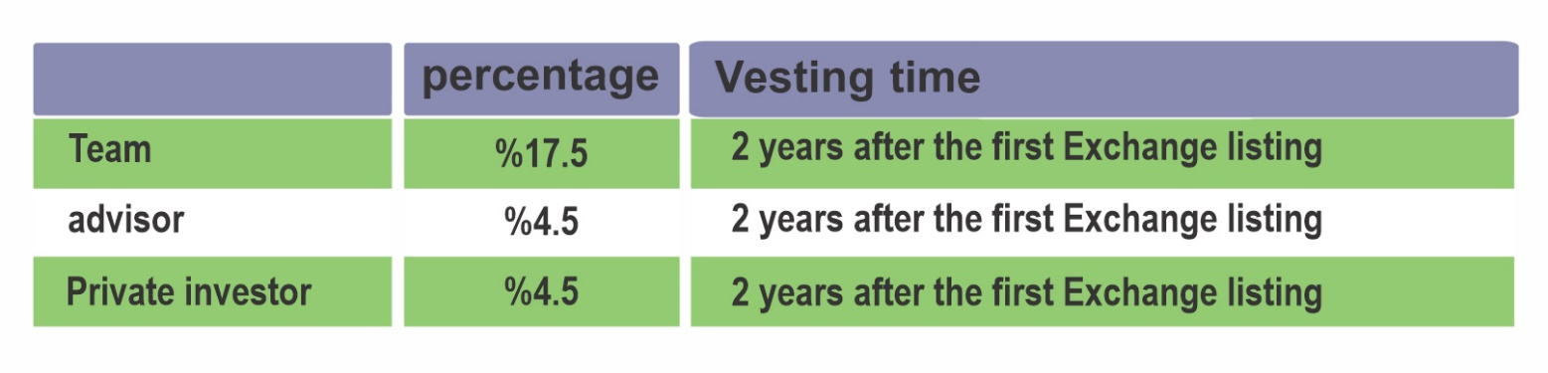

6.9. Distribution plan
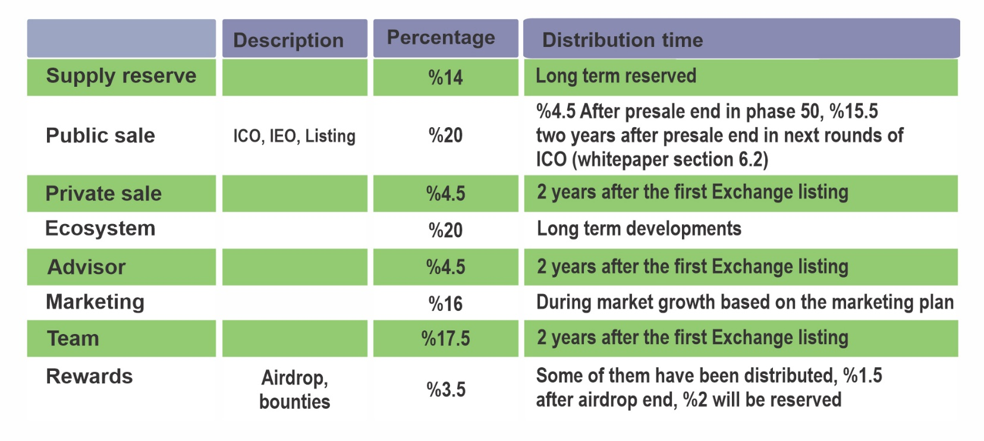

6.10. Important addresses
Base on the Certik audit issues in the preliminary audit report and also their recommendations we will disclose the important addresses to the community.

Certik Recommendation:
For BER-02 finding, the ultimate goal is to decentralize the identities that hold the ownership of the contract, updating the White paper / Medium / Blog / Youtube with key addresses, ie owners, devs, key members.
The below are important addresses:

Address | Quantity | Percentage | Label
0xda5e70d8d03fc79a33ceb021754380d911dd768b | 12,400,000,000 | 20. % | Public sale
0xa73e58ddaf7ee297cb21511b5cfdd63659b69e0a | 12,400,000,000 | 20% | Ecosystem
0x7e2754a22b2c948aaa2c59f1aa777e42aede39cf | 9,920,000,000 | 16% | Marketing
0x5dbe93a11caef55c81bdeb22b00db3b564fa3763 | 8,679,000,000 | 14% | Reserve
0x18e121bf38f27b69ee28ca4f1879017328629292 | 2,790,000,000 | 4.5% | Advisor
0x91ff53edfe24ef1064dce7add1fd610eed445b3c | 2,790,000,000 | 4.5 % | Private sale
0xd7f53e3839091d3fd5baf9326865f413ba0786d8 | 2,170,000,001 | 3.5% | Reward
0x67a90f7c0c0906c21282a8574432a5f0798df830 | 1,850,000,000 | 2.98% | Team1
0xc2b249faa3f362255df65100efe4af1d68530893 | 1,800,000,000 | 2.9% | Team2
0xa0d6ae1e7fbc4cbafbd6ecc44e7533dfcc57e0bc | 1,800,000,000 | 2.9% | Team3
0xe3265eb82fd7a84af9fbc2551ea2b677e832b1a7 | 1,800,000,000 | 2.9% | Team4
0x2a31d54c2f19b69626f9a3dab2aa5f95c3e9f594 | 1,800,000,000 | 2.9% | Team5
0xb99c880a0d834fe7b42369cedf08358f97597820 | 1,800,000,000 | 2.9% | Team6

7. Technical Details

7.1. BERTINITY Main-net
For now, BERTINITY ecosystem uses the Binance Smart Chain (BSC)
network.
The next generation of the consensus algorithms is Proof of Stake (PoS) since its previous version is Proof of Work (PoW). Because the PoW algorithm does not have low resource usage, PoS took its place.

To store, process, and verify the transactions, we need a sustainable network. BERTINITY main-net must cover up all functionalities which are needed.

The main net includes a native coin as the main coin and may contain a lot of tokens. The total supply of the native coin is already described in section “Supply”.

7.1.1. Consensus Algorithm
Our goal is to use the PoS (Proof of Stake) algorithm for the consensus procedures.

7.1.2. Max divisibility number
The maximum amount of divisibility in main-net is “100,000,000” per one unit, so
the smallest value in main-net is equal to “0.00000001”.

7.1.3. Smart contracts
We are aimed at providing a better kind of smart contracts. There is no need to do programming because BERTINITY smart contracts can be used easily by some simple steps.
So to create a smart contract in the BERTINITY blockchain, you don’t have to have programming knowledge.

7.1.4. Validators and block rewards
According to the PoS algorithm, as much as a node owns BERTINITY (the native token of the network), it has more chance to earn block rewards.

7.1.5. Native Tokens/Coins
Based on the total supply, there will be “62,000,000,000” BERTINITY tokens over the blockchain.
A crypto exchange token is a digital asset that is native to a cryptocurrency exchange. A crypto exchange may launch its own token for a variety of reasons, and exchange owners often give tokens to users as incentives. Using our native token, people can trade and pay fewer fees on our exchange.

7.1.6. Security tokens
These days some companies are eager to offer their shares on a blockchain-based network to fundraise. So, we want to provide a p2p STO platform to help them to get easier funds by bringing a p2p network.
In our P2P STO platform (DWSM), any kind of shares can be listed on the
platform. After the token is listed on DWSM, its price only can be
determined by the market since it’s all on a p2p network.

7.1.7. Anti-fraud labeling system
If an account/address is hacked, the account owner can add a label to its account which causes all addresses from that account to be automatically labeled over blockchain, so exchanges and traders will not process any transaction that is labeled.

7.1.8. Swap system

After launching of Main-net, All Bertinity token owners will be able to transfer their tokens to the Main-net.
There will be enough time for all users to do it.
All Bertinity tokens on Binance Smart Chain will be burned(moving to zero address) when the whole swap process will have finished.
The details will be announced at the time of launching the Main-net.

7.2. Cryptocurrency Payment Gateway (CPG)
A gateway to provide an ability for users to pay with cryptocurrencies. Our CPG supports variant cryptocurrencies to give many options to users. Since it’s an anonymous CPG, all users have an opportunity to keep their privacy, so they don’t have to reveal their identity while using our CPG system. Users may pay with our native coin.
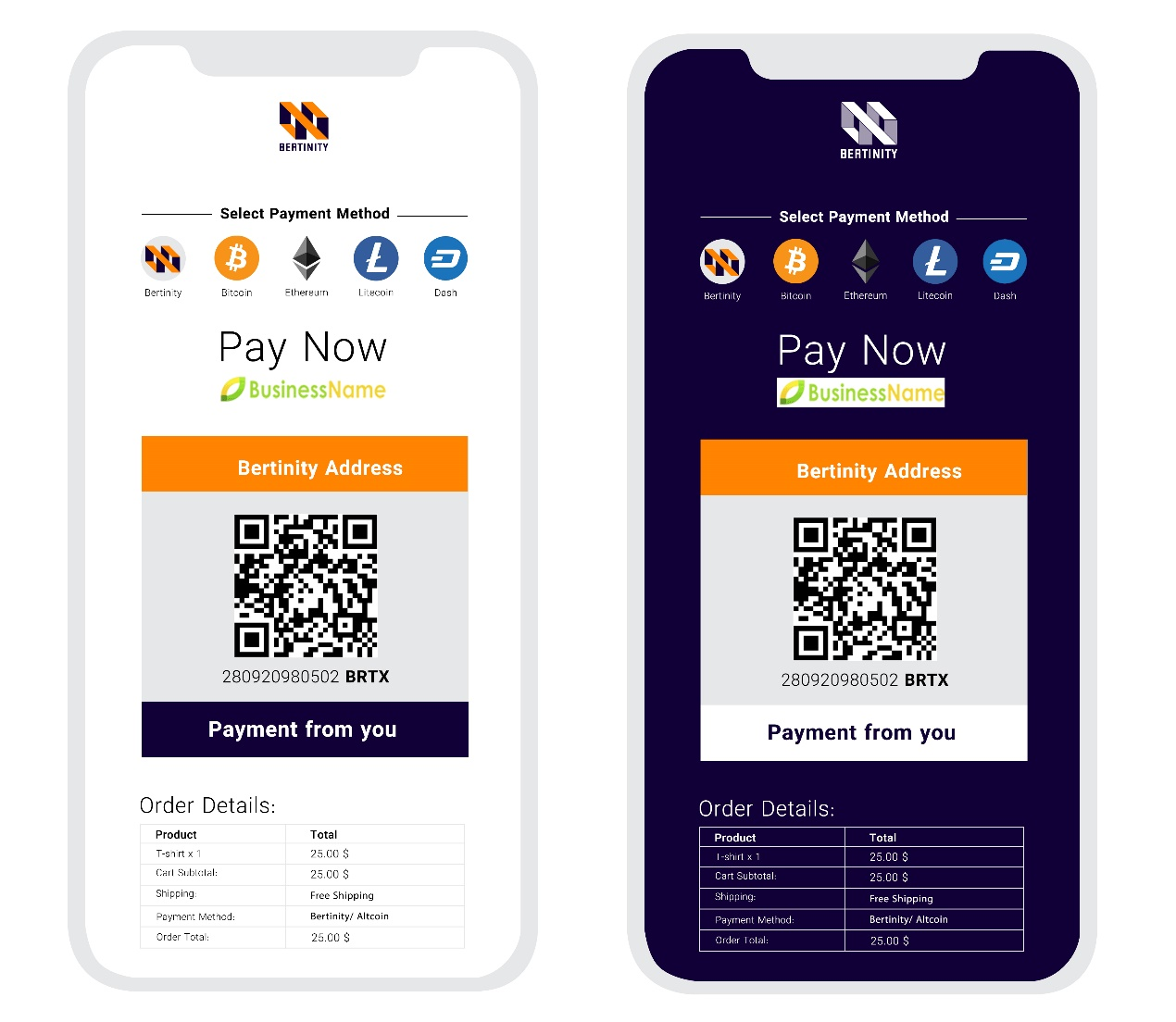

CPG checkout page

For example, an online-shop owner may use CPG on the website to provide an alternative payment method for the customers.

7.2.1. REST API
Users may use our REST API within technical documents to implement it into websites.

7.2.2. Control Panel
There is a control panel for each user to checkout balance, records, etc.

7.2.3. Coin support
There are 7 coins supported by our CPG for now.

Bitcoin, Litecoin, Bitcoin Cash, Ethereum, Tether, Binance Coin, and XRP.

7.2.4. Bertinity Cryptocurrency Payment Gateway for Merchants
Bertinity ecosystem has a special offer for merchants. Here is a comparison between our service and prepaid cards and credit cards.

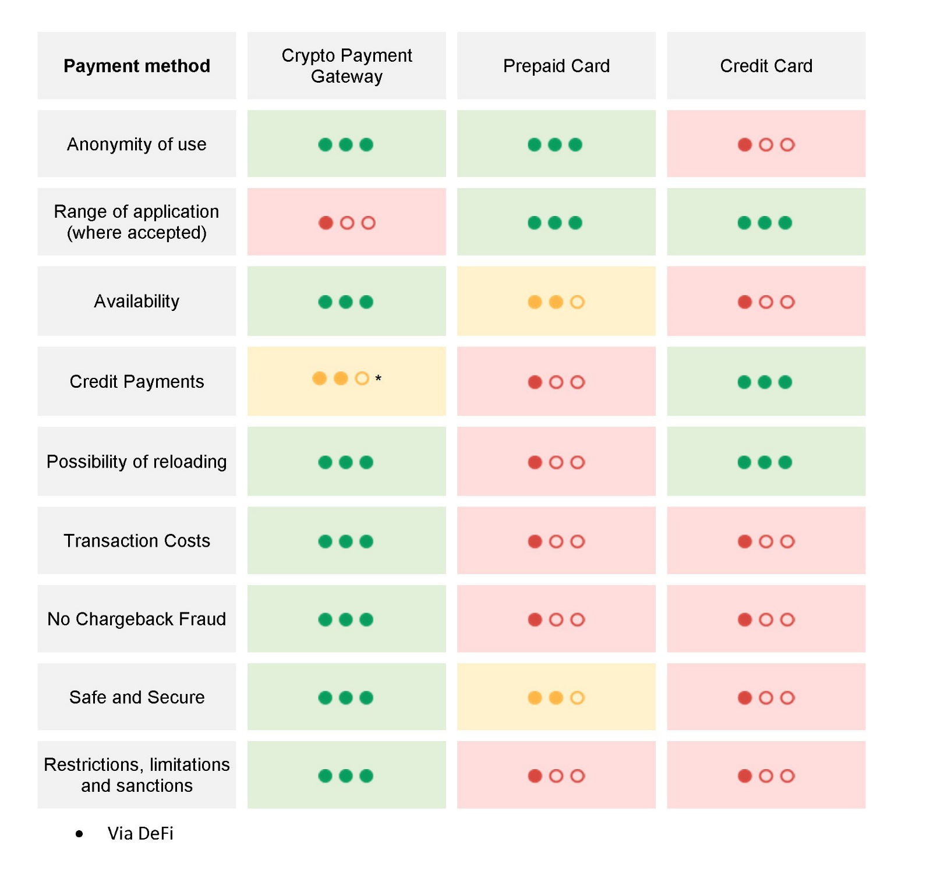
• Anonymity of use
Since Bertinity is an anonymous financial ecosystem, any payments which are done by our services are anonymous.

• Range of application
It takes a while to get accepted by more providers.

• Availability
Bertinity ecosystem is built on a decentralized network, a blockchain, so it’s
highly available and online forever.

• Credit payments
Customers may get credit by using DeFi contracts in the Bertinity ecosystem.

• Possibility of reloading
Users may reload/deposit the accounts as much as they want without any limit.

• Transaction costs
Since all transactions will be done on the blockchain, all transactions fee is much lower than prepaid cards or credit cards system.

• No chargeback fraud
All transaction is recorded on the blockchain accurately, so it’s not possible
for scammers to fraud.

• Safe and secure
All prepaid and credit card info may be recorded on thirty-party entities. as a consequence, they may access your critical info. But by our services, it’s impossible since you are the only one who has access to your account with the keys.

• Restrictions, limitations, and sanctions
Bertinity financial ecosystem is a borderless and anonymous platform, so there is no restriction to limit its availability for users.
• Number of coins/tokens to be supported
Over 100 coins, tokens, and stable coins will be available in the future.

• DeFi Lending
By using DeFi contracts, all merchants are capable to provide loans for customers who want to use cryptocurrencies as bail. All can surely be done anonymously since Bertinity is a No-KYC (anonymous) financial ecosystem.

7.3. Centralized Cryptocurrency Exchange (CEX)
We will support spot, futures, margin, and demo trading. Our CEX will be a NO-KYC platform and everyone can trade in cryptocurrencies and security tokens that we will offer.

7.3.1. CPG API
There will be a section for activating the CPG service. Users may request to issue a CPG API automatically.
Users use CPG API to configure their cryptocurrency payment gateway as a
payment tool.
All payments through CPG will be transferred automatically to the internal main wallet of the customer in CX.

7.3.2. Internal wallets
There will be three kinds of internal wallets on the CX platform.
• Main wallet to keep assets safe.
• Trading wallet which is used in the spot trading section.
• Margin wallet for margin trading.

▪ Users are free to transfer their assets between Main wallet, Trading wallet, and Margin wallet.

7.3.3. Trading zone
There are four main trading functionalities in trading.
- Spot trading
- Margin trading
- Future trading
- Demo trading

7.3.4. No-KYC
We are offering No-KYC services .As a result, your privacy is safe with us.

7.3.5. Premium API
If users are willing to use our CEX platform as a backend on their projects, we are providing premium and feature-rich API to cover up whatever they might need.

▪ Premium API service might cost users.

7.3.6. Multilingual support
We support some languages such as:
• English
• Germany
• Spanish

▪ Additional languages might be added in the future.

7.3.7. Apps
To cover up all devices, we are supporting three versions of the CX platform.
• Web-based (desktop & phones)
• Android app
• IOS app

7.3.8. Support
There are four main areas to help users.
• Documentation support
• Online helpdesk
• Ticketing
• FAQ

7.3.9. Announcements and News
There is a special section to announce new coin listing within any news which is proper to be set in this area.

7.4. Decentralized Cryptocurrency Exchange (DEX)
As we mentioned in section “Problems”, sometimes an exchange might get more powerful than usual and tries to control the whole or part of the market. So, to solve it, we are bringing a new platform as DEX to make sure none of the exchanges have enough power to force the users to follow their will.
Since we are using the Binance Smart Chain (BSC) main-net, our
DEX platform will be on Binance Smart Chain too.
Everyone is free to launch an exchange as a decentralized exchange into the main-net. All DEX nodes are communicating with each other through the main net.

• 24/7 availability
• All operations over the blockchain
• No sign-up needed

7.5. Wallet
BERTINITY-wallet is a native wallet to communicate to blockchain and manage accounts and transactions.

BERTINITY wallet can coverup most popular operating systems such as:

• Linux/Unix
• Windows
• Macintosh
• Android
• IOS

8. Roadmap
Q4-2020:

- Ideation (CPG, DEX, CEX, Main-net, DWSM platform, Wallet).
- Strategy.
Q1-2021:

- Ecosystem design.
- Mission, vision, initial strategy, key milestone
Q2-2021:
- Branding, Logo, Name.
- Releasing Whitepaper.
- Launching Social networks.
- Launching official website and channels.
- Expanding the team.
- CPG development.
- ICO Launchpad development

Q3-2021:
- Early Private investor
- Pre-ICO development
- ICO Launchpad release
- ICO event

Q4-2021:
- CPG development.
- CEX development.
Q1-2022:
- CPG development.
- Stress test and debug, improvement.
- CEX development.

Q2-2022:
- CEX development
- Launching basic CPG.

Q3-2022:

- CEX development.
- Mobile Application development.

Q4-2022:
- CEX development.
- CEX Launch
- Expanding the marketing and announcements.
Q1-2023:
- Expanding the marketing.
- More coins to support on CEX.
- Improvement.
- DEX design.
- Main-net design.
- STO design

Q2-2023:
- DEX development
- Main-net development.
- STO development

Q3-2023:
- Main-net development.
- STO development
- Expanding the marketing and announcements.

9. Risks
Obviously, there are some risks, but we are doing our best to manage them well.
Cryptocurrency trading can be extremely risky. Cryptocurrency trading may not generally be appropriate, particularly with funds drawn from retirement savings, student loans, mortgages, emergency funds, or funds set aside for other purposes. Cryptocurrency trading can lead to large and immediate financial losses. The volatility and unpredictability of the price of cryptocurrency relative to fiat currency may result in significant loss over a short period of time. Transactions in cryptocurrency may be irreversible, and, accordingly, losses due to fraudulent or accidental transactions may not be recoverable.
Purchasing cryptocurrencies comes with a number of risks, including volatile market price swings or flash crashes, fraud, market manipulation, and cybersecurity risks. In addition, cryptocurrency markets and exchanges are not regulated with the same control or customer protection available in equity, option, futures, or foreign exchange investing. There is no assurance that a person who accepts a cryptocurrency as payment at the present time will continue doing so in the future.
Before investing in a blockchain project, investors must be aware of all the risks involved in this project o others. They must accept that investing in the Bertinity project may be at a high risk of losing money and investing in Bertinity is no exception to the above mentioned risks.
The project roadmap may change for any reason without any notice.

9.1. Software security
There are two kinds of security issues.
• Application-based security issues
• Blockchain-based security issues

9.1.1. Application-based security issues
All applications are coded by a professional team including software engineers and pen testers. Everything will be fully tested and analyzed before the official release. There is a highly skilled team to debug and patch the applications if something goes wrong.
• Wallet application
o Using secure encryption algorithms
o Standard and secure communication protocols
o Secure and optimized coding during implementation

• Centralize cryptocurrency exchange (CX)
o secure communication protocols
o encrypted keys over databases
o latest and standard algorithms
o 2FA and security login parameters
o securing and hardening of the servers
o 24/7 online monitoring
o anti-cheat/bot system
o multi-layer management
o secure mechanisms to handle the hot-wallets and the cold-wallets

9.1.2. Blockchain-based security issues
We are aimed at building a secure, fast, and high scalable blockchain as main-net. We are aware of security issues like %51 attack, Sybil attack, Eclipse attack, double spending, etc. a lot of parameters are considered to make sure our blockchain is safe and fast.
• Network attacks
o One of the most important parts of our system is its consensus algorithm which is based on Proof of Stake (PoS), meaning that to do attacks like “%51”, the attacker should control over %50 of the network which means that the attacker must own a lot of BERTINITY token as a stake. This is impossible since BERTINITY tokens will be distributed among people and the foundation.

• To run a validator node in the BERTINITY main-net, there will be a minimum number of BERTINITY tokens as requirements.

▪ Details will be announced later. you may check out the roadmap.

9.2. Regulation
Since we are not physically located in any country, there will be no legal issues to worry about, although our lawyer team is always ready to solve anything might we face.

9.3. Long term development
Since the BERTINITY ecosystem is well funded and it’s using a proper strategy within a professional team, there will be no problem to worry about. BERTINITY ecosystem is here to stay.

✓ You may check out the roadmap section.

10. Channels

- https://www.bertinity.com/
- https://twitter.com/bertinity
- https://t.me/bertinity
- https://t.me/bertinityofficial
- https://www.linkedin.com/company/bertinity
- https://www.instagram.com/bertinity.io
- https://www.facebook.com/bertinity.io
- https://www.reddit.com/user/bertinity
- https://medium.com/@bertinity
- https://www.quora.com/profile/Bertinity
- https://github.com/Bertinity
- https://www.pinterest.de/bertinity/
- https://www.youtube.com/channel/UCyY_Vf3CYkCTnfBs4_Gs_EQ

11. Definition

✓ Liquidity: Liquidity is the measure of how quickly and easily a cryptocurrency can be converted into cash, without impacting the market price. Liquidity is important because it brings about better pricing, faster transaction times, and increased accuracy for technical analysis.
✓ CPG: A crypto payment gateway is a platform for online transactions that helps companies
accept payments in cryptocurrencies.
✓ Security token: A security token, represents an ownership stake in an asset, typically a company, and entitles its holder to a share of profits in the asset. Security tokens are much
less common.
✓ Peer to peer: A peer-to-peer (P2P) service is a decentralized platform whereby two individuals interact directly with each other, without intermediation by a third party.

11. Legal Disclaimer and Disclosures

Crypto / digital asset trading is highly risky and highly volatile, and you should never invest more than you can afford to lose. Risks associated with Token Bertinity may lose up to the full value of the funds. The Binance Smart Chain Blockchain network, like all existing ones, is a High-risk investment. Token Bertinity (BRTX) participants assume the risk associated with project development and deployment.
This document (‘White Paper) is for information purposes only and may be subject to change. We cannot guarantee the accuracy of the statements made or conclusions reached in this White Paper and we expressly disclaim all representations and warranties (whether express or implied by statute or otherwise) whatsoever, including but not limited to:
► any representations or warranties relating to merchantability, fitness for a particular purpose, suitability, wage, title or non-infringement;
► that the contents of this document are accurate and free from any errors; and
► that such contents do not infringe any third-party rights.
We shall have no liability for damages of any kind arising out of the use, reference to or reliance on the contents of this White Paper, even if advised of the possibility of damages arising.
This White Paper shall not and cannot be considered as an invitation to enter into an investment. It does not constitute or relate in any way nor should be considered as an offering of securities in any jurisdiction. The White Paper does not include nor contain any information or indication that might be considered as a recommendation or that might be used to base any investment decision on.
This White Paper does not constitute an offer or an invitation to sell shares, securities or rights belonging to Bertinity or any related or associated company.
No regulatory authority has examined or approved any of the information set out in this White Paper. No such action has or will be taken under the laws, regulatory requirements or rules of any jurisdiction. The publication, distribution or dissemination of this White Paper does not imply that applicable laws or regulatory requirements have been complied with.
This document is intended for people who have experience purchasing blockchain tokens. If you have not regularly participated in prior token sales, nor fully understand risks associated with it, we strongly advise against participating in the Bertinity sale. Each participant fully accepts any risks associated in the process of the token sales, distribution and accepts that no guarantees
will be made for the tradability of the token, nor protection against the exposure of volatility which may occur, resulting in a large difference in the value between the purchase date and the date Bertinity are tradable. By participating in the Bertinity and by acquiring Bertinity you acknowledge that the primary function of the Bertinity token is enabling the Bertinity Ecosystem, and not being a value storage asset.
Also, you accept that blockchain tokens inherently come with great risks, such as loss of value, theft, hacking or other complete loss of tokens, loss of usability and security and other weaknesses in Bertinity or third-party software. Please be aware that it is your own responsibility to adequately hold, store and trade the Bertinity tokens, for instance by choosing a compatible wallet. If you do not fully understand these risks and obligations, we encourage you to get informed or obtain relevant counsel or to abstain from any involvement.

Copyright © Bertinity 2021. All rights reserved.

