BERTINITY Whitepaper
v0.9.3.2

Toward Decentralization, Equity and Balance

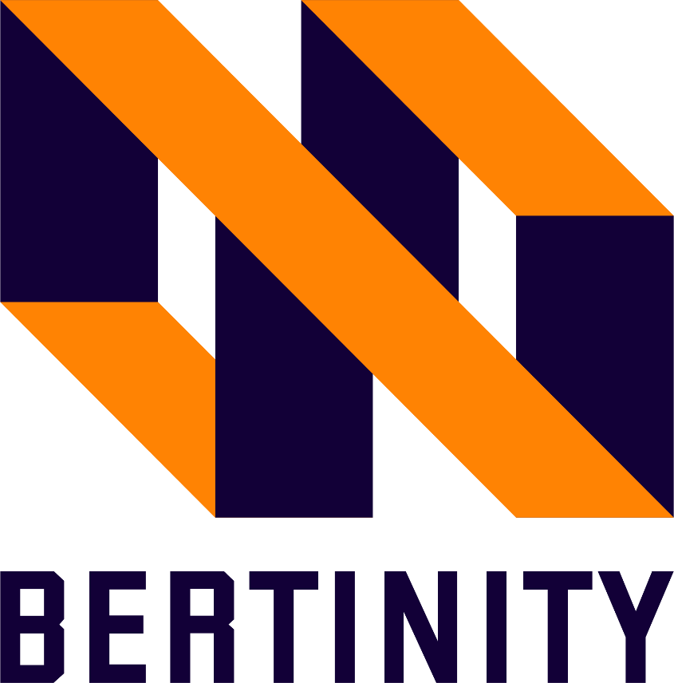

Table of Contents
1. Description 4
2. Introduction 4
3. Why us 5
3.1 Problems and Solutions 5
4. Product 8
4.1. Crypto Payment Gateway (CPG) 10
4.2. Centralized Exchange (CX) 10
4.2.1. No-KYC 10
4.2.2. Device Compatibility 11
4.3. Decentralized Exchange (DEX) 11
4.4. Decentralized Worldwide Stock Marketplace (DWSM) 11
4.5. Main-net 12
4.6. Wallet 13
4.7. Native token 13
5. How it works 13
5.1. Crypto Payment Gateway 14
5.2. Centralized Exchange 14
5.3. Decentralized Exchange 14
5.4. Coin 15
5.5. Wallet 15
5.6. Security Token 15
6. Supply and ICO 16
6.1. Overall 16
6.2. Sale events 17
6.3. Ecosystem 18
6.4. Rewards 18
7. Technical Details 18
7.1. BERTINITY Main-net 18
7.1.1. Consensus Algorithm 18
7.1.2. Max divisibility number 18
7.1.3. Smart contracts 19
7.1.4. Validators and block rewards 19
7.1.5. Native Tokens/Coins 19
7.1.6. Security tokens 19
7.1.7. Anti-fraud labeling system 19
7.2. Cryptocurrency Payment Gateway (CPG) 20
7.2.1. REST API 21
7.2.2. Control Panel 22
7.2.3. Coin support 22
7.2.4. Bertinity Cryptocurrency Payment Gateway for Merchants 22
7.3. Centralized Cryptocurrency Exchange (CEX) 24
7.3.1. CPG API 24
7.3.2. Internal wallets 24
7.3.3. Trading zone 24
7.3.4. No-KYC 25
7.3.5. Premium API 25
7.3.6. Multilingual support 25
7.3.7. Apps 25
7.3.8. Support 26
7.3.9. Announcements and News 26
7.4. Decentralized Cryptocurrency Exchange (DEX) 26
7.5. Wallet 26
8. Roadmap 27
9. Risks 29
9.1. Software security 29
9.1.1. Application based security issues 29
9.1.2. Blockchain based security issues 29
9.2. Regulation 30
9.3. Long term development 30
10. Channels 30
11. Definition 31

Description
BERTINITY is a fully anonymous blockchain ecosystem to utilize blockchain technology as financial tools in people's lives

Introduction
BERTINITY ecosystem is included:
- Cryptocurrency Payment Gateway (CPG)
- Centralized cryptocurrency Exchange (CX)
- Decentralized cryptocurrency Exchange (DEX)
- Decentralized Worldwide Stock Market (DWSM)
- Public Blockchain Network (MainNet)
- Native tokens/coins
- Wallet
- Other utilities:
- Crypto Forex Services
- DeFi Lending (No KYC Lending)
- Tokenizing assets
- NFTs
- Escrow service for P2P trades
- Smart Contracts

In the BERTINITY ecosystem, you can use our crypto payment gateway on your website to provide an alternative payment method to your customers. By our centralized exchange, you can trade easily and anonymously in a safe way while by our decentralized exchange you can even launch your exchange and you can trade in a fully decentralized and peer-to-peer way. Decentralized Worldwide Stock Market is another platform that is provided by us to facilitate fundraising events to our customers which makes the fundraising and investment process inclusive and accessible based on decentralized listing & delisting by blockchain consensus.

Why us
The world of central decision-makers is coming to an end and decisions must be made by consensus and freely, we are against governments, banks, and stock exchanges.
We are going toward balance and equity in access to modern global financial services by decentralizing and eliminating cumbersome, slowing, and restrictive governments, banks, and stock exchanges rules.
We should not wait for the wave of change, we do not want to wait for the wave of changes to pass over us, we want to be Mainstream.
Indeed, we are a startup that wants to create an anonymous ecosystem over a blockchain to utilize blockchain technology as financial tools in our life.
We are here to solve some of the problems that exist in blockchain-based projects.

3.1 Problems and Solutions
Government agents act as individuals responding to incentives, much as actors within a market. This reduces the effectiveness of indirect democratic systems. Currency is a creature of law, government control over money can be a form of oppression. Bitcoin is nothing less than a fundamental assault on the idea that a law of currency is a necessary prerequisite of modern monetary order.
The people in power would have us believe that this system is natural and inevitable but better alternatives to the current system are already here. Despite the increasing progress of blockchain-based projects and payment services, and financial ecosystems, there are still many problems, some of which are mentioned below.

- Unbanked people don't use traditional financial services such as credit cards and bank accounts; instead, they rely on alternative financial services, which are often expensive. Those who are underbanked have some type of bank account but still use cash and alternative financial services to make purchases. There are More than 2bn Unbanked or Underbanked in 140 countries including 1/3 of US and more than 2.7mn in UK Housewives, Youth, Immigrants and many more and they can't use savings accounts to build emergency funds and can't turn to time-saving tools for transactions such as paying bills and transferring money.

- Blockchain utilities are not yet truly decentralized and governments can restrict or intervene in them. there are still lots of Centralized decision-makers and financial monopolies held by the administrations and banks.
- There are so many cross-border payments restrictions, limitations, and costs for foreign merchants, foreign Labor remittances, tourists, freelancers, remote workers, and SMEs. There are many limitations in exterritorial payments with fiats, and limitations of using services and international online payments for anyone anywhere. In all financial and payment processes we have to trust third parties that means we can’t directly control our assets and it may cause fraud and scams. Furthermore, companies and banks are charging massive fees and taking multiple days to clear transfers and they can limit our transactions and control our financial accounts.
- You can buy the crypto of your choice from PayPal as well. While it’s not a crypto-focused company, the platform has a feature to buy, sell and hold crypto coins. So, there is a need for crypto exchanges so people can even trade cryptocurrencies. Most of the nowadays crypto exchanges need KYC or they have withdrawal limitations and are not accessible for anyone from anywhere. furthermore, if you want to trade security tokens in these types of exchanges you must be authenticated that causes some privacy problems and geographic limitations.

- Cryptocurrencies are more assets rather than payment tools

- Most fund and capital raising processes are exclusive, expensive, and extremely difficult for startups and small businesses and it’s not open to anyone anywhere. the capital raising process for companies is not streamlined and they can’t use all potential of their offering capability and they have lots of limitations. Furthermore, there are lots of cross-border stock investment restrictions.

We are here to solve these types of problems with our services. Here are some of our solutions:

- Anyone from across the globe can use the crypto payment gateway to pay the merchants with cryptocurrencies without any concern of time and fee and fiat payment limitation with our NO-KYC CPG services. We are providing easy, fast, reliable cross-border payment solutions and global financial services in a decentralized world to more than 2bn Unbanked and Underbanked in Bertinity financial ecosystem and without traditional financial system limitations.

- We are going to Increase the number of crypto payment gateways by providing easy and fast payment gateway services to SMEs at a lower cost than traditional payment gateways to convert cryptocurrencies to payment tools.

- One of our solutions is Decentralized and P2P services with No third parties and no centralized decision making as a paradigm and price is not controlled by anyone. Decentralized platforms are more secure because there’s no possibility of multiple users losing their funds and every user’s money will be in their hands alone.

- Simplified fund and capital raising and investment and Decentralized cross-border stock market and security token crowdfunding marketplace. We facilitate asset trading by streamlining liquidity and allows people around the world to invest and trade and connect in a peer-to-peer blockchain-based network. It protects investors through blockchain technology and a smart contract system and it makes it easy to unlock the blockchain to tokenize and trade traditional assets. our network makes the fundraising process inclusive and accessible. Fair and flexible. Innovative and easy. And open to anyone, anywhere.

- Disruptive innovation increases user satisfaction by eliminating local laws and going beyond national borders.

- With our no KYC platform, nobody has not to reveal their identity and because of that, we don’t have any geographical limitations. merchants to benefit from crypto payment and instant solutions for liquidity enabling them to
receive new income streams.

Product

BERTINITY ecosystem contains 6 main parts, including Crypto payment gateway, Centralized exchange, Decentralized exchange, Decentralized Worldwide Security Token Stock Market, Main-net & Native coin on the network, Crypto Wallet.
Product list:
- Cryptocurrency Payment Gateway (CPG)
- Centralized cryptocurrency Exchange (CX)
- Decentralized cryptocurrency Exchange (DEX)
- Decentralized Worldwide Stock Market (DWSM)
- Public Blockchain Network (MainNet)
- Native tokens/coins
- Wallet
- Crypto Forex Services
- DeFi Lending (No KYC Lending)
- Tokenizing assets
- NFTs
- Escrow service for P2P trades
- Smart Contracts

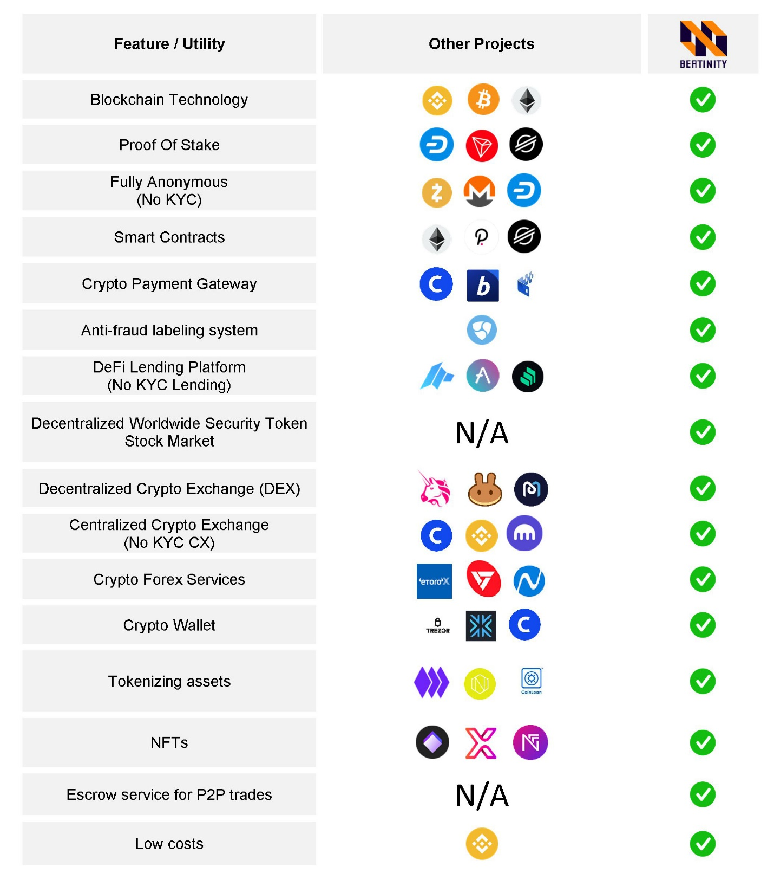
Bertinity Ecosystem Comparison Table

Crypto Payment Gateway (CPG)
A crypto payment gateway is a platform for online transactions that helps companies accept payments in cryptocurrencies. As we mentioned earlier for problems of cross-border payments, etc., we offer our NO-KYC CPG services. In our ecosystem, everyone can use our Crypto payment gateway (CPG) on his/her website to provide an alternative payment method to his/her customers and Anyone from across the globe can use the crypto payment gateway to pay the merchants with cryptocurrencies without any concern of time and fee and fiat payment limitation without any KYC. Also, you can track in real-time with our CPG API & plugins and connect the transaction systems with our e-commerce solutions. Our crypto payment Gateway will Remove cross-border restrictions and it is accessible for anyone anywhere.

Centralized Exchange (CX)
Centralized cryptocurrency exchanges (CX) are online platforms used to buy and sell cryptocurrencies. Decentralized platforms are slower than centralized ones. According to an analysis, centralized crypto exchanges take an average of 10 milliseconds to execute orders whereas a decentralized exchange takes a minimum of 15 seconds to match and fill an order. To work with the decentralized exchanges, some nodes needed to launch which it’s not possible for everyone. So, they are the most common means that investors use to buy and sell cryptocurrency. We will support spot, Futures, margin, and demo trading. Our CX will be a NO-KYC platform. we have two categories for traders: crypto trading and security token trading, so everyone can trade on cryptocurrencies and security tokens that we will offer. We immediately connect buyers with sellers by streamlining liquidity. by our user-friendly exchange, you can trade 24/7 with a small fee as fast as possible.
The coins we will firstly support as trading pairs are Bitcoin, Litecoin, Bitcoin Cash, Ethereum, Tether, Binance coin, XRP.

No-KYC
To respect user’s privacy, there is no KYC procedure on CX platform. All customers may sign-up without providing additional personal information about themselves.

Device Compatibility
Our goal is to bring our platform into the variant devices and operating systems such as:
- Web-based client
- Android client
- IOS client

Decentralized Exchange (DEX)
A decentralized exchange (DEX) is a peer-to-peer (P2P) marketplace that connects cryptocurrency buyers and sellers. In contrast to centralized exchanges (CCEs), decentralized platforms are non-custodial, meaning a user remains in control of their private keys when transacting on a DEX platform. By our CCE everyone can trade easily and anonymously and you can trade 24/7 with a small fee as fast as possible while by DEX you can even launch your own exchange and Every user’s money will be in their hand. The transactions are highly secure and wallet-to-wallet. Also, third parties can’t access your data. With our No-KYC decentralized exchange, all third parties are eliminated and everything is established on blockchain and helps better trading experience.

Decentralized Worldwide Stock Marketplace (DWSM)
Security tokens are essentially digital, liquid contracts for fractions of any asset that already has value, like real estate, a car, or corporate stock. Using security tokens means investors can expect that their ownership stake is preserved on the blockchain ledger. Our Security token platform is another platform that makes the fundraising process inclusive and accessible, Fair and flexible, Innovative and easy, and open to anyone, anywhere. We create a digital global investment marketplace with a P2P network that makes processed more streamlined for investors which makes the fundraising and investment process inclusive and accessible and a built-in exchange to allow global trade of securities. By our p2p network price is not controlled by anyone and it will be fully decentralized and because it is a no-KYC platform nobody has not to reveal their identity and because of that, we don’t have any geographical limitation. We create a digital investment marketplace with a P2P network that makes processes more streamlined for investors and a built-in exchange to allow global trade of securities.
Here are three levels for each project/security token to get listed on:
- Basic Level Market (BLM), For those who wish to not pay, there is no need to pay to apply, but it might be highly risky to get rejected while there is no control over the admission process, this plan is proper for small size projects/businesses.
- Rapid Entry Market (REM), For those who want to lower the risk by paying which is between $10000 to $50000, although there is still no control on the admission process, this plan is useful for medium-sized projects/businesses.
- Premium Enterprise Market (PEM), For those who want to lower the risk and increase the chance of success. This plan is proper to medium-large size projects/businesses, the admission process will be held on the blockchain.

 | Basic Level Market (BLM) | Rapid Entry Market (REM) | Premium Enterprise Market (PEM)
Initial due diligence | No | Yes | Yes
Admission | No Control | No Control | Blockchain Consensus
Risk | Medium to High | Medium | Low
Initial due diligence fee | No | $10000-$50000 | $10000-$50000

Main-net
Main-net is the term used to describe when a blockchain protocol is fully developed and deployed, meaning that cryptocurrency transactions are being broadcasted, verified, and recorded on a distributed ledger technology (blockchain). Our main-net is a dedicated network to keep all transaction records. Our Main-net will be a p2p network to act as a distributed ledger to keep track of assets, transactions and provide a lot of features to users, and may tokenize any asset on the blockchain. Any company and startup can tokenize their securities with our platform and we give them the services of tokenizing, whitepaper and business plan advice, and implementation of tokenizing their assets.

Wallet
A cryptocurrency wallet is an app that allows cryptocurrency users to store and retrieve their digital assets. When a user acquires cryptocurrency, such as bitcoins, she/he can store it in a cryptocurrency wallet and from there use it to make transactions. Our wallet is a multi-platform wallet (Windows, Mac, Linux, Android, IOS) to create and manage the accounts, transactions, assets, and the other functionalities which are provided by the ecosystem.

Native token
A crypto token is a digital asset that is native to a cryptocurrency exchange. A crypto exchange may launch its own token for a variety of reasons, and exchange owners often give tokens to users as incentives. With our native token people used to trade and pay fewer fees on our exchange. Some of our native token’s benefits are:
- Bertinity Exchange fee discount
- CPG transaction fee discount
- Security token and stock trade commission discount
- Acceptable on Bertinity payment gateway
- Ability to list on Bertinity other trusty exchanges
- Discount on purchases or trades in the ecosystem
- potential value increases due to project growth

How it works
For a person who wants to teleshopping or has cross-border payment, You can pay with our token with a discount, or any cryptocurrency using our CPG. So, anyone anywhere could pay and shop internationally with less fee and in a simple way. With CPG connect to our exchange that has two categories for you. One, you can trade cryptocurrencies and the second is that you can trade security tokens without KYC. You can also use our native token in exchange for trading crypto or security token with less fee. Furthermore, companies and startups that have fundraising problems and limitations or the ones who want to have cross-border stock investment can solve their problem using our STO platform and we will tokenize their securities and it will be tradable in our exchange.

Crypto Payment Gateway
When the user clicks the Place the Order button at the checkout. Then immediately the web browser encrypts the payment details. Also, sends the payment details to the merchant’s web server through an SSL connection.
Once the merchant receives details, the merchant sends details to the crypto payment gateway with an encrypted SSL.
The cryptocurrency payment gateway sends the details to the payment processor. Then it receives a request and sends a response code back to the payment processor. That response code has all the data and information about the transaction status.
Then the payment processor sends the response code to the gateway. From there it is forwarded to the website.
Finally, the website displays relevant information to the user.

Centralized Exchange
Our Centralized exchange is a platform that facilitates the buying and selling of cryptocurrencies. it functions as trusted intermediaries in trades, and often act as custodians by storing and protecting the funds.
Login transfer crypto to ex wallet without the private key
The buy and sell orders entered into order book order executed exchange commission transfer from ex wallet to own wallet.

Decentralized Exchange
A DEX or a decentralized cryptocurrency exchange is similar to a centralized one, except it doesn’t have a third party on which you can rely. All of the funds in this exchange remain stored on the blockchain.
These platforms allow peer-to-peer (P2P) trading for which it uses assets, proxy tokens, or an escrow system, unlike the IOU-based system a centralized crypto exchange uses.
A token owner raises an order: to exchange his/her assets/funds with another available on the DEX. The user also specifies the number of units they want to sell, the cost of each token, and until which time bidding for their assets is allowed.
Once the selling order as mentioned above is set, other users can submit bids through a buy order.
Once the time assigned by the seller expires, all the bids are reviewed and calculated for the best interest of both buyer & seller parties.
- log in to the DEX portal with your wallet
- submit a buy or sell request
- smart-contract logic gets executed and the transfer of assets is done
- requested tokens will be sent to your wallet
- Disconnect.

Coin

Used to trade and pay fees with a discount on our exchange.

Wallet
Handling the accounts and assets,
Create an account send, receive and hold

Security Token
Security tokens are issued on the blockchain. Security tokens provide companies with access to global capital. Investors receive a unique international investment opportunity. The property rights of investors are stored on the blockchain through smart contracts.
It has two plans for issuers and investors:
1. launch company’s token
2. buy, sell, or trade tokens

6. Supply and ICO
The total supply is 62,000,000,000 units and supply divisibility will be according on:

- Supply Reserve %14.0
- Public sale %20.0
- Private sale %4.5
- Ecosystem %20.0
- Advisor %4.5
- Marketing %16.0
- Team %17.5
- Rewards %3.5

6.1. Overall
Here is the overall chart about total supply.
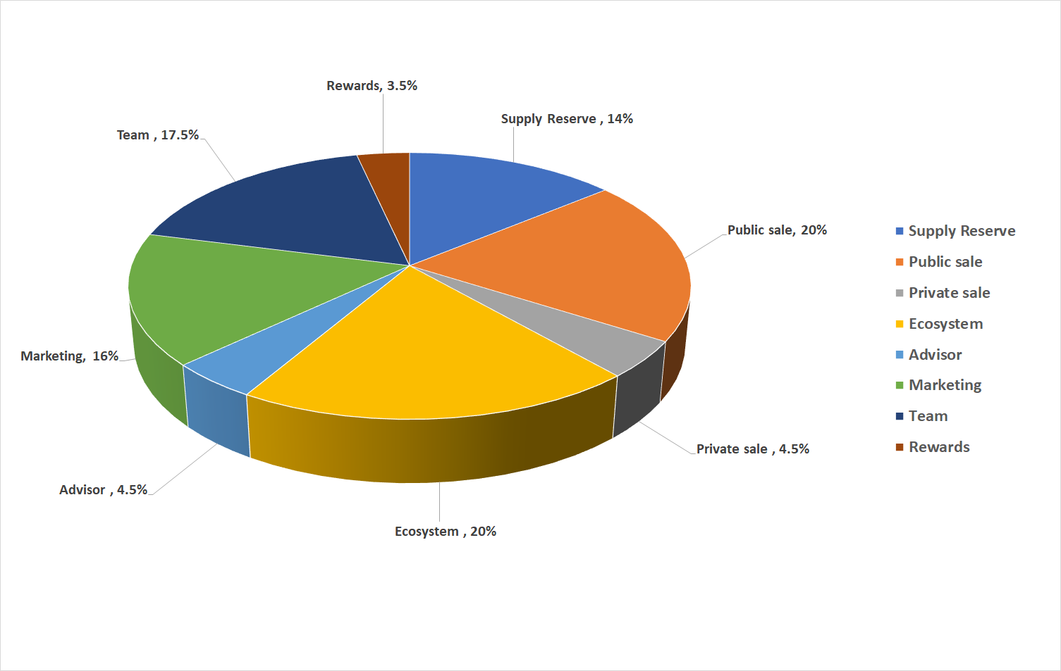

6.2. Sale events
• Public sale %20.0 :
- Pre-ICO: %4.5
- ICO round-1: %6.8
- ICO round-2: %5.0
- ICO round-3: %3.7
• Private sale %4.5

Public pre-ICO | %4.5
ICO round-1 | %6.8
ICO round-2 | %5.0
ICO round-3 | %3.7
Private sale | %4.5
TOTAL | %24.5

6.3. Ecosystem
Up to %20 of total supply can be used for development, infrastructure, and anything that helps us to the ecosystem growth for long term durations.

6.4. Rewards
Any bonus or gift can be paid up to %8 of the total supply to users as an incentive to move over time.

Technical Details

BERTINITY Main-net
For now, BERTINITY ecosystem uses the Binance Smart Chain (BSC) network.
The next generation of the consensus algorithms are proof of stake (PoS) since its previous version is proof of work (PoW). Hence PoW algorithms aren’t low resource usage, so PoS took its place.
Obviously, to store, process, and verify the transactions, we need a sustainable network to do it. BERTINITY main-net must cover up all functionalities which are needed to provide.
The main-net includes a native coin as the main coin and may contain a lot of tokens. The total supply of the native coin is already described in section “Supply”.

Consensus Algorithm
Our goal is to use PoS (Proof of Stake) algorithm for the consensus procedures.

Max divisibility number
The maximum amount of divisibility in main-net is “100,000,000” per one unit, so the smallest value in main-net is equal to “0.00000001”

Smart contracts
We have a goal to provide a better kind of smart contracts since there is no need to do programming because BERTINITY smart contracts can be used easily by some simple steps.
So to create a smart contract in BERTINITY blockchain you don’t have to have programming knowledge.

Validators and block rewards
According to PoS algorithm, as much as a node owns BERTINITY (the native token of the network), it has more chance to earn block rewards.

Native Tokens/Coins
Based on the total supply, there will be “62,000,000,000” BERTINITY toke over the blockchain.
A crypto exchange token is a digital asset that is native to a cryptocurrency exchange. A crypto exchange may launch its own token for a variety of reasons, and exchange owners often give tokens to users as incentives. With our native token people used to trade and pay fewer fees on our exchange.

Security tokens
These days some companies are eager to offer their shares on a blockchain-based network to fundraise. So we want to provide a p2p STO platform to help them to get easier funds by bringing a p2p network to do it.
In our P2P STO platform (DWSM), any kind of shares can be listed on the platform. Obviously after the token listing on DWSM then the price only can be determined by price, since it’s all on a p2p network.

Anti-fraud labeling system
If an account/address hacked, the account owner can add a label to its account which causes all addresses from that account will be automatically labeled over blockchain, so exchanges and traders will not process any transaction that is labeled.

Cryptocurrency Payment Gateway (CPG)
A gateway to provide an ability for users to pay by cryptocurrencies. Our CPG supports variant cryptocurrencies to give many options for users. Since it’s an anonymous CPG, all users have an opportunity to keep their privacy, so they don’t have to reveal their identity while using our CPG system. Users may pay and use our native coin.
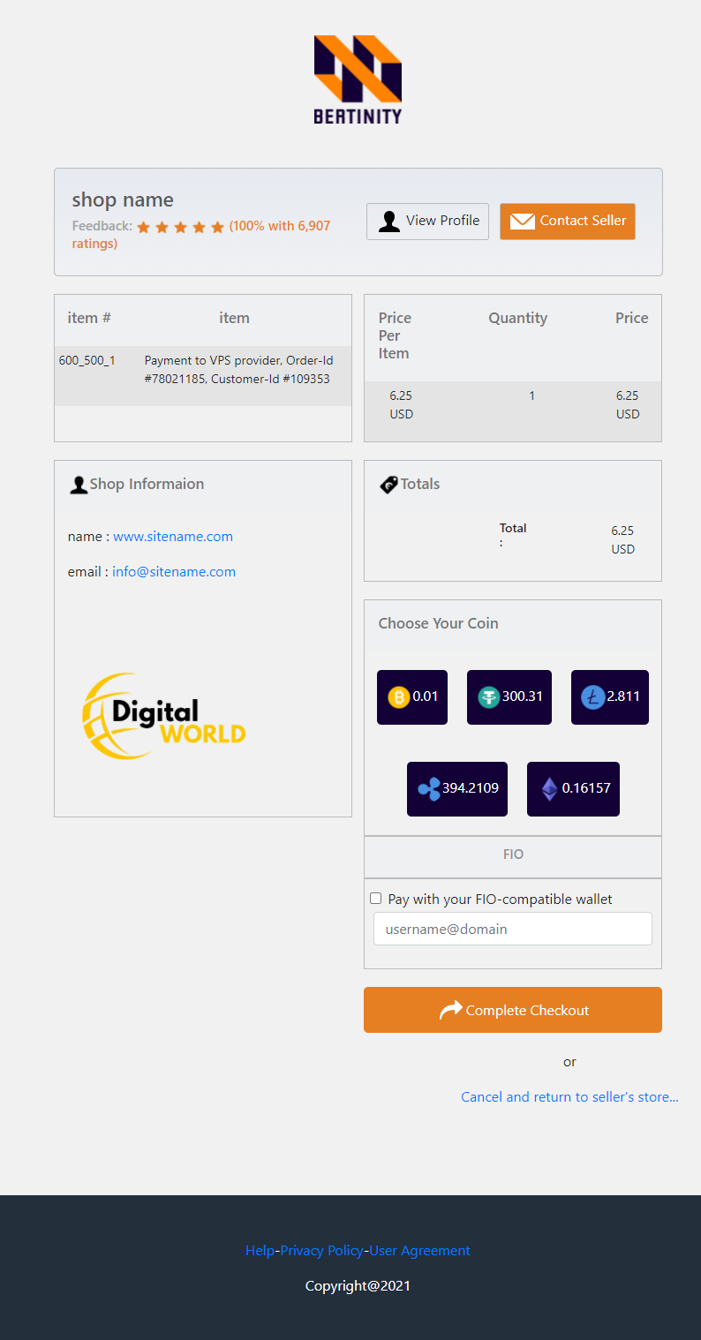
CPG checkout page

For example, an online-shop owner may use CPG on the website to provide an alternative payment method to the customers, So:

REST API
Users may use our REST API within technical documents to implement it into websites.

Control Panel
There is a control panel for each user to checkout balance, records, etc.

Coin support
There are 7 coins supported by our CPG, for now.
Bitcoin, Litecoin, Bitcoin Cash, Ethereum, Tether, Binance Coin, XRP.

Bertinity Cryptocurrency Payment Gateway for Merchants
Bertinity ecosystem has a special offer for merchants. Here is a comparison between our service and prepaid cards and credit cards.

Payment method | Crypto Payment Gateway | Prepaid Card | Credit Card
Anonymity of use
Range of application
(where accepted)
Availability
Credit Payments | *
Possibility of reloading
Transaction Costs
No Chargeback Fraud
Safe and Secure
Restrictions, limitations, and sanctions
*via DeFi
- Anonymity of use
Since Bertinity is an anonymous financial ecosystem, so any payments which are done by our services are anonymous.

- Range of application
Obviously, it takes a while to get accepted by more providers.

- Availability
Bertinity ecosystem is built on a decentralized network, a blockchain, so it’s highly available and online forever.

- Credit payments
Customers may get credit by using DeFi contracts on the Bertinity ecosystem.

- Possibility of reloading
Users may reload/deposit the accounts as much as wanted without any limit.

- Transaction costs
Since all transactions will be done on the blockchain, then all transactions fee is much lower than prepaid cards or credit cards system.

- No chargeback fraud
All transaction is recorded on the blockchain accurately, so it’s not possible for scammers to fraud.

- Safe and secure
All prepaid and credit card info may be recorded on thirty-party entities, so they may access your critical info. But by our services, it’s impossible since you are the only one who has access to your account by the keys.

- Restrictions, limitations, and sanctions
Bertinity financial ecosystem is a borderless and anonymous platform, so there is no restriction to limit its availability for users.

- Number of coins/tokens to supports
Over 100 coins, tokens, and stable coins will be available in the future.

- DeFi Lending
By using DeFi contracts, all merchants are capable to provide loans to customers who want to use cryptocurrencies as bail. Sure all can be done as anonymous since Bertinity is a No-KYC (anonymous) financial ecosystem.

Centralized Cryptocurrency Exchange (CEX)
We will support spot, Futures, margin, and demo trading. Our CEX will be a NO-KYC platform and everyone can trade on cryptocurrencies and security tokens that we will offer.

CPG API
To activate the CPG service, there will be a section to do it. Users may request to issue a CPG API automatically.
Users use CPG API to configure their cryptocurrency payment gateway as a payment tool.
All payments through CPG will be transferred automatically to the internal main wallet of the customer in CX.

Internal wallets
There will be three kinds of internal wallets in CX platform.
- Main wallet to keep assets safe.
- Trading wallet which is used on the spot trading section.
- Margin wallet for margin trading.

    - Users are free to transfer their assets between Main wallet, Trading wallet, and Margin wallet.

Trading zone
There are three main trading functionalities to trading.
- Spot trading
- Margin trading
- Future trading
- Demo trading

No-KYC
We are offering no-KYC, so your privacy is safe with us.

Premium API
If users are willing to use our CEX platform as a backend on their projects, so we are providing premium and feature-rich API to cover up whatever they might be need it.

    - Premium API service might cost users.

Multilingual support
We support some languages such as:
- English
- Germany
- Spanish

    - Additional languages might be added in the future.

Apps
To cover up all devices, we are supporting three versions of CX platform.
- Web-based (desktop & phones)
- Android app
- IOS app

Support
There are four main areas to help users.
- Documentation support
- Online helpdesk
- Ticketing
- FAQ

Announcements and News
There is a special section to announce new coin listing within any news which is proper to be set on this area.

Decentralized Cryptocurrency Exchange (DEX)
As we talked on section “Problems”, sometimes an exchange might get more powerful than usual and tries to control the whole or part of the market. So, to solve it, we are bringing a new platform as DEX to make sure none of the exchanges have enough power to force the users to follow their will.
Since we are using the Binance Smart Chain (BSC) main-net, so our DEX platform will be on Binance Smart Chain.
Everyone is free to launch an exchange as a decentralized exchange into the main-net. All DEX nodes are communicating with each other by the main net.

- 24/7 availability
- All operations over the blockchain
- No sign-up needed

Wallet
BERTINITY-wallet is a native wallet to communicate to blockchain and managing accounts and transactions.
BERTINITY wallet can coverup most popular operating systems such as:
- Linux/Unix
- Windows
- Macintosh
- Android
- IOS

Roadmap
Q4-2020:
- Ideation (CPG, DEX, CEX, Main-net, DWSM platform, Wallet).
- Strategy.
Q1-2021:
- Ecosystem design.
Q2-2021:
- Branding, Logo, Name.
- Releasing Whitepaper.
- Launching Social networks.
- Launching official website and channels.
- Expanding the team.
- CPG development.
Q3-2021:
- CEX development.
- CPG development.
Q4-2021:
- Launching basic CPG.
- CEX development.
Q1-2022:
- Stress test, debug, improvement.
- CEX development.
Q2-2022:
- Pre-ICO Development.
- Mobile Application development.
Q3-2022:
- Early Private Investor.
- ICO event.
Q4-2022:
- CEX development.
- CEX Launch
- Adding STO over CEX.
- Expanding the marketing and announcements.
Q1-2023:
- Expanding the marketing.
- More coins to support on CEX.
- Improvement.
- Main-net design.
Q2-2023:
- DEX design.
- Main-net development.
- [TBA]
Q3-2023:
- [TBA]

Risks
Obviously, there are some risks, but we are doing our best to manage them well.

Software security
There are two kinds of security issues.
- Application-based security issues
- Blockchain-based security issues

Application-based security issues
All applications are coded by a professional team included software engineers and pen testers. Everything will be fully tested and analyzed before the official release.
There is a highly skilled team to debug and patch the applications if something goes wrong.
- Wallet application
  - Using secure encryption algorithms
  - Standard and secure communication protocols
  - Secure and optimized coding during implementation

- Centralize cryptocurrency exchange (CX)
  - Secure communication protocols
  - Encrypted keys over databases
  - Using the latest and standard algorithms
  - 2FA and security login parameters
  - Securing and hardening of the servers
  - 24/7 online monitoring
  - Anti-cheat/bot system
  - Multi-layer management
  - Using secure mechanisms to handling the hot-wallets and the cold-wallets

Blockchain-based security issues
We have a goal to build a secure, fast, and high scalable blockchain as main-net.
We are aware of security issues like %51 attack, Sybil attack, Eclipse attack, double spending, etc, so we are considering a lot of parameters to make sure our blockchain is safe and fast.
- Network attacks
  - One of the most important parts of our system is its consensus algorithm which is based on Proof of Stake (PoS) which means to do attacks like “%51”, the attacker should control over %50 of the network which means that the attacker must own a lot of BERTINITY token as a stake which is impossible since BERTINITY tokens will be distributed among people and the foundation.

- To run a validator node in the BERTINITY main-net, there will be a minimum number of BERTINITY tokens as requirements.

    - Details will be announced later, you may check out the roadmap.

Regulation
Since we are not physically activating in any country, so there will be no legal issues to worry about, although our lawyer team is always ready to solve anything might we face.

Long term development
Since the BERTINITY ecosystem is well funded and it’s using a proper strategy within a professional team, so there will be no problem to worry about. BERTINITY ecosystem is here to stay.

- You may check out the roadmap section.

Channels

- https://www.bertinity.com/
- https://twitter.com/bertinity
- https://t.me/bertinity
- https://t.me/bertinityofficial
- https://www.linkedin.com/company/bertinity
- https://www.instagram.com/bertinity.io
- https://www.facebook.com/bertinity.io
- https://www.reddit.com/user/bertinity
- https://medium.com/@bertinity
- https://www.quora.com/profile/Bertinity
- https://github.com/Bertinity
- https://www.pinterest.de/bertinity/
- https://www.youtube.com/channel/UCyY_Vf3CYkCTnfBs4_Gs_EQ

Definition

- Liquidity: Liquidity is the measure of how quickly and easily a cryptocurrency can be converted into cash, without impacting the market price. Liquidity is important because it brings about better pricing, faster transaction times, and increased accuracy for technical analysis.
- CPG: A crypto payment gateway is a platform for online transactions that helps companies accept payments in cryptocurrencies.
- Security token: A security token, represents an ownership stake in an asset, typically a company, and entitles its holder to a share of profits in the asset. Security tokens are much less common.
- Peer to peer: A peer-to-peer (P2P) service is a decentralized platform whereby two individuals interact directly with each other, without intermediation by a third party.

