**Company Lockers Pvt. Ltd.**

**Language:** Java 1.8

**Methodology:** Agile

**Project Description:**

Develop a file management system (FMS), menu driven software, which should have the capabilities to perform the following action:

* Create file.
* Delete file.
* Search and Sort files based on the user selection.

**Software’s Requirement**

Eclipse - Project Development

**Developed By:** Roberto Domínguez

**Development Man-days:** 6

**Document Prepared By:** Roberto Domínguez

**Document Prepared Date:** 10/08/2023

**Submission Date:** 16/08/2023

**1.Project Description from Simplilearn:**

Based on the requirements from the LMS, I developed a FMS Menu Driven Software.

It must have 3 options and will work based on the User Entered Input.

* Option 1 – Sorting the Files in the Ascending Order.
* Option 2 – Trough this option, user can do the following actions:
  + -Add files.
  + Delete files.
  + Search files.
  + Back to Main Menu.
* Option 3 - Exit the application.

**Figure 01 - MAIN MENU**

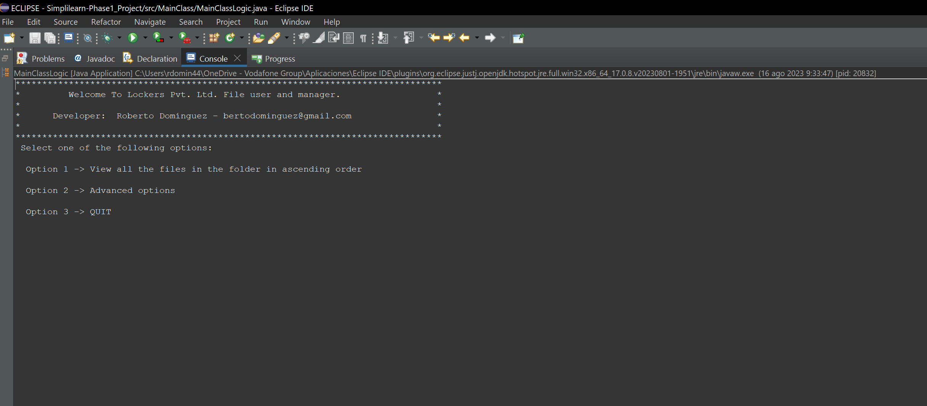

**Option 1 - Sort the files in the folder.**

Default behavior of the *Arrays.sort* method is to return the sorted objects in ascending order.

For avoiding error, the program will check the following options:

* When the user selects option 1, the application will check files from the root folder and if the root folder does not exist, it will create a new folder.
* FMS gets the file names for the root folder added to the Array Object and print those files using for each loop.
* If there are no files in the root directory it means that’s its empty, and then it will return error message (*Directory not exists or is empty.*)

**Figure 02 - Option 1 – Sorting in Ascending Order**

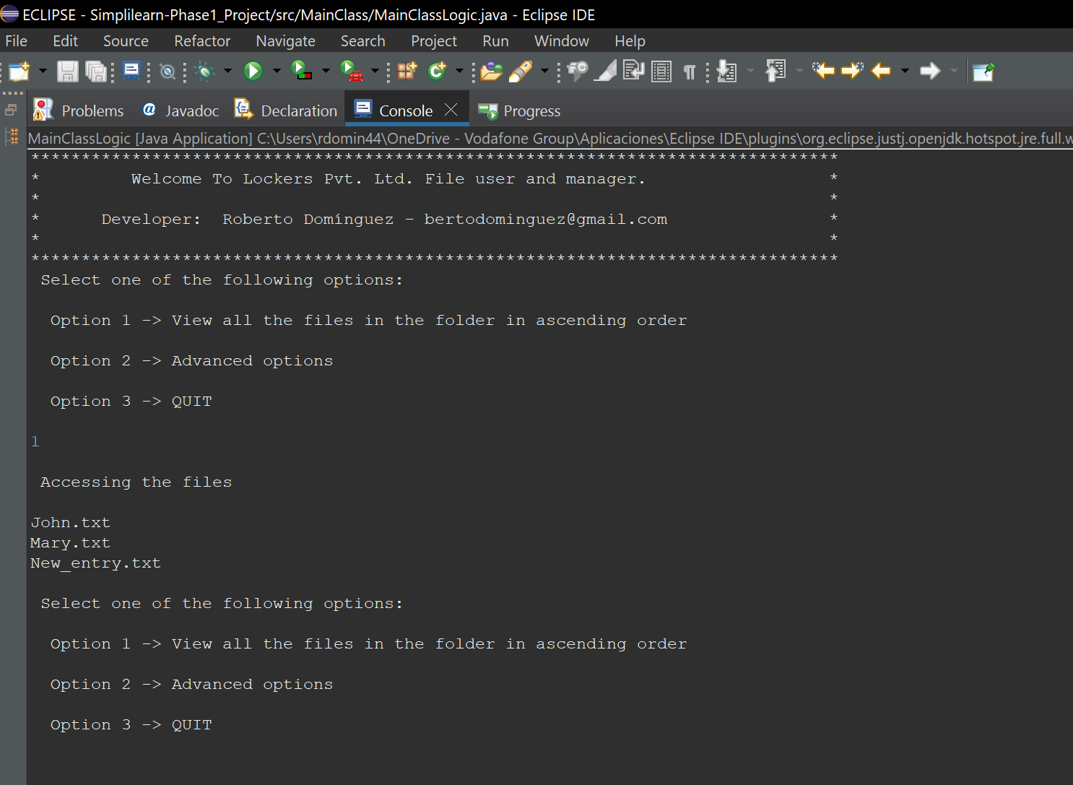

**Option 1 – Advanced options.**

In this menu, user can manage files in the working directory through the 4 options:

**Figure 03 – Advanced options**

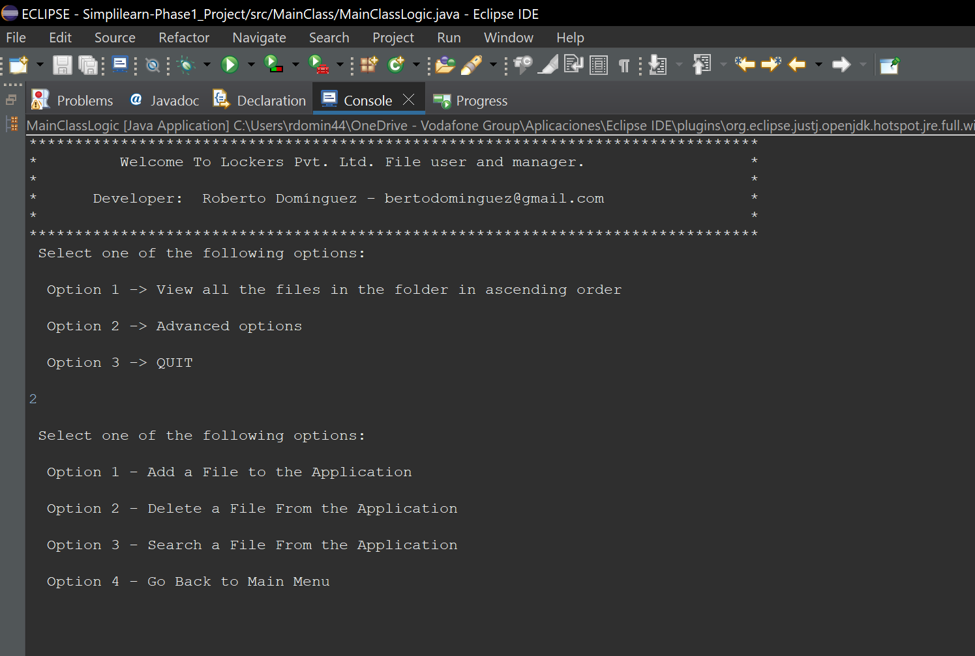

Option 1: - Add files.

If then file exist, will return error message:

**Figure 04 – Error message.**

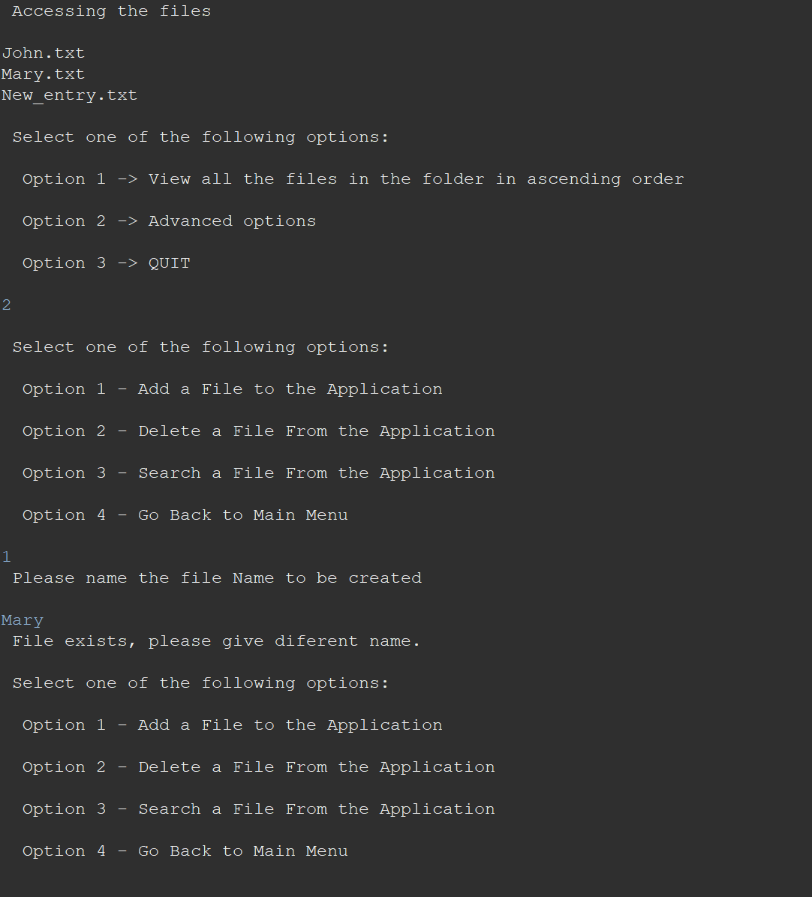

Option 2 – Delete Files.

The program will compare the provided file name to delete, and if it exists, it will delete and return a message indicating that the file is deleted:

**Figure 05 – Successful delete files.**

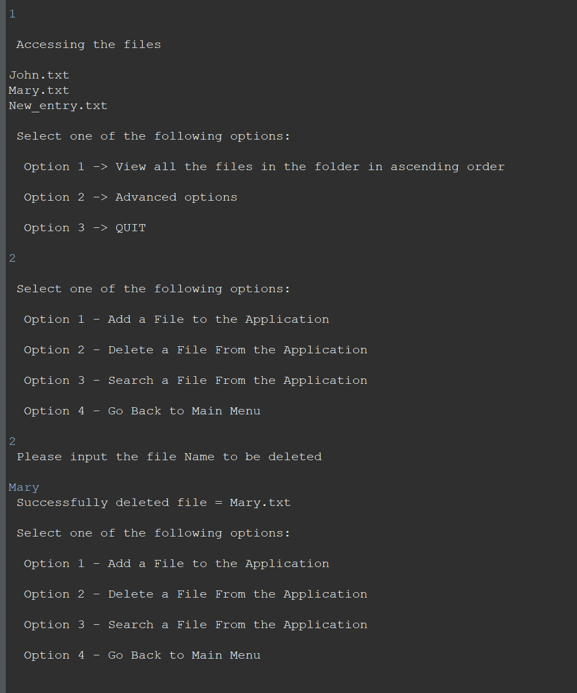

In case the provided file name does not exist, will return error message:

**Figure 06 – Delete files error message.**

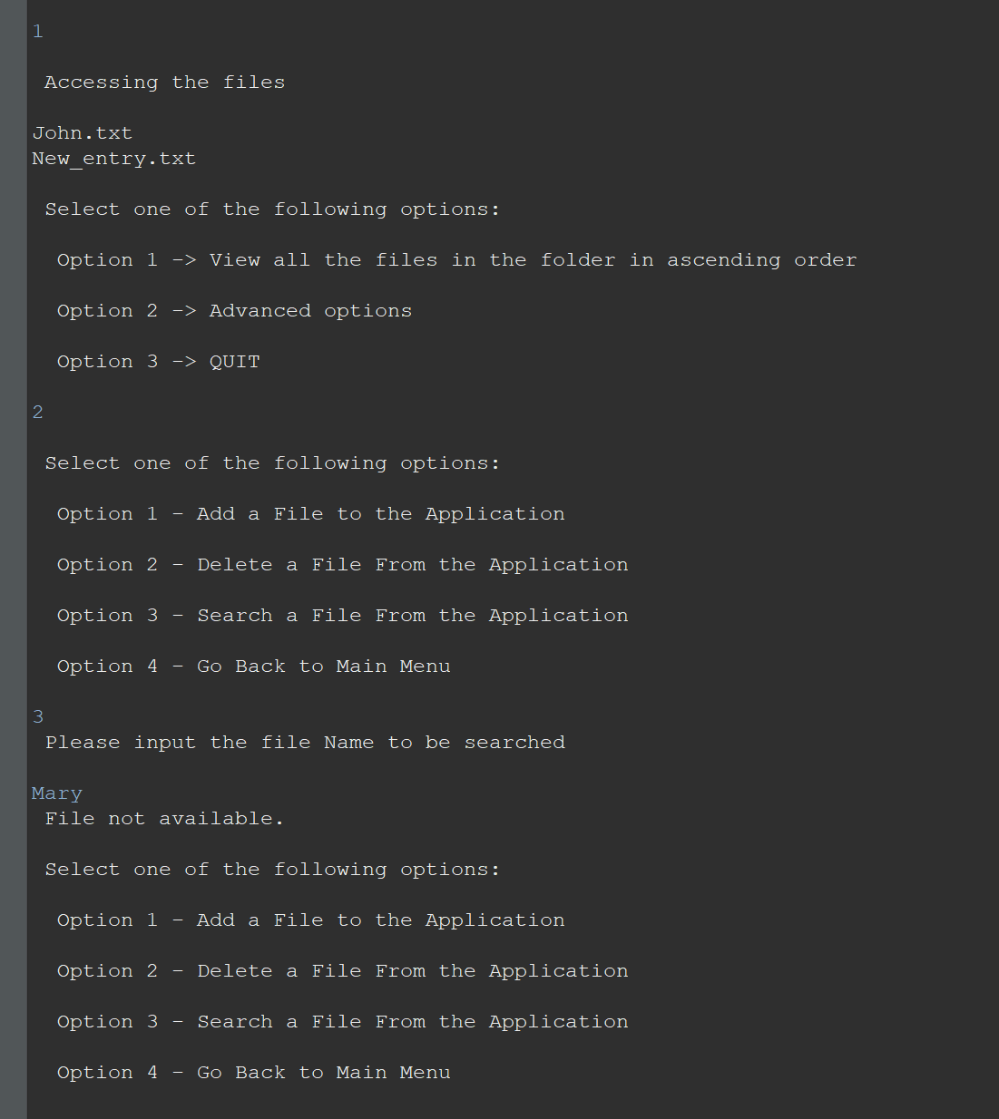

Option 3 – Search files in working directory

Will perform a search in the directory, and if the file does not exist, return a error message.

**Figure 07 – Search files message.**

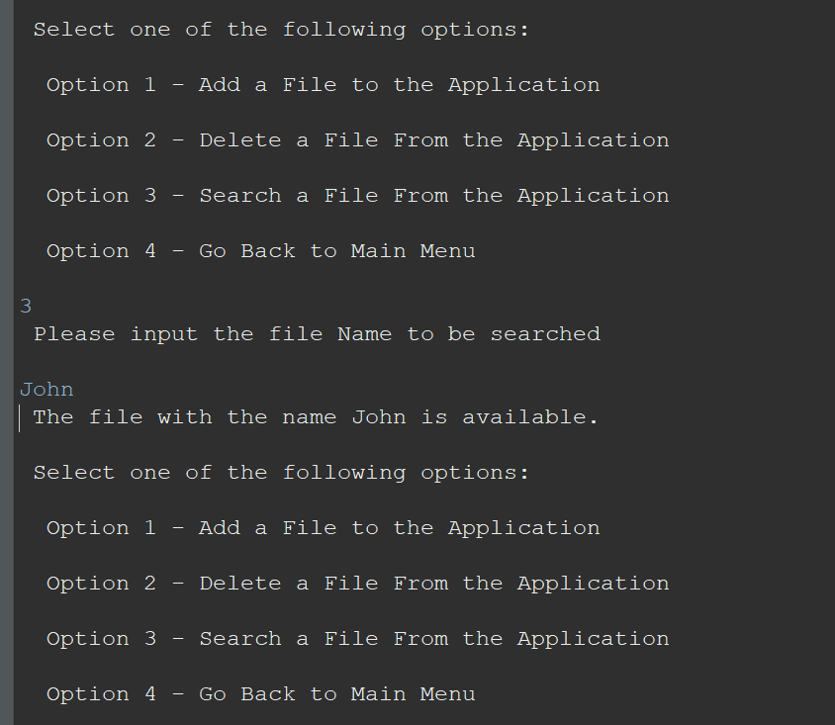

**Figure 08 – Search files error message.**

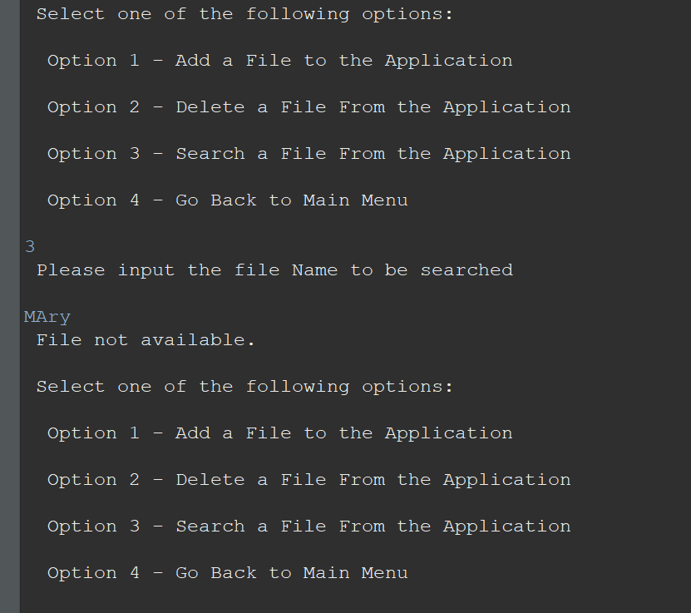

Option 4 -Return to main menu.

**Concepts used in the project :**

Classes.

File Handling.

Arrays.

Errors Handling

Scanner.

Manage user inputs.

**Github repo:**

<https://github.com/BertoVigo/2023_Java_Reskilling>