Permutation-test_boxplots.R

ornella

2021-01-29

#Permutation test  
  
library(coin) #one_way test

## Loading required package: survival

library(rcompanion) #pairwisePermutationTest  
library(ggpubr) #ggboxplot

## Loading required package: ggplot2

library(car) #Levene's test

## Loading required package: carData

#directory  
setwd("~/Desktop/Squirrel_June_8_2020/Code")  
  
#Import squirrel data  
squirrel.data1<-read.csv("squirrels_PEQ_res.csv", header=T)  
squirrel.data<-squirrel.data1[, c("PEQ_Meng", "Ecology")]  
squirrel.data2<-squirrel.data1[, c("OB_percentage", "Ecology")]  
squirrel.data3<-squirrel.data1[, c("PL_percentage", "Ecology")]  
squirrel.data4<-squirrel.data1[, c("Neocortex_surface_percentage", "Ecology")]  
  
comp<- list(c("Arboreal", "Fossorial"),c("Arboreal", "Scansorial"),   
 c("Arboreal", "Terrestrial"),c("Fossorial", "Glider"),c("Fossorial", "Scansorial"))  
  
###############PEQ permutation test  
  
##ggplot - boxplot - PEQ  
ggboxplot(squirrel.data1,x="Ecology", y="PEQ_Meng", fill="Ecology", palette=c("chartreuse3", "chocolate4", "steelblue1","firebrick2","yellow"))+  
 geom_point() +   
 geom_text(aes(label = abbreviation ), hjust = 0, nudge_x = 0.05)+  
 labs(x='Locomotion', y='Phylogenetic encephalization quotient')

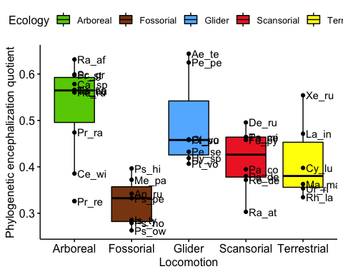

#Fisher-Pitman permutation test  
oneway_test(PEQ_Meng~Ecology,data=squirrel.data)

##   
## Asymptotic K-Sample Fisher-Pitman Permutation Test  
##   
## data: PEQ_Meng by  
## Ecology (Arboreal, Fossorial, Glider, Scansorial, Terrestrial)  
## chi-squared = 17.166, df = 4, p-value = 0.001794

squirrel.data$Ecology = factor(squirrel.data$Ecology, levels = c("Arboreal","Fossorial","Glider",  
 "Scansorial","Terrestrial"))   
  
PT_PEQ<-pairwisePermutationTest(PEQ_Meng~Ecology,data=squirrel.data,method="fdr")  
PT_PEQ

## Comparison Stat p.value p.adjust  
## 1 Arboreal - Fossorial = 0 3.143 0.001672 0.01672  
## 2 Arboreal - Glider = 0 0.7458 0.4558 0.50640  
## 3 Arboreal - Scansorial = 0 2.319 0.0204 0.05100  
## 4 Arboreal - Terrestrial = 0 2.065 0.03889 0.07778  
## 5 Fossorial - Glider = 0 -2.721 0.006506 0.03253  
## 6 Fossorial - Scansorial = 0 -2.414 0.0158 0.05100  
## 7 Fossorial - Terrestrial = 0 -1.987 0.04687 0.07812  
## 8 Glider - Scansorial = 0 1.65 0.09894 0.14130  
## 9 Glider - Terrestrial = 0 1.459 0.1445 0.18060  
## 10 Scansorial - Terrestrial = 0 0.106 0.9156 0.91560

#Test if data normally distributed (Normally distributed)  
shapiro.test(squirrel.data$PEQ_Meng)

##   
## Shapiro-Wilk normality test  
##   
## data: squirrel.data$PEQ_Meng  
## W = 0.95275, p-value = 0.1097

# Bartlett test when data are normally distrubuted (YES there is homogeneity of variances)  
bartlett.test(PEQ_Meng ~ Ecology, data = squirrel.data)

##   
## Bartlett test of homogeneity of variances  
##   
## data: PEQ_Meng by Ecology  
## Bartlett's K-squared = 3.8936, df = 4, p-value = 0.4206

############Olfactory bulb permutation test  
  
##ggplot - boxplot - OB  
ggboxplot(squirrel.data1,x="Ecology", y="OB_percentage", fill="Ecology", palette=c("chartreuse3", "chocolate4", "steelblue1","firebrick2","yellow"))+  
 geom_point() +   
 geom_text(aes(label = abbreviation ), hjust = 0, nudge_x = 0.05)+  
 labs(x='Locomotion', y='Olfactory bulb volume percentage')

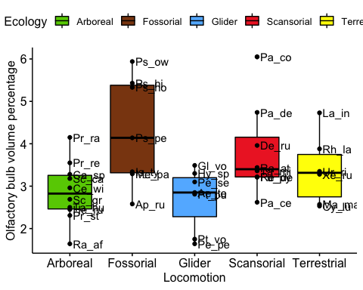

#Fisher-Pitman permutation test  
oneway_test(OB_percentage~Ecology,data=squirrel.data2)

##   
## Asymptotic K-Sample Fisher-Pitman Permutation Test  
##   
## data: OB_percentage by  
## Ecology (Arboreal, Fossorial, Glider, Scansorial, Terrestrial)  
## chi-squared = 11.424, df = 4, p-value = 0.02219

squirrel.data2$Ecology = factor(squirrel.data2$Ecology, levels = c("Arboreal","Fossorial","Glider",  
 "Scansorial","Terrestrial"))   
  
PT_OB<-pairwisePermutationTest(OB_percentage~Ecology,data=squirrel.data2,method="fdr")  
PT_OB

## Comparison Stat p.value p.adjust  
## 1 Arboreal - Fossorial = 0 -2.416 0.0157 0.1117  
## 2 Arboreal - Glider = 0 0.4785 0.6323 0.6323  
## 3 Arboreal - Scansorial = 0 -2.014 0.04404 0.1117  
## 4 Arboreal - Terrestrial = 0 -1.296 0.1949 0.2784  
## 5 Fossorial - Glider = 0 2.284 0.02238 0.1117  
## 6 Fossorial - Scansorial = 0 0.7732 0.4394 0.4882  
## 7 Fossorial - Terrestrial = 0 1.403 0.1605 0.2675  
## 8 Glider - Scansorial = 0 -2.007 0.0447 0.1117  
## 9 Glider - Terrestrial = 0 -1.49 0.1363 0.2675  
## 10 Scansorial - Terrestrial = 0 0.8222 0.411 0.4882

#Test if data normally distributed (not normally distributed)  
shapiro.test(squirrel.data2$OB_percentage)

##   
## Shapiro-Wilk normality test  
##   
## data: squirrel.data2$OB_percentage  
## W = 0.92484, p-value = 0.01385

# Levene's test when data are not normally distrubuted (YES there is homogeneity of variances)  
leveneTest(OB_percentage ~ Ecology, data = squirrel.data2)

## Levene's Test for Homogeneity of Variance (center = median)  
## Df F value Pr(>F)  
## group 4 0.9921 0.4256  
## 33

#############Petrosal lobule permutation test  
  
##ggplot - boxplot - Petrosal lobules  
ggboxplot(squirrel.data1,x="Ecology", y="PL_percentage", fill="Ecology", palette=c("chartreuse3", "chocolate4", "steelblue1","firebrick2","yellow"))+  
 geom_point() +   
 geom_text(aes(label = abbreviation ), hjust = 0, nudge_x = 0.05)+  
 labs(x='Locomotion', y='Petrosal lobule volume percentage')

## Warning: Removed 1 rows containing non-finite values (stat_boxplot).

## Warning: Removed 1 rows containing missing values (geom_point).

## Warning: Removed 1 rows containing missing values (geom_text).

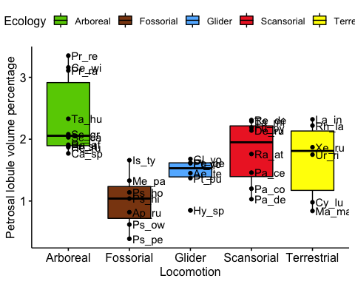

#Fisher-Pitman permutation test  
oneway_test(PL_percentage~Ecology,data=squirrel.data3)

##   
## Asymptotic K-Sample Fisher-Pitman Permutation Test  
##   
## data: PL_percentage by  
## Ecology (Arboreal, Fossorial, Glider, Scansorial, Terrestrial)  
## chi-squared = 17.39, df = 4, p-value = 0.001623

squirrel.data3$Ecology = factor(squirrel.data3$Ecology, levels = c("Arboreal","Fossorial","Glider",  
 "Scansorial","Terrestrial"))   
  
PT_PL<-pairwisePermutationTest(PL_percentage~Ecology,data=squirrel.data3,method="fdr")  
PT_PL

## Comparison Stat p.value p.adjust  
## 1 Arboreal - Fossorial = 0 3.163 0.001561 0.01561  
## 2 Arboreal - Glider = 0 2.603 0.009242 0.04163  
## 3 Arboreal - Scansorial = 0 1.873 0.0611 0.09999  
## 4 Arboreal - Terrestrial = 0 1.935 0.05303 0.09999  
## 5 Fossorial - Glider = 0 -1.812 0.06999 0.09999  
## 6 Fossorial - Scansorial = 0 -2.498 0.01249 0.04163  
## 7 Fossorial - Terrestrial = 0 -1.953 0.05082 0.09999  
## 8 Glider - Scansorial = 0 -1.474 0.1406 0.17580  
## 9 Glider - Terrestrial = 0 -0.836 0.4032 0.44800  
## 10 Scansorial - Terrestrial = 0 0.4573 0.6474 0.64740

#Test if data normally distributed (Normally distributed)  
shapiro.test(squirrel.data3$PL_percentage)

##   
## Shapiro-Wilk normality test  
##   
## data: squirrel.data3$PL_percentage  
## W = 0.97045, p-value = 0.4206

# Bartlett test when data are normally distrubuted (YES there is homogeneity of variances)  
bartlett.test(PL_percentage ~ Ecology, data = squirrel.data3)

##   
## Bartlett test of homogeneity of variances  
##   
## data: PL_percentage by Ecology  
## Bartlett's K-squared = 3.0935, df = 4, p-value = 0.5423

############ Neocortex permutation test  
  
##ggplot - boxplot - Neocortex  
ggboxplot(squirrel.data1,x="Ecology", y="Neocortex_surface_percentage", fill="Ecology", palette=c("chartreuse3", "chocolate4", "steelblue1","firebrick2","yellow"))+  
 geom_point() +   
 geom_text(aes(label = abbreviation ), hjust = 0, nudge_x = 0.05)+  
 labs(x='Locomotion', y='Neocortical surface area percentage')

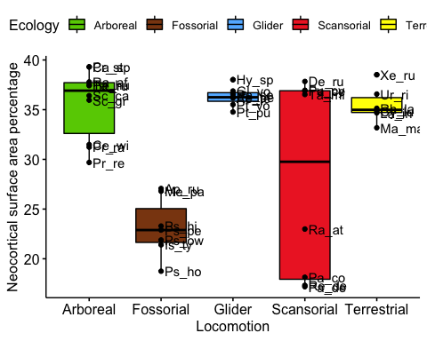

#Fisher-Pitman permutation test  
oneway_test(Neocortex_surface_percentage~Ecology,data=squirrel.data4)

##   
## Asymptotic K-Sample Fisher-Pitman Permutation Test  
##   
## data: Neocortex_surface_percentage by  
## Ecology (Arboreal, Fossorial, Glider, Scansorial, Terrestrial)  
## chi-squared = 19.879, df = 4, p-value = 0.0005277

#independence_test(Neocortex_surface_percentage~Ecology,data=squirrel.data)  
  
squirrel.data4$Ecology = factor(squirrel.data4$Ecology, levels = c("Arboreal","Fossorial","Glider",  
 "Scansorial","Terrestrial"))   
  
PT_Neo<-pairwisePermutationTest(Neocortex_surface_percentage~Ecology,data=squirrel.data4,method="fdr")  
PT_Neo

## Comparison Stat p.value p.adjust  
## 1 Arboreal - Fossorial = 0 3.569 0.0003586 0.002894  
## 2 Arboreal - Glider = 0 -0.5191 0.6037 0.670800  
## 3 Arboreal - Scansorial = 0 2.045 0.04088 0.101000  
## 4 Arboreal - Terrestrial = 0 0.08116 0.9353 0.935300  
## 5 Fossorial - Glider = 0 -3.441 0.0005787 0.002894  
## 6 Fossorial - Scansorial = 0 -1.217 0.2234 0.319100  
## 7 Fossorial - Terrestrial = 0 -3.242 0.001188 0.003960  
## 8 Glider - Scansorial = 0 1.956 0.05048 0.101000  
## 9 Glider - Terrestrial = 0 1.014 0.3108 0.388500  
## 10 Scansorial - Terrestrial = 0 -1.678 0.0934 0.155700

#Test if data normally distributed (Not normally distributed)  
shapiro.test(squirrel.data4$Neocortex_surface_percentage)

##   
## Shapiro-Wilk normality test  
##   
## data: squirrel.data4$Neocortex_surface_percentage  
## W = 0.81965, p-value = 2.696e-05

# Levene's test when data are not normally distrubuted (NO there is not homogeneity of variances)  
leveneTest(Neocortex_surface_percentage ~ Ecology, data = squirrel.data4)

## Levene's Test for Homogeneity of Variance (center = median)  
## Df F value Pr(>F)   
## group 4 20.898 1.158e-08 ***  
## 33   
## ---  
## Signif. codes: 0 '***' 0.001 '**' 0.01 '*' 0.05 '.' 0.1 ' ' 1

### END