Network Management System (NMS) Design Document

Overview
This document provides the design details for the Network Management System (NMS) application. The system is designed to manage network devices and connections, calculate optimal routes between devices, and log events for debugging and analytics.
The design adheres to object-oriented principles such as SOLID and GRASP and incorporates appropriate data structures and algorithms for extensibility and reliability.

UML Diagrams

1. Class Diagram
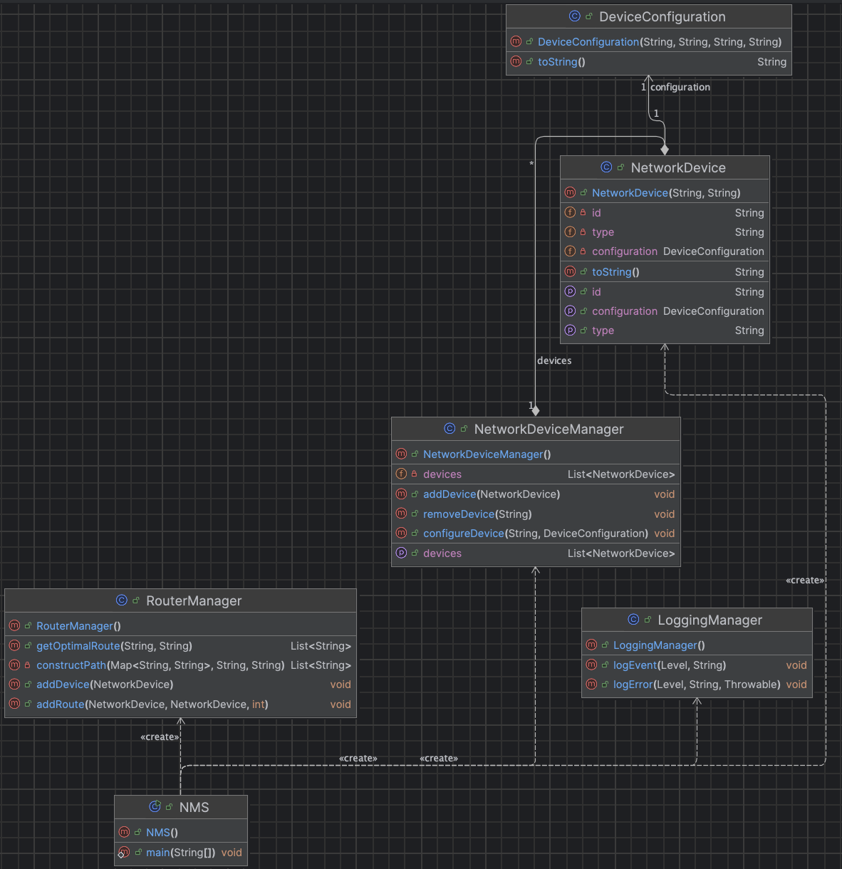
The class diagram below represents the structure of the system:
- LoggingManager: Handles logging of events and errors.
- NetworkDevice: Represents individual network devices.
- DeviceConfiguration: Stores configuration details for network devices.
- NetworkDeviceManager: Manages devices, including addition, removal, and configuration.
- RouterManager: Manages routes and calculates optimal paths between devices.
- NMS: Main entry point for the system.

2. Sequence Diagram
The sequence diagram illustrates the interactions between components when adding devices, configuring them, and calculating optimal routes.
- Actors: NMS, NetworkDeviceManager, RouterManager, LoggingManager.
- Interactions:
- NMS calls addDevice on NetworkDeviceManager.
- LoggingManager logs the event.
- NMS configures a device via NetworkDeviceManager.
- NMS calls addRoute on RouterManager.
- LoggingManager logs the route addition.
- NMS requests the optimal route from RouterManager.
- RouterManager calculates and returns the route.
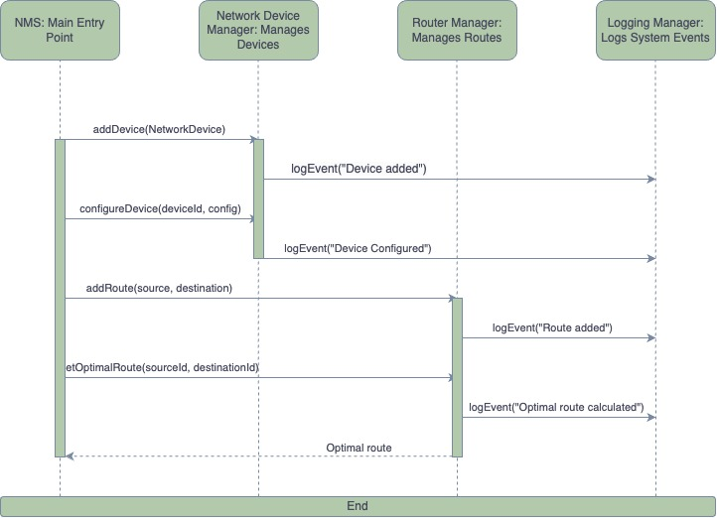

Object-Oriented Design Principles

SOLID Principles
- Single Responsibility Principle (SRP):
- Each class has a single, well-defined responsibility.
- Example: LoggingManager handles logging; NetworkDeviceManager manages devices.
- Open/Closed Principle (OCP):
- The design is open for extension but closed for modification.
- Example: Adding a new device type only requires extending the NetworkDevice class.
- Liskov Substitution Principle (LSP):
- Subtypes can replace their parent types without affecting the program.
- Example: Specialized device types can inherit from NetworkDevice.
- Interface Segregation Principle (ISP):
- Interfaces are designed for specific functionalities.
- Example: DeviceConfiguration encapsulates device-specific settings.
- Dependency Inversion Principle (DIP):
- High-level modules do not depend on low-level modules; both depend on abstractions.
- Example: RouterManager and NetworkDeviceManager interact through device IDs and configurations.

GRASP Patterns
- Controller: NMS class acts as the central controller.
- Information Expert: NetworkDeviceManager is responsible for managing the list of devices.

Design Patterns
- Factory Pattern:
  - Used for creating device configurations dynamically.
- Observer Pattern:
  - LoggingManager observes and logs events from NetworkDeviceManager and RouterManager.

Data Structures

Device Management
- Data Structure: List (ArrayList) in NetworkDeviceManager to store devices.
- Rationale: Allows efficient addition and removal of devices.

Route Management
- Data Structure: Map (HashMap) in RouterManager, mapping device IDs to their connections.
- Rationale: Enables quick lookups for connections.

Algorithm

Optimal Route Calculation
- Algorithm: Breadth-First Search (BFS)
- Rationale: Efficient for unweighted graphs to find the shortest path.
- Complexity: O(V + E), where V is the number of vertices (devices) and E is the number of edges (connections).

Extensibility

Adding New Features
- New Device Types:
  - Extend the NetworkDevice class.
  - Update NetworkDeviceManager to handle the new type.
- Weighted Routes:
  - Modify RouterManager to store and consider weights in route calculations.
- Multi-Device Routes:
  - Extend getOptimalRoute to calculate routes from one device to all others.

Conclusion
The design of the NMS is modular, extensible, and adheres to robust object-oriented principles. It can handle current requirements effectively while being adaptable for future enhancements.

