CM2108 – Computational Mathematics Coursework – Report
This project allows the user to visualise interactions between three circles determined by user inputs. The user data is processed as such:
- The first click from the user is assigned to (xCircle1, yCircle1) – the centre of the circle. The second click is a point on the circumference, such that dist(Point1 -> Point2) = radius1. [fig 1]
- The third click is the centre of the second circle (xCircle2, yCircle2), which has a tangential intersect with Circle1. [fig 2]
- The fourth and fifth clicks use an algorithm to snap an point to the closest point on either circle (They must be on different circles or program will prompt you to select another point) . [fig 3]
- The sixth click uses a similar algorithm to attach a point to the perpendicular bisector of the line between the centres of the two circles (green dashed line [fig 3]). The three snapped points are on the circumference of the third circle.
- With the three snapped points, the program calculates the final circle, plots it, and plots the perpendicular bisectors between the remaining two pairs of circles.
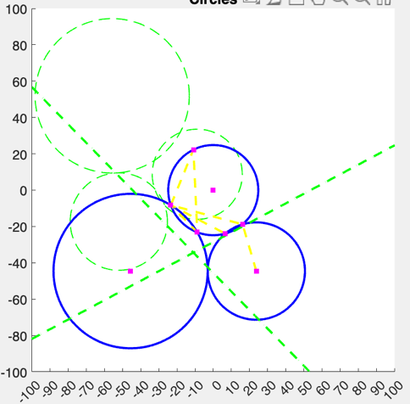
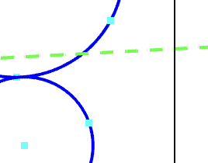
- All plotted points are then transformed using a matrix calculated to move circle3 to the origin and align the circle1&2 bisector with the y-axis. At this point, the program will also plot the original circles to show the before/after of the transformation. [fig 4]
Figure 4
Figure 3
The user also can save and reopen past plots, as well as hide parts of the constructions for a clearer view.

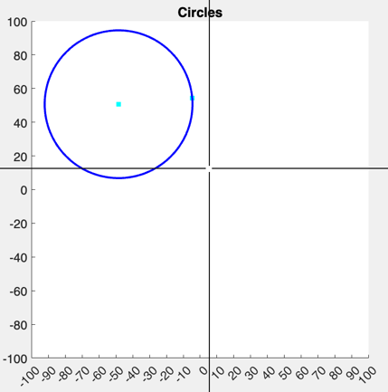
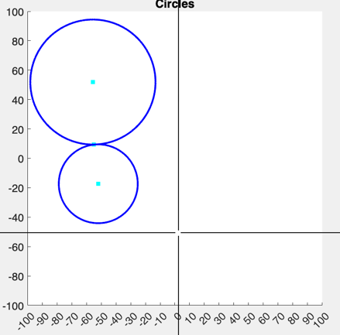
Figure 2
Figure 1

‘Novel Extensions’

Animated circles with intersections
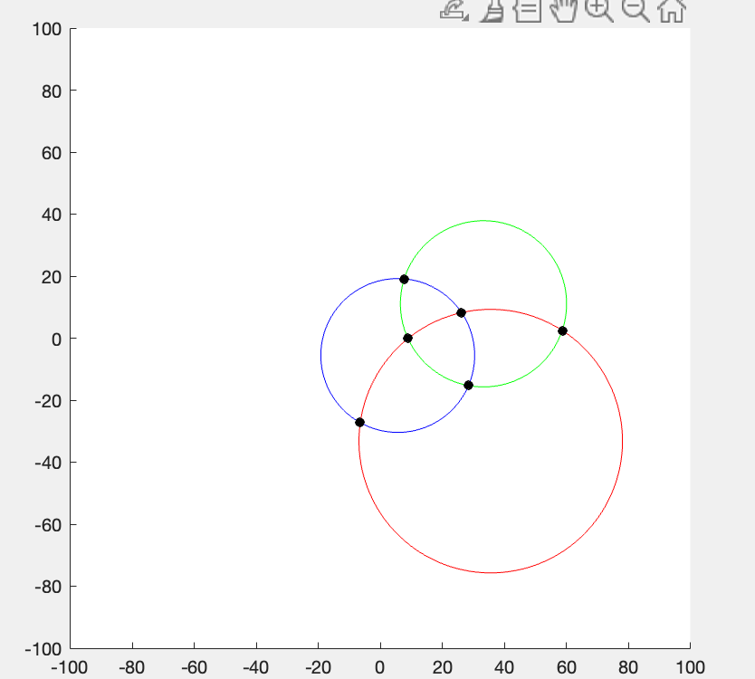
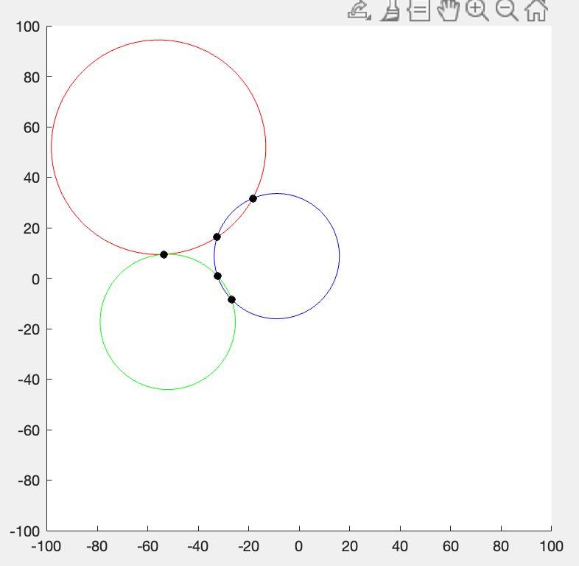
This function takes the given set of circles, moves each of them through the origin and back, showing the intersections.
Figure 6
Figure 5
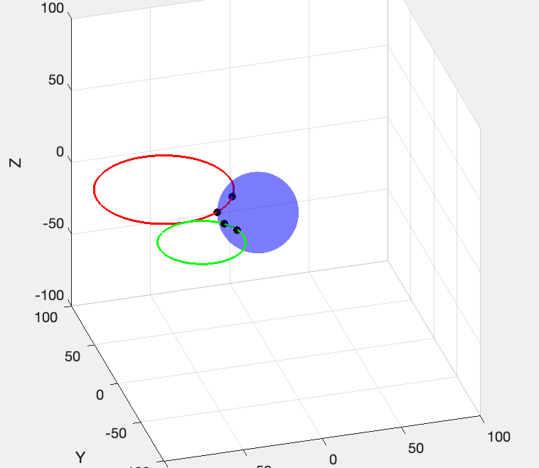
Figure 7

Sphere with intersections
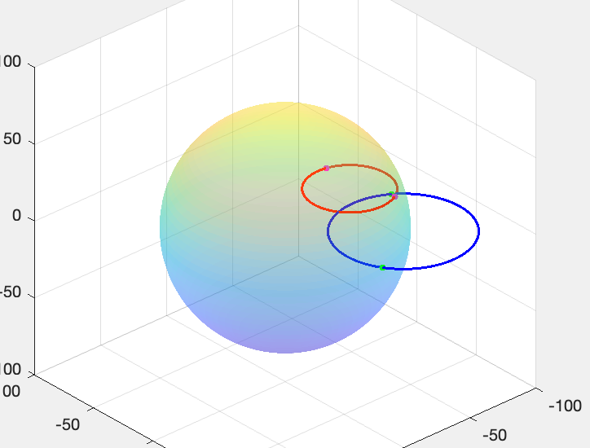
This can do two things, turn circle3 into a sphere and show the intersections in 3D as a static plot [fig 7] (if the checkbox is ticked), or the sphere will change in size and the other two circles move, showing the intersections and rotating the viewpoint to make it easier to see the changes. [fig 8, 9]
Figure 8
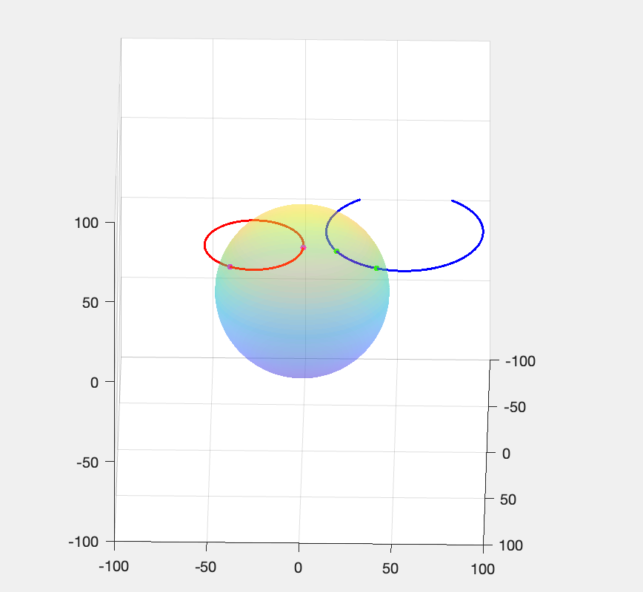
Figure 9

