OPENMOTIONGLOC
Version 55
Builder, Installation and Operating Manual
For Sega G-LOC motion cabinets and PC/MAME installations

FIRMWARE STATUS
v55 is proven on normal OpenMotionGLOC hardware using the native Sega 7-bit Parallel interface. The core calibration, encoder feedback, PID motion, limit handling, status return and Auto Tune functions have operated successfully on the target hardware. Serial mode remains available but has not been regression-tested to the same level in v55.

Author: Luke McMillan
Repository: github.com/BertyB3/OpenMotionGLOC
Manual edition: July 2026

Licence and attribution
This project is released for personal, educational and non-commercial use only. Modification and non-commercial sharing are permitted provided this notice is retained and Luke McMillan is credited. Commercial use, distribution or sale requires written permission.

Disclaimer
This software and manual are provided as-is and without warranty. High-current 48 V DC systems, moving structures and mains-powered equipment can cause serious injury, fire or death. The builder is responsible for design, wiring, protection, testing, compliance and safe use.

Competence
This manual assumes competent low-voltage electrical construction and access to a licensed electrician for mains wiring. It does not replace the manuals for the power supply, motor controllers, converters or cabinet hardware.
CRITICAL SAFETY ARCHITECTURE
The Arduino is not a safety-rated controller. Provide a hard-wired emergency stop that removes motor power or disables both motor drives independently of software. Do not rely on an Arduino input, USB connection or software command as the sole emergency stop.

Safety rules
- Disconnect and lock out mains and 48 V motor power before changing wiring.
- Keep people, tools and loose clothing clear of the platform whenever motor power is available.
- Commission with the cabin unloaded and use the lowest practical motor-current and speed settings.
- Fuse the 48 V supply and each controller branch. Fuse the separate 12 V control supply.
- Use suitable wire gauge, terminals, insulation, strain relief, enclosure and ventilation.
- Bond protective earth to exposed metalwork as required by local electrical rules.
- Do not route encoder, logic or parallel-bus wires alongside motor leads where avoidable.
- Confirm polarity and continuity with a meter. Never trust colour alone on a repaired cabinet.

Contents and build sequence
Part | Purpose
1. Understand the system | What OpenMotion replaces, what it retains, and the two operating modes.
2. Gather and inspect hardware | Bill of materials, original components, power, controllers and protection.
3. Build the control assembly | Arduino, TFT, controls, relays, converters and enclosure.
4. Wire the cabinet | Motors, encoders, limit switches, safety inputs and Sega-colour loom references.
5. Configure firmware | Libraries, source selection, upload and first checks.
6. Commission motion | Test Mode, limit validation, calibration and Auto Tune.
7. Run native Sega Parallel | Main PCB bus, status back-feed and operational checks.
8. Run MAMEHooker Serial | Windows 10, MAME, COM port, INI structure and troubleshooting.
9. Operate and maintain | Normal startup, shutdown, fault recovery and periodic inspection.
Appendices | Complete pin maps, serial protocol, screen guide and checklists.

RECOMMENDED APPROACH
Build and validate one layer at a time: control electronics, inputs, one motor drive, second motor drive, calibration, and only then the game interface. Do not connect every subsystem and attempt a first power-up as a single step.

1. System overview
OpenMotionGLOC replaces the original Sega motion-control electronics with an Arduino Mega 2560 and two modern four-quadrant DC motor controllers. It preserves the original motion mechanism and, where serviceable, the original motors, motor-mounted encoders, limit switches, cabinet sensors and wiring loom.

1.1 What is retained
- Original Sega main game PCB for native Parallel operation.
- Original left and right DC motion motors.
- Original incremental encoders mounted on the motors. Replacement is only required when an original encoder has failed or is physically damaged.
- Original four travel limit switches and cabinet safety sensors where serviceable.
- Original cabinet loom where its condition and pinout have been verified.

1.2 What is not required
- Original Sega motion-control PCB.
- Original analogue motion-control electronics.
- Analogue position potentiometers. v55 uses motor encoders for position feedback. A0 and A1 remain displayed in Test Mode in the supplied code but are not used for motion control.
- Replacement encoders as routine build items.

1.3 Operating modes
Mode | Signal source | Use case | v55 status
Native Sega Parallel | Original Sega main PCB 7-bit active-LOW bus | Restoration of an original G-LOC cabinet | Primary tested mode
Serial | Windows PC running standard MAME and MAMEHooker over USB | PC conversion or emulated cabinet | Implemented; validate carefully because v55 testing has focused on Parallel

1.4 Axis names
The firmware calls the left axis Q and the right axis R. Position is mapped from 1 to 32, with centre at 16. The firmware learns encoder direction and travel endpoints during every startup calibration.

2. Hardware and materials

2.1 Required new hardware
Qty | Item | Specification / note
1 | Arduino Mega 2560 | Genuine board or reliable compatible with stable USB serial.
1 | ST7735 TFT display | 160 x 128 SPI module; confirm its logic and supply voltage.
2 | MMT4Q or suitable four-quadrant brushed-DC motor controllers | One controller for each motion axis. Confirm voltage, current, enable, direction and analogue-reference requirements for the exact units.
2 | PWM-to-0-10 V analogue converter modules | Normally required because Mega D8/D9 provide 0-5 V PWM while many industrial drives expect a 0-10 V speed reference.
1 | 48 V DC power supply | At least 1200 W recommended. A 1200 W, 48 V supply provides approximately 25 A total nominal output.
1 | Dedicated regulated 12 V DC power supply | Use for control-side equipment and auxiliaries rather than relying on the cabinet amplifier-derived Sega 12 V rail.
1 | 5 V regulation / USB supply arrangement | Power the Mega and appropriate logic safely. Do not feed unverified cabinet rails into the Mega.
2 | Relay or interface channels | For start and danger lamps if retained.
1 set | Hard-wired emergency-stop components | Safety-rated contactor, drive-disable chain or equivalent suitable for the installation.
As required | Fuses, holders, breakers, disconnects and terminals | Main 48 V protection, one branch fuse per motor controller, 12 V control fuse and appropriately rated wiring.
As required | Enclosure, DIN rail, glands, ferrules and strain relief | Keep power and low-level signal wiring organised and protected.

48 V SUPPLY SIZING
1200 W is a practical minimum recommendation, not a substitute for measuring actual motor current. Size the supply, branch wiring and protection for the motors, controllers, duty cycle and expected regenerative conditions. Follow the controller and PSU manufacturers’ requirements.

2.2 Original parts to inspect
Component | Inspection
Motors | Check brushes, bearings, gearbox play, wiring insulation, mounting and free movement.
Motor encoders | Check connector condition, 5 V supply wiring and clean A/B transitions. Replace only if defective.
Limit switches | Confirm four NC switches operate mechanically and electrically. Replace damaged or intermittent switches.
Motion frame | Inspect pivots, bearings, stops, welds, fasteners and interference through full travel.
Main PCB | Required only for native Sega Parallel operation. Confirm the 25-pin motion interface and grounds.
Cabinet loom | Inspect for modifications, heat damage, brittle insulation and mismatched colours.

2.3 About the MMT4Q motor controllers
The OpenMotion design uses one four-quadrant brushed-DC motor controller per axis. A four-quadrant drive can command both motor directions and actively control braking, which is appropriate for a reversible motion platform. MMT4Q units exist in different versions and installations, so terminal names and adjustment ranges must be confirmed on the controller label or manufacturer documentation before wiring.
OpenMotion signal | Left/Q | Right/R | Controller-side function
Direction | Mega D10 | Mega D11 | Direction / polarity input
Speed command | Mega D8 through PWM-to-0-10 V converter | Mega D9 through PWM-to-0-10 V converter | Analogue speed reference, commonly 0-10 V
Enable | Mega D12 | Mega D13 | Enable input; supplied firmware drives LOW to enable
Logic common | Mega GND | Mega GND | Signal common only; follow controller isolation requirements
Motor power | 48 V branch | 48 V branch | Controller DC supply and motor output, fused independently

DO NOT GUESS MMT4Q TERMINALS
The terms DIR, EN and speed reference describe functions, not universal terminal numbers. Verify every terminal on the exact MMT4Q. Incorrect connection can destroy the controller, converter or Mega.

2.4 Motor-controller setup principles
1. Set current limits conservatively before initial motion. Increase only after safe commissioning and measurement.
2. Configure acceleration, deceleration and braking gently for the unloaded platform.
3. Confirm the speed-reference input accepts the converter output and that 0 V represents stop.
4. Confirm the direction input voltage and polarity are compatible with the Mega or use an interface/isolator.
5. Confirm the enable input is compatible with the firmware’s active-LOW output. Use a safe default-disabled hardware arrangement where possible.
6. Provide ventilation and mount each controller in accordance with its thermal requirements.

2.5 Power architecture and fusing
MAINS -> isolator / breaker -> 48 V DC PSU -> main DC protection
|
+-> Q branch fuse -> MMT4Q Q -> Q motor
|
+-> R branch fuse -> MMT4Q R -> R motor
MAINS -> separate 12 V PSU -> control fuse -> relays / converters / auxiliaries
USB or regulated 5 V -> Arduino Mega and appropriate logic

The 48 V motor system and low-voltage control system must share only the references required by the controller interfaces. Use a deliberate grounding scheme and avoid returning motor current through Arduino or encoder grounds.
FUSE SELECTION
This manual intentionally does not prescribe a universal fuse current. Select DC-rated protection using the controller rating, measured motor current, conductor ampacity, PSU capability and inrush. A fuse protects wiring and equipment; it is not selected only from the PSU wattage.

2.6 Dedicated 12 V supply
A separate regulated 12 V DC supply is recommended. In the original cabinet, the Sega 12 V source is associated with the amplifier assembly and may be noisy, unstable or unreliable after decades of service. A dedicated supply makes the control system easier to isolate and diagnose. Do not parallel independent 12 V supplies unless they are specifically designed for it.

3. Build the control assembly

3.1 Plan the enclosure
- Keep mains and 48 V terminals physically separated from Arduino and encoder wiring.
- Mount the Mega so USB remains accessible after installation.
- Mount the TFT where it can be read during calibration and fault diagnosis.
- Provide labelled terminal blocks for every cabinet connection.
- Provide test points for 5 V, 12 V, logic ground, PWM-converter outputs and controller enables.
- Use removable connectors so the controller assembly can be serviced outside the cabinet.

3.2 Arduino Mega core pin map
Function | Mega pin | Notes
Q direction | D10 | Left motor-controller direction
Q speed PWM | D8 | Through PWM-to-0-10 V converter
Q enable | D12 | Active LOW
R direction | D11 | Right motor-controller direction
R speed PWM | D9 | Through PWM-to-0-10 V converter
R enable | D13 | Active LOW
Q encoder A/B | D18 / D19 | A uses interrupt
R encoder A/B | D20 / D21 | A uses interrupt
Q upper / lower limits | D32 / D37 | NC to ground; LOW clear, HIGH triggered
R upper / lower limits | D4 / D5 | NC to ground; LOW clear, HIGH triggered
Cabin stop / boundary | D25 / D27 | Current v55 code treats LOW as active
Source select | D23 | Only used when compile-time mode is AUTO
Start / danger lamps | D40 / D41 | Relay/interface outputs
TFT CS / RST / DC | D22 / D24 / D26 | ST7735 control
TFT MOSI / SCK | D51 / D52 | Mega hardware SPI
Test / Settings | D14 / D6 | Active LOW at boot
Q jog fwd/rev | D15 / D31 | Active LOW
R jog fwd/rev | D17 / D34 | Active LOW
Speed/confirm | D33 | Active LOW

3.3 Wire the TFT display
Display signal | Mega connection | Notes
VDD | 3.3 V or module-rated supply | Confirm the exact module
GND | GND | Common logic ground
SCK / SCL | D52 | Hardware SPI clock
MOSI / SDA | D51 | Hardware SPI data
CS | D22 | Chip select
RST | D24 | Reset
DC | D26 | Data/command
LED / BLK | Module-rated supply | Confirm onboard resistor

3.4 Wire mode and test controls
Control | Pin | Operation
Test Mode switch | D14 to GND | Hold LOW during power-up to remain in Test Mode
Settings Mode switch | D6 to GND | Hold D6 and D14 LOW during power-up
Q forward | D15 to GND | Manual Q jog in Test Mode
Q reverse | D31 to GND | Manual Q jog in Test Mode
R forward | D17 to GND | Manual R jog in Test Mode
R reverse | D34 to GND | Manual R jog in Test Mode
Speed / confirm | D33 to GND | Cycles speed, requests Auto Tune and confirms save/resume

3.5 Build the speed-command interfaces
1. Connect Mega D8 to the input of the Q PWM-to-0-10 V converter and D9 to the R converter.
2. Power each converter from the voltage specified by its manufacturer, commonly from the dedicated 12 V supply.
3. Connect converter signal ground according to the MMT4Q input requirements. Use isolation if required.
4. With motor power disconnected, command several PWM values and verify the analogue output changes smoothly from near 0 V toward the configured maximum.
5. Do not connect the converter output to the MMT4Q until its polarity, maximum voltage and zero-speed behaviour are confirmed.

4. Wire the cabinet
USE SEGA COLOURS AS A TRACING AID
The original loom colours are the most practical way to follow the cabinet, but pin number and continuity are authoritative. Colours may be faded, repaired or substituted. Label both ends after verification.

4.1 Original motor encoders
Encoder lead | Motor-side colour | Sega loom note | Q connection | R connection
5 V | Red | Yellow/Black, Sega code 38 recorded in earlier wiring notes | 5 V | 5 V
0 V | Black | Verify continuity to logic ground | GND | GND
Channel A | White | Verify at motor connector | D18 | D20
Channel B | Green | Verify at motor connector | D19 | D21

The encoders are already fitted to the original motors. Do not add external position potentiometers. During calibration, the firmware records the encoder count at each physical endpoint and calculates centre.

4.2 Travel limit switches
Physical switch | Recorded Sega colour | Mega pin | Required electrical state
Upper Left / rear | Brown | D32 | NC to GND: LOW clear, HIGH triggered/open
Lower Left / front | Green | D37 | NC to GND: LOW clear, HIGH triggered/open
Upper Right / rear | Verify in cabinet | D4 | NC to GND: LOW clear, HIGH triggered/open
Lower Right / front | Verify in cabinet | D5 | NC to GND: LOW clear, HIGH triggered/open

BOOT INTERLOCK
If any travel limit reads HIGH at boot, v55 stops on LIMIT SWITCH ERROR. The platform must be off all four switches and all NC loops must be intact before normal calibration can start.

4.3 Cabin stop and boundary inputs
Function | Recorded cabinet colour | Mega pin | Current v55 interpretation
Safety common | White/Red | GND | Common reference
Cabin stop | Grey/Blue | D25 | LOW is active in the supplied code
Boundary detection | Grey/Yellow | D27 | LOW is active in the supplied code

POLARITY INCONSISTENCY
The travel limits are NC loops that read HIGH when opened, but the supplied v55 code treats D25 and D27 as active LOW. Test these inputs in Test Mode before relying on them. The hard-wired emergency stop must remain independent of this software behaviour.

4.4 Connect the motor controllers
1. Leave 48 V motor power isolated.
2. Connect Q direction D10, Q speed-converter output and Q enable D12 to the confirmed Q-controller inputs.
3. Connect R direction D11, R speed-converter output and R enable D13 to the confirmed R-controller inputs.
4. Connect signal commons using the controller manufacturer’s required grounding or isolation method.
5. Connect each controller to its corresponding motor with suitably rated cable and strain relief.
6. Connect the fused 48 V branch to each controller, but do not energise it yet.
7. Confirm the hard-wired emergency stop disables both drives or removes motor power regardless of Arduino state.

4.5 Native Sega Parallel interface colours and pinout
For native operation, connect the original main game PCB 25-pin motion interface directly to the Mega. The original Sega motion-control PCB is not required.
PCB pin | Recorded loom colour | Signal | Mega
1 | Blue / ground - verify | Ground | GND
2 | Red | Bit 0 + STROBE | D2 / INT0
3 | Ground | Ground | GND
4 | Orange | Bit 1 | D47
5 | Ground | Ground | GND
6 | Violet | Bit 2 | D48
7 | Ground | Ground | GND
8 | Purple | Bit 3 | D50
9 | Ground | Ground | GND
10 | Blue | Bit 4 | D30
11 | Ground | Ground | GND
12 | Green | Bit 5 | D29
13 | Ground | Ground | GND
14 | Orange | Bit 6 / MSB | D28
15 | Ground | Ground | GND

V55 BREAKING WIRING CHANGE
PCB pin 2, bit 0 and STROBE, connects to D2. Do not use the older D46 connection. D2 is the hardware interrupt input used for immediate bus capture.

4.6 Status return to the Sega main PCB
PCB pin | Function | Mega | Clear state | Triggered state
16 | Fixed logical HIGH | A2 | High impedance | Not asserted
17 | Ground | GND | Common | Common
18 | Upper Right | A3 | Float / PCB pulls HIGH | Sink LOW
19 | Lower Right | A4 | Float / HIGH | Sink LOW
20 | Upper Left | A5 | Float / HIGH | Sink LOW
21 | Lower Left | A6 | Float / HIGH | Sink LOW
22 | Reserved | A7 | Float | Reserved
23 | Reserved | A8 | Float | Reserved
24 | Reserved | A9 | Float | Reserved
25 | Reserved | A10 | Float | Reserved

OPEN-DRAIN ONLY
A2-A10 must never be actively driven HIGH. v55 reports HIGH by setting the pin to INPUT/high impedance and reports an asserted limit by sinking LOW. The Sega PCB provides the pull-up.

4.7 Recorded status-harness colours
Mega | Recorded colour
A2 | Black
A3 | Brown
A4 | Blue
A5 | Red
A6 | Green
A7 | White
A8 | Black
A9 | Green
A10 | Blue

5. Install and configure firmware

5.1 Software required
- Arduino IDE compatible with the Mega 2560.
- Adafruit GFX library.
- Adafruit ST7735 library.
- PID_v1 library.
- SPI and EEPROM libraries supplied with the Arduino environment.

5.2 Select the input mode
// 0 = AUTO using D23
// 1 = SERIAL only
// 2 = PARALLEL only
#define FORCE_INPUT_SOURCE 2

Installation | Recommended setting
Original cabinet using Sega main PCB | 2 - force Parallel
Dedicated Windows/MAME cabinet | 1 - force Serial
Changeable development system | 0 - Auto; D23 LOW Parallel, HIGH Serial

SERIAL USERS
The supplied v55 listing is compiled with FORCE_INPUT_SOURCE 2. A MAMEHooker installation must change this to 1 before upload, or send MODESx after the COM port opens. Compiling as Serial is simpler and more reliable for a dedicated PC system.

5.3 Upload
1. Disconnect or disable 48 V motor power.
2. Connect the Mega by USB.
3. Select Arduino Mega or Mega 2560 and the correct processor/port.
4. Compile the sketch and resolve all missing-library errors.
5. Upload the firmware.
6. Open Serial Monitor at 115200 only for initial diagnostics.
7. Close Serial Monitor and the Arduino IDE before MAMEHooker later attempts to use the port.

6. Pre-power inspection
Check | Pass criterion
Mechanical frame | Moves freely through expected range; no interference or loose fasteners.
Hard E-stop | Physically removes/blocks drive power without software.
48 V polarity | Correct at PSU and both controller branches.
Fuses | DC rated, correctly installed and appropriate to wiring/equipment.
Control supplies | 12 V and 5 V correct before connection to modules.
Grounding | No motor-current path through Arduino/encoder wiring.
Limits | All four NC loops show continuity when clear and open when actuated.
Encoders | 5 V polarity correct; A/B signals connected to correct pins.
Converters | 0-10 V output verified with motor power disabled.
Parallel/status harness | No short between PCB outputs and Mega outputs; open-drain lines verified.
USB | Cable restrained and clear of moving parts.

7. Commission in Test Mode
UNLOADED FIRST
Commission with no occupant in the cabin and with a second person at the hard-wired emergency stop. Start with conservative drive current and speed.

7.1 Enter Test Mode
1. Isolate 48 V motor power.
2. Hold the Test Mode input D14 LOW.
3. Power or reset the Mega.
4. Confirm the display shows TEST MODE.
5. Release the Test Mode switch after startup. The firmware remains in Test Mode until reset.
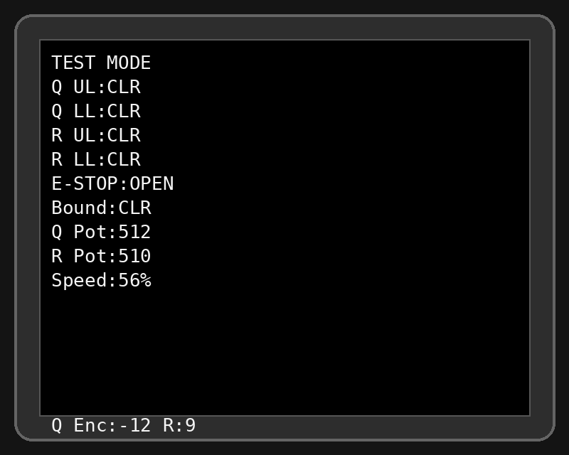
Simulated v55 Test Mode screen. Q Pot and R Pot remain in the code but are diagnostic-only and may show arbitrary values when A0/A1 are unconnected.

7.2 Validate inputs before motor power
1. Confirm Q UL, Q LL, R UL and R LL all show CLR while the platform is off the switches.
2. Operate each limit manually and confirm only the matching line changes to TRIG.
3. Check the displayed encoder counts while turning or moving each mechanism manually. Q Enc and R Enc should change without erratic jumps.
4. Test the cabin stop and boundary inputs and record the actual display state. Resolve the active-LOW polarity issue before normal operation.
5. Confirm the start and danger lamp relays blink once per second in Test Mode.

7.3 First powered jog
1. Set the MMT4Q current limits and converter maximums conservatively.
2. Clear the platform area and release the hard-wired E-stop.
3. Energise 48 V motor power.
4. Use the Speed button to select the lowest practical Test Mode speed.
5. Briefly press Q forward, then Q reverse. Verify controlled movement and encoder response.
6. Briefly press R forward, then R reverse.
7. If any command drives into a physical stop, immediately use the hard E-stop and correct motor direction/control wiring.
8. Increase speed only after direction, encoder counting and limit operation are proven.
TEST MODE LIMITATION
The supplied Test Mode code directly jogs the motors and does not apply the same direction-aware limit gating as normal PID operation. Use brief inputs and keep the hard-wired emergency stop ready.

8. Startup calibration
Normal startup automatically calibrates Q and then R. Each axis moves to the lower limit, records the encoder endpoint, moves to the upper limit, records the other endpoint, backs off and moves to calculated centre.

8.1 Start calibration
1. Reset with Test and Settings switches inactive.
2. Confirm no limit is already triggered.
3. Keep the platform clear.
4. Observe the TFT and movement of each axis.
5. Be ready to use the hard-wired emergency stop if travel direction or limit response is wrong.
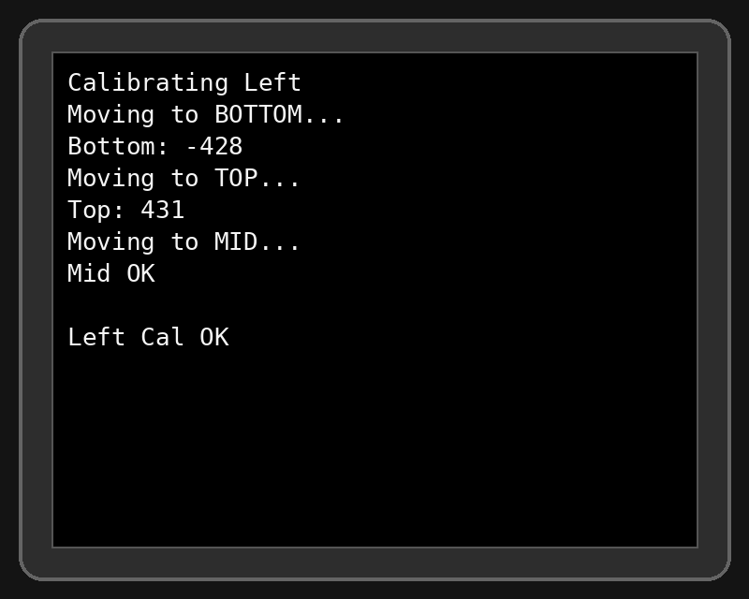
Simulated left-axis calibration. Encoder numbers are examples only.

8.2 Expected sequence
Screen | Expected action
Settings loaded | EEPROM settings loaded.
Running calibration / Starting Calibration | Calibration begins.
Calibrating Left - Moving to BOTTOM | Q axis drives to lower limit.
Bottom: [count] | Q lower encoder endpoint stored.
Moving to TOP | Q drives to upper limit.
Top: [count] | Q upper endpoint stored.
Moving to MID / Mid OK | Q centres.
Calibrating Right | Same process for R.
Calibration OK | Both axes calibrated.

8.3 Limit-switch error
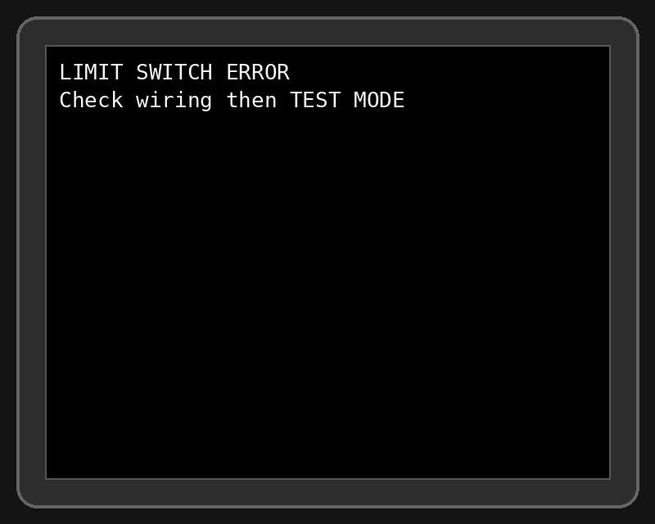
- Platform is resting on a limit switch.
- An NC switch or wire is open.
- A limit is connected to the wrong pin.
- The switch common is not connected to Mega ground.

9. Auto Tune
After successful calibration, v55 provides a three-second opportunity to request Auto Tune by holding the Speed button for approximately 0.9 seconds. Auto Tune moves each axis around positions 12, 16 and 20, evaluates response and proposes PID and PWM settings.
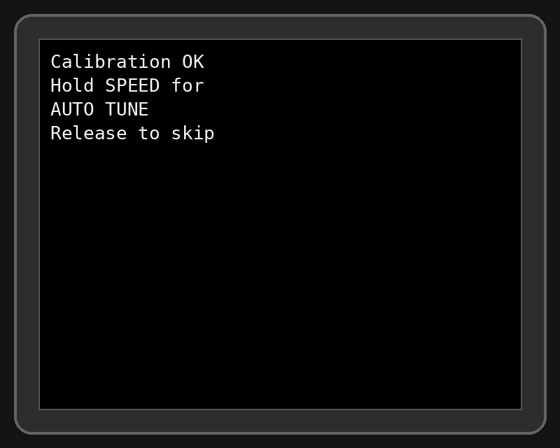
1. Keep the platform clear.
2. Hold Speed during the prompt to begin, or release/ignore to skip.
3. Allow up to five tuning passes.
4. Review the proposed settings.
5. Hold Speed for approximately 1.2 seconds within the save window to write them to EEPROM.
6. Do nothing for eight seconds to cancel and restore the original settings.
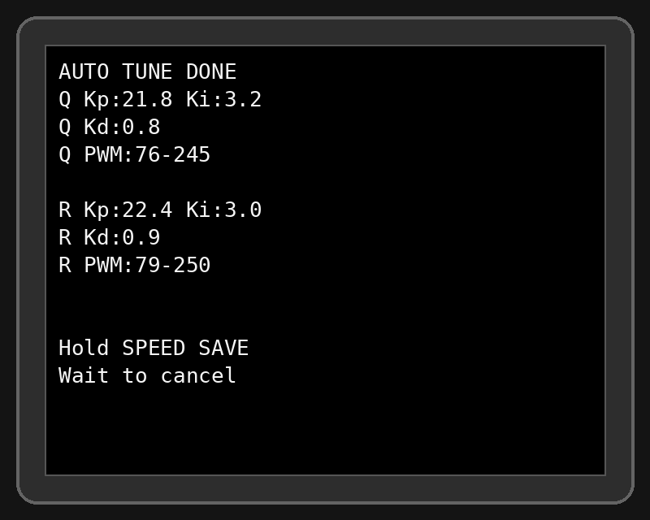
AUTO TUNE IS OPTIONAL
The system can run with valid existing settings. Auto Tune should be performed only after basic motion, limits and hard E-stop have been proven.

10. Native Sega Parallel operation

10.1 Firmware and wiring prerequisites
- FORCE_INPUT_SOURCE set to 2, or Auto mode with D23 LOW.
- Main PCB pins 2, 4, 6, 8, 10, 12 and 14 wired to D2, D47, D48, D50, D30, D29 and D28.
- Common grounds from the main PCB to Mega ground.
- Status returns A2-A10 wired as open-drain/high-impedance connections.
- Original Sega motion-control PCB removed or bypassed; original main game PCB retained.

10.2 Normal display
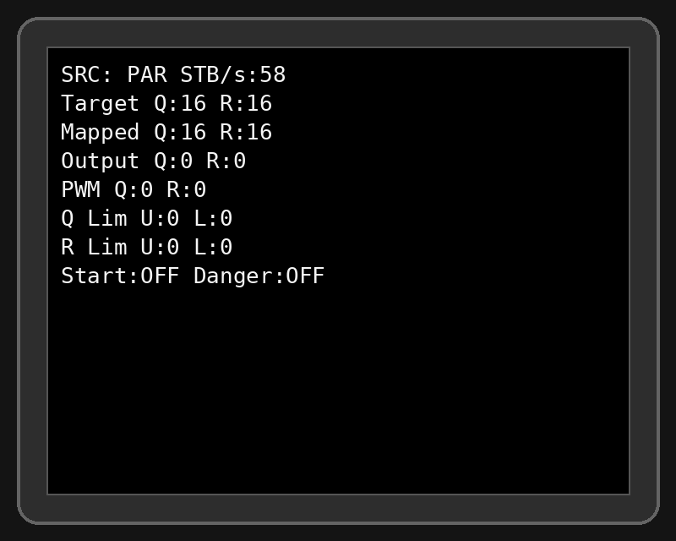
Field | Meaning
SRC: PAR | Parallel source selected.
STB/s | Number of captured strobe edges per second.
Target Q/R | Positions requested by the game.
Mapped Q/R | Current encoder positions mapped to 1-32.
Output Q/R | PID output values.
PWM Q/R | Command sent to the motor speed interface.
Q/R Lim U/L | 0 clear, 1 triggered/open for travel limits.
Start / Danger | Firmware relay state.

10.3 Parallel troubleshooting commands
Command (end with x) | Action
BUSONx | Enable periodic bus monitor output.
BUSOFFx | Disable monitor output.
BUSREADx | One-shot bus snapshot.
BUSPINx | Print bus pin map and active-LOW setting.
BUSMS50x | Set monitor interval to 50 ms.
BUSFALLx / BUSRISEx | v55 reports that edge selection is compile-time; change PAR_STROBE_EDGE_FALLING and recompile.

KEEP DEBUG SPARSE
Bus monitor output is useful during diagnosis but should be disabled during normal operation. It can add serial traffic and complicate PC serial testing.

11. Windows 10 MAME and MAMEHooker Serial mode
VALIDATION STATUS
The serial protocol is implemented and follows earlier OpenMotion behaviour, but Luke’s v55 hardware testing has focused on native Parallel mode. Treat Serial commissioning as a controlled validation process.

11.1 Required software and configuration
- Windows 10 PC.
- Standard Windows build of MAME.
- MAMEHooker.
- Arduino Mega connected by USB.
- v55 compiled with FORCE_INPUT_SOURCE 1, recommended for a dedicated serial installation.

11.2 MAME output configuration
Create or save mame.ini, then configure the OSD output provider required by the MAMEHooker version you are using. Older MAMEHooker setups commonly use the Windows output provider. Current MAME versions expose output-provider choices through the output option, so verify compatibility with your installed MAME/MAMEHooker combination.
mame -createconfig
# In mame.ini, use the output provider required by your MAMEHooker build.
# Older established setups commonly use:
output windows

VERSION COMPATIBILITY
Current official MAME documentation lists auto, none, console and network output options, while traditional MAMEHooker instructions use the older Windows output provider. If a current MAME release does not expose outputs to MAMEHooker, use a known-compatible MAME build or an output bridge supported by your MAMEHooker installation.

11.3 Prepare the Arduino
#define FORCE_INPUT_SOURCE 1
Serial.begin(115200);

Setting | Value
Baud | 115200
Data bits | 8
Parity | None / N
Stop bits | 1
Command terminator | x

11.4 Identify and reserve the COM port
1. Connect the Mega.
2. Open Windows Device Manager.
3. Expand Ports (COM & LPT).
4. Record the Arduino COM number.
5. If an older MAMEHooker build struggles with a high COM number, assign an unused lower number in Port Settings > Advanced.
6. Close Device Manager after confirming the port.
ONE PROGRAM OWNS THE PORT
Close Arduino Serial Monitor, Serial Plotter and the Arduino IDE before starting MAMEHooker. In Luke’s Windows 10 setup, leaving the Arduino software open prevents MAMEHooker from accessing the Mega reliably.

11.5 Administrator mode
1. Right-click MAMEHooker and choose Properties.
2. On Compatibility, enable Run this program as an administrator.
3. Apply the setting.
4. Run MAME at the same privilege level to avoid Windows integrity-level restrictions between the programs.

11.6 MAMEHooker serial structure
MAMEHooker uses cmo to open a COM port, cmw to write a message and cmc to close it. Replace 7 below with the actual COM number.
[General]
MameStart=cmo 7 baud=115200_parity=N_data=8_stop=1,cmw 7 MODESx
MameStop=cmw 7 Q16x,cmw 7 R16x,cmc 7
StateChange=
OnRotate=
OnPause=
[Output]
# Game-specific output mappings go here.

GAME-SPECIFIC INI FILES
The exact [Output] names and transformations depend on the MAME driver and working game configuration. Use the MAMEHooker debug window to identify the outputs exposed by G-LOC or Strike Fighter, then map them to Q, R, S, T, A and B commands. Do not copy an INI for a different ROM name without checking its outputs.

11.7 Test serial commands before MAME
1. Complete normal calibration first.
2. With the platform clear, open Serial Monitor at 115200.
3. Send MODESx if the sketch was not compiled as Serial.
4. Send Q16x and R16x to centre.
5. Test small movements with Q14x, Q18x, R14x and R18x.
6. Return to Q16x and R16x.
7. Test A1x/A0x and B1x/B0x if lamp relays are fitted.
8. Close Serial Monitor and completely close the Arduino IDE.
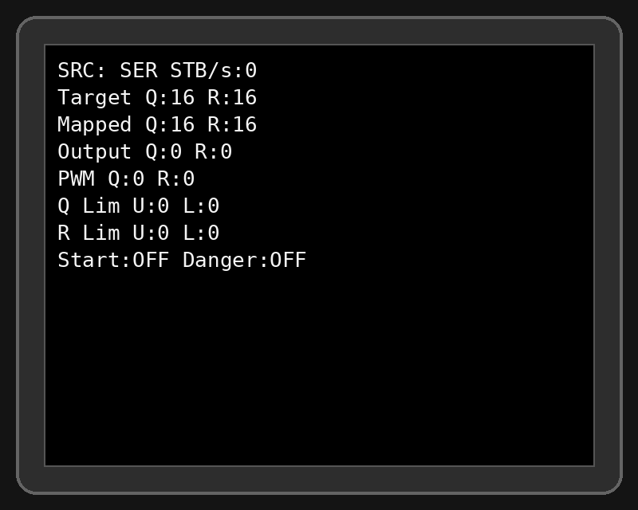

11.8 Serial command protocol
Command | Meaning | Range / example
Q##x | Set left/Q target position | 1-32; Q16x centre
R##x | Set right/R target position | 1-32; R16x centre
S##x | Set left speed scalar | 1-7
T##x | Set right speed scalar | 1-7
A0x / A1x | Start lamp off/on | Relay D40
B0x / B1x | Danger lamp off/on | Relay D41
MODEAx | Auto source selection | Uses D23
MODESx | Force Serial at runtime | Overrides source
MODEPx | Force Parallel at runtime | Overrides source

SPEED SCALAR CAVEAT
The supplied v55 normal PID loop calculates PWM from the PID output and stored min/max PWM values. motorSpeedQ and motorSpeedR are parsed from S/T commands but are not applied in the normal loop shown. Position commands and lamps are the critical serial functions in this build.

11.9 Start order
1. Power the OpenMotion control system.
2. Allow calibration to complete and centre the platform.
3. Close Arduino software.
4. Start MAMEHooker as Administrator.
5. Confirm its tray icon/debug window is active.
6. Start MAME as Administrator.
7. Launch the ROM whose INI filename matches the MAME short name.
8. Verify output changes in MAMEHooker before enabling full-speed occupied operation.

11.10 Five-second timeout
If the selected source receives no recognised command for five seconds, v55 commands both axes to position 16 and speed scalar 5. A MAMEHooker configuration that only transmits when outputs change may therefore allow the platform to centre during long steady states. The game INI may require recurring or state-change writes to keep serial data fresh.

12. Normal operation

12.1 Startup
1. Inspect the platform and clear the motion envelope.
2. Release the hard-wired E-stop only when safe.
3. Power the control electronics.
4. Power the motor system in the designed sequence.
5. Allow full Q and R calibration.
6. Run or skip Auto Tune at the prompt.
7. Confirm the correct source on the TFT: PAR or SER.
8. Start the game system and observe targets and mapped positions before allowing an occupant.

12.2 Shutdown
1. End gameplay and allow the platform to return near centre.
2. Disable or isolate motor power.
3. Close MAME/MAMEHooker if used.
4. Shut down the Sega PCB or PC and control supplies.
5. Use the main isolator where fitted.

12.3 E-stop and boundary behaviour
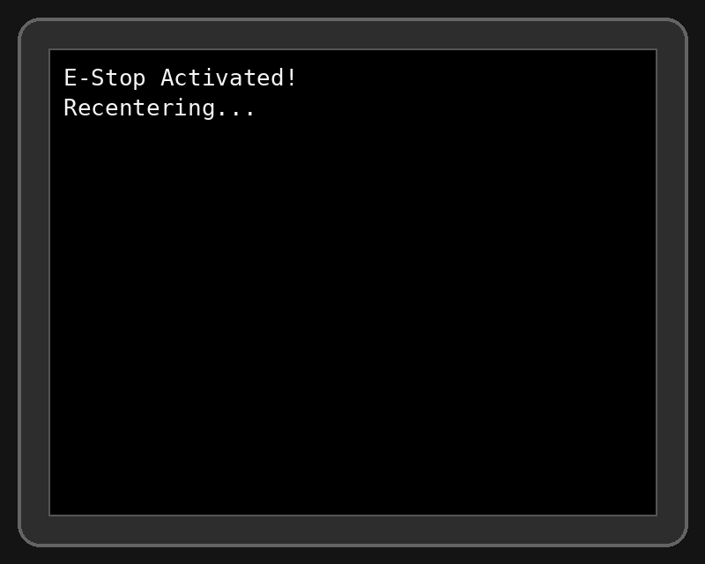
The software stops PWM immediately when the cabin E-stop input is detected. The hard-wired E-stop must independently disable the drives. The supplied runtime latch logic is incomplete: eStopLatched is set but not clearly reset in the normal loop shown. Test recovery behaviour before occupied operation.
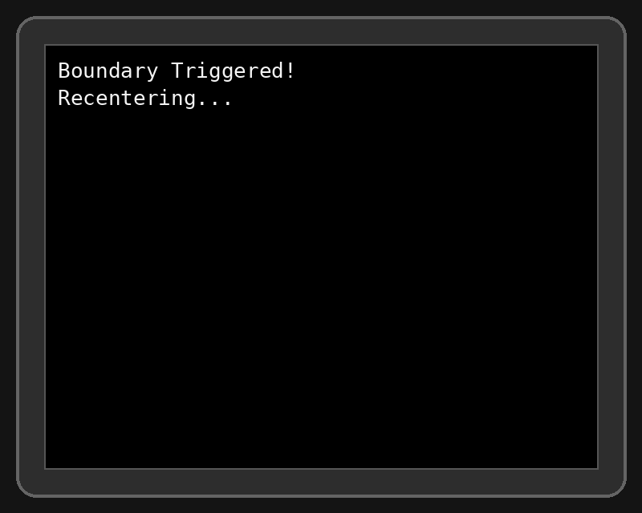
A boundary trigger stops both axes, commands centre and prompts for the Speed button after recovery. Verify this routine on the actual platform at low settings.

13. Troubleshooting
Symptom | Likely cause / action
No TFT display | Check module voltage, GND, D51 MOSI, D52 SCK, D22 CS, D24 RST and D26 DC.
LIMIT SWITCH ERROR at boot | A limit is actuated, an NC loop is open, wrong pin, or missing ground.
Axis moves opposite during calibration | Direction wiring or drive polarity is wrong. Use hard E-stop, correct wiring and retest in Test Mode.
Encoder value does not change | Check encoder 5 V/GND, A/B wiring, connector and encoder condition.
Encoder count is erratic | Noise, poor ground, damaged encoder, loose connector or signal cable routed with motor leads.
Motor only runs at full speed | PWM converter miswired, wrong analogue reference, missing common, converter not calibrated or MMT4Q input mode incorrect.
Motor hums but does not move | Current limit too low, mechanical binding, inadequate PSU, drive fault or zero/low speed reference.
Platform oscillates | PID/minPWM too aggressive, mechanical play, noisy encoder or speed converter. Reduce settings and re-tune.
Parallel display shows STB/s 0 | No strobe at D2, wrong PCB pin, missing ground, main PCB not running or older D46 wiring still present.
Parallel targets change but motion does not | Check motor enable, converter output, drive faults, limits and mapped encoder positions.
MAMEHooker cannot open COM port | Close Arduino IDE/Serial Monitor, confirm COM number, run as Administrator and check another process.
MAMEHooker runs but sees no outputs | Check MAME output-provider compatibility, correct ROM INI name, same privilege level and debug output list.
Serial seat recentres every five seconds | No recognised serial traffic within timeout. Add recurring/state-change commands.
SRC remains PAR in PC setup | Compile FORCE_INPUT_SOURCE 1 or send MODESx after opening the port.
Lamps do not work | Check relay interface, external lamp supply, D40/D41 state and cabinet lamp voltage. Do not drive lamps directly from the Mega.

14. Maintenance
Interval | Inspection
Before each use | Motion envelope clear, E-stop functional, abnormal noise, loose wiring, TFT faults.
Monthly / regular use | Limit-switch operation, encoder connectors, motor/controller terminals, fuse holders, cooling and fasteners.
After any mechanical work | Repeat Test Mode validation and full calibration.
After firmware or wiring change | Revalidate source mode, all four limits, both encoder directions, E-stop/boundary behaviour and timeout.
When motion quality changes | Inspect mechanical play and encoder signals before changing PID settings.
When replacing an encoder | Match electrical type and resolution as closely as possible; verify A/B direction and recalibrate.

15. Settings Mode reference
Hold Test Mode D14 and Settings Mode D6 LOW during boot. Use Q forward/reverse to move the cursor and R forward/reverse to change values. Set D6 HIGH to save and exit.
Index | Setting
0 | Q Kp
1 | Q Ki
2 | Q Kd
3 | Q minPWM
4 | Q maxPWM
5 | R Kp
6 | R Ki
7 | R Kd
8 | R minPWM
9 | R maxPWM
10 | EMERGENCY enable
11 | BOUNDARY enable
12 | CABIN E-STOP enable

Appendix A - Complete v55 pin list
Pin | Function
D2 | Parallel bit 0 + STROBE / INT0
D4 | R upper limit
D5 | R lower limit
D6 | Settings Mode
D8 | Q PWM
D9 | R PWM
D10 | Q direction
D11 | R direction
D12 | Q enable
D13 | R enable
D14 | Test Mode
D15 | Q forward
D17 | R forward
D18 | Q encoder A
D19 | Q encoder B
D20 | R encoder A
D21 | R encoder B
D22 | TFT CS
D23 | Source select in AUTO
D24 | TFT RST
D25 | Cabin stop input
D26 | TFT DC
D27 | Boundary input
D28 | Parallel bit 6
D29 | Parallel bit 5
D30 | Parallel bit 4
D31 | Q reverse
D32 | Q upper limit
D33 | Speed/confirm
D34 | R reverse
D37 | Q lower limit
D40 | Start lamp relay
D41 | Danger lamp relay
D47 | Parallel bit 1
D48 | Parallel bit 2
D50 | Parallel bit 3
D51 | TFT MOSI
D52 | TFT SCK
A0/A1 | Unused pots, displayed only
A2 | Fixed HIGH status return, high impedance
A3 | Upper Right status return
A4 | Lower Right status return
A5 | Upper Left status return
A6 | Lower Left status return
A7-A10 | Reserved status returns

Appendix B - Screen guide

Settings loaded
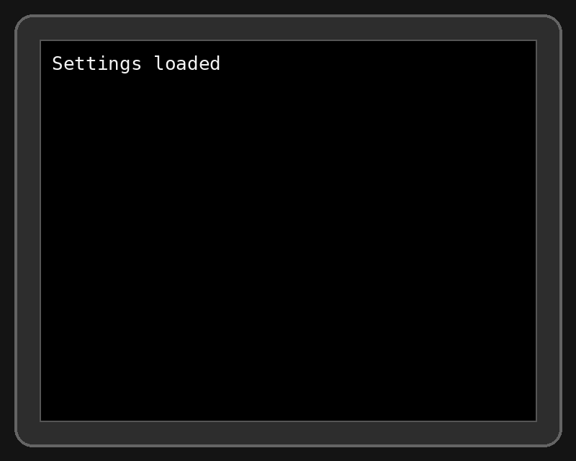
EEPROM settings accepted.

Limit switch error

Resolve the open/triggered travel-limit input before calibration.

Left calibration

Q endpoint and centre sequence.

Auto Tune prompt

Hold Speed to begin.

Auto Tune running
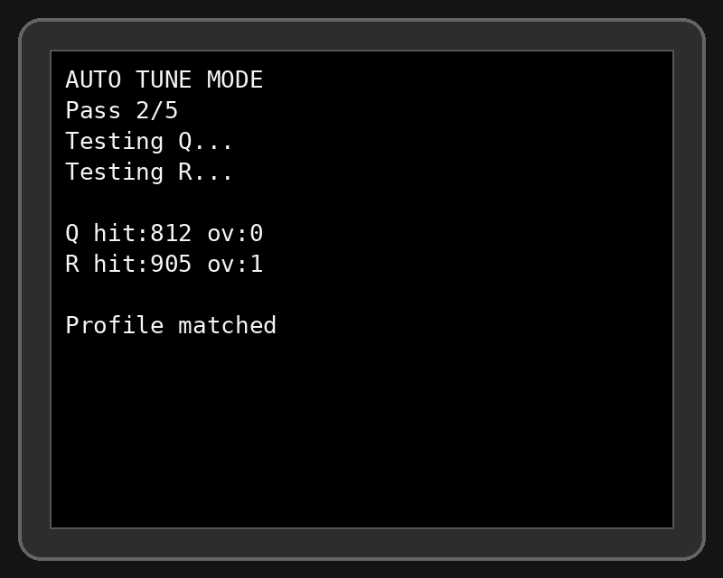
The platform will move repeatedly.

Auto Tune result

Hold Speed to save or wait to cancel.

Parallel normal display

Native Sega bus active.

Serial normal display

PC serial source active.

Test Mode

Manual commissioning and input diagnostics.

Appendix C - Commissioning record
Item | Result / value | Initials / date
48 V PSU voltage
12 V control voltage
Q branch fuse
R branch fuse
Control fuse
Q controller current limit
R controller current limit
Q converter 0-10 V range
R converter 0-10 V range
Q encoder lower / upper counts
R encoder lower / upper counts
Q PID / PWM settings
R PID / PWM settings
Hard E-stop tested
All limits tested
Boundary tested
Parallel STB/s or Serial COM port
Unloaded run complete
Occupied test approved

Appendix D - Build completion checklist
☐ All mains wiring completed or inspected by a competent person.
☐ 48 V supply and branch protection installed.
☐ Separate regulated 12 V control supply installed.
☐ Hard-wired E-stop disables both drives independently of Arduino.
☐ Two motor controllers correctly configured.
☐ PWM-to-0-10 V converters calibrated.
☐ Original motor encoders verified; no unnecessary replacement encoders fitted.
☐ Analogue position pots omitted.
☐ Four NC travel limits verified.
☐ Cabin stop and boundary polarity tested.
☐ TFT and controls operational.
☐ Test Mode completed at low speed.
☐ Calibration completed safely.
☐ Auto Tune completed or intentionally skipped.
☐ Native Parallel or Serial source clearly selected.
☐ Sega loom colours labelled and verified by pin/continuity.
☐ Documentation and fuse/current settings stored with the cabinet.

Appendix E - Technical notes and sources
This manual is based on the supplied OpenMotionGLOC v55 firmware, the v55 Arduino and filter-board wiring guides, earlier recorded Sega loom colours, and the builder’s practical Windows 10/MAMEHooker experience. External software references were checked against current MAME documentation and established MAMEHooker documentation in July 2026.
- MAME official documentation: configuration and OSD output options, docs.mamedev.org.
- MAMEHooker command structure: cmo, cmw and cmc conventions documented by the MAMEHooker community and TeamOpenFIRE.
- OpenMotionGLOC repository and licence: github.com/BertyB3/OpenMotionGLOC.
FIRMWARE COMMENTS VERSUS IMPLEMENTATION
Some header comments in the supplied sketch describe older features such as automatic edge selection, triple-sampling and busy-poll fallback. The actual v55 code shown uses a fixed compile-time strobe edge and a single delayed sample inside the ISR. This manual follows the implemented code where they differ.

