小论文模型图和理论支撑整理：

1. the user engagement mechanism in a living steaming context through **multimedia learning 、information foraging theories,**

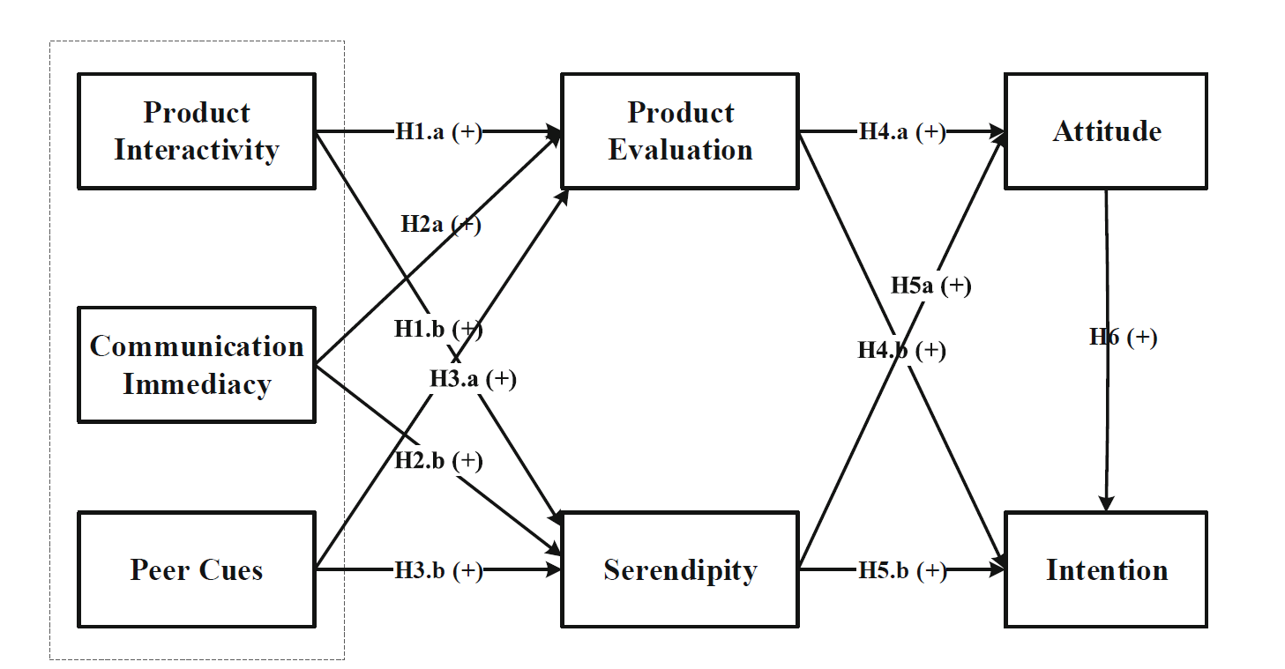

1. 题目：The impact of live video streaming on online purchase intention

理论：construal level theory、perceived uncertainty、Psychological distance

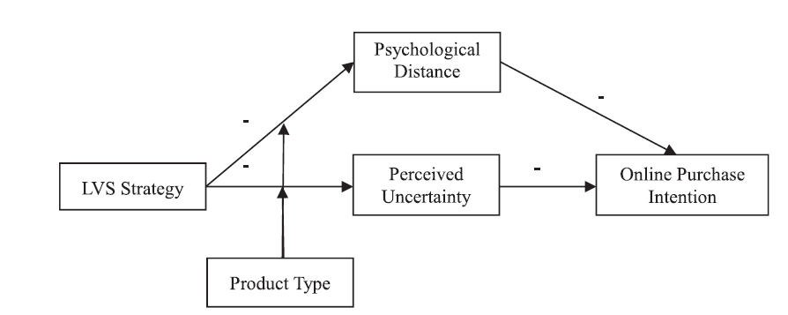

1. Live streaming commerce from the sellers’ perspective: implications for online relationship marketing

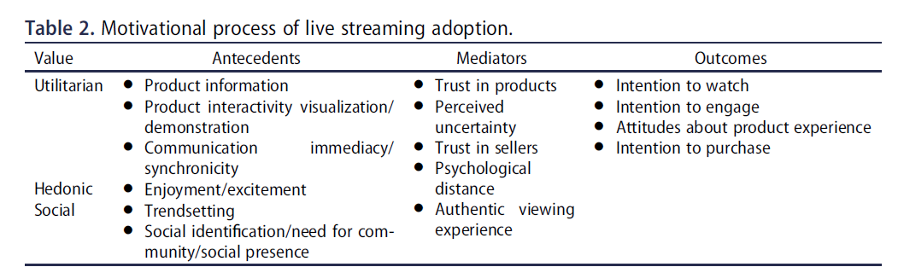

1. Uses and gratifications theory
2. 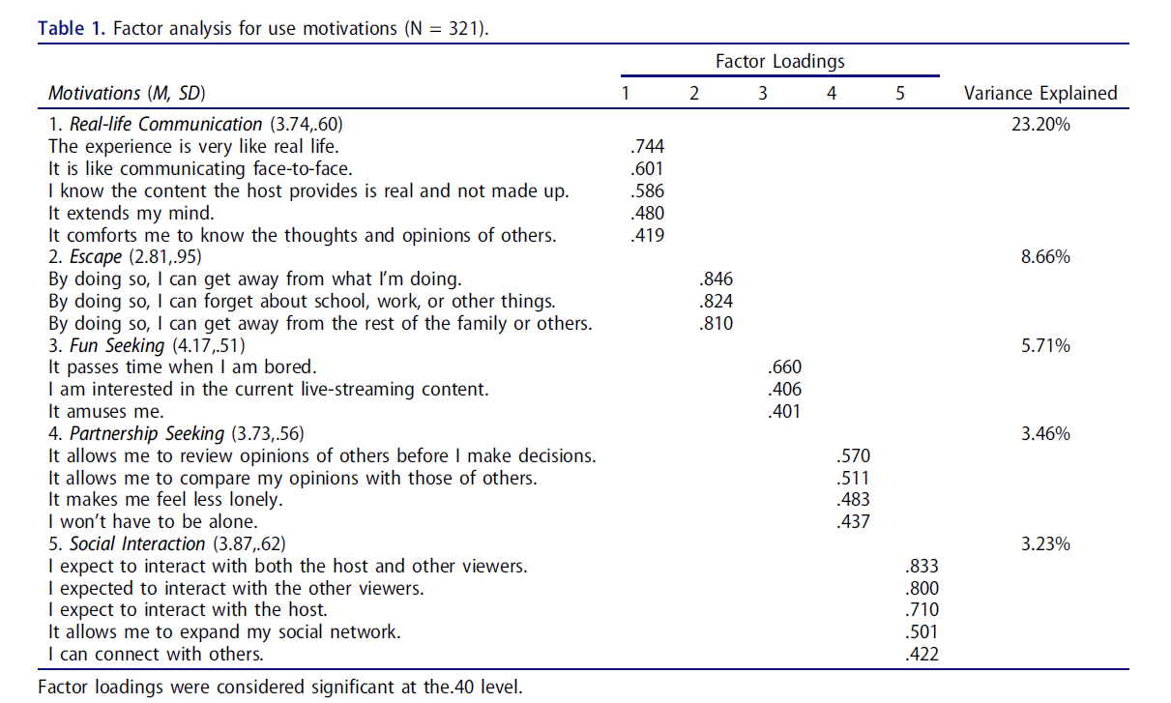
3. Factors influencing people’s continuous watching intention and consumption intention in live streaming Evidence from China（这儿的消费指的是给主播送礼物）

理论基础：Uses and gratification theory

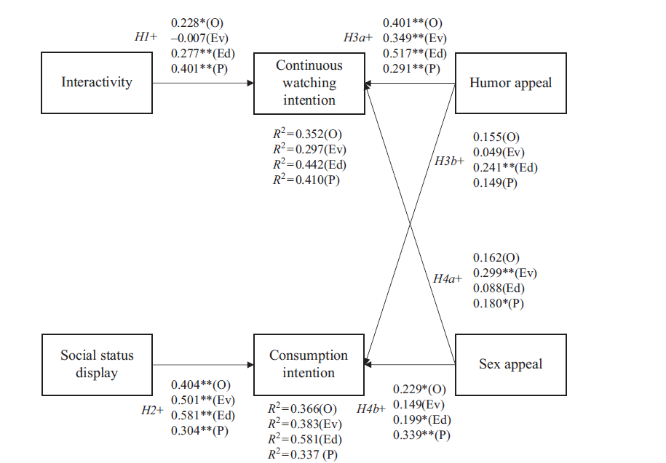

1. The role of live streaming in building consumer trust and engagement with social commerce sellers(可参考这篇文章的用户信任和用户参与)

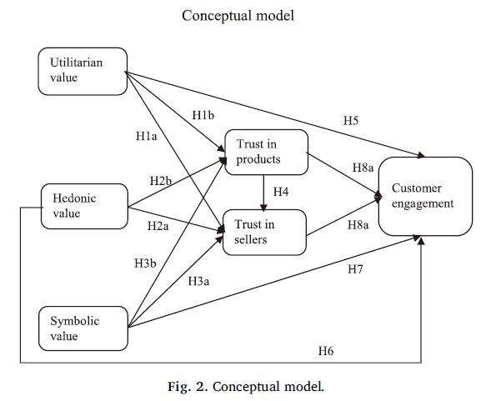(Wongkitrungrueng and Assarut 2018)

1. Some things are just better rich: how social commerce feature richness affects consumers’ buying intention via social factors

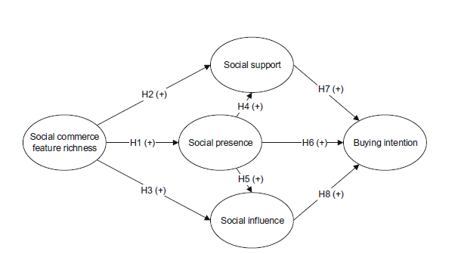

1. See now, act now: How to interact with customers to enhance social

commerce engagement?

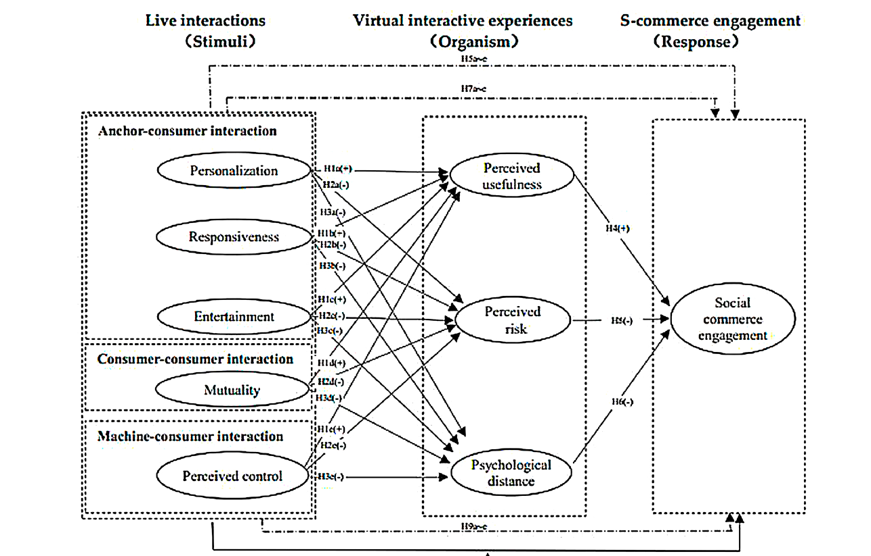

1. Exploring consumers’ purchase intention in social commerce(主题也是S-O-R理论)

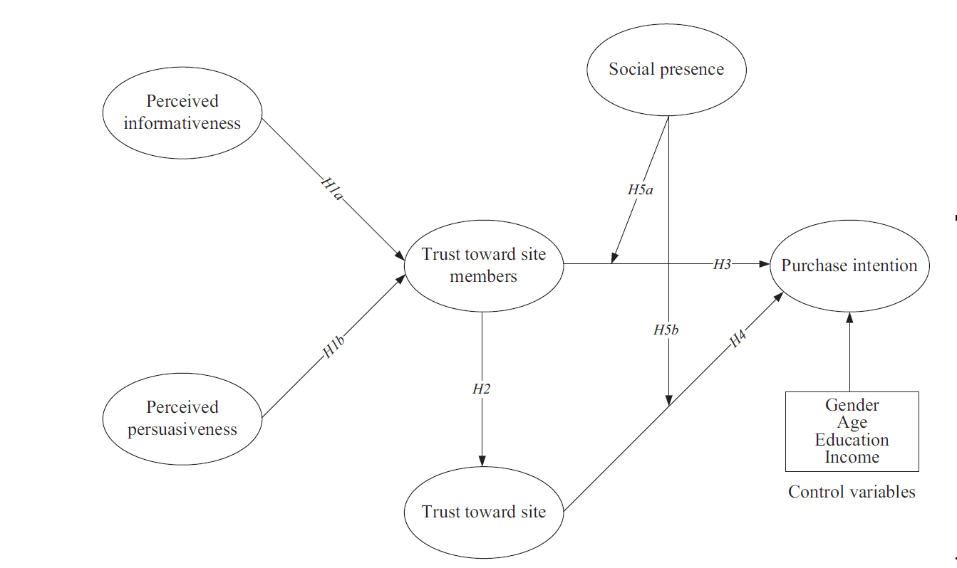

1. Enhancing consumer engagement in e-commerce live streaming via relational bonds

使用模型：SOR model和Affective commitment 注意数据是使用问卷星收集的

1. 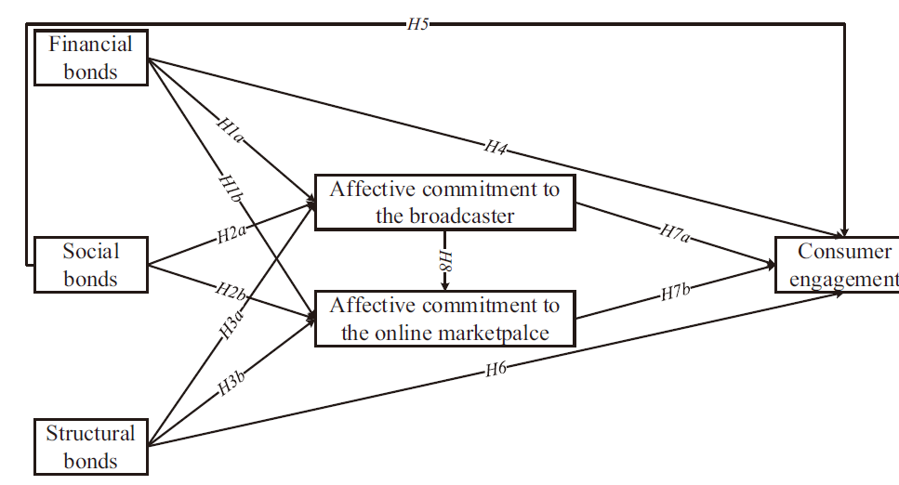

模型初步框架：

Product visualization 、social presence 、consumer trust 、consumer engagement、 Intention to purchase、celebrity-streamer、professional-streamer

1. Exploring consumers’ impulse buying behavior on social commerce platform: The role of para-social interaction

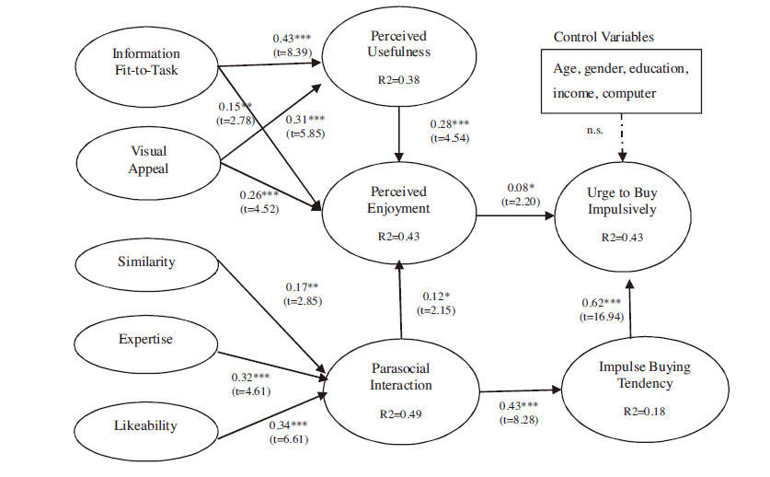

研究的冲动性购买行为——创新在于引入了para-social interaction。

1. How live streaming influences purchase intentions in social commerce: An

IT affordance perspective-研究的是直播环境下的购买意愿

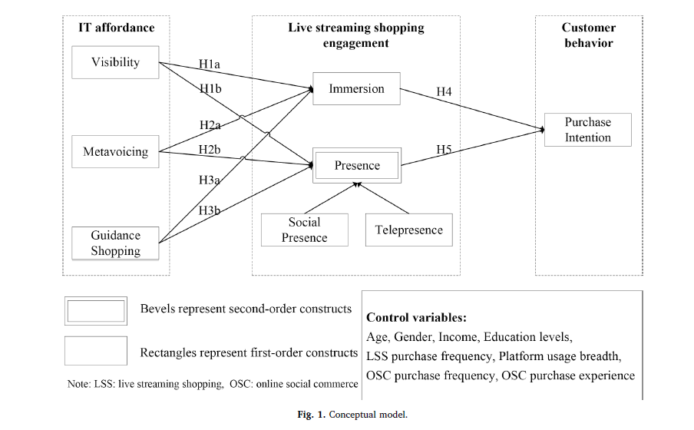

1. 研究的是在线冲动性购买

Defining key drivers of online impulse purchasing: A perspective of both impulse shoppers and system users

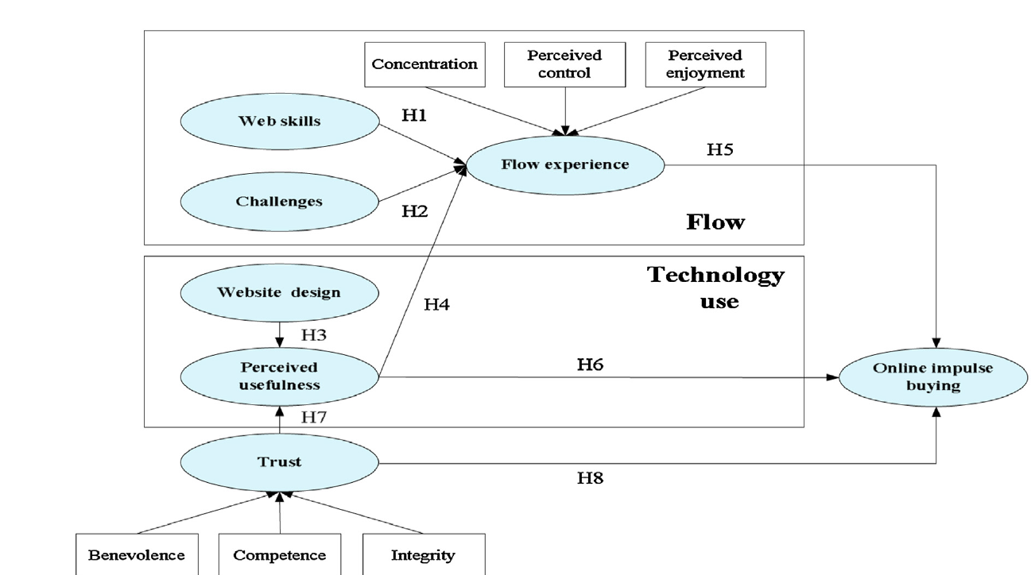

1. Understanding customers’ repeat purchase intentions in B2C e-commerce: the roles of utilitarian value, hedonic value and perceived risk

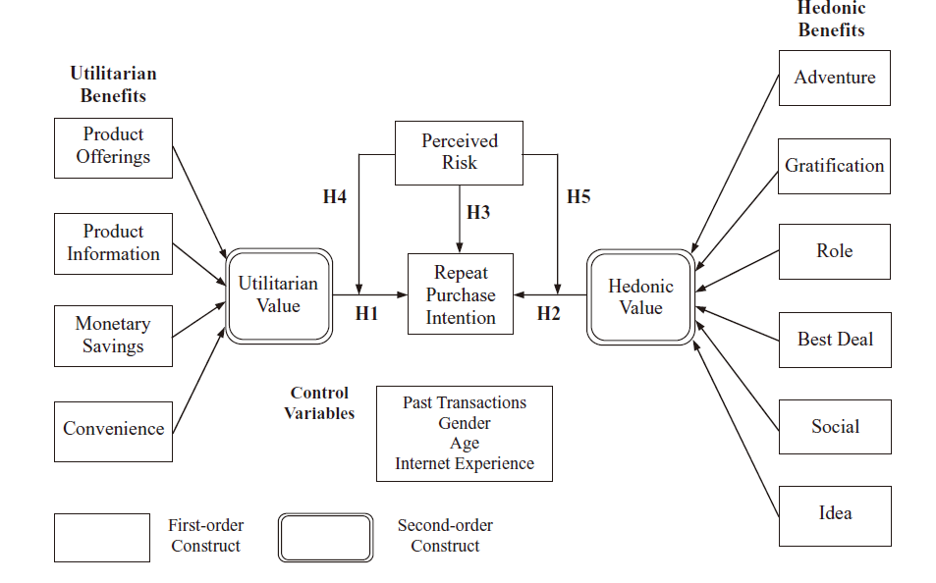

1. What motivates customers to participate in social commerce? The impact of technological environments and virtual customer experiences

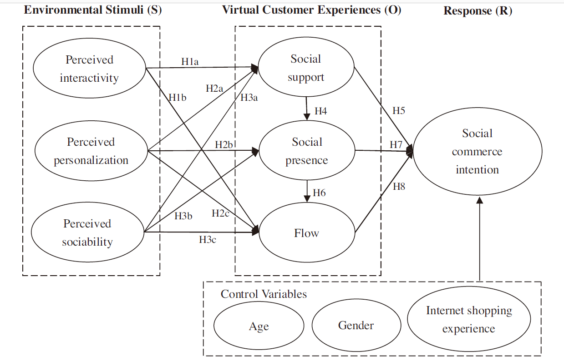

1. Consumer perceived value, involvement, trust, susceptibility to interpersonal influence, and intention to participate in online group buying

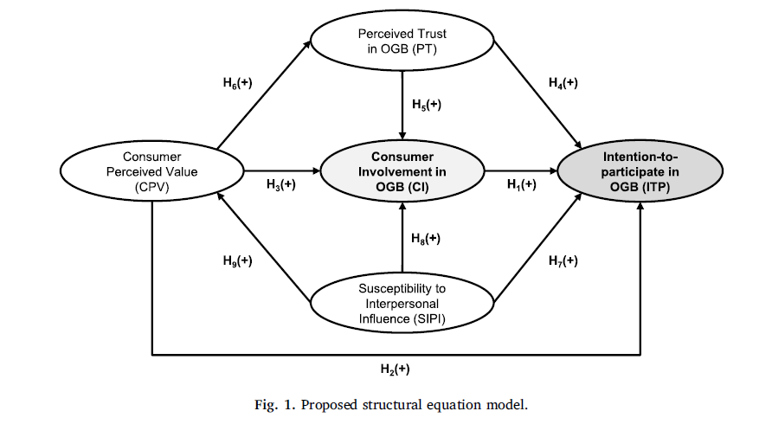

1. (Lee and Gan 2020) and para‑social interactions (PSI) towards impulse

buying: the Malaysian perspective

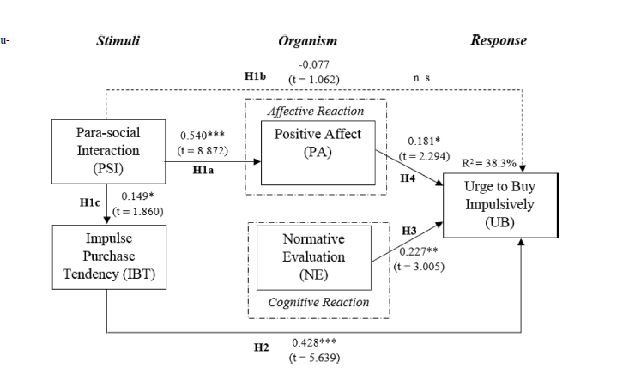

1. How vloggers embrace their viewers: Focusing on the roles of parasocial

interactions and flow experience

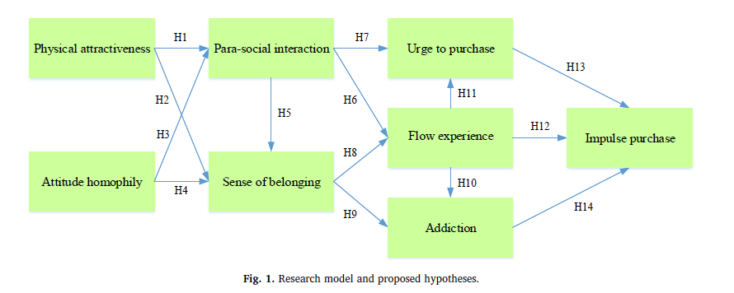

1. What drives live-stream usage intention? The perspectives of flow, entertainment, social interaction, and endorsement

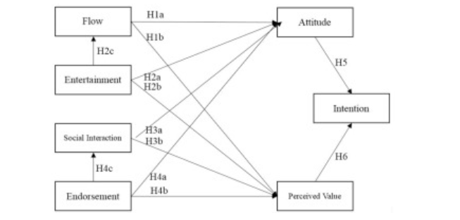

研究角度：虽然商家自己做主播可以通过直播的方式展示商品，但是流量有限，因此商品的销售转换率较低。为了提高商品的曝光度，吸引更多的流量，越来越多的品牌方开始邀请网红主播或者明星做客直播间。但是关于这一现状的研究相对不足。因此，本文主要解决以下几个问题：1）主播带货环境下影响消费者购买的动机有哪些？2）平台邀请网红或者明星，是否能够有效提升消费者参与，并刺激其购买行为呢？3）网红主播以及明星主播是如何通过刺激消费者购买提升企业的商品销售转化率的？

Lee, Y. Y. and C. L. Gan (2020). "Applications of SOR and para-social interactions (PSI) towards impulse buying: the Malaysian perspective." Journal of Marketing Analytics **8**(2): 85-98.

Wongkitrungrueng, A. and N. Assarut (2018). "The role of live streaming in building consumer trust and engagement with social commerce sellers." Journal of Business Research.