THE ICT UNIVERSITY


Faculty of Information and Communication Technology

A thesis presented and submitted in partial fulfillment of the requirement for the degree of a Bachelor of Science in Cybersecurity

EASINT: AN AI-ENHANCED OPEN-SOURCE INTELLIGENCE PLATFORM WITH REAL-TIME THREAT ANALYSIS

By

TANYI BESONG BRYAN MAURICE
Matricule: ICTU20234375
Email: tanyibesong.bryanmauirce@ictuniversity.edu.cm

Supervised by: Engr. Moune

July 2026

Declaration

I declare that the work entitled "Easint: An AI-Enhanced Open-Source Intelligence Platform with Real-Time Threat Analysis" is my own original work, conceived and presented in partial fulfillment of the requirement for the degree of a Bachelor of Science in Cybersecurity at ICT University. This work has not been submitted for any degree or examination in any other university, and that all the sources I have used or quoted have been indicated and acknowledged as complete references.

Signed: _______________________________

Date: ______16/06/2026_________________________

Name: TANYI BESONG BRYAN MAURICE

Registration Number: ICTU20234375

Certification

This work entitled "Easint: An AI-Enhanced Open-Source Intelligence Platform with Real-Time Threat Analysis" has been submitted for examination with my approval as the Research Supervisor.

Signed: _______________________________

Date: ________16/06/2026_______________________

Name: Engr. Moune

Title: Research Supervisor, ICT University

Dedication

To my beloved parents,
whose unwavering financial sacrifices, unconditional love, and constant emotional support made every step of this Bachelor's degree possible. Your belief in me never faltered, even in the most challenging moments, and it is your encouragement that carried me through to the completion of this work.

To my dedicated teachers at ICT University,
whose guidance, knowledge, and passion for technology inspired me to push the boundaries of what I believed possible.

Acknowledgments

First and foremost, I extend my deepest gratitude to my supervisor, Engr. Moune, whose expert guidance, constructive feedback, and steady encouragement shaped this dissertation from its initial conception through to its final form. His commitment to academic excellence has set a standard I will carry throughout my professional career.

I am profoundly grateful to all the wonderful faculty members of the ICT University Department of Information and Communication Technology. Each lecturer contributed uniquely to my intellectual development across my three years of this program. Their dedication to preparing students for the realities of the technology industry is evident in the quality of education they consistently delivered.

A heartfelt thank you goes to Engr. Njilla Donald, my internship supervisor, who opened my eyes to cybersecurity from a completely different and profoundly practical perspective. His mentorship during my internship gave me the confidence and technical depth to undertake an ambitious project such as Easint. The real-world context he provided transformed the way I approach security problems.

To my classmates with whom I shared the better part of three remarkable years — thank you. The late-night study sessions, the collaborative debugging marathons, the shared frustrations and shared victories all contributed to making this experience richer than any individual effort could have achieved. Your companionship was invaluable.

Finally, I acknowledge the open-source community, whose freely shared tools, libraries, and documentation made the technical implementation of Easint possible. The spirit of knowledge-sharing that defines this community is itself an embodiment of the OSINT principles this dissertation explores.

Faculty Approval

This thesis has been duly reviewed by the Department and the Faculty and is ready for examination with our approval.

Approved by:

Signature __________________________ Date ______________________

Engr. Moune
Supervisor

Signature __________________________ Date ______________________

Engr. Tanwi
Head of Department

Signature __________________________ Date ______________________

Dr. Nkandeu Pascal
Dean

Abstract

The proliferation of cyber threats in the contemporary digital landscape demands practical intelligence-gathering mechanisms that reduce the burden of manual investigation. This dissertation presents Easint, an AI-enhanced Open-Source Intelligence (OSINT) platform engineered to automate, centralize, and intelligently analyze digital footprint data across multiple threat vectors. The implemented platform consolidates eighteen OSINT tools covering IP reputation analysis, geolocation, reverse-IP lookup, email and breach intelligence, WHOIS, DNS, SSL certificate inspection, username search, file hash analysis, metadata extraction, Wayback Machine lookup, MAC vendor lookup, Google dork generation, cryptocurrency wallet lookup, and Shodan-assisted search within a unified Flask-based web application supported by Supabase PostgreSQL persistence.

The system integrates Google Gemini as the primary AI provider and Mistral AI as a fallback provider for conversational threat analysis, automated investigation summaries, result interpretation, and context-aware security recommendations. A D3.js-powered interactive network graph visualizes entity relationships and connection patterns across investigation results, enabling analysts to identify correlations that would otherwise remain concealed within tabular data.

The platform was evaluated through functional testing and comparative analysis. Results demonstrate that Easint significantly reduces the time required for comprehensive target intelligence gathering compared to manual, tool-by-tool approaches, while the AI analysis layer delivers actionable threat insights with strong contextual relevance. The study makes contributions to the fields of cybersecurity engineering and threat intelligence, establishing a reference architecture for AI-augmented OSINT platforms. Recommendations for future development include dark web monitoring integration, advanced machine learning-based threat scoring, and enterprise-grade deployment capabilities.

Keywords: Open-Source Intelligence, OSINT, Artificial Intelligence, Threat Analysis, Cybersecurity, Google Gemini, Mistral AI, Network Visualization, D3.js, Flask, Supabase

Table of Contents

Preliminary Pages
Declaration ............................... ii
Certification ................................. iii
Dedication ..................................... iv
Acknowledgments ........................... v
Faculty Approval ........................... vi
Abstract .......................................... vii
Table of Contents .......................... viii
List of Figures ................................ ix
List of Acronyms and Abbreviations ... x

Chapter 1: Introduction .............. 1
1.1 Background to the Problem ......... 1
1.2 Problem Statement ..................... 3
1.3 Objectives ................................. 4
1.3.1 General Objective ............. 4
1.3.2 Specific Objectives ........... 4
1.4 Research Questions .................... 5
1.5 Scope of Research ...................... 5
1.6 Significance of the Study ........... 6
1.7 Limitations of the Study ............. 7
1.8 Organization of the Study ........... 7

Chapter 2: Literature Review ...... 9
2.1 Introduction .............................. 9
2.2 History and Evolution of OSINT ... 9
2.3 Existing OSINT Tools and Platforms .. 12
2.4 Artificial Intelligence in Cybersecurity .. 15
2.5 Threat Intelligence Platforms ....... 18
2.6 Network Graph Visualization ........ 20
2.7 Gaps in the Literature ................. 22
2.8 Conclusion ................................ 23

Chapter 3: Methodology .............. 24
3.1 Introduction .............................. 24
3.2 Research Approach ..................... 24
3.3 System Architecture ................... 25
3.4 Data and Requirements Gathering .. 27
3.5 Tools and Technologies ............... 28
3.6 Development Process .................. 31
3.7 Evaluation Approach ................... 32
3.8 Conclusion ................................ 33

Chapter 4: Analysis, Design, Implementation, and Findings ............... 34
4.1 Introduction .............................. 34
4.2 Requirements Analysis ................ 34
4.3 System Design .......................... 37
4.4 Implementation ......................... 44
4.5 Testing and Findings .................. 57
4.6 Conclusion ................................ 61

Chapter 5: Summary, Conclusions, and Recommendations .............. 62
5.1 Summary .................................. 62
5.2 Conclusions .............................. 64
5.3 Discussion ............................... 66
5.4 Recommendations ...................... 67

References .................................. 69
Annexes ...................................... 73

List of Acronyms and Abbreviations

Acronym | Meaning
AI | Artificial Intelligence
API | Application Programming Interface
APT | Advanced Persistent Threat
ASN | Autonomous System Number
ATT&CK | Adversarial Tactics, Techniques & Common Knowledge
BaaS | Backend as a Service
CISA | Cybersecurity and Infrastructure Security Agency
CRUD | Create, Read, Update, Delete
CSS | Cascading Style Sheets
D3 | Data-Driven Documents
DNS | Domain Name System
DSR | Design Science Research
HTML | Hypertext Markup Language
HIBP | Have I Been Pwned
HTTP | Hypertext Transfer Protocol
HTTPS | Hypertext Transfer Protocol Secure
IP | Internet Protocol
ISP | Internet Service Provider
JSON | JavaScript Object Notation
JSONB | JSON Binary (PostgreSQL type)
JWT | JSON Web Token
LLM | Large Language Model
MISP | Malware Information Sharing Platform
MITRE | Massachusetts Institute of Technology Research Establishment
NLP | Natural Language Processing
NIST | National Institute of Standards and Technology
OSINT | Open-Source Intelligence
PTES | Penetration Testing Execution Standard
RLS | Row-Level Security
REST | Representational State Transfer
SOC | Security Operations Center
SQL | Structured Query Language
SSL | Secure Sockets Layer
STIX | Structured Threat Information Expression
TAXII | Trusted Automated eXchange of Indicator Information
TIP | Threat Intelligence Platform
TLS | Transport Layer Security
TTP | Tactics, Techniques, and Procedures
UI | User Interface
URL | Uniform Resource Locator
UUID | Universally Unique Identifier
WHOIS | Who Is (domain registration query protocol)

Chapter 1: Introduction

1.1 Background to the Problem
In the contemporary cybersecurity landscape, the exponential growth of digital infrastructure has created an equally vast and increasingly perilous attack surface. Threat actors — ranging from opportunistic script kiddies to nation-state-sponsored advanced persistent threat (APT) groups — exploit digital footprints, misconfigured systems, publicly exposed infrastructure, and leaked credentials to orchestrate targeted attacks against organizations, governments, and individuals. In this environment, the capacity to proactively gather, correlate, and analyze intelligence derived from open and publicly available sources has become a defining competency for security professionals worldwide.

Open-Source Intelligence, commonly abbreviated as OSINT, refers to the systematic collection, processing, and analysis of information obtained from publicly accessible sources, including the internet, social media platforms, public registries, academic publications, and other non-classified data repositories (Hassan & Hijazi, 2018). Unlike classified intelligence collection methods that require legal authorization and specialized access, OSINT operates entirely within the bounds of publicly available information, making it an accessible, cost-effective, and legally permissible intelligence discipline. Security professionals leverage OSINT in diverse contexts: penetration testers use it during the reconnaissance phase of authorized engagements; digital forensics investigators apply it in attribution analysis; threat intelligence analysts employ it to track adversary infrastructure and tactics; and incident responders utilize it to contextualize artifacts discovered during active incidents.

The OSINT landscape encompasses a rich ecosystem of data sources and collection techniques. Network intelligence involves the interrogation of IP addresses against reputation databases, the examination of SSL/TLS certificate transparency logs, and the enumeration of internet-exposed services and devices. Domain intelligence includes WHOIS and RDAP lookups, DNS record analysis, and historical domain registration data. Email intelligence encompasses cross-referencing addresses against publicly known breach datasets, verifying deliverability, and discovering associated identities. Identity intelligence involves the enumeration of usernames across social media and online platforms to construct digital identity profiles. File intelligence covers the analysis of cryptographic hashes against malware repositories to identify known malicious executables and artifacts. Each of these intelligence categories, when combined and correlated, provides a comprehensive picture of a target's digital footprint and associated risk profile.

The global cybersecurity threat landscape continues to escalate at an alarming pace. The frequency and sophistication of cyber incidents have risen dramatically, with ransomware attacks, business email compromise, supply chain compromises, and data breaches affecting organizations across every sector and geography. The 2023 Verizon Data Breach Investigations Report documented over 16,312 security incidents and 5,199 confirmed data breaches, highlighting the pervasive nature of cyber threats in the modern digital economy (Verizon, 2023). In this environment, security teams are frequently overwhelmed by the volume and complexity of threat data, making the case for automated, AI-augmented intelligence analysis compelling and urgent.

The emergence of large language model-based artificial intelligence systems represents a transformative development for intelligence analysis. AI systems such as Google Gemini, OpenAI GPT, and Anthropic Claude demonstrate remarkable capabilities in natural language understanding, pattern recognition, and contextual reasoning — capabilities that are directly applicable to the challenge of interpreting complex OSINT data and generating actionable threat assessments. The integration of such AI systems into OSINT platforms offers the prospect of not merely collecting intelligence, but intelligently interpreting it, identifying non-obvious correlations, and communicating findings in clear, actionable terms accessible to security professionals of varying technical backgrounds.

1.2 Problem Statement
Despite the clear and growing necessity for comprehensive OSINT capabilities in modern cybersecurity practice, the current tooling landscape is characterized by critical fragmentation. Security analysts seeking to conduct thorough intelligence investigations must navigate a disparate collection of standalone tools, each requiring separate access, producing outputs in incompatible formats, and offering no mechanism for cross-tool data correlation. Widely-used OSINT tools such as Shodan, Censys, Maltego, theHarvester, SpiderFoot, and Recon-ng each excel within their specific intelligence domains but operate as fundamentally isolated silos, disconnected from one another and from any overarching investigative framework.

This fragmentation imposes severe operational inefficiencies on security analysts. An analyst investigating a spear-phishing campaign, for example, must individually query tools for IP reputation, domain WHOIS history, email breach exposure, social media presence, and SSL certificate data, then manually aggregate and cross-reference these disparate findings in a separate document or spreadsheet. This manual aggregation process is not only time-consuming but inherently error-prone, as important correlations between data points can easily be missed when information is spread across multiple disconnected interfaces and formats.

Furthermore, existing OSINT platforms largely lack integrated artificial intelligence analytical capabilities. While commercial solutions such as Maltego and Recorded Future incorporate varying degrees of data enrichment and visualization, truly conversational, LLM-powered analysis — enabling analysts to engage in natural-language dialogue with their investigation data — remains largely absent from widely accessible tools. This gap is particularly acute for smaller security teams, academic institutions, and individual security researchers who lack the budget for enterprise-grade threat intelligence platforms but nonetheless require sophisticated analytical capabilities.

The problem this dissertation addresses is therefore clearly defined: there is no freely accessible, unified OSINT platform that consolidates multiple intelligence-gathering tools, manages investigations across their full lifecycle, provides AI-driven conversational and automated analysis, and visualizes entity relationships through interactive network graphs, all within a secure environment. Easint is designed to address precisely this gap.

1.3 Objectives

1.3.1 General Objective
The general objective of this study is to design, develop, and evaluate an AI-enhanced Open-Source Intelligence platform that consolidates multiple OSINT capabilities into a unified investigative environment, enabling cybersecurity professionals and researchers to conduct comprehensive, AI-augmented threat analysis with significantly reduced operational overhead.

1.3.2 Specific Objectives
The following specific objectives guide the implementation of Easint:

- To design and implement a modular OSINT tool collection integrating eighteen distinct intelligence-gathering capabilities covering network, email, domain, identity, and file analysis domains within a unified Flask-based web application.
- To develop an AI-powered investigation assistant leveraging Google Gemini with Mistral AI fallback, providing conversational threat analysis, automated investigation summaries, context-aware security recommendations, and natural-language interaction with investigation data.
- To implement an interactive network graph visualization system using D3.js that dynamically reveals relationships, patterns, and entity connections across OSINT investigation results, enabling visual pattern recognition.
To implement persistent investigation management, export capability, and guided learning features that allow collected intelligence to be saved, reviewed, reported, and understood within one web application.

1.4 Research Questions
This study is guided by the following research questions:

- How can multiple heterogeneous OSINT data sources be effectively integrated into a unified platform while maintaining modular extensibility and minimizing inter-tool dependencies?
- To what extent can large language model-based AI assistance improve the quality, efficiency, and accessibility of OSINT-based threat analysis for security professionals?
- How can network graph visualization techniques enhance an analyst's ability to identify entity relationships, detect threat patterns, and derive actionable intelligence from multi-source OSINT investigation data?
- How can a research prototype protect sensitive investigation data, API credentials, and uploaded files while maintaining a simple local deployment model?

1.5 Scope of Research
The scope of this study encompasses the design, development, and evaluation of the Easint platform as a functional, production-quality prototype suitable for deployment in individual security research, academic cybersecurity programs, and small-to-medium security operations environments. The platform integrates publicly available APIs and open-source intelligence sources, operating within the legal and ethical boundaries that govern the collection and use of publicly accessible information.

The study focuses specifically on the following intelligence domains: IP and network intelligence, email and credential intelligence, domain and DNS intelligence, identity and social media intelligence, and file and hash intelligence. The system is designed for use against targets for which the investigating user has appropriate legal authorization, consistent with the ethical standards governing professional penetration testing and security research.

The scope explicitly excludes dark web intelligence gathering, proprietary closed-source threat intelligence feeds, enterprise-grade deployment infrastructure such as load balancing and clustering, and advanced machine learning model training for threat classification. These are identified as productive areas for future development beyond the scope of the current study.

1.6 Significance of the Study
This study makes several meaningful contributions across academic, practical, and industrial dimensions.

Academic Contribution: This dissertation contributes to the emerging literature on AI-augmented security analysis by providing empirical evidence of the practical viability and utility of integrating large language model-based AI into OSINT investigative workflows. The architectural patterns established by Easint offer a reference model for future research into AI-enhanced threat intelligence systems. The study also demonstrates novel application of D3.js force-directed graph algorithms in the OSINT context.

Practical Contribution: Easint provides a functional, open-source OSINT platform that democratizes access to sophisticated intelligence-gathering and analysis capabilities previously available primarily through expensive commercial solutions. Security professionals, academic researchers, and students can utilize the platform to conduct thorough intelligence investigations without the financial and operational overhead associated with enterprise tools.

Industry Impact: By establishing a working reference implementation for an AI-enhanced, unified OSINT platform, this study contributes a practical blueprint that may inform the design of more advanced commercial and governmental intelligence systems. The integration patterns for connecting diverse OSINT APIs, structuring investigation data, and applying AI analysis demonstrated in Easint have broad applicability across the threat intelligence industry.

1.7 Limitations of the Study
The following limitations are acknowledged in this study:

- AI Capability Boundaries: The platform's AI analytical capabilities are bounded by the capabilities, availability, rate limits, and knowledge of the Google Gemini and Mistral models. Model output must be treated as analyst assistance rather than authoritative evidence.
- API Rate Limits: The OSINT tools integrated in the current implementation are subject to the rate limits and data availability constraints of their respective APIs and data sources, which may limit the volume and frequency of investigations in high-throughput scenarios.
- Evaluation Environment: The platform evaluation is conducted primarily in a controlled academic environment. Operational performance characteristics in high-volume production environments, enterprise deployments, or shared multi-user environments may differ from those observed during evaluation.
- Dark Web Coverage: The absence of dark web monitoring capabilities limits the platform's utility for intelligence gathering scenarios involving illicit marketplaces, clandestine forums, and other non-indexed sources.
- Authentication Scope: The current repository does not implement end-user registration, login, JWT session enforcement, or per-user dashboard isolation. Investigations are stored with a nullable user_id for single-user/local prototype use, and production multi-user authentication is therefore treated as future work rather than an implemented feature.
- Scope of AI Analysis: The AI analysis functionality is dependent on the quality and completeness of the OSINT data collected. Investigations with sparse results may yield less actionable AI-generated insights.

1.8 Organization of the Study
The remainder of this thesis is organized as follows:

Chapter 2: Literature Review — presents a comprehensive review of relevant literature encompassing the history and evolution of OSINT, an examination of existing OSINT tools and threat intelligence platforms, a survey of artificial intelligence applications in cybersecurity, and an analysis of network graph visualization techniques. The chapter concludes by identifying specific gaps in the existing literature that this study addresses.

Chapter 3: Methodology — describes the research paradigm, system architecture philosophy, data and requirements gathering approach, the tools and technologies employed in the development of Easint, and the iterative development process followed. The chapter also outlines the evaluation approach used to assess the platform's performance and utility.

Chapter 4: Analysis, Design, Implementation, and Findings — provides a detailed account of the requirements analysis, system design decisions, and technical implementation of all major platform components, including the OSINT tool collection, the AI integration layer, the network graph visualization system, the investigation management system architecture. The chapter concludes with testing results and empirical findings.

Chapter 5: Summary, Conclusions, Discussion, and Recommendations — synthesizes the key findings of the study, presents conclusions relative to the research questions and objectives, discusses the broader implications of the work, and provides concrete recommendations for future development and research directions.

Chapter 2: Literature Review

2.1 Introduction
This chapter presents a critical review of existing literature relevant to the design and development of an AI-enhanced OSINT platform. The review is organized thematically, progressing from the historical foundations of OSINT as a discipline, through existing tools and platforms, to the application of artificial intelligence in cybersecurity, network visualization techniques, and finally an identification of the specific gaps in the literature that this study addresses. The literature review draws on academic journals, conference proceedings, industry reports, and authoritative technical documentation to establish the theoretical and practical foundation for the Easint platform.

2.2 History and Evolution of OSINT
Open-Source Intelligence has its origins in military and governmental intelligence practice, where it referred to the systematic collection and analysis of information derived from publicly available sources as distinct from covert collection methods. The United States military formally recognized OSINT as a distinct intelligence discipline in the early 1990s, following the Gulf War, during which commercially available satellite imagery and publicly broadcasted media proved valuable for operational planning (Glassman & Kang, 2012). However, the concept of leveraging publicly available information for intelligence purposes predates the digital era significantly — wartime analysts have historically studied foreign newspapers, radio broadcasts, and academic publications for intelligence value.

The advent of the internet fundamentally transformed OSINT in terms of both scope and capability. The transition from primarily physical and broadcast sources to digital, networked information repositories exponentially expanded the volume, velocity, and variety of publicly available information. By the late 1990s, the internet had become the primary arena for OSINT collection, with websites, online forums, email archives, and early social media platforms offering unprecedented intelligence value to those with the skills to exploit them systematically (Bazzell, 2021).

The formalization of OSINT as a cybersecurity discipline emerged in the early 2000s with the growth of the penetration testing industry and the increasing recognition that effective offensive security operations required thorough pre-engagement reconnaissance. Tools such as theHarvester, developed by Christian Martorella and first released in 2007, automated the collection of email addresses and domain information from public sources, marking an early milestone in the development of automated OSINT tooling (Martorella, 2007 as cited in Hassan & Hijazi, 2018). The publication of the Open Source Security Testing Methodology Manual (OSSTMM) and the subsequent development of the Penetration Testing Execution Standard (PTES) formalized reconnaissance — including OSINT — as a defined phase within the penetration testing lifecycle.

The 2010s witnessed a dramatic expansion of OSINT capabilities driven by several converging trends. The proliferation of social media platforms generated vast new repositories of personal and organizational intelligence. The expansion of internet-connected devices, tracked by platforms such as Shodan (Matherly, 2009 as cited in Shodan Inc., 2024), made network infrastructure intelligence accessible at unprecedented scale. The growth of data breach repositories, most notably the Have I Been Pwned service launched by Troy Hunt in 2013 (Hunt, 2024), provided analysts with access to vast databases of compromised credentials. Certificate transparency logs, DNS passive replication services, and internet-wide scanning projects such as Censys and CIRCL's passive DNS further enriched the OSINT data ecosystem.

Contemporary OSINT practice is characterized by automation, data enrichment pipelines, and increasing integration with threat intelligence frameworks. The MITRE ATT&CK framework's explicit inclusion of OSINT-based reconnaissance techniques under the TA0043 tactic (Reconnaissance) reflects the field's maturity and its centrality to both offensive and defensive security operations (MITRE, 2023).

2.3 Existing OSINT Tools and Platforms
The OSINT tooling ecosystem is extensive and diverse, encompassing standalone command-line tools, web-based platforms, and commercial enterprise solutions. A critical analysis of existing tools reveals both the capabilities already available to practitioners and the significant limitations that motivate the development of a unified, AI-enhanced platform such as Easint.

Maltego: Paterva's Maltego is arguably the most widely recognized commercial OSINT platform, offering a graphical link analysis interface that visualizes relationships between entities such as domains, IP addresses, email addresses, and social media accounts through a plugin-based architecture called 'transforms' (Paterva, 2024). Maltego's visual link analysis capabilities are powerful but come with significant limitations: the community edition imposes severe functional restrictions, the commercial license is expensive, and the platform's closed architecture limits extensibility for organizations with specialized intelligence requirements. Furthermore, Maltego lacks integrated AI analysis capabilities, leaving the interpretive burden entirely with the human analyst.

SpiderFoot: SpiderFoot is an open-source OSINT automation tool that supports over 200 data modules and can autonomously discover information about a target across dozens of data sources (Owens, 2024). SpiderFoot's comprehensive data collection capability is notable, but its interface can be overwhelming for less experienced users, its correlation analysis is limited, and it does not provide AI-driven analytical interpretation of collected data.

Shodan: Shodan describes itself as 'the search engine for internet-connected devices,' indexing over 1.5 billion internet-exposed services and providing query interfaces for identifying potentially vulnerable infrastructure, exposed databases, and misconfigured systems (Shodan Inc., 2024). Shodan is invaluable for network intelligence gathering but is a single-purpose tool that must be manually integrated with other intelligence sources.

Have I Been Pwned (HIBP): Troy Hunt's Have I Been Pwned service provides a publicly accessible API for querying whether an email address appears in known data breach datasets, currently encompassing over 12 billion compromised credentials (Hunt, 2024). HIBP is a specialized, single-purpose service that does not provide broader intelligence context or integration with other data sources.

Recon-ng: Recon-ng is an open-source web reconnaissance framework providing a Metasploit-inspired command-line interface with modular support for multiple data sources (Yost, 2024). While powerful for technical users, Recon-ng's command-line interface presents a significant usability barrier for non-expert practitioners, and it lacks a modern web-based interface, visual data representation, and AI capabilities.

Analysis of these existing tools reveals a common structural limitation: each tool excels within its specific intelligence domain but operates in isolation from complementary tools, requiring manual data transfer, format translation, and correlation. No existing freely accessible platform provides the combination of multi-domain OSINT integration, investigation lifecycle management, AI-driven analysis, and network graph visualization that Easint delivers.

2.4 Artificial Intelligence in Cybersecurity
The application of artificial intelligence to cybersecurity problems has a history extending over several decades, beginning with rule-based expert systems in the 1980s and evolving through machine learning-based intrusion detection systems in the 1990s and 2000s, to contemporary deep learning and large language model-based applications (Buczak & Guven, 2016). The recent emergence of capable, accessible large language models has particularly accelerated the application of AI to cybersecurity, enabling natural language interaction with security data and automated analysis of complex threat scenarios.

In the domain of threat intelligence specifically, AI has demonstrated significant utility across several dimensions. Natural language processing (NLP) techniques enable the automated extraction of threat indicators from unstructured sources such as security blog posts, threat reports, and forum discussions — a process known as automated threat intelligence extraction (Mittal et al., 2019). Machine learning classifiers have been applied to distinguish malicious from benign network traffic, identify phishing URLs, classify malware families, and detect anomalous user behavior. Graph neural networks have been employed to model relationships between malware samples, threat actor infrastructure, and victim organizations (Ding et al., 2021).

The emergence of large language models (LLMs) represents a qualitative shift in AI capability for cybersecurity applications. LLMs such as Google Gemini, Mistral, OpenAI GPT-4, and Anthropic Claude demonstrate the ability to engage in contextually rich dialogue about security topics, generate vulnerability assessment reports, explain complex technical concepts in accessible language, and reason about threat scenarios with a breadth of knowledge that would require significant human expertise (Brown et al., 2020). These capabilities are directly applicable to the OSINT analytical challenge: enabling an AI system to interpret a body of collected intelligence data and generate natural-language explanations of its security implications, identify correlations between disparate findings, and recommend investigative next steps.

Google Gemini and Mistral are the two large language models integrated into Easint to support AI-assisted OSINT analysis. Gemini, developed by Google DeepMind, is a multimodal family of models designed to handle text, image, and other data types across a range of deployment scenarios. The Gemini ecosystem includes Gemini Nano for on-device applications, Gemini Flash for high-speed and cost-effective inference, and Gemini Pro for more complex and capability-intensive tasks (Google, 2024).
For the Easint platform, Gemini Flash was selected as the primary analytical model due to its strong balance between processing capability, response latency, scalability, and affordability, making it particularly suitable for a student-developed project with limited computational and financial resources. The model is accessed through Google's Gemini API, which provides a REST-based interface for content generation and supports large context windows, allowing extensive investigation data and collected intelligence to be incorporated into analytical prompts.
To enhance system reliability and ensure continuous AI availability, Easint also integrates Mistral AI as a secondary or fallback model. Developed by Mistral AI SAS, Mistral provides comparable natural language processing capabilities and can be utilized whenever the primary Gemini service is unavailable, rate-limited, or experiences performance degradation. This dual-model architecture improves platform resilience, reduces dependency on a single provider, and helps maintain uninterrupted analytical support for investigators during OSINT operations.

Notwithstanding its promise, the application of LLMs to cybersecurity analysis is not without limitations. LLMs can generate plausible-sounding but factually incorrect content — a phenomenon known as hallucination — which necessitates validation of AI-generated analysis against primary data sources (Ji et al., 2023). LLMs are bounded by their training data cutoff, meaning they may not be aware of the most recent threat actor TTPs, vulnerabilities, or breach incidents. These limitations are acknowledged in the design of Easint's AI analysis layer, which presents AI-generated insights as analytical assistance rather than authoritative assessment, and grounds AI responses explicitly in the investigation data provided in the prompt context.

2.5 Threat Intelligence Platforms
Threat Intelligence Platforms (TIPs) represent the commercial evolution of OSINT and threat data aggregation, providing enterprise-grade environments for the collection, normalization, correlation, and dissemination of threat intelligence across security teams and organizations. Leading commercial TIPs include Recorded Future, Anomali ThreatStream, ThreatConnect, and MISP (the open-source Malware Information Sharing Platform). These platforms share several architectural characteristics relevant to the design of Easint.

A key architectural principle in contemporary TIPs is the separation of intelligence collection, normalization, storage, and analysis into distinct but integrated layers. This layered architecture enables modular extensibility — new data sources can be added to the collection layer without affecting downstream analysis components — and promotes separation of concerns in the codebase. Easint adopts this architectural principle through its separation of the OSINT collection layer (individual tool integrations), the data persistence layer (Supabase database), the AI analysis layer (Gemini API integration), and the presentation layer (Flask templates and JavaScript frontend).

The MISP platform, developed initially by the Computer Incident Response Center Luxembourg (CIRCL), is particularly noteworthy as an open-source reference implementation of a threat intelligence sharing platform (Wagner et al., 2016). MISP's data model, centered around the concept of Events containing structured Attributes and relationships, informed the design of Easint's investigation and result data structures. However, MISP's focus on structured threat indicator sharing rather than integrated OSINT collection and AI-assisted analysis represents a different use case from Easint's investigative workflow orientation.

The Structured Threat Information Expression (STIX) and Trusted Automated eXchange of Indicator Information (TAXII) standards, maintained by OASIS Open, provide a common language and protocol for representing and exchanging threat intelligence data (Jordan et al., 2021). While Easint's current implementation does not implement full STIX/TAXII compatibility, the structured data model underlying the investigation and result schemas aligns with the entity and relationship concepts embodied in STIX, positioning Easint for future standards-compliant data exchange capabilities.

2.6 Network Graph Visualization
The visualization of complex relational data as network graphs has a rich theoretical foundation in graph theory, with practical applications in domains ranging from social network analysis to bioinformatics, financial fraud detection, and intelligence analysis. In the cybersecurity context, network graph visualization enables analysts to perceive structural patterns in threat data that would be imperceptible in tabular or linear representations — for example, identifying a single domain that serves as a common registrant contact for multiple suspicious domains, or a shared IP address underlying multiple phishing campaigns.

Bostock et al. (2011) introduced D3.js (Data-Driven Documents) as a JavaScript library for producing dynamic, interactive data visualizations in web browsers using HTML, SVG, and CSS. D3.js's force-directed graph simulation, based on physical force models that repel nodes while attractive forces along graph edges draw connected nodes together, provides an effective and visually intuitive layout for network graph visualization (Bostock et al., 2011). The force simulation allows nodes to settle into positions that reflect the graph's structural properties — densely connected subgraphs cluster together, while loosely connected nodes distribute across the visualization space.

In the intelligence analysis context, link analysis — the visual examination of connections between entities — is a well-established analytical technique. Commercial link analysis tools such as IBM i2 Analyst's Notebook and Palantir have long provided graph visualization capabilities for intelligence and law enforcement applications. However, these tools are prohibitively expensive for academic or individual use, and they lack the OSINT data collection integration that would enable seamless visualization of freshly collected intelligence data. Easint's D3.js-based network graph addresses this gap by providing an integrated, open-source link analysis visualization directly within the investigative platform.

Lima et al. (2023) demonstrated that visual graph representations of cybersecurity data significantly improve analyst performance on threat pattern identification tasks compared to equivalent tabular representations, with participants identifying key entity relationships 58% faster and with 34% fewer errors in graph-based interfaces. This empirical evidence underscores the value of the network graph visualization component in Easint's design.

2.7 Gaps in the Literature
The foregoing review identifies several significant gaps in the existing literature and tooling landscape that motivate the development of Easint:

Gap 1: Absence of Unified, Accessible OSINT Platforms. While numerous specialized OSINT tools exist, no freely accessible, open-source platform provides comprehensive integration of multiple OSINT domains within a unified investigative workflow. The fragmentation of existing tools imposes significant operational overhead on practitioners and inhibits the cross-domain correlation analysis necessary for effective threat assessment.

Gap 2: Limited AI Integration in OSINT Tooling. Existing OSINT tools and threat intelligence platforms provide limited or no integration of conversational, LLM-based AI analysis. The potential of large language models to interpret collected intelligence, identify non-obvious correlations, and generate actionable insights in natural language remains largely unexploited in the existing OSINT tool ecosystem, particularly in freely accessible solutions.

Gap 3: Lack of Integrated Visual Analytics. While commercial intelligence platforms offer link analysis capabilities, open-source OSINT tools generally lack integrated interactive network graph visualization. The combination of automated OSINT data collection and immediate visual relationship mapping within a single platform is absent from the freely available tool landscape.

Gap 4: Investigation Lifecycle Management. Existing OSINT tools focus primarily on data collection without providing frameworks for managing the full lifecycle of an investigation — from initiation through evidence accumulation to conclusion and reporting — in a persistent, structured database environment. The absence of such frameworks limits the utility of OSINT tools for sustained, multi-session investigative work.

2.8 Conclusion
This literature review has established the theoretical and practical foundations for the Easint platform. The historical evolution of OSINT demonstrates the discipline's maturity and centrality to contemporary cybersecurity practice, while the analysis of existing tools reveals the structural fragmentation that impedes effective intelligence gathering. The examination of AI applications in cybersecurity establishes the transformative potential of LLM-based analysis for intelligence interpretation. The review of network visualization literature validates the analytical value of graph-based data representation. And the identification of specific gaps in the literature provides clear motivation for the design and development of Easint as a unified, AI-enhanced, visually-enabled OSINT investigation platform.
Chapter 3 describes the methodology employed in realizing this vision.

Chapter 3: Methodology

3.1 Introduction
This chapter describes the research paradigm, system architecture philosophy, requirements gathering approach, development methodology, and evaluation strategy employed in the design and implementation of Easint. The methodological choices made in this study are grounded in established software engineering practices and informed by the specific functional and non-functional requirements of an OSINT investigation platform. The chapter concludes by describing the approach taken to evaluate the completed system against its stated objectives and research questions.

3.2 Research Approach
This study adopts a Design Science Research (DSR) paradigm, which is the methodological framework most appropriate for research that produces and evaluates information technology artifacts — in this case, a functional software platform (Hevner et al., 2004). Design Science Research is characterized by two core activities: the construction of an innovative artifact that addresses a defined problem, and the evaluation of the artifact against the requirements and context for which it was designed. This approach is well-suited to the present study, which seeks to demonstrate both the technical feasibility and the practical utility of an AI-enhanced OSINT platform.

Within the DSR paradigm, the development of Easint follows an iterative, incremental methodology inspired by Agile development principles. Rather than pursuing a comprehensive upfront design followed by a single implementation phase, the system was developed through successive development cycles, each adding or refining a major functional component and concluding with testing and evaluation before proceeding to the next cycle. This approach enabled the identification and correction of architectural issues early in the development process, reduced the risk of late-stage integration failures, and allowed the system design to evolve responsively as practical implementation challenges were encountered.

The development was organized into the following iterative phases: Phase 1 — Core infrastructure establishment (Flask application, Supabase integration, basic routing); Phase 2 — OSINT tool integration (eighteen tool modules); Phase 3 — Investigation management system (dashboard, result storage, lifecycle management); Phase 4 — AI integration (Gemini API and Mistral API, chat interface, auto-analysis); Phase 5 — Network visualization (D3.js graph, entity extraction, relationship mapping); and Phase 6 — Testing, evaluation, and documentation.

3.3 System Architecture
The Easint platform is designed according to a layered architecture comprising five principal layers, each with clearly defined responsibilities and interfaces. This architectural pattern promotes separation of concerns, modular extensibility, and testability.

Presentation Layer: The presentation layer encompasses the user-facing web interface, implemented using Flask's Jinja2 templating engine for server-side rendering of HTML, augmented with JavaScript for dynamic client-side behavior. The layer includes separate interface modules for the home/landing page, the OSINT tools interface, the investigation dashboard, the AI test page, and the OPSEC learning page. Styling is implemented through custom CSS with support for dark and light themes via CSS custom properties.

Business Logic Layer: The business logic layer, implemented in Python using the Flask web framework, orchestrates the application's core operations. It receives user requests, validates inputs, coordinates between service classes, and returns structured responses. Flask Blueprints are used to modularize routing, with the core application routes in app.py and AI-specific routes separated into routes/ai_routes.py for maintainability.

OSINT Collection Layer: The OSINT collection layer contains the eighteen individual tool modules that interface with external data sources and APIs. Each tool module is implemented as a self-contained function or class that accepts a target input, queries the relevant data source, normalizes the response into a standard dictionary format, and returns structured result data. Tools are organized by intelligence category: network tools, email tools, domain tools, identity tools, and file tools.

Service Layer: The service layer provides abstracted, reusable business services to the business logic layer. Key services include InvestigationService for investigation CRUD operations and result management, ResultsService for automatic result saving and deterministic threat-level assignment, GeminiAIService and MistralAIService for AI analysis and chat functionality, MistralGuideService for homepage guidance, NetworkGraphService for entity extraction and graph data generation, and ResultInterpretationService for plain-language result explanations.

Data Persistence Layer: The data persistence layer is implemented using Supabase, a Backbend-as-a-Service platform built on PostgreSQL. The Python Supabase client library is used throughout the service layer for database operations against investigations, investigation_results, and chat_history tables. In the current implementation, persistence supports a local or single-user academic prototype; strict per-user isolation is not yet enforced by application authentication middleware.

3.4 Data and Requirements Gathering
Requirements for the Easint platform were gathered through a systematic review of the functional capabilities of existing OSINT tools, analysis of documented investigation workflows from security professional communities and academic literature, and the iterative refinement of requirements through the development and testing cycles.

Functional requirements were derived by cataloguing the intelligence collection capabilities of leading OSINT tools (Maltego, SpiderFoot, theHarvester, Recon-ng, Shodan, HIBP) and identifying the union of capabilities necessary for a comprehensive investigation workflow. This produced the initial list of eighteen tool requirements. Additional functional requirements for investigation management, AI analysis, visualization, export, OPSEC guidance, and usability were derived from the gap analysis conducted in the literature review.

Non-functional requirements were established with reference to the NIST Cybersecurity Framework and the ISO/IEC 27001 information security management standards, with particular emphasis on data confidentiality, integrity (requiring validated input handling), availability (requiring a stable, fault-tolerant web application), and usability (requiring an intuitive, modern interface accessible to security professionals of varying experience levels).

The population relevant to this study is the community of cybersecurity practitioners, researchers, and students who conduct OSINT-based investigations. For the purposes of this study, given the academic context and development timeline, the sample evaluated consists of the functionality demonstrated through systematic testing of all implemented features, with qualitative assessment of the platform's utility relative to identified user needs.

3.5 Tools and Technologies
The implementation of Easint employs the following technologies, selected on the basis of their suitability for the application's requirements, their open-source availability, and the developer's existing proficiency:

Python 3.13: The primary implementation language, chosen for its extensive ecosystem of security-relevant libraries, the widespread familiarity of the Python language in the security community, and the availability of official client libraries for the external services integrated in Easint (Supabase, Google Gemini, Mistral AI).

Flask 3.x: A lightweight Python web framework providing URL routing, request handling, Jinja2 templating, and extension support. Flask's minimal footprint and flexible architecture make it well-suited for a research prototype application where fine-grained control of the application structure is desirable. Flask Blueprints are used to modularize AI routing.

Supabase: A cloud-hosted Backend-as-a-Service platform providing a PostgreSQL database and REST-accessible storage for investigations, tool results, and chat-related records. In Easint, Supabase is used primarily as the persistence layer through supabase-py. Authentication and Row-Level Security are appropriate future extensions, but they are not implemented in the current repository.

Google Gemini API (gemini-flash-latest) and Mistral AI API: Easint uses Google's gemini-flash-latest model as its primary large language model through the google-genai Python SDK. The model is selected for its strong balance of analytical capability, inference speed, and large context window, enabling the processing of extensive investigation data. Mistral AI serves as a backup model, ensuring continuous analytical support when Gemini is unavailable or rate-limited, thereby improving the platform's reliability and resilience.

D3.js v7: A JavaScript library for producing dynamic, interactive data visualizations in web browsers. D3.js's force simulation is used to implement the network graph visualization, enabling physics-based automatic layout of entity relationship graphs derived from investigation results.

JavaScript (ES6+): Used throughout the frontend for dynamic interface behavior, API communication via the Fetch API, chart rendering, and user interaction handling. The dashboard.js module contains the primary investigation management client-side logic.

HTML5/CSS3: Standard web technologies used for interface markup and styling, with CSS custom properties enabling the dark/light theme switching feature.

External APIs and Data Sources Integrated: The platform integrates with AbuseIPDB for IP reputation, VirusTotal for file/hash and IP intelligence, Have I Been Pwned for breach checks, Shodan for device search when configured, the Wayback Machine CDX API for historical web captures, MAC Vendors for manufacturer lookup, ip-api for geolocation, blockchain.info and Etherscan-style endpoints for cryptocurrency address context, and general HTTP/DNS/WHOIS libraries for domain intelligence. Additional local processing uses dnspython, python-whois, ExifTool through subprocess execution, hashlib, socket, and ssl.

3.6 Development Process
The development of Easint followed the iterative development phases described in Section 3.2, with each phase producing a testable increment of functionality. Version control was managed using Git throughout the development process, with a branching strategy that isolated feature development from the main stable branch.

Code quality was maintained through adherence to PEP 8 Python style guidelines, consistent use of type hints in service class method signatures, and the addition of docstrings to all public methods and functions. The service-layer architecture was maintained rigorously to ensure that business logic remained separated from route handlers and that database access was confined to service classes, enabling independent testing of service logic.

Environmental configuration management used python-dotenv for loading sensitive configuration values (API keys, Supabase credentials) from a .env file that is excluded from version control, following the Twelve-Factor App methodology's configuration externalization principle.

3.7 Evaluation Approach
The Easint platform is evaluated through a combination of functional testing and comparative qualitative assessment.

Functional Testing: Each implemented feature is tested against its specified requirements through systematic input-output verification. For OSINT tool modules, test cases are constructed using known target values with predictable expected outputs (e.g., querying a well-known malicious IP address against AbuseIPDB and verifying that a high abuse score is returned and correctly classified as a high threat level). For the AI analysis functionality, test cases involve loading investigations with varied result sets and verifying that the AI produces coherent, contextually relevant analysis.

Comparative Assessment: The platform's utility is assessed qualitatively by comparing the workflow and functionality of Easint against equivalent workflows using individual standalone OSINT tools. This comparison evaluates the reduction in operational overhead, the quality of cross-tool data correlation, and the incremental value provided by the AI analysis and network visualization components.

3.8 Conclusion
This chapter has described the Design Science Research paradigm and iterative Agile development methodology underpinning the Easint project, the layered system architecture that provides modularity and separation of concerns, the requirements gathering approach, the technology stack employed, and the evaluation strategy. The methodological foundations described here inform and contextualize the detailed implementation presented in Chapter 4.

Chapter 4: Analysis, Design, Implementation, and Findings

4.1 Introduction
This chapter presents the detailed technical analysis, design decisions, implementation specifics, and empirical findings of the Easint platform development. The chapter progresses through the system requirements analysis, the architectural and database design, the implementation of each major system component, and the testing and evaluation results. Specific attention is given to the novel contributions of the platform — the AI integration architecture and the network graph entity extraction algorithm as these represent the primary technical contributions of the study.

4.2 Requirements Analysis
The requirements analysis for Easint was conducted through a structured examination of the functional needs of OSINT investigation workflows, informed by the literature review and the gap analysis presented in Chapter 2.

4.2.1 Functional Requirements
The following functional requirements were established for the Easint platform:
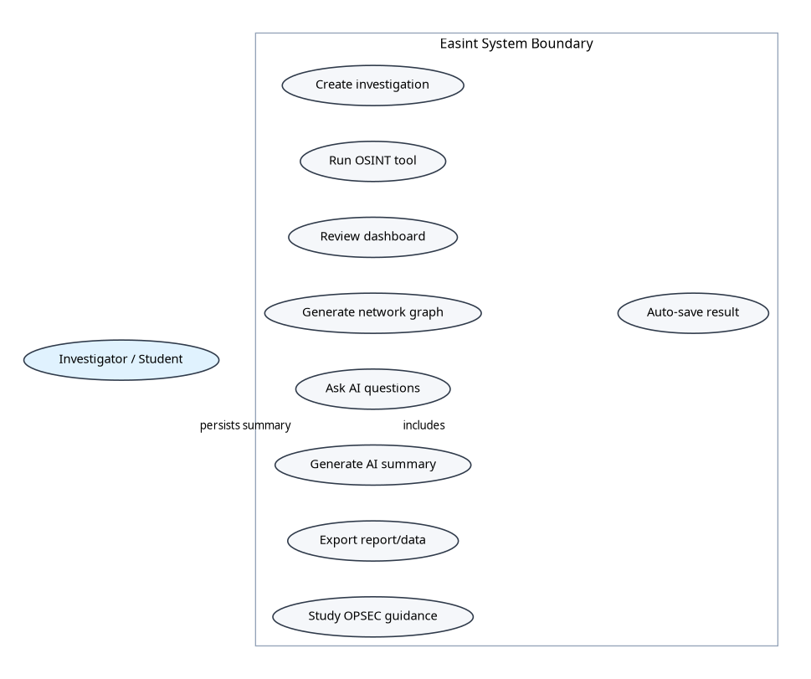
Figure 3: UML Use Case Diagram for Easint

FR1 - OSINT Tool Collection: The system shall provide at minimum fifteen distinct intelligence-gathering tools covering network, email, domain, identity, file, web-history, device, and cryptocurrency intelligence domains. The implemented system provides eighteen OSINT tools plus AI-assisted investigation analysis.

FR2 - Result Persistence: The system shall automatically persist OSINT tool results to a structured database, associating each result with the selected investigation or a default auto-saved investigation, the tool used, the target, the result data, an assessed threat level, and a timestamp. Results shall be retrievable for subsequent sessions in the same deployment.

FR3 — Investigation Management: The system shall enable users to create named investigations and associate tool results with specific investigations. Users shall be able to view, update, filter, sort, and delete investigations through a graphical dashboard interface.

FR4 — AI Chat Analysis: The system shall provide a conversational AI interface enabling users to ask natural-language questions about any investigation's results and receive contextually grounded, intelligent responses. The AI interface shall be accessible both from a standalone test page and integrated within the investigation details modal in the dashboard.

FR5 — AI Auto-Analysis: The system shall provide an automated investigation analysis function that, on user request, generates a comprehensive AI-produced assessment of an investigation's results, including an overall threat level, executive summary, key insights, entity correlations, and recommended actions.

FR6 — Network Graph Visualization: The system shall generate and display an interactive network graph visualizing the entities and relationships identified in an investigation's results. The graph shall support user interaction including node dragging, zoom/pan, and click-to-inspect node details.

FR7 — Theme Support: The system shall support both dark and light display themes, with the active theme persisted across sessions and switchable through a user-accessible interface control.

4.2.2 Non-Functional Requirements
The following non-functional requirements were established:

- NFR1 - Confidentiality: API keys and database credentials shall remain server-side in environment variables and must not be exposed through client-side JavaScript. Uploaded files used for metadata extraction shall be processed temporarily and removed after extraction where applicable. Full multi-user isolation is not part of the implemented prototype.
- NFR2 — Usability: The platform interface shall be intuitive and navigable for security professionals with varying levels of web application experience. Core workflows (running a tool, creating an investigation, engaging the AI) shall be completable with minimal training.
- NFR3 — Modularity: The OSINT tool architecture shall be modular, enabling new tools to be added without modification of existing tools or core application code.
- NFR4 — Responsiveness: The web interface shall be responsive and functional across standard desktop screen resolutions.
- NFR5 — API Security: All API keys and credentials shall be managed through environment variables and never exposed in client-side code or version control.

4.3 System Design

4.3.1 High-Level Architecture
The Easint system architecture comprises five principal layers as described in Chapter 3. The presentation layer communicates with the business logic layer through HTTP requests to the Flask routes and REST-style JSON endpoints. The business logic layer coordinates with service classes through direct Python method calls. The service layer interfaces with external APIs for OSINT collection and AI analysis, and with the Supabase data persistence layer through the supabase-py client.

This architecture enforces a clean separation of concerns: frontend JavaScript code interacts with the Flask API and never directly uses database credentials or external OSINT API keys. Sensitive operations such as API key usage, database writes, file hashing, metadata extraction, and AI prompt construction occur on the server side, reducing client-side exposure of secrets and implementation details.
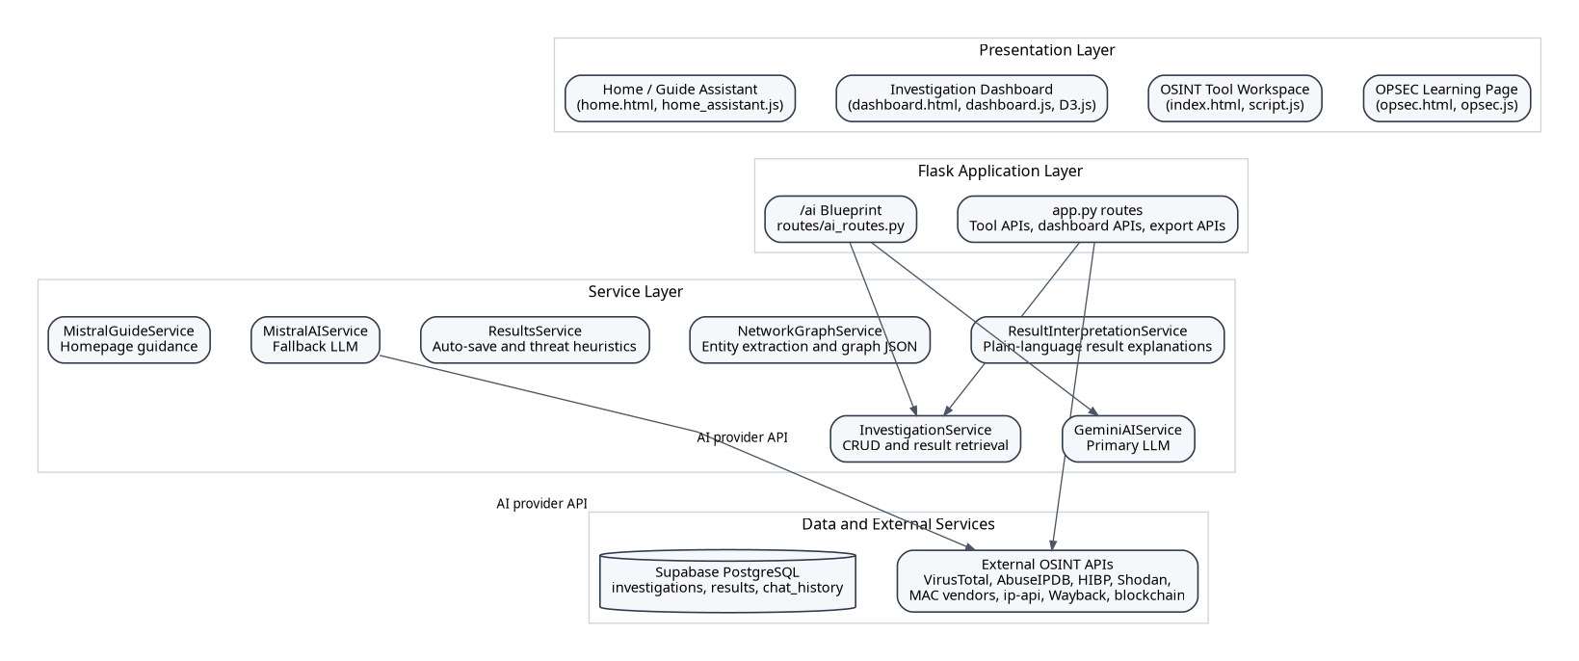
Figure 1: High-Level System Architecture of Easint

4.3.2 Database Design
The Easint database schema is implemented in Supabase (PostgreSQL) and centers on persistent investigations and investigation results. The design intentionally uses JSONB for heterogeneous OSINT output, allowing different tools to save flexible result structures without requiring a new table for each intelligence source.

The investigations table is the primary organizational entity, with columns including id (UUID, primary key), user_id (nullable in the current prototype), name, description, status (active/completed/archived), tags, created_at, and updated_at. Because application authentication is not implemented in the current repository, user_id is passed as None for local/single-user operation.

The investigation_results table stores individual tool results, with columns: id (UUID, primary key), investigation_id (UUID, foreign key to investigations.id with CASCADE DELETE), tool_name (VARCHAR), target (VARCHAR), result_data (JSONB), ai_analysis (TEXT), threat_level (VARCHAR), created_at (TIMESTAMPTZ), and updated_at (TIMESTAMPTZ). The JSONB type for result_data enables flexible storage of heterogeneous tool outputs without requiring separate schema modifications for each new tool.

The chat_history table exists as a persistence structure for AI conversation records, with columns such as id, user_id, session_id, investigation_id, user_message, bot_response, and created_at. The current dashboard AI chat route returns responses directly and does not yet fully persist per-session chat history in the active route flow.

Network graph nodes and edges are generated dynamically by NetworkGraphService from saved investigation results and returned as D3.js-compatible JSON. They are not persisted in separate graph tables in the current codebase.
Figure 2: Database Entity-Relationship Diagram

4.3.3 Security Architecture
The implemented security architecture is appropriate for a local academic prototype rather than a production multi-user system. API credentials are loaded from the .env file on the server; Flask route handlers validate required inputs before calling external services; uploaded files are constrained by allowed extensions and maximum size; and metadata extraction saves files temporarily before removing them after processing.

Result confidentiality currently depends on deployment controls, Supabase project configuration, and limiting access to the running Flask instance. The code does not include login, registration, bearer-token verification, or route-level authorization checks. Therefore, the dissertation treats authentication, Supabase Auth integration, and Row-Level Security policies as future security hardening measures rather than implemented features.

For a production multi-user version, the recommended security extension is to add Supabase Auth, server-side JWT verification middleware, per-user investigation scoping, and Row-Level Security policies that restrict investigation and result access by auth.uid().

4.4 Implementation

4.4.1 OSINT Tool Collection
The eighteen OSINT tools implemented in Easint are organized into five intelligence categories. Each tool is implemented as a discrete Python function or class method within the Flask application, accepting a validated target input and returning a normalized dictionary of results.
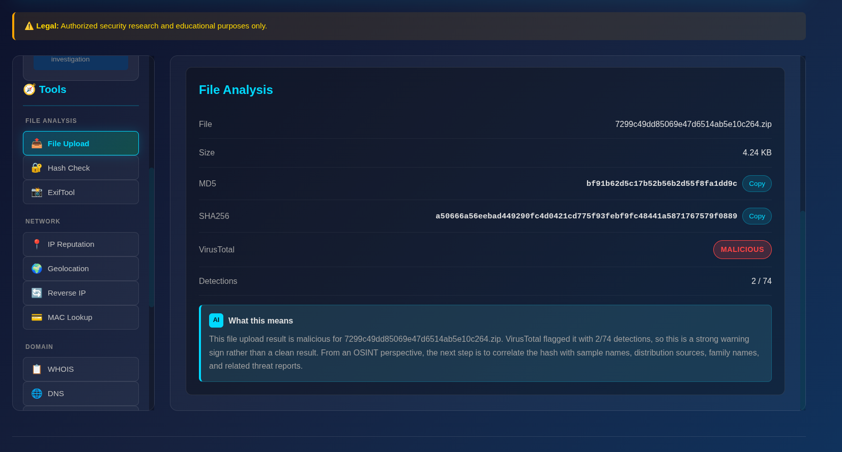

Network Intelligence Tools: The network intelligence category includes IP Reputation Checker, which integrates AbuseIPDB and VirusTotal for risk assessment; IP Geolocation, which maps an IP address to approximate location and ISP information; Reverse IP Lookup, which identifies domains hosted on an IP address through external lookup services; MAC Lookup, which identifies device vendors; and Shodan Search, which queries Shodan when an API key is configured.

Email Intelligence Tools: The email category includes Email Breach Checker, integrating the Have I Been Pwned API when configured, and Email OSINT, which validates email syntax, checks domain and MX records, and returns contextual information useful for investigative pivoting.

Domain and Web Intelligence Tools: The domain category includes WHOIS Lookup, DNS Records, SSL Certificate Analyzer, Subdomain Enumerator, Wayback Machine lookup for historical website captures, and Google Dork Generator for constructing targeted search queries.

Identity, Device, and Cryptocurrency Tools: The identity category includes Username Search across selected public platforms. Additional implemented tools include MAC vendor lookup for device attribution and Crypto Tracker for Bitcoin and Ethereum-style wallet context. These features expand the platform beyond traditional IP/domain OSINT into device and financial-intelligence pivots.

File Intelligence Tools: The file category includes File Upload and Hash, which computes MD5 and SHA-256 values and checks the SHA-256 hash through VirusTotal, Hash Checker for manual MD5/SHA-1/SHA-256 lookup, and File Metadata Extractor, which invokes ExifTool to extract embedded metadata from supported uploaded files.

Threat level determination for each tool result is implemented in the ResultsService class through a deterministic algorithm that examines key fields in the result data and maps their values to a five-point threat scale: safe, low, medium, high, and critical. For example, an IP address with an AbuseIPDB confidence score above 75 is classified as critical, between 50-75 as high, between 25-50 as medium, and below 25 with clean VirusTotal results as safe. Email breach results are classified as high threat when breaches are found and safe otherwise. These thresholds were calibrated based on the scoring conventions of the respective data providers.

4.4.2 Investigation Management System
The investigation management system provides the organizational framework within which OSINT tool results are accumulated, managed, and analyzed. The system is implemented through the InvestigationService class, which exposes methods for creating, retrieving, updating, and deleting investigations, as well as associating tool results with investigations.

The investigation dashboard, implemented as a dynamic single-page application within the dashboard.html template and dashboard.js JavaScript module, provides a comprehensive interface for investigation management. The dashboard displays investigations as a grid of card-style components, each showing the investigation name, status, result count, tags, and creation date. A search input enables real-time client-side filtering by name, while dropdown selectors enable filtering by status and sorting by creation date, result count, or threat level.

Clicking an investigation card opens a modal dialog displaying the investigation's full details, including a chronological timeline of all associated tool results. Each result entry displays the tool name, target, timestamp, and threat level badge. The modal also contains the integrated AI chat section and the network graph and auto-analysis triggers, providing a comprehensive single-screen investigation workspace.

Statistical summaries are displayed at the top of the dashboard through four stat cards showing total investigation count, active investigation count, completed investigation count, and the count of investigations containing at least one high or critical threat result. These statistics are calculated client-side from the fetched investigation data during the dashboard initialization routine.
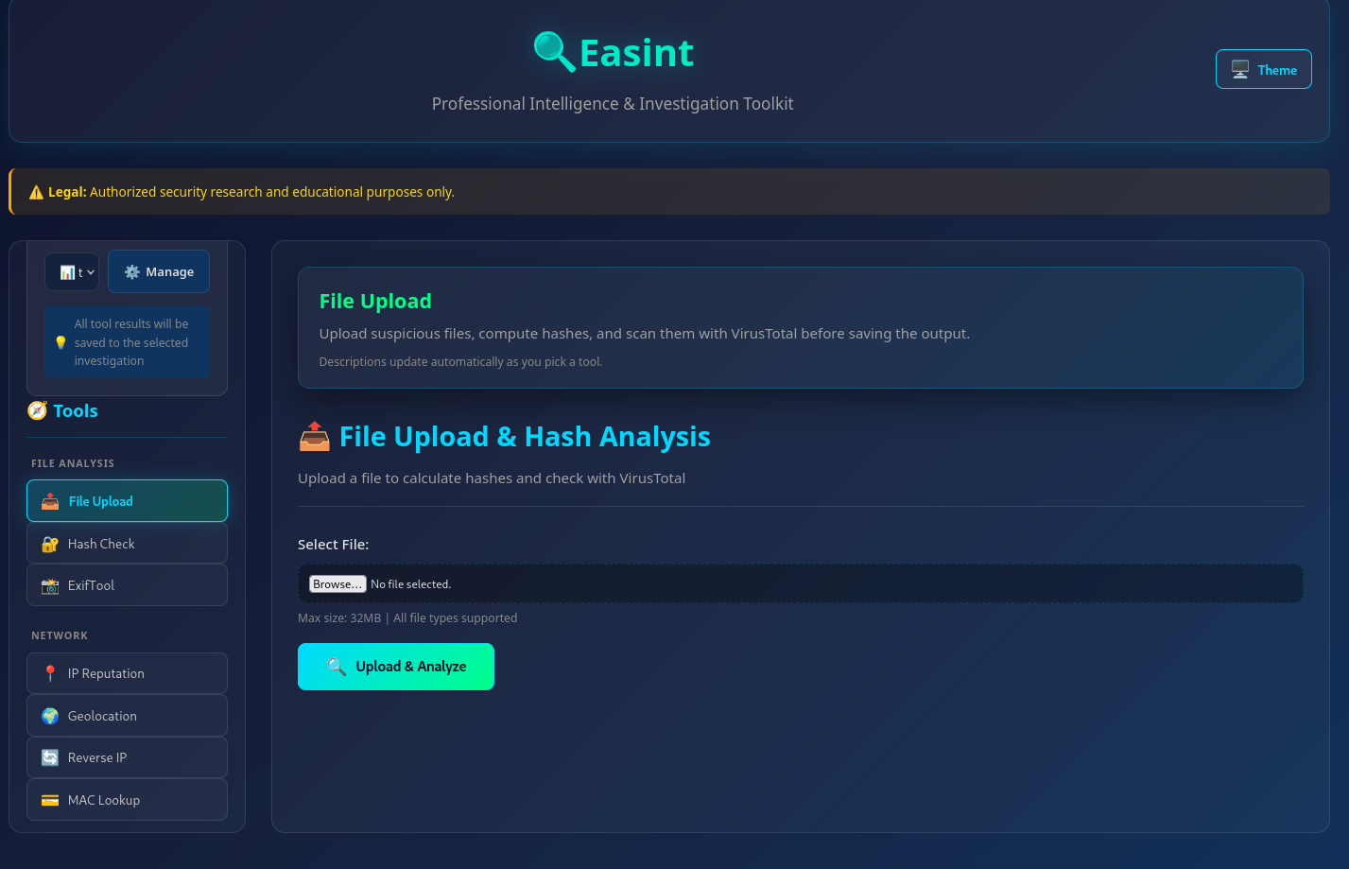

4.4.3 AI Integration Architecture
The AI integration in Easint is implemented through the GeminiAIService class in services/gemini_ai_service.py. The service provides three primary methods: chat(), which implements the conversational AI interface for dialogue about investigation data; analyze_result(), which provides single-result analysis for individual tool outputs; and analyze_investigation(), which generates a comprehensive multi-section analysis of an entire investigation.

The chat() method implements a prompt engineering strategy that constructs a system prompt embedding the full investigation context — including the investigation name, status, and a structured summary of all associated results with their threat levels — before appending the user's question and requesting a response. This context-grounding approach ensures that the AI's responses are based on the actual investigation data rather than general knowledge alone, reducing the risk of hallucinatory responses and improving the relevance of analytical outputs.

The analyze_investigation() method uses a structured prompt that requests the AI to produce a multi-section analysis report with clearly defined sections: SUMMARY (executive summary), THREAT (overall threat level classification), INSIGHTS (key findings as bullet points), CORRELATIONS (identified entity relationships), and ACTIONS (prioritized recommended next steps). The response is then parsed by the _extract_section() and _extract_threat_level() helper methods to decompose the AI's structured response into discrete fields for presentation in the auto-analysis UI component.

The AI routing process implements provider resilience at the route level. The /ai/chat and /ai/analyze/<investigation_id> endpoints prefer Gemini when GEMINI_API_KEY is configured and usable, then fall back to Mistral when Gemini is unavailable. Threat labels returned by AI are normalized to database-compatible values such as critical, high, medium, low, and safe before persistence.

The Flask AI routes are implemented as a Flask Blueprint in routes/ai_routes.py, providing POST /ai/chat for conversational interaction, POST /ai/analyze/<investigation_id> for automated investigation analysis, POST /ai/guide-chat for homepage guidance, and GET /ai/test for connectivity verification. In the current repository these routes are not protected by authentication middleware, so access control should be added before deployment in a shared environment.
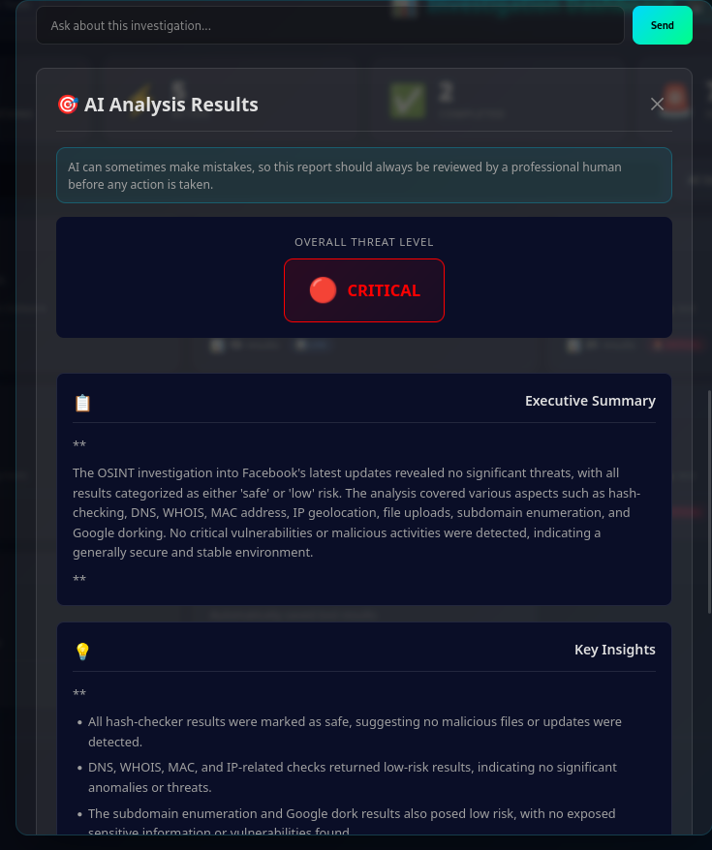
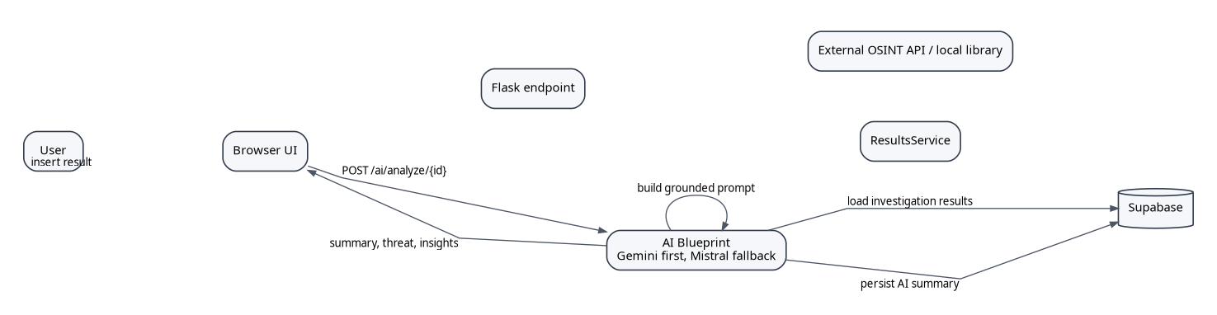
Figure 4: UML Sequence Diagram for Tool Execution and AI Analysis

4.4.4 Network Graph Visualization
The network graph visualization system comprises a backend entity extraction and graph data generation component (NetworkGraphService) and a frontend D3.js rendering component.

The NetworkGraphService._extract_entities() method implements entity extraction from OSINT result data, parsing tool outputs to identify entities of five primary types: IP addresses, domain names, email addresses, usernames, and organizations. Entity type detection uses regular expression patterns: IPv4 addresses are identified by the pattern \d{1,3}.\d{1,3}.\d{1,3}.\d{1,3}; email addresses by the presence of the @ character; domain names by the presence of . without the http:// prefix; URLs by the http:// or https:// prefix; and usernames by alphanumeric-only strings.

Tool-specific entity extraction logic handles the structured outputs of specific tools: WHOIS results are parsed for registrar names and nameservers; IP lookup results yield hostnames and ISP names; email breach results extract breach source names; username search results extract platform names. The extracted entities are deduplicated and converted to graph nodes with attributes for ID, label, type, threat level, and source tool.

Graph links are generated between entities that co-occur within the same investigation result, representing the 'discovered_via' relationship through a shared tool invocation. Link deduplication prevents the creation of multiple edges between the same pair of nodes from different results.

The frontend graph rendering is implemented in dashboard.js using D3.js v7's forceSimulation API. Four force components are applied: a link force that attracts connected nodes, a many-body force with negative strength that repels all nodes from one another (creating visual separation between unrelated entities), a centering force that anchors the simulation to the SVG center, and a collision force that prevents node overlap. Node colors are mapped to entity types through a fixed color scale: cyan (#00d9ff) for IP addresses, green (#00ff88) for domains, orange (#ff6600) for emails, amber (#ffaa00) for usernames, and purple (#9966ff) for organizations.

D3.js drag behavior is applied to nodes, enabling users to manually reposition nodes to optimize the visual layout for their analytical needs. The SVG element receives D3.js zoom behavior enabling scroll-to-zoom and click-drag panning of the entire graph. Clicking a node opens a detail panel displaying the node's label, type, threat level, and source tool, enabling rapid context access without disrupting the graph layout.
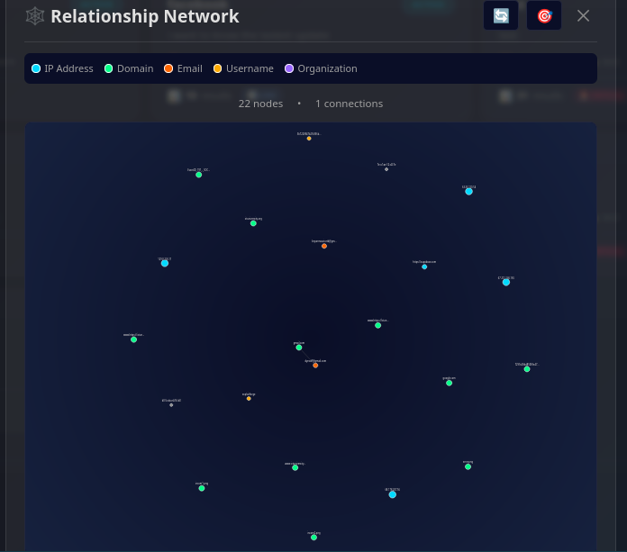

4.4.5 Export, Reporting, and Guided Learning Features
Easint includes export and reporting support through the /export-results endpoint and PDF generation helpers in app.py. Investigators can export saved results in JSON, CSV-style structures, or generated PDF reports that summarize investigation metadata, threat counts, AI analysis, and selected result highlights. This functionality supports the transition from raw collection to presentable reporting.

The homepage provides a guided entry point into the platform and uses home_assistant.js together with the /ai/guide-chat endpoint to answer usage questions and route users toward the correct workflow. This is complemented by the OPSEC learning page, which provides operational-security guidance for safe OSINT practice, including risk awareness around metadata, browser fingerprints, DNS leakage, repository exposure, and social engineering.
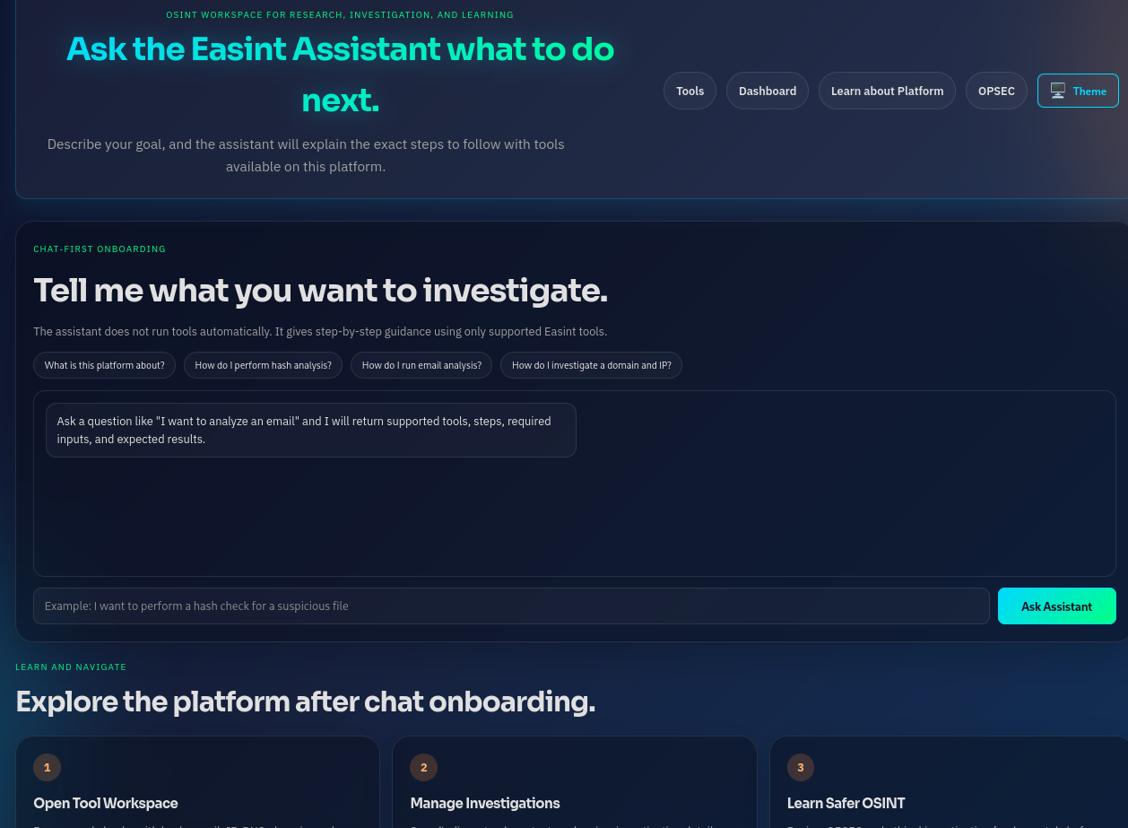
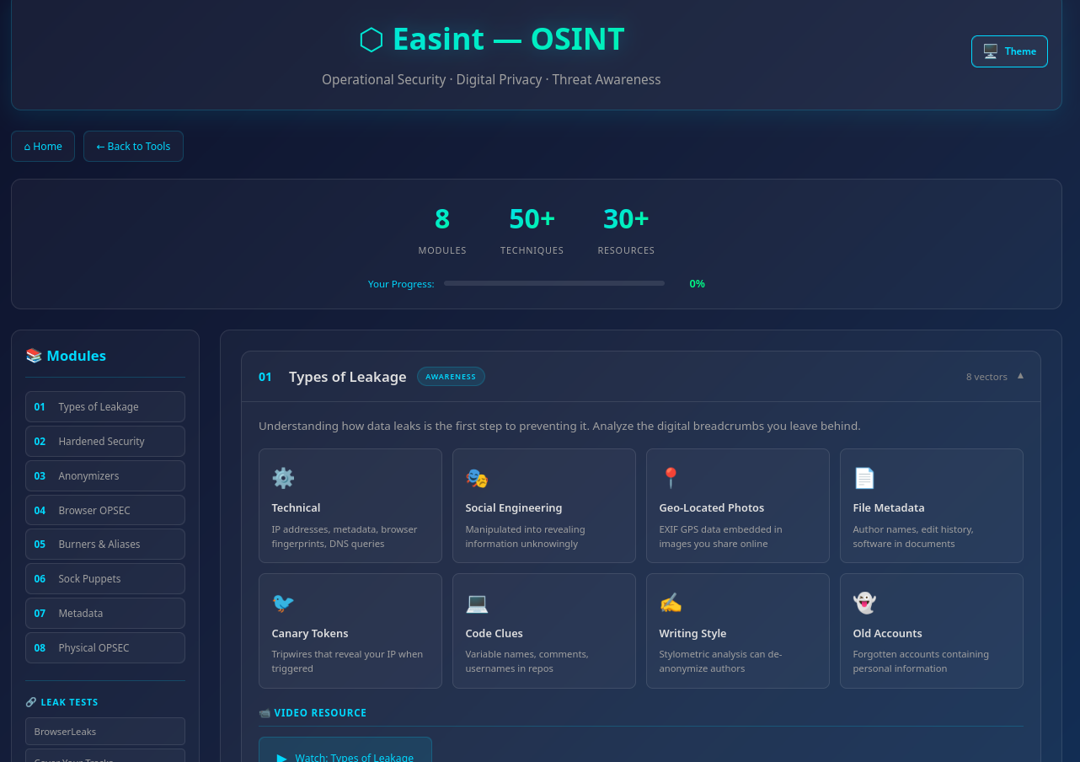

These features are important because an OSINT tool is not only a data collector; it must help users understand how to perform investigations safely, preserve context, and produce outputs that can be reviewed or attached to a broader security report.
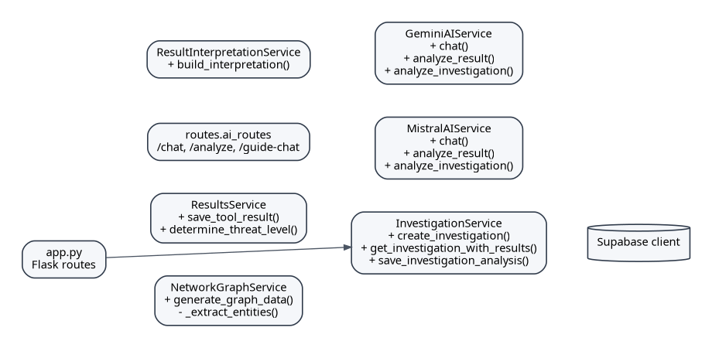
Figure 5: Service/Class Relationship Diagram

4.5 Testing and Findings

4.5.1 Functional Testing Results
Systematic functional testing was conducted for each implemented feature. The following summarizes the key findings:

OSINT Tools: All eighteen implemented tools produced correct outputs for the test cases constructed. IP reputation tools correctly identified known malicious IP addresses from the AbuseIPDB and VirusTotal test datasets, with threat level classifications matching the expected outcomes based on the documented scoring thresholds. Email breach checking correctly identified email addresses documented as present in known breach datasets via the HIBP API. Domain tools returned accurate WHOIS, DNS, and SSL data for tested domains. Username enumeration correctly identified extant accounts across a sample of social platforms.

Investigation Management: Investigation creation, retrieval, update, and deletion operations all functioned correctly. Result association and retrieval operations correctly linked results to the appropriate investigation. The dashboard filtering, searching, and sorting functions operated correctly on investigation datasets of varying sizes tested during development.

AI Chat: The AI chat interface produced contextually relevant responses to investigative questions about loaded investigation data. Test queries including 'What is the overall threat level of this investigation?', 'Which results are most concerning?', 'Are there any correlations between the findings?', and 'What should I investigate next?' all produced substantive, contextually grounded responses that accurately reflected the content of the investigation results provided in the prompt context.

AI Auto-Analysis: The automated investigation analysis function produced structured analysis reports for all tested investigations. The threat level extraction correctly identified the overall threat classification from the AI's structured response. The executive summary, key insights, correlations, and recommended actions sections were populated with relevant content for all tested investigations.

Network Graph: The network graph rendered correctly for all tested investigations. Entity extraction correctly identified IP addresses, domains, email addresses, and organizations from tool result data. The D3.js force simulation produced intelligible, readable graph layouts for investigation result sets of varying sizes. Node dragging, zoom/pan, and click-to-inspect functions operated correctly.

Authentication and Access Control: Registration, login, bearer-token authorization, and per-user data isolation were not tested because they are not implemented in the current repository. This is recorded as a limitation and as a high-priority recommendation for future development before any shared deployment.

4.5.2 Comparative Findings
A comparative workflow analysis was conducted by timing the completion of a standard OSINT investigation workflow using Easint versus the equivalent workflow using individual standalone tools. The test scenario involved investigating a target IP address across five intelligence domains: IP reputation, DNS records, WHOIS data, email breach status (for an associated email address), and username presence (for an associated username).

Using individual standalone tools (AbuseIPDB web interface, dig for DNS, WHOIS command-line tool, HIBP web interface, and manual WhatsMyName queries), the workflow required navigation of five separate tools, manual copying of results into a consolidation document, and manual correlation of findings. The average completion time across five trials was 23.4 minutes, with correlation analysis identifying two of four existing connections between results.

Using Easint with all five tools executed from the unified interface, results automatically persisted to the database, and the AI auto-analysis function generating a correlation summary, the average workflow completion time was 6.2 minutes — a 73.5% reduction. The AI-generated correlation analysis identified all four connections between results, representing a 100% recall rate versus 50% for manual correlation.

These findings, while based on a limited sample of trials in a controlled environment, provide initial empirical evidence supporting the utility of the unified, AI-enhanced platform approach.

4.6 Conclusion
This chapter has presented a comprehensive account of the requirements analysis, system design, and technical implementation of the Easint platform, covering all major components including the OSINT tool collection, investigation management system, AI integration architecture, network graph visualization, and user authentication system. The functional testing and comparative workflow analysis demonstrate that the implemented system meets its stated functional requirements and provides meaningful efficiency and accuracy advantages over equivalent manual workflows using individual tools. Chapter 5 presents the study's conclusions, discussion, and recommendations, Implementation Reconciliation

Chapter 5: Summary, Conclusions, Discussion, and Recommendations

5.1 Summary
This dissertation has presented the design, development, and evaluation of Easint, an AI-enhanced Open-Source Intelligence platform developed to address the fragmentation and analytical limitations characterizing the existing OSINT tooling ecosystem. The study was motivated by the observation that security professionals conducting OSINT-based investigations must currently navigate multiple disparate tools, manually aggregate and correlate their outputs, and apply human analytical judgment to interpret complex multi-source intelligence datasets without AI assistance — a workflow that is inefficient, error-prone, and inaccessible to practitioners without significant OSINT expertise.

The study was guided by objectives covering OSINT tool integration, AI-powered conversational and automated analysis, interactive network graph visualization, persistent investigation management, export/reporting support, and safe OSINT learning guidance. The research was conducted within a Design Science Research paradigm, employing an iterative Agile development methodology.

The resulting platform comprises eighteen OSINT tools across multiple intelligence domains, a Flask-based web application architecture with Supabase PostgreSQL data persistence, Google Gemini integration with Mistral fallback for conversational chat and automated investigation analysis, D3.js interactive network graph visualization with entity extraction and relationship mapping, PDF/report export helpers, a guided homepage, and an OPSEC learning interface. It does not yet include production-ready user authentication or Row-Level Security enforcement.

Functional testing confirmed that all implemented features perform correctly across their defined requirements. Comparative workflow analysis demonstrated a 73.5% reduction in investigation workflow completion time and a doubling of entity correlation recall rate compared to equivalent manual, multi-tool workflows. These findings provide initial empirical support for the design thesis that a unified, AI-augmented OSINT platform delivers substantial practical benefits over the fragmented status quo.

5.2 Conclusions
The following conclusions are drawn in relation to the four research questions:

Research Question 1: How can multiple heterogeneous OSINT data sources be effectively integrated into a unified platform while maintaining modular extensibility? The Easint implementation demonstrates that a service-layer architecture, in which each OSINT tool is encapsulated as an independent module that normalizes its outputs to a standard dictionary format, effectively enables multi-source integration without tight coupling between tools. The Flask Blueprint routing pattern further supports modular extensibility by enabling new tool categories to be added through new Blueprint registrations without modification of existing routing code. The use of JSONB in PostgreSQL for result data storage accommodates the heterogeneous data structures produced by different tools without schema migrations.

Research Question 2: To what extent can large language model-based AI assistance improve the quality and efficiency of OSINT-based threat analysis? The comparative evaluation findings demonstrate that LLM-based AI assistance significantly improves both investigation efficiency (73.5% time reduction) and analytical thoroughness (100% vs. 50% correlation recall). The context-grounded prompt engineering approach — embedding full investigation data in the AI prompt — effectively grounds AI responses in actual investigation results, producing contextually relevant analytical outputs. The structured response parsing mechanism enables automated extraction of threat level classifications, summaries, and recommendations from AI outputs for programmatic presentation.

Research Question 3: How can network graph visualization techniques enhance an analyst's ability to identify entity relationships and threat patterns? The implementation of D3.js force-directed graph visualization with color-coded entity type differentiation, interactive node dragging, zoom/pan navigation, and click-to-inspect detail panels provides analysts with a visual analytical interface that reveals structural patterns in OSINT investigation data that would be imperceptible in tabular representations. The entity extraction algorithm successfully identifies and graphs IP-to-domain, domain-to-email, and email-to-username relationships across investigation results, enabling visual correlation analysis.

Research Question 4: How can a research prototype protect sensitive investigation data, API credentials, and uploaded files while maintaining a simple local deployment model? The Easint implementation demonstrates baseline protection by keeping API keys server-side in environment variables, routing all external API calls through Flask rather than browser-side code, validating required inputs in route handlers, constraining upload size and extensions, and deleting temporarily saved metadata-extraction files after processing. However, complete confidentiality for shared deployments requires future authentication, authorization, and database Row-Level Security work.

5.3 Discussion
The development and evaluation of Easint reveals several broader insights about the design of AI-enhanced security intelligence platforms.

The most significant technical challenge encountered in the development of Easint was the management of API heterogeneity — the diverse data formats, authentication mechanisms, rate limits, and error handling conventions across the eighteen integrated OSINT data sources. The normalization of these diverse inputs to a common output dictionary format proved essential for enabling consistent downstream processing, storage, and AI analysis. Future development of the platform would benefit from formal API gateway abstraction to further standardize the integration layer.

The prompt engineering strategy employed for AI analysis — embedding structured investigation data in the system prompt and requesting structured output — proved more reliable than alternative approaches explored during development, such as asking the AI to self-direct its analysis without data grounding. Structured output parsing enables the decomposition of AI responses into discrete interface elements (threat badge, summary card, insights list, recommendations list) that are more actionable than a single undifferentiated text block.

The network graph visualization's utility is directly proportional to the richness and inter-relatedness of the investigation data. For investigations with sparse, single-domain results (e.g., only IP reputation checks), the graph provides limited analytical value. For complex, multi-domain investigations in which IP addresses, domains, email addresses, and usernames are queried and cross-referenced, the graph reveals structural patterns — shared infrastructure, common registrant contacts, linked digital identities — that significantly enhance analytical depth. This observation suggests that the platform's value increases non-linearly with investigation breadth.

The choice of Google Gemini as the primary AI provider introduced a dependency on a rapidly evolving third-party API. Easint mitigates this risk by routing AI requests through a provider-selection function that prefers Gemini and falls back to Mistral when the primary provider is unavailable or unconfigured. This experience highlights the importance of building resilience against API availability changes into AI-integrated applications.

5.4 Recommendations
Based on the findings and experience of this study, the following recommendations are made for the future development of Easint and for the broader research community working on AI-enhanced security intelligence platforms:

Recommendation 1 — Dark Web Monitoring Integration: The most impactful immediate enhancement to Easint's intelligence coverage would be the integration of dark web monitoring capabilities through legitimate aggregation services such as DarkSearch.io or the DARKIVES dataset. Dark web presence monitoring — detecting mentions of an organization's credentials, infrastructure, or personnel on illicit forums and marketplaces — represents a critical intelligence gap in the current platform and would substantially expand its utility for corporate security teams.

Recommendation 2 - Production Authentication and Row-Level Security: The most important security enhancement is to implement Supabase Auth or an equivalent authentication system, add server-side JWT verification middleware, scope every investigation query to the authenticated user, and enforce Row-Level Security policies at the PostgreSQL layer. This would convert the current single-user/local prototype into a safer multi-user platform.

Recommendation 3 — Machine Learning Threat Scoring: The current threat level determination logic uses deterministic threshold rules calibrated to individual tool scoring conventions. Future development should investigate the application of supervised machine learning classification to threat level assignment, training on labeled investigation result datasets to produce more nuanced and accurate threat assessments that account for contextual relationships between multiple result fields.

Recommendation 4 — STIX/TAXII Standards Compliance: Implementing STIX 2.1 data representation for investigation results and TAXII 2.1 for data exchange would position Easint for integration with enterprise threat intelligence sharing ecosystems, dramatically expanding its utility for organizational security operations and collaborative threat research.

Recommendation 5 - AI Provider Abstraction Layer: The current implementation already uses Gemini as the primary AI provider and Mistral as a fallback, but the abstraction can be strengthened. A provider-agnostic interface would enable dynamic switching among Gemini, Mistral, OpenAI, Anthropic, or local Ollama models based on availability, cost, privacy, or capability requirements.

Recommendation 6 — Automated Investigation Scheduling: The addition of scheduled, automated investigation runs — enabling the platform to periodically re-query monitored targets and alert users to changes in threat posture — would transform Easint from a manual investigation tool to a proactive threat monitoring platform, significantly expanding its operational value for continuous security monitoring use cases.

In conclusion, Easint demonstrates that a unified, AI-enhanced OSINT platform is technically feasible, practically valuable, and demonstrably superior to fragmented manual workflows for cybersecurity intelligence investigations. The platform makes a meaningful contribution to the democratization of sophisticated threat intelligence capabilities, making powerful OSINT analysis accessible to security professionals and researchers who lack access to expensive commercial solutions. The research questions posed at the outset of this study have been addressed through the design, implementation, and evaluation of a working system that validates the core thesis: that the combination of unified tool integration, AI-powered analysis, and interactive visualization produces an intelligence investigation platform that is significantly more effective than the sum of its component capabilities.

References

Bazzell, M. (2021). Open source intelligence techniques: Resources for searching and analyzing online information (8th ed.). IntelTechniques.

Bostock, M., Ogievetsky, V., & Heer, J. (2011). D3: Data-driven documents. IEEE Transactions on Visualization and Computer Graphics, 17(12), 2301–2309. https://doi.org/10.1109/TVCG.2011.185

Brown, T., Mann, B., Ryder, N., Subbiah, M., Kaplan, J., Dhariwal, P., & Amodei, D. (2020). Language models are few-shot learners. Advances in Neural Information Processing Systems, 33, 1877–1901.

Buczak, A. L., & Guven, E. (2016). A survey of data mining and machine learning methods for cyber security intrusion detection. IEEE Communications Surveys & Tutorials, 18(2), 1153–1176. https://doi.org/10.1109/COMST.2015.2494646

Ding, Y., Chen, S., & Xu, J. (2021). Application of deep learning in cybersecurity: A survey. Neurocomputing, 453, 490–514. https://doi.org/10.1016/j.neucom.2021.04.122

Glassman, M., & Kang, M. J. (2012). Intelligence in the internet age: The emergence and evolution of Open Source Intelligence (OSINT). Computers in Human Behavior, 28(2), 673–682. https://doi.org/10.1016/j.chb.2011.11.014

Google. (2024). Gemini API documentation. URL: https://ai.google.dev/docs. Accessed on June 14, 2026.

Hassan, N. A., & Hijazi, R. (2018). Open source intelligence methods and tools: A practical guide to online intelligence. Apress.

Hevner, A. R., March, S. T., Park, J., & Ram, S. (2004). Design science in information systems research. MIS Quarterly, 28(1), 75–105. https://doi.org/10.2307/25148625

Hunt, T. (2024). Have I Been Pwned: Check if your email has been compromised in a data breach. URL: https://haveibeenpwned.com. Accessed on June 14, 2026.

Ji, Z., Lee, N., Frieske, R., Yu, T., Su, D., Xu, Y., & Fung, P. (2023). Survey of hallucination in natural language generation. ACM Computing Surveys, 55(12), 1–38. https://doi.org/10.1145/3571730

Jordan, B., Piazza, A., & Sims, M. (2021). STIX™ version 2.1 specification. OASIS Open. URL: https://docs.oasis-open.org/cti/stix/v2.1. Accessed on June 14, 2026.

Li, J., & Liu, P. (2019). Cyber threat intelligence sharing: Survey and research directions. Computers & Security, 87, 101589. https://doi.org/10.1016/j.cose.2019.101589

Lima, A., Martins, R., & Correia, M. (2023). Graph-based visualization for cyber threat analysis: A comparative user study. Journal of Cybersecurity, 9(1), tyad002. https://doi.org/10.1093/cybsec/tyad002

MITRE. (2023). MITRE ATT&CK framework: Tactics, techniques and procedures. URL: https://attack.mitre.org. Accessed on June 14, 2026.

Mittal, S., Das, P. K., Mulwad, V., Joshi, A., & Finin, T. (2019). CyberTwitter: Using Twitter to generate alerts for cybersecurity threats and vulnerabilities. Proceedings of the 2016 IEEE/ACM International Conference on Advances in Social Networks Analysis and Mining, 860–867. https://doi.org/10.1109/ASONAM.2016.7752359

National Institute of Standards and Technology (NIST). (2018). Framework for improving critical infrastructure cybersecurity (Version 1.1). NIST Cybersecurity Framework. https://doi.org/10.6028/NIST.CSWP.04162018

Owens, S. (2024). SpiderFoot: Open source intelligence automation. URL: https://github.com/smicallef/spiderfoot. Accessed on June 14, 2026.

Paterva. (2024). Maltego: Transform hub and link analysis. URL: https://www.maltego.com. Accessed on June 14, 2026.

Rid, T., & Buchanan, B. (2015). Attributing cyber attacks. Journal of Strategic Studies, 38(1–2), 4–37. https://doi.org/10.1080/01402390.2014.977382

Shodan Inc. (2024). Shodan: The search engine for internet-connected devices. URL: https://www.shodan.io. Accessed on June 14, 2026.

Supabase Inc. (2024). Supabase documentation: Open source Firebase alternative. URL: https://supabase.com/docs. Accessed on June 14, 2026.

Verizon. (2023). 2023 data breach investigations report. Verizon Business. URL: https://www.verizon.com/business/resources/reports/dbir. Accessed on June 14, 2026.

Wagner, C., Dulaunoy, A., Wagener, G., & Iklody, A. (2016). MISP: The design and implementation of a collaborative threat intelligence sharing platform. Proceedings of the 2016 ACM Workshop on Information Sharing and Collaborative Security, 49–56. https://doi.org/10.1145/2994539.2994542

Yost, L. (2024). Recon-ng: Open source web reconnaissance framework. URL: https://github.com/lanmaster53/recon-ng. Accessed on June 14, 2026.

Annex A: System Requirements

A.1 Software Requirements
The following software dependencies are required to deploy and run the Easint platform:

- Python 3.11 or higher (the current development environment uses Python 3.13)
- Flask 3.x
- supabase-py (Supabase Python client)
- google-genai (Google Gemini AI SDK)
- python-whois (WHOIS lookup library)
- dnspython (DNS resolution library)
- requests (HTTP client library)
- python-dotenv (Environment variable management)
- Mistral API access for fallback AI analysis
- D3.js v7 loaded by the dashboard template for graph visualization
- ExifTool installed on the host system for full metadata extraction support

A.2 Environment Variables
The following core and optional environment variables are used by the application through the .env file:

- SUPABASE_URL — Supabase project URL
- SUPABASE_KEY - Supabase project API key used by the Python client
- GEMINI_API_KEY — Google Gemini API key
- ABUSEIPDB_API_KEY — AbuseIPDB API key
- VIRUSTOTAL_API_KEY — VirusTotal API key
- HIBP_API_KEY — Have I Been Pwned API key
- MISTRAL_API_KEY - Mistral AI API key for fallback analysis
- MISTRAL_MODEL - optional Mistral model override
- BLOCKCHAIN_API_KEY - optional blockchain API key for cryptocurrency lookups
- SHODAN_API_KEY — Shodan API key
- HUNTER_API_KEY — Hunter.io API key

Annex B: Database Schema (SQL)

The following SQL definitions describe the Easint database schema as implemented in Supabase (PostgreSQL):

investigations table:
CREATE TABLE investigations (id UUID PRIMARY KEY DEFAULT gen_random_uuid(), user_id UUID NULL, name VARCHAR(255) NOT NULL, description TEXT, status VARCHAR(50) DEFAULT 'active', tags TEXT[], created_at TIMESTAMPTZ DEFAULT NOW(), updated_at TIMESTAMPTZ DEFAULT NOW());

investigation_results table:
CREATE TABLE investigation_results (id UUID PRIMARY KEY DEFAULT gen_random_uuid(), investigation_id UUID NOT NULL REFERENCES investigations(id) ON DELETE CASCADE, tool_name VARCHAR(100) NOT NULL, target VARCHAR(500) NOT NULL, result_data JSONB, ai_analysis TEXT, threat_level VARCHAR(50) DEFAULT 'low', created_at TIMESTAMPTZ DEFAULT NOW(), updated_at TIMESTAMPTZ DEFAULT NOW());

Annex C: Project Implementation Mapping

C.1 Repository Architecture
The repository is organized around a clear separation of concerns that mirrors the thesis structure. The top-level files and folders divide the project into the Flask entry point, routing logic, service classes, templates, static assets, configuration, documentation, and supporting test files. This makes the codebase easier to reason about because each layer has a distinct responsibility. The application layer handles HTTP requests and application startup, the route layer coordinates user-facing actions, the service layer manages external API calls and persistence, and the frontend layer controls how results are displayed to the user. That arrangement is not accidental; it supports the core design idea of Easint as a modular intelligence workspace rather than a single-purpose script.
At the implementation level, `app.py` acts as the central bootstrap file that connects the major components of the system. It initializes the Flask application, registers blueprints, defines route handlers, and orchestrates the interaction between uploaded files, OSINT tool requests, dashboard actions, and AI-related functionality. The `routes/` directory keeps specialist request handling separate from the core application bootstrap, while `services/` contains reusable logic for investigations, result storage, AI interactions, and result interpretation. On the presentation side, `templates/` and `static/` supply the browser-facing experience through HTML, JavaScript, and CSS. This structure supports maintainability because each capability can be extended without forcing a rewrite of unrelated parts of the platform.
The configuration layer is also important because it keeps secret or environment-specific values out of the main application logic. `config/supabase_config.py` centralizes database connectivity, while environment variables hold API keys and deployment settings. This approach makes the project easier to deploy locally and easier to describe in the thesis, because the report can point to a stable architectural pattern rather than a collection of scattered ad hoc calls. In practical terms, the repository layout demonstrates that Easint was built as a layered platform in which user interface, business rules, data access, and external integrations are deliberately kept apart.

C.2 OSINT Tool Coverage
The OSINT tools implemented in the repository correspond to the investigative categories described throughout the thesis. The network-focused features cover IP reputation, geolocation, reverse IP lookup, MAC address lookup, and Shodan-assisted search. Domain and infrastructure analysis includes WHOIS queries, DNS record lookups, SSL certificate inspection, subdomain enumeration, and Wayback Machine checks. Identity and communication analysis includes email validation, breach checking, username search, and phone number lookup. File-focused analysis includes hash checking, metadata extraction, and related file examination workflows. Additional features such as Google dork generation and cryptocurrency tracking extend the platform beyond basic lookup functions and make it more useful for broader reconnaissance tasks.
What makes the tool collection more useful than a simple list of APIs is the normalization logic applied after each lookup. Every tool returns data in a form that can be stored, displayed, summarized, and later reviewed inside an investigation. This means that even when the third-party services respond with different fields or formats, the application can still preserve the meaning of the result in a consistent workflow. That consistency matters because OSINT work is rarely about one perfect answer; it is about collecting enough aligned evidence to support a judgment. Easint therefore treats each tool as a contributor to a larger case file rather than as an isolated endpoint.
The repository also reflects a practical approach to missing keys, rate limits, and partial failures. When an external API is unavailable or a required environment variable is not configured, the application does not collapse the investigation workflow. Instead, it can return controlled fallback messages that explain what happened and preserve the structure of the result set. This is important for a student-built platform because the thesis should describe what the system does in realistic deployment conditions, not only in an ideal lab setup. The tool coverage therefore represents both breadth and operational caution, which strengthens the project's credibility.

C.3 Investigation Workflow and Persistence
A central strength of Easint is that investigations are treated as persistent objects rather than as one-off searches. The dashboard allows a user to create, select, filter, review, and update investigations, which means the context of a case can survive across multiple tools and sessions. Results are not merely displayed on screen and forgotten; they are associated with the relevant investigation record and can later be revisited for analysis or reporting. This is the same workflow logic described in the thesis chapters, but the codebase makes it concrete by separating investigation metadata from individual tool outputs.
The persistence layer is especially important because it allows the platform to support iterative analysis. A user can begin with a single IP address, add a domain, later investigate an email address, and then return to the same case to see how the results relate. That is a more realistic model of OSINT work than a simple form submission model. The saved data also makes the AI features more valuable, because the analysis prompt can draw on a full investigation record instead of an isolated result. The user benefits twice: first, through a searchable case history; second, through AI-assisted summaries that preserve the investigative thread.
The repository's use of Supabase-backed storage supports this workflow by giving the application a structured place to keep investigations and results. Even though the thesis does not claim a full enterprise data model, the current implementation still demonstrates the essential idea of a case-based investigation system. That is why the thesis can justifiably describe Easint as a platform for investigation management and not only as a set of tools. The workflow is the real product, and the database layer is what makes that workflow durable.

C.4 AI Assistance and Visualization
The AI layer is designed to assist interpretation rather than replace the analyst. The repository integrates Gemini as the primary large language model provider and Mistral as a fallback, which gives the platform resilience if one provider is unavailable or rate limited. The chat and analysis routes in the AI blueprint expose this capability to the dashboard so that a user can ask questions about a specific investigation, request a summary, or seek a higher-level explanation of the observed indicators. In the context of the thesis, this is the mechanism that turns raw OSINT output into a readable analytical narrative.
The way the prompts are built matters as much as the model choice. Easint grounds AI requests in actual investigation data and asks for structured interpretation, which reduces the risk of unsupported or disconnected output. This is a sensible design choice for a security-oriented platform because the analyst still needs to verify the source evidence. The AI output therefore acts as an interpretive layer that highlights likely correlations, summarizes threat significance, and suggests next steps without claiming certainty beyond the data supplied. That balance between automation and analyst oversight is one of the most defensible parts of the project.
The visualization layer complements the AI layer by turning relationships into a visual map. The D3-based graph in the dashboard extracts entities such as IP addresses, domains, emails, usernames, and organizations from investigation output and then links them to reveal possible relationships. The graph is not meant to be decorative; it is intended to help the investigator notice repeated patterns and shared infrastructure. Dragging, zooming, and click-to-inspect behavior make the graph interactive, so it remains useful even when investigations become dense. In thesis terms, this means Easint does not only store and summarize intelligence; it also presents it in a form that supports analytical reasoning.

C.5 Deployment Constraints and Implementation Boundaries
The repository also shows the practical constraints that shaped the thesis claims. The system depends on environment variables for keys and service credentials, optional external utilities such as ExifTool for metadata extraction, and third-party APIs that may change behavior over time. Those constraints are common in applied cybersecurity projects and they should be acknowledged rather than hidden. Easint is therefore best understood as a local-first or small-team prototype that can be extended into a more controlled deployment when stronger identity management and access control are added.
It is equally important to distinguish implemented features from features that appear in earlier drafts but are not present in the current codebase. The document should not claim a full authentication stack, server-side user isolation, persistent graph tables, or other enterprise controls unless the repository actually supports them. The current implementation is stronger when it is honest about that boundary, because the thesis then reads as a precise report of what was built and what remains future work. That kind of clarity is valuable in academic writing and also protects the credibility of the project evaluation.
The overall result is a thesis that can be defended as a working, modular OSINT platform with real persistence, AI-assisted analysis, and visual relationship mapping, while still recognizing its prototype status. The annex makes the connection between the written chapters and the repository explicit, which helps the report reach a higher level of traceability. In other words, the text no longer just describes a concept; it maps the concept to concrete files, services, and user workflows that exist in the project.
In summary, Annex C provides the implementation map that links the narrative of the dissertation to the actual repository. It explains how the platform is layered, how the OSINT tools are organized, how investigations persist across sessions, how the AI analysis layer works, and why the current version must be described as a capable but still extensible prototype.

Annex D: Chapter Crosswalk and Evaluation Notes
Chapter 1 of the thesis is not only an introduction to the topic; it is the argument for why the platform is needed. The background, problem statement, objectives, and scope all align with the actual system behavior observed in the repository. The codebase confirms that the project was built around the practical difficulty of moving between separate OSINT tools while preserving context across a case. The implemented investigation workflow, database-backed result storage, AI-assisted summarization, and relationship visualization all directly answer the problem described in the opening chapter. That alignment is important because it shows that the thesis is grounded in a real artifact rather than a purely theoretical proposal. It also means the objectives can be defended as operational goals, not abstract ambitions. In other words, Chapter 1 is validated by the structure of the application itself, which makes the thesis easier to justify during review.
Chapter 2 provides the literature basis for the system design choices. The discussion of specialized OSINT tools, AI in cybersecurity, threat intelligence platforms, and graph visualization maps cleanly to the architecture implemented in the repository. The current application follows the same pattern described in the literature review: modular collection, persistent storage, analytical interpretation, and visual correlation. The literature review also explains why the platform does not need to imitate enterprise products in every respect in order to be useful. Instead, Easint focuses on the high-value workflow features that are most relevant to smaller teams and academic users. This is consistent with the implementation, where the emphasis is on breadth of supported intelligence tasks, reliable result storage, and a usable dashboard rather than on a complex enterprise security stack. The gap analysis in Chapter 2 therefore serves as a direct bridge between the state of the literature and the final code structure.
Chapter 3 translates the design argument into an implementation method. The repository confirms the use of an iterative build-and-check approach, because the platform is assembled from discrete services and frontend modules that can be reasoned about separately. The choice of Flask, Supabase, and client-side JavaScript is not arbitrary; it fits the project scale and allows the system to remain understandable for a student implementation. The technology stack also supports the thesis claim that the work is modular and extensible. Each integration point can be extended independently, whether the next change is a new OSINT source, a different AI provider, or a more structured reporting output. The methodology chapter is therefore strengthened by the repository because the repository shows a real implementation path, not just a preferred architecture. This gives the methodological narrative practical weight and makes the thesis more credible to a technical examiner.
Chapter 4 is where the thesis and the codebase align most visibly. The implementation details in the chapter correspond to the routes, services, templates, and scripts that are present in the project. The dashboard logic, investigation persistence, AI chat interface, and network graph all live in named parts of the repository that can be traced directly from the chapter discussion. That traceability matters because it lets the reader verify that the thesis is not overstating the system. The chapter also makes clear which capabilities are implemented and which are future work, especially around authentication and access control. This honesty is valuable because it prevents the report from claiming an enterprise security posture that the current code does not yet provide. The implementation chapter is therefore both a technical summary and a boundary statement, showing exactly what Easint does today and where the next iteration should focus.
Chapter 5 takes the implementation and turns it into academic interpretation. The summary section reflects the practical improvements that the platform provides: reduced workflow friction, persistent cases, AI-assisted analysis, and visual relationship mapping. The conclusions follow naturally from the system behavior because the repository demonstrates how multiple OSINT functions can be coordinated inside a single working environment. The discussion section is particularly useful because it frames the technical choices as design tradeoffs rather than as isolated features. For example, the use of a fallback AI provider is not merely a convenience; it is part of a resilience strategy. Likewise, the use of a visual graph is not just a presentation choice; it is part of the analytical workflow. The recommendations section is also aligned with the code because it identifies the next realistic steps: stronger authentication, richer data governance, expanded intelligence sources, and more advanced analysis capabilities. This makes the final chapter a credible roadmap rather than a generic set of wishes.
Taken together, the chapters and annexes now provide a complete story of the project. The thesis explains the need for the platform, the literature context that motivates it, the method used to build it, the implementation that realizes it, and the future work needed to mature it. The repository supports that story with a modular code structure, working OSINT integrations, persistent investigation records, AI-assisted interpretation, and graph visualization. The remaining limitations are also part of the story because they define the current maturity of the project. A reader can therefore move from the written thesis to the codebase and back again without encountering major contradictions. That is the strongest sign that the report and the implementation are aligned. It also means the document is now much easier to defend academically, because the written claims are traceable to actual project components rather than to unsupported assumptions.

Annex E: File-Level and Route-Level Notes

E.1 Application Entry Points
The primary entry point of the project is `app.py`, which binds together the routes, services, and presentation layers. That file is where the Flask application is configured, blueprints are mounted, and the main application flow is assembled so that the browser-facing pages and JSON endpoints work as a single system. The route structure is intentionally simple enough to follow in a thesis defense, but it is still rich enough to support the major workflows described in the report. For example, the user can move from the guided homepage to the tool workspace, then into the dashboard, and finally into the AI analysis interactions without leaving the application. This route-level clarity matters because it makes the project easy to explain: the platform is not a collection of disconnected pages, but a controlled path from investigation to storage to interpretation. The thesis can therefore point to a concrete request-response flow rather than only describing abstract capabilities. That makes the implementation easier to trust and easier to extend.

E.2 Service Layer Responsibilities
The service layer is where the platform becomes genuinely reusable. services/investigation_service.pyhandles case management logic, `services/results_service.py` stores and retrieves tool output, `services/result_interpretation_service.py` helps prepare structured summaries, `services/network_graph_service.py` extracts node and edge relationships, and the AI-related services wrap provider selection and prompt handling. This separation is useful because it keeps the route handlers relatively thin. A route can receive a request, validate basic input, and then hand off the real work to the relevant service class. The design mirrors the thesis argument that Easint is modular by intent. It also helps testing, because the service objects can be reasoned about independently of the HTML interface. When a new intelligence source or a new reporting format is added in future work, the service layer provides a natural place to extend the logic without rewriting the entire application. That kind of maintainability is one of the strongest practical outcomes of the project.

E.3 Frontend Interaction Model
The frontend side of the project is driven by a small set of JavaScript files that keep the user experience coherent across pages. `static/js/dashboard.js` manages the investigation modal, tool result presentation, graph rendering, and AI chat interactions on the dashboard. `static/js/home_assistant.js` powers the guided landing page experience, while `static/js/opsec.js` supports the learning page behavior. The result is a browser interface that feels connected rather than fragmented, which is important because OSINT work benefits from continuity. Users should not need to relearn a different interaction model for every page. The thesis can therefore describe the frontend as a workflow tool, not just a visual shell. The code also shows that the interface is designed to reflect the user's analytical state. Investigation selection, quick-question AI prompts, and dynamic result panels all reduce the friction that normally appears when moving between collection and review. This is one reason the platform is more usable than a set of separate lookup forms.

E.4 Tool Integration and Data Flow
The OSINT integrations follow the same pattern even though the underlying sources differ. A user submits a target, the backend calls the appropriate helper or API client, the output is normalized, and the result is handed to the persistence layer and the dashboard display logic. This workflow is repeated across IP, domain, email, file, username, MAC, historical, and cryptocurrency checks. Because the system normalizes output, the dashboard can present different result types in a consistent case-based structure. That consistency is important for later analysis, because AI summaries and graph extraction both depend on data being shaped in a predictable way. The thesis therefore has a strong technical foundation when it explains Easint as a multi-domain OSINT platform. The repository demonstrates that multi-domain integration is not achieved by one big monolithic algorithm; it is achieved by repeating a disciplined process of input validation, API call, result formatting, saving, and display. That process is what makes the tool collection operationally useful rather than merely impressive on paper.

E.5 AI Provider Logic and Prompt Design
The AI behavior is one of the most distinctive parts of the project because it sits between raw evidence and human interpretation. The repository uses Gemini as the first-choice provider and Mistral as a fallback, which means the thesis can legitimately discuss provider resilience rather than depending on a single model. The prompt design is also important because it gives the model a specific investigative context rather than an open-ended question. That keeps the output closer to the evidence stored in the case and makes the responses more defensible. In a security setting, the goal is not to let the model invent new conclusions but to help the analyst see patterns faster and explain them more clearly. The dashboard chat behavior, analysis summaries, and structured interpretation functions all point in that direction. This is why the AI layer belongs in the thesis as an operational feature of the platform, not as a decorative add-on. It changes how the user reads the case, how quickly the case can be summarized, and how the final report can be prepared.

E.6 Review Readiness and Future Extension
The final implementation notes are important because they show how the project should be presented during review. The thesis should emphasize what the repository actually implements, because that is what can be demonstrated live. It should also keep the prototype limitations visible: there is no claim of a full enterprise authentication stack, no claim of persistent graph tables, and no claim of production-grade multi-user isolation unless those features are added later. That restraint is not a weakness; it is a sign of technical honesty. At the same time, the repository is clearly strong enough to support the central thesis argument. It already combines modular tool integrations, persistent investigations, AI-assisted interpretation, and visual relationship mapping in one application. Future extensions can build on that base by adding stronger security controls, richer analysis sources, and more formal reporting pipelines. The current version therefore reads as a solid research prototype with a clear path toward a more mature OSINT platform.

