#include <iostream>

main()
{
int c=5;
cout<<"c="<<c<<endl;
cout<<"c="<<++c<<endl;
cout<<"c="<<c++<<endl;
cout<<"c="<<c<<endl;
c++;
cout<<"c="<<c<<endl;
c+=1;
cout<<"c="<<c<<endl;
c=c+1;
cout<<"c="<<c<<endl;
++c;
cout<<"c="<<c<<endl;
}

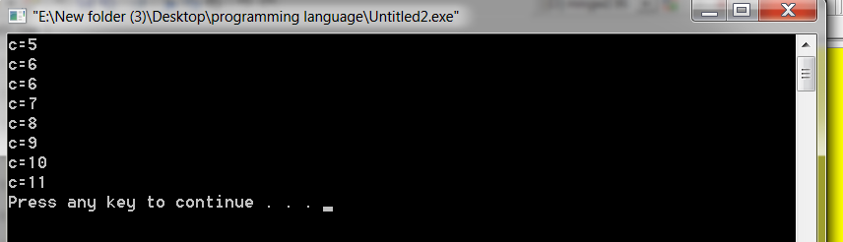

#include <iostream>

main()
{
int z, a=5,b=2, c=3;
z=(a*b/c+(a-b*2+c)*2%2);
cout<<"z="<<z<<endl;
}



#include <iostream>
#include <math.h>
main()
{
int z, a=5,b=2, c=3;
z=pow(a,2)+pow(b,3)-pow(c,pow(b,2));
cout<<"z="<<z<<endl;
}


#include <iostream>
#include <math.h>
main()
{
int z, a=5,b=2, c=3;

cout<< (a>b) <<endl;
cout<< !(a>b) <<endl;
cout<< ((a>b)&&(b>c))<<endl;
cout<< ((a>b)||(b>c))<<endl;
cout<< ((a>b)==(b<c))<<endl;
cout<< !(a)<<endl;
cout<< ((a>b)!=(b<c))<<endl;
}



#include <iostream>
#include <math.h>
main()
{
bool a=true,b=false;

cout<< (a) <<endl;
cout<< !(a) <<endl;
cout<< (a&b)<<endl;
cout<< (a|b)<<endl;
cout<< !(b)<<endl;
}

#include<iostream>
#include<math.h>
main()
{
int a=5,b=6;
float c;
c=a/b;
cout<< "c="<<c <<endl;
float x=5.0, y=6.0,z;
z=x/y;
cout<< "z="<<z <<endl, z;
}



#include<iostream>
main()
{
int a=5,b=6;
float c;
c=a/b;
cout<< "c="<<c <<endl;
float c1;
c1=(float)a/(float)b;
cout<< "c1="<<c1 <<endl;
float x=5.0, y=6.0,z;
z=x/y;
cout<< "z="<<z <<endl, z;
}


#include<iostream>
main()
{
char c ='A';
cout<< "c="<<c <<endl;
cout<< " integer value of "<<c<<" = "<< (int)c <<endl;
}

#include<iostream>
#include<string.h>
main()
{
char c[] ="Ahmed";
cout<< "c="<<c <<endl;
cout<< " integer value of "<<c<<" = "<< (int)c <<endl;
}


