//Program 1-1:
//This program will display a message on the screen.
#include<iostream.h>
main ( )
{
cout <<"welcome to C++";
}
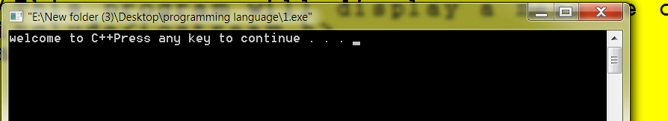

=============================================================
/*Program 1-1:
This program will display a message on the screen.*/
#include<iostream.h>
main ( )
{
cout <<"welcome to C++";
}
=============================================================
/*Program 1-1:
This program will display a message on the screen.*/
#include<iostream.h>
main ( )
{
cout <<"welcome to C++";
cout <<"welcome to C++";
cout <<"my name is";

}
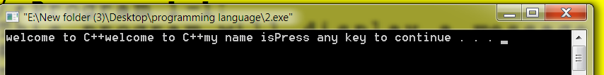
=============================================================
/*Program 1-1:
This program will display a message on the screen.*/
#include<iostream.h>
main()
{
cout <<"welcome to C++/n";
cout <<"welcome to C++";
cout <<"my name is";
}
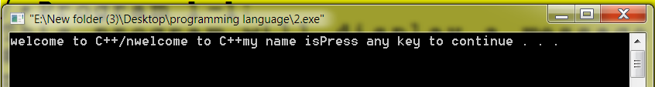
/*Program 1-1:
This program will display a message on the screen.*/
#include<iostream.h>
main()
{
cout <<"welcome to C++\n";
cout <<"welcome to C++\n";
cout <<"my name is\n";
}
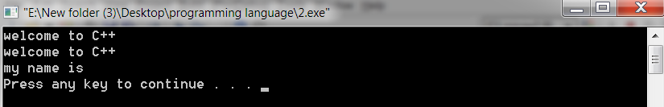
=============================================================
/*Program 1-1:
This program will display a message on the screen.*/
#include<iostream.h>
main()
{
cout <<"welcome to C++\n"
<<"welcome to C++\n"
<<"my name is\n";
}
=============================================================
/*Program 1-1:
This program will display a message on the screen.*/
#include<iostream.h>
main()
{
cout <<"welcome to C++\n"<<"welcome to C++\n"<<"my name is\n";
}
=============================================================
/*Program 1-1:
This program will display a message on the screen.*/
#include<iostream.h>
main()
{
cout <<"welcome to C++"<<endl
<<"welcome to C++"<<endl
<<"my name is"<<endl;
}
=============================================================
/*Program 1-1:
This program will display a message on the screen.*/
#include<iostream.h>
main()
{
cout <<"welcome to C++"<<endl
<<"welcome to C++ endl"<<endl
<<"my name is"<<endl;
}
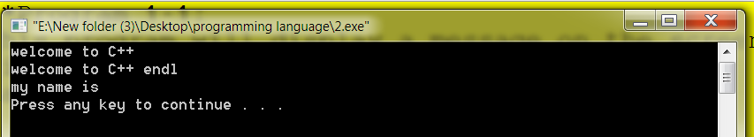
=============================================================
/*Program 1-1:
This program will display a message on the screen.*/
#include<iostream.h>
main()
{
cout <<"welcome to C++"<<endl
<<"welcome to C++\t"
<<"my name is\n";
}
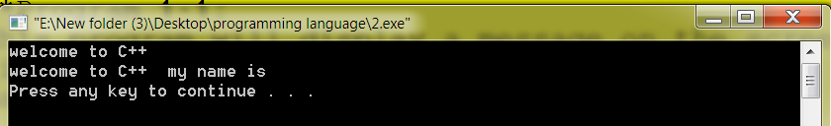
=============================================================
/*Program 1-1:
This program will display a message on the screen.*/
#include<iostream.h>
main()
{
cout <<"welcome to C++"<<endl
<<"welcome to C++"
<<"my name is\n";
}
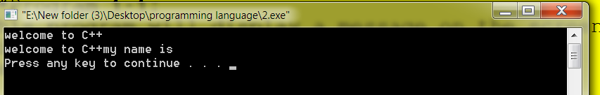
=============================================================
/*Program 1-1:
This program will display a message on the screen.*/
#include<iostream.h>
main()
{
cout <<"welcome to C++"<<endl
<<55<<"\t"
<<"66\n"
<<"88";
}
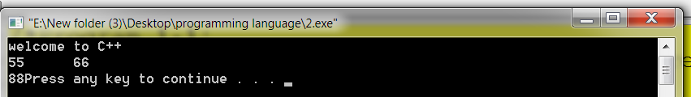
=============================================================
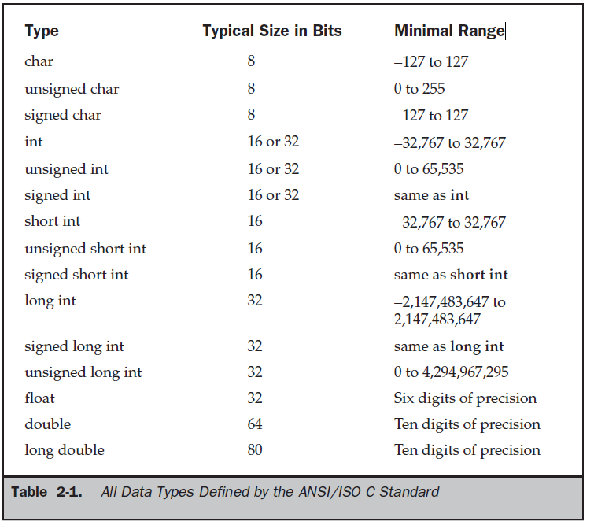

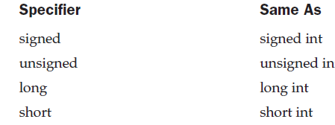
#include<iostream.h>
main()
{
int x=-2;
cout <<"x="<<x<<endl;
}

#include<iostream.h>
main()
{
int x;
x=-2;
cout <<"x="<<x<<endl;
}

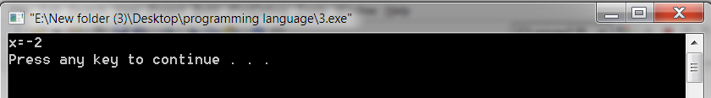
=============================================================
#include<iostream.h>
main()
{
unsigned int x=2;
cout <<"x="<<x<<endl;
}
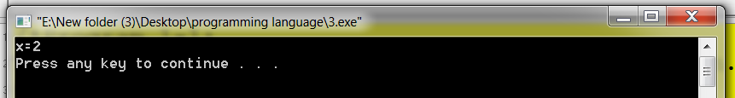

#include<iostream.h>
main()
{
unsigned int x=-2;
cout <<"x="<<x<<endl;
}
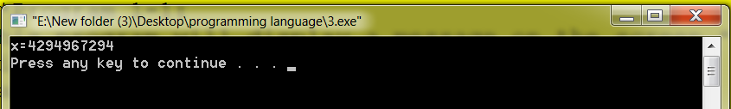

#include<iostream.h>
main()
{
unsigned int x=+2;
cout <<"x="<<x<<endl;
}

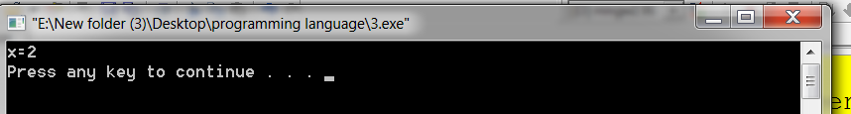

#include<iostream.h>
#include<string>
main()
{
short x=-2;
short y=-2.5;
float z=5.3;
long r=8.5;
double m=55;
char a='-5';
unsigned char c='-k';
string b="rana";

cout <<"x="<<x<<endl;
cout <<"y="<<y<<endl;
cout <<"z="<<z<<endl;
cout <<"r="<<r<<endl;
cout <<"m="<<m<<endl;
cout <<"a="<<a<<endl;
cout <<"b="<<b<<endl;
cout <<"c="<<c<<endl;
}
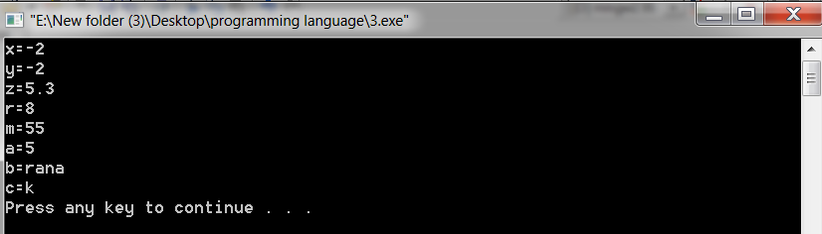

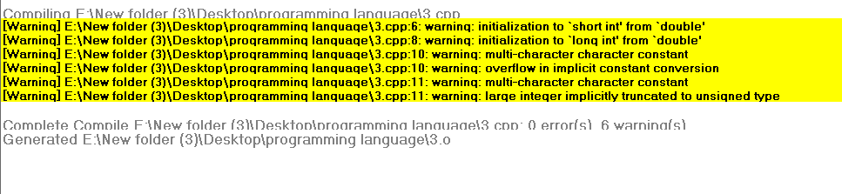

#include<iostream.h>
#include<string>
main()
{
char a='5mtr';
unsigned char c='-kln';
}
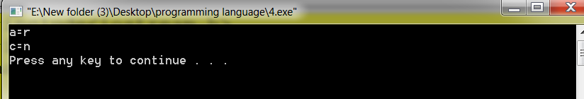

#include <iostream.h>
main()
{
const int x=5;
cout<<"x="<<x<<endl;
const char c='b';const float y=5.4;int s=6;
cout<<"c="<<c<<endl;
cout<<"y="<< y<<endl;
cout<<"s="<< s<<endl;

s=s+8;
s=s-2;
cout<<"sum="<< x+s+5<<endl;
cout<<"s="<< s<<endl;
}

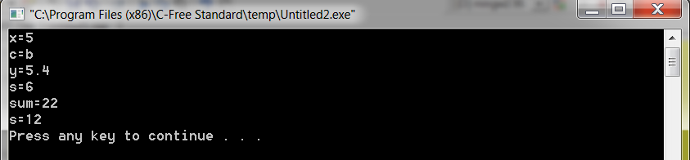

#include <iostream.h>
main()
{

int a=4,b=5,c;
cout<<a+b;
}

اكتب برنامج لحساب وطباعة مساحة دائرة (area = PI * r * r)
ومحيطها (circumference = 2 * PI * r).
إذا علمت أن نصف قطرها (r) يساوي 5.2 وأن PI = 3.1415926

#include <iostream.h>
main()
{
float r, PI;
r = 5.2;
PI = 3.1415926;
cout<<"area = "<< PI * r * r<<"\n";
cout<<"circumference = "<< 2 * PI * r;
}

2 اكتب برنامج لإدخال طول (length) وعرض (width) مستطيل.
ويحسب ويطبع حافة المستطيل (perimeter = 2*(length+width) ) ومساحته (area=length*width)

#include <iostream.h>
main()
{
int length, width;
cout<<"length = "; cin>>length;
cout<<"width = "; cin>>width;
cout<<"perimeter = "<<2*(length+width)<<"\n";
cout<<"area = "<<length*width;
}

3 اكتب برنامج لقراءة درجات أربع مواد (m1, m2, m3, m4)
ثم يحسب ويطبع المعدل ( avg = (m1+m2+m3+m4)/4 )

#include <iostream.h>
main()
{
int m1, m2, m3, m4;
cout<<"Enter marks \n";
cin>>m1>>m2>>m3>>m4;
cout<<"avg = "<< (m1+m2+m3+m4)/4;
}

4 اكتب برنامج لطباعة اسمك في السطر الأول من الجهة اليسرى، وعنوانك في وسط السطر الثالث، والجنسية في الجهة اليمنى
#include <iostream.h>
main()
{
cout<<"Abdulla Awad \n\n\t\t\t";
cout<<"BaitBoss zone \t\t\t Yemeni";
}
5 اكتب برنامج يقرأ درجة الحرارة بالفهرانهايت ((f، ثم يحسبها بالمئوية ( c= (f-32)*5/9 ) ويطبعها

#include <iostream.h>
main()
{
float f;
cout<<"f = "; cin>>f;
cout<<"c = "<< (f-32)*5.0/9.0;
}

6 اكتب برنامج يقرأ درجة الحرارة بالمئوية (c)، ثم يحسبها بالفهرانهايت ( f= c*9/5+32) ) ويطبعها

#include <iostream.h>
main()
{
float c;
cout<<"c = "; cin>>c;
cout<<"f = "<< c*9.0/5.0+32;
}

7 اكتب برنامج لإيجاد 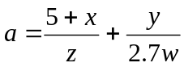 و 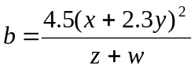
#include <iostream.h>
#include <math.h>
main()
{
float w,x,y,z;
cout<<"Enter w,x,y,z\n";
cin>>w>>x>>y>>z;
cout<<"a = \n"<< ((5+x)/z) + (y/2.7*w);
cout<<"b = "<< (4.5*pow(x+2.3*y,2)) / (z+w);
}

8 اكتب برنامج يقرأ العجلة الثابتة (a) والزمن (t)، ثم يحسب ويطبع المسافة ( d=0.5*a*pow(t,2) ) والسرعة النهائية ( v=a*t )

#include <iostream.h>
#include <math.h>
main()
{
float a, t;
cout<<"a = "; cin>>a;
cout<<"t = "; cin>>t;
cout<<"d = \n"<< 0.5*a*pow(t,2);
cout<<"v = "<< a*t;
}

