

**Faculty of engineering - Shoubra**

**Benha University**

**Research Article / Research Project / Literature Review**

|  |  |
| --- | --- |
| **Department** | **Engineering Mathematics and physics** |
| **Division** |  |
| **Academic Year** | **2019-2020 preparatory** |
| **Course name** | **COMPUTER** |
| **Course code** | **ECE001** |

|  |  |  |  |
| --- | --- | --- | --- |
|  | Name | Edu mail | B.N |
| **1** | بيشوي مجدي صبحي | Bishouy180265@feng.bu.edu.eg | 1116 |

**Name :بيشوي مجدي صبحي حنا**

**B.N :1116**

**Topic :programming languages**

**Github link :**

**Github page(published website) :**

**Application brief**

Computers massively affect modern human life. And a computer program controls the computer The programming languages are used to create computer programs, So they are the foundation of all the conveniences that we feel. The programming languages are responsible for all programs created , rostering systems, virtual reality, scheduling software, online games ,mobile apps, anti-virus ,etc. Mastering programming languages thus helps one understand how all digital technology originates.

**Screenshots :**

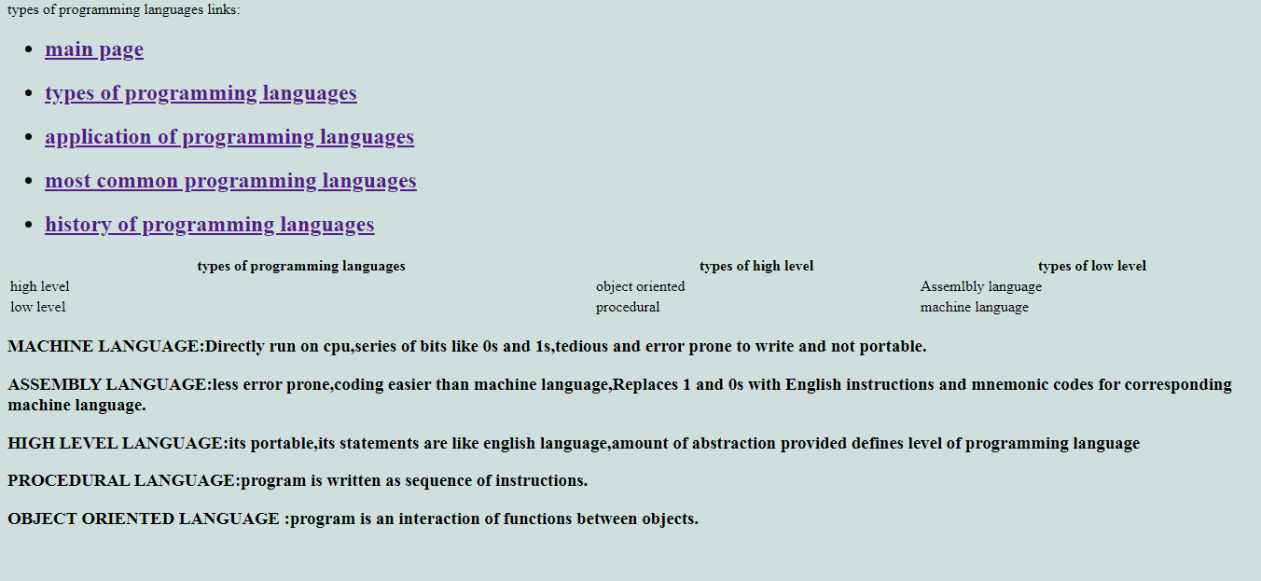

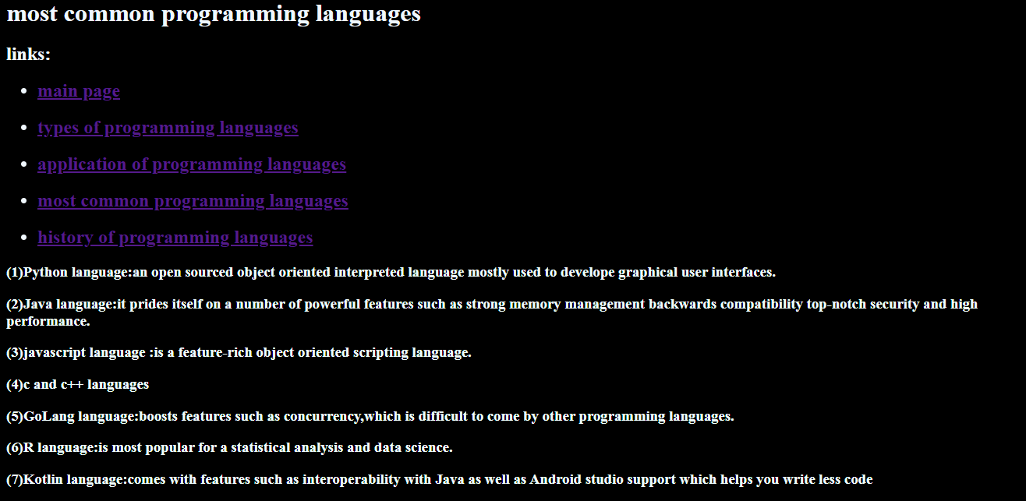

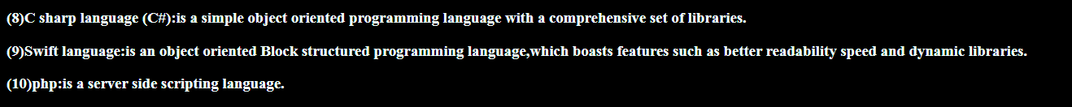

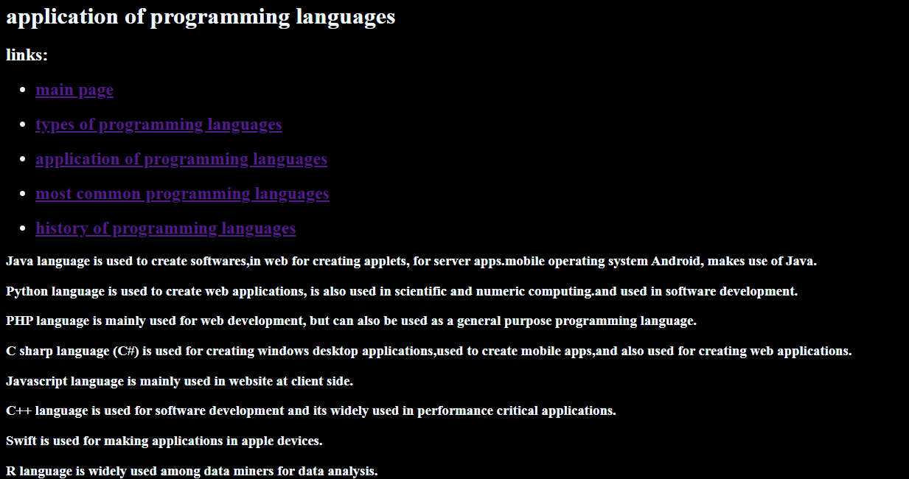

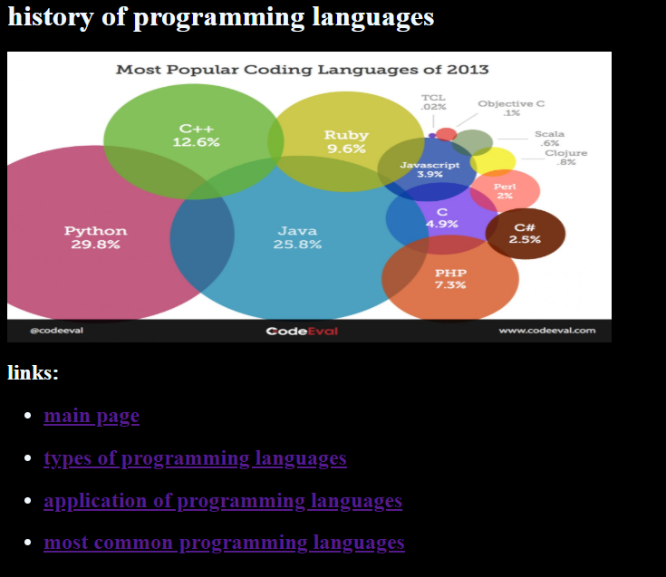

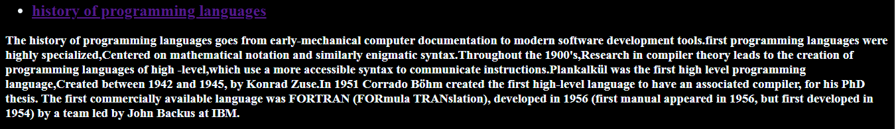

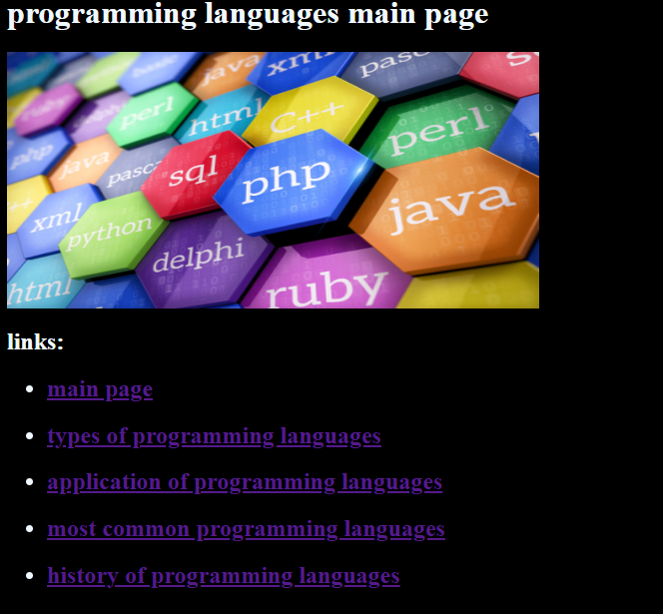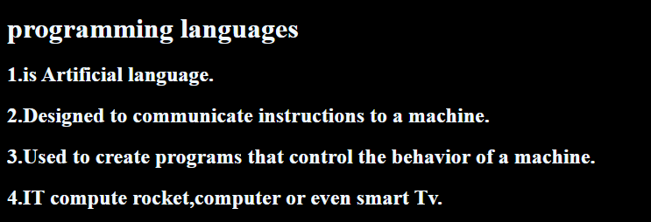

**source code:**