**Assignment 3: Deploying your Data science models**

Team 3 in INFO 7390

Team Members: Hongwei Hu, Guangnan Liang

GitHub: <https://github.com/Besimilar/AdvancedDataAnalysis>

Resources:

1. URL: [besimilar.pythonanywhere.com/search](http://besimilar.pythonanywhere.com/search) (Under Construction. My teammate is still working on his part, I had to deploy assignment 2 as an example)
2. Model deployment: Azure Machine Learning
3. Flask REST API deployment: <https://www.pythonanywhere.com/>

Note: Red lines means Very Important Steps

**Part1: Deploy models on Azure Machine Learning**

1. Algorithms:
   1. Linear Regression
   2. Logistic Regression
   3. Decision Forest: I chose built-in algorithms for easily tuning training parameters.
   4. Neural Network
2. Workflows:
   1. Prediction (For detailed code of R script blocks, refer to “R-Blocks-Code/Prediction/*.R”):
      1. Linear Regression

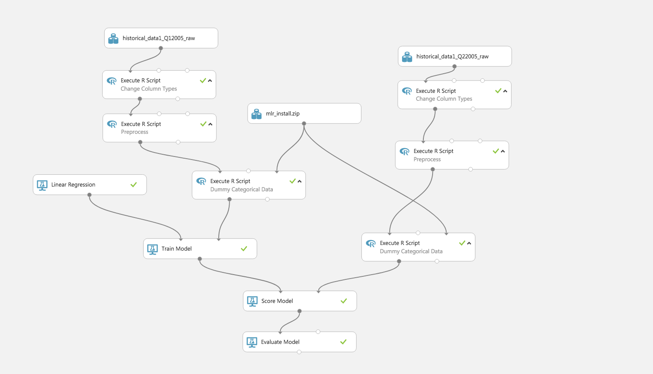

* + 1. Decision Forest Regression

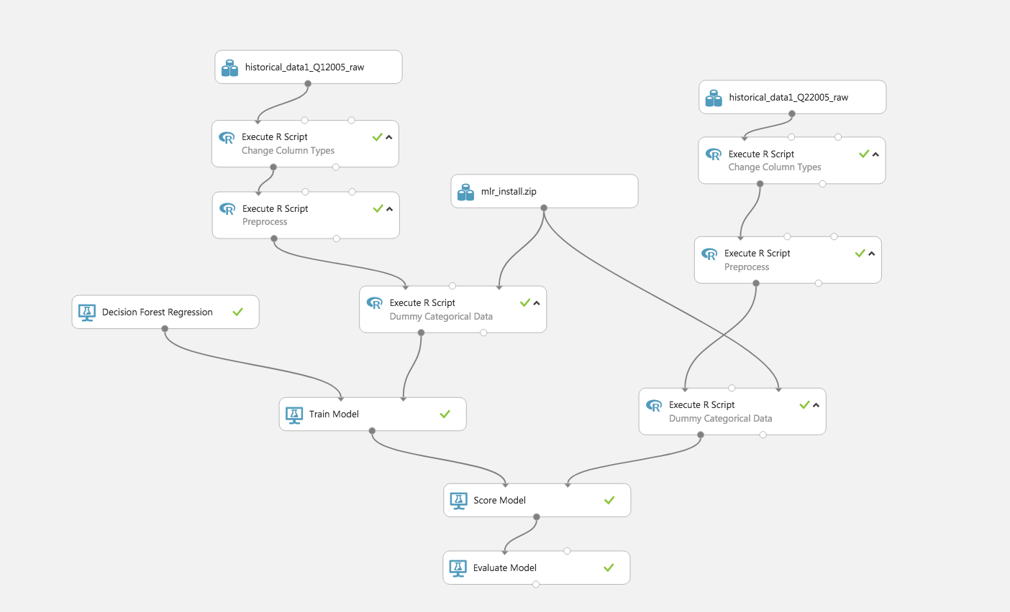

* + 1. Neural Network Regression

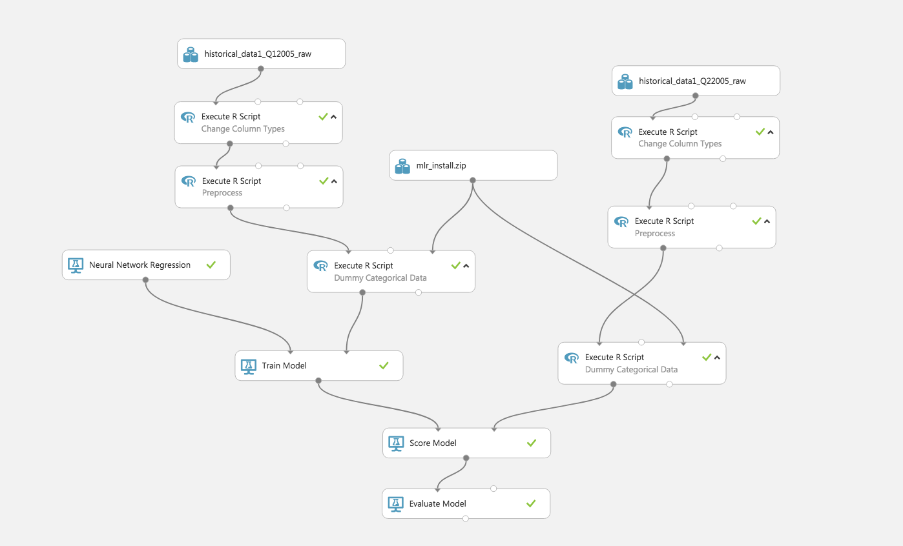

* 1. Classification (For detailed code of R script blocks, refer to “R-Blocks-Code/Classification/*.R”)::
     1. Two-class Logistic Regression

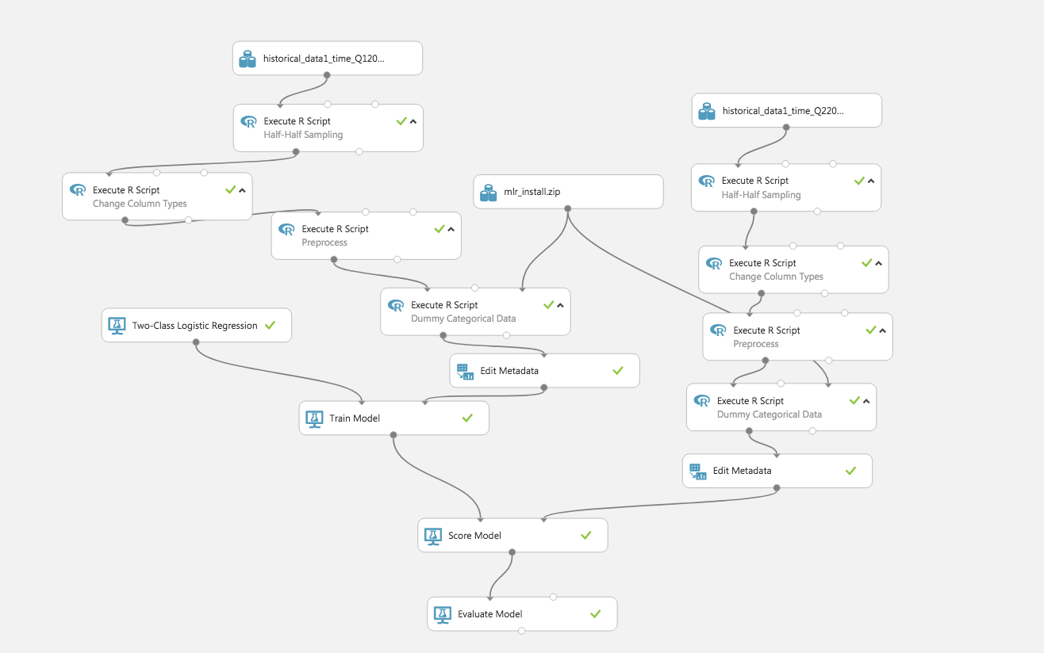

* + 1. Two-class Decision Forest

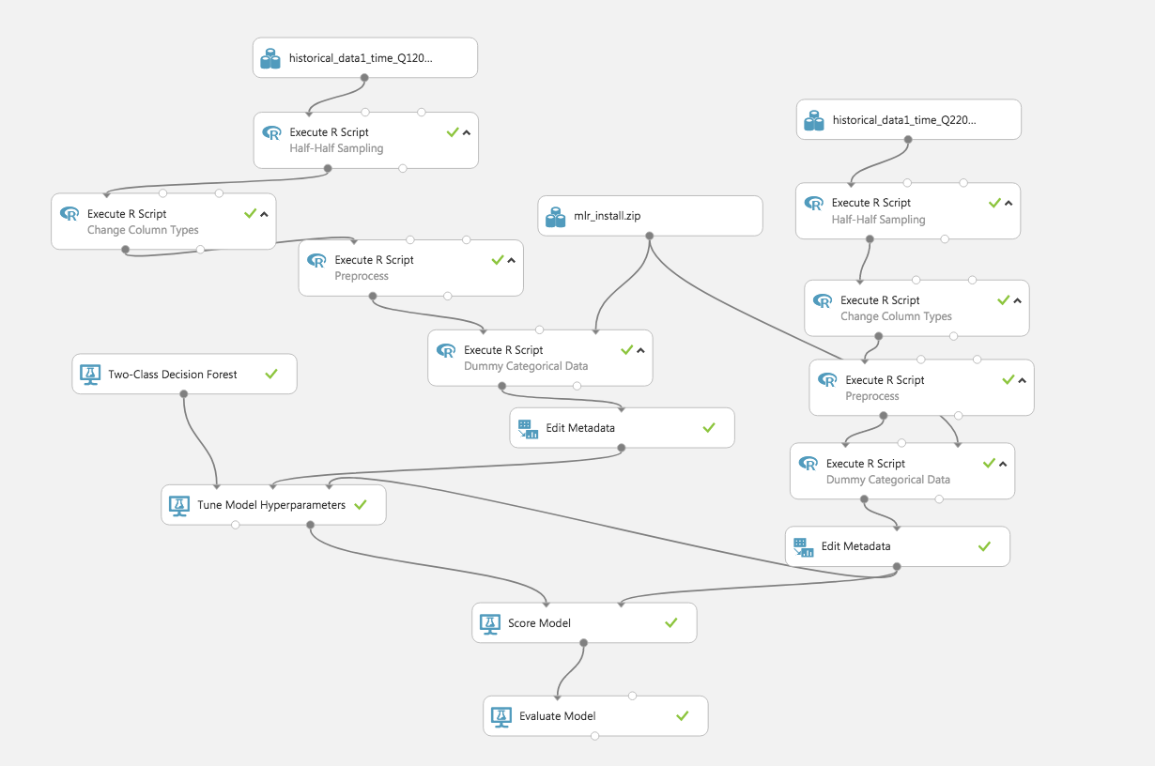

* + 1. Two-class Neural Network

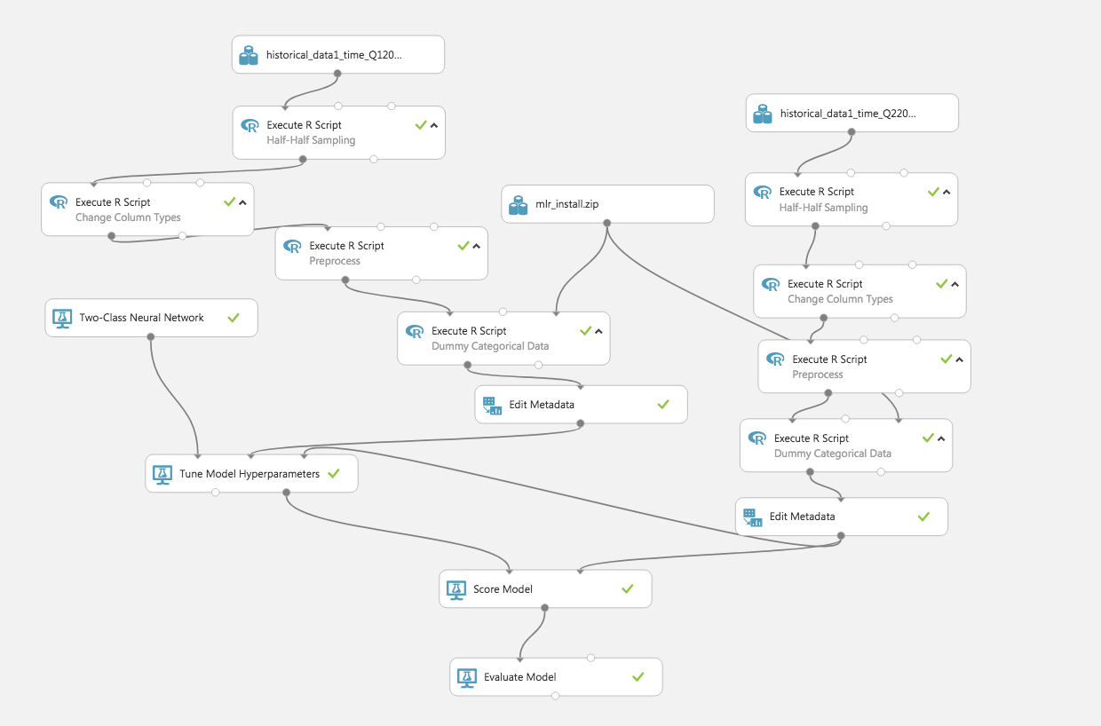

1. Evaluation:
   1. Prediction:
      1. Linear Regression

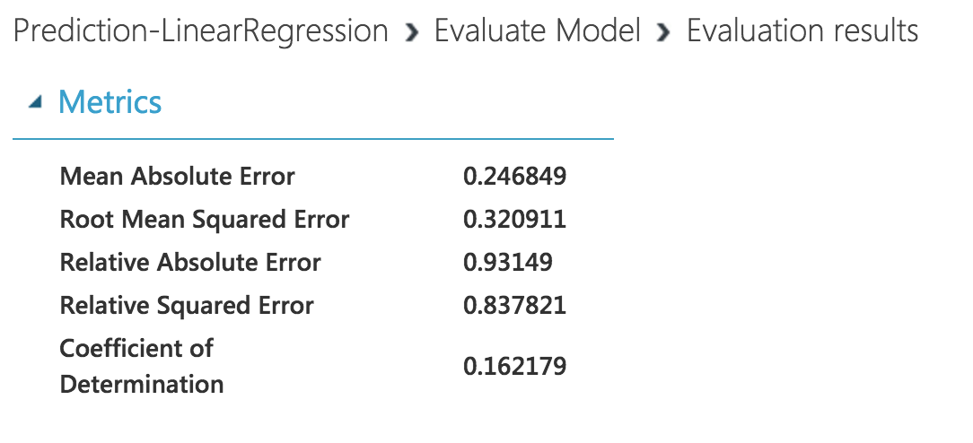

* + 1. Decision Forest Regression

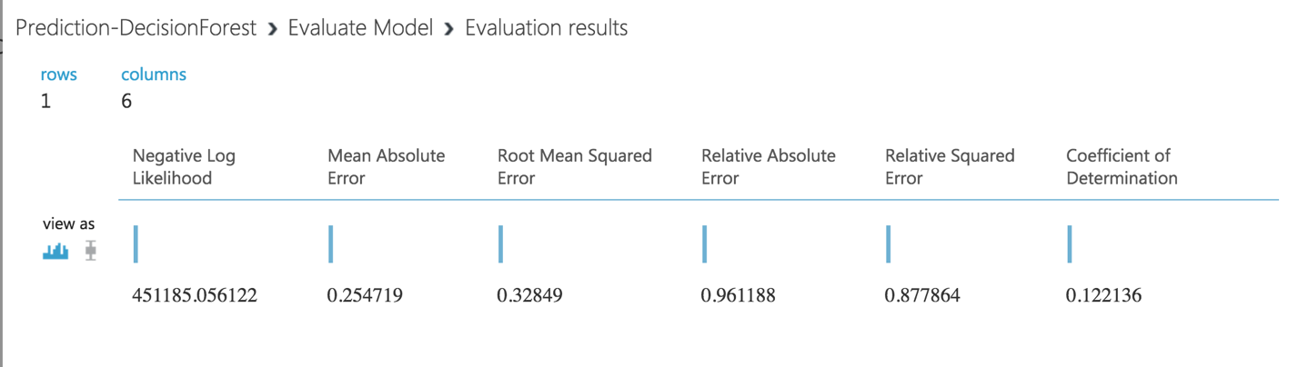

* + 1. Neural Network Regression

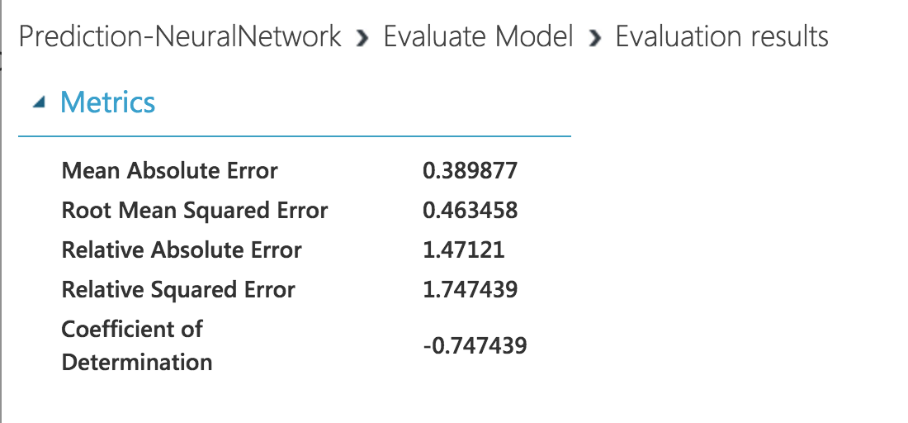

* 1. Classification:
     1. Two-class Logistic Regression

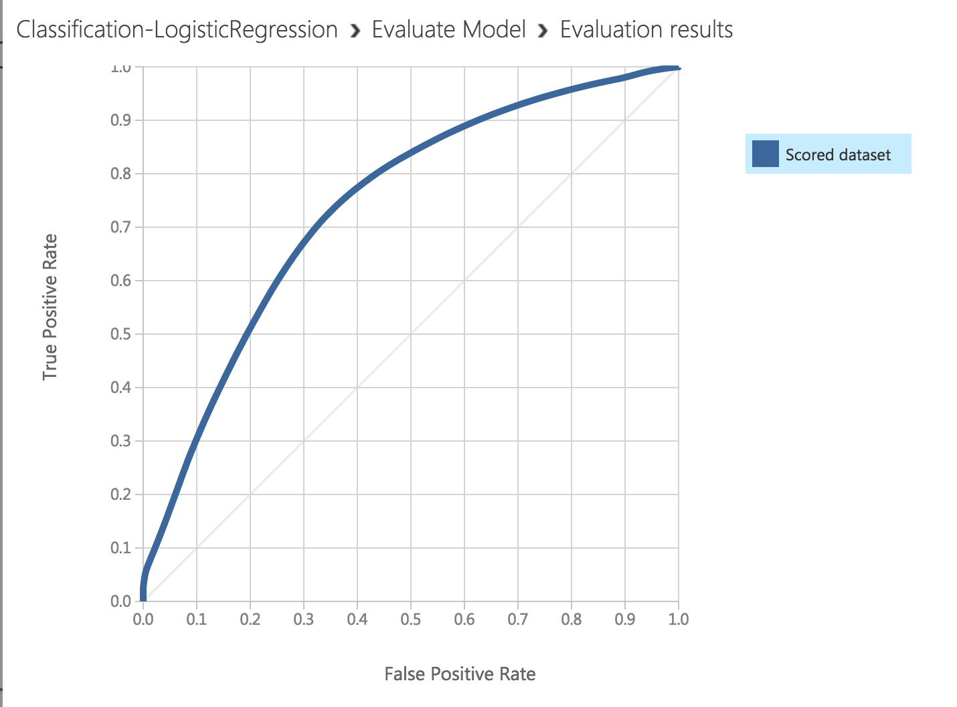

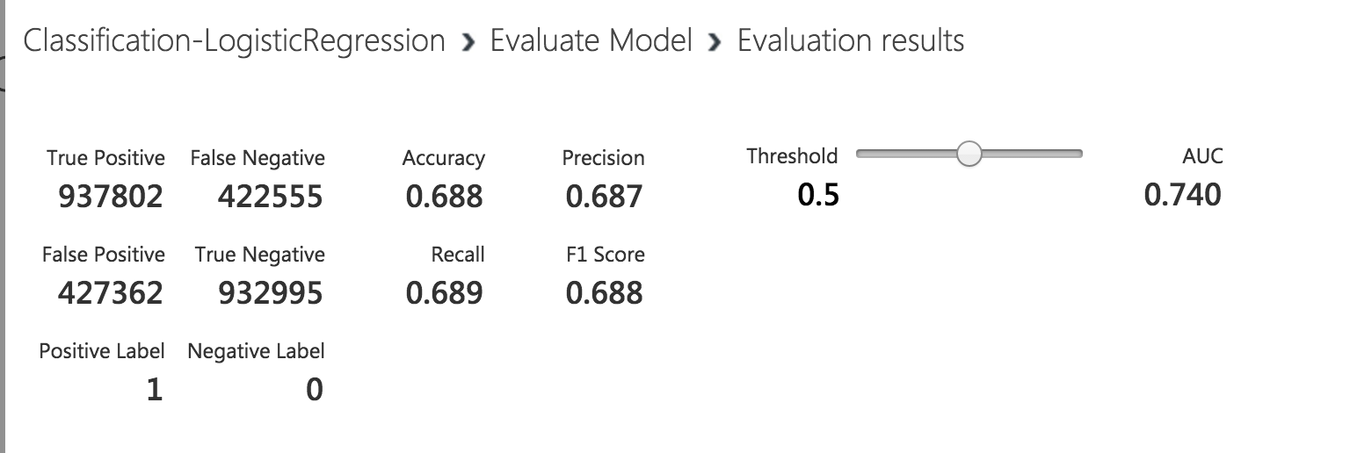

* + 1. Two-class Decision Forest

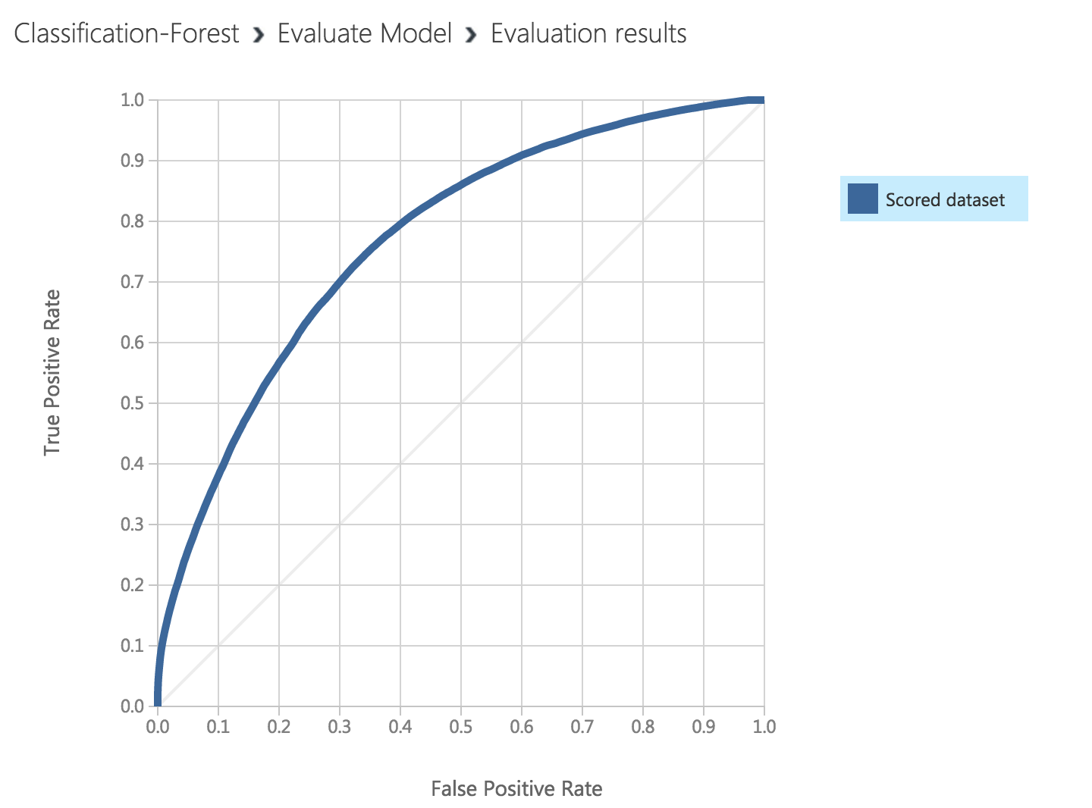

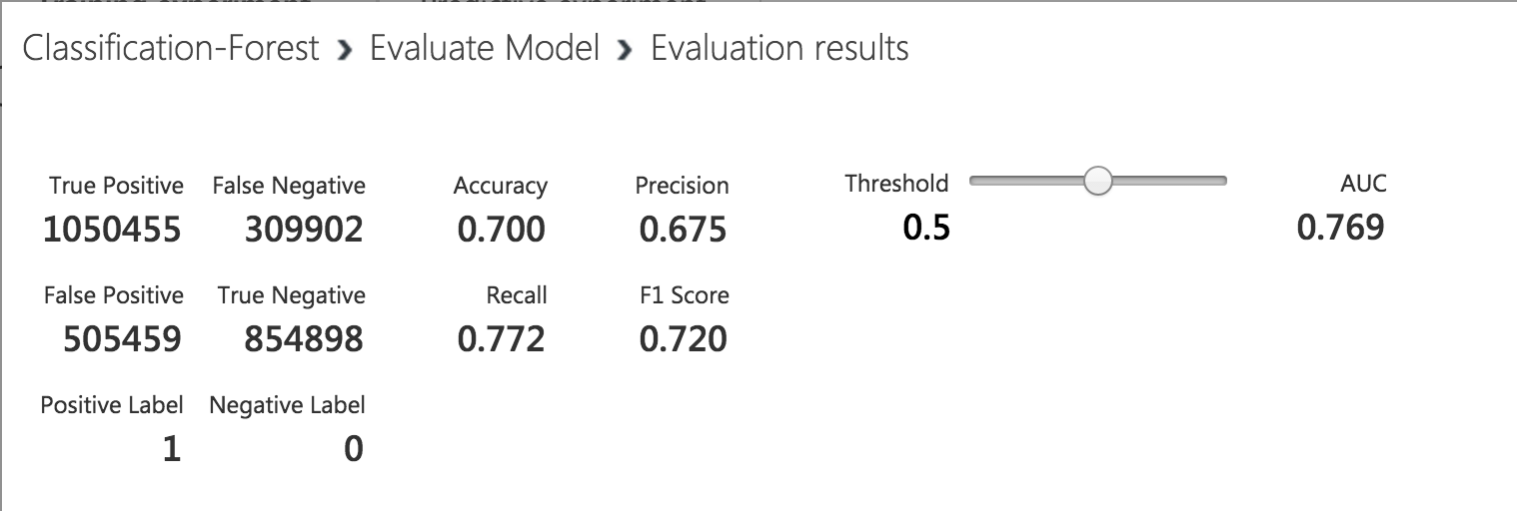

* + 1. Two-class Neural Network

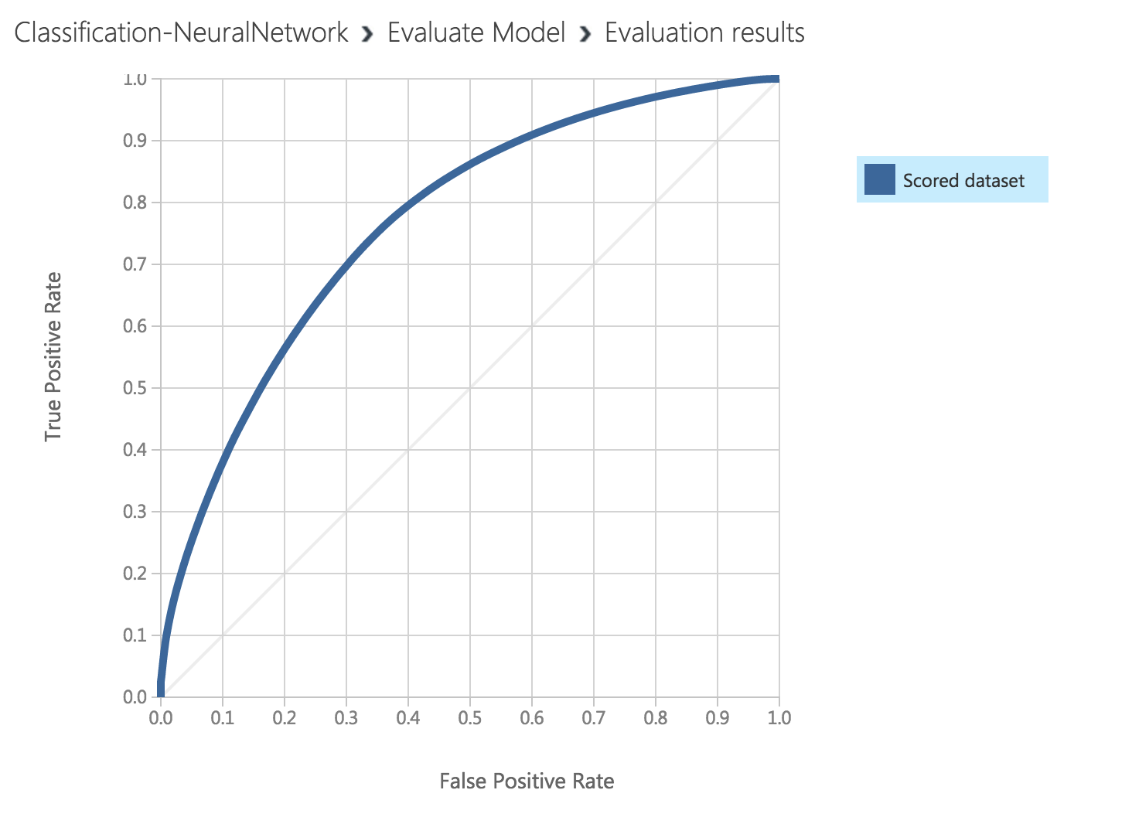

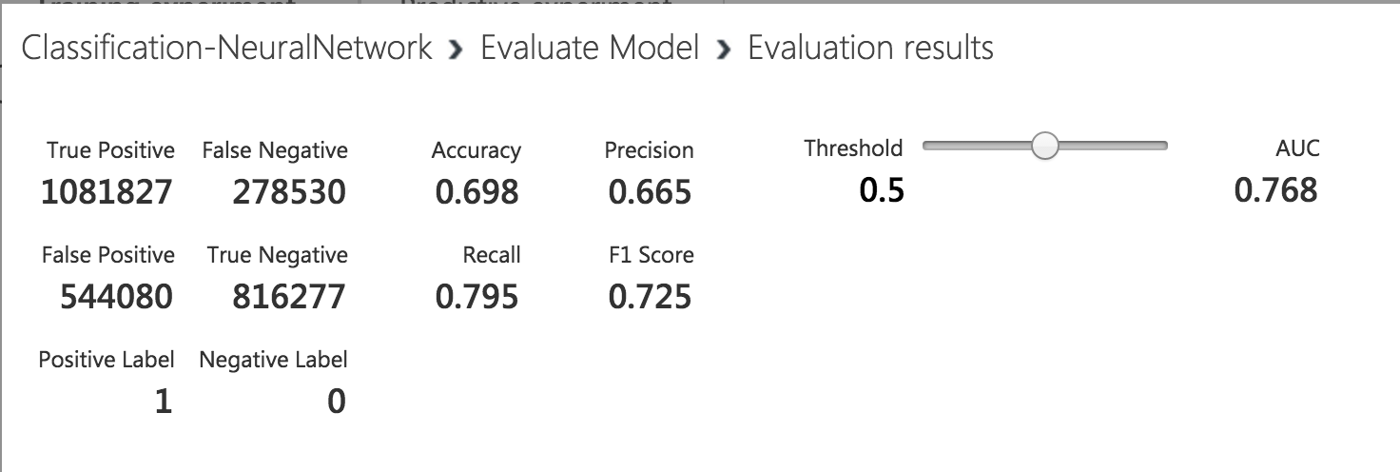

1. Important steps for running R packages not installed on Azure:
   1. Upload R packages (“R-Block-Code/Packages/*.zip”) to Azure
   2. Drag the zip file as optional Script Bundle for “Execute R Script” Blocks
2. API: refer to “API/*” for how to consume service

**Part2: Deploy Flask REST API to PythonAnywhere**

1. Service URL: [besimilar.pythonanywhere.com/search](http://besimilar.pythonanywhere.com/search) (Under Construction. My teammate is still working on his part, I had to deploy assignment 2 as an example)
2. Screenshots:

