**INFO 7390**  **Final Project Report** *Liang, Guangnan*

**Final Project Report**

1. **Preprocess:**

Convert the “AQS Parameter Desc” and “Sample Measurement” columns from wide to long, and concat them with the original dataset.

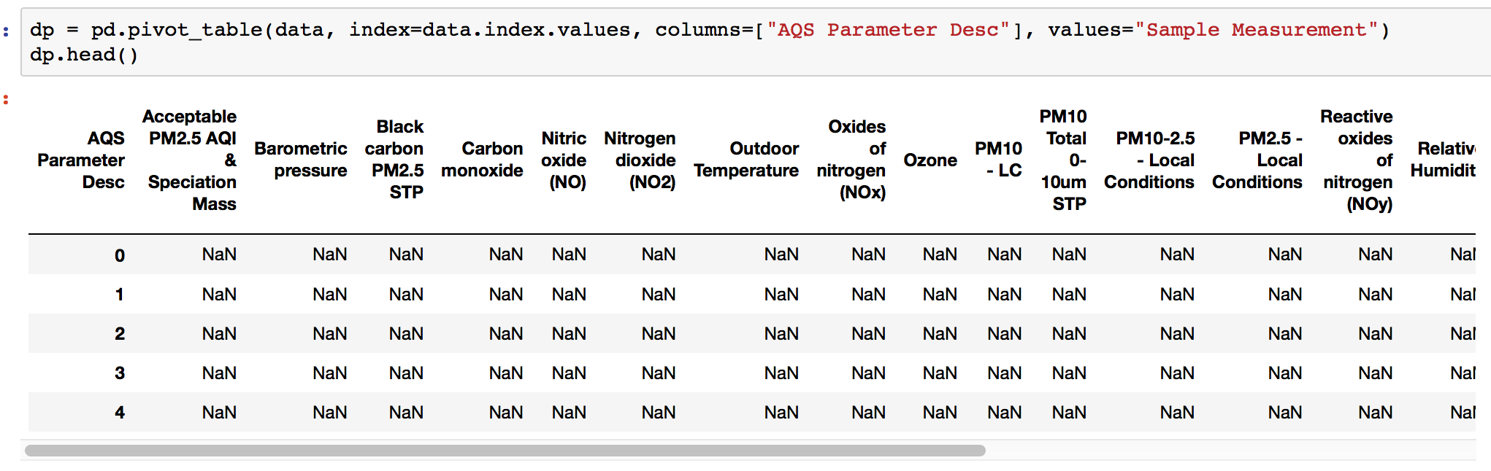

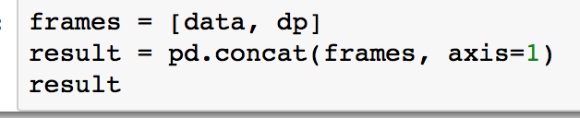

Using the mean between two closest finite value:

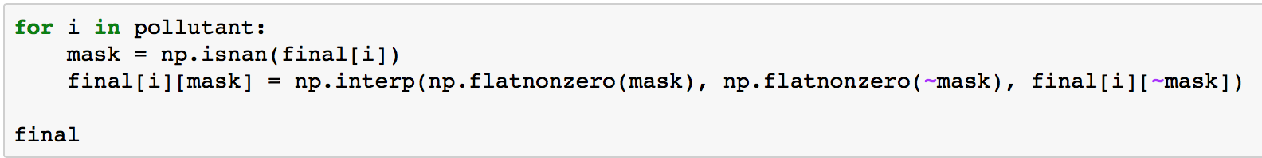

1. **EDA:**
2. PM 2.5:

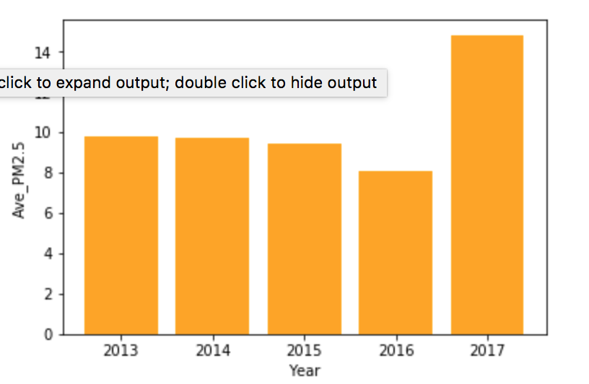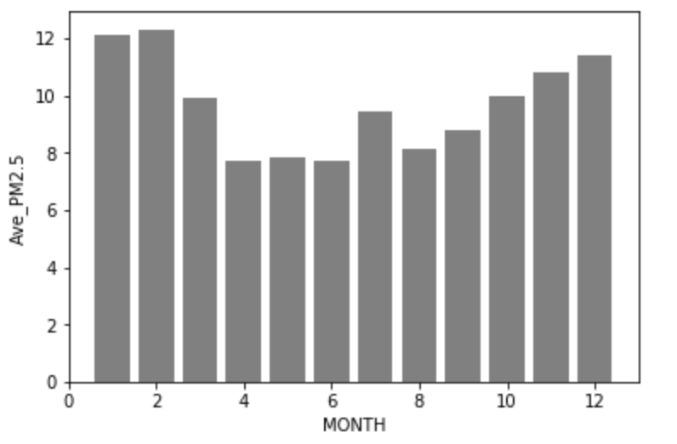

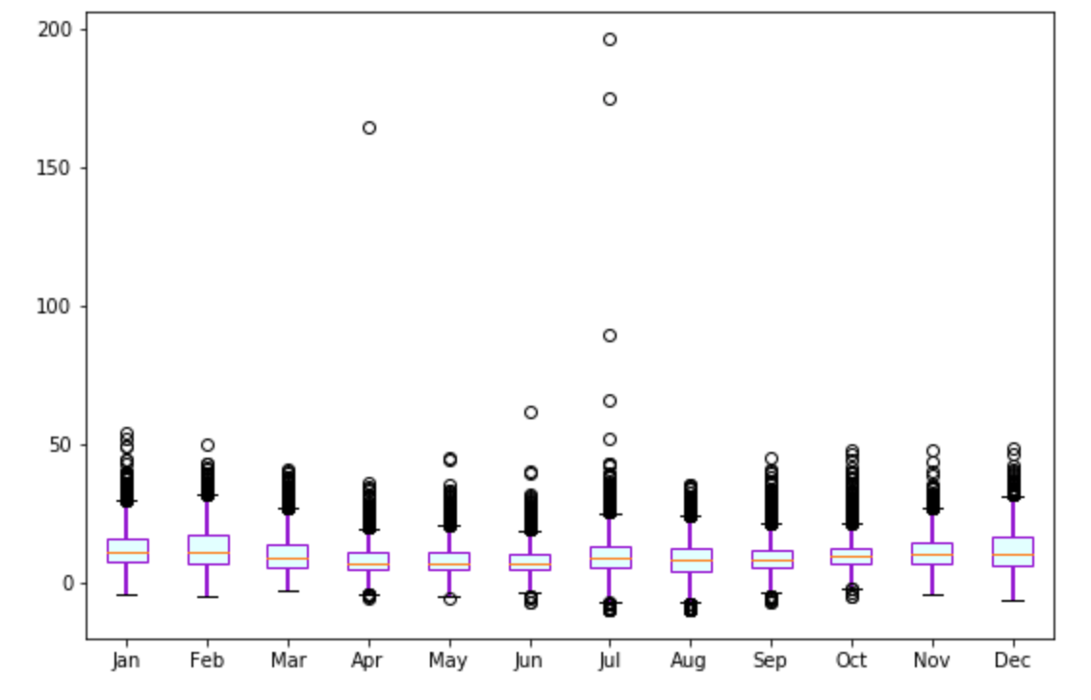

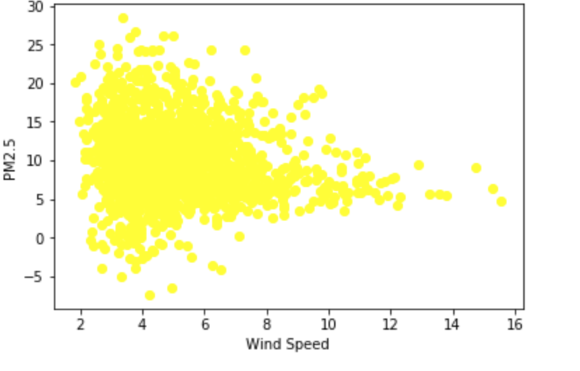

1. Ozone:

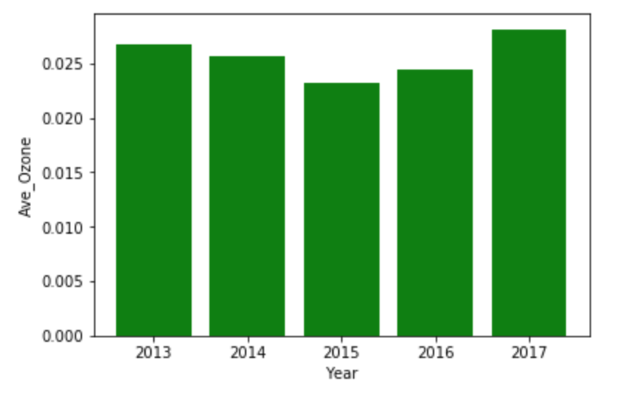

1. NO2:

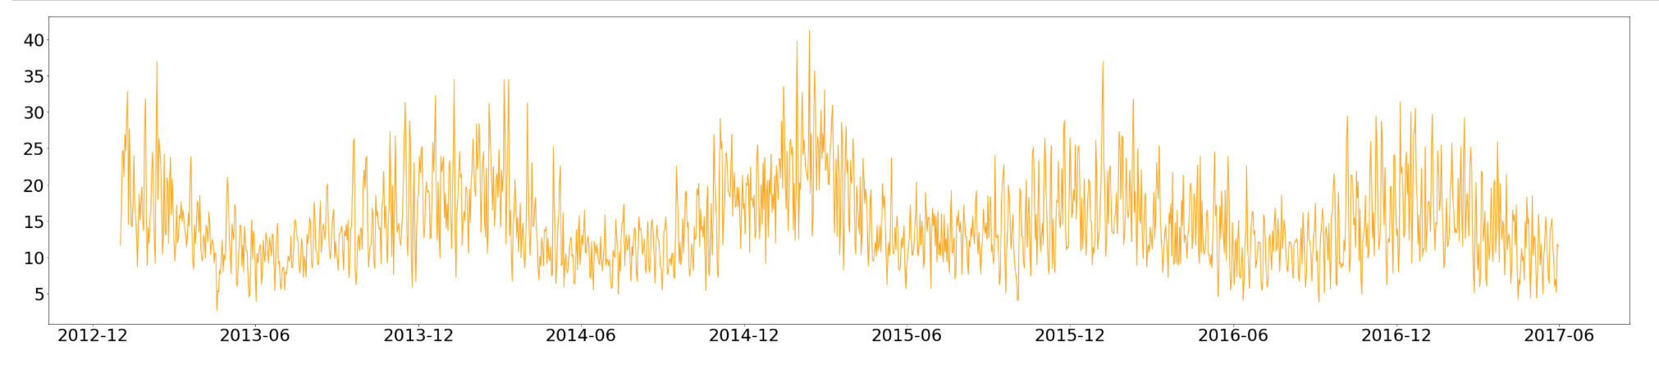

1. **API:**
2. Set parameters:

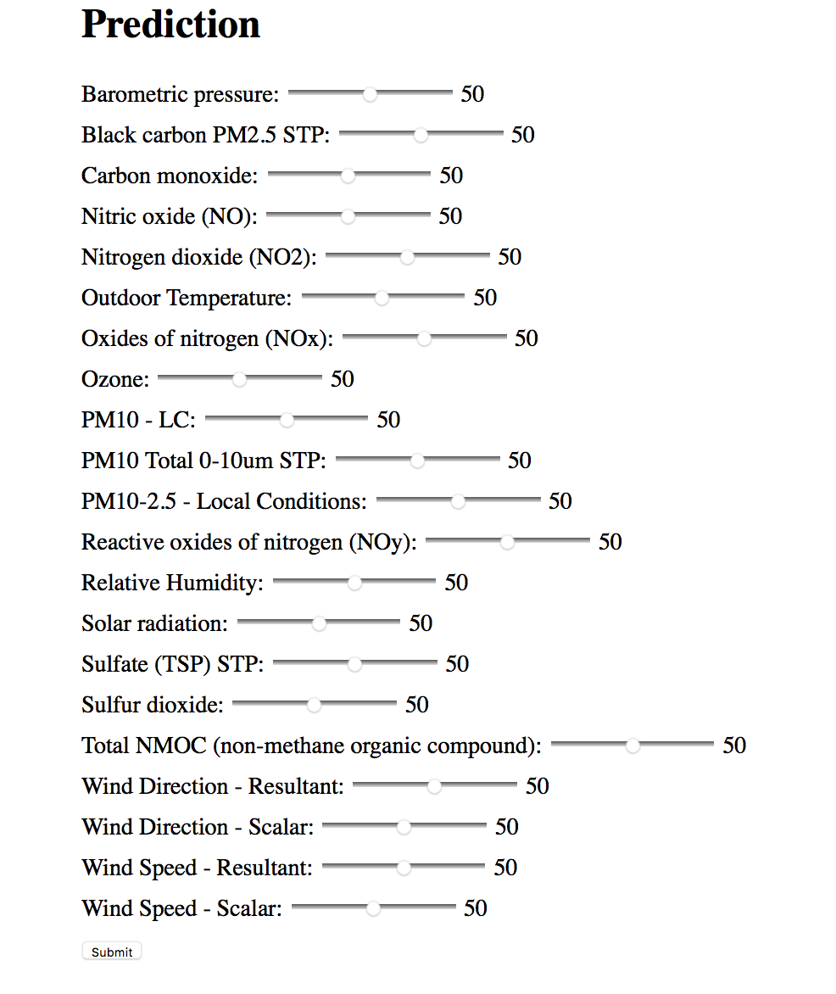

1. View scored labels and download docker images:

