NAME: BESOMBA BOANERGES
PROJECT NAME: PROFESSIONAL PORTFOLIO
COMPANY: N-TEC LAB
DATE:20/03/2026
LIVE-LINK: https://portfolio-rho-blond-c6u7pe2ki0.vercel.app/
GITHUP: https://github.com/BesombaBoanerges/Portfolio.git
PROJECT OVERVIEW:
The aim of the project to give the basics of html, css , and javascript. This project serves as a digital resume and a demonstration of frontend architecture, version control, and cloud deployment.
Architecture & Design Decisions :
-CSS Flexbox : I used flexbox inside sections for fine alignment and positioning.
-CSS Grid: I used gride for the main layout structure
Challenges & Resolutions :
For the deployment I wanted to deploy on github but I could not , So I decided to deploy on vercel where I had no problem to deploy.
I had smalle problem with the naming of my code both in html and css, when a dot is add in the html and not added in the css the css breakdown . So I need but all my codes with the same name.
Screenshots & Evidence :
Desktop View :
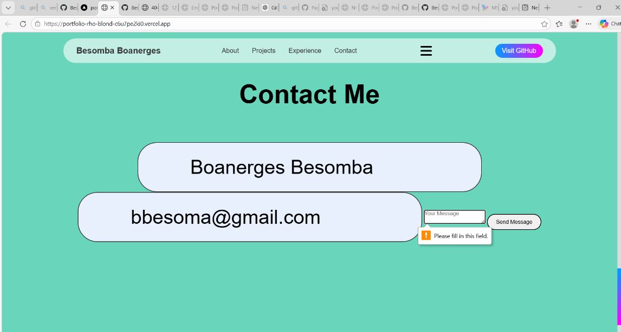
Mobile View :