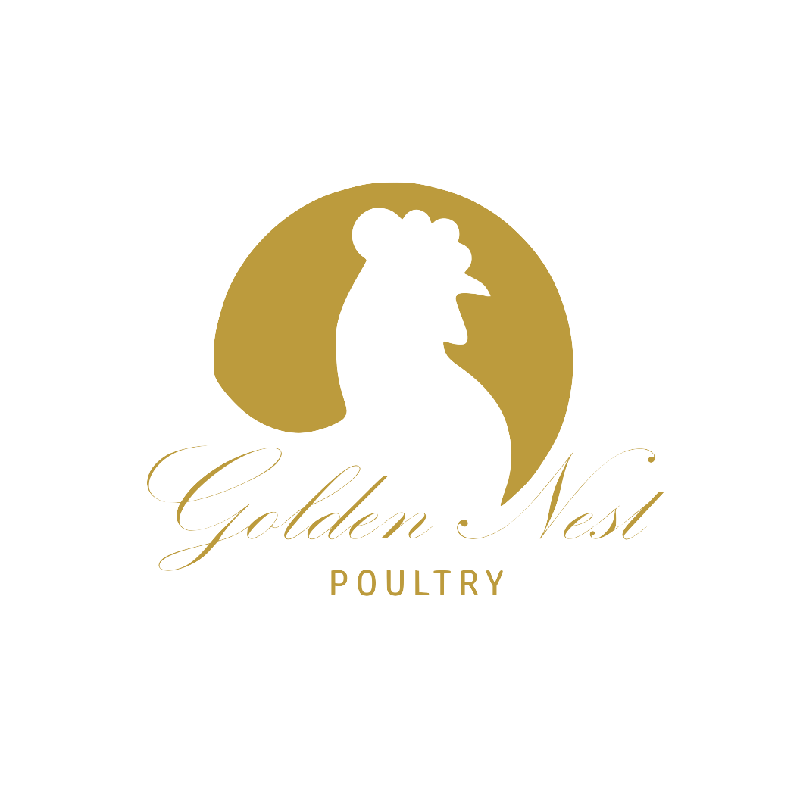
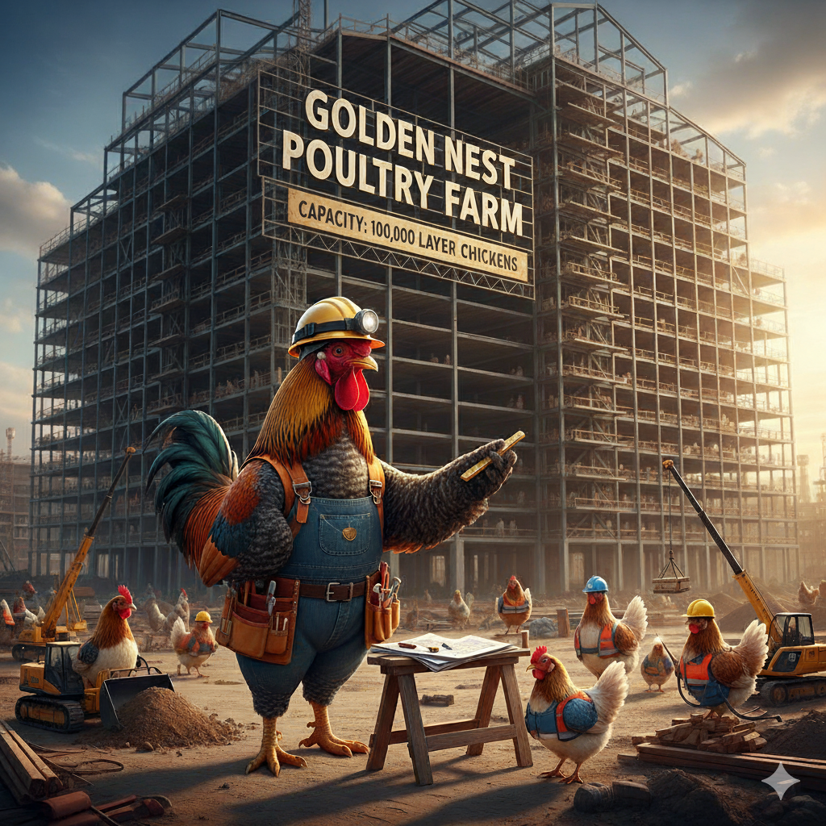
BAKONE GOLDEN NEST POULTRY FARM
BUSNIESS PLAN AND FUNDING PROPOSAL
BUSINESS INFRASTRUCTURE SUPPORT PROGRAMME

Table of Contents
- Executive Summary ............................................................................................Page 3
- Our Story: From Small Dreams to Regional Impact ........................................Page 4
  - Our Foundation Years ...........................................................................Page 4
  - Building Community Partnerships .......................................................Page 4
  - Innovation and Continuous Improvement ...........................................Page 4
  - The Next Chapter ..................................................................................Page 4
- Market Analysis & Opportunity .........................................................................Page 5
  - South African Egg Market Overview ...................................................Page 5
  - Market Dynamics Favoring Expansion ................................................Page 5
  - Competitive Advantages ......................................…..............................Page 5
- Operational Plan & Phased Growth Strategy ...................................................Page 6
  - Phase 1: Foundation Stabilization (Months 1-6) ..................................Page 6
  - Phase 2: Controlled Expansion (Months 7-12) ........................…..........Page 7
  - Phase 3: Full-Scale Operations (Months 13-36) ...................................Page 9
  - Phase 4: Strategic Positioning (Months 37-48) ....................................Page 10
- Infrastructure & Technology Investment ..........................................................Page 11
  - Core Poultry Infrastructure .................................…...............................Page 11
  - Univent UV600 Comprehensive System ...............................................Page 11
  - Supporting Infrastructure .................................…..................................Page 11
- Essential Machinery & Equipment Portfolio .....................................................Page 12 `
  - Primary Agricultural Equipment ............................................................Page 12
  - Specialized Transport Equipment .........................................................Page 12
  - Future-Ready Agricultural Implements ................................................Page 12
- Comprehensive Funding Strategy .....................................................................Page 14
  - Detailed Fund Allocation ........................................................................Page 14
  - Investment Justification .........................................................................Page 15
- Comprehensive Staffing Plan .............................................................................Page 16
  - Current Staffing Baseline .......................................................................Page 16
  - Expanded Staffing Requirements .........................................................Page 16
  - Training & Development Program ........................................................Page 17
  - Compensation & Benefits Strategy .......................................................Page 17
  - Organizational Integration ....................................................................Page 17
- Risk Management & Mitigation Strategies ................................…....................Page 18
  - Operational Risks .............................................................…..................Page 18
  - Market Risks .....................................................................…..................Page 18
  - Financial Risk..........................................................................................Page 18
- Financial Projections & Return Analysis ..........................................................Page 19
- Calculations .......................................................…..............................................Page 20
- Sustainability & Community Impact ..............................................….................Page 22
  - Environmental Stewardship ...............................................…................Page 22
  - Community Development ..................................................….................Page 22
- Economic Impact ...........................................................................…..................Page 22
- Conclusion: A Vision Realized...……………….............................…....................Page 24

Executive Summary
Golden Nest Poultry represents the embodiment of South African agricultural excellence—a testament to how family values, innovative thinking, and relentless dedication can transform a modest farming operation into a cornerstone of regional food security. What began as a passionate commitment to producing premium eggs has evolved into a sophisticated, technology-driven enterprise that consistently outperforms industry benchmarks.
Our remarkable journey from humble beginnings to our current position as a highly efficient operation managing 16,600 laying hens with exceptional profitability speaks to both our operational excellence and market understanding. Now, we stand at the threshold of our most ambitious chapter yet: a strategic, scientifically planned expansion that will position us as a regional market leader while maintaining the quality standards and community focus that define our brand.
This comprehensive business plan presents our roadmap to achieve this vision through a meticulously structured R20.18million investment program. Our immediate objective is the construction and commissioning of a state-of-the-art, fully automated poultry facility capable of housing 51,200 additional layers—representing a calculated 308% increase in our production capacity.
This expansion is built upon proven success. Our recent operational achievements speak volumes: between July and September 2025, we executed a flawless scale-up increasing our flock size by 419% in just 60 days, while maintaining industry-leading metrics including a 55% profit margin and 97% lay rate—performance indicators that significantly exceed industry standards and demonstrate our readiness for large-scale operations.

Key Investment Highlights:
- Proven Track Record: Consistent above-industry performance metrics
- Strategic Location: Positioned in Limpopo's growing agricultural corridor with excellent logistics access
- Technology Integration: Investment in cutting-edge systems
- Risk Mitigation: Graduated expansion approach minimizing operational risk
- Market Position: Strong existing relationships with established distribution channels

Our Story: From Small Dreams to Regional Impact
Golden Nest Poultry's story began with a fundamental belief that excellence in agriculture starts with integrity, innovation, and an unwavering commitment to quality. Founded on the principle that South African families deserve access to fresh, nutritious, locally produced eggs, our journey reflects the broader transformation happening across the country's agricultural sector.
Our Foundation Years: What started as a family-operated farm with modest beginnings has grown through strategic reinvestment, continuous learning, and an absolute focus on operational efficiency. Every rand earned has been reinvested into better systems, improved genetics (chicken breed), and enhanced biosecurity measures. This disciplined approach has allowed us to build not just a business, but a sustainable operation that contributes meaningfully to local food security.
Building Community Partnerships: Throughout our growth, we have cultivated strong relationships with local suppliers, distributors, and customers. Our reputation for consistency, quality, and reliability has become our most asset. Local retailers know that Golden Nest eggs represent dependable supply, superior freshness, and consistent quality—attributes that have allowed us to command premium pricing even in competitive markets.
Innovation and Continuous Improvement: We have consistently embraced new technologies and methodologies that improve efficiency while maintaining our commitment to animal welfare and environmental responsibility. Our investment in automated systems, precision nutrition programs, and data-driven management practices has positioned us at the forefront of modern poultry production in the region.
The Next Chapter: Today, we stand ready to leverage our proven model, established relationships, and operational expertise to make the leap from local success story to regional market leader. This expansion represents not just growth for Golden Nest, but a significant contribution to South Africa's broader food security objectives.

Market Analysis & Opportunity
South African Egg Market Overview: The South African egg industry represents a R8.5billion market with consistent annual growth of 3-4%. Limpopo Province, with its favorable climate, lower operational costs, and strategic location, has emerged as a key growth region for poultry production. Our location in Modimolle positions us optimally to serve both the growing Gauteng market (280km south) and the expanding northern regions.

Market Dynamics Favoring Expansion:
- Growing Demand: Population growth and increasing protein consumption driving sustained demand
- Supply Chain Disruptions: Recent challenges with large-scale producers creating opportunities for reliable, regional suppliers
- Premium Positioning: Increasing consumer awareness and willingness to pay for locally sourced, fresh products
- Retail Consolidation: Major retailers preferring fewer, more reliable suppliers with consistent quality and volume capabilities
- Competitive Advantages: Our expansion will build upon several key competitive advantages:
- Geographic Positioning: Central location with excellent access to major markets
- Quality Reputation: Established brand recognition for superior product quality
- Operational Efficiency: Demonstrated ability to achieve above-industry performance metrics
- Technology Integration: Investment in cutting-edge automation ensuring competitive cost structure
- Relationship Capital: Strong existing partnerships with distributors and retailers

Operational Plan & Phased Growth Strategy
Our expansion strategy has been designed with careful attention to risk management, operational efficiency, and sustainable growth. The phased approach allows us to leverage our existing expertise while gradually building capabilities for larger-scale operations.

Phase 1: Foundation Stabilization (Months 1-6)
During this critical preparation period, we will maintain optimal performance of our existing 16,600-bird operation while executing the infrastructure development program:

Current Operations Management:
- Maintain industry-leading 97% lay rate and 55% profit margins
- Continue building market relationships and securing forward contracts
- Implement enhanced data collection systems to optimize feed conversion and production metrics
- Execute comprehensive staff training programs for new technology integration

Infrastructure Development:
- Complete site preparation and civil works for the new facility
- Secure all necessary environmental and operational permits
- Install and commission the Big Dutchman Univent UV600 system
- Integrate new facility systems with existing farm management infrastructure

Phase 2: Controlled Expansion (Months 7-12)
The introduction of new birds will follow a carefully managed schedule designed to optimize system performance and minimize operational stress:

Graduated Stocking Program:
- Month 7: Introduction of first 9,900 chickens to new facility (Total capacity: 26,500 birds)
- Month 8: Second cohort introduction (Total capacity: 36,400 birds)
- Month 9: Third cohort introduction (Total capacity: 46,300 birds)
- Months 10-12: Complete stocking to full capacity (Total capacity: 67,800 birds)

Performance Optimization:
Each stocking phase includes a 30-day optimization period focusing on:
- Feed conversion ratio optimization
- Climate control fine-tuning
- Egg quality standardization
- Staff workflow optimization
- System integration refinement
Month | New Chickens Added | Total Birds | Notes
1-6 | - | 16,600 | Initial population (existing facility)
7 | 9,900 | 26,500 | First batch chickens are introduced
8 | 9,900 | 36,400 | Second cohort introduction
9 | 9,900 | 46,300 | Third cohort introduction
10 | 9,900 | 56,200 | Continuing steady increase
11 | 9,900 | 66,100 | Approaching full capacity
12 | 1,700 | 67,800 | Final stocking to reach full capacity
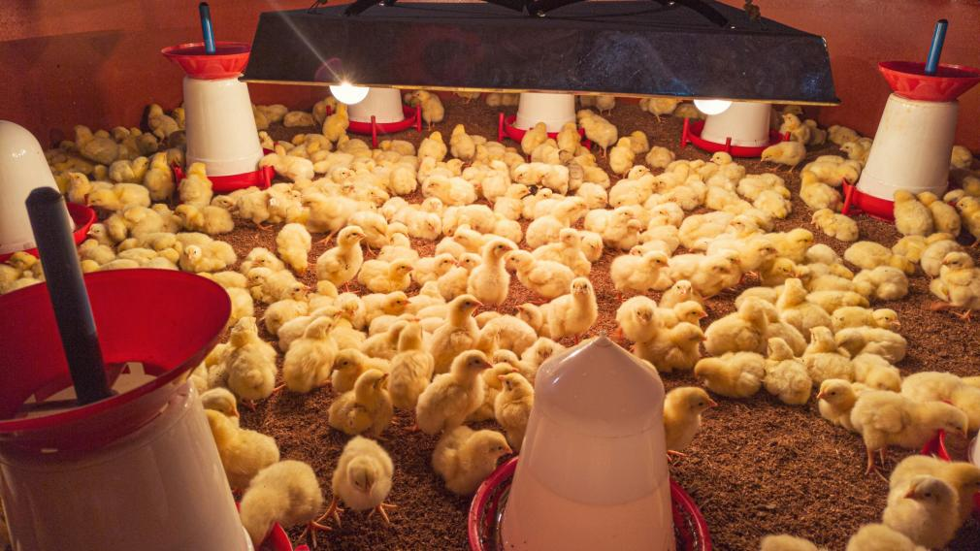
222Table 1: Chicken population increase until capacity is reached

image 4: Baby chicks kept separately before being introduced to the production houses.

Phase 3: Full-Scale Operations (Months 13-36)
Upon reaching full capacity, our focus shifts to maximizing operational efficiency and profitability:

Production Targets:
- 67,800 layers producing approximately 65,000 eggs per day
- Target 96%+ lay rate consistently maintained
- Feed conversion ratio of 2.1:1 or better
- Yearly production of ~23.6million eggs at R21.7million net profit at 50%

Continuous Improvement Initiatives:
- Implementation of predictive maintenance programs
- Advanced data analytics for production optimization
- Genetic improvement programs for enhanced performance
- Sustainability initiatives including waste-to-energy projects

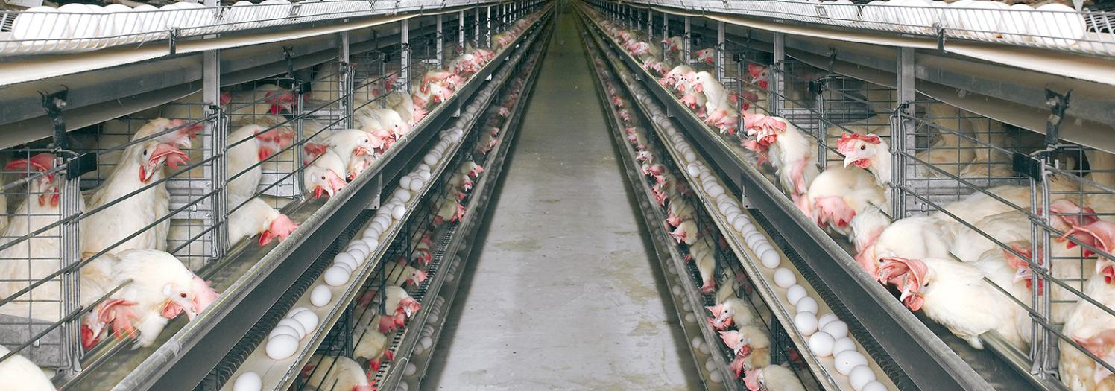

Image 2: The Dutchman UniVent UV600

Phase 4: Strategic Positioning (Months 37-48)
The final phase prepares for our next major expansion milestone:

Capital Generation:
- Proven profitability at 67,800-bird scale provides foundation for Phase 2 expansion funding
- Enhanced market position enables premium contract negotiations
- Operational efficiencies generate surplus capital for reinvestment

Expansion Preparation:
- Site preparation for second identical facility
- Advanced planning for 100,000-bird operational systems
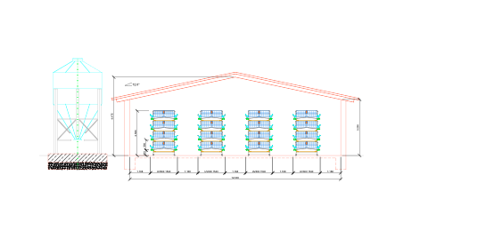
- Market development for expanded production capacity

Image 3: CAD drawing of the UniVent UV600 installation and Silo feed structure
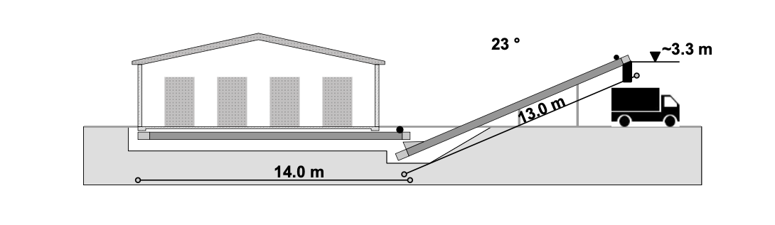
image 4: CAD designs of the waste removal system. Operations are carried out weekly.

Infrastructure & Technology Investment
Core Poultry Infrastructure: Our technology investment centers on The Big Dutchman Univent UV600 system—a world-class solution that represents the pinnacle of modern layer housing technology:

Univent UV600 Comprehensive System:
- Advanced Cage Design: Multi-tier system optimized for bird comfort, health, and productivity
- Automated Feeding Systems: Precision feed distribution with minimal waste and optimal nutrition delivery
- Intelligent Watering Systems: Nipple-based watering with automatic cleaning and pressure regulation
- Gentle Egg Collection: Automated belt systems ensuring minimal egg damage and maximum freshness
- Climate Control Excellence: Sophisticated ventilation with temperature, humidity, and air quality management
- Integrated Monitoring: Real-time data collection and alert systems for proactive management

Supporting Infrastructure:
- Feed Storage Systems: Climate-controlled silos with automated inventory management
- Egg Processing Facility: Washing, grading, and packaging systems for value-added processing
- Waste Management Systems: Automated manure removal with composting capabilities
- Biosecurity Infrastructure: Enhanced entry protocols, disinfection systems, and quarantine facilities
- Emergency Backup Systems: Power generation and water storage for uninterrupted operations.

Essential Machinery & Equipment Portfolio
To ensure comprehensive operational capability, our machinery investment encompasses versatile equipment for all aspects of farm management:

Primary Agricultural Equipment:

Tractor-Loader-Backhoe (TLB)
- Purpose: Multi-functional construction and maintenance support
- Capabilities: Front-end loading, trenching, landscaping, material handling
- Applications: Site preparation, routine maintenance, infrastructure development

High-Performance Tractor (100-230 HP)
- Purpose: Heavy-duty operations and implement management
- Capabilities: Hauling, tillage, attachment operation
- Applications: Feed transport, waste management, general farm operations

Specialized Transport Equipment:

8-Tonne Refrigerated Panel Truck
- Purpose: Premium egg transport and distribution
- Features: Temperature-controlled environment, GPS tracking, custom racking systems
- Impact: Ensures product quality, enables direct-to-retail delivery, reduces distribution costs

Future-Ready Agricultural Implements:
- Precision Planters: For potential crop diversification opportunities
- Advanced Tillage Equipment: Discs and ploughs for soil management
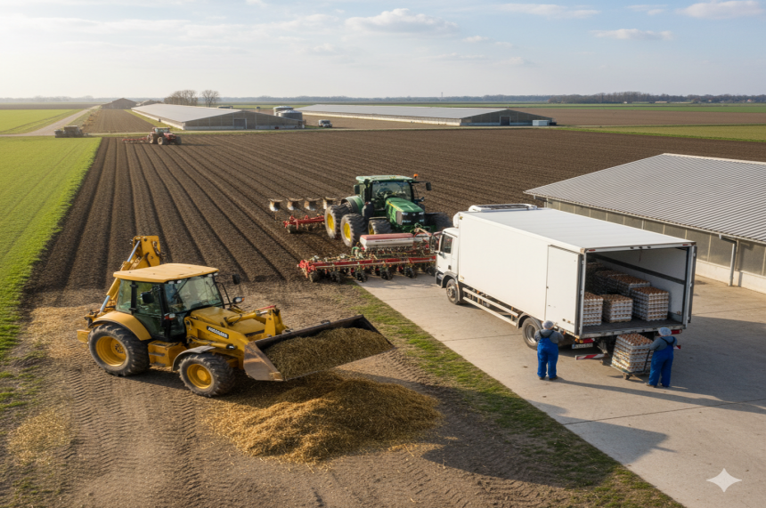
- Versatility Focus: Equipment selection prioritizes multi-purpose functionality
Image 5: Machinery at work

Comprehensive Funding Strategy
Our R20,186 970 funding request represents a strategic investment in mission-critical infrastructure that will directly translate into substantial production increases and enhanced profitability.

Detailed Fund Allocation
Investment Category | Amount (ZAR) | Percentage | Strategic Purpose
Infrastructure Development | R20,186,970 | 68.6% | Core Production Capability
Poultry Infrastructure & Automation | R19,386,970 | 65.8% | Primary production systems
Administrative Software Systems | R800,000 | 2.7% | Operational management technology
Machinery & Equipment | R4,250,000 | 14.4% | Operational Support Systems
Essential Farm Machinery | R4,250,000 | 14.4% | Comprehensive equipment portfolio
Total Investment | R24,436,970 | 100.0% | Complete Expansion Program
Table 2: Investment allocation based on category and sub-categories

Investment Justification
Each funding component has been calculated based on:
- Detailed Engineering Studies: Comprehensive technical assessments ensuring accurate cost estimation
- Vendor Quotations: Firm pricing from established suppliers and contractors
- Contingency Planning: Built-in buffers for unforeseen circumstances
- Performance Optimization: Investment levels designed to achieve maximum operational efficiency
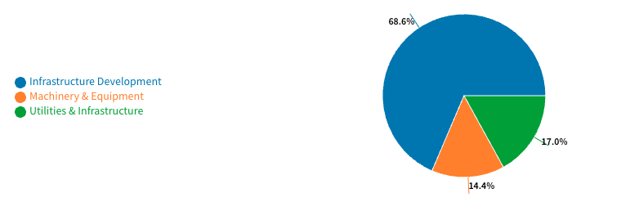
Chart 1: Investment Allocation by Category

Comprehensive Staffing Plan
The expansion to 51,200 additional birds requires a carefully planned staffing strategy that ensures operational excellence while maintaining our company culture of dedication and continuous learning.

Current Staffing Baseline
Our existing operation employs 12 full-time staff members across production. This team has demonstrated exceptional efficiency, managing 16,600 birds with industry-leading performance metrics.

Expanded Staffing Requirements

Production Team (18 additional positions)
- Senior Production Supervisors (2): Oversight of daily operations, quality control, and staff coordination
- Layer House Technicians (6): Specialized operators for automated systems, monitoring bird health and system performance
- Feed Management Specialists (2): Responsible for feed quality control, inventory management, and nutrition optimization
- Egg Collection & Processing Staff (4): Handling automated collection systems, quality grading, and packaging operations
- Maintenance Technicians (2): Specialized in automated equipment maintenance and repair
- Biosecurity Officers (2): Ensuring compliance with health protocols and maintaining facility security

Support Services (6 additional positions)
- Administrative Coordinator (1): Managing expanded paperwork, compliance reporting, and communication systems
- Quality Assurance Specialist (1): Implementing and monitoring quality control procedures across expanded operations
- Logistics Coordinators (2): Managing increased transportation and distribution requirements
- General Farm Workers (2): Supporting various operational activities as needed

Training & Development Program

Pre-Expansion Training (Months 1-6):
- Comprehensive Big Dutchman system training for all technical staff
- Advanced biosecurity protocols and emergency response procedures
- Leadership development for supervisory positions
- Cross-training initiatives to ensure operational flexibility

Ongoing Development:
- Monthly technical update sessions
- Annual performance reviews with career development planning
- Industry conference attendance for key staff
- Skills development partnerships with agricultural training institutions

Compensation & Benefits Strategy
Golden Nest is committed to being an employer of choice in the region:
- Competitive Salaries: Above-market compensation reflecting our commitment to attracting and retaining top talent
- Performance Incentives: Quarterly bonuses tied to production metrics and quality standards
- Training Investment: Comprehensive professional development opportunities
- Career Progression: Clear advancement pathways within our growing organization
- Community Benefits: Educational support, and community development programs

Organizational Integration
New staff will be introduced a month (week 20) before construction is completed and commissioned.
- Week 20: Company orientation, safety training, and cultural integration
- Weeks 22-24: Technical training and mentorship programs
- Month 25: Performance evaluation and role refinement
- Month 26: Full operational integration with ongoing support

Risk Management & Mitigation Strategies

Operational Risks
- Disease Management: Comprehensive biosecurity protocols, vaccination programs, and quarantine procedures
- Equipment Failure: Preventive maintenance schedules, spare parts inventory, and service agreements
- Climate Events: Insurance coverage, backup power systems, and emergency response procedures

Market Risks
- Price Volatility: Diversified customer base, forward contracting, and premium product positioning
- Competition: Continuous improvement programs, customer relationship management, and cost optimization
- Regulatory Changes: Proactive compliance monitoring and industry association participation

Financial Risks
- Cash Flow Management: Working capital reserves, conservative growth planning, and diversified revenue streams
- Interest Rate Exposure: Fixed-rate financing options and financial hedging strategies where appropriate
- Currency Fluctuations: Local supplier preference and natural hedging through cost structure
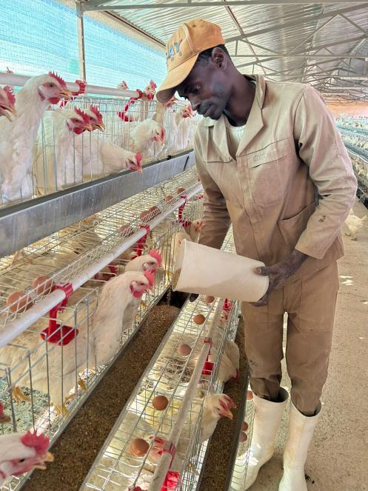
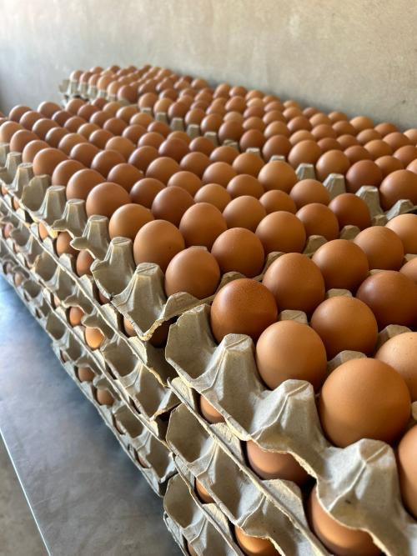
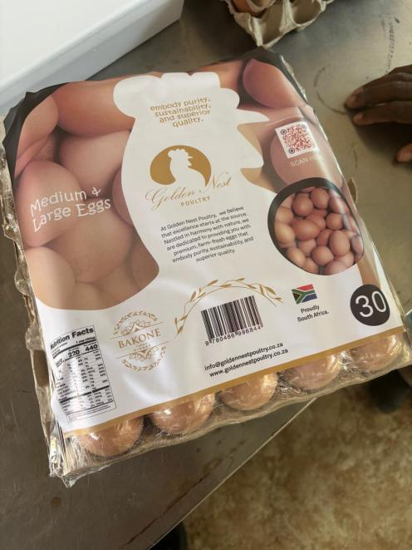
Image 3: Onsite images.

Financial Projections & Return Analysis
Based on our proven operational performance and conservative market assumptions, the expansion investment is projected to generate substantial returns:
Year 0 (Current Operation) Projections:
- Total Production: 16,600 layers producing ~16 100 eggs/day at R55/tray of 30 eggs
- Gross Revenue: ~R29 500/day or ~R885 000/month
- Operating Costs: ~R398 000/month (@55% margin maintained)
- Net Profit: ~R487 000/month or ~R5.84 million/year

Year 1 (Post-Expansion) Projections:
- Total Production: 67,800 layers producing ~24 million eggs annually
- Gross Revenue: ~R45.2 million/year at R55/tray
- Operating Costs: ~R20.3 million/month (55% margin maintained)
- Net Profit: ~R24.8 million/year

Year 2 (Post Phase 2 Expansion) Projections:
- Total Production: 100,000 layers producing ~35.4 million eggs annually
- Gross Revenue: ~R70 million/year at R55/tray
- Operating Costs: ~R29.2 million/month (55% margin maintained)
- Net Profit: ~R35.7 million/year

Year 3 (Post Phase 2 Expansion) Projections:
- Total Production: 100,000 layers producing ~35.4 million eggs annually
- Gross Revenue: ~R70 million/year at R55/tray
- Operating Costs: ~R29.2 million/month (55% margin maintained)
- Net Profit: ~R35.7 million/year

Return Metrics:
- Payback Period: 2.8 years
- IRR: 35.4%
- NPV (10% discount): R58.3 million over 10 years

Costs and Revenue Projection
Feed accounts to most of our operational costs. We have concluded the optimal amount of feed each chicken required per day is 110g. This based on the feed we currently use. We want to start buying feed
Chickens | Daily Flock Consumption | Yearly Consumption | Bags Required | Feed Costs | Yearly Feed Costs
16 600 | 1 826 Kg | 666,5 tons | 13 330 bags | R 298/bag | R 3 972 000
67 800 | 7 458 Kg | 2 722.2 tons | 54 444 bags | R 298/bag | R 16 224 000
100 000 | 11 000 Kg | 4 015 tons | 80 300 bags | R 298/bag | R 23 930 000
Table 3: Yearly cost of Chicken feed at 110g daily consumption per chicken. 1 Ton = 20 bags
Operational costs vary from month to month based on several factors. Based on previous performances, looking at revenue and profits, we can safely assume an 8% operation cost on revenue based on flock size. Materials costs such as eggs trays, wrapping plastics and labeling paper tend to increase as the flock gets bigger.
Based on the projected plan in this document, we predict that we will have 100 000 chickens within 3 years with the steady increase plan.
Year | Total Hens | Production (Eggs) | Gross Revenue | Feed Costs | Operations | Net Profit
0 | 16 600 | 5 876 500 | R10 775 000 | R 4 000 000 | R 935 000 | R 5 840 000
1 | 67 800 | 24 747 000 | R 44 008 000 | R16 300 000 | R 2 908 000 | R 24 800 000
2 | 100 000 | 35 405 000 | R 64 909 000 | R 24 000 000 | R 5 209 000 | R 35 700 000
3 | 100 000 | 35 405 000 | R 64 909 000 | R 24 000 000 | R 5 209 000 | R 35 700 000
4 | 100 000 | 35 405 000 | R 64 909 000 | R 24 000 000 | R 5 209 000 | R 35 700 000
5 | 100 000 | 35 405 000 | R 64 909 000 | R 24 000 000 | R 5 209 000 | R 35 700 000
Table 3: Yearly Finacial prediction for 5 years assuming R55/tray (30 eggs) at 97% yield
Based on projections, we are estimated to generate R 179.44million in net profits over the next 6 years.

Sustainability & Community Impact

Environmental Stewardship
- Advanced waste management systems converting manure to high-quality fertilizer
- Energy-efficient automation reducing overall environmental footprint
- Water conservation systems and recycling programs
- Local sourcing preference reducing transportation emissions

Community Development
- Creation of 24 permanent jobs with above-average compensation
- Skills development programs contributing to regional capability building
- Support for local suppliers and service providers
- Contribution to regional food security objectives

Economic Impact
- Significant contribution to local GDP and tax base
- Foreign exchange savings through import substitution
- Supply chain development supporting related industries
- Demonstration effect encouraging additional agricultural investment in the region
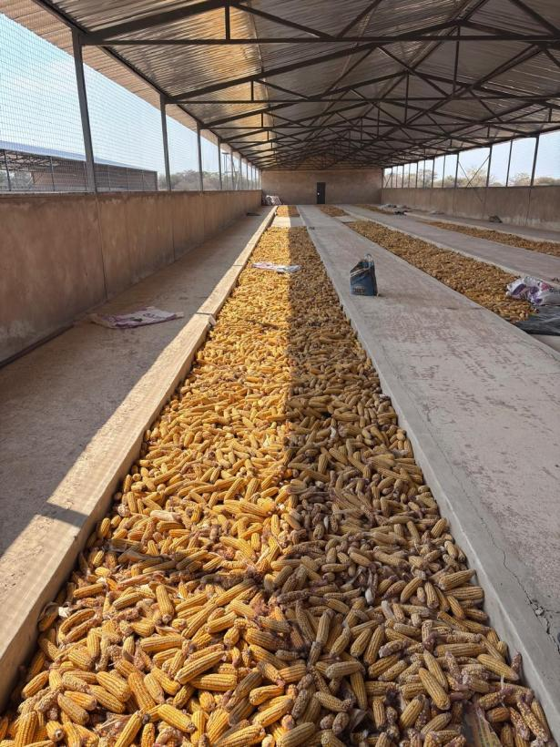
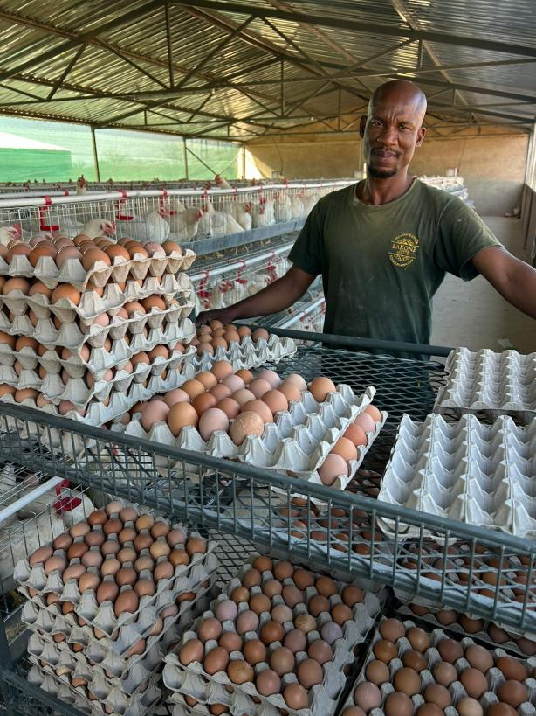
Image 2: With the new expansion we plan to deliver meaningful change to the community

Conclusion: A Vision Realized
Golden Nest Poultry's expansion represents far more than a business growth initiative—it is a strategic investment in South Africa's agricultural future. Our proven track record, combined with cutting-edge technology and a experienced management team, positions this project for exceptional success.
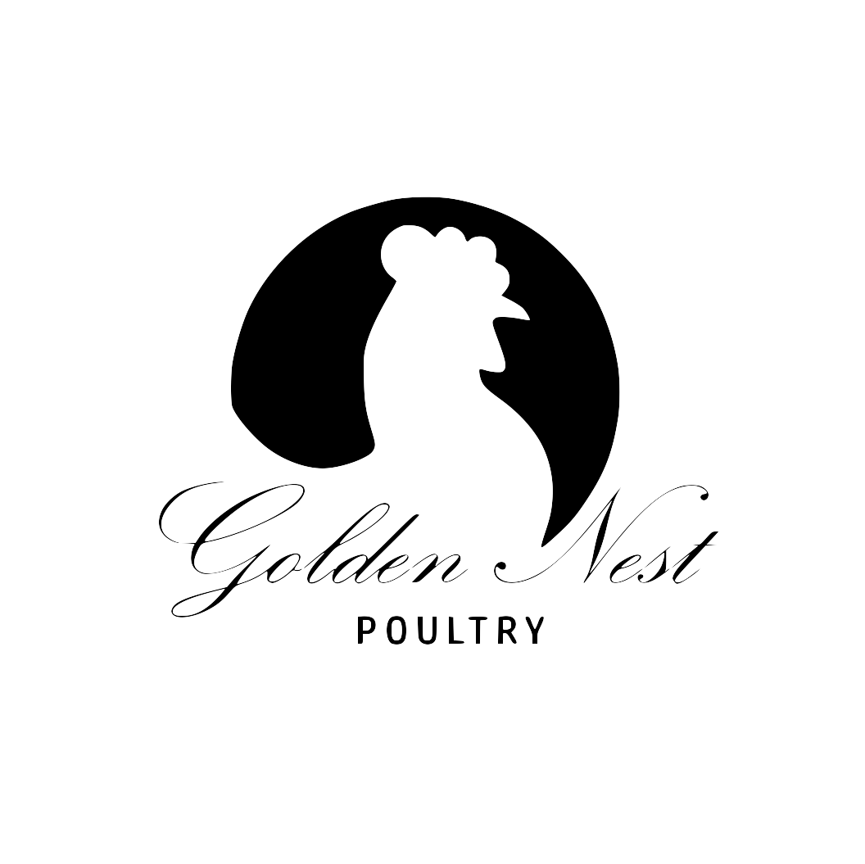
The R20.18 million investment will transform Golden Nest from a successful local operation into a regional leader, creating substantial value for investors while contributing meaningfully to food security and economic development. Our phased approach, comprehensive risk management, and commitment to operational excellence ensure that this expansion will deliver sustainable, profitable growth for years to come.
We invite investors to join us in this exciting journey as we build upon our foundation of success to create a truly world-class poultry operation that serves as a model for agricultural excellence in South Africa.

