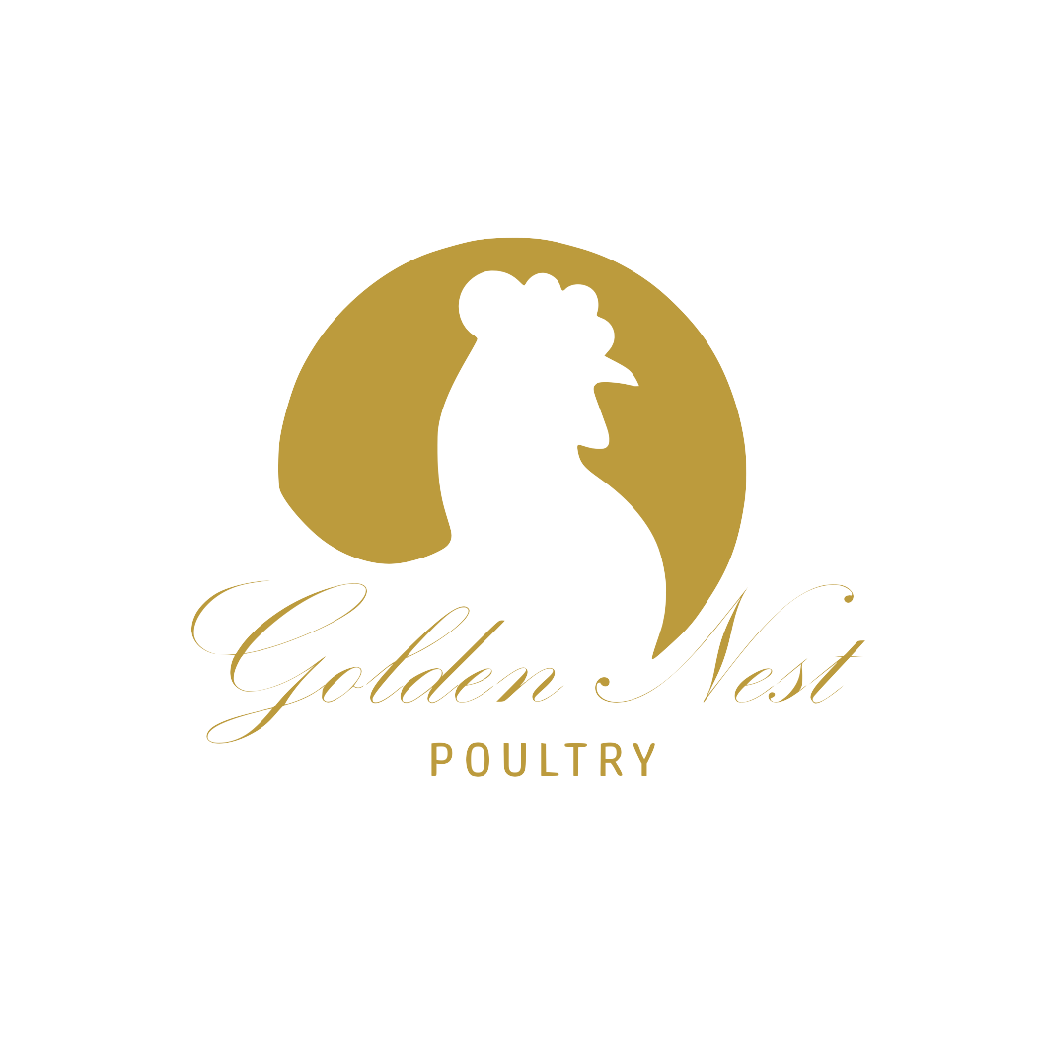
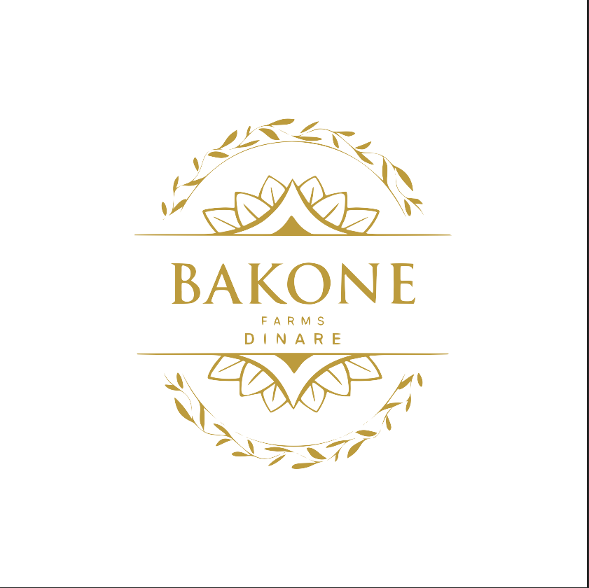

Executive Summary
This document outlines a compelling investment opportunity in Golden Nest Poultry, a proven, high-growth agribusiness poised to disrupt the South African egg market. We have a validated track record of exceptional performance, achieving a remarkable 419% growth in our flock size in just two months while maintaining industry-leading profit margins. This success is the foundation for our next phase: a strategic expansion to 100,000 birds, leveraging cutting-edge automation to create a technological advantage that will secure our position as a top-tier producer.
Our strategy is deliberately designed to capitalise on the market restructuring that followed the recent Avian Influenza outbreak. While established players rely on outdated infrastructure, our state-of-the-art, bio-secure facility will allow us to offer a reliable, high-quality supply at a scale and efficiency that competitors cannot match. This proposal, backed by detailed financial data, demonstrates a clear path to generating exceptional returns with a projected annual return on investment of 125% to 235% and a potential exit value of up to R500 million. We invite you to partner with us in building a new standard for sustainable and profitable poultry farming in South Africa.

- The Golden Nest Story: From Family Farm to Market Leader
Golden Nest Poultry is a family-owned business with deep roots in Modimole, Limpopo. What began as a small, passionate operation has steadily grown into a commercially viable enterprise. Our journey is a testament to our commitment to quality, ethical farming, and community. We have always believed that producing high-quality food should not come at the expense of our values, a belief that has earned us the trust of our local community and a loyal customer base.
In recent months, we have demonstrated our ability to scale with incredible speed and precision. From July to September 2025, after an expansion to our farm, we grew our chicken flock from 3,200 to 16,600, an astonishing 419% growth rate. During this rapid expansion, we not only maintained but exceeded key performance benchmarks, proving our operational model is robust and highly efficient. This period of explosive growth has solidified our confidence in our ability to manage a much larger, fully automated operation, confirming that we are no longer just a small farm, but a commercial entity ready for a major expansion.

2. The Market Opportunity: A Gap in the South African Egg Market
South Africa’s R8.2 billion egg market is ripe for disruption. The recent HPAI outbreak, while devastating for many producers, created a unique opportunity for businesses that can guarantee a consistent, bio-secure supply. Consumers and major retailers are now prioritising stability and traceability, a demand that many legacy producers with their aging infrastructure cannot reliably meet.
Our business plan is designed to exploit this critical market gap. The major industry players, like Quantum Foods, are burdened by older facilities that are less bio-secure and less efficient. Golden Nest, by contrast, will be a "greenfield" operation, built from the ground up with the latest technology. This allows us to leapfrog the competition, establishing a new, higher standard for efficiency, bio-security, and quality. Our existing customer base already validates the strong demand for our product, with a 96% absorption rate of our current production. With this expansion, we will be able to penetrate a larger share of the market, targeting both wholesalers and institutional clients who are actively seeking professional and reliable partners.

3. Our Competitive Advantage: A Technology-Enabled “Moat"
The core of our strategy is the creation of a technological advantage, often referred to as a "moat," that will protect our business from competitors and ensure long-term profitability. This will be achieved through a strategic partnership with Big Dutchman, the world’s leading supplier of automated poultry systems. The provided quotation details a complete, turnkey solution to house 102,400 chickens. This is far more than just a chicken house; it is a fully integrated production ecosystem.
This system, which includes the Univent UV600 layer housing system, offers several key benefits that will set us apart:
- Superior Bio-security: The automated process will minimise human contact with the birds, drastically reducing the risk of disease transmission. This is our most significant advantage in a post-HPAI market, offering peace of mind to our customers and security to our business.
- Unmatched Efficiency: The technology ensures optimal use of resources. Automated feeding, watering, and climate control will lead to a better Feed Conversion Ratio, or FCR, which is a measure of how efficiently chickens convert feed into eggs. Our current FCR of 2.1:1 already outperforms the industry average of 2.3:1, and the new system will allow us to maintain this advantage at a massive scale.
- Consistent Quality: Automated egg collection and climate control ensure that every egg is handled with care and produced under ideal conditions, resulting in a consistently high-quality product.
- Reduced Operational Costs: While the initial investment is substantial, the long-term cost savings in labor, feed, and energy are significant, making our operation leaner and more profitable than traditional farms.

4. Operational Excellence: Our Proven Track Record
Our recent performance serves as indisputable proof that our management team can execute on our vision. The growth we experienced from July to September 2025 was not a matter of luck but a result of meticulous planning and flawless execution. The key performance metrics from this period are not just numbers; they are a validation of our entire operational model.
Our Operational Triumphs, Quantified:
- Unprecedented Growth: We scaled our flock from 3,200 to 16,600 birds, demonstrating that we have a scalable model and the capability to handle rapid expansion.
- Industry-Leading Profitability: We maintained a 55% profit margin, far surpassing the industry average of 35%. This shows that our operational efficiency allows us to generate significant profit even during periods of high-speed growth.
- Superior Productivity: Our production rate remained stable at 97%, significantly higher than the industry average of 85%. This means our birds are healthier and more productive, a direct result of our careful management practices.
- Exceptional Efficiency: Our Feed Conversion Ratio of 2.1:1 is a testament to our disciplined approach to nutrition, ensuring that we get the most out of every kilogram of feed.
This period of rapid growth provided us with a real-world, high-pressure test of our capabilities, and we passed with flying colours. We have a baseline of excellence that few others can claim, and we are ready to apply these same principles to our next phase of growth.

5. The Path Forward: Our Strategic Implementation Plan
This expansion plan is a multi-phase, carefully orchestrated process designed to maximise efficiency and minimise risk. The (19.75) R23.5million investment will be strategically deployed to build our technology-forward facility and purchase essential machinery.
Phase 1: Construction and Automation (Months 1-8)
The first phase involves the complete setup of the two new poultry houses, totalling over 3,100 square meters. This includes the installation of the Big Dutchman Univent UV600 systems, which are designed to be a full turnkey operation, Improvements to the Water Supply and and upgrade of our Electrical Infrastructure from single to 3-phase. This period will be a hive of activity, transforming a greenfield site into a state-of-the-art production facility.
Phase 2: Initial Flock Stocking and Ramp-Up (Months 10-18)
Once the facilities are complete, we will begin stocking the first house. This is a critical period of ramp-up where we will gradually increase our flock by over 50 000 additional chickens to ensure everything is working as expected. The data from our recent growth spurt gives us high confidence in our ability to manage this transition smoothly, ensuring the health of our birds and the consistency of our production.
Phase 3: Full-Scale Operation (Months 19-36)
This phase will see the second house become operational, bringing our total flock to over 100,000 birds. At this point, Golden Nest will be one of the top producers in the region, with the capacity to produce approximately 92,000 eggs daily. Our focus will be on optimising our supply chain and expanding our reach into new markets, leveraging our technological edge to secure major contracts with retailers and wholesalers.

6. Financial Projections and Return on Investment
Our financial model is built on conservative assumptions and validated by our recent performance. We have stress-tested our projections to ensure they are robust and realistic. The capital investment of (19.75) R23.5million is specifically allocated to the automation and infrastructure required for the expansion, as detailed in the Big Dutchman quotation.
Our Financial Forecast:
- Current Annual Profit: R5.5 million
- Future (100K birds) Annual Profit: R35.5 million
- Projected Annual Return on Investment (ROI): We project an annual ROI between a conservative 125% and an optimistic 235%. This is a rare level of return for a capital-intensive agricultural project.
- Payback Period: Our model shows a payback period as short as 15 months, indicating a rapid and highly efficient return of capital.
- Exit Value: For investors seeking a long-term strategy, we project a potential exit value of R280M to R500M within 3-5 years, providing a return multiple of 14x to 25x.
This is not a theoretical model; it is a direct extension of our proven track record, adjusted for the economies of scale and efficiencies that our new technology will unlock. We are confident in these numbers because they are built on a foundation of real-world success.

7. Risk Mitigation and Strategic Resilience
We understand that all investments carry risk, and we have developed a comprehensive plan to mitigate potential threats. Our approach is to turn traditional industry risks into a source of competitive advantage.
- Disease Outbreaks: The number one risk in poultry farming is disease. Our investment in Big Dutchman’s automated, bio-secure systems is our primary defence. By minimising human and external contact, we create a controlled environment that significantly reduces the probability of an outbreak.
- Feed Price Volatility: Feed is our largest variable cost. We will mitigate this risk through a combination of forward contracts with suppliers and by potentially exploring on-farm feed milling to gain greater control over costs and supply.
- Power Supply Interruptions: South Africa's power challenges are a known risk. We have accounted for this by integrating power redundancy and will explore solar energy and energy storage solutions, to ensure uninterrupted operation, a critical factor for maintaining climate control and productivity.
- Market Fluctuations: Our strategy of focusing on both high-volume wholesale clients and direct, high-margin retail channels diversifies our customer base, ensuring that we are not over-reliant on any single market segment. Our superior product quality will also allow us to command a premium price, insulating us from downward market pressure.

8. Conclusion: An Invitation to Partner in Our Vision
Golden Nest Poultry is at a pivotal moment. We have outgrown our current infrastructure and are ready to make the leap to become a regional leader in a high-demand market. We have the vision, the operational track record, and the strategic plan to achieve this goal. This proposal is more than a request for funding; it is an invitation to partner with us in building a truly world-class, technology-enabled agribusiness that will set a new standard for the industry.
We have demonstrated our ability to deliver on our promises, and with your partnership, we will realise the full potential of this exceptional opportunity, generating significant financial returns while contributing to the stability and security of South Africa's food supply.

Appendices: Detailed Data and Financials

This section contains the detailed data, graphs, and charts that support the narrative of this proposal.
1. Financial Performance Dashboard (July-September 2025)
Metric | July 2025 | September 2025 | Growth
Flock Size | 3,200 | 16,600 | 419%
Monthly Revenue | R 170,000 | R 880,000 | 418%
Daily Production | 3,104 eggs | 16,072 eggs | 402%
Feed Costs | R 79,430 | R 339,720 | 327%
Net Profit | R 90,570 | R 459,000 | 407%

2. Key Operational Performance Indicators
Performance Metric | Golden Nest | Industry Average | Golden Nest Advantage
Production Rate | 97% | 85% | 14%
Feed Conversion Ratio (FCR) | 2.1:1 | 2.3:1 | 9% more efficient
Mortality Rate | <2% | 5% | 60% lower
Profit Margin | 55% | 35% | 57%

3. Total Addressable Market (TAM) Analysis in Rands
<img src="https://i.ibb.co/L519R4J/Market-Opportunity-Funnel.png" width="500" height="300" alt="Funnel chart illustrating the market opportunity. TAM: 1.358 billion eggs (R8.15 billion). SAM: 543 million eggs (R3.26 billion). Target SOM: 96 million eggs (~7% of SAM).">
4. Project Funding Allocation
<img src="https://i.ibb.co/305z4kM/Funding-Allocation-Pie-Chart.png" width="500" height="300" alt="Pie chart showing the allocation of the R19.75 million funding request. Poultry Infrastructure & Automation accounts for 78.5% and Essential Machinery accounts for 21.5%.">
5. Financial Projections and Return on Investment
Initial Investment: R19.75M

Conservative Exit Value: R280M (14x return)
Base Case Exit Value: R350M (18x return)
Optimistic Exit Value: R500M (25x return)

IRR Analysis:
- 3-year exit at R280M: 192% IRR
- 4-year exit at R350M: 178% IRR
- 5-year exit at R500M: 168% IRR

DOCUMENT END

