**GITHUB:**

**STEP 1:** First login to github. After successful login this will be your dashboard

* + Click on “New” button to create a new repository
  + Right side you can see the already created repositories

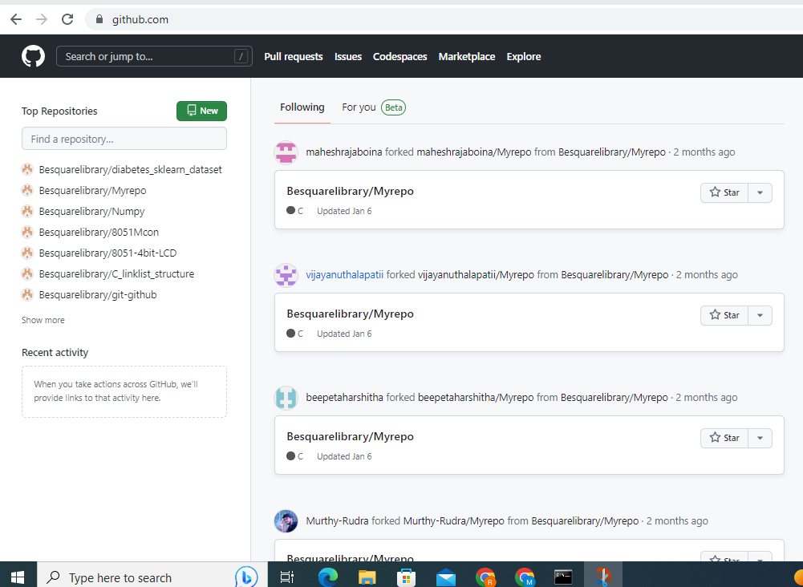

**STEP 2:** Click on “Repository name” give an name to repository

* Click on “Description” write description about your project

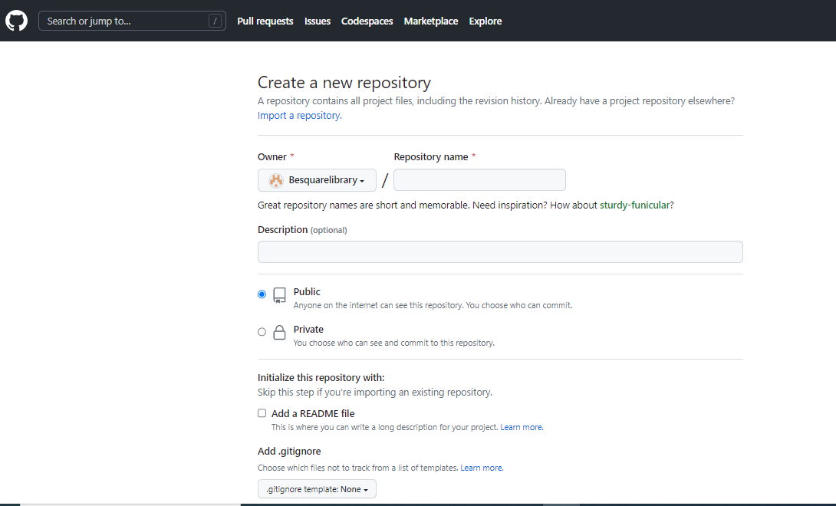

**STEP 3:** Click on “Create repository”, Then your repository will be created

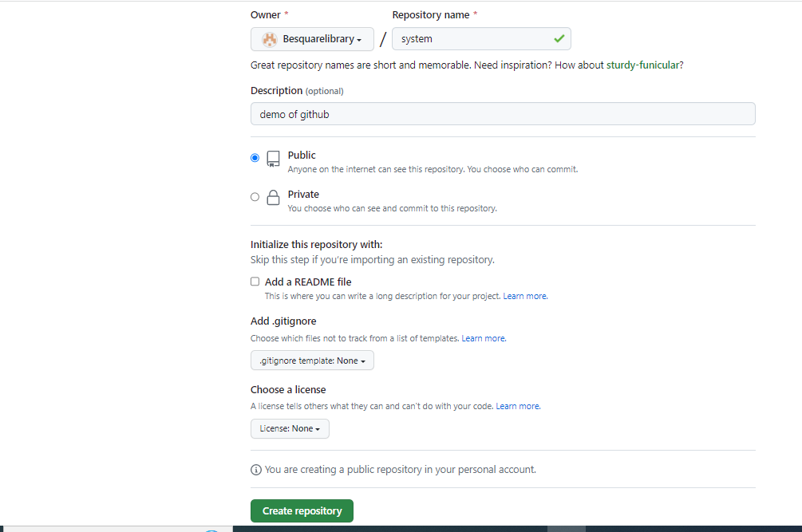

**STEP 4:** When repository is created then it will display URL of repository in <https://github.com/Besuarelibrary/system.git>

We need copy the URL and paste in local machine using “git clone <url>” command

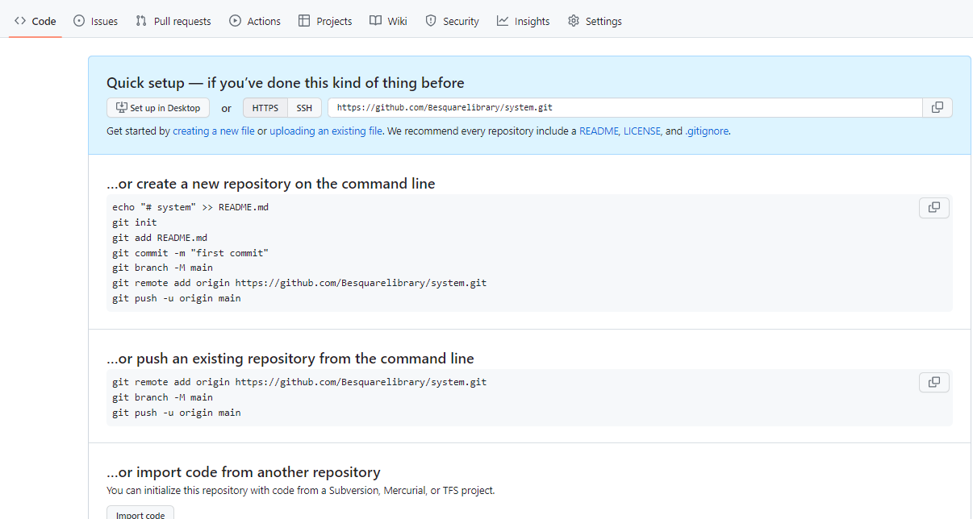

**GIT BASH:**

**After successful creation of github repository, Now go to GIT or CMD in your local machine**

**STEP 1:** Open git in local machine or command promt

* Select the path in system where you are going to clone the repository by using “cd <path>” command
* After selecting path use “git clone <repository url>” to clone from github server to local machine
* Use “ls” command to check repository cloned to ur local machine and to check files present in that folder
* Use vim editor to create a file “vim <file name with extension>”

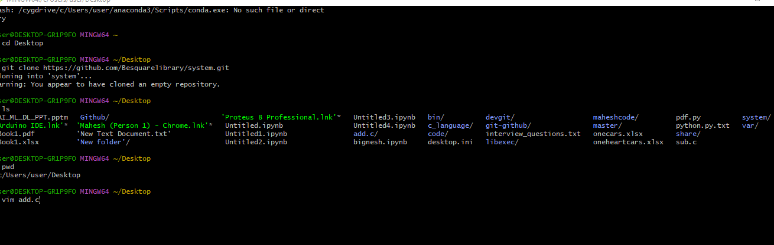

**STEP 2:** When enter “vim add.c” press enter, vim editor will open as shown in below fig.

* + Press “i-insert” to write code in vim
  + After writing code press “Esc” + “:wq” to save the file.

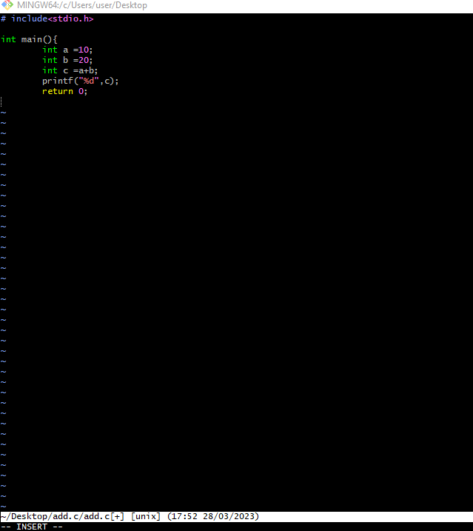

**STEP 3:** Add the file(add.c) to repository by using “git add <file>” or “git add .” .

**STEP 4:** Commit the file using “git commit” command and press enter it will commit

**STEP 5:** Push the code to github server by using “git push” command press enter it will be pushed to server directly

**STEP 6:** Open github server and refresh the page, Then you can see the file you have pushed in git bash

**JENKINS:**

**STEP 1:** First go to jenkins file path in command promt and enter “java –jar jenkins.war” press enter.

**STEP 2:** Go to server and type in search bar “localhost:8080” press enter.

**STEP 3:** Login with your mail ID

* After successful login you will enter into Dashboard

**STEP 4:** Click on “+ New item” to create new project in jenkins

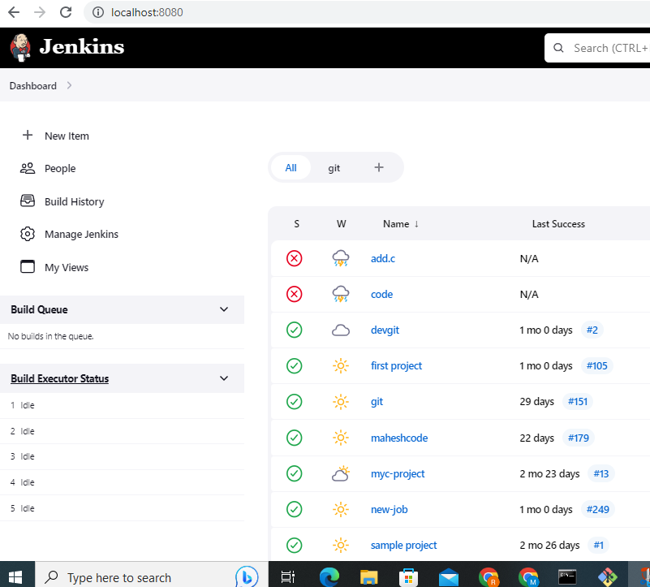

**STEP 5:** Click on “Enter item name” and enter project name

* + Click on “Freestyle project” option
  + Click on “OK” button

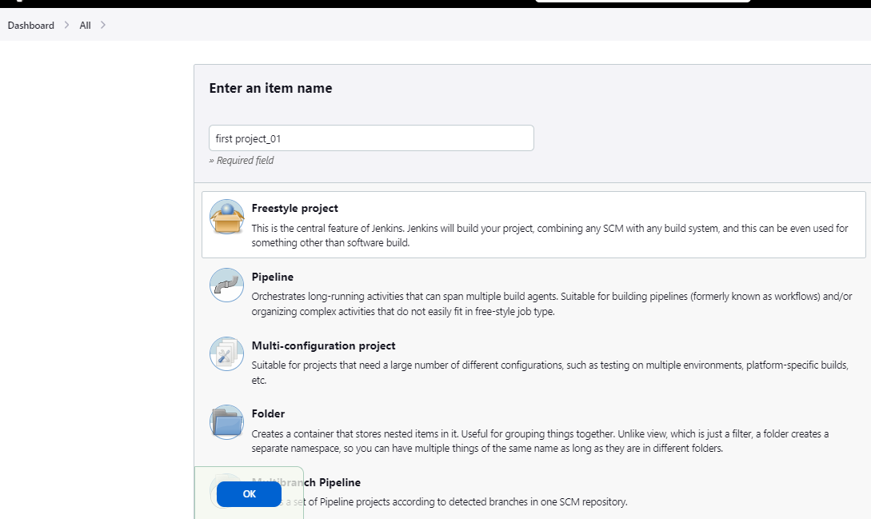

**STEP 6:** After creating project in jenkins we need to enter all configuration of project

* + Click on “Description” and write about project description
  + Click on “GitHub project”

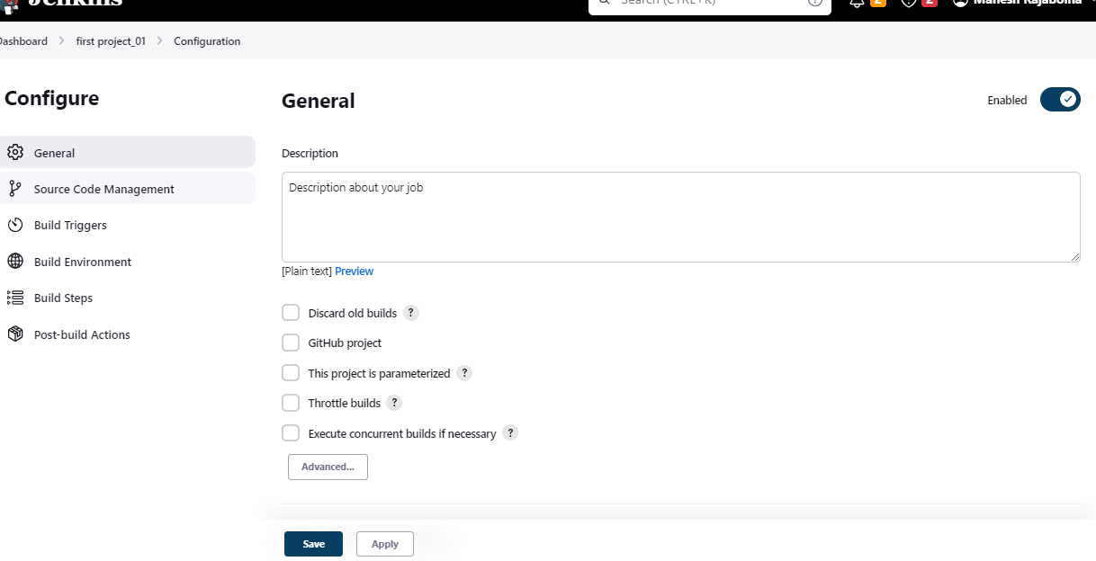

**STEP 7:** Go to github server page copy the project path in search bar and also copy the HTTPS url of repository

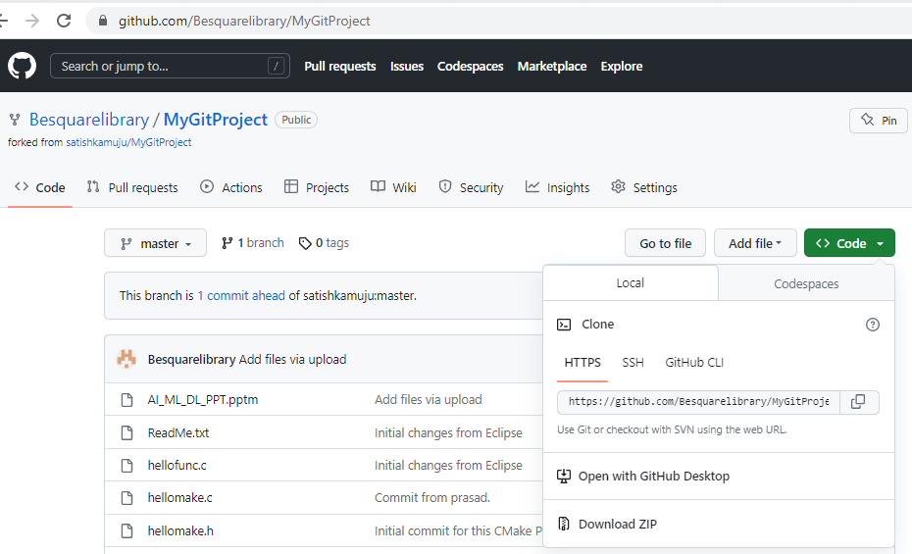

**STEP 8:** Paste the project url in GitHub project, which copy from github server

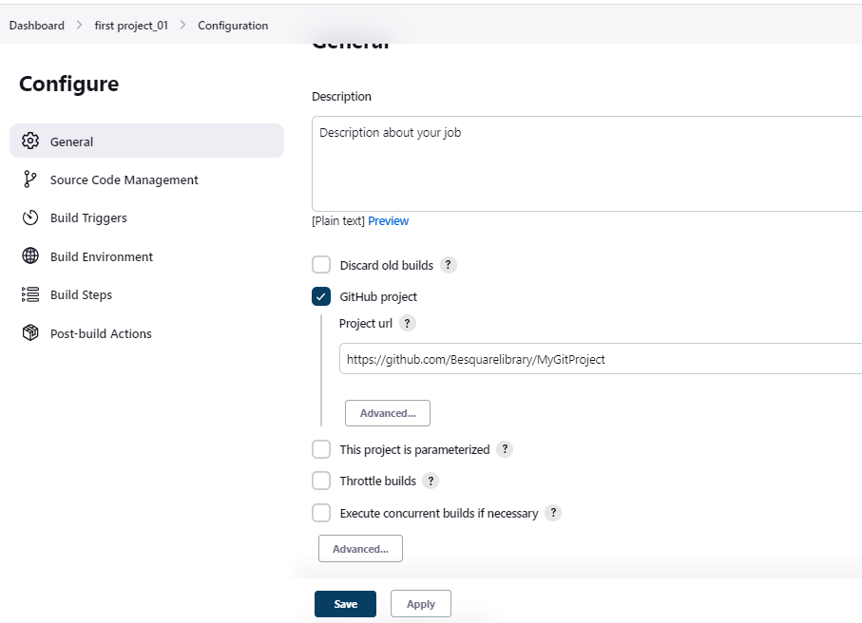

**STEP 9:** In “Source code Management” select Git

* Paste the repository url of github server in repository url

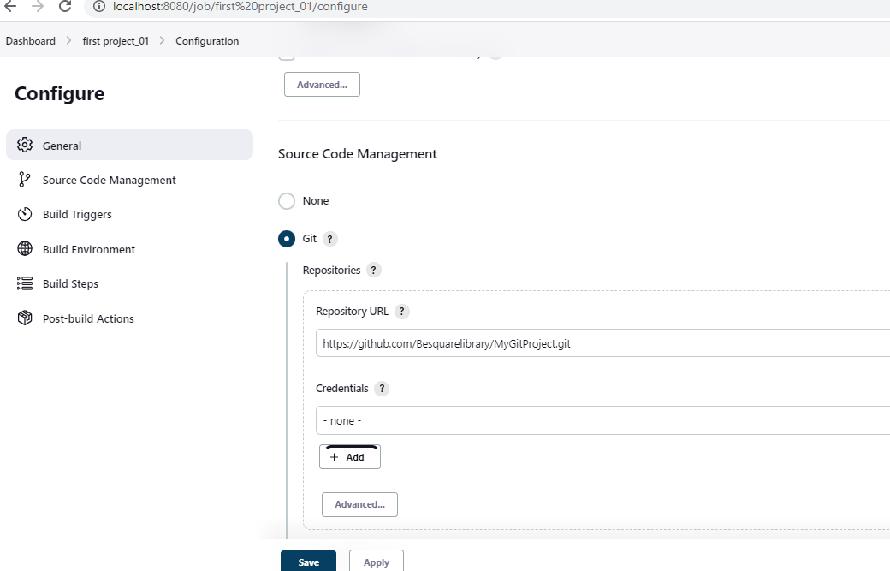

**STEP 10:** In “Build Triggers” select “Build periodically” option and enter in schedule “H/15 * * * * “

* Click on “save” and “apply”

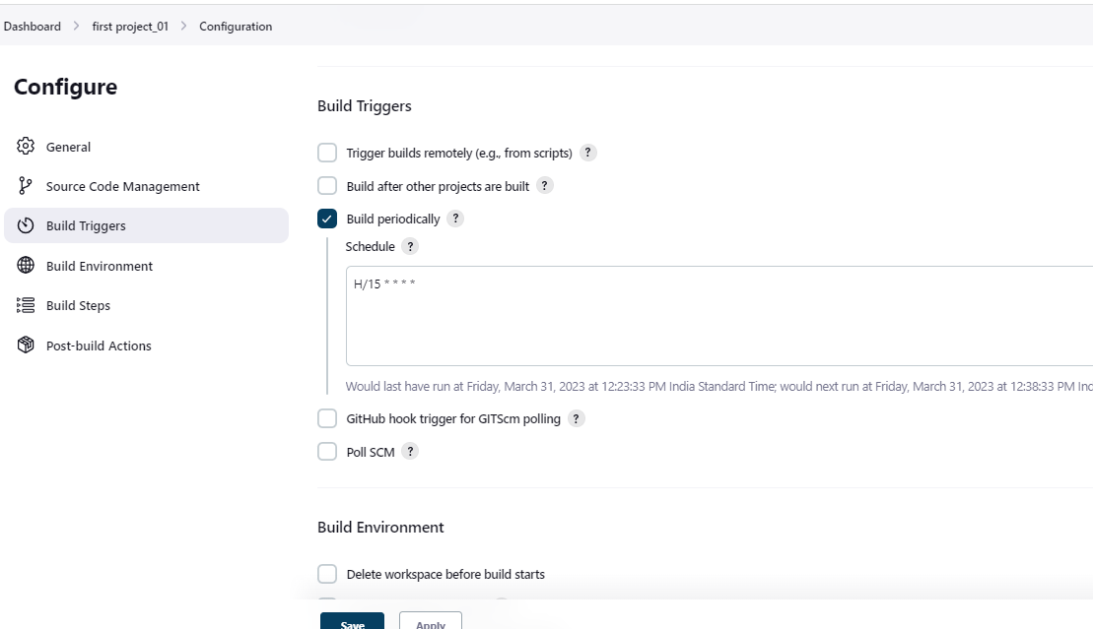

**STEP 11:** Once project is created we need to Build now so, for that Click on “Build Now”

* Once Build is completed it will show in “Filter builds” like (#1), If we want to see output click on “#1”

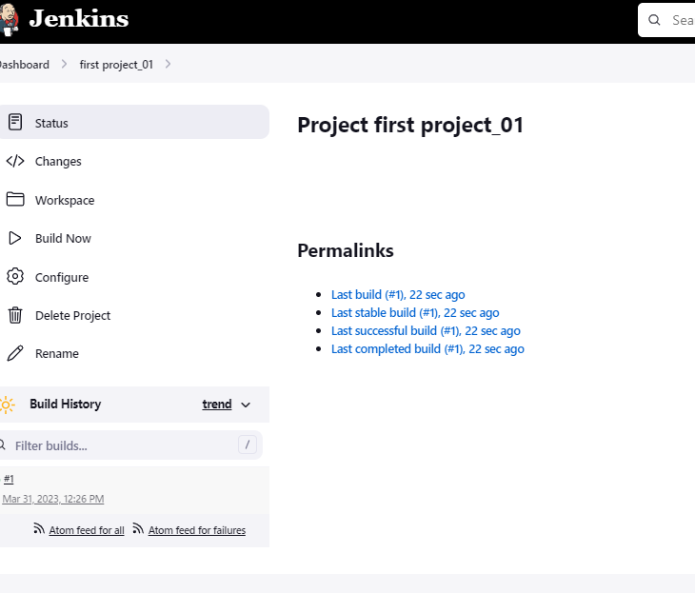

**STEP 12:** If we want to see the build output Click on “Console Output” option.

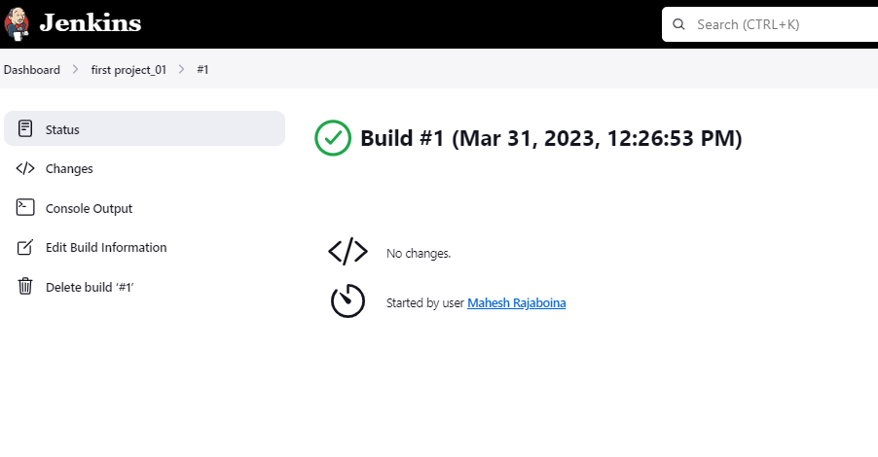

**STEP 13:** You can see console output whether it is success or failure

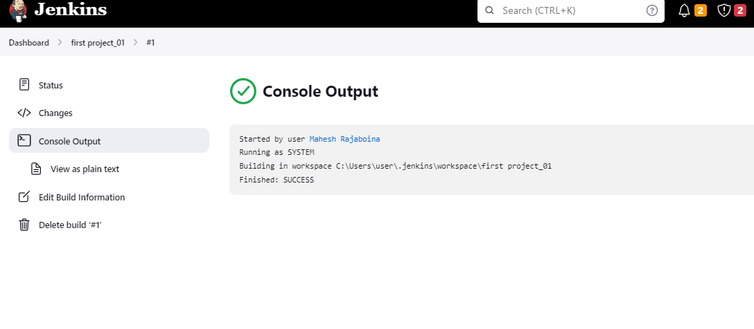

STEP 14: Click on “Dashboard" there you can see how many time build is success or failure

