1、

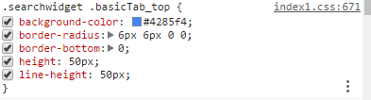

改background-color为#23a1eb：.searchwidget .basicTab_top {background-color: #23a1eb;}