[INSERT ALU LOGO]

Evaluating Guarantor Network Features for Explainable Loan Write-Off Prediction at Umwalimu SACCO, Rwanda
BSc. in Software Engineering
Best Verie Iradukunda
[FILL: course name and code]
Supervisor: Bernard Odartei Lamptey
2026
DECLARATION
This Project Report is my original work, unless stated, and all external sources have been referenced or cited in my document. This work has not been presented for the award of a degree or for any similar purpose in any other university.

Signature.............................. Date................................
Best Verie Iradukunda
CERTIFICATION
The undersigned certifies that he has read and hereby recommends for acceptance by African Leadership University a report entitled "Evaluating Guarantor Network Features for Explainable Loan Write-Off Prediction at Umwalimu SACCO, Rwanda".

Signature........................... Date...............................
Mr. Bernard Odartei Lamptey
Faculty, Bachelor of Software Engineering, ALU
DEDICATION AND ACKNOWLEDGEMENT
To Umwalimu SACCO, for trusting an undergraduate with its real records; this work exists because you opened the door.
To the Mastercard Foundation, whose scholarship carried me to and through this degree.
And to my grandmother, resting in heaven, who believed in me first.
[FILL: add any further acknowledgements you wish, e.g. supervisor, family, friends]
ABSTRACT
Savings and Credit Cooperatives (SACCOs) are central to Rwanda's financial inclusion, yet problem loans remain persistently higher in the SACCO sub-sector than in the banking sector, whose non-performing-loan ratio stood at 2.5% in December 2025 (National Bank of Rwanda, 2026) against SACCO-sector estimates of about 12.5% (Nsengiyumva & Harelimana, 2020). Umwalimu SACCO collateralises its Emergency on Savings loans with member guarantees and savings, but each loan is assessed individually and the structure of the guarantor network is never analysed. This study modelled the guarantor relationships of Umwalimu SACCO as a directed network over 11,015 closed loans from 11 branches (2022-2023), of which 226 (2.1%) were written off, engineered 11 borrower and 7 guarantor-network features strictly as of each loan's disbursement date, and compared borrower-only against network-augmented XGBoost models under borrower-grouped cross-validation. The deployed, isotonic-calibrated, monotone-constrained model ranked write-off risk at ROC-AUC 0.924 (PR-AUC 0.519) and caught about 80% of write-offs at a recall-first operating threshold. Network features were predictive on their own (PR-AUC 0.218 against a 0.021 base rate), but their incremental lift over borrower features was within noise, consistent with homophily. The deliverable is GuarantorLens, a deployed, explainable decision-support tool that presents each score with SHAP-derived plain-language reasons and guarantor-network warnings, within a human-in-the-loop workflow in which the officer proposes and the credit manager decides.
TABLE OF CONTENTS

[In Word: right-click the table and choose "Update Field" to populate it.]
LIST OF TABLES
Table 1.1: Research Budget
Table 2.1: Summary of Reviewed Literature
Table 2.2: Strengths and Weaknesses of Existing Systems versus the Proposed System
Table 3.1: Dataset description
Table 3.2: Feature set (18 features)
Table 3.3: Guarantor-network feature definitions
Table 3.4: Leakage screen: blocked fields versus the admitted feature set
Table 3.5: Functional requirements
Table 3.6: Non-functional requirements
Table 3.7: Key concepts in plain terms
Table 3.8: Development tools
Table 4.1: Functional test scenarios and asserted outcomes
Table 4.2: Automated test summary
Table 5.1: Feature-set comparison (out-of-fold)
Table 5.2: Best configuration per model family (CV PR-AUC)
Table 5.3: Imbalance-handling strategies (PR-AUC)
Table 5.4: Confusion matrix at the operating threshold
Table 6.1: Objectives and evidence
LIST OF FIGURES
Figure 1.1: Research timeline (Gantt chart)
Figure 3.1: Cohort size, class balance, and distributions
Figure 3.2: Leakage evidence (blocked post-outcome features)
Figure 3.3: Machine-learning pipeline
Figure 3.4: System architecture
Figure 3.5: Use-case diagram
Figure 3.6: Class diagram (backend domain and services)
Figure 3.7: Entity-relationship diagram
Figure 3.8: Data-flow diagram (level 1)
Figure 3.9: Sequence diagram (assess a loan)
Figure 5.1: ROC and precision-recall curves
Figure 5.2: PR-AUC by model family and feature set
Figure 5.3: Class weighting vs SMOTE variants
Figure 5.4: Confusion matrix, deployed model at the 80% recall point
Figure 5.5: Confusion matrix, selected model before the realism constraint
Figure 5.6: SHAP feature importance and direction
Figure 5.7: Predicted vs observed write-off rate (calibration)
Figure 5.8: Anomaly detectors vs the supervised model
LIST OF ACRONYMS/ABBREVIATIONS
Acronym | Meaning
API | Application Programming Interface
AUC | Area Under the Curve
CRISP-DM | Cross-Industry Standard Process for Data Mining
CV | Cross-Validation
DFD | Data-Flow Diagram
ERD | Entity-Relationship Diagram
FR / NFR | Functional / Non-Functional Requirement
JWT | JSON Web Token
ML | Machine Learning
MLP | Multi-Layer Perceptron
NPL | Non-Performing Loan
PR-AUC | Area Under the Precision-Recall Curve
ROC-AUC | Area Under the Receiver Operating Characteristic Curve
SACCO | Savings and Credit Cooperative
SHAP | SHapley Additive exPlanations
SMOTE | Synthetic Minority Over-sampling Technique
SQL | Structured Query Language
UML | Unified Modeling Language
XGBoost | Extreme Gradient Boosting

CHAPTER ONE: INTRODUCTION

1.1 Introduction and Background
Rwanda's financial inclusion rose from 93% in 2020 to 96% in 2024, about 7.8 million adults (MINECOFIN, 2024), with digital financial services growing from 30% to 73% of adults over the same period (Access to Finance Rwanda, 2024). A large share of this inclusion is delivered through cooperatives, notably the Umurenge SACCO programme created under Vision 2020 to reach citizens underserved by banks (Rwanda Cooperative Agency, n.d.).
This study was conducted at Umwalimu SACCO, the national teachers' cooperative, created in June 2006 and licensed by the National Bank of Rwanda in February 2008 (Umwalimu SACCO, n.d.-a). Members save five percent of their net monthly salary through a check-off system and access a portfolio of loan products, typically at 11% per annum for public teachers and 14% for private teachers (Kawera, 2021; Umwalimu SACCO, n.d.-b); by 2014 the cooperative already ran thirty branches across the country's districts with about 70,000 members (AllAfrica, 2014) [VERIFY: open the article and confirm the branch and membership figures appear in it]. The product this study examined, the Emergency on Savings loan, carries a two-year repayment period and is collateralised by the borrower's guarantors and savings rather than by physical assets, which other products require; guarantors become liable if the borrower fails to repay, subject to eligibility rules that include a cap of eight active guarantees per member (from an informal discussion with a member of the SACCO's IT operations staff, May 2026).
This report distinguishes three related terms. A loan is in default when payments are missed; a non-performing loan (NPL) is 90+ days past due and may still recover or be restructured; a write-off is the later institutional act of removing a failed loan from the books. The prediction target here was write-off, the most severe and unambiguous outcome. Throughout this report and the tool's interface, each term keeps its own meaning: "written-off" is the historical label (and "prior write-off" a member's past severe loss), "non-performing" describes a loan currently 90+ days in arrears and monitored separately, and "default risk" names the model's forward-looking prediction of write-off; "default" alone appears only when describing prior literature.
Loan assessment in Rwandan SACCOs has remained manual and individual (Karekezi, 2018; Nsengiyumva & Harelimana, 2020). Machine learning is widely used for credit scoring (Lessmann, Baesens, Seow, & Thomas, 2015), but existing approaches either score borrowers individually or analyse guarantee networks only for corporate lending (Cheng, Niu, & Zhang, 2020); the structure of a SACCO's guarantor network remained unexploited for risk analysis in the settings reviewed.

1.2 Problem Statement
First, non-performing loans were a persistent, documented concern for Rwandan SACCOs (Musengamana, 2019; Nikuze, Wen, Gakuru, & Seydou, 2024): the sub-sector's NPL ratio rose to about 12.5% in 2015-2016, up from 8.2% the year before (Nsengiyumva & Harelimana, 2020), while the banking sector stood at about 2.6% in late 2025 (National Bank of Rwanda, 2025). Because an NPL may still recover, the institution's ultimate loss is concentrated in loans that end in write-off, the outcome this study addressed.
Second, although guarantors and savings are this product's collateral, loans were assessed one borrower at a time and the guarantor network was never analysed. A borrower who looks acceptable individually may be backed by financially strained guarantors, and a member carrying many guarantees holds contingent liabilities that recovery from their savings and salary can trigger, which may be associated with their own later write-off (association, not causation, given observational data). The SACCO's eligibility rules are applied to one guarantor at a time, and officers had no way to inspect a member's aggregate guarantor exposure at the point of decision (from an informal discussion with the SACCO's IT operations staff, May 2026).
These failures have identifiable stakeholders. The primary ones are the borrowers whose applications are judged with incomplete information, and the loan officers and credit managers who must make and defend those judgements. The secondary ones are the guarantors, about 2.5 per loan on average in the records studied, whose savings and salaries are recovered against when a backed loan fails, and the wider membership, since every write-off is a loss to the pooled savings of a cooperative that already served some 70,000 teachers a decade ago (AllAfrica, 2014). In the sampled branches alone, 226 of 11,015 loans (2.1%) ended in write-off, each typically triggering recovery against two or three fellow teachers.
Third, existing software did not close the gap: SACCO systems treat guarantors as static collateral records, digital lenders score individuals from phone data, and guarantee-network research targets corporate lending abroad (Cheng, Niu, Tu, & Zhang, 2018; Cheng, Niu, & Zhang, 2020). This project therefore developed a graph-based machine learning solution that modelled Umwalimu SACCO's guarantor relationships as a directed network, tested whether network features improve write-off prediction beyond individual features on real repayment outcomes, and delivered an explainable, network-aware decision-support tool for loan officers.

1.3 Project's Main Objective
To develop and evaluate an explainable, graph-based machine learning solution that models the guarantor network of Umwalimu SACCO and tests whether guarantor-network features improve loan write-off prediction beyond traditional individual features, delivered as a decision-support tool for loan officers.

1.3.1 List of the Specific Objectives
- To collect, quality-validate, and pseudonymise the SACCO's loan and guarantor records under institutional authorisation, and construct a directed guarantor network with engineered individual and network features (weeks 3-7).
- To develop and compare supervised models for write-off prediction, baseline (individual features) versus network-augmented, under a borrower-grouped cross-validation design (by week 9).
- To evaluate both models on PR-AUC, ROC-AUC, recall, and precision, assess improvement uncertainty with bootstrap confidence intervals, and verify calibration (by week 10).
- To design, implement, and deploy a decision-support dashboard presenting each score with a SHAP explanation and a guarantor-network view, as guidance rather than automated approval (by week 12).
Together, these four objectives deliver the main objective: the first two produce the network-aware model and its fair comparison, the third establishes whether and how much it helps, and the fourth turns the answer into a tool an officer can actually use.

1.4 Research Questions
- What was the structure of the guarantor network built from the SACCO's records, and how were written-off loans distributed across it?
- Were guarantor-network features associated with write-off, and did they improve prediction over individual features alone?
- How did network features rank in importance relative to individual features?
- Could the risk assessment be presented explainably, fairly, and in a way operationally acceptable to loan officers?
Hypotheses (association and predictive contribution, not causation): H0, network features are not associated with write-off and do not improve prediction; H1, they are and do (H1a: greater guarantor exposure, higher write-off; H1b: connection to prior write-offs, higher write-off). Support for H1 required the augmented model to beat the borrower-only baseline on PR-AUC and ROC-AUC out-of-fold, with bootstrap confidence intervals on the difference.

1.5 Project Scope
Content: a case study on Umwalimu SACCO's internal records of closed Emergency on Savings loans, using only information available at each loan's disbursement date, on pseudonymised data; predictive association, not causal effect or operational impact. Geographical: 11 of the SACCO's approximately 30 branches (AllAfrica, 2014): Rusizi, Nyagatare, Gasabo, Rubavu, Nyamagabe, Nyanza, Ngororero, Kicukiro, Rutsiro, Nyarugenge, and headquarters, sampled whole to keep guarantor relationships intact. Time: loans disbursed 2022-2023 (a matured cohort given the two-year term); research conducted over fourteen weeks, [FILL: start date] to [FILL: end date] 2026. Product: GuarantorLens, a prototype React + FastAPI + PostgreSQL decision-support tool showing a calibrated risk score, SHAP explanation, network warnings, what-if simulation, and a network view; it made no live lending decisions, and its public demo ran on synthetic data only. Data: real institutional records, not simulated or synthetic; synthetic data was used only to seed the public demonstration. Out of scope: live lending decisions, prospective measurement of write-off reduction, fairness auditing, and data beyond the sampled branches and product.

1.6 Significance and Justification
For Umwalimu SACCO, the project quantified a dimension of risk that individual appraisal cannot capture, using data already stored; demonstrating an actual reduction in non-performing loans and write-offs would require prospective deployment beyond this study's scope. Every prediction ships with an explanation, supporting trust and adoption in a regulated setting. Academically, to the researcher's knowledge, the reviewed literature did not identify a prior application of guarantor-network analysis to a Rwandan SACCO (Cheng, Niu, & Zhang, 2020), so the setting and its labelled dataset are themselves contributions.

1.7 Research Budget
All core tools were open-source; training ran on Google Colab and a standard computer.
Item | Description | Cost (RWF)
Cloud GPU compute | GPU sessions for the neural-network comparison model | 50,000
Software and libraries | Python, React, PostgreSQL, open-source libraries | 0
Total |  | 50,000

Table 1.1: Research Budget

1.8 Research Timeline
The fourteen-week execution, from literature review and data access through modelling, evaluation, development, and reporting, is mapped in Figure 1.1.
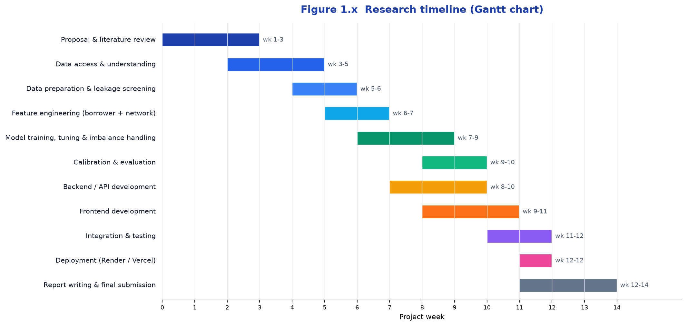
Figure 1.1: Research timeline (Gantt chart)

CHAPTER TWO: LITERATURE REVIEW

2.1 Introduction
This chapter reviews literature directly related to the software problem: systems and machine-learning methods for predicting loan default and write-off, with a focus on those that use guarantor or borrower networks. Sources were gathered from IEEE Xplore, the ACM Digital Library, ScienceDirect, SpringerLink, PLOS, MDPI, arXiv, IJCAI and KDD proceedings, and Google Scholar, using terms combining loan default prediction, credit scoring, guarantee network, graph neural network, SACCO credit risk, class imbalance, calibration, and explainable machine learning. Deployed software products and published studies are different kinds of evidence, so existing systems are reviewed separately (Section 2.3) from the academic literature (Section 2.4). Purposive sampling favoured peer-reviewed, recent (2018 onward), and closely related work; from roughly forty to fifty initial results, about twenty-five sources were reviewed in depth, prioritising open-access versions.

2.2 Historical Background of the Research Topic
Credit assessment in cooperative finance has historically been judgmental, resting on the "5Cs" framework that Rwandan SACCO appraisal still uses (Karekezi, 2018). Rwanda's cooperative channel is a deliberate policy instrument: Umurenge SACCOs were created under Vision 2020 to reach the underserved (Rwanda Cooperative Agency, n.d.), with Umwalimu SACCO established in 2006 as the teachers' cooperative (Umwalimu SACCO, n.d.-a). Industry credit scoring meanwhile moved from judgmental methods to statistical models and then machine learning, with ensembles overtaking logistic regression (Lessmann, Baesens, Seow, & Thomas, 2015). The newest thread, from about 2018, models loan-guarantee relationships as networks and shows that network position predicts default (Cheng, Niu, Tu, & Zhang, 2018). This study brought that thread, so far applied to corporate lending abroad, to a Rwandan teachers' cooperative.

2.3 Overview of Existing System
Three categories of existing software surround the problem. First, operational SACCO and microfinance management platforms such as Mifos X / Apache Fineract manage members, savings, loans, and guarantors end to end (Mifos Initiative, n.d.; Apache Software Foundation, n.d.), but treat a guarantor transactionally, as recorded security to pursue after default; they neither model the guarantee network nor predict outcomes. Second, machine-learning digital lenders such as M-Shwari in Kenya score applicants automatically from mobile-money and phone data (Suri, Bharadwaj, & Jack, 2021); their scoring is individual and behavioural and does not fit a SACCO's socially secured, member-guarantees-member lending. Third, academic guarantee-network systems: a visual-analytics framework for networked-guarantee loans (Niu, Cheng, Yan, & Zhang, 2018), the iConViz contagion-exploration tool (Niu, Li, Wu, Cheng, & Zhang, 2020), and the iConReg deep graph system (Cheng, Niu, & Zhang, 2022) prove that guarantee structure carries default signal, but they target corporate/SME lending and regulators, and rely on deep models a loan officer cannot interpret. To the researcher's knowledge, the reviewed literature did not identify a system applying interpretable, network-aware prediction to a community SACCO's member-guarantees-member structure, the gap this study addressed.

2.4 Review of Related Work
This section reviews six streams: credit risk in Rwandan SACCOs; machine learning for credit scoring; graph and network-based approaches; network-feature engineering; methodological work on leakage, validation, imbalance, calibration, and thresholds; and explainability.

2.4.1 Credit Risk and Non-Performing Loans in Rwandan SACCOs
Nsengiyumva and Harelimana (2020) surveyed 78 repeat borrowers of Umurenge SACCOs and found credit risk control the strongest influence on financial performance; Karekezi (2018) censused 35 Kigali SACCOs and documented 5Cs-based appraisal with the guarantor treated as collateral; Musengamana (2019) showed NPLs undermining microfinance performance in a Umurenge SACCO case study. More recently, Nikuze, Wen, Gakuru, and Seydou (2024) provided fresh econometric evidence on the factors driving non-performing-loan growth in Rwanda, which shows the problem is current rather than historical. Together these confirm the problem and the prevailing one-borrower-at-a-time method, but all are descriptive: none predicts outcomes at the loan level or examines the guarantor network.

2.4.2 Machine Learning for Credit Scoring and Default Prediction
Lessmann et al. (2015) benchmarked credit-scoring classifiers across real datasets and found ensembles consistently beating single classifiers and logistic regression, setting the multi-metric comparison style this study followed. Chen and Guestrin (2016) introduced XGBoost, whose strength on sparse, imbalanced tabular data made it this study's primary model, with network structure supplied as engineered columns. Addo, Guegan, and Hassani (2018) found tree-based models more stable and interpretable than the neural networks they tested, supporting interpretable trees for a tool used by loan officers. The stream's shared limitation is that every model scores each applicant alone, ignoring relationships between borrowers.

2.4.3 Graph and Network-Based Approaches to Credit Risk
Cheng, Niu, Tu, and Zhang (2018) first predicted defaults on networked-guarantee loans, showing that network-diffusion information improves prediction over conventional baselines, direct evidence for this study's hypothesis, though for enterprises and without officer-level interpretability. Cheng, Wang, Zhang, and Zhang (2020) added a dynamic graph attention network capturing how the guarantee network evolves, and the same group's iConReg confirmed the approach at national scale (Cheng, Niu, & Zhang, 2022), all corporate and opaque. Óskarsdóttir, Bravo, Sarraute, Vanthienen, and Baesens (2019) propagated default influence through phone-call networks and significantly improved AUC over traditional data, demonstrating with real data that connections to known defaulters carry signal, the intuition this study transferred to guarantor networks. Zandi, Korangi, Óskarsdóttir, Mues, and Bravo (2025) made the same argument for consumer credit with a dynamic multilayer graph neural network on US mortgages. One social-science finding frames how such results should be read: homophily, the well-documented tendency of similar people to be connected (McPherson, Smith-Lovin, & Cook, 2001), implies strained borrowers tend to be backed by similarly strained guarantors, so part of any network signal overlaps with individual features; this study used homophily as its interpretive lens. Across the stream, the network approach is proven but corporate or large-consumer, data-hungry, and uninterpretable at the point of decision.

2.4.4 Network-Feature Engineering for Credit Risk
Between purely individual models and end-to-end graph neural networks lies the middle path this study took: engineering explicit network features for a standard tabular learner, as Óskarsdóttir et al. (2019) did with propagated influence scores and Cheng et al. (2018) with diffusion variables. The alternatives sit at two extremes. Learned embeddings such as node2vec (Grover & Leskovec, 2016) capture structural position automatically, but their dimensions carry no meaning an officer can inspect. End-to-end GNNs (Cheng, Wang, Zhang, & Zhang, 2020; Zandi et al., 2025) lead benchmarks but demand large data and are opaque. For a small, heavily imbalanced SACCO dataset with an explainability requirement, hand-crafted features (guarantor counts and means, neighbour prior-default rates, community default rates) are nameable, auditable, and SHAP-attributable, which is why this study adopted them.

2.4.5 Temporal Leakage and Time-Aware Validation
Leakage, using information at training time that would not exist at decision time, produces models that excel in evaluation and fail in production (Kaufman et al. (2012) [VERIFY reference fits before submission]. This study adopted both disciplines: all features were computed as of disbursement and folds were grouped by borrower. This answers the temporal-leakage concern raised at the proposal stage.

2.4.6 Imbalance, Calibration, and Decision Thresholds
On metrics, Saito and Rehmsmeier (2015) showed precision-recall analysis more informative than ROC on imbalanced data, since ROC flatters models when positives are rare; with a 2.1% write-off rate, PR-AUC was this study's headline metric. On imbalance, SMOTE oversampling (Chawla, Bowyer, Hall, & Kegelmeyer, 2002) has long been the default, but recent evidence shows it often adds little over class weighting for strong classifiers (Elor & Averbuch-Elor, 2022), matching this study's own comparison. On probabilities and thresholds, boosted trees produce distorted probability estimates correctable post hoc with isotonic regression (Niculescu-Mizil & Caruana, 2005), and cost-sensitive theory shows unequal error costs shift the optimal threshold toward flagging more of the expensive class (Elkan, 2001); since a missed write-off costs a SACCO far more than a reviewed false alarm, this motivates a recall-first threshold on calibrated probabilities. Finally, unsupervised anomaly detection offers a label-free alternative to all of the above: Isolation Forest isolates unusual records through random partitioning (Liu, Ting, & Zhou, 2008), and Local Outlier Factor scores density-based deviation from a record's neighbours (Breunig, Kriegel, Ng, & Sander, 2000). This study evaluated both before committing to supervised learning, as a check on whether the write-off labels were actually necessary; their underperformance (Chapter Five) is what justified the supervised path.

2.4.7 Explainability in Credit-Risk Models
Lundberg and Lee (2017) introduced SHAP, a model-agnostic, game-theoretic framework attributing predictions to features, supporting both local explanations and global importance; this study adopted it to explain each score and to rank network against individual features, noting SHAP explains association rather than causation. Bussmann, Giudici, Marinelli, and Papenbrock (2021) combined XGBoost with SHAP for credit risk across 15,000 SMEs, motivated by the unsuitability of black-box AI in regulated finance, the same ingredients as this work, though their network arises from explanation similarity rather than real guarantor relationships.

2.4.8 Summary of Reviewed Literature
The literature falls into six themes. Rwandan SACCO studies confirm the problem but are descriptive; individual-level machine learning is effective but relationship-blind; network approaches prove relational signal but are corporate, deep, and opaque, with homophily implying overlap with individual features; feature-engineering work shows hand-crafted graph features trade some power for the interpretability this setting requires; methodological work establishes leakage as a first-order threat (as-of features, grouped validation), PR-AUC for rare positives, class weighting as a strong baseline, calibration for usable probabilities, and cost-based thresholds; and explainability tooling is mature. No reviewed study combines a guarantor network, real SACCO outcomes, and an interpretable, calibrated model.
Author (Year) | Focus / Method | Key Finding | Relevance / Gap for This Study
Nsengiyumva & Harelimana (2020) | Survey of loan management in Rwandan SACCOs | Credit risk control most affects performance | Confirms problem; individual appraisal, no network
Karekezi (2018) | Census of 35 SACCOs | 5Cs appraisal; guarantor as collateral | Documents the method this study augments
Musengamana (2019) | Case study of NPLs in a Rwandan SACCO | NPLs undermine performance | Real problem; no prediction
Lessmann et al. (2015) | Benchmark of credit-scoring classifiers | Ensembles beat single models | Justifies RF/XGBoost vs logistic baseline
Chen & Guestrin (2016) | XGBoost | Scalable, strong on tabular data | Primary model; needs engineered network features
Addo et al. (2018) | ML vs deep learning for default | Trees more stable than neural nets | Supports interpretable trees; no network
Cheng et al. (2018) | Network risk diffusion, guarantee loans | Network position improves prediction | Foundational; corporate, not interpretable
Cheng et al. (2020) | Dynamic graph attention network | Temporal + structural signal helps | Confirms network value; deep, opaque, corporate
Zandi et al. (2025) | Multilayer GNN+RNN, consumer default | Connections propagate default risk | Same argument; not guarantor/SACCO
Óskarsdóttir et al. (2019) | Social network analytics for scoring | Defaulter influence improves AUC | Connections carry signal; call networks
McPherson et al. (2001) | Homophily in social networks | Similar individuals connect | Lens for incremental network value
Grover & Leskovec (2016) | node2vec embeddings | Learns node positions automatically | Alternative representation; not inspectable
Kaufman et al. (2012) | Leakage in data mining | Leaked features inflate evaluation | Frames the as-of feature discipline
Elkan (2001) | Cost-sensitive learning | Unequal costs shift optimal threshold | Justifies recall-first threshold
Liu et al. (2008) | Isolation Forest anomaly detection | Isolates outliers via random partitioning | Label-free baseline; underperformed here
Breunig et al. (2000) | Local Outlier Factor | Density-based outlier scoring | Label-free baseline; underperformed here
Saito & Rehmsmeier (2015) | Metrics for imbalanced data | PR more informative than ROC | Justifies PR-AUC headline metric
Chawla et al. (2002) | SMOTE oversampling | Synthetic minority oversampling | Benchmarked; beaten by class weighting
Elor & Averbuch-Elor (2022) | SMOTE vs class weighting | Oversampling adds little for strong models | Matches this study's result
Niculescu-Mizil & Caruana (2005) | Probability calibration | Boosted trees need calibration | Justifies isotonic calibration
Lundberg & Lee (2017) | SHAP | Model-agnostic attribution | Explainability method adopted
Bussmann et al. (2021) | XGBoost + SHAP for credit | Black-box AI unsuitable in finance | Same combination; corporate setting

Table 2.1: Summary of Reviewed Literature

2.5 Strengths and Weaknesses of the Existing System(s)
System / Approach | Strengths | Weaknesses | How This Study Differed
SACCO management software (Mifos X / Fineract) | Manages members, savings, loans, guarantors end to end | Guarantor is a static record; no network analysis or prediction | Turned the guarantor network into a predictive risk signal
Digital lenders (M-Shwari) | ML scoring of thin-file borrowers at scale | Individual phone-data scoring; no guarantor relationships | Used the SACCO's member-to-member guarantees
Graph research systems (DGANN, iConViz, iConReg) | Model guarantee networks; high performance | Corporate/SME; deep, opaque; not for officers | Interpretable, feature-based model for SACCO members
Traditional manual appraisal | Simple, transparent, trusted | One borrower at a time; blind to network risk | Added network-aware, learnable risk with explanations
This study (GuarantorLens) | Interpretable, calibrated, individual + network features, SHAP | 11-branch sample; association not causation | Filled the gap for a SACCO

Table 2.2: Strengths and Weaknesses of Existing Systems versus the Proposed System
Each category is strong at its purpose, record-keeping, scale scoring, or systemic-risk analysis, yet none turns a SACCO's own guarantor network into an interpretable, calibrated risk signal at the point of decision, which is what this study provided.

2.6 General Comments and Conclusion
Taken together, the literature shows that write-offs are a real problem in Rwandan SACCOs, that machine learning predicts default well but at the individual level, and that network-based risk analysis works but has been corporate, deep, and opaque. The methodological literature prescribes how such a model must be evaluated to be believed: leakage-safe as-of features, grouped validation, PR-AUC on rare positives, a strong imbalance baseline, calibrated probabilities, and a cost-based threshold. The practical side of the gap was also corroborated at the study site: an IT Operations Officer who works with the SACCO's loan systems confirmed that the studied product is collateralised by guarantors and savings, that eligibility rules including the guarantee cap are applied one guarantor at a time, and that the systems in use offer no aggregate view of a member's guarantor exposure (informal discussion, May 2026). To the researcher's knowledge, the reviewed literature did not identify a study or system applying interpretable guarantor-network analysis to a Rwandan SACCO under a leakage-controlled design; this study addressed that gap.

CHAPTER THREE: SYSTEM ANALYSIS AND DESIGN

3.1 Introduction
This chapter presents the research design and development model, the dataset and its labelling, the requirements that scoped GuarantorLens, the model pipeline, the system architecture and design diagrams, the ethical safeguards, and the development tools. Implementation and testing follow in Chapter Four; results in Chapter Five.

3.2 Research Design (including the development model used)
The design was comparative and quantitative: a borrower-only baseline model versus models adding guarantor-network features, evaluated on the same real outcomes so that any difference is attributable to the network features.
This was framed as a machine learning problem, not a rules problem, for a specific reason. The SACCO already applies rules to guarantors, but those rules are fixed, checked one guarantor at a time, and cannot learn from outcomes or weigh eighteen interacting signals at once. The task was therefore cast as supervised learning: given the 18 features knowable on the disbursement date (the inputs), predict the probability that the loan ends in write-off (the target variable), learned from 11,015 labelled historical loans and evaluated against explicit baselines with metrics suited to rare outcomes. A rule cannot be improved by data; this model is retrained as outcomes accumulate. The software followed iterative, incremental development, and the machine-learning work followed CRISP-DM (Wirth & Hipp, 2000). Iteration was necessary because requirements evolved with data understanding: the write-off label's meaning was clarified during data understanding, and the leakage rules were tightened after early modelling exposed post-outcome information in the naive feature set.

3.2.1 Dataset and Dataset Description
Real (not simulated or synthetic) anonymised member and loan records were provided by Umwalimu SACCO under institutional authorisation under the written authorisation granted by Umwalimu SACCO's Director General, carrying opaque client identifiers only. The sample covered 11 of the SACCO's 30 branches, one in each district of Rwanda (Umwalimu SACCO, n.d.-a): Rusizi, Nyagatare, Gasabo, Rubavu, Nyamagabe, Nyanza, Ngororero, Kicukiro, Rutsiro, Nyarugenge, and headquarters; whole-branch sampling kept guarantor relationships intact.
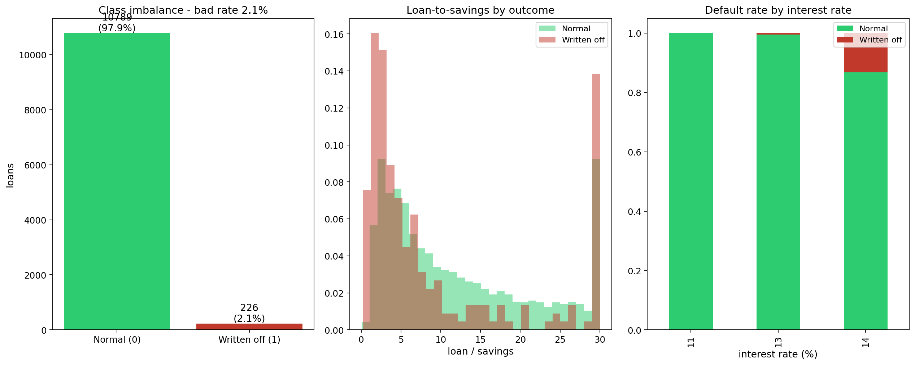
Figure 3.1: Cohort size, class balance, and distributions
Data arrived as two workbooks, Normal.xlsx (label 0) and Written Off.xlsx (label 1), merged to one row per loan with written-off records taking precedence. The target variable (the label) was binary write-off: 1 if the SACCO ultimately wrote the loan off, 0 for every other closed loan. The dataset's Repayment Status column records post-write-off recovery and was explicitly not the label, a distinction clarified with the supervisor. The loans in scope were the Emergency on Savings product, two-year term, collateralised by the borrower's guarantors and savings rather than physical assets (from an informal discussion with the SACCO's IT operations staff, May 2026). After cleaning, the cohort held 11,015 loans, 226 written off (2.1%), disbursed 2022-2023; given the two-year term, the cohort had fully matured within the observation window, which limits label delay. The sample contained 22,485 members with about 2.5 guarantors per loan; outcomes were 10,667 repaid (97%), 226 written off (2%), and 122 in arrears 90+ days (1%). With a 2.1% positive rate, accuracy is meaningless and ROC can flatter, so PR-AUC was the headline metric (Saito & Rehmsmeier, 2015).
Property | Value
Source | Umwalimu SACCO internal records (authorised, anonymised, opaque IDs)
Loan product | Emergency on Savings: two-year term, collateralised by guarantors and savings
Sampling | 11 of ~30 branches, whole-branch sampling
Cohort | 11,015 loans disbursed 2022-2023; 22,485 members; ~2.5 guarantors per loan
Positive class | 226 written-off loans (≈2.1%)
Label | Ultimately written off by the SACCO; Repayment Status is not the label
Features | 18: 11 borrower/loan + 7 guarantor-network

Table 3.1: Dataset description
Group | Features
Borrower / loan (11) | log_amount, savings, salary, interest_rate, loan_to_savings, loan_to_salary, account_age, b_prior_loans, b_prior_writeoff, b_prior_arrears_rate, b_recent_loans
Guarantor network (7) | n_guarantors, g_mean_savings, g_mean_salary, g_prior_default_rate, g_prior_arrears_rate, g_sav_ratio, community_prior_default_rate

Table 3.2: Feature set (18 features)
Table 3.3 defines each guarantor-network feature and the risk logic behind it; all are computed on the guarantee graph as it existed at the loan's disbursement date.
Network feature | What it measures | Why it signals risk
n_guarantors | Number of guarantors backing this loan | Fewer backers means thinner security behind the loan
g_mean_savings | Mean savings balance of the loan's guarantors | Since guarantors' savings are part of the collateral, low balances mean weak recovery capacity
g_mean_salary | Mean salary of the loan's guarantors | Low guarantor income limits their ability to absorb the debt if called
g_prior_default_rate | Share of this loan's guarantors with a write-off in their own history before this loan's disbursement | Being backed by prior defaulters was the study's H1b: distress clusters in the network
g_prior_arrears_rate | Share of this loan's guarantors with prior 90+ day arrears before disbursement | An earlier-stage distress signal than write-off among the backers
g_sav_ratio | Mean of the guarantors' savings divided by the borrower's own savings plus one | Measures whether the borrower is backed by savers financially stronger than themselves; the plus-one keeps the ratio defined when the borrower has no savings
community_prior_default_rate | As-of write-off rate of the borrower's connected community in the guarantee graph (union-find components) | Captures neighbourhood-level risk beyond direct backers: high-default clusters

Table 3.3: Guarantor-network feature definitions
A leakage screen divided the raw fields into two sets by one test: is the value knowable on the loan's disbursement date? Fields failing the test (leaking) were blocked; the 18 features of Table 3.2 all pass it (non-leaking), with network features computed on the guarantee graph reconstructed as of that date, so a guarantor's later default cannot leak backward. The screen also dropped time_since_last_loan after it was found to encode post-outcome information. community_prior_default_rate used a union-find grouping over borrower-guarantor edges, taking the as-of write-off rate of the borrower's cluster.
Blocked (leaking) field | Why it leaks
Days in arrears | Records repayment behaviour that happens after disbursement; near-proxy for the label
Repayment status (Repaid/Active) | The post-write-off recovery state, downstream of the outcome itself
Last payment date | Post-disbursement behaviour, unknown at decision time
Loan closure/outcome fields | Only exist once the outcome has occurred
time_since_last_loan | Dropped by the screen after it was found to encode post-outcome information

Table 3.4: Leakage screen (blocked fields versus the admitted feature set) [CONFIRM the blocked list against the screen's output / 01_leakage_evidence.png]
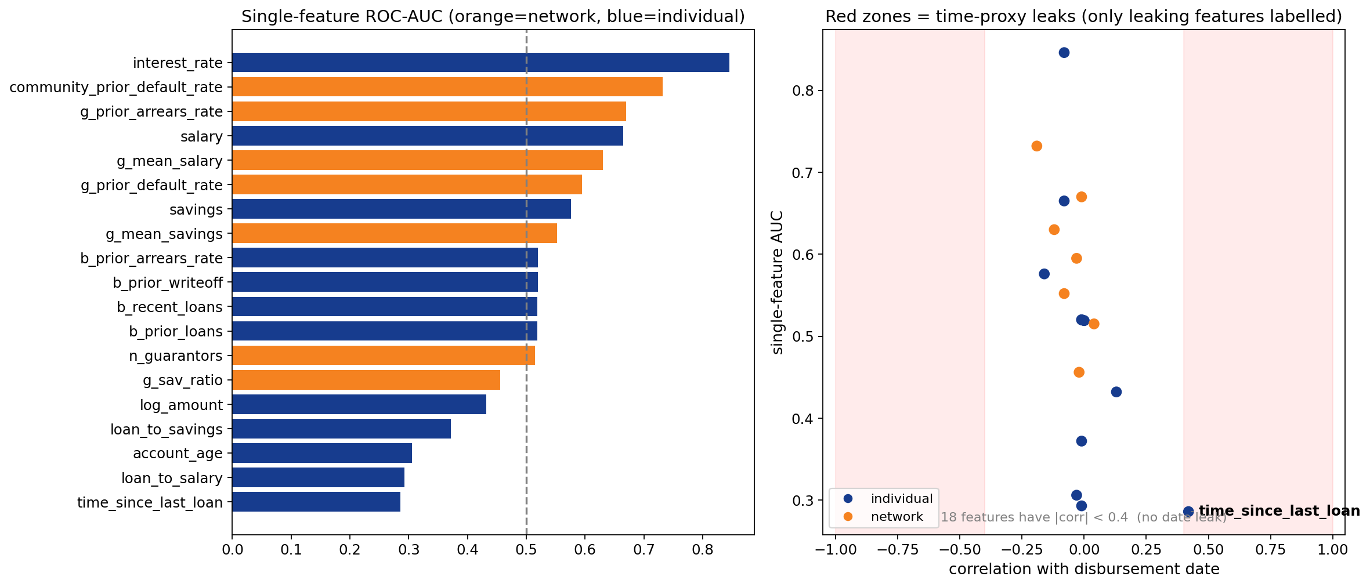
Figure 3.2: Blocked post-outcome features
Borrower savings and salary were complete for all 11,015 loans (0% missing); missingness sat on the guarantor side, where members who only ever backed loans have no financial record (51% of members), so guarantor-mean features averaged over available guarantors, with remaining gaps median-imputed (SimpleImputer) and ratio denominators falling back to training medians. Evaluation used five-fold borrower-grouped cross-validation, all of a borrower's loans in one fold, with metrics reported on out-of-fold predictions across all 11,015 loans; grouped validation prevents the optimistic bias that arises when the same entity appears on both sides of a split (Kaufman et al., 2012). This specifies the validation design the proposal left open.

3.3 Functional and Non-Functional Requirements
GuarantorLens scores a proposed loan using the borrower and their guarantor network, explains the score, and flags network risks; it supports the officer's decision and never approves or declines.
ID | Requirement
FR1 | Score a proposed loan's default risk (0-100 plus a Low/Medium/High band)
FR2 | Explain each score: top drivers (SHAP) plus plain-language reasons
FR3 | Flag guarantor-network red flags (over-committed backer; defaulter backers)
FR4 | What-if simulation (change amount, savings, guarantors) and re-score
FR5 | Fix-it advisor: suggest stronger same-branch guarantors with the new score
FR6 | Member profile, guarantor network graph, and contagion view
FR7 | Portfolio insights (overview, weak links, monitoring/early warning)
FR8 | Applications workflow: create → escalate → recommend
FR9 | Role-based access (loan officer / credit manager / admin)
FR10 | Export a printable PDF report of an assessment
FR11 | Admin: hot-swap the model and re-seed the reference dataset (delete old data and re-seed, with a seed timestamp and row counts shown as proof)

Table 3.5: Functional requirements
ID | Requirement
NFR1 | Explainability: no unexplained "black-box" score
NFR2 | Calibrated probabilities usable at an operating threshold
NFR3 | Leakage-free: features use only information available at decision time
NFR4 | Security: JWT authentication; anonymised data; no secrets in the repository
NFR5 | Availability: transparent rule-based fallback if the model cannot load
NFR6 | Usability/responsiveness: desktop, tablet, and mobile
NFR7 | Performance: sub-second scoring after cold start
NFR8 | Maintainability/deployability: CI-friendly, one-command run

Table 3.6: Non-functional requirements
Non-functional requirements cannot be implemented on their own; they were decomposed into implemented functional behaviour. Security (NFR4), for example, became concrete features: JWT-authenticated login, salted password hashing, single-use reset tokens, and role gating on the recommendation endpoint. Explainability (NFR1) became FR2's SHAP-derived reasons, and availability (NFR5) became the rule-based fallback.

3.3.1 Proposed Model Diagram
The pipeline ran in eight stages. (1) Prepare and label the data and remove leakage; (2) engineer the borrower and guarantor-network features; (3) try unsupervised methods first, anomaly detection with IsolationForest and Local Outlier Factor, which proved too weak without labels (Chapter Five) and so justified the supervised path; (4) train and evaluate five supervised families (Logistic Regression, Decision Tree, Random Forest, XGBoost, and a neural network) under borrower-grouped cross-validation, with imbalance handled by class weighting after benchmarking against SMOTE variants; (5) select the best family from the leaderboard, XGBoost (Chen & Guestrin, 2016); (6) pair the selected model with the guarantor-network features via the feature-set comparison that answers the research question; (7) finalise in five technical steps: monotone constraints on the six constrainable features (savings pushes risk down; loan size, loan-to-savings, loan-to-salary, the guarantors' prior arrears rate, and the community prior default rate push it up), isotonic probability calibration (Niculescu-Mizil & Caruana, 2005), Low/Medium/High risk bands cut at the 70th and 90th score percentiles, SHAP explainability, and export of the serving bundle (guarantorlens_serving.joblib: model, feature list, bands, imputation medians, metrics); and (8) deploy behind the FastAPI /assess-risk endpoint, which scores and explains each loan. Calibration matters because the tool exposes probabilities to non-technical users at an operating threshold (NFR2); the constraints encode domain logic that makes scores defensible, at a measured metric cost quantified in Chapter Five.
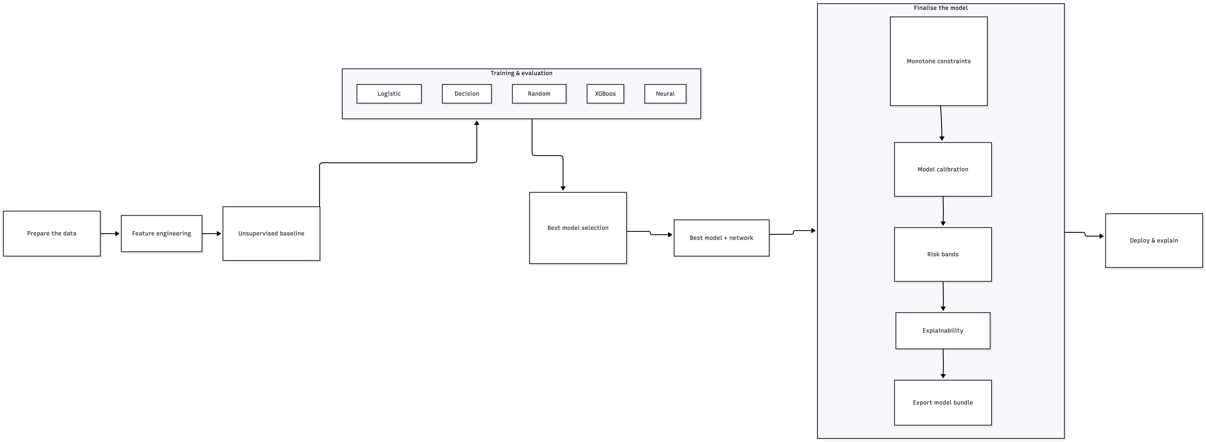
Figure 3.3: Machine-learning pipeline (eight stages)
Because several of these concepts recur throughout Chapters Three to Five, Table 3.7 states each in plain terms.
Concept | In plain terms | Why it matters here
Calibrated probabilities | When the model says "10% risk," about 10% of such loans really do end in write-off | Officers act on the number shown; boosted trees exaggerate probabilities by default, so isotonic calibration corrects them
Operating threshold (0.218) | The score cut-off above which a loan is flagged for extra review | Chosen backwards from the goal: the SACCO wants at least 80% of future write-offs caught, and 0.218 is the deployed model's cut-off that achieves it (181 of 226)
Recall (0.801) | Of all loans that truly ended in write-off, the share the tool flagged | A missed write-off is the SACCO's costly error, so recall was put first when choosing the threshold
Precision (0.138) | Of all flagged loans, the share that truly became write-offs | Roughly one flag in seven is a real future write-off; the rest are reviews of safe loans, the price of catching 80% when every flag is reviewed by a human
PR-AUC vs ROC-AUC | PR-AUC scores how well the model finds the rare bad loans; ROC-AUC scores its overall ranking of all loans | With rare positives, ROC-AUC flatters a model, so PR-AUC is the headline metric
Class weighting | Training penalises a mistake on the rare write-off class more heavily than one on the common repaid class | Simpler than generating synthetic minority examples (SMOTE), and it scored better in this study's comparison
Borrower-grouped cross-validation | Every loan is scored by a model that never saw that borrower during training; "out-of-fold" metrics come from these unseen predictions | Stops the model from simply remembering a borrower, giving an honest estimate of real performance
Monotone constraints | Rules baked into the model: more savings can never raise the score, and a bigger loan can never lower it | Keeps behaviour explainable and defensible to credit staff, at a small measured cost in raw metrics
SHAP | A method that splits each prediction into the contribution of every feature | Turns a score into the plain-language reasons an officer reads on screen
Bootstrap confidence interval | Recomputing a result many times on resampled data to see how much it varies | Showed the network features' PR-AUC lift could plausibly be zero, which kept the claims honest
Homophily | Similar people tend to be connected to each other | Strained borrowers tend to have strained guarantors, so the network partly repeats what borrower finances already show

Table 3.7: Key concepts in plain terms

3.4 System Architecture and Design Diagrams
The system had three layers: a React (Vite, TypeScript, Tailwind) presentation layer on Vercel; a FastAPI application layer on Render with focused modules (auth.py, risk.py, applications.py, members.py, insights.py, scoring.py) behind HTTPS/JWT; and a PostgreSQL data layer accessed through SQLAlchemy that holds all tabular data in six tables: the transactional workflow data (users, applications, recommendations) and the anonymised reference data (members, loans, guarantees), seeded once from the anonymised files, which serve only as the seed. At startup the reference tables are loaded read-only into memory, because the network computations (communities, contagion, weak links) traverse the whole graph, and in-memory traversal is far faster than per-row SQL: the database is the source of truth, the in-memory graph is the read path. The trained model loads separately from its versioned bundle file, so a bad training run cannot corrupt operational data, and the API falls back to rule-based scoring (NFR5) if the bundle fails to load. The public deployment is seeded with synthetic data only; real pseudonymised records remain local (NFR4). Keeping immutable artifacts separate from the transactional database means a bad training run cannot corrupt operational data, and the API falls back to rule-based scoring (NFR5) if the bundle fails to load.
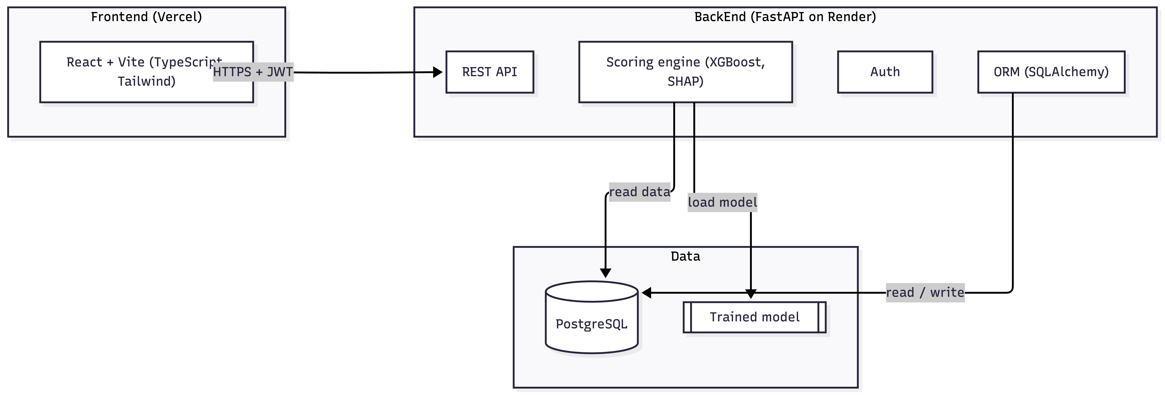
Figure 3.4: System architecture
The use case diagram covers the loan officer (assess risk, including explanation and what-if; create and escalate applications; explore members and network; view insights), the credit manager (inherits the officer's cases, reviews the queue, records recommendations), and the admin (manages model and data).
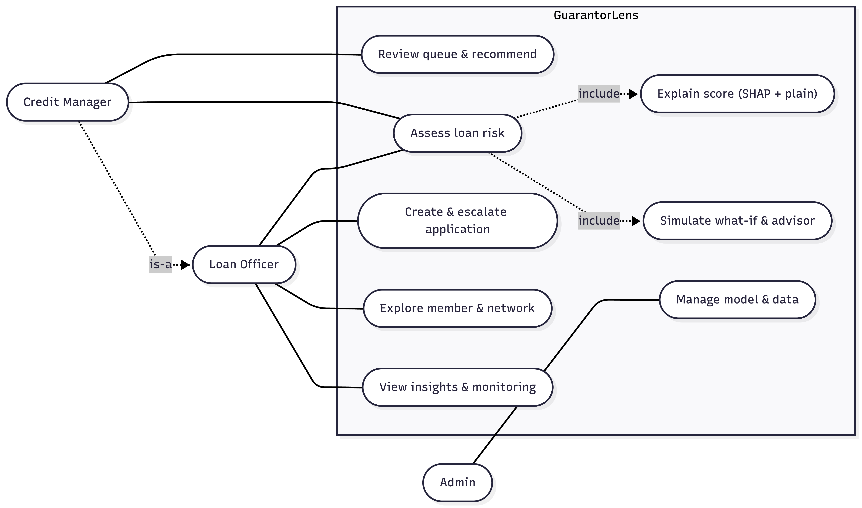
Figure 3.5: Use-case diagram
The class diagram, generated from the real code so it matches the implementation, centres on ScoringService (as-of features, calibrated ScoringModel, SHAP, band adjustment, guarantor suggestions) with NetworkData, InsightsService, and AuthService, and the domain classes User, Application, Recommendation, and RiskAssessment, including the central domain classes the proposal's diagram omitted.
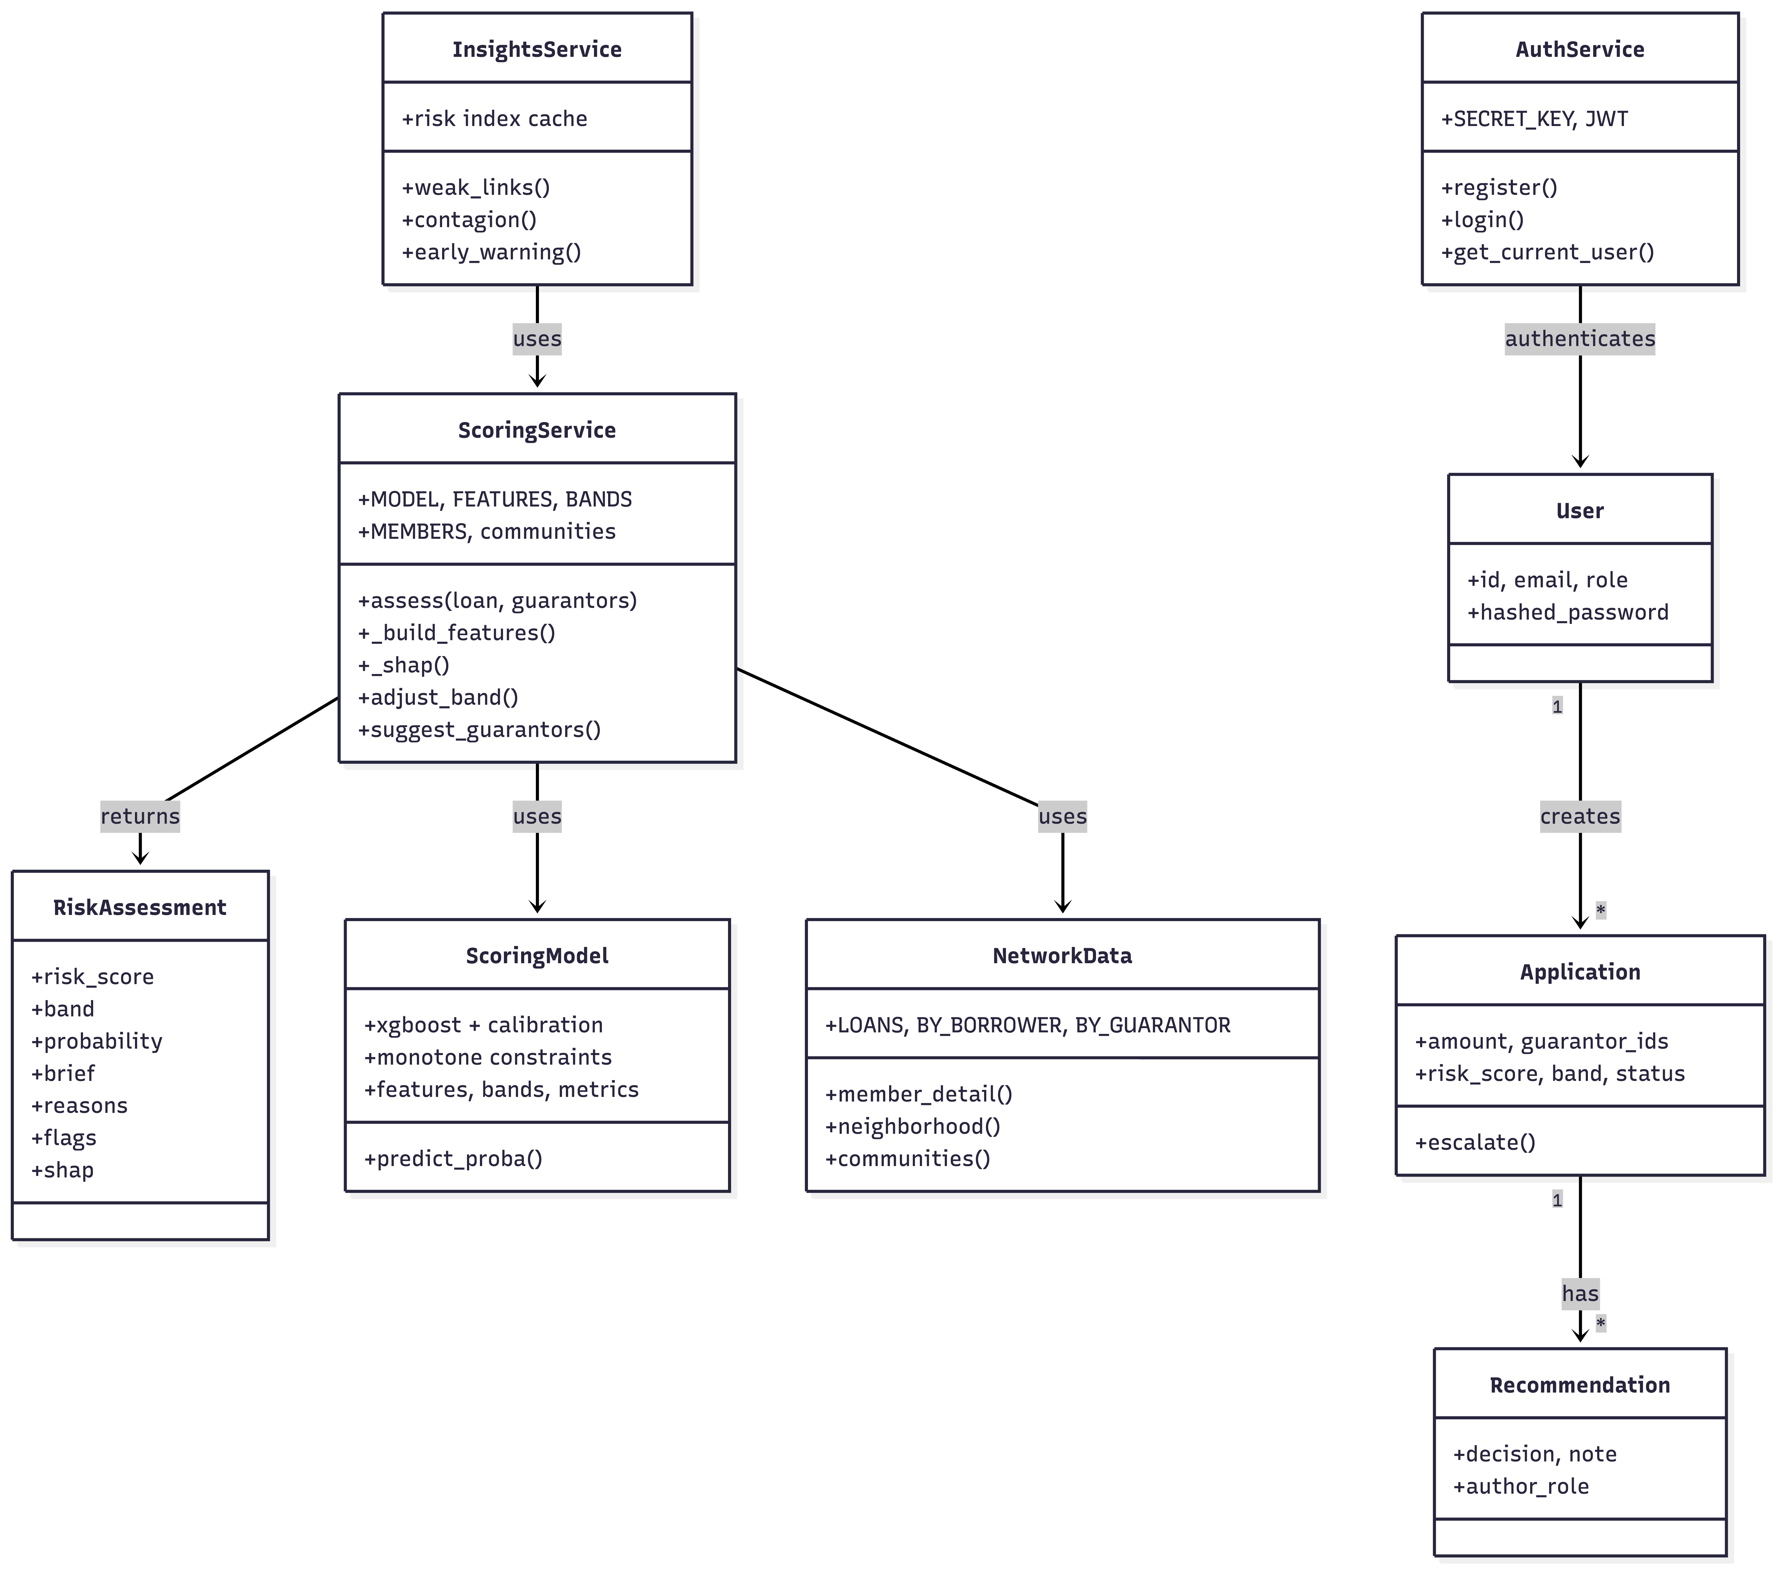
Figure 3.6: Class diagram (backend domain and services)
The ERD shows the six real database tables: the transactional cluster, USER (1)-() APPLICATION (1)-() RECOMMENDATION, and the reference cluster now persisted in PostgreSQL, MEMBER (1)-() LOAN (1)-() GUARANTEE with GUARANTEE also referencing MEMBER as guarantor, exactly the member-guarantees-member structure analysed. RECOMMENDATION also records its author (a USER), which is what the role-gating requirement checks: only a credit manager's account may author one. The diagram is generated from the ORM models in app/models.py, so every field matches the text; this fixes the ERD inconsistency flagged at the proposal stage.
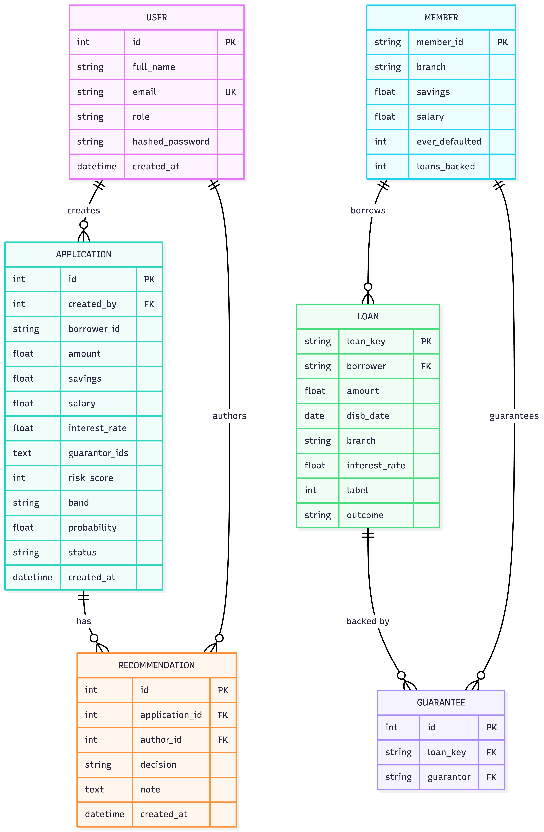
Figure 3.7: Entity-relationship diagram (six database tables)
The level-1 data-flow diagram decomposes the system into three processes and three stores. Process 1.0 (Assess Risk) takes the loan details from the officer, reads features from D2 (member and loan data), exchanges features for a probability with D1 (the trained model), returns the risk score with its explanation to the officer, and saves the assessed application to D3 (application data). Process 2.0 (Manage Applications) records the credit manager's recommendation and stores the decision in D3. Process 3.0 (Serve Insights) reads the network from D2 and the portfolio from D3 to serve the insights and monitoring views.
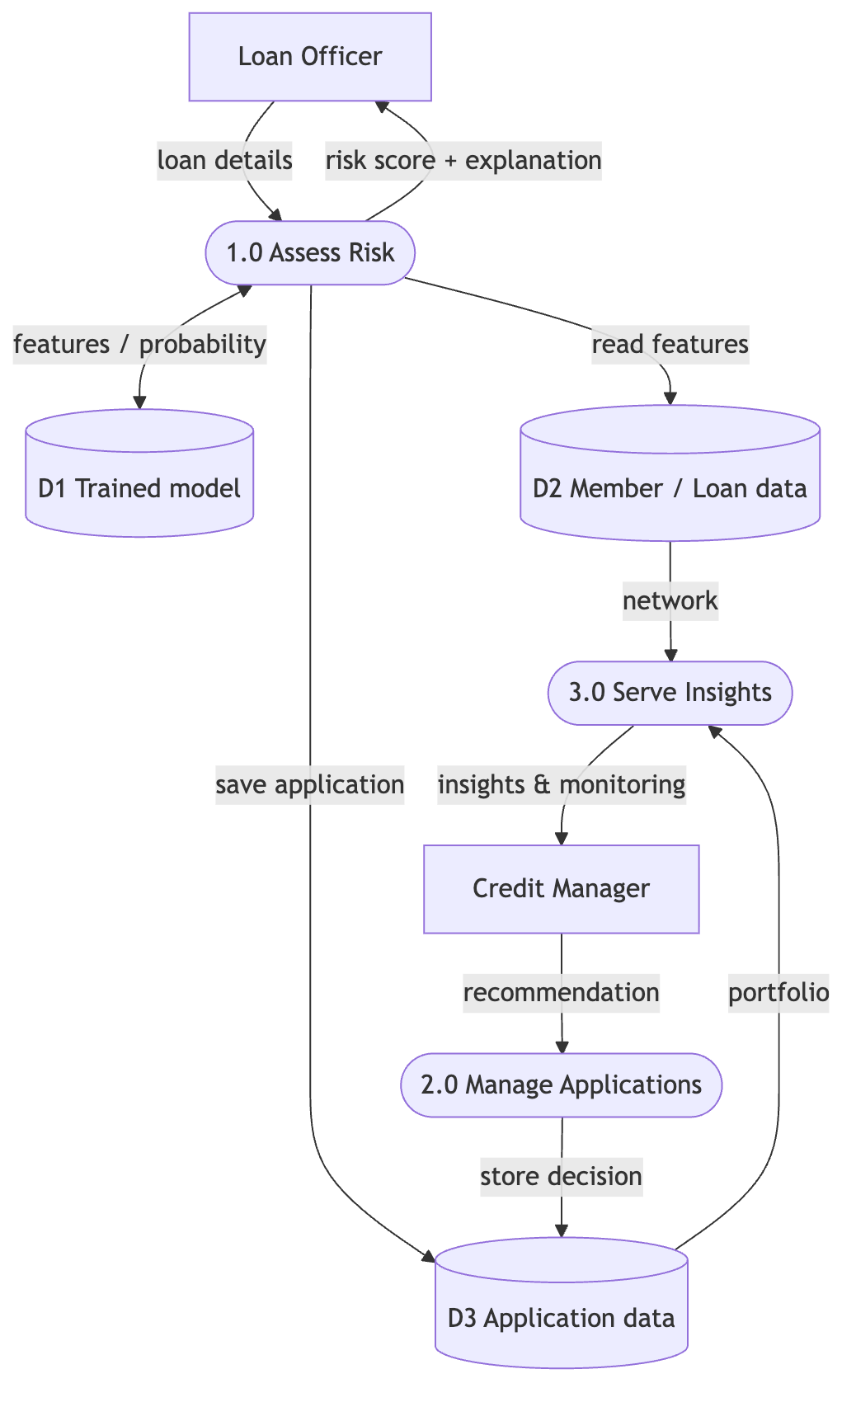
Figure 3.8: Data-flow diagram, level 1
The sequence of one assessment: officer enters loan and guarantors; frontend POSTs /assess-risk with JWT; the scoring service builds as-of features, runs the model, computes SHAP, adjusts the band; score, band, drivers, and flags return as JSON rendered as a gauge with plain-language reasons; saving posts to /applications, and the API inserts the assessed application into the database.
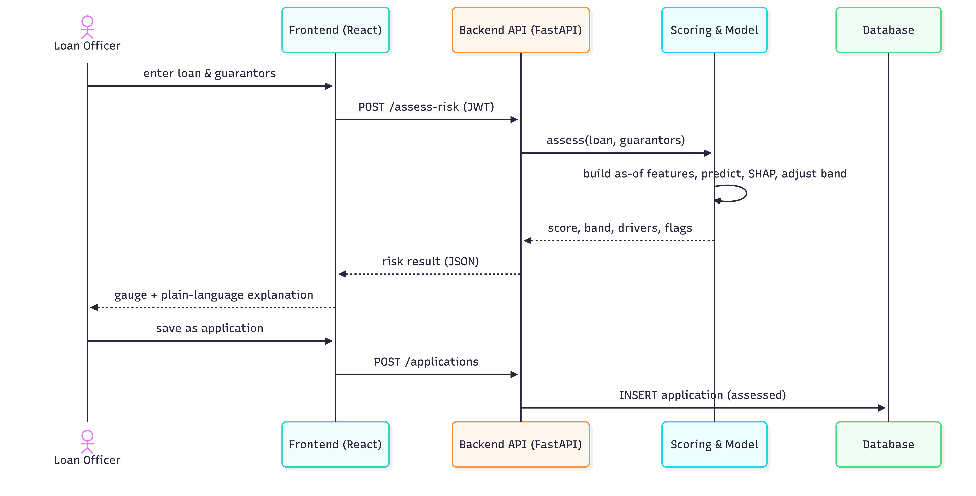
Figure 3.9: Sequence diagram: assess a loan

3.5 Ethical Considerations
Privacy and pseudonymisation. The dataset carried opaque client identifiers only; identifiers were replaced with consistent codes rather than simply hidden (pseudonymisation). Because consistent codes preserve the guarantee network, the data was treated as personal data and given the full protections Rwanda's Law No. 058/2021 requires (Republic of Rwanda, 2021), under Umwalimu SACCO's institutional authorisation. Data access followed the cooperative's own approval chain: an initial request to management, then a formal written request addressed to the Director General for the data, after which the Director General instructed the ICT Director to release the anonymised extract used in this study. Sensitive financial data (savings, salary, default history) was stored anonymised, never committed to the repository, and accessed only behind JWT authentication. Bias, fairness, and guilt by association: network features can penalise a borrower for who backs them; this risk was disclosed, the model reported association rather than causation, network warnings were shown as explicit inspectable facts, and a branch-parity/fairness audit was recommended as a precondition for operational use (not performed; a stated limitation). Misuse and human-in-the-loop: the tool must never auto-approve, auto-decline, or profile members; the implemented workflow has the officer propose and the credit manager decide, with role gating blocking an officer from recommending on their own case, and the prototype made no live lending decisions. Retention, access, and breach: the anonymised extract was held only on the researcher's local machine for the duration of the project, never committed to the code repository, and never uploaded to the cloud database; access was limited to the researcher, and the deployed prototype was seeded with synthetic data only, so no real member record is exposed by the live system. The dataset is to be deleted at the close of the project unless the SACCO authorises longer retention. Any suspected exposure would be reported to the cooperative as the data owner. Ethical approval: the study was carried out under the data-sharing authorisation granted by Umwalimu SACCO through its Director General, together with the anonymisation, access-control, and human-in-the-loop safeguards described above; the supervisor reviewed and approved the research design. [CONFIRM whether ALU additionally requires a separate ethics-committee clearance for this capstone, and add its reference if so.]

3.6 Development Tools
Layer | Tools
Modelling | Python, pandas, scikit-learn 1.6.1, XGBoost 3.2.0, imbalanced-learn 0.14.2, SHAP, NumPy, Matplotlib; Google Colab
Backend | FastAPI, Uvicorn/Gunicorn, SQLAlchemy, PyJWT, joblib
Frontend | React 19, Vite, TypeScript, Tailwind CSS
Database | PostgreSQL (production), SQLite (local)
Hosting/CI | Render (API), Vercel (frontend), GitHub
Testing | pytest, httpx

Table 3.8: Development tools
All tools were free and open-source: pandas (McKinney, 2010), scikit-learn (Pedregosa et al., 2011), XGBoost (Chen & Guestrin, 2016), imbalanced-learn (Lemaitre, Nogueira, & Aridas, 2017), SHAP (Lundberg & Lee, 2017), Matplotlib (Hunter, 2007), FastAPI (Ramírez, n.d.).

CHAPTER FOUR: SYSTEM IMPLEMENTATION AND TESTING

4.1 Implementation and Coding

4.1.1 Introduction
This section covers how the designed system was built: the trained model (Colab notebook, exported as a serving bundle), the FastAPI backend that loads it, and the React frontend officers use. Graphical results follow in 4.2 and testing in 4.3.

4.1.2 Description of Implementation Tools and Technology
The deployed estimator was XGBoost (Chen & Guestrin, 2016) wrapped in five-fold isotonic calibration so probabilities track observed write-off rates (Niculescu-Mizil & Caruana, 2005), with monotone constraints tying it to domain logic (more savings never raises risk; a larger loan never lowers it). Class weighting handled the 2.1% imbalance after benchmarking against SMOTE variants (Chawla et al., 2002; Elor & Averbuch-Elor, 2022); imbalanced-learn remains a dependency to unpickle the pipeline. SHAP produced per-feature contributions (Lundberg & Lee, 2017) that the backend translates into plain-language reasons. FastAPI provided the REST API with automatic Swagger docs, JWT authentication, and salted password hashes; React with TypeScript and Tailwind implemented the officer interface. Each tier's tool was chosen deliberately: FastAPI because the model is Python, so it serves in-process with no cross-language bridge, and its automatic Swagger documentation doubles as API evidence; React with TypeScript because a typed, componentised frontend keeps the assessment, member, and insights views maintainable; PostgreSQL in production with SQLite locally because SQLAlchemy makes the two interchangeable with no code changes; and Render plus Vercel because both deploy from GitHub on push, so the demo stays live. One operational detail: the bundle was pickled with scikit-learn 1.6.1, and a version mismatch drops the API to its rule-based fallback, so versions were pinned in requirements.txt; that turns a silent compatibility failure into controlled, observable behaviour.

4.1.3 Key Implementation Details (code samples)
Leakage-safe, as-of feature building. Serving-time features are computed exactly as training-time features were, as of the disbursement date, so there is no train/serve skew: _build_features assembles the 18-feature vector and _feat_value resolves each feature with the same imputation fallbacks used in training. ```python

app/scoring.py (excerpt): one serving-time feature, computed exactly as in training
def _feat_value(name, amount, savings, salary, disb, guarantor_ids, borrower_id, interest_rate=None):
g = guarantor_ids
sav = [_member(x)["savings"] for x in g if _member(x).get("savings") is not None]
if name == "loan_to_savings":
return amount / (savings + 1) if savings else None # missing -> median-fill (matches training)
if name == "g_mean_savings":
return float(np.mean(sav)) if sav else None
if name == "g_sav_ratio":
gms = float(np.mean(sav)) if sav else None
return None if gms is None else gms / ((savings or 0.0) + 1)
if name == "community_prior_default_rate":
return _community_rate(borrower_id, guarantor_ids)
...
def _build_features(amount, savings, salary, disb, guarantor_ids, borrower_id=None, interest_rate=None):
"""Build the bundle's feature vector for one loan, imputing gaps from medians."""
out = {}
for f in FEATURES:
v = _feat_value(f, amount, savings, salary, disb, guarantor_ids, borrower_id, interest_rate)
if v is None or (isinstance(v, float) and v != v): # None or NaN
v = float(MEDIANS.get(f, 0.0))
out[f] = v
return out

**Union-find community feature.** `_load_communities` groups members into connected components over borrower-guarantor edges and `_community_rate` returns the as-of write-off rate of the borrower's cluster, a neighbourhood-risk signal at O(edges) cost with no graph database or GNN. ```python
# app/scoring.py (excerpt): union-find over borrower-guarantor edges -> community default rates
def _load_communities():
parent = {}
def find(x):
parent.setdefault(x, x)
while parent[x] != x:
parent[x] = parent[parent[x]]; x = parent[x]
return x
def union(a, b):
ra, rb = find(a), find(b)
if ra != rb:
parent[ra] = rb
loans = data_store.load_loans()
for ln in loans:
b = ln.get("borrower")
for g in (ln.get("guarantors") or []):
union(b, g)
agg = {} # root -> [n_loans, n_bad]
for ln in loans:
root = find(ln["borrower"])
cell = agg.setdefault(root, [0, 0])
cell[0] += 1
cell[1] += int(ln.get("label", 0) or 0)
comm = {m: find(m) for m in parent}
rate = {root: (bad / n if n else 0.0) for root, (n, bad) in agg.items()}
return comm, rate

def _community_rate(borrower_id, guarantor_ids):
"""Default rate of the cluster this loan connects into (borrower's, else a guarantor's).
None for a brand-new, unconnected member (then filled from the training median)."""
root = _COMMUNITY.get(borrower_id) if borrower_id else None
if root is None:
for g in (guarantor_ids or []):
if g in _COMMUNITY:
root = _COMMUNITY[g]; break
return _COMMUNITY_RATE.get(root) if root is not None else None
Leak-free band escalation. Independently of the model, adjust_band overlays hard network facts, for example escalating the band when multiple backers have prior write-offs, computed from the same as-of data so the overlay adds caution without leakage. ```python

app/scoring.py (excerpt): leak-free rule overlay on concentrated network red flags
def adjust_band(base_band, guarantor_ids, borrower_id=None):
"""Escalate the risk band on concentrated guarantor-network red flags; the model
probability is unchanged. Concentrated signals only: in a dense guarantor network
almost every loan touches some over-committed or once-defaulted guarantor, so a
single-link rule would flag nearly everything and tell the officer nothing.
- whole backing group over-committed -> +1 band (the guarantee itself is weak)
- two or more backers defaulted before -> High (a serious cluster of bad backers)"""
band = base_band
gs = guarantor_ids or []
over = [g for g in gs if (_member(g).get("loans_backed") or 0) >= FLAG_TH["over_committed_loads"]]
defaulters = [g for g in gs if _member(g).get("ever_defaulted") == 1]
if gs and len(over) == len(gs):
band = _bump(band, 1)
if len(defaulters) >= 2:
band = "High"
return band

**Data storage and seeding.** The reference data (`members`, `loans`, `guarantees`) lives in PostgreSQL and is loaded into memory at startup; the anonymised files are only the seed. This split exists because the network computations traverse the whole graph, which is far faster in memory than as per-row SQL, while the database remains the source of truth that survives redeploys. An admin upload deletes and re-seeds the tables and records a timestamped seed row with row counts as proof (FR11). ```python
# app/data_store.py (excerpt): delete + re-seed the reference tables, with proof
def _seed(db, members_data, loans_data):
"""Delete the existing reference data, insert the given records, and record a
DatasetSeed row (timestamp + counts) as proof. Returns the seed record dict."""
deleted = (db.query(Guarantee).delete() + db.query(Loan).delete() + db.query(Member).delete())
db.query(DatasetSeed).delete()
db.commit()
n_m = n_l = n_g = 0
if members_data:
mrows = [_member_row(m) for m in members_data if _mkey(m) is not None]
db.bulk_insert_mappings(Member, mrows); n_m = len(mrows)
if loans_data:
lrows = [_loan_row(ln) for ln in loans_data if ln.get("loan_key")]
db.bulk_insert_mappings(Loan, lrows); n_l = len(lrows)
gts = [{"loan_key": ln["loan_key"], "guarantor": g}
for ln in loans_data if ln.get("loan_key")
for g in (ln.get("guarantors") or [])]
if gts:
db.bulk_insert_mappings(Guarantee, gts); n_g = len(gts)
rec = DatasetSeed(members=n_m, loans=n_l, guarantees=n_g, deleted=deleted)
db.add(rec)
db.commit()
return {"members": n_m, "loans": n_l, "guarantees": n_g, "deleted": deleted}

def ensure_seeded():
"""Create the tables and, if the members table is empty, seed from the JSON artifacts."""
Base.metadata.create_all(bind=engine)
with SessionLocal() as db:
if db.query(Member.member_id).first() is None:
_seed(db, _read_json(MEMBERS_PATH), _read_json(LOANS_PATH))
Band-consistent display score. _display_for_band maps the calibrated probability to the 0-100 score monotonically and so it can never contradict the band shown beside it. ```python

app/scoring.py (excerpt): the displayed score can never contradict the band
_BAND_FLOOR = {"Low": 0, "Medium": 40, "High": 70}
def _display_for_band(p: float, band: str) -> int:
"""adjust_band can raise the band on a leak-free rule without changing the
probability. Without this, a flagged loan reads e.g. 'High 46/100'. Since
adjust_band only ever raises the band, lift the score to that band's floor,
so a flag-escalated loan reads High 70+, and the what-if delta moves the
right way."""
return max(_display_score(p), _BAND_FLOOR.get(band, 0))

## 4.2 Graphical View of the Project

### 4.2.1 System Navigation

The system tells one story in a fixed flow: an officer signs in and lands on the dashboard; starts an assessment by entering the borrower, amount, and guarantors; receives the score, band, plain-language reasons, and any network flags; can click a guarantor to open the member view (savings, loans, who backs them, whom they back) or the network graph; saves the assessment as an application and, if concerned, escalates it; the credit manager then opens the queue, reviews, and records a recommendation; either can export the assessment as a printable report. The screenshots below follow that navigation order.

### 4.2.2 Screenshots with Description

[INSERT screenshots from the captioned deck; each maps to a functional requirement:]

- [Screenshot: empty assessment form]: entering borrower, amount, and up to eight guarantors (FR1).
- [Screenshot: Low-risk result]: gauge, band, calibrated probability (FR1, NFR2).
- [Screenshot: High-risk result with network flags]: defaulter-backer and over-committed warnings (FR3).
- [Screenshot: plain-language drivers]: SHAP-derived reasons, network vs individual (FR2, NFR1).
- [Screenshot: fix-it advisor / what-if]: swapping a guarantor and re-scoring (FR4, FR5).
- [Screenshot: insights and monitoring]: portfolio overview, weak links, early warning (FR7).
- [Screenshot: member profile, network graph, contagion view]: who backs whom, defaulters marked (FR6).
- [Screenshot: applications workflow]: create, escalate, recommend with role gating (FR8, FR9).
- [Screenshot: printable PDF report]: exported assessment (FR10).
- [Screenshot: mobile/tablet views]: responsive layouts (NFR6).

## 4.3 Testing

### 4.3.1 Introduction and Objective

Testing combined automated pytest suites (with httpx against the real API) and manual cross-environment checks, to confirm correct functionality, sane and defensible model behaviour, enforced access control, and usability across devices.

### 4.3.2 Unit Testing Outputs

`tests/test_scoring_unit.py` (8 tests) exercised the scoring logic: band boundaries; the display score aligning with its band and monotonic in probability; two defaulter guarantors escalating to High; `assess()` returning the full expected shape. Two were metamorphic tests, checking invariants rather than fixed outputs (more savings never raises risk; a bigger loan never lowers it), the natural way to test a learned component.

### 4.3.3 Validation Testing Outputs

`tests/test_validation.py` (5 tests): the deployed model beats the baseline and meets spec (PR-AUC far above the 2.1% base rate; ROC-AUC ≥ 0.85); band thresholds are ordered; the displayed score never contradicts the band across the full 0-1 sweep; the API rejects a zero amount (400) and a missing amount (422). Model-level validation beyond the suite: the leakage screen, the calibration curve, borrower-grouped CV, and bootstrap confidence intervals on the network lift, which honestly showed the incremental PR-AUC interval crossing zero (Chapter Five).

### 4.3.4 Integration Testing Outputs

`tests/test_api_integration.py` (6 tests), real HTTP with auth: health check; unauthenticated requests rejected; `/assess-risk` returns a valid band and score; a well-covered loan scores no higher than a thin one; an officer is blocked (403) from recording a recommendation while a manager succeeds.

### 4.3.5 Functional and System Testing Results

`tests/test_functional_cases.py` (6 tests) automated five verified scenarios asserting the band and flag, plus a rate-lever sanity test (a higher interest rate never lowers the band). The interface was also verified on desktop, tablet, and mobile widths in more than one browser [INSERT: cross-device screenshots from screenshots/].

| # | Inputs (amount / savings / salary / rate / guarantors) | Asserted result |
|---|---|---|
| 1 | 300k / 2.5M / 400k / 13% / 2 clean | Low |
| 2 | 5M / 90k / 220k / 14% / 2 clean | Medium |
| 3 | 12M / 30k / 150k / 14% / 2 clean | High |
| 4 | 2M / 300k / 300k / 14% / over-committed + clean | Medium + over-committed flag |
| 5 | 1.5M / 200k / 250k / 14% / 2 defaulters | High + defaulter flag |

Table 4.1: Functional test scenarios and asserted outcomes

### 4.3.6 Acceptance Testing Report

`tests/test_acceptance.py` (3 tests) ran end-to-end user scenarios: officer proposes → escalates → manager records a recommendation (statuses assessed → escalated → recommendation recorded); an officer cannot approve their own case (403); a manager sees the escalation queue. The same scenarios were demonstrated live to the supervisor. One honest boundary: acceptance testing here was scenario-based and expert-reviewed, not a field trial; the tool has not yet been tested hands-on by SACCO loan officers, which is recorded as a limitation and as the natural next step before any operational use.

### 4.3.7 Test Summary

| Testing category | File | Tests | Result |
|---|---|---:|---|
| Unit | test_scoring_unit.py | 8 | Passed |
| Validation | test_validation.py | 5 | Passed |
| Integration | test_api_integration.py | 6 | Passed |
| Functional / system | test_functional_cases.py | 6 | Passed |
| Acceptance | test_acceptance.py | 3 | Passed |
| **Total** | | **28** | **28 passed (100% pass rate)** |

Table 4.2: Automated test summary

cd guarantorLens_mission_capstone_BE
venv/bin/pip install -r requirements-dev.txt
venv/bin/python -m pytest # 28 passed

The verbatim end of the test run is the evidence (full per-test output kept in `test_results.md`):

tests/test_scoring_unit.py - 8 passed (incl. metamorphic: more savings never raises risk; bigger loan never lowers it)
tests/test_validation.py - 5 passed (model beats baseline and meets spec; bands ordered; score never contradicts band)
tests/test_api_integration.py - 6 passed (auth enforced; officer 403 / manager allowed)
tests/test_functional_cases.py - 6 passed (five scenarios + rate lever)
tests/test_acceptance.py - 3 passed (assess -> escalate -> recommend; own-case block; queue)
============================== 28 passed in 0.33s ==============================

[INSERT optional screenshot: the same terminal run]

CHAPTER FIVE: THE DESCRIPTION OF THE RESULTS

5.1 Model Results
All metrics are out-of-fold from five-fold borrower-grouped cross-validation over the full 11,015-loan cohort. Three baselines anchor the comparison: the base rate (predicting from class frequency alone), logistic regression as the interpretable statistical baseline (Table 5.2), and the borrower-only feature set as the baseline for the network question.
Model set | PR-AUC | ROC-AUC
Baseline (base rate) | 0.021 | 0.500
Borrower-only | 0.592 | 0.939
Network-only | 0.218 | 0.805
Borrower + network (unconstrained) | 0.593 | 0.944
Borrower + network (monotone constraints → deployed) | 0.519 | 0.924

Table 5.1: Feature-set comparison (out-of-fold)
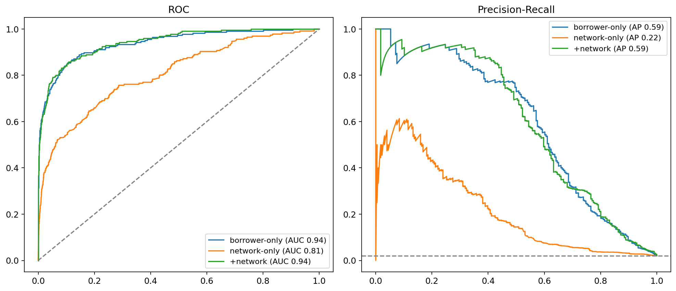
Figure 5.1: ROC and precision-recall curves
Three readings matter. Both feature groups carried real signal: the network-only model, with no borrower financials at all, reached PR-AUC 0.218, roughly ten times the base rate. Adding network features to borrower features lifted ROC-AUC from 0.939 to 0.944 but left PR-AUC essentially unchanged. And the deployed model traded raw performance (0.519 / 0.924) for monotone constraints, a deliberate choice discussed in 5.3.
Every model family trained is reported below, with each family's best configuration and its selection-stage cross-validation metrics.
Model | Feature set | CV PR-AUC | ROC-AUC | Precision | Recall
XGBoost | borrower-only | 0.612 | 0.927 | 0.631 | 0.545
Random Forest | borrower + network | 0.486 | 0.954 | 0.702 | 0.325
Decision Tree | borrower-only | 0.379 | 0.881 | 0.143 | 0.795
Neural Net (MLP) | borrower + network | 0.350 | 0.886 | 0.690 | 0.159
Logistic Regression | borrower + network | 0.346 | 0.891 | 0.570 | 0.137

Table 5.2: All model families trained, with selection-stage cross-validation metrics (precision and recall at the default 0.5 threshold; ranked by PR-AUC)
The PR-AUC values in Table 5.2 come from the model-selection stage's cross-validation, while Table 5.1 reports the final out-of-fold evaluation of the selected model, which is why the XGBoost figures differ slightly between the two (0.612 at selection, 0.592 in the final run). Table 5.2 also carries a live illustration of the metrics argument: Random Forest posted the highest selection ROC-AUC of all families (0.954) while trailing far behind on PR-AUC, which is exactly how ROC flatters a model on rare positives (Saito & Rehmsmeier, 2015).
The ordering has clear explanations. XGBoost led because gradient-boosted trees capture the non-linear interactions in small, imbalanced tabular data that this problem presents, which is exactly what the benchmarking literature predicts (Lessmann et al., 2015; Chen & Guestrin, 2016). Random Forest followed: also an ensemble of trees, but less able to focus successive learning on the rare write-off class. A single Decision Tree overfits and is unstable, so it trailed the ensembles. The neural network underperformed because 226 positive examples are far too few for it to learn from, and Logistic Regression, being linear, cannot represent interactions such as a large loan combined with strained guarantors. Precision and recall are reported per model because AUC alone hides the operational question: of the loans a model flags, how many are real (precision), and of the real future write-offs, how many does it catch (recall); Table 3.7 states each metric in plain terms.
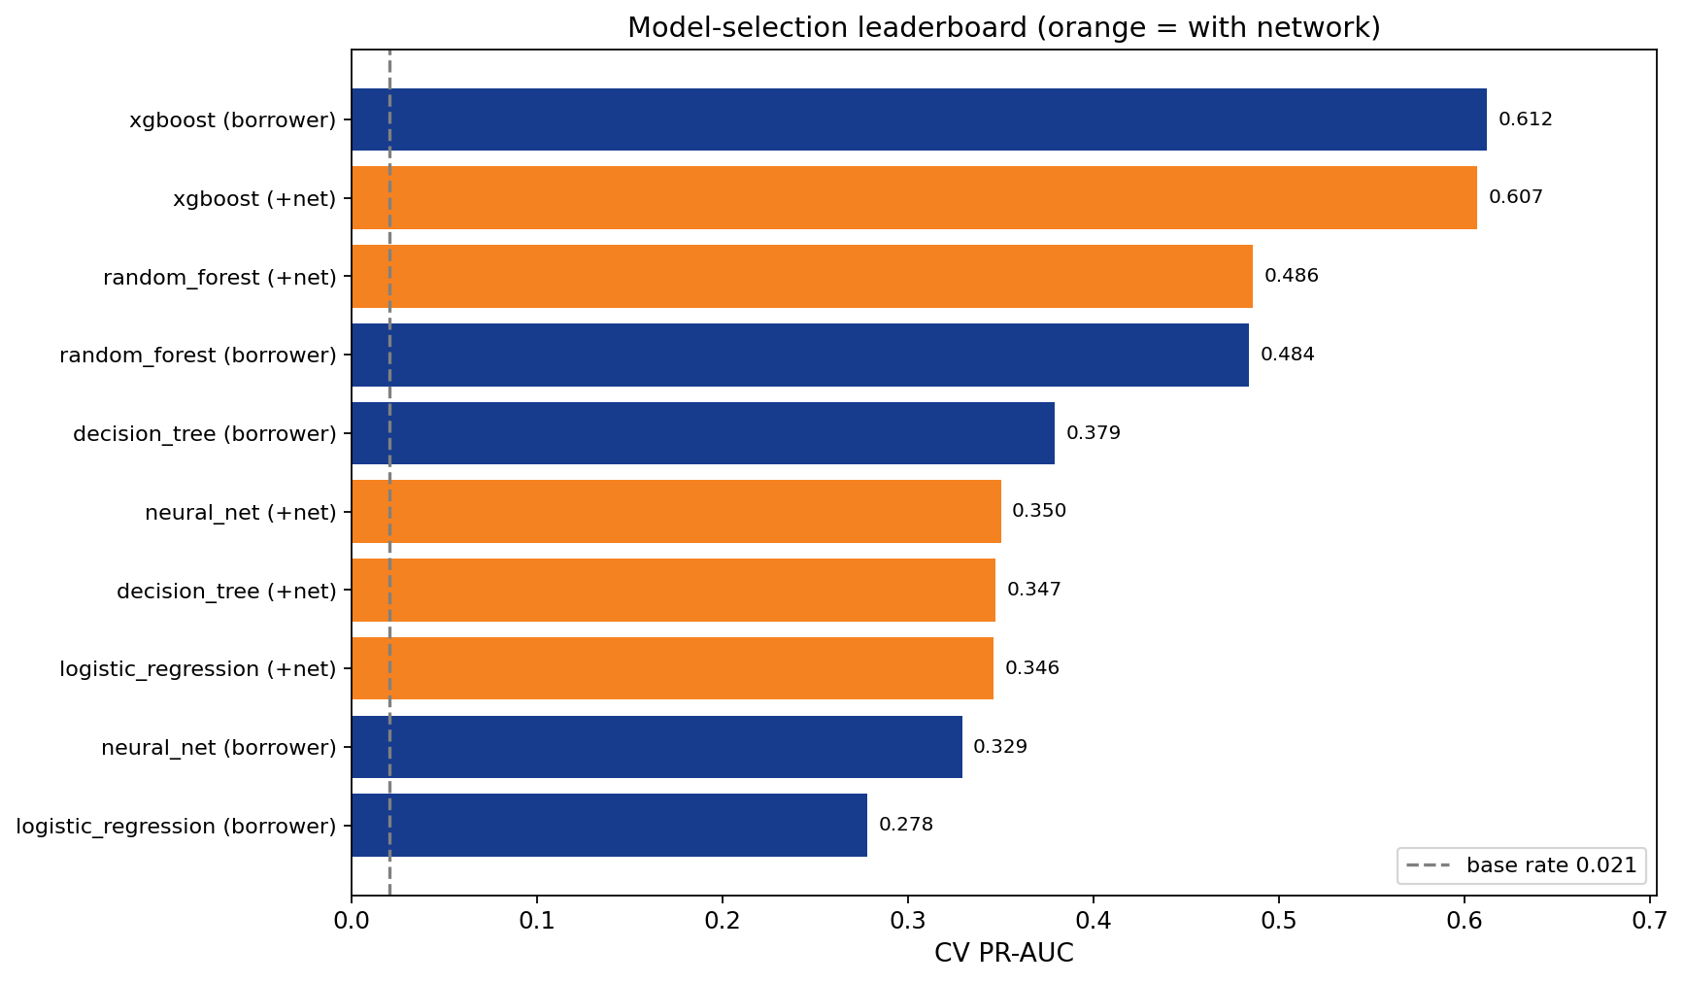
Figure 5.2: PR-AUC by model family and feature set
Class weighting matched or beat every resampling variant, so it was chosen, consistent with Elor and Averbuch-Elor (2022).
Strategy | PR-AUC
Class weighting | 0.593
BorderlineSMOTE | 0.543
SMOTETomek | 0.519
SMOTE | 0.516
ADASYN | 0.512
Undersampling | 0.434

Table 5.3: Imbalance-handling strategies (PR-AUC)
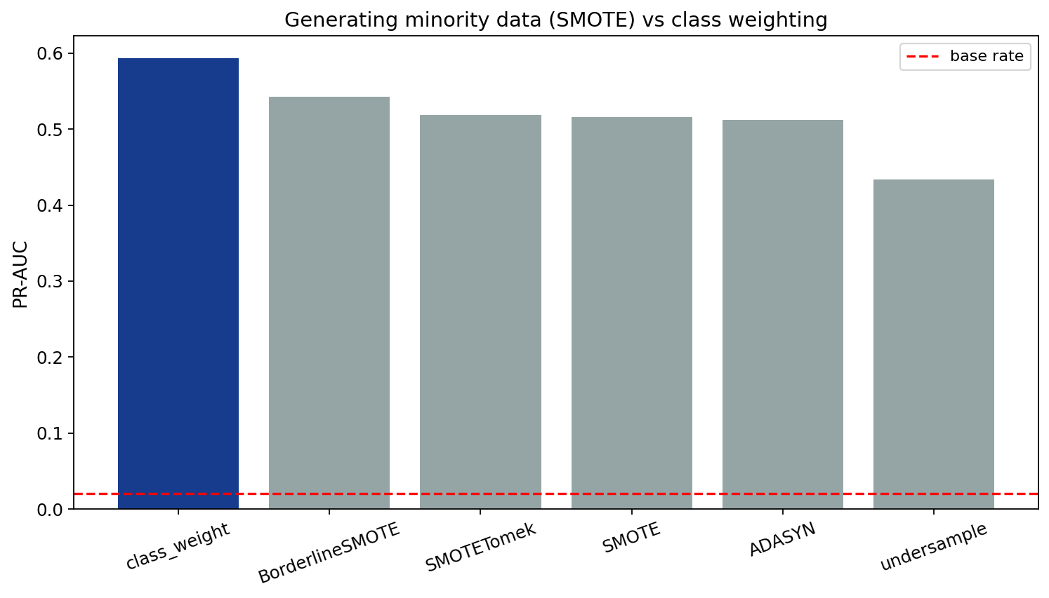
Figure 5.3: Class weighting vs SMOTE variants
Because a missed write-off is the costly error, the operating point was chosen recall-first (Elkan, 2001): require at least 80% of future write-offs caught, then read off each model's score cut-off that achieves it. Table 5.4 shows this point for both the model as selected (unconstrained) and the deployed monotone-constrained model, so the cost of the realism constraint is visible.
Metric | Unconstrained (selection) | Deployed (monotone)
Threshold (≥80% recall) | 0.267 | 0.218
True negatives / False positives | 10,115 / 674 | 9,657 / 1,132
False negatives / True positives | 45 / 181 | 45 / 181
Recall | 0.801 (181 of 226 caught) | 0.801 (181 of 226 caught)
Precision | 0.212 | 0.138
F1 | 0.335 | 0.235

Table 5.4: Confusion matrices at the ≥80% recall operating point (out-of-fold)
Both models catch the same 181 of 226 write-offs at this point; the deployed monotone model gets there with roughly 1.7 times more false alarms (1,132 vs 674), the honest price of forcing every score to move in a believable direction. In plain terms, the cut-off is chosen backwards from the goal of catching at least 80% of write-offs, which lands at 0.218 for the deployed model (Table 3.7 states these concepts in plain terms).
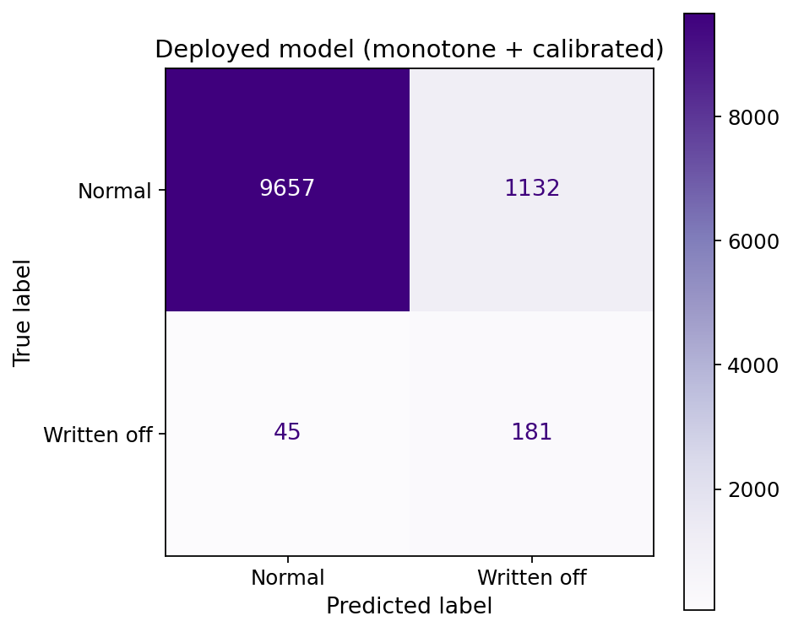
Figure 5.4: Confusion matrix, deployed model at the ≥80% recall point
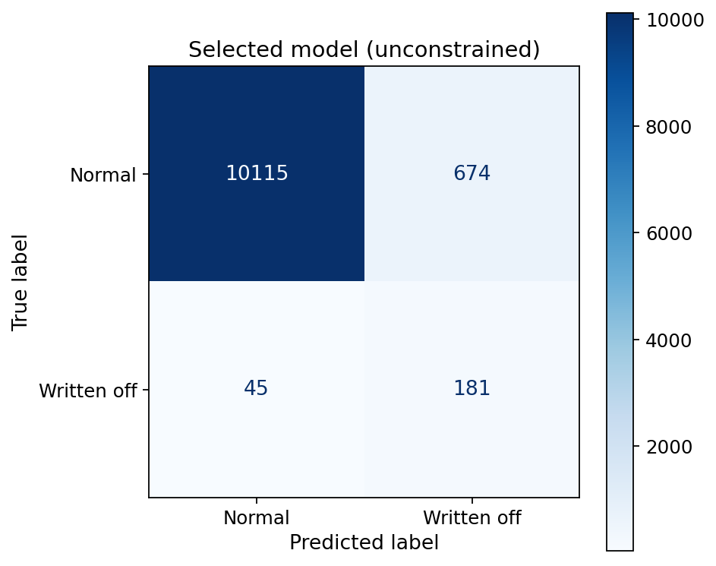
Figure 5.5: Confusion matrix, selected model before the realism constraint
SHAP ranked the drivers: interest_rate, salary, loan_to_salary, account_age, and loan_to_savings led, with two network features, g_sav_ratio and community_prior_default_rate, among the top drivers alongside savings (Lundberg & Lee, 2017). The isotonic-calibrated probabilities tracked observed write-off rates, making the threshold and the displayed probability meaningful (NFR2). As a sanity check, unsupervised anomaly detectors on the same features peaked at IsolationForest ROC 0.889 / PR-AUC 0.232, with Local Outlier Factor far weaker still (0.598 / 0.031), well below the supervised model, which confirms that the write-off labels carry most of the predictive value.
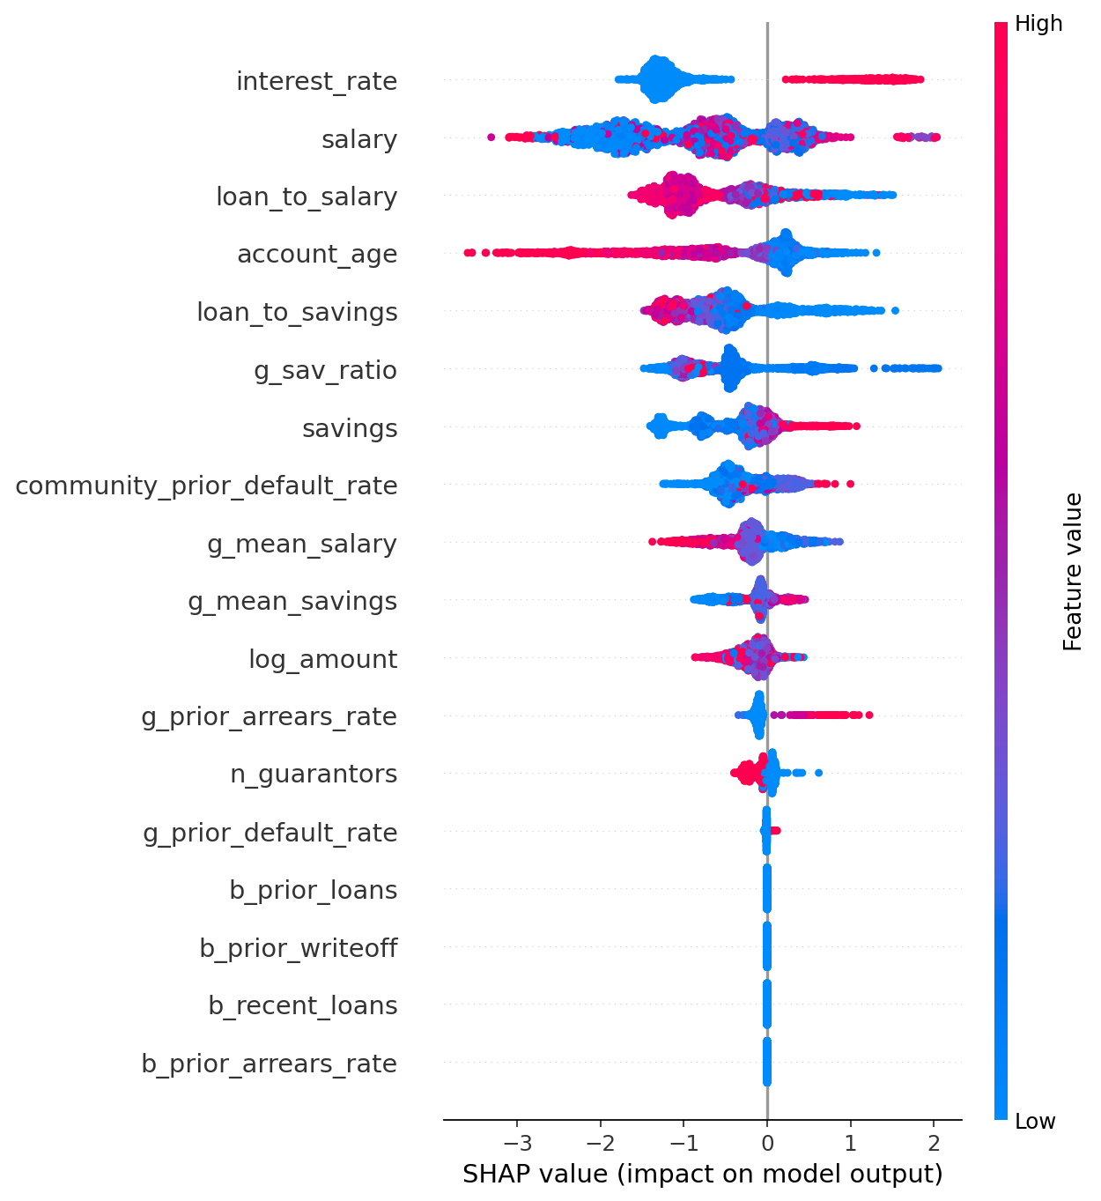
Figure 5.5: SHAP feature importance and direction
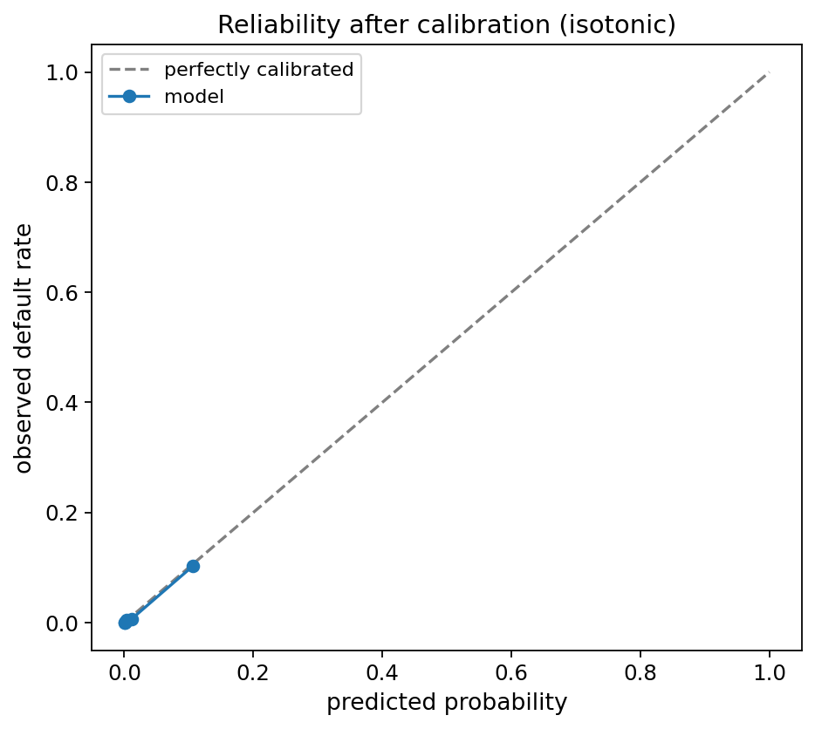
Figure 5.6: Predicted vs observed write-off rate
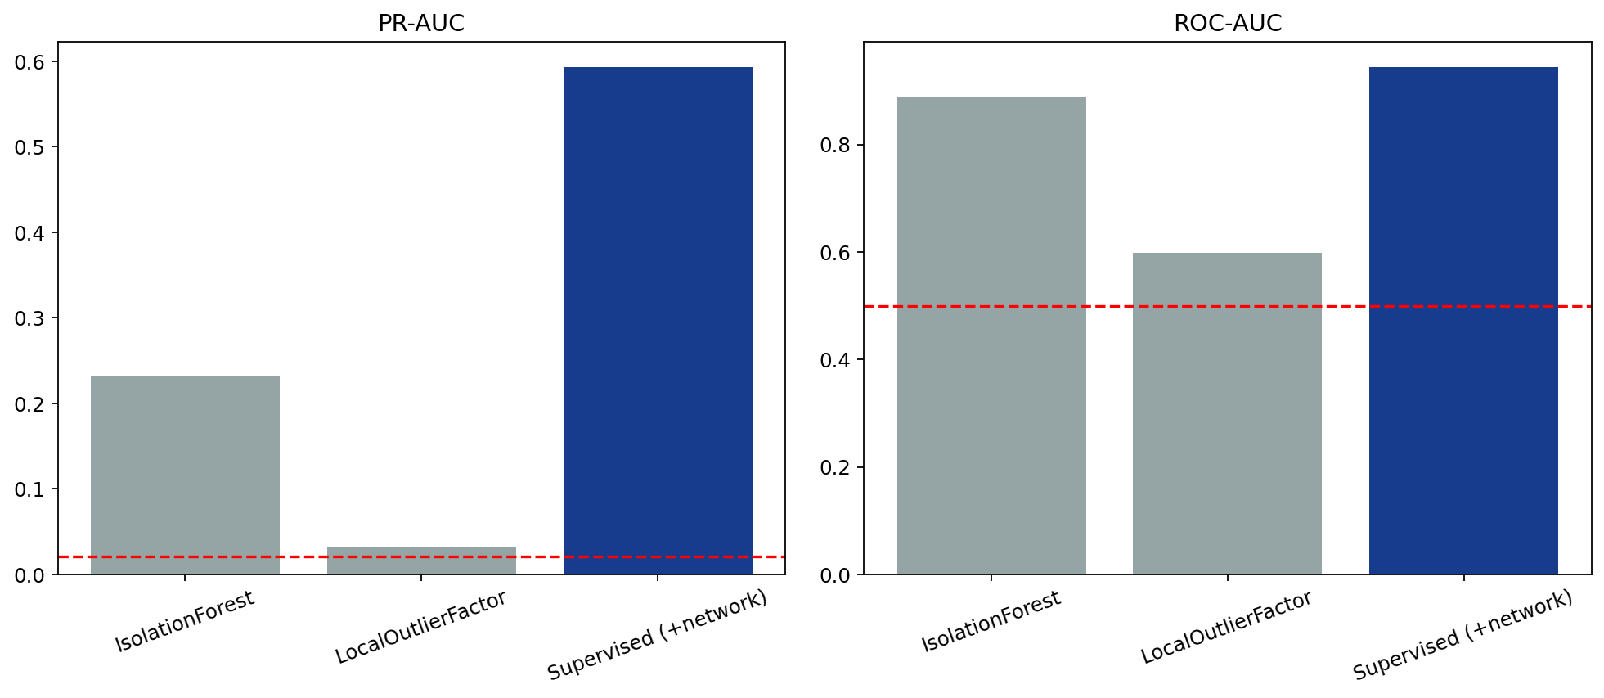
Figure 5.7: Anomaly detectors vs the supervised model

5.2 System Results
For the software side of the results, the key features are evidenced by the screenshots in Section 4.2, and the system is deployed live rather than recorded. The project delivered a working decision-support tool (live URLs in the repository README) that scores, explains with SHAP-derived plain-language reasons, flags guarantor-network risks, supports what-if simulation and a fix-it advisor, and carries a role-gated applications workflow. The five functional scenarios in Table 4.1 produced the expected bands and flags across the risk spectrum, so the served system behaves consistently with the evaluated model.

5.3 Discussion
RQ1 (network structure). The network connected 22,485 members across 11 branches through about 2.5 guarantees per loan, grouped into 1,288 communities by connected components. Write-offs sat unevenly across it: network position and neighbourhood features alone predicted write-off at PR-AUC 0.218 against a 0.021 base rate.
RQ2 (association and improvement). The hypothesis split cleanly. Network features were associated with write-off (supporting H1a/H1b at the association level): the network-only model performed far above chance and network features ranked among the top SHAP drivers. But the incremental improvement over borrower features was small (ROC 0.939 to 0.944) and, for PR-AUC, within noise: the bootstrap interval on the lift crossed zero. The plausible explanation is homophily (McPherson, Smith-Lovin, & Cook, 2001): strained borrowers are backed by similarly strained guarantors, so borrower financials already carry much of the network's information. H1's association component was supported; its improvement component was not statistically established, so H0 could not be rejected for the incremental claim. Reporting this honestly is itself a contribution: the network view adds interpretable warnings and standalone signal, not a large accuracy jump over good borrower data.
RQ3 (feature ranking). Individual features dominated the top of the SHAP ranking, with network features g_sav_ratio and community_prior_default_rate among the leading drivers, consistent with RQ2.
RQ4 (explainability, fairness, acceptability). Explainability was achieved end to end (SHAP drivers in plain language; network warnings as explicit facts), with calibrated probabilities and sub-second scoring supporting acceptability. Fairness was not audited: no branch-parity or group-level evaluation was performed, so operational acceptability is only partially established and a fairness audit is a stated precondition for real use.
Findings against the literature. The results agree with several authors and qualify others. They agree with Cheng et al. (2018) and Óskarsdóttir et al. (2019) that network position carries genuine default signal, with Lessmann et al. (2015) and Chen and Guestrin (2016) that tree ensembles dominate this kind of tabular credit data, with Addo et al. (2018) that trees beat the neural network tested, with Saito and Rehmsmeier (2015) that ROC flattered the models while PR-AUC told the stricter story, and with Elor and Averbuch-Elor (2022) that class weighting matches or beats SMOTE. Where this study qualifies the literature is on the size of the network gain: the corporate guarantee-network studies report substantial improvements from network information, whereas in this SACCO the incremental lift over strong borrower features was within noise. That is a boundary condition rather than a contradiction: homophily (McPherson et al., 2001) means that in a member-guarantees-member cooperative, borrower and guarantor finances are strongly correlated, so less of the network signal is new.
Design trade-off. Monotone constraints cost measurable PR-AUC (0.593 unconstrained vs 0.519 deployed) and roughly 1.7 times more false alarms at the operating point (1,132 vs 674, Table 5.4) in exchange for guaranteed sane behaviour: more savings never raises risk and a bigger loan never lowers it. For a decision-support tool a loan officer must trust and defend, believable behaviour was judged worth the extra review load.

5.4 Limitations
The 11-branch sample leaves generalisation to the full network untested; the write-off label carries delay despite the matured two-year-term cohort; the binary label hides restructuring and partial recovery; no fairness audit was performed; acceptance testing was scenario-based and supervisor-reviewed rather than a hands-on trial with SACCO loan officers; and the model reports association, not causation.

5.5 Link to Objectives
Objective 1 (leakage-safe data with quality validation): achieved via the leakage screen and explicit missingness handling. Objective 2 (network feature engineering): achieved, 7 network features alongside 11 borrower features. Objective 3 (tuned, calibrated model with uncertainty-aware evaluation): achieved, PR-AUC 0.519 / ROC-AUC 0.924 out-of-fold, calibration verified, bootstrap intervals on the lift. Objective 4 (explainable decision-support interface): achieved with the deployed tool of Section 5.2.

CHAPTER SIX: CONCLUSIONS AND RECOMMENDATIONS

6.1 Introduction
This chapter summarises what was achieved against the objectives, answers the research questions, states the contribution and limitations, and gives recommendations and future work.

6.2 Summary of Objectives and How They Were Met
Objective | Met | Evidence
Leakage-safe dataset with quality validation | Yes | Leakage screen (Figure 3.2); missingness characterised and imputed
Borrower + guarantor-network feature engineering | Yes | 18 features: 11 borrower + 7 network
Trained, tuned, calibrated model, uncertainty-aware evaluation | Yes | PR-AUC 0.519 / ROC-AUC 0.924 out-of-fold; calibration curve; bootstrap CIs
Explainable decision-support interface | Yes | Deployed tool: SHAP + plain language + network flags (Chapter Four)

Table 6.1: Objectives and evidence

6.3 Answers to the Research Questions
RQ1: the network connected 22,485 members across 11 branches (~2.5 guarantors per loan, communities by connected components); write-offs were unevenly distributed, with network position alone predicting at ten times the base rate (PR-AUC 0.218 vs 0.021). RQ2: network features were associated with write-off, but their incremental lift over borrower-only was small (ROC 0.939→0.944) and within noise for PR-AUC (bootstrap interval crossing zero), plausibly due to homophily; H1's association component was supported, its improvement component not statistically established. RQ3: borrower features led the SHAP ranking, with g_sav_ratio and community_prior_default_rate among the top drivers. RQ4: explainability was delivered end to end with calibrated probabilities and sub-second scoring; fairness was not audited and remains a precondition for operational use.

6.4 Main Findings and Contribution
The project built a loan write-off risk model for a Rwandan SACCO that can be trusted: it uses only information that existed on the day each loan was issued, its probabilities mean what they say, and every score comes with a plain-language explanation. It runs as a working decision-support prototype in which the loan officer proposes and the credit manager decides. The main finding is an honest one: the guarantor network does carry real risk information on its own and produces clear, useful warnings, but adding it to good borrower data improves accuracy only slightly, because risky borrowers tend to be backed by similarly risky guarantors, so the network largely repeats what the borrower's own finances already show. Finally, to the researcher's knowledge, no earlier study had applied guarantor-network analysis to a Rwandan SACCO, so bringing the approach to this setting is itself a contribution.

6.5 Limitations
An 11-branch sample of roughly 30 branches; write-off label delay despite the matured cohort; a binary label that hides restructuring and partial recovery; no fairness or branch-parity audit; and association, not causation.

6.6 Recommendations
Umwalimu SACCO should use the tool strictly as decision support, officer proposing and credit manager deciding, never automatic approval or decline; extend the data beyond the 11-branch sample and let recent cohorts mature so the positive class grows; and monitor calibration and run a fairness/branch-parity audit on live scores before any operational reliance.

6.7 Future Work
Three directions follow from the findings: a prospective evaluation, deploying the tool alongside existing appraisal to measure whether write-offs actually fall, the claim this study deliberately did not make; temporal and dynamic network features from time-stamped repayment and arrears history (already requested from the SACCO), enabling true early warning on running loans; and a fairness/branch-parity audit with server-side reporting to complete the path from prototype to operational trust.

6.8 Conclusion
This project asked a simple question: when a teacher's loan is secured by fellow members rather than by property, does knowing who those members are, and how they are connected, help predict which loans will end in write-off?
To answer it, the study turned Umwalimu SACCO's own records into a guarantor network: 11,015 Emergency on Savings loans from 11 branches, linking 22,485 members, of which 226 loans (2.1%) were ultimately written off. Every feature was computed only from information that existed on the day each loan was disbursed, and every loan was scored by a model that had never seen its borrower, so the reported results are honest rather than inflated. The final model, an XGBoost classifier with calibrated probabilities and common-sense constraints, ranked write-off risk at ROC-AUC 0.924 and caught about 80% of eventual write-offs at its chosen operating threshold.
The answer came in two parts. Yes, the guarantor network carries real risk information: on its own, with no borrower financials at all, it predicted write-off at roughly ten times the base rate. But no, adding it to strong borrower features did not produce a large accuracy gain, because risky borrowers tend to be backed by similarly strained guarantors, so much of what the network says is already visible in the borrower's own finances. That finding is useful in itself: the network's real value to a SACCO lies in clear, factual warnings, an over-committed guarantor, a backer with a prior write-off, a high-risk community, rather than in a dramatic jump in accuracy.
All of this was delivered as GuarantorLens, a working decision-support tool in which every score comes with plain-language reasons and network warnings, and in which the loan officer proposes and the credit manager decides; the model never approves or declines a loan. What this study established is that the approach works and can be trusted. Whether it actually reduces write-offs in practice is a question Umwalimu SACCO can now answer, by using the tool and measuring what happens.

References
Access to Finance Rwanda. (2024). 96% of Rwandans are financially included - FinScope Survey 2024. Kigali: Access to Finance Rwanda. https://afr.rw
Addo, P. M., Guegan, D., & Hassani, B. (2018). Credit risk analysis using machine and deep learning models. Risks, 6(2), 38. https://www.mdpi.com/2227-9091/6/2/38
AllAfrica. (2014, June 19). Rwanda: Umwalimu SACCO has restored pride of teachers. https://allafrica.com/stories/201406190434.html [VERIFY author/outlet before submission]
Top Africa News. (2024, September 25). Umwalimu SACCO and WIFR collaboration: A step towards gender equality and financial empowerment. Top Africa News.
Apache Software Foundation. (n.d.). Apache Fineract: Open source core banking. https://fineract.apache.org/
Breunig, M. M., Kriegel, H.-P., Ng, R. T., & Sander, J. (2000). LOF: Identifying density-based local outliers. In Proceedings of the 2000 ACM SIGMOD International Conference on Management of Data (pp. 93-104). ACM.
Bussmann, N., Giudici, P., Marinelli, D., & Papenbrock, J. (2021). Explainable machine learning in credit risk management. Computational Economics, 57(1), 203-216.
Chawla, N. V., Bowyer, K. W., Hall, L. O., & Kegelmeyer, W. P. (2002). SMOTE: Synthetic minority over-sampling technique. Journal of Artificial Intelligence Research, 16, 321-357. https://doi.org/10.1613/jair.953
Chen, T., & Guestrin, C. (2016). XGBoost: A scalable tree boosting system. In Proceedings of the 22nd ACM SIGKDD International Conference on Knowledge Discovery and Data Mining (pp. 785-794). ACM.
Cheng, D., Niu, Z., & Zhang, L. (2022). Regulating systemic crises: Stemming the contagion risk in networked-loans through deep graph learning (iConReg). IEEE Transactions on Knowledge and Data Engineering. https://doi.org/10.1109/TKDE.2022.3162339
Cheng, D., Niu, Z., & Zhang, Y. (2020). Contagious chain risk rating for networked-guarantee loans. In Proceedings of the 26th ACM SIGKDD International Conference on Knowledge Discovery and Data Mining (KDD '20) (pp. 2715-2723). ACM.
Cheng, D., Niu, Z., Tu, Y., & Zhang, L. (2018). Prediction defaults for networked-guarantee loans. In Proceedings of the 24th International Conference on Pattern Recognition (ICPR) (pp. 361-366). IEEE.
Cheng, D., Wang, X., Zhang, Y., & Zhang, L. (2020). Risk guarantee prediction in networked-loans. In Proceedings of the 29th International Joint Conference on Artificial Intelligence (IJCAI-20). https://www.ijcai.org/proceedings/2020/0618.pdf
Elkan, C. (2001). The foundations of cost-sensitive learning. In Proceedings of the 17th International Joint Conference on Artificial Intelligence (IJCAI-01) (pp. 973-978).
Elor, Y., & Averbuch-Elor, H. (2022). To SMOTE, or not to SMOTE? arXiv preprint arXiv:2201.08528. https://arxiv.org/abs/2201.08528
Grover, A., & Leskovec, J. (2016). node2vec: Scalable feature learning for networks. In Proceedings of the 22nd ACM SIGKDD International Conference on Knowledge Discovery and Data Mining (pp. 855-864). ACM.
Hagberg, A. A., Schult, D. A., & Swart, P. J. (2008). Exploring network structure, dynamics, and function using NetworkX. In Proceedings of the 7th Python in Science Conference (SciPy 2008) (pp. 11-15).
Hunter, J. D. (2007). Matplotlib: A 2D graphics environment. Computing in Science & Engineering, 9(3), 90-95. https://doi.org/10.1109/MCSE.2007.55
Karekezi, J. (2018). Credit risk management and loan performance: A case of Umurenge SACCOs in Kigali City, Rwanda. International Journal of Recent Innovations in Academic Research, 2(8).
Kaufman, S., Rosset, S., Perlich, C., & Stitelman, O. (2012). Leakage in data mining: Formulation, detection, and avoidance. ACM Transactions on Knowledge Discovery from Data, 6(4), Article 15.
Kawera, C. (2021, October 8). Inside Umwalimu SACCO's socio-economic drive. Umwalimu SACCO. https://umwalimusacco.rw/?p=2431
Lemaitre, G., Nogueira, F., & Aridas, C. K. (2017). Imbalanced-learn: A Python toolbox to tackle the curse of imbalanced datasets in machine learning. Journal of Machine Learning Research, 18(17), 1-5.
Lessmann, S., Baesens, B., Seow, H.-V., & Thomas, L. C. (2015). Benchmarking state-of-the-art classification algorithms for credit scoring: An update of research. European Journal of Operational Research, 247(1), 124-136.
Liu, F. T., Ting, K. M., & Zhou, Z.-H. (2008). Isolation forest. In Proceedings of the 8th IEEE International Conference on Data Mining (ICDM) (pp. 413-422). IEEE.
Lundberg, S. M., & Lee, S.-I. (2017). A unified approach to interpreting model predictions. In Advances in Neural Information Processing Systems 30 (NeurIPS) (pp. 4765-4774).
McKinney, W. (2010). Data structures for statistical computing in Python. In Proceedings of the 9th Python in Science Conference (pp. 56-61).
McPherson, M., Smith-Lovin, L., & Cook, J. M. (2001). Birds of a feather: Homophily in social networks. Annual Review of Sociology, 27, 415-444.
Mifos Initiative. (n.d.). Features. https://mifos.org/shortcodes/features/
Ministry of Finance and Economic Planning (MINECOFIN). (2024). Rwanda FinScope 2024 survey. Kigali: MINECOFIN.
Musengamana, A. (2019). Non-performing loans and financial performance of microfinance institutions in Rwanda: A case study of Umurenge SACCO (2016-2018) (Master's thesis). University of Rwanda, Kigali.
National Bank of Rwanda. (2026). Monetary Policy and Financial Stability Statement [February 2026]. Kigali: National Bank of Rwanda. https://www.bnr.rw [VERIFY exact title, date, and figures against the published statement]
Niculescu-Mizil, A., & Caruana, R. (2005). Predicting good probabilities with supervised learning. In Proceedings of the 22nd International Conference on Machine Learning (pp. 625-632). ACM.
Nikuze, L., Wen, B., Gakuru, E., & Seydou, R. A. (2024). Factors influencing the growth of non-performing loans: Fresh evidence from Rwanda, autoregressive distributed lag approach. International Journal of Engineering and Management Sciences.
Niu, Z., Cheng, D., Yan, J., & Zhang, J. (2018). Visual analytics for networked-guarantee loans risk management. arXiv preprint arXiv:1705.02937.
Niu, Z., Li, R., Wu, J., Cheng, D., & Zhang, J. (2020). iConViz: Interactive visual exploration of the default contagion risk of networked-guarantee loans. In Proceedings of the IEEE Conference on Visual Analytics Science and Technology (VAST).
Nsengiyumva, A., & Harelimana, J. B. (2020). The contribution of loan management on the financial performance of Umurenge Savings and Credit Cooperatives in Rwanda. Austin Journal of Business Administration and Management, 4(2), Article 1047.
Óskarsdóttir, M., Bravo, C., Sarraute, C., Vanthienen, J., & Baesens, B. (2019). The value of big data for credit scoring: Enhancing financial inclusion using mobile phone data and social network analytics. Applied Soft Computing, 74, 26-39.
Pedregosa, F., Varoquaux, G., Gramfort, A., Michel, V., Thirion, B., Grisel, O., et al. (2011). Scikit-learn: Machine learning in Python. Journal of Machine Learning Research, 12, 2825-2830.
Ramírez, S. (n.d.). FastAPI documentation. https://fastapi.tiangolo.com/
Republic of Rwanda. (2021). Law No. 058/2021 of 13/10/2021 relating to the protection of personal data and privacy. Official Gazette of the Republic of Rwanda.
Rwanda Cooperative Agency. (n.d.). About SACCOs. https://www.rca.gov.rw/cooperatives/about-saccos
Saito, T., & Rehmsmeier, M. (2015). The precision-recall plot is more informative than the ROC plot when evaluating binary classifiers on imbalanced datasets. PLOS ONE, 10(3), e0118432.
Suri, T., Bharadwaj, P., & Jack, W. (2021). Fintech and household resilience to shocks: Evidence from digital loans in Kenya. Journal of Development Economics, 153, 102697.
Umwalimu SACCO. (n.d.-a). Profile. https://umwalimusacco.rw/?page_id=26
Umwalimu SACCO. (n.d.-b). Loan products. https://umwalimusacco.rw/?page_id=36
Wirth, R., & Hipp, J. (2000). CRISP-DM: Towards a standard process model for data mining. In Proceedings of the 4th International Conference on the Practical Application of Knowledge Discovery and Data Mining (pp. 29-39).
Zandi, S., Korangi, K., Óskarsdóttir, M., Mues, C., & Bravo, C. (2025). Attention-based dynamic multilayer graph neural networks for loan default prediction. European Journal of Operational Research, 321(2), 586-599.

