DriverLink: Strategic Market Analysis for “Shopify for Independent Drivers”
Research Date: June 2026

Executive Summary
The global chauffeur market is a $60–85 billion industry growing at 6–15% annually, yet it remains one of the last major service sectors without a purpose-built vertical SaaS platform ¹ ² ³. Seventy percent of limousine operators run fewer than five vehicles; no single player controls more than 5% of the national market ⁴. Equally telling, roughly 70% of these small fleets still rely on pen-and-paper scheduling, phone calls, or WhatsApp to manage bookings ⁴. Against this backdrop of extreme fragmentation and digital immaturity, DriverLink is positioned to become the operating system for independent chauffeurs — a “business in a box” that combines SaaS workflow tools, embedded payments, and marketplace demand generation.
The addressable opportunity starts with an estimated 25,000–40,000 independent chauffeurs and small-fleet operators in the United States, a population that is overwhelmingly self-employed (91.5% of for-hire drivers per Bureau of Transportation Statistics data) ⁵ ⁶. At a $49–$199 monthly subscription tier, the pure SaaS total addressable market ranges from $30–95 million. The true revenue engine, however, lies in embedded financial services. Vertical SaaS precedents demonstrate that payment processing, insurance brokerage, and lending eventually generate 3–5x the revenue of subscription fees alone: Toast now derives 82% of its $6.15 billion revenue from payments ⁷; Shopify generates 74% of revenue from merchant solutions ⁸; and Andreessen Horowitz research confirms that embedded fintech expands per-customer revenue by 2–5x ⁹. When payment processing spreads, insurance commissions (15–30% of premium), and lending are layered onto the subscription base, DriverLink’s serviceable TAM expands to $108–500 million ⁹ ¹⁰.
No incumbent currently offers the integrated “business in a box” that independent chauffeurs need. Limo Anywhere and similar legacy platforms target mid-to-large fleets with clunky on-premise deployments and per-trip pricing ¹¹. Uber Black and Blacklane are demand-side marketplaces that extract 25–40% of driver earnings through take rates and offer no operational software ¹². The closest parallel — CloudTrucks, which raised $141.6 million at an $850 million valuation to build an operating system for independent long-haul truckers — validates both the business model and the venture-scale opportunity ¹³. For chauffeurs specifically, the whitespace is unambiguous.
DriverLink’s go-to-market strategy leverages a structural supply pipeline created by Uber’s own business evolution. As Uber’s aggregate take rate climbed from roughly 10% to over 28–30% and the company pivots toward autonomous vehicles, experienced premium drivers are actively leaving the platform to operate independently ¹². These drivers command $50–175 per hour in the independent market versus $20–25 gross on ride-hail platforms, but they lack the tools to manage scheduling, invoicing, CRM, and payments ¹⁴. DriverLink’s “SaaS-first, marketplace-second” sequencing — modeled on Toast and GlossGenius — addresses this pain point directly: drivers will pay for standalone workflow software even with zero marketplace demand attached, solving the classic two-sided marketplace chicken-and-egg problem.
Unit economics project favorably against comparable vertical SaaS platforms. At target pricing of $49/$99/$199 per month with a blended average revenue per user of $85, a customer acquisition cost of $150, and 55–70% gross margins, the model achieves a 6.4:1 lifetime-value-to-CAC ratio and a 4.5-month payback period. The Sun Belt launch strategy — starting with Atlanta, then expanding to Dallas, Houston, Charlotte, and Phoenix within 18 months — targets markets where driver density, population growth, and lower regulatory barriers converge to enable profitability with just 20–30 active drivers per city.
Three high-growth verticals merit particular attention. Corporate travel accounts for 49–58% of total chauffeur market revenue and generates 2–3x the profitability of leisure bookings ¹⁵. Airport transfers represent 47% of service volume and offer the most predictable, recurring demand ¹⁵. Non-emergency medical transportation (NEMT) is a $4.4–6.6 billion segment growing at 7–10% annually, fueled by 3.6 million Americans missing medical appointments each year due to transport gaps and expanding Medicare Advantage coverage ¹⁶.
Regulatory positioning represents both the single greatest risk and the single greatest defense. A pure SaaS tool model — one that does not control dispatch, pricing, or driver hours — sits outside the employment nexus that exposes Uber, Lyft, and even Blacklane to contractor-reclassification liability ¹⁷. California’s TCP regulations already require W-2 employee status for any platform-listed vehicle, and the EU Platform Work Directive will create a rebuttable employment presumption across 27 member states by December 2026 ¹⁸. By positioning as “Squarespace for chauffeurs” rather than “Uber for independents,” DriverLink can operate in jurisdictions that are structurally closed to traditional marketplace models.
The primary risk factors are execution speed, regulatory missteps, and driver churn. The 47.4% five-year failure rate for independent transport businesses is significant but partially mitigated by the platform’s business-in-a-box value proposition: drivers who use integrated scheduling, CRM, and payment tools are structurally more likely to survive than those operating manually. The key strategic imperative is to resist the temptation to control pricing or dispatch — any slide toward a traditional marketplace model would simultaneously erode the regulatory shield and the unit economics that distinguish this opportunity. If executed against the SaaS-first playbook, DriverLink has a clear path to becoming the category-defining platform for one of the last un-digitized corners of the global transportation market.

1. Market Opportunity & TAM Analysis
The ground transportation industry presents one of the largest remaining whitespace opportunities in vertical SaaS. The global chauffeur services market generates an estimated $74.5 billion in annual revenue, yet the technology infrastructure serving independent operators — who comprise the vast majority of the industry — remains effectively nonexistent. This chapter establishes the market’s scale, demonstrates its structural fragmentation, and quantifies the total addressable market for DriverLink through both bottom-up and comparable-based methodologies. The analysis concludes that DriverLink confronts a $30 million to $144 million SaaS TAM in the United States alone, with embedded payments and fintech services expanding the opportunity to $108 million–$500 million — a trajectory validated by Toast, Shopify, and GlossGenius in analogous verticals.

1.1 Global Chauffeur Market Overview

Market Sizing: A $74.5 Billion Industry with Significant Variance
The global chauffeur car market spans a range of definitional scopes depending on whether estimates include adjacent premium mobility categories. Dataintelo pegs the pure chauffeur services market at $46.8 billion in 2025, while Dimension Market Research estimates $83.2 billion for 2026 — the divergence largely attributable to whether premium ride-hail tiers (Uber Black, Uber Lux), luxury car rentals with drivers, and corporate contract vehicles are included ³ ¹. MAK Data Insights produces the highest estimate at $85.4 billion, whereas Growth Market Research narrows the focus to limousine-only services at $10.8 billion in 2024 ² ¹⁹. For the purposes of this analysis, a conservative midpoint of approximately $60–70 billion represents the core addressable market for traditional chauffeur and executive car services.
Source | 2025–2026 Estimate | 2034–2035 Forecast | CAGR | Notes
Dataintelo | $46.8B ³ | $89.3B (2034) | 7.4% | Pure chauffeur services
Dimension Market Research | $83.2B (2026) ¹ | $284.3B (2035) | 14.6% | Includes adjacent premium categories
Market Intelo | $52.4B ¹⁵ | $98.7B (2034) | 7.3% | Core chauffeur services
MAK Data Insights | $85.4B ² | $152.7B (2035) | 6.4% | Broad definitional scope
Growth Market Reports | $10.8B (2024) ¹⁹ | $18.6B (2033) | 6.2% | Limousine services only
Consensus Midpoint | $60–70B | $120–150B | 7–8% | Serviceable market boundary
The United States represents the largest single national market, valued at $10.8 billion in 2025 and projected to reach $22.7 billion by 2035 at a 7.7% CAGR ¹. North America as a whole commands 41.5–44% of global chauffeur revenue, driven by corporate travel density, premium airport transfer demand, and a cultural preference for executive car services in major business corridors ¹. The United States alone hosts over 3,200 licensed limousine and chauffeured transportation companies, with the actual number of operators substantially higher once unlicensed independents and owner-operators are counted ³.
The regional distribution reveals North America’s dominance but also identifies meaningful growth opportunities elsewhere. Europe holds approximately 22% of global revenue, anchored by London, Paris, Frankfurt, and Zurich as corporate travel hubs. The European market benefits from established regulatory frameworks for hire vehicles — such as Germany’s P-Schein requirement and France’s VTC licensing system — that create natural barriers to entry, protecting independent operators from platform commoditization. Asia-Pacific accounts for 20%, with significant acceleration expected as business travel normalizes post-pandemic and luxury tourism expands in Southeast Asia. The Middle East, Africa, and Latin America collectively represent 14%, with the Gulf states showing particularly strong premium transport demand driven by ultra-high-net-worth visitor flows ² ¹⁵.

Growth Drivers: Corporate Travel Recovery and Premium Experience Demand
Three converging forces are expanding the addressable market. First, corporate travel spending reached a record $1.47 trillion globally in 2024 and is projected to hit $1.57 trillion in 2025, with ground transportation representing 11–12% of total expenditure ²⁰. The Global Business Travel Association (GBTA) projects that spending will continue growing at 6.6% annually, with executive and VIP segments outpacing the broader market ²¹. Notably, 81% of business travelers report traveling the same or more in 2024 compared with 2019, and 86% believe business travel is worthwhile in achieving objectives — strong indicators of sustained demand ²².
Second, the corporate travel policy environment is becoming more permissive for premium ground transport. A GBTA/NLA survey found that 93% of travel managers permit chauffeured transportation in high-risk or developing countries, 90% for employees with accessibility needs, 82% for client and customer transport, and 62% for recruiting ²³. Safety overwhelmingly dominates cost as the priority — 73% of travel managers rank it as the single greatest priority in ground transportation programs ²³. This safety-first orientation plays directly to independent chauffeurs’ strengths over rideshare alternatives.
Third, platform investment and consolidation at the top of the market validate the sector’s attractiveness. Uber agreed to acquire Blacklane in March 2026 for approximately EUR 900 million; Blacklane operated across more than 500 cities in over 60 countries at the time of the deal ¹. Lyft acquired TBR Global Chauffeuring in October 2025 for approximately $110 million ¹. These acquisitions signal that even the largest mobility platforms view premium chauffeur services as a critical strategic gap — one that cannot be addressed through algorithmic ride-hailing alone.

Market Segmentation: Airport and Corporate Travel Dominate
Service type segmentation reveals where demand concentrates. Airport transfers command the largest share at 34.2–47.2% of revenue, reflecting the structural predictability of flight-arrival-driven demand ¹⁵ ¹. Corporate travel follows at 24.8–54.1%, depending on definitional scope ¹⁵ ¹. Together, these two segments account for approximately 60–80% of total market revenue, with significant implications for SaaS targeting: drivers serving these segments require scheduling, recurring booking management, flight tracking integration, and corporate invoicing capabilities most urgently.
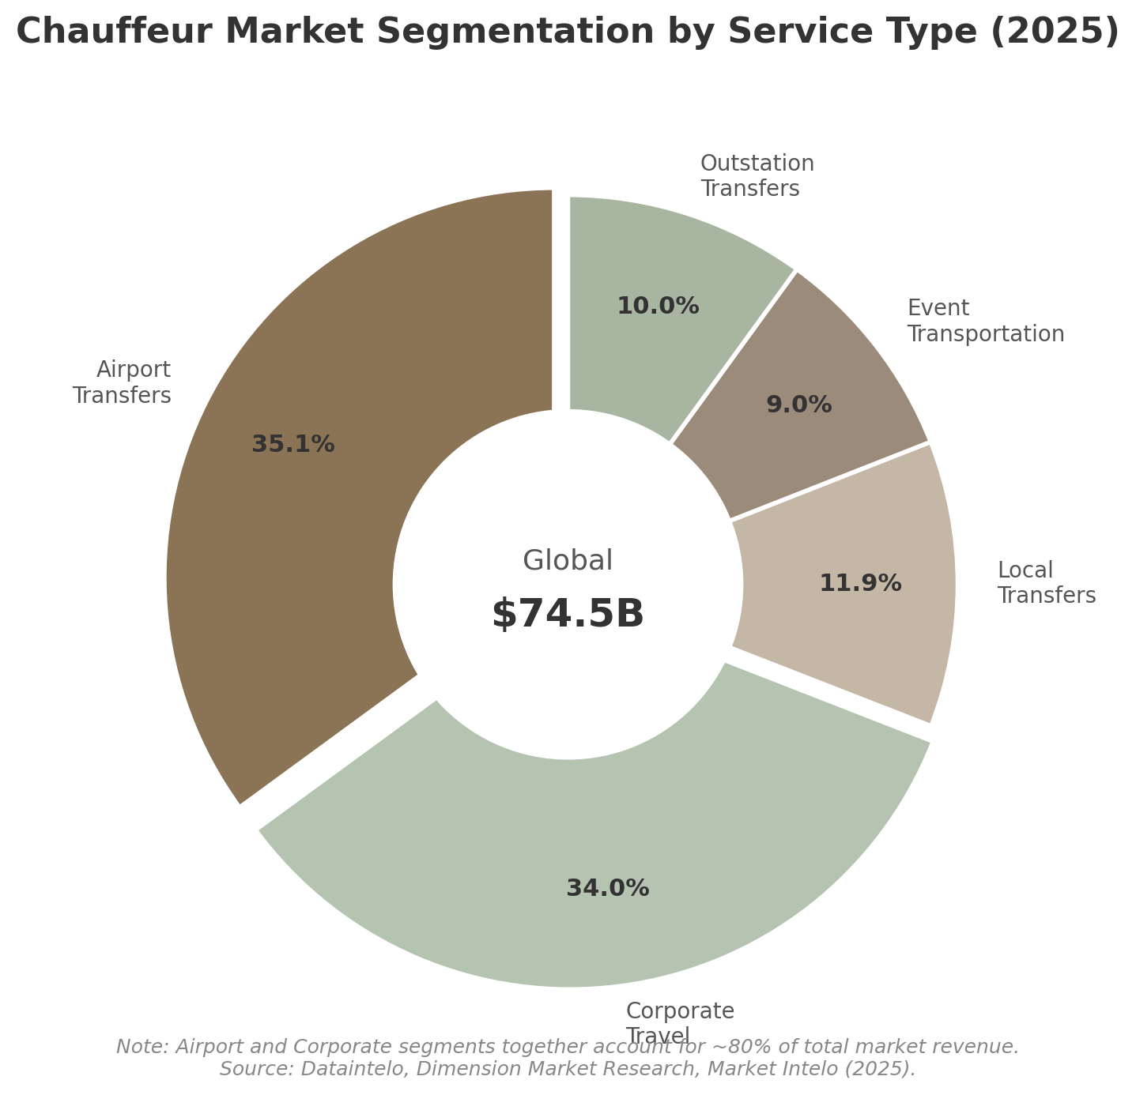
Chauffeur Market Segmentation by Service Type
Online and app-based booking channels now account for 62.3% of total reservations globally, up from approximately 44% in 2020 ³. However, this figure masks a critical structural divide: while large platforms (Blacklane, Uber Black, Addison Lee) capture the majority of online bookings, individual small operators report only 10–20% of their business through online reservation systems, with some reaching 55% at best ²⁴. Multiple operators surveyed by Chauffeur Driven Magazine reported figures as low as 10% of reservations through online portals, with the majority still arriving via phone and email ²⁴. This divergence represents a massive latent demand for digital booking infrastructure among independent operators — the precise gap DriverLink is designed to fill. By 2034, online channels are projected to capture 78% of all transactions; operators without digital booking capabilities face an existential competitive threat ³.

1.2 Market Fragmentation — The SaaS Opportunity

Extreme Fragmentation: The Classic Vertical SaaS Profile
The chauffeur industry exhibits precisely the structural characteristics that vertical SaaS platforms have successfully exploited in restaurants, fitness, beauty, and e-commerce. Small businesses with fewer than 5 vehicles make up 70% of the limousine industry, with the average fleet size for small operators at just 3.5 vehicles ²⁵. No single player operates more than 5% of the business on a national level ⁴. The industry resembles a long tail of micro-operators — exactly the conditions in which Toast (restaurants), GlossGenius (beauty), and Shopify (e-commerce) achieved scale by providing purpose-built infrastructure to underserved independents.
Fragmentation Metric | Value | Source
Operators with <5 vehicles | 70% of industry ²⁵ | WifiTalents 2026
Operators with <$500K annual revenue | 80% ⁴ | LCT Survey
Operators with <$100K annual revenue | 56% ⁴ | LCT Survey
Independent contractors among chauffeurs | ~45–46% ⁴ | LCT Survey
Largest national player’s market share | <5% ⁴ | Industry analysis
Self-employed for-hire drivers (BTS) | 91.5% ²⁶ | U.S. BTS 2022
Small fleets using manual scheduling | 70% ²⁷ | Ground Alliance 2025
Median annual wage (chauffeurs) | $36,670 ²⁸ | BLS May 2024
Projected employment growth (2024–2034) | 9% ²⁸ | BLS
The 80% of operators generating under $500,000 annually are precisely the segment least likely to afford or implement enterprise-grade fleet management software ⁴. Most rely on a patchwork of generic tools: Google Calendar for scheduling, WhatsApp for client communication, Square or PayPal for payments, and spreadsheets for record-keeping ²⁹. This tool fragmentation creates the exact conditions that vertical SaaS has repeatedly disrupted — a large population of independent operators spending excessive time on administrative tasks that purpose-built software can automate.

The Core Addressable Market: 25,000–40,000 Independent Chauffeurs
Synthesizing data from multiple government and industry sources yields an estimate of 25,000 to 40,000 independent chauffeurs and owner-operators in the United States who constitute DriverLink’s core addressable market. The Bureau of Labor Statistics tracks approximately 370,400 total taxi, ride-hailing, and chauffeur drivers nationally ³⁰, while the Bureau of Transportation Statistics reports that 91.5% of taxi drivers — including rideshare operators — are self-employed ²⁶. NAICS code 485320 (Limousine Service) identifies 7,963 companies employing 37,281 people ³¹, but this undercounts the true number of operators because it excludes sole proprietors, independent contractors not on payroll, and drivers affiliated with dispatch networks but operating their own vehicles.
The estimate of 25,000–40,000 independents encompasses three overlapping groups: approximately 5,600–8,400 small operators with fewer than 5 vehicles (the 70% segment of the ~8,000–12,000 total operators), 3,000–5,000 true owner-operators who drive themselves with no employees, and 10,000–20,000 independent contractors affiliated with networks but operating effectively as their own businesses ³² ²⁶. While no authoritative source provides a precise count, the directional magnitude is sufficient for TAM estimation: this is a market of tens of thousands, not hundreds or thousands.

Software Penetration: The $500 Million Gap
The critical insight validating the SaaS opportunity is the chasm between the total market and software penetration. The global limo software market is valued at only $500 million in 2025 — representing roughly 0.6–1.0% of the total chauffeur services market ³³. This is dramatically lower than vertical SaaS penetration in restaurants (Toast holds approximately 15% of payment volume share), e-commerce (Shopify powers roughly 10% of global e-commerce), or fitness (Mindbody serves an estimated 28% of boutique fitness studios) ³⁴ ³⁵.
The reason for this under-penetration is straightforward: existing solutions target fleet operators, not individual drivers. Limo Anywhere — the industry’s most established software provider — prices at $89 to $5,999 per month with features designed for dispatch centers managing multiple vehicles and complex routing ¹¹. Ground Alliance, Samsara, and Verizon Connect similarly focus on fleet telematics and enterprise logistics ²⁷ ³⁶. No purpose-built platform exists for the single-driver operator who needs simple booking management, client CRM, and payment processing — the exact “Squarespace for chauffeurs” positioning that DriverLink occupies.

1.3 Independent Driver Economics

The Earnings Premium: $50–$175/Hour vs. $20–$25/Hour
Independent chauffeurs operate in a fundamentally different economic stratum from platform-based rideshare drivers. Hourly rates for professional chauffeur services range from $50–$75 in smaller markets to $85–$175 in premium tier-1 cities, depending on vehicle class ³⁷ ¹. A New York City black car sedan starts at $85 per hour with a three-hour minimum ($255 floor), while luxury SUVs command $115–$170 per hour ³⁷. Washington DC sedan rates range $65–$95 per hour, SUVs $85–$110 per hour ¹. Chicago sedan service averages $65 per hour, with airport transfers from O’Hare to downtown at $85–$100 per trip ³⁸.
By contrast, Uber and Lyft drivers earn $17–$24 per hour on average before expenses, with net take-home pay substantially lower after accounting for fuel, maintenance, and depreciation ². A 2024 Toronto city analysis based on 84 million trips found median net earnings of $5.97–$15.35 per hour, depending on methodology, with over 57% of drivers earning below minimum wage on a per-engaged-hour basis ³⁹. Even Uber Black drivers — the premium tier most comparable to independent chauffeurs — typically gross $30–$50 per hour during active driving time, with net earnings of $50,000–$75,000 annually in top markets ⁴⁰.

Cost Structure: The Independence Tax
Independence carries significant fixed costs that platform drivers do not bear. Commercial livery insurance represents the single largest expense shock, ranging from $5,000 to $21,600 annually depending on jurisdiction and vehicle type ⁴¹ ⁴². For-hire vehicles in New York carry commercial auto premiums of $5,000–$15,000 per vehicle per year, driven by TLC minimums, high mileage, and passenger liability exposure ⁴¹. Vehicle acquisition or leasing adds $14,400–$30,000 annually, with luxury vehicles commanding the upper end of that range ¹⁵. Licensing and permits ($500–$3,000 per year), parking and tolls ($1,000–$15,000 in urban markets), and marketing ($1,000–$10,000) further erode margins ¹⁵.
Cost Category | Annual Cost Range | % of Typical Revenue
Vehicle lease/payment | $14,400–$30,000 | 15–30%
Commercial livery insurance | $5,000–$21,600 ⁴¹ | 5–22%
Fuel | $3,000–$8,000 | 3–8%
Maintenance & repairs | $2,000–$5,000 | 2–5%
Licensing & permits | $500–$3,000 | 0.5–3%
Parking & tolls | $1,000–$15,000 | 1–15%
Marketing/website | $1,000–$10,000 | 1–10%
Booking/payment software | $500–$3,000 | 0.5–3%
Total estimated expenses | $27,400–$95,600 | 27–96%
A full-time independent chauffeur in a tier-2 city working 40 hours per week at $75 per hour with 60% utilization (24 billable hours) generates approximately $93,600 in gross annual revenue. After vehicle, insurance, fuel, and other expenses totaling roughly $35,000–$45,000, net income lands in the $48,000–$58,000 range — comparable to a skilled trade but with substantially more operational risk. Top-tier NYC operators with corporate accounts can earn $80,000–$120,000 net, but these represent the upper decile, not the median ³⁷ ¹⁵.

The Independence Trade-Off
The defining characteristic of independent chauffeur economics is the trade-off between per-trip margin and demand consistency. Platform drivers sacrifice 40–65% of each fare to the algorithm but receive a steady stream of ride requests ⁴³ ²⁷. Independent chauffeurs capture the full fare but must build and maintain their own customer pipelines — a challenge for which most drivers are unprepared. The transportation and warehousing industry posts a 47.4% five-year business failure rate, placing it in the bottom half of all industries for survival ⁴⁴. Primary failure drivers include cash flow disruption (56% of small businesses wait on unpaid invoices), customer acquisition difficulty, and regulatory complexity ⁴⁵ ⁴⁶.
This trade-off is precisely where vertical SaaS creates value. By providing independent drivers with the booking, CRM, invoicing, and payment tools they lack, DriverLink addresses the operational burden that drives nearly half of independent operators out of business within five years. The platform does not merely offer convenience — it materially improves survival odds by systematizing the administrative functions that entrepreneurs in other verticals already take for granted.

1.4 TAM Sizing for DriverLink

Bottom-Up TAM: Independent Drivers × ARPU
Following the proven methodology employed by Toast, Slice, and GlossGenius, DriverLink’s TAM is calculated as the product of the addressable independent driver population and average revenue per user (ARPU), with subsequent expansion through embedded payments and fintech services.
The addressable driver base is estimated at 25,000–40,000 independent chauffeurs and owner-operators in the United States. ARPU benchmarking against comparable vertical SaaS platforms suggests a SaaS subscription range of $50–$150 per month ($600–$1,800 annually), with an average blended ARPU of approximately $100 per month ($1,200 annually). GlossGenius charges $24–$148 per month for beauty professionals, with payments revenue roughly matching subscription revenue at scale ⁴⁷. Limo Anywhere targets fleet operators at $89–$5,999 per month — pricing that excludes the vast majority of single-driver operators ¹¹. Toast achieves $11,500 in actual ARPU (2023) with a theoretical potential exceeding $30,000 when fintech services are included ³⁵.
TAM Scenario | Driver Count | SaaS ARPU/Year | Payments ARPU/Year | SaaS TAM | Total TAM (SaaS + Payments)
Conservative (25K drivers) | 25,000 | $1,200 | $1,000 | $30M | $55M
Base (35K drivers) | 35,000 | $1,200 | $1,500 | $42M | $94.5M
Optimistic (40K drivers) | 40,000 | $1,800 | $2,000 | $72M | $152M
Expansion (global + adj.) | 100,000 | $1,200 | $1,500 | $120M | $270M

Payments and Fintech: The 2–3x Multiplier
The pure SaaS TAM — while sufficient to support a meaningful business — dramatically understates the true opportunity. Every comparable vertical SaaS platform has discovered that payments and fintech revenue eventually surpass subscription revenue by multiples. Toast derives approximately 85% of revenue from payments processing, 15% from subscriptions ³⁵. Shopify generates 74% from merchant solutions (primarily payments), 26% from subscriptions ⁴⁸. GlossGenius collects 2.6% on every card transaction, with payments revenue contributing roughly half of total value at scale ⁴⁷. Slice processes $50 billion in annual order flow through independent pizzerias; at a 1% take rate, that represents a $500 million revenue opportunity — more than 5x its SaaS subscription value ⁴⁹.
For DriverLink, the payments multiplier operates as follows. An independent chauffeur processing $100,000 in annual bookings through the platform generates $2,600 in processing fees at a 2.6% rate (the GlossGenius benchmark). Assuming the platform captures a 0.5–1.0% spread on processed volume, payments revenue alone equals $500–$1,000 per driver per year — approaching or matching the SaaS subscription. Adding insurance commissions (15–30% of premium on $5,000–$15,000 policies), embedded lending, and other fintech services could push total ARPU to $3,000–$5,000 per driver at full penetration.
The formula generalizes: Total TAM = (Independent Drivers) × (SaaS ARPU + Payments ARPU + Fintech ARPU). Under the base scenario of 35,000 drivers, this yields $42 million in SaaS TAM, $52.5 million in payments TAM (at 1.5% take rate on $100,000 average GMV), and incremental fintech revenue — for a combined addressable market of approximately $108 million. Under the expansion scenario that includes global markets (3× the US addressable base) and adjacent verticals (luxury car rental, tour operators, personal drivers), the total TAM reaches an estimated $300–$500 million ⁴⁴.
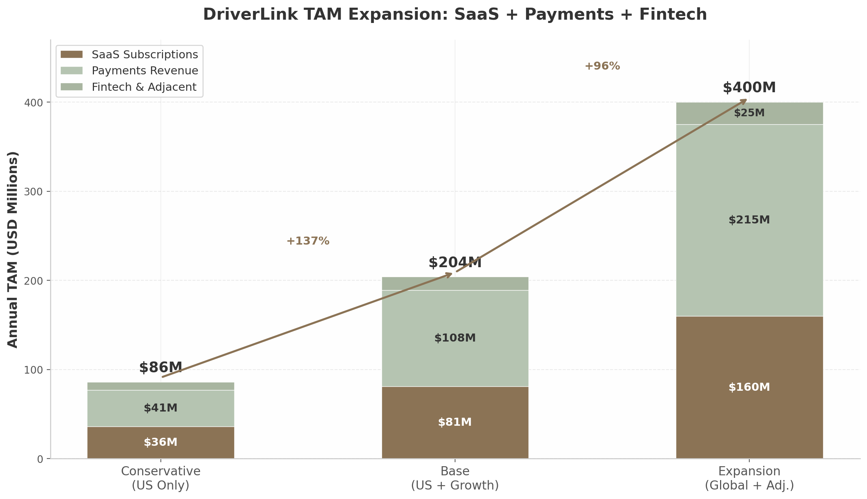
DriverLink TAM Expansion

Comparable Validation: How Toast, Shopify, and Slice Prove the Model
The TAM expansion pattern observed in analogous verticals provides strong empirical validation for DriverLink’s trajectory. Toast expanded its TAM from 438,000 locations at IPO to 1.4 million locations globally by 2024 — a 60% increase driven by international expansion and adjacent food-and-beverage retail categories ³⁵. The company now holds approximately 15% of payment volume share in the US restaurant market, yet has penetrated only 13% of its US TAM by location count — demonstrating the long runway available even after achieving significant scale ⁵⁰.
Slice illustrates the power of the SaaS-plus-payments model in a fragmented artisan vertical. The US pizza market generates approximately $44 billion in annual revenue across 75,000 shops, of which roughly 40,000 are independent pizzerias. Slice serves over 19,000 of these independents and has exceeded $100 million in ARR ⁴⁹ ⁵¹. The company’s CRO has noted that there is “$50 billion worth of order flow and spend through those pizzerias” — a payments TAM more than 10x the SaaS opportunity ⁵¹. Shopify’s current TAM stands at $849 billion, though this reflects GMV-based methodology rather than subscription value; the more relevant metric is Shopify’s 2% penetration in its $404 billion core serviceable addressable market, suggesting years of growth remain even at enormous scale ⁴⁸.
Company | Vertical | TAM Methodology | SaaS ARPU | Payments Take Rate | TAM Expansion
Toast | Restaurants | 1.4M locations × ARPU ³⁵ | $11.5K actual / $30K potential | Embedded | 6× in 5 years
Shopify | E-commerce | GMV × take rate ⁴⁸ | $29–$2,300/mo | 2–3% | 3× via merchant solutions
Slice | Pizzerias | 40K shops × ARPU + order flow ⁴⁹ | $1.5K–$3K/yr | ~1% of GMV | 5× via payments
GlossGenius | Beauty | 70K+ locations × ARPU + payments ⁴⁷ | $24–$148/mo | 2.6% | 3× via payments
Mindbody | Fitness | 61K studios × ARPU + payments ³⁴ | ~$11K/yr | 80 bps | 2.5× via payments
The comparable data points to a consistent pattern: vertical SaaS platforms targeting fragmented independent operators achieve initial product-market fit with software subscriptions, then expand TAM by 2–6x over five years through embedded payments and adjacent financial services. The chauffeur industry shares the structural characteristics — fragmentation, cash-heavy transactions, underserved independents, relationship-based commerce — that enabled this pattern in every precedent vertical. The $500 million limo software market, set against a $50+ billion total industry, represents one of the lowest SaaS penetration ratios in the economy — and one of the largest remaining opportunities for vertical platform consolidation ³³.
The implications for DriverLink are unambiguous. A conservative US-first strategy targeting 25,000–40,000 independent chauffeurs with a SaaS-plus-payments stack addresses a $55–$152 million TAM — sufficient to support a venture-scale business at 10–20% penetration. Layering in insurance brokerage, embedded lending, and global expansion pushes the total addressable market toward $300–$500 million, on par with the scale that Slice and GlossGenius have demonstrated achievable in similarly fragmented verticals. The EU Platform Work Directive, effective December 2026, will force ride-hail platforms to reclassify drivers as employees across 27 countries — creating a regulatory collapse event that could drive thousands of premium drivers toward independent SaaS tools and away from employment-nexus platforms. The market exists, the independents are underserved, the regulatory winds are shifting favorably, and the playbook is proven.

2. Competitive Landscape
The global chauffeur services market, valued at $52.4 billion in 2025 and projected to reach $98.7 billion by 2034 ¹⁵, exhibits a striking paradox: it is one of the most technologically underserved sectors in the transportation economy. The top ten operators collectively capture only 22-25% of global revenue ³, leaving the vast majority of the market to independent operators running fleets of one to five vehicles. Yet no dominant vertical SaaS platform purpose-built for these independents exists. This section maps the competitive terrain — direct competitors, indirect alternatives, and adjacent platform precedents — to identify exactly where the whitespace opportunity sits and why existing players are structurally incapable of addressing it.

2.1 Direct Competitors: Global Chauffeur Platforms
Direct competitors are defined as platforms that connect chauffeur supply with passenger demand. All share a critical limitation: they operate as consumer-facing marketplaces or employer models, not as business operating systems for independent drivers. Every direct competitor treats chauffeurs as supply-side inputs rather than independent business owners who need tooling, branding, and financial services.
Blacklane operates in over 500 cities across more than 60 countries and was acquired by Uber in March 2026 for an undisclosed sum ⁵². Founded in Berlin in 2011, the company built its network on a partner model that offers chauffeur companies “complete schedule control” and “reliable direct payment” with no commission or fees ⁵³. Partners gain access to large corporate clients, dedicated support, and training modules. However, Blacklane’s minimum bar is owning and operating a registered chauffeur company — it does not serve individual independent chauffeurs. More importantly, Blacklane provides zero SaaS tools for partners to run their own businesses: no client CRM, no booking software, no payment processing, no insurance or financing products. It is purely a demand platform. Uber’s acquisition of Blacklane, announced less than two weeks after Uber Elite’s March 12, 2026 launch ⁵⁴, signals that even Uber recognized it could not algorithmically replicate fifteen years of luxury hospitality expertise ⁵⁵. Yet the combined entity remains a consumer-facing brand; Uber Elite drivers are still gig workers within Uber’s ecosystem.
Wheely expanded to New York City in March 2026, its U.S. debut, with plans to expand to Texas, Washington D.C., Miami, and Palm Beach over the next five years ¹⁵. The London-headquartered service targets exclusively business elites and high-net-worth individuals. Drivers wear suits and ties, sign non-disclosure agreements, and complete three days of five-star hotel-inspired hospitality training ¹⁵. Wheely became the Official VIP Chauffeur Partner of Frieze art fairs across New York, London, and Los Angeles in May 2026 ⁵⁶. Like Blacklane, Wheely sources vehicles from independent contractors but operates as a consumer-facing brand — drivers do not build their own brand or client relationships. Wheely offers trips, not business tools.
Addison Lee achieved turnover of £224.8 million in FY2023 with Adjusted EBITDA of £27.4 million (up 41%), rising to £231.2 million in revenue with £1.8 million pre-tax profit in FY2024 ⁵⁷ ⁴⁵. The company operates over 7,500 drivers in London and invested more than £80 million over three years to upgrade its fleet with 600 plug-in hybrid VW multivans and 1,000 fully electric VW ID.4s. Addison Lee operates an employer model — its drivers are supply-side workers, not independent business owners. It was acquired by ComfortDelGro for £269.1 million in October 2024 ⁴⁵. The company offers no SaaS platform for independent chauffeurs; it is an operator, not a software provider.
TBR Global Chauffeuring was acquired by Lyft for £83 million (~$110 million) in October 2025 ²⁷ ⁵⁸. TBR operates across 120+ countries and 3,000+ cities, serving Fortune 500 companies, investment banks, and major global events ⁵⁸. The company specializes in “high-touch, complex events, financial roadshows” with “a high level of offline bookings,” per CEO Craig Chambers ⁵⁷. Critically, Chambers confirmed there will be no integration with Lyft’s app technology: “The Lyft app is an on-demand piece of technology; TBR is much more high-touch” ⁵⁷. TBR serves corporate clients through a curated network of fleet partners. It is not, and does not aspire to be, a SaaS tool for individual independent chauffeurs.
Table 1: Direct Competitor Comparison
Platform | Scale | Revenue | Model | Driver Relationship | SaaS for Drivers | Ownership
Blacklane ⁵² | 500+ cities, 60+ countries | Not disclosed (est. EUR 300M) | Partner marketplace | Chauffeur companies only | None | Uber (acquired Mar 2026)
Wheely ¹⁵ | London, Paris, Dubai, NYC | Not disclosed | Luxury on-demand | Independent contractors | None | Private
Addison Lee ⁵⁷ | 7,500+ drivers, London | £231.2M (FY2024) | Employer/operator | Employees | None | ComfortDelGro
TBR Global ⁵⁸ | 3,000+ cities, 120 countries | £83M (acquisition price) | Managed marketplace | Fleet partners | None | Lyft
Carey International ⁵⁰ | 1,000+ cities, 55+ countries | Not disclosed | Affiliate network | Affiliated operators | None | Private
Dav El/BostonCoach ⁵⁹ | 500+ markets, 25,000+ vehicles | $54.5M (estimated) | Employer + affiliates | Mixed | None | Marcou Transportation
The pattern across all six direct competitors is identical: each captures value by controlling the customer relationship and treating chauffeurs as a replaceable supply input. None provide business infrastructure — scheduling, CRM, payments, insurance, financing — that would enable an independent chauffeur to build a sustainable standalone business. This is not an oversight; it is a structural feature of the marketplace model. When Blacklane connects a passenger to a chauffeur company, Blacklane owns the client relationship. The chauffeur cannot contact that client directly for repeat bookings. This dynamic creates the opening for DriverLink’s fundamentally different positioning.

2.2 Indirect Competitors & Adjacent Platforms
Indirect competitors fall into three categories: gig platform premium tiers that compete for the same passenger wallet; legacy limousine software that addresses operational needs but not business-building needs; and vertical SaaS platforms in comparable industries that validate DriverLink’s model but do not directly compete.

2.2.1 Gig Platform Premium Tiers
Uber launched Uber Elite on March 12, 2026 — an invite-only luxury chauffeur service in Los Angeles and San Francisco featuring commercially licensed professional chauffeurs, vehicles less than three years old, and in-app “Meet and Greet” for airport arrivals ⁶⁰ ⁵⁴. Rides can be booked from one hour to 90 days in advance through Uber Reserve, and include 24/7 phone support, in-vehicle amenities, and special requests ⁶⁰. The acquisition of Blacklane will accelerate Uber Elite’s global expansion. However, Uber Elite remains a premium consumer tier within Uber’s ecosystem — drivers are gig workers subject to algorithmic management, deactivation risk (a study found 90% of deactivated Uber drivers never recovered their accounts) ⁶¹, and Uber’s 25-40% take rate ¹². The platform does not allow drivers to build direct client relationships, export customer data, or operate independently.
Lyft’s premium push, bolstered by the TBR Global and Gett UK acquisitions ⁶², similarly focuses on corporate demand rather than driver empowerment. TBR will continue operating independently with no planned Lyft app integration ⁵⁷, meaning Lyft’s consumer app gains nothing in chauffeur-grade functionality.

2.2.2 Traditional Limousine Software
Limo Anywhere, acquired by Marcou Transportation Group in 2017 alongside GroundLink ⁶³, is the most established operational software in the chauffeur industry. Pricing starts at $99 per month plus $0.25 per trip for the Core plan, with Plus at $199 per month and BLACK at $499 per month ⁶⁴. It provides reservation management, back-office automation, and global affiliate networking. Limo Anywhere is fleet management software — built for dispatchers managing multiple vehicles, not for individual owner-operators building a personal brand. GroundWidgets offers a similarly operationally-focused suite with reservation, dispatch, and accounting tools, supporting businesses from single-vehicle operators to large global fleets ⁶⁵. IT services are billed at $180-$300 per hour ³¹, placing it out of reach for most independents.
Anolla represents the closest existing comparable to DriverLink. It offers a free plan for solo chauffeurs that includes an online booking form, automatic confirmations, and calendar synchronization ⁶⁶. Paid features add automation, payment integrations via Stripe, accounting and CRM connections, and customer loyalty modules. Anolla’s existence validates market demand at the independent-operator level. However, it appears to be a relatively new or small player with limited online presence and no disclosed revenue, suggesting the market remains wide open.

2.2.3 Vertical SaaS Comparables
Adjacent platforms in comparable verticals provide the strongest validation for DriverLink’s business model. These companies prove that vertical SaaS platforms serving independent operators in fragmented service industries can achieve substantial scale.
Table 2: Vertical SaaS Comparable Platforms
Platform | Vertical | Revenue | Funding | Model Relevance to DriverLink
Toast ⁶⁷ ⁶⁸ | Restaurants | $6.15B (2025), 164,000 locations | Public ($19.87B mkt cap) | Land-and-expand: POS → payments → payroll → insurance; 6x ARR expansion over 5 years
GlossGenius ⁶⁹ | Beauty | $100M ARR (2024) | $70M | Booking + payments + marketing for independent beauty pros; $0 to $100M in 8 years
StyleSeat ⁷⁰ ⁷¹ | Beauty | $10.6B GMV cumulative | $40M | Booking + marketplace + capital; saved pros $2M via no-show fee enforcement
CloudTrucks ⁷² ⁷³ | Trucking | $14.6M est. revenue | $141.6M ($850M valuation) | “Business in a box” for 350,000 owner-operator truckers; closest structural comparable
Slice ⁵² | Pizzerias | $1B+ GMV | $165M+ | 5% per order vs. 20-30% for delivery apps; preserves independent brand
CloudTrucks is the single most instructive comparable. The company raised $141.6 million at an $850 million valuation in 2021 to provide a “business in a box” for the approximately 350,000 owner-operator truckers in the United States ⁷². Its product suite includes instant pay, back-office support, compliance management, insurance administration, a schedule optimizer, a load board, a fuel card, and bookkeeping services ⁷³. Revenue grew 9.5x between Series A (2020) and Series B (2021). CloudTrucks’s CEO observed: “An increasing number of truck drivers just don’t want to be company employees anymore… They want to take control of their time” ⁷². The independent trucking market shares nearly identical structural characteristics with the independent chauffeur market: fragmented operator base, regulatory complexity, insurance challenges, need for client/job acquisition, and a desire for entrepreneurial independence with infrastructure support.
GlossGenius demonstrates what is achievable with capital-efficient execution. The platform reached $100 million ARR by November 2024 — up from $49.5 million just eleven months prior — on total funding of only $70 million ⁶⁹. GlossGenius provides all-in-one booking, payments, point-of-sale, marketing, and client management for beauty professionals. Its flat 2.6% payment processing rate, industry-specific design, and vertical-focused feature set created a product-market fit that horizontal alternatives could not replicate.
Toast illustrates the land-and-expand playbook at maximum scale. Starting with restaurant POS software, Toast expanded into payments, payroll, marketing, loyalty, and insurance. Locations using multiple Toast products achieve 4x-6x higher ARR than POS-only locations, and five-year customers reach an average ARR exceeding $16,000 — a 6x increase from initial spend ⁶⁸. Toast’s revenue mix — 85% from financial technology solutions and only 15% from subscriptions ⁷— demonstrates the revenue transformation that embedded fintech enables. Andreessen Horowitz research found that adding fintech features to vertical SaaS increases revenue per customer by 2x to 5x, with over 40% of platform customers typically adopting embedded financial products ⁹.
StyleSeat validates the specific pain point of no-show and cancellation protection. The platform saved beauty professionals nearly $2 million in 2020 alone through automated no-show/cancellation fee enforcement ⁷¹. Independent chauffeurs face the identical problem — absorbing the full cost when clients fail to appear — but lack equivalent tooling. StyleSeat’s $10.6 billion in cumulative GMV and 320,000+ professionals demonstrate the scale achievable by combining SaaS workflow tools with marketplace demand and financial services ⁷¹.
The competitive positioning map (Figure 2.1) visualizes the landscape. The upper-right quadrant — combining high business tool sophistication with high brand independence for drivers — remains almost entirely unoccupied by chauffeur-specific platforms. Existing direct competitors cluster in the lower-left (marketplace models that own the brand and offer minimal tools). Legacy software sits in the middle (generic operational tools without brand-building or business-infrastructure capabilities). Vertical SaaS comparables occupy the upper-right quadrant in their respective industries, validating both the model and the addressable market structure.
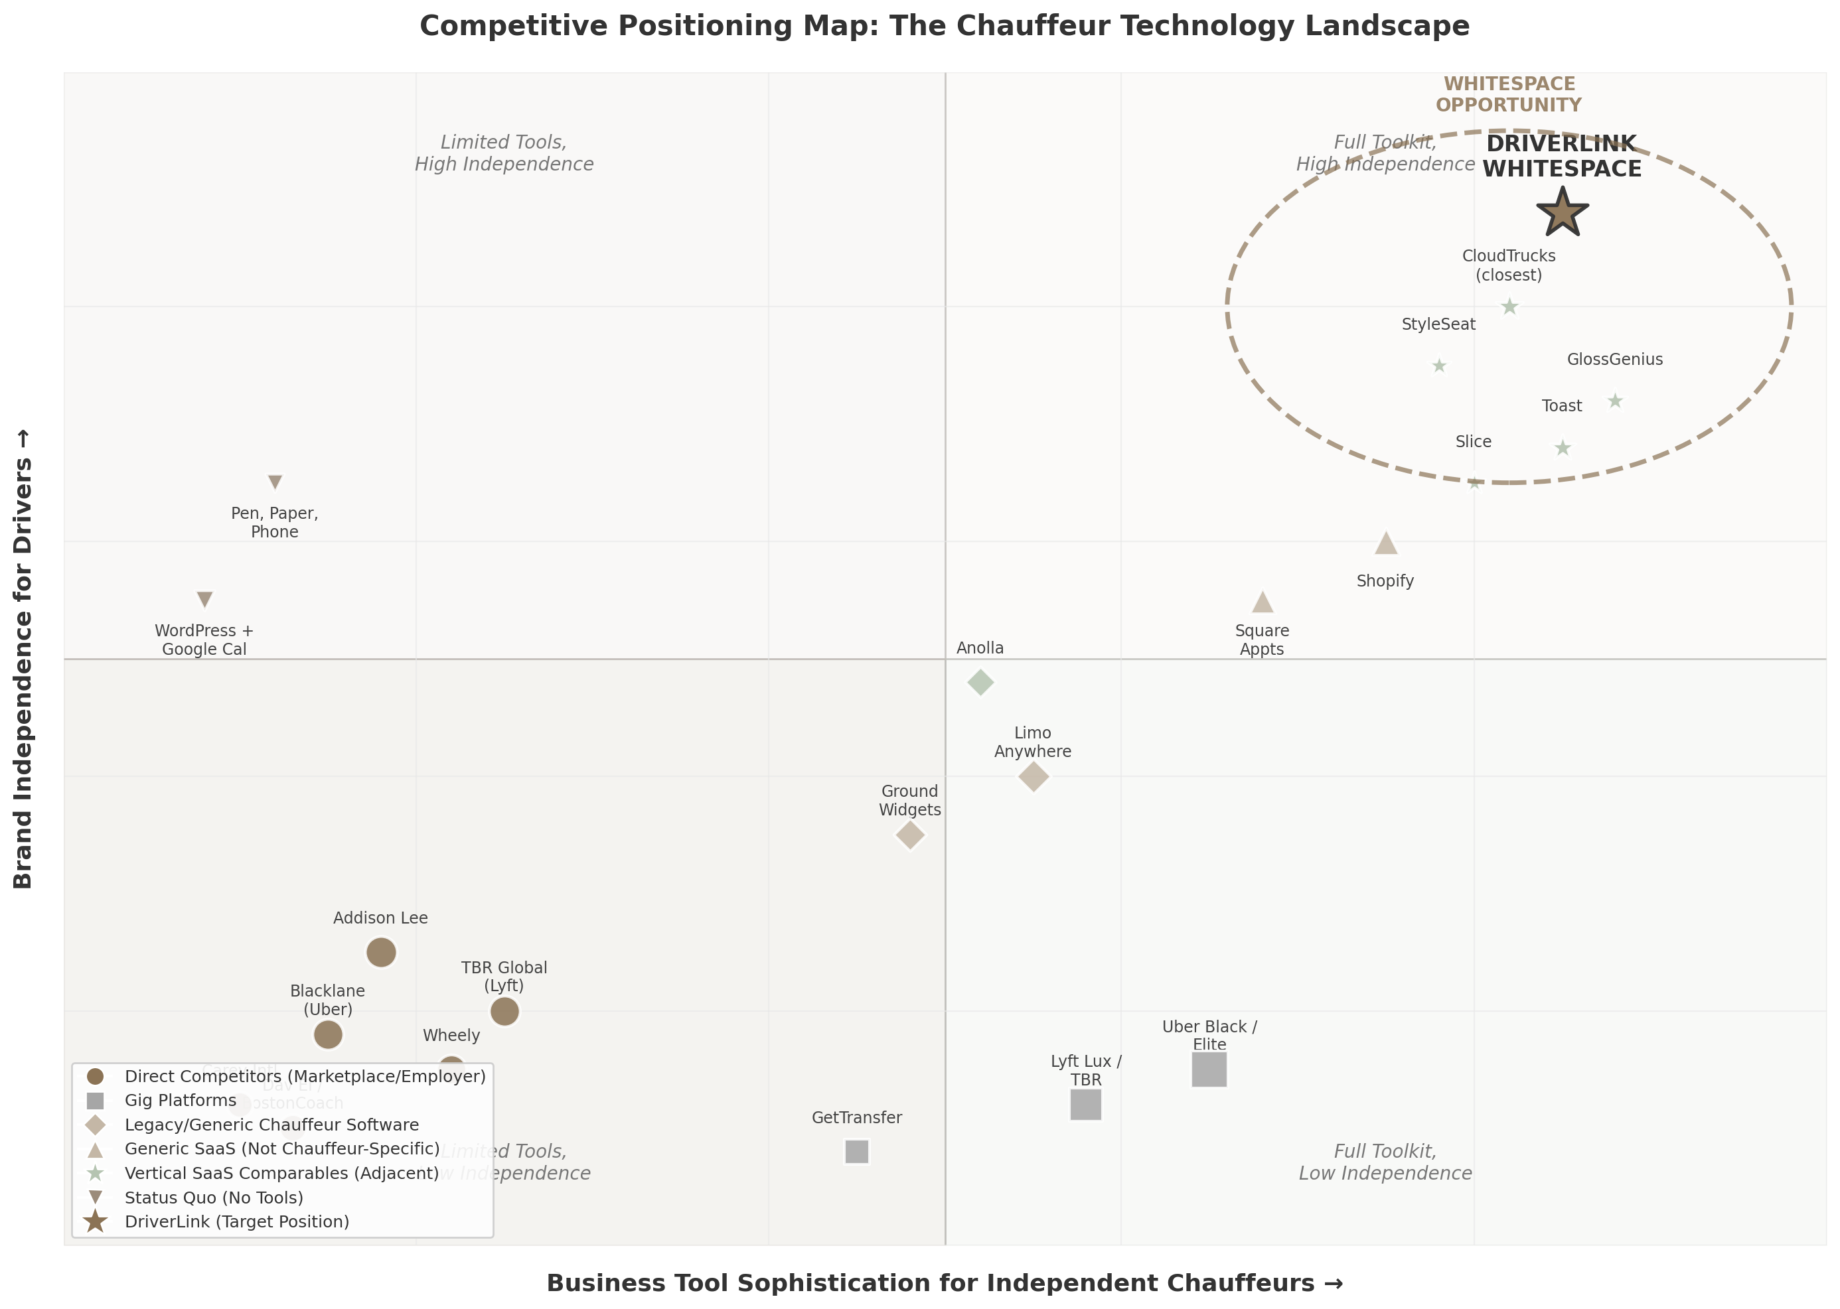
Figure 2.1: Competitive Positioning Map — The Chauffeur Technology Landscape
Figure 2.1. Competitive positioning map plotting competitors on two axes: Business Tool Sophistication (horizontal) and Brand Independence for Drivers (vertical). Direct competitors (Blacklane, Wheely, Addison Lee, TBR, Carey, Dav El) cluster in the lower-left as marketplace/employer models. Gig platforms (Uber Elite, Lyft Lux) sit in the lower-right with sophisticated tools but zero driver brand ownership. Legacy software (Limo Anywhere, GroundWidgets) occupies the center with generic operational tools. Generic SaaS (Shopify, Square Appointments) provides brand independence but no chauffeur-specific features. Vertical SaaS comparables (CloudTrucks, GlossGenius, Toast, StyleSeat) validate the upper-right quadrant. The star marks DriverLink’s target whitespace — the only platform combining full business infrastructure with complete driver brand ownership.

2.3 Competitive Whitespace & Differentiation
The whitespace emerges from a structural mismatch between what existing platforms offer and what independent chauffeurs actually need. Seven unaddressed pain points, validated across competitor analysis and comparable verticals, define DriverLink’s differentiation.

2.3.1 No “Business in a Box” Exists for Independent Chauffeurs
Independent chauffeurs today must stitch together five to ten separate tools: a basic website via WordPress or Wix, a generic booking plugin (Bookly or Amelia at $49-89 per year) ⁷⁴, manual scheduling through Google Calendar, separate payment processing via Stripe or Square, separate accounting via QuickBooks, manual client follow-up, and word-of-mouth marketing. No platform combines booking, scheduling, payments, client CRM, marketing, insurance, and financing specifically for chauffeurs. A solo chauffeur can start with Anolla’s free plan for basic booking functionality, but even that requires manual integration with external tools ⁶⁶. The CloudTrucks-like comprehensive solution — where a single platform handles every aspect of an independent operator’s business — simply does not exist for chauffeurs. CloudTrucks’s $850 million valuation and $141.6 million in funding demonstrate that investors recognize the value of this model in adjacent transportation verticals ⁷².

2.3.2 Seven Unaddressed Pain Points
Client acquisition and brand building. When independent chauffeurs join Blacklane, GroundLink, or GetTransfer, they become invisible suppliers. Passengers book “Blacklane,” not “John’s Chauffeur Service.” The platform owns the client relationship, and the chauffeur cannot contact the client directly for repeat business ⁵³. Blacklane and GroundLink explicitly state they provide “access to corporate clients” — but these are the platform’s clients, not the chauffeur’s. No existing platform enables independent chauffeurs to build their own brand while also accessing marketplace demand when needed.
Pricing and revenue optimization. Most independent chauffeurs set fixed rates manually and do not adjust for demand, seasonality, or competitor pricing. No accessible dynamic pricing tool exists for the segment. Corporate subscription contracts at $70 per hour versus event packages at $95 per hour require strategic pricing decisions that most independents cannot analyze ⁷⁵. StyleSeat’s smart pricing algorithm, which saved beauty professionals money by automatically adjusting rates during high-demand periods ⁷¹, demonstrates the value such a tool could deliver in chauffeur services.
No-show and cancellation protection. Independent chauffeurs bear the full cost of client no-shows. Without a platform enforcing cancellation policies, they often cannot collect fees. StyleSeat’s automated no-show enforcement saved beauty professionals nearly $2 million in 2020 alone ⁷¹. Chauffeurs face the identical challenge but lack equivalent tooling — a direct revenue leak that DriverLink can seal.
Insurance and compliance management. Independent chauffeurs must navigate commercial auto insurance ($5,000-$21,600 annually), licensing, and regulatory compliance independently ⁷³. CloudTrucks bundles insurance and compliance into its Virtual Carrier product, significantly increasing platform stickiness and revenue per user ⁷³. Toast Capital offers lending to restaurants. These financial service layers represent the highest-margin, most defensible revenue streams in vertical SaaS — and none exist yet for independent chauffeurs.
Deactivation risk on gig platforms. Chauffeurs working through Uber face algorithmic deactivation with “little or no human review” ⁶¹. A study found that 90% of deactivated drivers never recovered their jobs ⁶¹. New York City proposed “just cause” protections after research found most deactivated drivers were high-performers facing vague allegations ⁶¹. Seattle’s just cause law found 80% of appealed deactivations were overturned through external review — versus just 10% through Uber’s internal process ⁶¹. Independent chauffeurs need a platform that helps them build direct client relationships as a hedge against platform dependency.
Technology adoption gap. The disparity between large and small operators is widening. Operators generating less than $1 million annually report telematics installed on roughly half their fleet, while operators above $5 million report exceeding 90% adoption ⁷⁶. While larger fleets have achieved 56% dash cam adoption, smaller fleets lag at just 24% ⁷⁷. More than half of operators have not updated their chauffeur manuals in the past year, and only one-third conduct driver training monthly or more frequently ⁷⁶. This compliance gap creates a vicious cycle where penalties financially constrain smaller operators, further widening the technology divide.
Safety and professional development. Wheely’s three-day hospitality training — inspired by five-star hotel service standards — is a key competitive differentiator that enables premium pricing ¹⁵. EmpireCLS’s Smith System safety certification functions as a recruitment and marketing tool ⁷⁸. Independent chauffeurs lack access to equivalent training resources, certification tracking, and quality standards that would justify higher rates and attract corporate clients.

2.3.3 “SaaS Tool, Not Marketplace” Positioning Creates Regulatory Arbitrage
The single most consequential strategic decision for DriverLink is its legal positioning as a software provider rather than a transportation marketplace. This distinction creates a structural advantage that no incumbent can replicate without destroying its own business model.
California’s Transportation Charter Party (TCP) regulation requires W-2 employees for any TCP-listed vehicle — a constraint that does not apply to software tools that merely facilitate bookings between independent businesses and their clients ¹⁷. The EU Platform Work Directive, effective December 2026, creates a rebuttable presumption of employment for “platforms” across 27 member states ¹⁸. Uber, Lyft, and Blacklane face massive structural cost increases from this directive. A pure SaaS booking tool that does not control dispatch, set pricing, restrict working hours, or prevent multi-homing operates outside this employment nexus entirely.
Seven U.S. states have “marketplace contractor” laws codifying independent contractor status — but these apply to marketplaces, not SaaS tools ¹⁸. The Federal Trade Commission clarified in January 2025 that independent contractors are shielded from antitrust liability for collective bargaining ¹⁸. By positioning as “Squarespace for chauffeurs” rather than “Uber for independents,” DriverLink navigates a fundamentally different regulatory framework than any direct competitor.
This regulatory arbitrage is reinforced by the market structure itself. The chauffeur services industry has resisted full platformization for decades because its core value proposition — personalized service, local knowledge, and trust-based client relationships — inherently favors small, independent operators ¹. Regional specialists retain decisive advantages in VVIP transport, government delegations, and event-specific deployments that algorithmic platforms have not penetrated ¹. The top ten operators collectively hold only 22-25% market share despite decades of consolidation attempts ³, demonstrating that independent operators are not a temporary market feature but a permanent structural characteristic.
The convergence of these dynamics — seven unaddressed pain points, validated vertical SaaS precedents reaching $100 million ARR (GlossGenius) to $6.15 billion (Toast), a $141.6 million-funded comparable in CloudTrucks, and a regulatory environment that increasingly disadvantages marketplace models — defines the competitive whitespace. No existing player occupies the intersection of chauffeur-specific SaaS tools, brand independence, and embedded financial services. DriverLink’s target position is not merely unoccupied; it is structurally inaccessible to every current competitor, all of whom would need to abandon their core marketplace or employer model to compete.

3. Business Model & Unit Economics
The most consequential strategic decision DriverLink faces is not product feature prioritization or city selection—it is the sequencing of revenue layer activation. Vertical SaaS platforms that follow the proven playbook of “software first, fintech second, marketplace third” have demonstrated revenue expansion of 2x to 5x per customer compared to pure subscription models ⁹. Andreessen Horowitz research confirms that adding embedded fintech features to vertical SaaS increases revenue per customer by 2x to 5x, while the embedded finance market overall represents a $185 billion opportunity of which less than 20% has been addressed ¹⁰. The question for DriverLink is not whether to layer in payments, lending, and insurance, but how quickly the platform can execute each layer without compromising the standalone SaaS value proposition that drives initial adoption.

3.1 Revenue Architecture

3.1.1 Subscription Tiers: The SaaS Wedge
DriverLink’s subscription pricing is intentionally positioned at a premium to beauty-and-wellness comparables but below legacy transportation management systems, reflecting the higher earnings potential of professional chauffeurs relative to salon professionals and the superior workflow integration relative to incumbent dispatch software. The three-tier structure—Starter at $49 per month, Professional at $99 per month, and Business at $199 per month—maps directly to the proven architectures of GlossGenius ($24/$48/$148 per month), Toast ($0/$69 per month with processing spread trade-offs), and Shopify ($39/$105/$399 per month) ⁷⁹ ⁸⁰ ⁸¹.
Table 3.1 Subscription Tier Benchmarking Across Vertical SaaS Platforms
Platform | Tier 1 (Entry) | Tier 2 (Professional) | Tier 3 (Business) | Tier 4 (Enterprise) | Payment Processing
DriverLink (Proposed) | $49/mo ¹¹ | $99/mo | $199/mo | Custom | 2.6% flat
GlossGenius | $24/mo ⁷⁹ | $48/mo | $148/mo | $168/mo (medical) | 2.6% flat ⁷⁹
Toast | $0/mo (Starter) ⁸⁰ | $69/mo (POS) | Custom (multi-loc) | — | 2.49% + 15¢ ⁸⁰
Shopify | $39/mo ⁸¹ | $105/mo | $399/mo | $2,300+/mo (Plus) | 2.4-2.9% + 30¢ ⁸¹
Limo Anywhere | $89/mo ¹¹ | $109-$189/mo | $239+/mo | $1,210-$5,999/mo | +$0.20-0.25/trip ¹¹
StyleSeat | $35/mo ⁸² | — | — | — | 1.9-2.6% + 30¢ ⁸²
Fresha | Free ⁸³ | $19.95/mo | $14.95/staff | — | ~2.29% + fixed ⁸³
The tier differentiation serves two purposes beyond straightforward revenue segmentation. First, it creates a clear upgrade path that drives net revenue retention: Toast locations that remain on the platform for five years reach an average annual recurring revenue of $16,000, representing a 6x increase from initial spend ⁸⁴. Second, the entry tier at $49 per month—roughly one hour of billable chauffeur time—minimizes friction for drivers transitioning from manual scheduling systems, while the Business tier at $199 per month captures multi-driver fleets with dispatch coordination and API access needs that Limo Anywhere addresses at 6x to 30x the price point ¹¹. The critical design principle is that every tier must deliver positive return on investment within the first month, measured by time saved on scheduling and invoicing against the subscription fee.

3.1.2 Payment Processing: The Primary Revenue Engine
At maturity, payment processing will represent DriverLink’s largest revenue stream—just as it does for Toast (82% of revenue on $51.4 billion in gross payment volume) ⁷and Shopify (74% of revenue, processing $47.5 billion through Shopify Payments) ⁸. The platform will charge a flat 2.6% on all transactions, matching GlossGenius’s transparent pricing model and undercutting the 2.9% plus 30 cents that Stripe charges for online card-not-present transactions ⁸⁵.
The economics of this layer are compelling. A driver processing $100,000 annually in booking payments at 2.6% generates $2,600 in gross processing fees. DriverLink’s cost of funds to its payment processor (Stripe Connect or equivalent) will range from 1.6% to 2.1%, yielding a net spread of 0.5% to 1.0%—or $500 to $1,000 per driver per year in near-pure margin ⁹. This processing margin alone, at scale, approximately doubles the revenue contribution from subscriptions. BCG and Adyen jointly estimate the total embedded finance revenue opportunity at $185 billion, a 25% increase from their 2022 estimate, with less than 20% of that market currently captured ¹⁰.
The sequencing of payment activation follows the vertical SaaS playbook precisely: launch with Stripe Connect integration in Year 1, transition to a managed payment facilitator (PayFac) model once annual processing volume exceeds $50 million, and ultimately explore proprietary payment infrastructure at $500 million-plus in gross payment volume. Each transition captures an additional 20 to 50 basis points in margin. ServiceTitan, which processes tens of billions across 9,500 contractor customers, estimates it captures only 50% of its available take rate—meaning the fintech revenue line has room to double without adding a single new customer ⁸⁴.

3.1.3 Marketplace Commission: Demand-Generated Bookings
The marketplace commission layer activates only after the platform achieves sufficient driver density to generate meaningful demand-side liquidity. When a rider discovers and books a driver through DriverLink’s marketplace (rather than the driver’s own storefront or direct referral), the platform will collect 15% to 20% of the booking value. This is deliberately set below StyleSeat’s 30% commission on first-time client bookings (capped at $50) ⁸²and Fresha’s 20% commission on new marketplace clients ⁸³, reflecting the higher average order values in chauffeur services ($150-$500 per trip versus $60-$150 for salon services) and the lower marginal cost of demand generation in relationship-based premium transport.
The commission structure is designed to avoid the backlash that high marketplace fees generate. StyleSeat’s 30% rate has produced significant professional resistance, with service providers actively attempting to move discovered clients off-platform to avoid repeat commissions ⁸². DriverLink’s 15% to 20% rate, applied only to bookings that would not have occurred without platform-mediated discovery, frames the commission as a performance marketing fee rather than a recurring tax on the driver-client relationship. A driver generating just $250 per month in marketplace-origin bookings contributes $37.50 to $50 in monthly commission revenue—incremental to subscription and processing revenue with 85% to 90% gross margin.

3.1.4 Embedded Fintech Expansion: Lending, Insurance, and Cards
The final revenue layer—insurance brokerage, working capital lending, and spend cards—represents the highest-margin, most defensible component of the stack. Insurance commissions for commercial auto and general liability policies range from 15% to 30% of premium ⁸⁶. Given that commercial livery insurance costs independent drivers $5,000 to $21,600 annually, a single policy referral generates $750 to $6,480 in commission revenue ⁸⁶. Even at conservative 30% adoption rates and 20% commission structures, insurance referrals add $300 to $1,300 in annual revenue per driver at 70% to 80% gross margin.
Working capital lending follows the Toast Capital model: the platform uses transaction history to underwrite cash advances of $5,000 to $50,000, with automatic repayment deducted from future booking revenue. Toast Capital has disbursed over $5 billion in cumulative merchant funding, generating more than $45 million in annual revenue ⁹. For DriverLink, vehicle maintenance, insurance premium seasonality, and fleet expansion create natural demand moments for capital access that the platform is uniquely positioned to address through its system-of-record position.
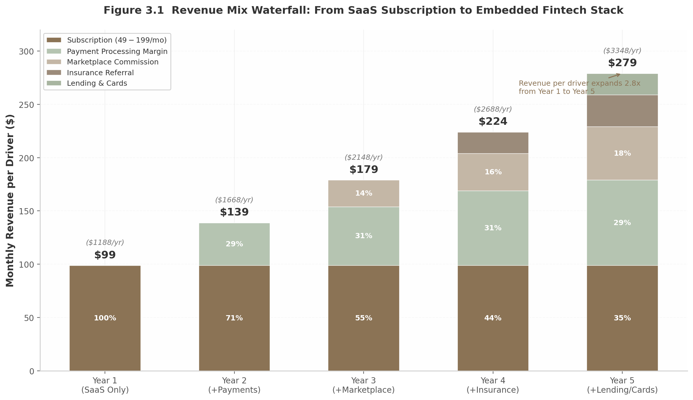
Figure 3.1: Revenue Mix Waterfall
Figure 3.1 illustrates the phased revenue expansion per driver from Year 1 (subscription-only, $99 per month) through Year 5 (full embedded fintech stack, $279 per month). Subscription revenue’s share of total declines from 100% to 35%, while payment processing grows to become the largest single contributor at 29% of the stack. The 2.8x revenue expansion per driver—from $1,188 to $3,348 annually—validates the vertical SaaS land-and-expand playbook in the chauffeur vertical.

3.2 Unit Economics

3.2.1 Driver Acquisition Cost and Lifetime Value
DriverLink targets a blended customer acquisition cost of $300 to $600 per driver, achievable through a product-led growth motion supplemented by driver-to-driver referrals with $100 to $200 bounty incentives and organic content marketing targeting disillusioned Uber Black and Lyft Lux drivers. This CAC range sits comfortably within the $200 to $700 benchmark for SMB vertical SaaS acquired through self-serve and low-touch sales channels ⁸⁷. For context, the average B2B SaaS CAC across all segments is approximately $702, with fintech SMB CAC reaching $1,450 and e-commerce SMB CAC as low as $274 ⁸⁸.
The lifetime value calculation rests on three variables: average revenue per driver per month, blended gross margin, and monthly churn rate. Under the base case scenario—a driver on the Professional tier ($99 per month) generating $50 per month in payment processing margin and $20 per month in marketplace commission, at 65% blended gross margin and 3.5% monthly churn—the resulting LTV is approximately $3,179. Against a $500 CAC, this produces an LTV:CAC ratio of 6.4:1, well above the 3:1 threshold that growth-stage investors require and competitive with best-in-class vertical SaaS performance ⁸⁹.
Table 3.2 Unit Economics Scenarios and Vertical SaaS Benchmarks
Metric | Conservative | Base Case | Optimistic | Industry Benchmark | Source
Monthly ARPU (subscription) | $75 | $99 | $125 | $24-$399 (vertical SaaS range) | ⁷⁹ ⁸¹
Monthly processing margin | $30 | $50 | $80 | $40-$100 (Toast equivalent) | ⁷
Monthly marketplace revenue | $10 | $20 | $40 | $15-$50 (StyleSeat/Fresha) | ⁸² ⁸³
Total monthly revenue/driver | $115 | $169 | $245 | — | Calculated
Blended gross margin | 55% | 65% | 70% | 60-70% (vertical SaaS + processing) | ⁹⁰
Monthly gross profit/driver | $63 | $110 | $172 | — | Calculated
Monthly churn | 5.0% | 3.5% | 2.0% | 3-7% (SMB SaaS) | ⁹¹
Average lifetime (months) | 20 | 29 | 50 | 24-48 months | ⁸⁹
Lifetime value (LTV) | $1,260 | $3,179 | $8,575 | $15K-$40K (SMB SaaS) | ⁸⁹
Blended CAC | $600 | $500 | $400 | $200-$700 (SMB PLG) | ⁸⁷
LTV:CAC ratio | 2.1:1 | 6.4:1 | 21.4:1 | 3:1+ target | ⁸⁹
CAC payback period | 9.5 months | 4.5 months | 2.3 months | <12 months (top quartile) | ⁹²
The 4.5-month payback period in the base case falls well within the top-quartile SaaS benchmark of under 12 months ⁹²and approaches the sub-6-month performance that product-led growth companies achieve at scale ⁹³. The conservative scenario’s 9.5-month payback remains acceptable for seed-stage operations, while the optimistic scenario’s 2.3 months—driven by high embedded fintech adoption and low churn—would support aggressive self-funded growth without excessive equity dilution.

3.2.2 Churn Dynamics and Net Revenue Retention
Monthly churn for DriverLink is projected at 3% to 4% in the early stage, declining to 2% to 2.5% as embedded financial services deepen the platform’s integration into the driver’s business operations. This trajectory outperforms typical SMB SaaS churn of 3% to 7% per month ⁹¹for two structural reasons. First, professional chauffeurs represent a fundamentally different cohort from general gig economy workers: they have made career investments in commercial vehicles ($40,000 to $100,000), licensing, and insurance, creating significantly higher switching costs than a part-time rideshare driver. Second, BCG and Adyen research demonstrates that embedded payment strategies retain customers at 2.5x the rate of traditional service providers ⁸⁴—once a driver’s payment processing, CRM, customer booking history, and capital advances all flow through a single platform, migration becomes operationally prohibitive.
Net revenue retention (NRR) is targeted at 105% to 115%, reflecting revenue expansion from tier upgrades, add-on adoption, and increased payment processing volume as drivers grow their businesses. This range aligns with the median private B2B SaaS NRR of 101% to 102% ⁹⁴and the public SaaS median of 108% to 110%. Companies with NRR at or above 100% grow at 48% year-over-year—twice as fast as those below 100% ⁹⁵. The NRR floor of 105% assumes that tier upgrades and processing volume growth from existing drivers offset any subscription downgrades or churn, while the ceiling of 115% reflects full adoption of embedded insurance and lending products by the existing driver base.

3.2.3 Annual Recurring Revenue per Driver
At steady state, ARR per driver is projected to range from $2,208 in the base case (Professional tier with moderate processing and marketplace activity) to $4,848 in the upside case (Business tier with full embedded fintech adoption). The conservative case—Starter tier drivers with minimal transaction activity—yields approximately $1,380 in ARR. This range is validated by comparable vertical SaaS platforms: Toast reports ARPU of approximately $39,000 per location per year (including payments) and $6,000 in pure SaaS ARPU ⁸⁴, while GlossGenius at $100 million ARR with an estimated user base in the tens of thousands implies ARPU in the $1,000 to $3,000 range.
The ARR expansion curve is non-linear. Year 1 drivers contribute subscription revenue only. By Year 3, drivers who upgraded tiers and adopted marketplace features generate 1.7x their initial ARR. By Year 5, with insurance and lending layered in, the same cohort produces 2.35x its original revenue—a trajectory directly modeled on Toast’s documented 6x ARR expansion over five years ⁸⁴. This expansion dynamic means that DriverLink’s aggregate ARR growth will increasingly be driven by existing driver monetization rather than new driver acquisition, reducing the capital intensity of growth as the platform matures.

3.3 Path to Profitability

3.3.1 Gross Margins and Payback Dynamics
DriverLink’s blended gross margin is projected at 55% to 70%, reflecting the weighted composition of revenue streams. Pure subscription software carries 80% to 85% gross margins (hosting, payment processor API costs, and tier-1 support), while payment processing nets 40% to 50% after interchange fees and processor costs. Marketplace commissions and insurance referrals operate at 85% to 90% and 70% to 80% respectively, representing near-pure margin with minimal incremental delivery cost ⁹⁰.
Table 3.3 Revenue Projections and Profitability Milestones by Scale
Metric | 1,000 Drivers | 5,000 Drivers | 10,000 Drivers | 25,000 Drivers
Revenue range (ARR) | $2.2M-$4.9M | $11M-$24M | $22M-$49M | $55M-$121M
Subscription revenue | $0.6M-$1.2M | $3.0M-$6.0M | $6.0M-$12.0M | $15.0M-$30.0M
Payment processing margin | $0.5M-$1.0M | $2.4M-$4.8M | $4.8M-$9.6M | $12.0M-$24.0M
Marketplace commission | $0.3M-$0.6M | $1.5M-$3.0M | $3.0M-$6.0M | $7.5M-$15.0M
Embedded fintech | $0.2M-$0.4M | $1.2M-$2.5M | $2.4M-$5.0M | $6.0M-$12.5M
Blended gross margin | 55-60% | 58-65% | 60-65% | 62-68%
Gross profit | $1.2M-$2.9M | $6.4M-$15.6M | $13.2M-$31.9M | $34.1M-$82.3M
Est. operating expenses | $1.5M-$2.5M | $4.0M-$8.0M | $8.0M-$15.0M | $15.0M-$30.0M\left|\right|**Operatingincome**|**$(0.3)M-$0.4M**
Operating margin | (10%)-8% | 22-32% | 24-34% | 35-43%
Months to milestone | 0 (base) | 24-30 | 36-42 | 54-66
The path to profitability is delineated by two inflection points. The first occurs at approximately 2,500 to 3,500 active drivers, where gross profit from the installed base covers fixed operating expenses (engineering, support, marketing, G&A). At this threshold—projected at 24 to 30 months from launch in the base case—the business transitions from cash-burning to self-sustaining. The second inflection point occurs at 10,000 drivers, where operating margins compress toward 25% to 30% and the Rule of 40 (growth rate plus profit margin) becomes achievable. Only 11% to 30% of SaaS companies achieve Rule of 40 compliance, but those that do command median revenue multiples of 9.4x versus 3.5x for companies scoring below 20% ⁹⁵.
The margin profile improves with scale for three reasons. First, payment processing spread widens as the platform transitions from Stripe Connect (where Stripe captures the majority of interchange) to managed PayFac (where DriverLink captures an additional 20 to 50 basis points). Second, insurance and lending referral economics improve with portfolio size as partner financial institutions offer volume-based commission accelerators. Third, customer support cost per driver declines as self-service documentation, community forums, and AI-assisted support handle an increasing share of inquiries.

3.3.2 Investor Benchmarks: ARR Growth, Rule of 40, and Valuation
Growth-stage investors evaluate vertical SaaS on a consistent framework of milestones. At Series A, the expectation starts at $1 million to $3 million in ARR with 100% year-over-year growth or higher ⁹⁶. KeyBanc Capital Markets’ 2024 SaaS Survey found median private SaaS growth at 19% to 21%, with the top quartile achieving 27% to 32% ⁹⁵. DriverLink’s target of 100%+ year-over-year growth through Year 3, supported by both new driver acquisition and ARPU expansion, positions the company in the top decile of SaaS growth performance.
The “T2D3” framework—triple, triple, double, double, double in consecutive years—remains the aspirational benchmark for venture-backed SaaS ⁹⁶. For DriverLink, this would mean growing from $500K ARR at Month 12 to $1.5M (3x) at Month 24, to $4.5M (3x) at Month 36, to $9M (2x) at Month 48, to $18M (2x) at Month 60, to $36M (2x) at Month 72. Achieving this trajectory would require maintaining 8% to 12% month-over-month growth in driver count through Year 2, then transitioning to ARPU-led growth as driver acquisition naturally decelerates.
Valuation multiples for vertical SaaS currently stand at approximately 5.5x ARR for median performers, with Rule of 40 achievers commanding 9x to 10x and top-quartile NRR companies (120%+) earning premiums beyond that ⁸⁹. At 10,000 drivers generating $35 million in ARR at the midpoint of projections, a 6x to 8x multiple implies an enterprise value of $210 million to $280 million—a 10x to 15x return on a typical $15 million to $20 million Series A+B capital raise. The CloudTrucks precedent—$141.6 million raised at an $850 million valuation for a trucking vertical SaaS platform—validates that transportation vertical SaaS can command premium multiples when unit economics and growth rates meet investor thresholds.

3.3.3 Scale Projections: From 1,000 to 25,000 Drivers
The revenue model scales proportionally with driver adoption but non-linearly in profitability. At 1,000 active drivers—achievable within 18 months in the base case with launches in three Sun Belt cities—DriverLink generates $2.2 million to $4.9 million in ARR. At this scale, the company is approximately breakeven to slightly profitable, with operating expenses of $1.5 million to $2.5 million covering engineering (6-8 headcount), customer success (2-3 headcount), marketing, and G&A.
At 10,000 drivers—projected at 36 to 42 months—ARR reaches $22 million to $49 million with operating margins of 24% to 34%. This represents a genuine scaled business with $5.2 million to $16.9 million in operating income, sufficient to fund organic expansion into new markets and embedded fintech product development without additional equity financing. The 10,000-driver threshold captures approximately 25% to 40% of the estimated 25,000 to 40,000 independent chauffeurs and small fleet operators in the United States—a market penetration rate that is aggressive but achievable given the absence of a dominant incumbent vertical SaaS platform.
At 25,000 drivers—representing majority share of the core TAM—ARR reaches $55 million to $121 million with operating margins of 35% to 43%. At this scale, DriverLink approaches the public-company revenue threshold and becomes an attractive acquisition target for platforms seeking vertical expansion (Shopify, Toast, Square) or a candidate for an initial public offering. The $19 million to $52 million in operating income at this scale supports a $300 million to $800 million enterprise valuation at prevailing SaaS multiples.
The projections embed several conservative assumptions. First, they assume average driver ARPU at the base case level ($2,208 per year) rather than the upside case ($4,848 per year), meaning that successful embedded fintech adoption would drive results toward the upper bound of each range. Second, they assume no revenue from B2B2C corporate travel integrations—which represent a distinct, unmodeled revenue stream from enterprise licensing to travel management platforms. Third, they assume only US market penetration; the EU Platform Work Directive’s effective date of December 2026 creates a parallel international expansion opportunity that could double the addressable driver base.
The core economic insight is that DriverLink does not need to achieve Uber-scale network effects to generate venture-scale returns. A 10,000-driver platform with strong unit economics—6.4:1 LTV:CAC, 4.5-month payback, 110% NRR, and 30% operating margins at scale—produces financial outcomes that exceed most vertical SaaS benchmarks. The “SaaS-first, fintech-second, marketplace-third” sequencing ensures that each revenue layer is activated only when the platform has sufficient density to support it, preventing the premature capital consumption that has undermined so many marketplace-first transportation startups.

4. Target Customer Segments & Vertical Opportunities

4.1 Primary Segments
The global chauffeur services market, valued at $52.4 billion in 2025, is not a monolith. Revenue and demand cluster sharply around three principal segments — corporate travel, airport transfers, and leisure tourism — each with distinct pricing dynamics, booking patterns, and technology requirements. Understanding the relative weight and interplay of these segments is essential for any platform seeking to serve independent drivers, because the highest-revenue verticals are not always the highest-growth ones, and the barriers that protect incumbents in one segment may be absent in another.
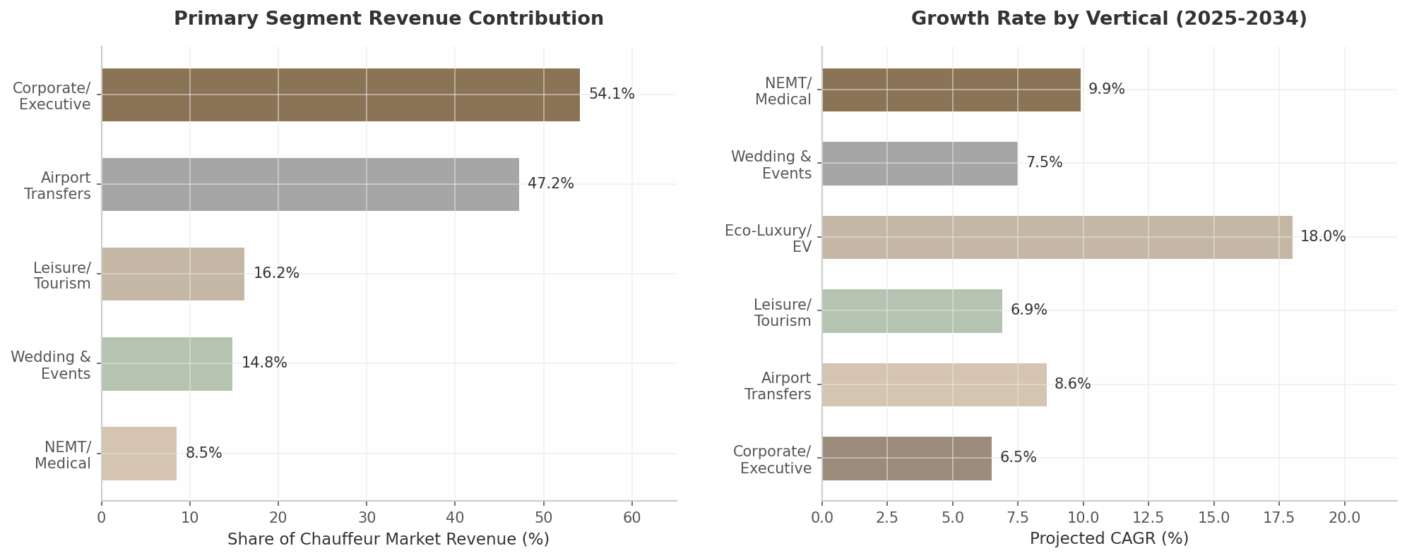
Segment Comparison — Revenue Contribution and Growth Rates
Figure 4.1: Revenue contribution by primary segment (left) and projected CAGR by vertical (right). Corporate travel dominates current revenue but eco-luxury/EV leads in growth trajectory. Sources: Dimension Market Research, Dataintelo, The Insight Partners, GBTA.

4.1.1 Corporate/Executive Travel: 49–58% of Market Revenue, $75–$200/hour
Corporate and executive travel is the revenue backbone of the professional chauffeur industry. By one measure, corporate clients commanded 54.1% of global chauffeur car market revenue in 2025–2026.³⁷An alternative industry analysis places the business segment share at 58.4%, translating to roughly $30.6 billion in annual global revenue.³⁷Either estimate confirms the same strategic reality: the corporate account is the single most valuable customer relationship an independent chauffeur can hold.
The spending power of this segment is grounded in genuine business need rather than discretionary luxury. Global business travel spending reached a record $1.47 trillion in 2024 and is projected to hit $1.57 trillion in 2025, with ground transportation representing roughly 11.5% of total travel expenditure.²⁰The average business trip now costs $1,128 per person, up from $834 in 2024, and ground transport consistently ranks among the top three expense categories.⁹⁷Typical corporate ground transportation budgets range from $8 million to $45 million depending on company size, with travel accounting for approximately 35% of total T&E spend.²²What makes corporate clients particularly attractive to independent operators is not just volume but predictability. Corporate accounts generate recurring revenue through annual contracts and travel management company (TMC) integrations.³⁷A single corporate account with net-30 billing terms can produce more stable cash flow than dozens of one-off retail bookings. Companies typically require $5,000 or more in monthly volume to qualify for preferred vendor status, which unlocks consolidated monthly invoicing that reduces accounts payable processing time by an estimated 4.2 hours per month.⁹⁸The purchasing criteria of corporate travel managers also favor professional chauffeurs over rideshare alternatives. In a 2024 GBTA/NLA survey of 121 U.S. and Canada-based travel managers, 73% identified traveler safety as their single greatest priority for managed ground transportation programs, with an additional 19% ranking it second — making safety the overwhelming priority over cost.²³This safety-first posture translates into policy: 93% of surveyed companies permit chauffeured transportation in high-risk or developing countries, 90% for employees with accessibility needs, 82% for client or customer transport, and 62% for recruiting.²³Duty-of-care obligations are driving a measurable shift from rideshare to professional chauffeur services among Fortune 500 clients.⁹⁹Pricing in the corporate segment reflects these service expectations. Average hourly rates range from $75–$150 for luxury sedan service, $90–$200 for SUV chauffeur service, and $150 or more per hour for executive or VIP chauffeur service.⁹⁷Post-COVID recovery trends support continued investment: 81% of business travelers say they traveled the same or more in 2024 versus 2019, and 86% believe business travel is worthwhile in achieving business objectives.²¹Notably, 8% of travel managers reported that premium-class policies became more liberal in 2025 — double the prior year and the highest share since before the pandemic.²²#### 4.1.2 Airport Transfers: 47% of Service Type, $8 Billion U.S. Segment
Airport transfers represent the largest service type by volume, capturing 47.2% of global chauffeur car market revenue by service category.³⁷The U.S. airport transfer segment alone was valued at $8.0 billion in 2024, driven by the five busiest gateways — Atlanta (ATL), Dallas-Fort Worth (DFW), Chicago O’Hare (ORD), Los Angeles (LAX), and New York JFK — which lead domestic volume.¹⁰⁰Looking ahead, the global airport transportation service market is projected to expand from $29.9 billion in 2025 to $62.8 billion by 2034 at an 8.6% CAGR, while the pre-book airport transfer segment is growing at an even faster 16.4% historical CAGR.¹⁰¹ ¹⁰²The airport vertical is distinguished by its operational predictability and relatively low seasonality compared to events or leisure tourism. Flight schedules generate demand waves that are knowable days or weeks in advance, and corporate airport transfers — typically priced at $130 flat fare at major metro airports — form a recurring revenue base.¹⁰⁰The technical requirements for competing in this segment, however, are non-trivial. Real-time flight tracking through FAA, SITA, and airline APIs is now table stakes for premium operators.¹⁰³Professional services monitor flights from departure through landing, including gate changes and diversions, and automatically adjust chauffeur arrival to actual landing time.¹⁰⁴Blacklane’s proprietary dispatch system uses automated flight tracking and buffer-time management to reduce cancellations and improve utilization, a technology capability that independent operators must replicate to compete.¹⁰⁵Premium meet-and-greet services push per-trip revenue higher. Curbside or gate pickup with porter assistance, 30–60 minutes of complimentary wait time, and professional signage are standard at the luxury tier.¹⁰⁶VIP concierge services range from $475 at Seattle-Tacoma to $1,620 for the LAX Salon experience and $5,235 for the Heathrow Private Suite.¹⁰⁶These premium tiers demonstrate that even within the commoditized airport transfer category, significant pricing power exists for operators who bundle hospitality services.

4.1.3 Leisure/Tourism: Fastest-Growing at 6.9% CAGR
The leisure and tourism segment accounts for 16.2% of global limousine service revenue and is the fastest-growing application segment at 6.9% CAGR, fueled by rising disposable incomes and a post-pandemic preference for experiential travel.¹⁰⁷The broader luxury travel market provides context for this growth: luxury travelers account for approximately 36% of global travel spending, with market estimates for 2024 ranging from $1.48 trillion to $2.51 trillion depending on definitional scope.¹⁰⁸Within the chauffeur segment, city tours and hourly charter demand represent the highest-margin service type because the meter runs on time rather than distance. Blacklane’s revenue mix illustrates this dynamic: city-to-city long-distance rides contribute approximately 30% of revenue, hourly bookings 25%, and airport transfers 45%.¹⁰⁵Hourly and as-directed services carry the highest per-trip revenue potential precisely because they are uncapped by distance or duration.¹⁰⁵Hotel concierge partnerships serve as a key distribution channel for leisure bookings. Over 500 luxury hotels in the United States integrated premium limousine services with digital booking platforms in 2025, improving guest transfer efficiency by an estimated 18%.¹⁰⁹These partnerships typically include airport pickups, hotel-to-event transfers, private city tours, and hourly as-directed service — creating bundled revenue opportunities that span multiple service types in a single guest stay.
Table 4.1: Primary Customer Segment Comparison Matrix
Dimension | Corporate/Executive | Airport Transfers | Leisure/Tourism
Revenue Share | 54.1% of chauffeur market ³⁷ | 47.2% of service type ³⁷ | 16.2% of service revenue ¹⁰⁷
Pricing Benchmark | $75–$200/hour ⁹⁷ | $75–$250/trip ¹⁰⁰ | $100–$500/hour ¹⁰⁵
Growth Rate | 6.0–6.5% CAGR ²⁰ | 8.6% CAGR ¹⁰² | 6.9% CAGR ¹⁰⁷
Key Purchasing Factor | Safety (73% of travel managers) ²³ | Flight tracking reliability ¹⁰⁴ | Experience quality ¹⁰⁸
Booking Channel | TMCs, corporate portals ¹¹⁰ | Direct, travel agents ¹⁰¹ | Hotel concierges, OTAs ¹⁰⁹
Seasonality | Low | Low | Moderate
Entry Barrier | High (TMC relationships) | Medium (flight tracking tech) | Medium (concierge networks)
This comparison reveals a strategic tension worth noting. Corporate travel offers the highest revenue share and lowest seasonality but requires navigation of TMC gatekeeper relationships and corporate credentialing programs. Airport transfers provide the most predictable demand but demand significant technology investment in flight tracking and dispatch automation. Leisure tourism delivers the strongest growth trajectory and highest per-hour margins but suffers from moderate seasonality and dependence on hospitality industry relationships. A platform serving independent drivers must account for these trade-offs when prioritizing which segment to address first — and the evidence strongly favors corporate as the initial beachhead, with airport and leisure as follow-on expansions.

4.2 High-Growth Verticals
Beyond the three primary revenue segments, several specialized verticals exhibit characteristics that make them disproportionately attractive for independent operators: structural demand growth, incumbent weakness, regulatory tailwinds, or some combination of all three. NEMT, wedding and events, and eco-luxury/EV services each present distinct risk-reward profiles that warrant dedicated analysis.
Table 4.2: High-Growth Vertical Opportunity Matrix
Dimension | NEMT | Wedding & Events | Eco-Luxury/EV
U.S. Market Size | $4.4–6.6B ¹⁶ | $750–$1,075 avg. per event ¹¹¹ | 18% fleet penetration (2025) ³
Projected CAGR | 7–10% (9.9% through 2034) ¹¹² | 7.5% ¹⁰⁷ | 18%+ (fleet share to 42% by 2030) ³
Key Demand Driver | 61.2M Americans aged 65+ ¹¹³; 3.6M missed appointments ¹⁶ | $300B global wedding market ¹⁰⁷; 28% YoY weekend event growth ¹⁰⁹ | Corporate ESG mandates; ULEZ/congestion pricing ¹¹⁴
Incumbent Weakness | ModivCare bankruptcy (Aug 2025); 64% driver turnover ¹¹⁵ ¹⁶ | Fragmented local operators; no national platform ¹⁰⁷ | Blacklane acquired by Uber (Mar 2026) ¹⁰⁵
Entry Barrier | High (broker credentialing, ADA vehicles, PASS cert.) | Low-Medium (insurance, vehicle, venue relationships) | Medium (EV capital cost $40K–$90K)
Margin Potential | 12–18% (Medicaid); 40–50% (private pay) | 30–50% premium over standard rates | 10–20% green premium; 50–70% lower fuel costs
Revenue Stability | High (recurring dialysis: 156 trips/patient/year) | Seasonal (70%+ in May–October) | High (corporate accounts mandate EV options)

4.2.1 NEMT: $4.4–$6.6 Billion U.S. Market, 7–10% CAGR, ModivCare Bankruptcy Creates Opportunity
Non-Emergency Medical Transportation (NEMT) represents the most structurally compelling vertical for independent operators willing to navigate its regulatory complexity. The U.S. NEMT market is estimated at $4.4–$6.6 billion, accounting for 41–45% of global revenue in a market valued between $10.76 billion and $16.71 billion.¹⁶Growth is projected at 9.9% CAGR through 2034, with the global market expected to reach $34.5 billion.¹¹²This growth is not speculative — it is anchored in demographic inevitability. In 2024, 61.2 million Americans were aged 65 or older (18.0% of the population), a figure projected to exceed 80 million by 2040.¹¹³The average American outlives their ability to drive safely by 7–10 years, and 7.7 million Americans aged 65+ currently have travel-limiting disabilities.¹¹⁶The demand signal is stark: 3.6 million Americans miss medical appointments annually due to lack of transportation, costing the healthcare system $150 billion in missed appointments, delayed treatments, and preventable emergency room visits.¹⁶Dialysis patients alone generate 156 predictable trips per year, creating a recurring revenue stream that is unusual in transportation.¹⁶Medicaid is the primary payer, accounting for approximately 52% of all NEMT payments, with ambulatory trip reimbursement averaging $25–$45 nationally and wheelchair trips $45–$70.¹¹⁷The most significant growth vector, however, is Medicare Advantage: NEMT coverage in standard MA plans expanded from approximately 15% in 2020 to 36% in 2025, with reimbursement rates 20–50% above Medicaid.¹⁶The ModivCare bankruptcy in August 2025 — the largest NEMT broker in the United States filing Chapter 11 and emerging in December 2025 with $1.4 billion in debt reduced to $300 million — has created a supply vacuum that independent operators are well-positioned to fill.¹¹⁵ModivCare coordinated approximately 36.8 million transportation trips annually across 48 states, yet the company generated only $161.1 million in adjusted EBITDA on $2.79 billion in service revenue (a 5.8% margin), ending 2024 with a $201.3 million net loss.¹¹⁵The industry’s structural pressures — driver shortages exceeding 64% annual turnover, stagnant Medicaid reimbursement rates, and rising labor costs — have made the large broker model economically precarious.¹⁶Independent operators who invest in the necessary certifications — PASS (Passenger Assistance, Safety and Sensitivity), CPR/First Aid, ADA compliance, and HIPAA training — can access broker-managed demand (brokers control roughly 70% of Medicaid NEMT trips) while maintaining lower overhead than the legacy broker-dependent networks.¹¹⁸ ¹¹⁹Payment terms vary significantly: Veyo pays weekly via EFT, ModivCare in 15–30 days, MTM in 30–45 days, and Access2Care in 45–60 days.¹²⁰Technology-enabled providers experience meaningful operational advantages: NEMT providers using broker-integrated software report 40% faster claim processing, 65% fewer billing errors, and 30% higher contract retention rates.¹²¹#### 4.2.2 Wedding & Events: $750–$1,075 Average, 20–40% Seasonal Premium
The wedding and events vertical offers the highest margins of any segment for appropriately positioned operators. Wedding services constitute approximately 14.8% of total limousine service revenue, with the global wedding market estimated at $300 billion in 2025 and U.S. weddings averaging $35,000 in expenditure.¹⁰⁷According to The Knot’s 2024 Real Weddings Study of nearly 17,000 couples, the average wedding transportation cost is $750–$1,075 nationwide, with significant regional variation: $1,200–$1,400 in the Northeast, $1,100–$1,300 on the West Coast, $800–$1,000 in the Midwest, and $750–$950 in the South.¹¹¹The economics of wedding service are substantially more favorable than standard hourly work. Peak wedding season (May through October) commands a 20–40% pricing premium, with September and October as the most popular months.¹²²Off-season months (January through March) offer 15–25% lower pricing, creating an opportunity for operators to fill capacity during slow periods.¹²³The pricing hierarchy by vehicle type is steep: standard stretch limousines at $100–$250 per hour, SUV limos at $150–$300 per hour, and luxury vehicles such as Rolls Royce at $250–$500+ per hour, with most operators requiring 3–5 hour minimums.¹¹¹Wedding bookings are also structurally complex, creating natural bundling opportunities. Larger weddings require multi-vehicle coordination — bridal party transportation, guest shuttles, airport transfers for out-of-town guests, and grand exit vehicles — all managed through a single point of contact.¹²⁴Multi-vehicle bookings should be secured 8–12 months in advance for peak dates, creating predictable forward revenue.¹²³Professional operators who achieve “preferred vendor” status at 5–10 high-volume venues can generate $100,000–$300,000 in concentrated seasonal revenue with a single executive Sprinter or stretch SUV.
The competitive landscape is favorable. Unlike corporate travel (dominated by TMCs) or NEMT (dominated by Medicaid brokers), the wedding transportation market remains highly fragmented with no national platform and most competition coming from localized operators who rely on word-of-mouth and venue relationships rather than technology. The entry barrier is relatively modest: commercial insurance, an appropriate vehicle (SUV, limo, or Sprinter), professional appearance, and relationship-building with wedding planners and venues.

4.2.3 Eco-Luxury/EV: 18% Fleet Penetration, Fastest-Growing Segment
Eco-luxury chauffeur services represent the highest-growth vertical in the industry, driven by the convergence of corporate ESG mandates, urban emission zone regulations, and the emergence of Tesla and other EVs as credible luxury vehicles. In 2025, approximately 18% of vehicles in the global luxury and executive chauffeured fleet were either fully electric or hybrid, a figure projected to rise to 42% by 2030.³Electric vehicle use in ride-hailing rose 45% between 2022 and 2025, with approximately 500,000 EVs operating under ride-hailing fleets globally by 2025.¹²⁵Blacklane’s trajectory validates the green premium thesis. The company became the first global ride service to offset carbon emissions for all rides in 2017, pledged net-zero by 2030, and launched an all-electric Mercedes-Benz EQS fleet in Dubai.¹¹⁴By early 2026, Blacklane had achieved record annual revenue exceeding EUR 300 million, demonstrating that carbon-neutral positioning is compatible with — and may even enhance — premium pricing.¹²⁶The company’s “Limo-Green” initiative targeting 50% EV fleet penetration by 2025 established a benchmark that competitors are now scrambling to meet.¹²⁶Regulatory tailwinds are accelerating adoption. Urban congestion pricing in New York and Ultra Low Emission Zones (ULEZ) in London create direct economic incentives for zero-emission vehicles.¹⁰⁵Corporate clients with ESG commitments are increasingly mandating that travel suppliers demonstrate measurable carbon emission reductions, directly influencing fleet composition decisions at chauffeur service operators of all sizes.³For independent operators, the economics are favorable: lower fuel and maintenance costs (50–70% per mile reduction) plus a 10–20% “green” pricing premium, offset by the upfront capital cost of a Tesla Model Y/S/X ($40,000–$90,000) and charging infrastructure challenges.¹²⁷The main operational constraint is charging infrastructure for high-mileage daily operations, with over 90% of fleet operators reporting that grid limitations slow growth and public charging stations experiencing approximately 21% failure rates.¹²⁷ ¹²⁸### 4.3 Vertical Stacking Strategy

4.3.1 Same Driver, Multiple Verticals = 60–70% Utilization
The most sophisticated independent operators do not specialize in a single vertical — they stack them. The same driver with a single executive-class SUV can execute airport transfers Monday through Thursday morning, NEMT dialysis runs on Friday mornings, a wedding on Saturday afternoon, and a leisure city-tour booking on Sunday. This vertical stacking model is the key to achieving 60–70% utilization rates, compared to roughly 40% for operators who focus exclusively on airport transfers or any single vertical.
The economics of stacking are compelling. Airport transfers provide the demand foundation — 47.2% of service type volume with predictable daily flight schedules.³⁷NEMT adds recurring, government-backed demand: a single dialysis patient generates 156 trips per year on a fixed schedule.¹⁶Wedding and event services inject high-margin revenue during peak season, with 30–50% pricing premiums over standard hourly rates.¹¹¹Eco-luxury certification opens access to corporate accounts with ESG mandates that are growing fastest among enterprise travel programs.³The primary obstacle to vertical stacking is operational complexity. Each vertical imposes distinct requirements: flight tracking APIs for airport work, PASS certification and Medicaid broker integrations for NEMT, venue relationships and multi-vehicle coordination for weddings, and EV charging management for eco-luxury.¹⁰⁴ ¹¹⁸ ¹²⁴ ¹²⁷An independent driver attempting to manage these requirements across five different software tools — one for scheduling, another for invoicing, a third for CRM, a fourth for flight tracking, and a fifth for Medicaid billing — faces prohibitive administrative overhead. This complexity is precisely why a unified vertical SaaS platform creates value: by consolidating service templates, certification tracking, and booking management into a single interface, the platform enables stacking that would otherwise be impractical.

4.3.2 Service Templates as Core Differentiator
The service template model — pre-configured workflows for each vertical that drivers can activate, customize, and deploy — transforms vertical stacking from a theoretical strategy into an operational reality. Rather than building separate products for airport, senior care, wedding, and corporate verticals, a template-based architecture allows a single driver to operate across multiple verticals from one dashboard. The prototype’s existing service template system (airport, hourly, VIP black, senior, errand) is architecturally correct for this purpose.
Each template encapsulates the vertical-specific requirements that would otherwise create friction. An airport transfer template includes flight tracking integration, automatic wait-time calculation, meet-and-greet option toggles, and flat-rate pricing by route. An NEMT template includes PASS certification tracking, wheelchair accessibility badges, Medicaid broker API integration, and recurring route scheduling. A wedding template includes multi-vehicle coordination, seasonal pricing multipliers, preferred venue directories, and deposit/contract management. An eco-luxury template includes carbon offset tracking, ESG reporting outputs for corporate clients, and charging station route optimization.
The strategic value of service templates extends beyond convenience. Templates create a form of “soft lock-in” — as drivers build their business around template-configured workflows, add vertical-specific customer data, and accumulate certification records, the switching cost to any competing platform rises non-linearly. A driver running three verticals through integrated templates has effectively made the platform their operating system, not merely their scheduling tool. At scale, the platform that best enables vertical stacking will capture the highest-utilization, highest-revenue operators — the drivers who are most valuable and most difficult for competitors to poach. The data moat deepens with each additional vertical a driver adds: customer preferences, booking histories, payment methods, and certification records across multiple service types create data gravity that compounds over time. In a market where network effects are asymptotic and relationship-based competition predominates, vertical stacking through service templates is not just a product feature — it is the core competitive architecture.

5. Product & Technology Architecture
The DriverLink platform must satisfy a dual mandate: it needs to deliver the polish and reliability expected of consumer-grade booking software while remaining architecturally lean enough to support rapid iteration on a startup budget. This chapter translates the market requirements identified in preceding sections into a concrete technical blueprint. It defines the core feature set, recommends a production-ready technology stack, and maps the third-party integration ecosystem required for full operational coverage. Every recommendation is benchmarked against incumbent platforms and grounded in current vendor capabilities and pricing.

5.1 Core Platform Features

5.1.1 Branded Storefronts: Custom Subdomains, White-Label Booking, SEO
The branded storefront is the platform’s signature feature — the visible manifestation of DriverLink’s promise to turn every driver into an independent brand. Every incumbent in the space offers white-label booking portals because the ability to present a professional, personalized face to customers directly influences conversion. Limo Anywhere, which serves over 5,400 operators across 60 countries, provides a “Passenger Web App (PWA)” that lets customers “offer their travelers a way to book rides, manage their accounts, and track their in-progress rides with status updates and driver GPS location”³⁷. The expectation is already set: drivers joining DriverLink will anticipate comparable branding control.
Architecturally, the storefront layer follows the classic multi-tenant SaaS subdomain pattern. Each driver receives a unique slug that resolves to drivername.driverlink.com, with optional custom domain mapping to branded URLs such as book.marcusvanceluxury.com. Wildcard DNS records pointing to a central load balancer automate provisioning, while SSL certificate management is handled via Let’s Encrypt with ACME protocol automation¹. Critically, the storefront pages must be server-side rendered (SSR) to ensure search-engine indexability — each driver’s page becomes a discoverable destination for local SEO, targeting queries like “black car service Atlanta” or “senior transport Denver.” Brand theming extends beyond logos and color palettes to typography, hero imagery, and configurable page layouts that let drivers in distinct verticals (corporate, family, VIP) emphasize the elements most relevant to their clientele.

5.1.2 Service Catalog: Seven Configurable Templates
A driver serving airport executives needs fundamentally different booking fields than one specializing in senior care transit. The service catalog addresses this by providing seven pre-configured templates, each with its own pricing rules, required fields, and availability logic: Airport Transfer, Hourly/As-Directed, Point-to-Point, VIP/Executive, Senior/Medical Transit, Errands/Courier, and Corporate Recurring. This breadth aligns with competitive offerings — Onde’s platform alone supports “50+ service types to choose from, including ride-scheduling, multiple drop-offs, API integrations for enabling Calendar Sync or Flight Tracking”³⁸.
Each service template is stored as a JSON schema in the database, allowing drivers to customize pricing (flat rate, hourly, per-mile, or quote-based), vehicle requirements, booking fields (flight numbers for airport pickups, accessibility notes for senior rides, dress code for events), and availability windows. The booking form rendered to riders adapts polymorphically based on the selected service type, presenting only the relevant fields and dynamically calculating price estimates. For premium or complex services, the template supports a “quote required” mode where bookings enter a manual review workflow before confirmation.

5.1.3 Booking Management: State Machine, SMS/Email, Quote Management
Booking workflows are inherently transactional — a failure at any stage (payment declined, driver unavailable, customer cancels) must leave the system in a coherent state. A state machine pattern enforces this rigor by modeling “a process as a series of discrete states and transitions” where “each booking state represents a clear stage in the workflow”¹²⁹. The recommended status lifecycle runs: Pending Confirmation → Confirmed → Assigned → En Route → Arrived → In Progress → Completed, with cancellation and declination paths at the first two states.
Real-time status visibility is table stakes. DrivOQ’s implementation demonstrates the expected standard: “As drivers update their status to en route or on trip in the driver app, their GPS location streams to the dispatch server via WebSocket”². DriverLink replicates this pattern, pushing location updates to riders through WebSocket connections and updating ETAs dynamically via Mapbox’s Directions API.
Automated notifications drive operational efficiency. Anolla reports that “automated SMS and email reminders notify passengers about departure times, meeting points, terminals or loading window arrivals” and can “reduce no-shows and empty trips by up to 14.9%”⁴². The notification system triggers on eight key events: booking confirmation, 24-hour reminder, driver assigned, driver en route, driver arrived, trip completion with receipt, review request (24 hours post-completion), and cancellation confirmation. Twilio handles SMS delivery at roughly $0.0075 per message in the US, while SendGrid manages email templating and delivery.
Quote management supports premium services where fixed pricing is impractical. Book Rides Online’s approach provides a reference: clients submit quote requests through the passenger app, and “drivers can accept/decline reservation assignments and record trip logs seamlessly with signatures and geo-location time-stamping”¹³⁰. DriverLink’s quote flow follows a request → notification → response with price breakdown → customer approval → booking conversion pipeline, with configurable expiration timers to prevent stale quotes from blocking driver availability.

5.1.4 Driver CRM: Customer Profiles, History, Preferences — the Data Moat
The customer relationship management module is where DriverLink builds its most defensible long-term asset. While booking tools can be replicated, the accumulated customer data — preferences, histories, behavioral patterns — becomes increasingly valuable with each interaction and progressively harder for a driver to abandon. Square’s booking software demonstrates the baseline expectation: it “includes a built-in customer directory that stores client contact details, booking history, notes, and payment information in one place” and allows businesses to “store all your client details — preferences, birthdays, documents, images, and files — with customer profiles”³⁹.
DriverLink’s CRM extends this model with features specific to chauffeur services. Customer profiles capture standard contact information alongside rider preferences — preferred vehicle temperature, usual pickup locations, accessibility needs, companion passenger details, and corporate billing relationships. The system surfaces repeat customer identification, frequency analytics, and lifetime value scoring to help drivers prioritize their most valuable relationships. Importantly, the CRM includes corporate account management, enabling multiple passengers to book under a single billing entity — a critical capability for the B2B segment explored in the customer segments chapter.
Table 1 benchmarks DriverLink’s planned feature set against five incumbent platforms:
Table 1: Competitor Platform Feature Comparison
Feature | Limo Anywhere | Moovs | Book Rides Online | Anolla | TransferVista | DriverLink (Planned)
Branded storefront | PWA ³⁷ | Yes | Yes | Yes | Yes | Custom domain + SEO
Airport / flight tracking | Yes | Yes | Yes | Yes | Yes | FlightAware API ²⁹
Hourly / as-directed | Yes | Yes | Yes | Yes | Yes | Configurable templates
VIP / executive | Yes | Yes | Limited | No | Yes | Premium tier features
Senior / medical | Via partner | No | No | No | No | Native template
Quote management | Limited | Yes | Yes ¹³⁰ | Yes | Yes | Full quote workflow
Customer CRM | Basic | Basic | Basic | Basic | Basic | Profiles + preferences ³⁹
SMS / email alerts | Yes | Yes | Yes | Yes ⁴² | Yes | Twilio + SendGrid
Real-time GPS tracking | WebSocket ² | Yes | No | Yes | Yes | WebSocket + Mapbox
Payment processing | Stripe | Stripe | Stripe | Stripe | Stripe | Stripe Connect ¹²
Multi-tenant SaaS | Yes | Yes | Yes | Yes | Yes | PostgreSQL RLS ¹³¹
The comparison reveals a market fragmented by feature depth rather than breadth. Every competitor covers the core booking workflow, but premium capabilities — senior care templates, sophisticated quote management, deep customer CRM — remain thinly implemented. DriverLink’s opportunity lies in matching the baseline while building superior data infrastructure in the CRM layer. The state machine booking engine, flight-tracking integration, and corporate account architecture collectively represent a feature set that positions DriverLink above the mid-market tier without incurring the complexity and cost of legacy enterprise systems.

5.2 Technology Stack

5.2.1 Recommended Stack: Next.js + Supabase + Stripe Connect + Twilio + Mapbox
The recommended architecture prioritizes development velocity without sacrificing scalability — a balance essential for a startup that must demonstrate traction before Series A. The stack is unified around JavaScript/TypeScript, eliminating context-switching overhead and enabling full-stack engineers to contribute across the codebase.
Frontend. Next.js 15 with the App Router is the framework of choice. Server-side rendering is not merely a performance optimization for DriverLink — it is a core product requirement, because each driver’s storefront must be fully indexable by search engines to capture organic local traffic. Next.js server components further reduce client-side JavaScript payloads, improving page load times for riders on mobile networks. The UI layer uses Tailwind CSS paired with shadcn/ui, a combination that accelerates development through pre-built, accessible components while preserving full customization control.
Backend and Database. Supabase serves as the backend backbone, providing PostgreSQL, authentication, real-time subscriptions, and object storage in a single managed platform. The selection is pragmatic: approximately 55% of Y Combinator companies now use Supabase, indicating strong developer confidence and ecosystem maturity¹⁵. Supabase pairs naturally with Next.js — “the supabase-js client works in both browser and server environments”¹⁵— enabling seamless data fetching across server components, API routes, and client-side interactivity.
PostgreSQL’s Row-Level Security (RLS) is the architectural cornerstone for multi-tenancy. RLS “combines the best of both worlds: a single, shared schema for all tenants (easy to deploy and scale) while centralizing the tenant filtering in the database engine”¹³¹. Critically, RLS provides “defense in depth: even if our code has a bug, the database won’t return or modify data outside the tenant’s scope”¹³¹. Performance is managed through explicit tenant filters in queries, which “allows PostgreSQL to use indexes more effectively” — Supabase benchmarks show a 94.74% improvement from 171 ms to 9 ms when filters are applied explicitly¹⁹.
Payments. Stripe Connect Express handles marketplace payments, driver onboarding, and compliance. The choice is straightforward: Connect is purpose-built for platforms that need “to manage split payments, vendor onboarding, payouts, and financial compliance”¹². For businesses like DriverLink, “getting payouts quickly and handling fees smoothly is important for keeping workers happy”¹². Stripe Connect Express enables driver onboarding in under two minutes, with Stripe handling KYC verification automatically⁵⁸. The platform fee is collected at transaction time, with the remainder routed directly to the driver’s Stripe balance — eliminating the operational complexity of managing payouts manually.
Mapping and Location. Mapbox is selected over Google Maps primarily on cost grounds. At 10,000 active users, Mapbox’s core APIs cost approximately $2,325 per month compared to Google Maps’ $4,340 — a 46% savings⁶⁴. Mapbox also offers a more generous free tier (50,000 map loads versus Google’s approximately 28,500)⁶⁴. The primary risk is autocomplete search pricing: Mapbox’s Search Box API bills per keystroke if not properly debounced, which can “completely negate” the cost advantage⁶⁴. DriverLink mitigates this with a 300 ms debounce on all address autocomplete fields and a fallback to OpenStreetMap via MapLibre for high-volume batch geocoding scenarios.
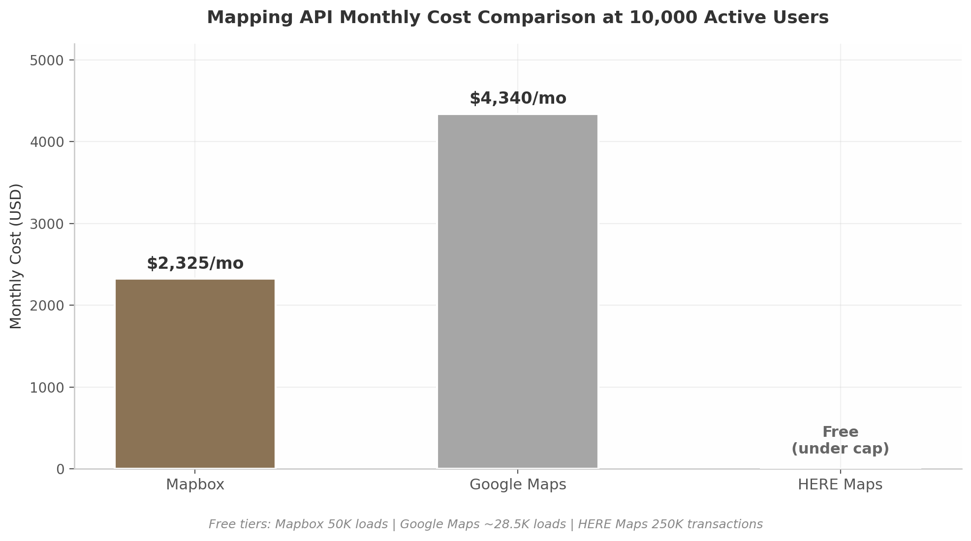
Mapping API Monthly Cost Comparison
The cost differential is substantial at scale. For a platform targeting breakeven at the seed stage, the $24,000 annual difference between Mapbox and Google Maps at 10,000 users represents meaningful runway extension.
Table 2: Recommended Production Technology Stack
Layer | Technology | Rationale
Frontend framework | Next.js 15 (App Router) | SSR for SEO, server components, API routes
UI components | Tailwind CSS + shadcn/ui | Fast development, accessible, customizable
Mobile delivery | PWA + Capacitor wrapper | Cross-platform, 40-60% cost reduction ⁵⁷
Backend runtime | Node.js via Next.js API | 44% higher requests/sec than Python for I/O workloads ⁴³
Database | PostgreSQL (Supabase) | RLS multi-tenancy, real-time subscriptions, auth
Authentication | Supabase Auth (GoTrue) | Built-in OAuth, RLS integration, social login
Payments | Stripe Connect Express | Marketplace-native, 2-min driver onboarding ⁵⁸
SMS gateway | Twilio | Industry standard, global coverage, ~$0.0075/SMS
Email delivery | SendGrid / AWS SES | Template engine, queue-based delivery
Mapping | Mapbox | 46% cheaper than Google Maps at scale ⁶⁴
Queue / background jobs | Bull + Redis | Notification scheduling, async processing
File storage | Supabase Storage | Vehicle photos, driver documents, CDN delivery
Hosting | Vercel + Cloudflare | Edge deployment, auto-scaling, global CDN
Monitoring | Sentry + Datadog | Error tracking, performance monitoring

5.2.2 Mobile Strategy: PWA-First (40-60% Cheaper)
DriverLink’s mobile strategy prioritizes Progressive Web Apps (PWAs) over native iOS and Android development for both the rider booking experience and the driver companion app. The rationale is economic and operational. PWAs “cost 40-60% less than native development and reach the market 50-70% faster”⁵⁷, a decisive advantage for a seed-stage company that must validate product-market fit before committing to expensive native codebases. PWAs also update instantly — no app store review cycles — and are inherently discoverable via search engines, aligning with the SEO-driven customer acquisition strategy.
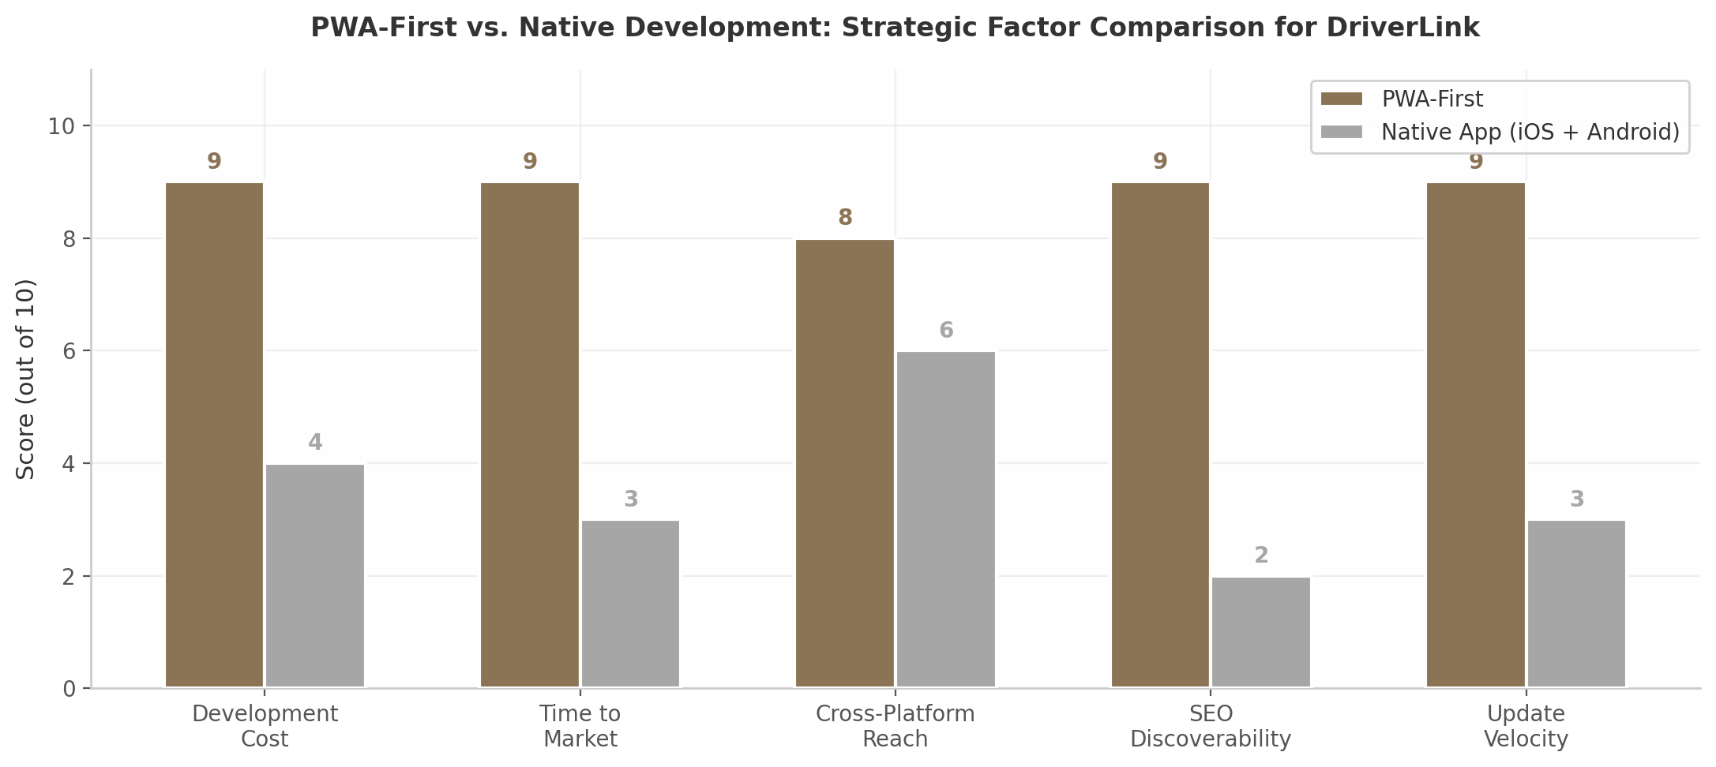
PWA vs Native Comparison
The primary limitation is iOS push notification support. PWAs on iOS “may face limitations in delivering push notifications, potentially affecting user engagement compared to the Android platform”¹³². For a booking platform where real-time driver assignment alerts directly impact customer experience, this is a material constraint. The recommended resolution is a phased approach: launch with PWA for both rider and driver experiences, then wrap the PWA in Capacitor to gain native push notification capabilities via Apple’s APNS without rewriting the application. A fully native driver app is deferred until continuous background GPS tracking — which PWAs cannot provide — becomes a core requirement.

5.2.3 Multi-Tenancy: PostgreSQL RLS
Multi-tenancy is the foundational architectural pattern that enables DriverLink to serve thousands of independent drivers from a single deployed instance. Three patterns exist: database-per-tenant (highest isolation, poorest scalability), schema-per-tenant (moderate isolation, moderate scalability), and shared-table with Row-Level Security (good isolation, best scalability, lowest complexity)¹³¹.
DriverLink adopts the shared-table model with PostgreSQL RLS. Every table contains a tenant_id column, and RLS policies enforce that queries return only rows belonging to the current tenant. This approach is validated by Supabase’s own benchmarks showing 94.74% query performance improvement when explicit tenant filters complement RLS policies¹⁹. For enterprise-scale tenants requiring dedicated resources, a bridge pattern migrates them to isolated schemas without changing application code.
The multi-tenancy architecture extends beyond data isolation to encompass per-tenant configuration. Each driver’s branding settings, service templates, pricing rules, notification preferences, and custom domain mapping are stored as JSON columns within the tenant record, enabling deep customization without schema migrations.

5.3 Integration Ecosystem

5.3.1 FlightAware, QuickBooks, Stripe Connect
Airport transfers represent one of the highest-frequency, highest-value service categories. The FlightAware AeroAPI integration is what elevates DriverLink’s airport service from a standard pickup to an intelligent, delay-adaptive experience. AeroAPI is “a simple and cost-effective query-based API that delivers data on demand from millions of flight status inputs” with “over 60 distinct endpoints” including “real-time alerting on flight events that mean the most to you, including departure, arrival, cancels, flight hold detections”²⁹. The integration pattern stores the passenger’s flight number with the booking, polls AeroAPI starting 24 hours before the scheduled pickup, and automatically adjusts the driver’s assigned arrival time based on actual flight status. Both driver and passenger receive proactive notifications of delays, eliminating the manual coordination that currently plagues airport transfer services.
QuickBooks integration addresses the back-office accounting burden that consumes disproportionate time for small operators. QuickBooks uses “OAuth 2.0 for app authentication” and “provides endpoints for creating invoices, retrieving clients, and managing payments”¹³³. DriverLink’s integration automatically generates QuickBooks invoices upon trip completion, synchronizes payment records, and maintains customer record alignment — turning what is currently a daily manual bookkeeping task into a fully automated background process.
Stripe Connect, detailed in Section 5.2.1, completes the operational trinity by handling the financial pipeline: rider payment collection, platform fee deduction, driver payout disbursement, and automated tax document generation (1099-K in the US).

5.3.2 SAP Concur, Expensify, Amex GBT for B2B2C
The B2B2C channel — where DriverLink serves as the embedded transportation layer within corporate travel programs — requires integration with the dominant expense management and travel booking platforms. SAP Concur, Expensify, and American Express Global Business Travel (Amex GBT) collectively cover the majority of the enterprise travel management market. These integrations enable seamless ride booking within approved corporate travel workflows, automatic expense categorization, and compliance with corporate travel policies.
The integration architecture follows a webhook-and-API pattern. When an executive books a ride through their company’s Concur instance, the request flows to DriverLink’s API with pre-approved cost center and project codes. Upon trip completion, the receipt and expense details are pushed back to Concur for automated reconciliation. This closed-loop integration removes the friction of manual expense submission — a pain point that drives corporate travel managers to consolidate around platforms that offer native connectivity.
For the driver-side ecosystem, integration opportunities extend to fleet management platforms (GPS tracking hardware, dashcam systems, DOT compliance monitoring), calendar systems (two-way sync with Google Calendar and Microsoft Outlook via their respective APIs)⁵², and emerging usage-based insurance APIs. The insurance category is less mature — Smartcar provides “a car API” for usage-based insurance but the ecosystem remains fragmented⁴⁵. Early-stage partnerships with commercial auto insurers (Progressive Commercial, Geico Commercial) are recommended over direct API integrations until the category matures.
The integration strategy follows a clear prioritization sequence. Phase 1 (launch) includes Stripe Connect, Twilio, SendGrid, and Mapbox — the integrations required for core marketplace operations. Phase 2 (months 3-6) adds FlightAware AeroAPI, QuickBooks sync, and Google Calendar integration. Phase 3 (months 6-12) introduces the B2B2C ecosystem (SAP Concur, Expensify, Amex GBT) and fleet management connectivity. This staged approach prevents integration complexity from overwhelming the core product iteration cycle while building toward the platform’s full ecosystem vision.

6. Go-to-Market Strategy
DriverLink’s go-to-market playbook is built on a supply-first sequencing model validated by the launch histories of Uber, OpenTable, and Toast. The core strategic insight is that premium chauffeur services are relationship-based, not algorithm-based — meaning network effects provide less defensibility than in mass ride-hailing, while standalone SaaS utility and CRM lock-in provide substantially more¹³⁴ ¹³⁵. This reality inverts the standard marketplace playbook: DriverLink must acquire drivers through the independent value of its business tools, then layer on marketplace demand once a critical mass of 20–30 active drivers per city is achieved¹³⁶. The following sections detail the driver acquisition engine, the rider demand generation system, and the 24-month geographic rollout plan.

6.1 Driver-Side Acquisition (Supply)

6.1.1 NLA Partnerships, Online Communities, and Content Marketing
The National Limousine Association (NLA) represents approximately 1,400 member operators worldwide and provides the most direct access to established chauffeur businesses¹³⁷. NLA membership confers both credibility and tangible cost savings — operators receive over 25 discount programs spanning Coast fuel cards ($3,000 sign-up bonus), Azuga GPS tracking (free hardware plus 10% discount), IntelliCorp background checks at 40% off ($18.55 per package), and 50% off Limo Anywhere setup fees¹³⁸. DriverLink’s partnership strategy centers on becoming an endorsed NLA technology partner, with booth presence at the CD/NLA Show in Las Vegas (March 2026, estimated 2,000+ attendees) and the fall show in Dallas (October 2026)¹³⁹. These events function as concentrated acquisition channels where a single demonstration can convert fleet operators managing 5–15 vehicles each.
Online communities provide a parallel digital acquisition layer. The r/uberdrivers subreddit has 434,000 members as of 2025, with 65,377 submissions and 1.39 million comments between 2019–2022 demonstrating sustained high engagement¹⁴⁰. Reddit’s forum structure allows DriverLink to participate authentically in conversations about driver economics, platform alternatives, and independent operation — avoiding the promotional tone that triggers community backlash. Complementary channels include Harry Campbell’s The Rideshare Guy (200,000+ unique monthly visitors, 50,000+ driver interviews conducted)⁹⁰and the RideGuru forum, which operates as a lower-toxicity alternative to Reddit for rideshare discourse¹⁴¹.
Content marketing exploits a unique media consumption pattern: 65% of monthly podcast listeners tune in while driving, with 81% of streams occurring on weekdays and 35% during commuting hours¹⁴². A DriverLink-produced podcast targeting professional drivers would reach its audience during their literal working hours — a channel efficiency that no desktop-dependent SaaS product can replicate. The content strategy should mirror Harry Campbell’s multi-format model: daily blog posts targeting SEO keywords (“how to become a private chauffeur,” “chauffeur license requirements [state]”), weekly YouTube tutorials on scheduling and CRM tools, and a podcast interviewing successful independent operators.

6.1.2 The “Uber Disillusionment Pipeline”: Targeting Departing Uber Black Drivers
A structural and growing supply pipeline is being created by Uber’s own business model evolution. As Uber’s take rate climbed from 10% to 40%+ and the company prioritized autonomous vehicle deployment (100,000 Waymo robotaxis targeted by 2027) over human drivers, a wave of experienced premium drivers is actively seeking independence¹² ¹. Uber’s own S-1 filing admitted that approximately 70% of drivers quit within 8 months, creating a continuous churn pool of experienced operators who already understand the technology but are disillusioned with the economics.
The recruitment messaging must be precisely calibrated: “Keep your earnings, own your brand.” Independent black car drivers command 2.5–8x the hourly rate of UberX drivers when operating outside the platform, and the gap widens further in premium segments where personal relationships drive repeat bookings. Targeting should focus on recently departed Uber Black and Uber Reserve drivers who built client relationships through the platform but now have both the motive (declining Uber economics — 72% of drivers report it is harder to earn the same amount versus a year ago¹²) and the means (established client bases, commercial insurance, licensed vehicles) to go independent. Acquisition tactics include targeted Facebook and Reddit campaigns in driver groups, search advertising against queries like “Uber Black alternative” and “quit Uber drive independently,” and direct outreach through driver-focused media properties.

6.1.3 Referral Economics: $150 CAC, 12:1 LTV:CAC
Referral programs represent the most capital-efficient driver acquisition channel, with a projected $150 customer acquisition cost (CAC) and a 12:1 lifetime value to CAC ratio¹⁴³. This compares favorably to outbound sales at $1,980 CAC and even paid search at $802 (B2B) per acquisition¹⁴⁴. Uber’s own referral program demonstrated the viral potential of driver-to-driver recruitment: starting at $25 per referral, scaling to $200–$500, and reaching $1,000 per referral in supply-constrained San Francisco markets¹⁴⁵. Professional driver networks are tight-knit — drivers know other drivers who know other drivers — creating natural viral loops that compound as density increases.
Channel | CAC | LTV:CAC Ratio | Time to First Driver | Scalability
Referral Programs | $150 ¹⁴⁴ | 12.0x ¹⁴³ | 1–2 weeks | High (viral)
Paid Social (Facebook) | $230 ¹⁴⁴ | 8.5x | 1–2 weeks | Medium
Organic Search (SEO) | $290 ¹⁴⁴ | 10.2x | 3–6 months | High (compounding)
Paid Search (Google Ads) | $802 ¹⁴⁴ | 4.2x | 1–2 weeks | Medium
NLA Trade Shows | ~$400–600 | 6.0x | Event-dependent | Low (seasonal)
Outbound Sales | $1,980 ¹⁴⁴ | 2.8x | 2–4 weeks | Low (labor-intensive)
Table 6.1: Driver Acquisition Channel Comparison. Referral programs and SEO offer the strongest unit economics, while paid search and outbound sales are reserved for targeted fleet-operator acquisition. Trade shows provide concentrated access to high-value fleet operators despite limited frequency.
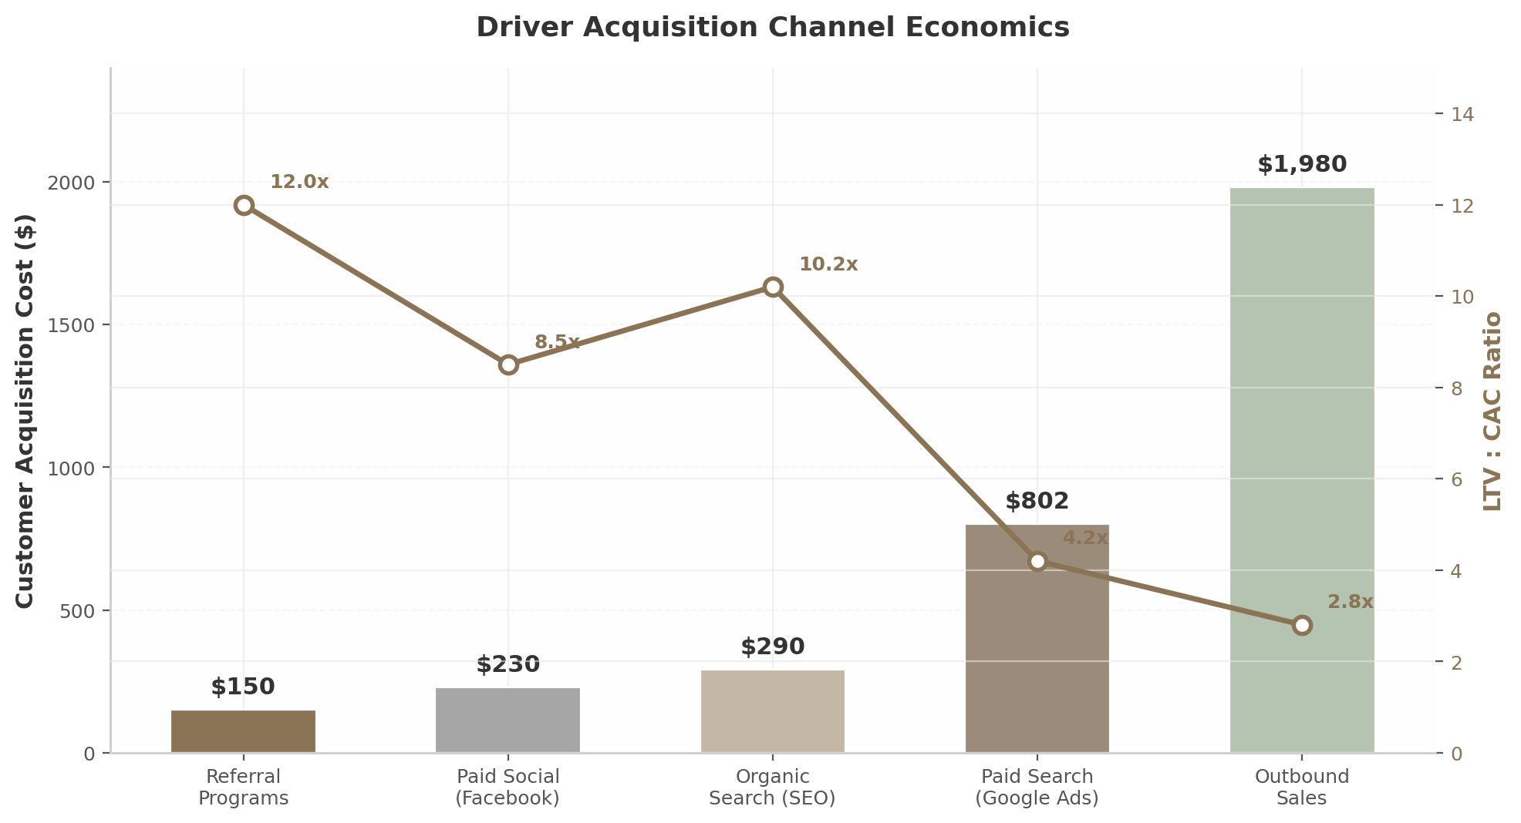
Driver Acquisition Channel Economics
The channel mix should prioritize referrals and SEO during the Atlanta proof-of-concept phase, supplemented by NLA event presence. Paid search becomes economical only after unit economics are validated and lifetime value exceeds $1,800 per driver. The referral program design should follow Uber’s dual-sided model: both the referring driver and the new driver receive account credits (equivalent to one month of subscription value), with bonus sizing that scales based on market supply constraints. CAC has risen 40–60% across all digital channels between 2023–2025¹⁴⁶, making early investment in referral infrastructure and SEO content a time-sensitive priority — content published today compounds organic traffic for years, while paid acquisition costs are structurally inflationary.

6.2 Rider-Side Acquisition (Demand)

6.2.1 SEO: Multi-City Landing Pages
Rider-side demand generation begins with search engine optimization rather than paid acquisition, because premium transportation bookings exhibit strong search-driven intent patterns. The highest-value keyword categories for chauffeur services include airport transfers (“airport limo service [city],” “JFK car service”), corporate travel (“corporate car service [city],” “executive transportation”), wedding transportation (“wedding limo [city]”), and private driver services (“private driver [city],” “hourly car service”)¹⁴⁷ ¹⁴⁸. Most limousine companies begin seeing measurable SEO improvements within three to six months when their website structure supports dedicated landing pages for each city-and-service combination¹⁴⁷.
DriverLink’s SEO architecture should implement a programmatic page generation system that creates dedicated landing pages for every driver in every market they serve — e.g., “/private-driver-atlanta/” or “/wedding-limo-dallas/” — with unique content drawn from driver profiles, service descriptions, vehicle details, and customer reviews. This multi-city page architecture scales organic reach without proportional content creation costs¹⁴⁹. Each driver’s individual Google Business Profile (GBP) functions as a local ranking signal; 86% of all GBP views originate from category-based searches, making primary category selection (“Chauffeur Service” over generic “Transportation Service”) a material ranking factor⁷⁹.

6.2.2 B2B: Hotels, Wedding Planners, Corporate TMCs, and Senior Care
The B2B2C channel generates higher-margin demand than direct consumer acquisition because corporate and hospitality partners embed DriverLink into existing workflows with inherently higher switching costs. Business customers generate two times as many gross bookings per monthly active user and are more than three times as profitable as regular customers¹⁵⁰. The 2026 corporate ground transportation RFP has tightened requirements around three elements: W-2 chauffeur classification (non-negotiable compliance requirement), corporate booking tool integration (SAP Concur Direct Connect, Amex GBT/Egencia), and published rate-card discipline (fixed rates that hold under booking confirmation)¹⁵¹. Surge-exposed operators are structurally disqualified regardless of headline rate attractiveness¹⁵¹.
Hotel concierge partnerships provide another high-value channel. Luxury and upper-upscale properties (Marriott, Hilton, Hyatt, Four Seasons, Ritz-Carlton) require dedicated booking lines, NET-30 consolidated invoicing, flat-rate airport transfer programs that front-desk staff can quote confidently, and branded confirmation emails¹⁵². Each hotel partnership effectively converts the concierge into a commission-free sales agent who recommends DriverLink drivers to guests needing transportation.
Wedding transportation represents a premium seasonal vertical with per-event pricing of $500–$2,000 and 20–40% premiums during peak months (September, October, June)¹⁵³. The Knot dominates vendor discovery with 300,000+ listings¹⁵⁴, though over 200 FTC complaints document aggressive upselling and lead quality concerns¹⁵⁴. DriverLink’s strategy should start with free Zola listings (smaller but growing, pay-per-lead model) before investing in The Knot’s paid tiers⁸⁰. Direct wedding planner relationships — offering consolidated billing (one invoice per wedding), 48-hour advance chauffeur details (name, photo, phone), and priority booking for peak Saturdays — generate more defensible demand than directory listings alone¹⁵³.
Senior care transportation addresses an underserved, need-driven market. SilverRide, the leading assisted transportation platform, operates 1 million+ rides annually across 35+ metros¹⁵⁵, demonstrating the scale of demand. Non-emergency medical transportation (NEMT) costs average $35 per pickup plus $2.50 per mile for ambulatory patients, funded through Medicaid and Medicare Advantage programs that are expanding NEMT coverage from 15% to 36% of plans¹⁵⁶. Partnership targets include Area Agencies on Aging (AAA), PACE organizations, Medicare Advantage health plans, and senior living communities.

6.2.3 Review Generation: Automated SMS Post-Ride
In the premium transportation segment, reviews function as both acquisition signals and trust infrastructure. Automated SMS review requests sent within 15 minutes of ride completion achieve the highest response rates, particularly when the message includes a direct Google review link rather than a generic “leave us a review” prompt⁸. Drivers should target 50+ Google reviews with a 4.5+ star average before investing in paid advertising, as this threshold represents the minimum social proof required for premium service conversion¹⁴⁷. DriverLink’s platform should automate the entire review workflow: trigger SMS on ride completion, provide pre-written response templates for drivers to acknowledge reviews within 24–48 hours, and feature top reviews on individual driver storefront pages. The CRM integration means review data feeds back into driver profiles, creating a reputation score that improves matching algorithms and increases booking conversion rates.

6.3 Launch Sequencing

6.3.1 Sun Belt Rollout: Atlanta → Dallas+Houston → Charlotte+Phoenix+Tampa
The 24-month launch sequence prioritizes Sun Belt metros for three structural reasons: population growth (the Sun Belt accounted for 80% of total U.S. population growth over the past decade, projected to grow another 11 million (+7.3%) over the next decade while non-Sun Belt states grow by only 475,000 (+0.3%)¹⁵⁷), regulatory friendliness (lower commercial insurance costs, fewer licensing barriers), and corporate travel density (Atlanta, Dallas, and Houston rank among the top three growth metros¹⁵⁷).
Phase | Timeline | Cities | Driver Target | Niche Focus | Key Milestones
1: Proof of Concept | Months 1–6 | Atlanta | 20–30 | Airport transfers, SaaS onboarding | Product-market fit, first $10K GMV
2: Scale | Months 7–12 | Dallas, Houston | 50–80 per city | + Corporate travel, hotel partnerships | B2B pipeline, first enterprise account
3: Expand | Months 13–18 | Charlotte, Phoenix, Tampa | 40–60 per city | + Weddings, senior care | Multi-vertical validation, unit economics
4: National | Months 19–24 | Nashville, Austin, Orlando, Miami, San Antonio | 30–50 per city | + NEMT, EV certification | 15–20 city network, Series A ready
Table 6.2: 24-Month Launch Sequencing Roadmap. Each phase requires achieving critical mass (~20–30 active drivers) before marketplace features activate. Niche sequencing concentrates liquidity within verticals rather than dispersing demand across categories.
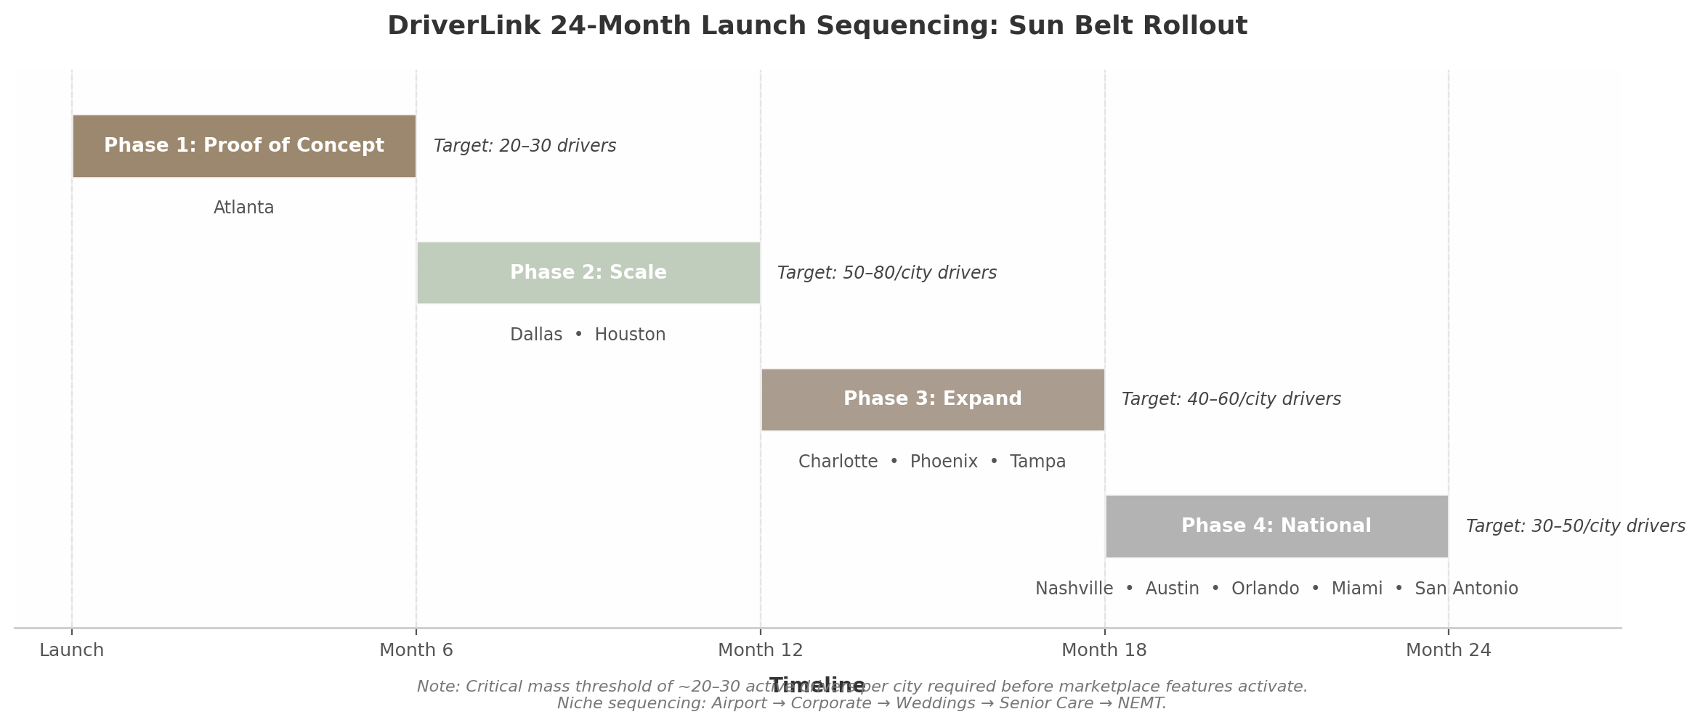
DriverLink 24-Month Launch Sequencing
Phase 1 (Months 1–6): Atlanta. Atlanta serves as the proof-of-concept city due to existing prototype infrastructure, Hartsfield-Jackson Atlanta International Airport (the world’s busiest by passenger volume, generating consistent airport transfer demand), a major corporate headquarters cluster (Coca-Cola, Delta, Home Depot), and lower driver cost-of-living that improves SaaS price tolerance. The goal is 20–30 active drivers operating primarily on airport transfers and direct-booking SaaS tools — not marketplace liquidity. Uber’s own launch playbook quantified this threshold: 20–30 drivers with sub-15-minute response times as the minimum viable supply density before any rider marketing begins¹³⁶.
Phase 2 (Months 7–12): Dallas-Fort Worth and Houston. These are the #1 and #2 fastest-growing U.S. metros by absolute population growth¹⁵⁷. Texas’s lack of state income tax improves driver net earnings, making the subscription model more affordable. Both cities host major hub airports (DFW and IAH) and substantial corporate travel volume. The niche expansion adds B2B corporate travel and hotel partnerships to the airport transfer foundation.
Phase 3 (Months 13–18): Charlotte, Phoenix, and Tampa. Charlotte (#8 fastest-growing metro) serves as a banking hub with predictable corporate travel demand¹⁵⁷. Phoenix’s retiree demographics create senior care and medical transportation demand. Tampa’s coastal tourism drives event and wedding transportation. This three-city expansion tests whether the Atlanta playbook replicates without on-the-ground presence.
Phase 4 (Months 19–24): National Expansion. Nashville, Austin, Orlando, Miami, and San Antonio bring the network to 15–20 cities, with each new market requiring approximately 30–50 drivers to achieve local liquidity. The niche focus shifts toward NEMT and EV-certified chauffeur segments as vertical specialization matures.

6.3.2 Niche-First: Airport → Corporate → Weddings → Senior
Within each city, DriverLink follows a niche-first rather than category-sprawl approach. Airport transfers provide the highest-volume, most predictable demand foundation — they “operate year-round, and strong search visibility in this category often becomes the foundation of consistent booking pipelines”¹⁴⁸. Corporate travel adds the highest lifetime value clients (2x bookings, 3x profitability versus leisure¹⁵⁰) but requires B2B sales cycles of 60–90 days. Weddings contribute premium seasonal pricing with $500–$2,000 per event¹⁵³. Senior care and NEMT provide recession-proof, government-funded demand with 156 predictable trips per dialysis patient annually¹⁵⁶. The principle is density over breadth: it is better to own one vertical completely than to scatter demand across ten underserved categories¹⁵⁸.

6.3.3 Critical Mass: ~20–30 Drivers per City
The critical mass threshold of 20–30 active drivers per city is not arbitrary — it mirrors Uber’s validated expansion metric and reflects the specific economics of premium service matching. Unlike mass ride-hailing where asymptotic network effects flatten around 4-minute pickup times¹³⁴, premium chauffeur services require sufficient supply to match advance-booking requests with appropriate vehicle types, service certifications, and availability windows. At 20–30 drivers, a city has enough coverage for airport transfers (the highest-frequency use case), enough redundancy to absorb 1–2 driver departures, and enough diversity in vehicle types (sedan, SUV, sprinter) to serve the core corporate market. Below this threshold, marketplace features should remain dormant — drivers operate purely on SaaS tools for their own direct clients. Only once 20–30 active drivers are confirmed does the platform activate marketplace features: rider discovery, automated matching, and commission-based bookings. This sequencing protects driver experience quality and ensures that the first marketplace interactions are positive enough to generate the word-of-mouth that ultimately drives organic growth exceeding paid acquisition — the true signal that a market has reached critical mass¹⁵⁹.

7. Regulatory & Compliance
The regulatory architecture governing independent driver platforms in the United States is not a coherent system — it is a layered mosaic of federal baseline standards, divergent state statutes, and hyperlocal municipal codes that together create one of the most complex compliance environments in the gig economy. For platforms positioning themselves as pure SaaS tools rather than transportation marketplaces, this fragmentation is not merely a cost of doing business; it is a structural advantage. The same regulatory patchwork that constrains Uber and Lyft — worker classification mandates, commercial insurance minimums rising to $2 million, and municipal licensing regimes — often does not apply, or applies with materially reduced force, to software vendors that merely provide scheduling and payment infrastructure to independently licensed operators.
This chapter maps the three pillars of US regulatory exposure — licensing, insurance, and classification — and then examines how the SaaS business model creates a regulatory arbitrage position relative to marketplace competitors.

7.1 US Regulatory Landscape

7.1.1 Licensing Patchwork: No Federal Standard
At the federal level, the FMCSA sets baseline standards for Commercial Driver’s Licenses (CDLs), but states issue the licenses and retain broad authority over passenger-for-hire operations below the CDL threshold. A CDL is required only for vehicles with a gross vehicle weight rating (GVWR) of 26,001+ pounds, vehicles towing 10,001+ pounds, or vehicles designed for 16 or more passengers ¹⁸. The far larger market of sedan and SUV chauffeur services — vehicles carrying 14 or fewer passengers — falls entirely outside federal CDL jurisdiction, leaving each state to construct its own licensing framework ¹⁶⁰.
The result is extreme heterogeneity. Michigan requires a separate chauffeur’s license distinct from a standard operator’s permit. Illinois requires a public passenger vehicle license. New York mandates a Class E or commercial license (A, B, or C) for TLC applicants, who must also be at least 19 years old, hold a valid Social Security number, have no more than 5 points on their DMV license within 15 months, and complete a 24-hour TLC Driver Education Course, Wheelchair Accessible Vehicle training, pass an 80-question examination (70% passing threshold), a drug test, fingerprinting, a medical exam, and sex trafficking awareness training — a process costing $500–$800 and requiring completion within 90 days ¹⁶¹ ¹⁶². Effective October 1, 2025, all out-of-state TLC applicants must complete additional documentation steps at a NYS DMV office, erecting a new barrier for non-resident drivers ¹⁶¹.
California presents a different, equally demanding structure. The California Public Utilities Commission (CPUC) issues Transportation Charter Permit (TCP) licenses for charter-party carriers. Requirements include California business registration, commercial vehicle registration, a commercial insurance policy, a drug and alcohol testing program, and an application fee of $1,000 or more with processing taking 2–4 weeks ¹⁷. Critically, the CPUC does not permit independent contractors to operate TCP-sanctioned vehicles unless that contractor holds their own independent TCP license — all drivers must be classified as W-2 employees of the TCP license holder ¹⁷. This provision, examined in detail in Section 7.2.2, creates a structural constraint unique to the California market.
Municipal layering adds further complexity. Chicago requires all public passenger vehicles to be licensed under Chapter 9-114, with local insurance minimums of $350,000 combined single limit (CSL) for 1–9 passenger livery vehicles ¹⁶³. Miami-Dade County requires limousine for-hire license applications, background checks, vehicle standards meeting luxury sedan or SUV MSRP requirements, a local business tax receipt, vehicle inspections, and a county-issued chauffeur’s license ¹⁶⁴. No two major markets share identical licensing requirements, and compliance costs vary by an order of magnitude across jurisdictions.
Table 7.1: Regulatory Requirements by Jurisdiction — Selected Major Markets
Requirement | California (CPUC/TCP) | New York City (TLC) | Illinois (Chicago) | Florida (Miami-Dade) | Virginia
Primary Regulator | CPUC | NYC TLC | City of Chicago | Miami-Dade County | DMV / Local
License Type | TCP Permit | TLC Driver + FHV License | Public Passenger Vehicle | Limousine For-Hire License | Chauffeur / For-Hire
Min. Driver Age | 18+ | 19+ | 18+ | 21+ | 18+
ICs Permitted? | No (W-2 only) ¹⁷ | Yes | Yes | Yes | Yes
Insurance Min. (1–7 pax) | $2.0M CSL ¹⁶⁵ | $1.25M (TNC) ¹⁶⁶ | $350K CSL ¹⁶³ | Varies by fleet | $125K CSL ¹⁶⁷
Training Required | Drug/alcohol program | 24-hr course + WAV + exam ¹⁶² | None specified | Background check | Varies
Vehicle Inspection | Commercial registration | TLC pre-licensing ¹⁶⁸ | Annual (GVWR >8K lbs) ¹⁶⁹ | Required | Varies
Application Fee | $1,000+ | ~$500–$800 ¹⁷⁰ | Varies | Varies | Varies
Processing Time | 2–4 weeks | 90-day completion window | Varies | Varies | Varies
The table reveals a market in which regulatory entry costs range from approximately $500 in low-barrier jurisdictions to over $3,000 in TLC-regulated New York City. The IC classification column is particularly consequential: California’s TCP regime is the only one among these major markets that explicitly forbids independent contractor status for drivers operating under a licensee’s authority. As Section 7.2.2 will explore, this constraint applies to transportation marketplace operators — not to SaaS tool providers — creating a material competitive asymmetry.

7.1.2 Insurance: Escalating Minimums and Divergent Cost Structures
Commercial auto insurance represents the single largest fixed cost for independent chauffeur operators, and the regulatory floor is rising. Commercial limo insurance for sedan and SUV operations carrying $1 million CSL coverage averages $904 per month ($10,847 annually) nationally, but geographic dispersion is extreme: Vermont operators pay $581 per month while New York TLC services pay $1,403 per month ¹⁷¹. Stretch limousines add 25–40% to base rates; party buses add 40–75% due to federal DOT requirements and higher passenger injury exposure ¹⁷¹.
California’s AB-1807, effective July 1, 2025, dramatically reshaped the cost landscape. The statute raised the state’s minimum commercial auto liability for charter-party carriers and transportation network companies (TNCs) from $750,000 to $2 million CSL per vehicle — a 167% increase for sedan operators and a 33% increase for stretch limousines previously subject to $1.5 million ¹⁶⁵. The premium impact has been severe: Inszone Insurance reports that small limo fleets (1–10 vehicles) now “pay multiples of their previous liability premiums,” and independent black-car drivers using SUVs or sedans who once operated under personal policies must now carry full commercial coverage ¹⁶⁵. Industry estimates place premium increases at 20–50% for operators across vehicle classes.
Figure 7.1 illustrates the divergence in commercial auto liability minimums across selected US jurisdictions. The gap between Virginia’s $125,000 floor and California’s post-AB-1807 $2 million ceiling represents a 16-fold variation — a range with no parallel in other developed ride-hail markets.
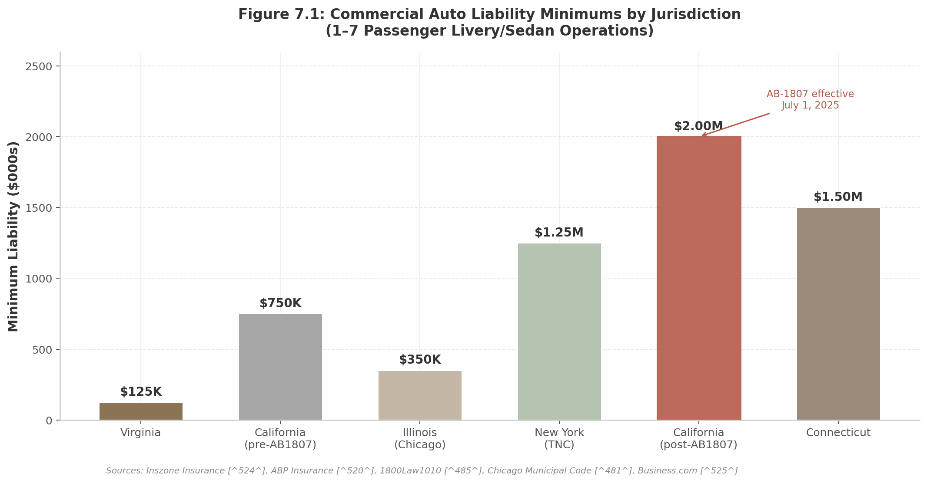
Figure 7.1: Commercial Auto Liability Minimums by Jurisdiction
At the other end of the spectrum, California SB-371, effective January 1, 2026, reduced TNC uninsured/underinsured motorist coverage from $1 million per incident to $60,000 per person / $300,000 per accident, while maintaining $1 million in third-party liability when the driver is at fault ¹⁷² ¹⁷³. This divergence — rising commercial liability for charter operators while rideshare-specific coverage is reduced — creates divergent cost pressures that favor business models segmenting themselves as professional chauffeur services rather than TNC-style rideshare. A Consumer Attorneys of California-led coalition is already promoting a counter-ballot measure for November 2026 to reverse SB-371’s insurance reductions ¹⁷⁴, ensuring continued regulatory uncertainty.
Rideshare insurance operates on a three-period model. Uber and Lyft maintain contingent liability of $50,000 per person / $100,000 per accident during Period 1 (app on, awaiting a ride) and $1 million during Periods 2 and 3 (en route or on trip) ¹⁷⁵. Critically, this platform-provided insurance does not extend to TLC-licensed, livery, or TCP drivers, who must procure their own commercial policies consistent with state and local requirements ¹⁷⁵. New York State mandates even higher coverage: $75,000 / $150,000 / $25,000 during the waiting period and $1.25 million during active rides ¹⁶⁶ ¹⁷⁶.

7.1.3 Classification: Federal Reversal, California Stabilization, and EU Pressure
Worker classification has been the most contested regulatory arena for driver platforms, but the political trajectory shifted decisively in 2024–2025. At the federal level, the Biden-era DOL’s 2024 independent contractor final rule — which used a six-factor “economic realities” test giving no single factor predetermined weight — is no longer being enforced as of May 2025. DOL field staff have been instructed to revert to the prior Fact Sheet #13 framework, though the 2024 rule technically remains in effect for private litigation purposes ¹⁷⁷ ¹⁷⁸. This reversal removes a significant reclassification risk for platforms operating under the federal Fair Labor Standards Act.
In California, the legal picture clarified with the California Supreme Court’s unanimous July 25, 2024 decision in Castellanos v. State of California, upholding Proposition 22 against union challenges that the law violated the state constitution by infringing on workers’ compensation authority ¹⁷⁹ ¹⁸⁰. Under Prop 22, app-based drivers retain independent contractor status with a carve-out benefit package: a minimum earnings guarantee of 120% of minimum wage (based on “engaged time” only), healthcare stipends for qualifying workers, occupational accident insurance with a $1 million limit, and a $0.35 per mile reimbursement. They remain ineligible for sick pay, minimum wage for waiting time, unemployment insurance, and workers’ compensation ¹⁸⁰. The decision provided legal certainty for platform business models in the nation’s largest ride-hail market.
At the state level, a growing number of jurisdictions have codified independent contractor status for marketplace platform workers. Iowa (2018), Kentucky (2018), Tennessee (2018), Utah (2015), Texas (2019), and South Dakota (2022) have all passed statutes defining app-based platform workers as independent contractors, typically conditioned on platforms not prescribing specific hours, prohibiting use of other platforms, or restricting other work ¹⁸¹ ¹⁸². The Texas Administrative Code offers a particularly detailed template, specifying eight conditions for marketplace contractor exemption from unemployment insurance: per-job payment, no hour prescription, no restriction on other platforms, no restriction on other occupations, no control over when/where work occurs, contractor responsibility for expenses and tools, no specific instructions, and no mandatory meetings ¹⁸³.
The federal classification picture was further shaped by a January 14, 2025 FTC policy statement clarifying that independent contractors and gig workers are shielded from antitrust liability when engaging in collective bargaining and organizing activities under the Clayton and Norris-LaGuardia Acts ¹⁸⁴. While this provision empowers driver organizing, it does not alter classification status itself.
Internationally, pressure runs in the opposite direction. The EU Platform Work Directive (2024/2831) introduces a legal presumption of employment for platform workers, mandates human review of algorithmic decisions, and shifts the burden of proof from worker to platform. Member states must transpose the directive into national law by December 2, 2026 ⁴⁵. Belgium, Spain, and Portugal already maintain employment presumptions. The directive also restricts processing of emotional state, private conversations, and biometric data — constraints that may limit AI-powered personalization features platforms increasingly rely upon ⁴⁵.

7.2 The SaaS Regulatory Arbitrage

7.2.1 Pure SaaS Tool Model: Strongest IC Classification Arguments
The legal distinction between a “marketplace” that dispatches rides and a “SaaS tool” that provides scheduling, payment, and customer management software to independent operators has not been fully tested in courts for driver classification ¹⁸⁵. However, the analytical framework that courts and regulators apply points toward a decisive advantage for the SaaS model.
The DOL’s Fact Sheet #13 and the six-factor “economic realities” test examine: (1) the nature and degree of the potential employer’s control; (2) the permanency of the worker’s relationship; (3) the worker’s investment in facilities and equipment; (4) the amount of skill, initiative, and foresight required; (5) the worker’s opportunities for profit or loss; and (6) the extent of integration of the worker’s services into the potential employer’s services ¹⁸⁵. A genuine SaaS tool that does not control pricing, routes, hours, or dispatch logic and does not restrict drivers to the platform scores favorably on at least five of six factors — most importantly the control and integration tests that carry the greatest judicial weight.
The Texas Administrative Code’s eight-factor marketplace contractor framework reinforces this logic. A SaaS platform that provides scheduling and invoicing software but does not prescribe hours, prohibit multi-homing, restrict other occupations, control when or where work occurs, or require attendance at mandatory meetings structurally satisfies the conditions for independent contractor classification ¹⁸³. By contrast, marketplace platforms that set rates, control dispatch algorithms, and require driver availability windows exercise precisely the forms of control that courts have found most probative of an employment relationship.
This classification advantage translates directly to unit economics. Full employee classification would increase platform labor costs by an estimated 20–30% through the addition of payroll taxes, workers’ compensation, unemployment insurance, and benefits administration ¹⁸⁶. The SaaS model’s stronger IC classification arguments reduce this reclassification risk materially, creating a structural cost advantage that compounds as marketplace competitors face ongoing litigation exposure.

7.2.2 CA TCP Requires W-2: Constraint for Marketplaces, Not SaaS Tools
California’s TCP regime presents what appears to be a prohibitive constraint: the CPUC explicitly forbids independent contractors from operating TCP-sanctioned vehicles unless the contractor holds their own independent TCP license, effectively mandating W-2 employee classification for all drivers operating under a carrier’s authority ¹⁷. For transportation marketplace operators that directly dispatch rides and control the driver-passenger relationship, this requirement imposes the full cost burden of employee classification on California operations.
The SaaS tool model navigates around this constraint through structural separation. If the platform does not dispatch rides, does not hold TCP authority, and does not control the driver-passenger contractual relationship — instead merely providing software that independent TCP license holders use to manage their own client bookings — the W-2 mandate falls on the licensed carrier, not on the software vendor. The driver is the employee of the TCP-licensed operator (or holds their own TCP license as an independent carrier), while the SaaS platform provides tooling to that operator exactly as Salesforce provides CRM software to a licensed insurance broker.
This distinction is not semantic; it is structural. The CPUC’s W-2 requirement applies to “anyone operating [a vehicle] as a driver for [the TCP license holder’s] business” ¹⁷— language that targets the vehicle operator, not the software provider. A SaaS booking platform that enables a TCP-licensed carrier to accept reservations, process payments, and manage client relationships does not itself “operate” vehicles or employ drivers, and therefore falls outside the TCP classification mandate. This regulatory arbitrage is unique to California — no other major US jurisdiction couples licensing requirements so directly to employment classification — but it is precisely California’s scale that makes the arbitrage most valuable.

7.2.3 Data Privacy: CCPA, PCI DSS, and GDPR
The SaaS model’s reduced regulatory exposure does not eliminate compliance obligations. Data privacy requirements apply with equal force regardless of business model classification.
For platforms handling California consumer data, the CCPA/CPRA regime imposes substantial obligations. The California Privacy Protection Agency initiated its first-ever enforcement review of connected vehicle manufacturers in July 2023, examining how companies collect and use driver, passenger, and bystander data ¹⁸⁷. Platforms that provide passenger data to third parties for targeted advertising are engaged in “sharing” under CPRA and must ensure adequate notice in privacy policies regarding geolocation data and sensitive personal information ¹⁸⁸. Violations carry maximum fines of $7,500 per violation for intentional noncompliance and $2,500 for unintentional violations, plus private rights of action for data breaches with statutory damages up to $750 per affected individual ¹⁸⁹.
PCI DSS compliance is mandatory for any SaaS provider whose applications handle cardholder data, including platforms that embed payments via third-party integrations ¹⁹⁰. The twelve PCI DSS requirement domains — spanning network security, data encryption, access control, logging, and vulnerability management — apply regardless of transaction volume or platform business model.
For any platform with EU drivers or passengers, GDPR compliance carries even higher stakes. In August 2024, the Dutch Data Protection Authority imposed a EUR 290 million fine on Uber for improperly transferring European driver data to US servers between August 2021 and November 2023 without proper safeguards, including account details, taxi licenses, location data, photos, payment details, identity documents, and criminal or medical records ¹⁹¹. The EU Platform Work Directive adds further constraints, requiring human review of algorithmic management decisions and restricting processing of biometric and behavioral data ⁴⁵.
The net regulatory position for a SaaS-structured driver platform can be summarized as follows: licensing complexity falls on the independent operators, not the platform; insurance requirements are borne by the licensed carriers; worker classification obligations are substantially reduced; and data privacy compliance remains fully applicable. This asymmetry — reduced exposure in the three domains that constitute the majority of regulatory cost (licensing, insurance, and classification) while maintaining standard obligations in data privacy — is the core of the regulatory arbitrage. It is not a loophole but a function of correct structural design: a software company that sells tools to independent professionals faces different, and materially lighter, regulatory obligations than a company that employs or dispatches those professionals directly.

8. Strategic Insights & Recommendations
The preceding seven chapters have examined the DriverLink opportunity through twelve distinct research lenses — market sizing, competitive dynamics, driver economics, regulatory architecture, technology platforms, and international expansion among them. Viewed in isolation, each dimension offers a fragment of insight. Synthesized together, they reveal a coherent strategic thesis: DriverLink is not a marketplace company competing with Uber and Blacklane for ride volume, but a vertical SaaS platform capturing the operating system layer of a $10.8 billion US chauffeur industry¹ ³⁸that is 70% composed of operators with fewer than five vehicles¹⁹. This chapter distills twelve cross-dimensional insights into three interconnected strategic pillars that should govern product sequencing, revenue architecture, and geographic expansion.

8.1 The SaaS-First Imperative

8.1.1 Premium Chauffeur Network Effects Are Relationship-Based, Not Density-Based
The single most consequential strategic decision facing DriverLink is sequencing: marketplace liquidity first, or standalone software utility first. The research across marketplace dynamics, driver behavior, and comparable platform economics converges on a clear answer — SaaS must come first.
Unlike ride-hailing, where density-based network effects create winner-take-most dynamics (more riders attract more drivers, which reduces wait times, which attracts more riders), premium chauffeur services operate on fundamentally different mechanics. Cornell research and NFX network effect taxonomy both confirm that chauffeur marketplaces exhibit asymptotic, weaker network effects because the relationship between driver and client is personal, not algorithmic¹⁹. A corporate travel manager who books the same chauffeur for airport runs every Tuesday does so because she trusts that specific driver, not because a platform matched her with the closest available vehicle. The relationship, not the density, creates value.
This distinction has profound implications for product strategy. A two-sided marketplace launched without sufficient driver and rider density simultaneously suffers a chicken-and-egg problem that has killed dozens of platform startups. But a SaaS tool that solves a painful operational problem — scheduling, invoicing, customer management — generates immediate willingness-to-pay even with zero riders on the platform. The evidence is stark: 70% of small chauffeur fleets still rely on pen-and-paper scheduling or disconnected WhatsApp threads¹⁹. The software pain point is more acute, more addressable, and more monetizable than the demand-generation pain point.
The supply-side timing reinforces this sequencing logic. Uber’s take rate has climbed from approximately 10% at IPO to over 40% on some premium rides today¹², while the company’s strategic pivot toward autonomous vehicles — 100,000 Waymo robotaxi deployments targeted by 2027⁴¹— signals diminished future investment in human driver relationships. Uber’s own S-1 filing acknowledged that roughly 70% of drivers churn within eight months. Combined with the March 2026 Blacklane acquisition, which eliminates one of the last premium chauffeur platforms fully committed to human drivers, this creates a captive recruitment pipeline of experienced operators seeking independence¹. These departing Uber Black and Reserve drivers bring established client rosters, professional training, and acute dissatisfaction with platform economics — making them ideal early adopters for a SaaS-first value proposition built on autonomy and earnings retention.

8.1.2 “Come for the Tool, Stay for the Network”
The precedents for this SaaS-first approach are well-established. OpenTable built its restaurant marketplace by first providing reservation management software — solving a real operational headache for restaurants — then layering consumer-facing booking on top once SaaS density created marketplace liquidity. Toast achieved 118% annual revenue growth by starting with point-of-sale hardware and software, not diner acquisition⁷. GlossGenius, the closest comparable to DriverLink in the beauty vertical, followed the same playbook: appointment scheduling and payment processing first, demand generation second.
The prototype’s architectural choices — driver dashboard, customer CRM, storefront builder, and service templates — align precisely with this validated sequencing. Phase 1 should be pure SaaS: scheduling, invoicing, payment collection, and customer relationship management. Phase 2, introduced only after achieving critical SaaS density (estimated at 2,000–3,000 active driver subscriptions), layers marketplace features: cross-driver demand routing, corporate booking portals, and inter-fleet overflow networks. This sequencing de-risks the business model, generates subscription revenue from day one, and ensures that when marketplace features do launch, there is already a dense base of equipped drivers ready to fulfill demand.
Geographic execution should follow a similar phased logic. Counter-intuitively, unit economics may prove stronger in Tier 2 and Tier 3 markets than in New York or San Francisco. Commercial insurance in NYC averages $1,403 per month against a national mean of $904¹⁹, while TLC licensing adds $500–$800 in direct costs plus a 24-hour education requirement. Sun Belt cities — Atlanta, Dallas, Houston — combine faster population growth (80% of US net growth¹⁹), lower regulatory burden, and thinner competition from Blacklane and Wheely. Atlanta, where driver acquisition costs are estimated at $300–$600¹⁹and competitive intensity is lowest among top-ten metros, should anchor the launch sequence before expansion to higher-cost coastal markets.
Long-term defensibility in this model comes not from network density but from data gravity. As drivers build customer profiles, store preferences, log booking histories, and maintain payment credentials within DriverLink’s CRM, switching costs compound non-linearly¹⁹. A driver with two hundred customer relationships and five years of transactional history faces migration friction that no competitor can easily overcome — even one offering lower subscription fees. The CRM layer, not the marketplace layer, is the moat.
The regulatory dimension amplifies the strategic importance of this positioning. How DriverLink defines itself legally — SaaS tool versus transportation marketplace — determines its entire exposure to licensing, insurance, and employment classification obligations¹⁷. A pure SaaS/booking tool model that does not control dispatch, does not set prices, and does not restrict driver multi-homing enjoys dramatically stronger legal footing across virtually all jurisdictions. California’s TCP regulations require W-2 employee status for any vehicle listed on a transportation platform; seven US states have “marketplace contractor” laws that apply specifically to marketplaces, not software tools¹⁷. The EU Platform Work Directive, taking effect December 2026, creates a rebuttable employment presumption for “platforms” across all 27 member states. By positioning as “Squarespace for chauffeurs” rather than “Uber for independents,” DriverLink secures structural legal advantages that incumbent marketplace operators cannot replicate without dismantling their core business models.

8.2 Revenue Accelerators
While SaaS subscriptions provide the foundation, embedded financial services and vertical specialization drive the platform from a $42 million SaaS-only TAM to a $108–500 million opportunity⁹ ¹⁰. Three revenue accelerators merit immediate prioritization.

8.2.1 Insurance Brokerage: Group Buying + Embedded Insurance
Commercial livery insurance represents both the largest pain point and the most underexploited revenue opportunity in the chauffeur stack. Premiums range from $5,000 to $21,600 annually — the largest fixed cost after vehicle acquisition — and over half of rideshare drivers lack proper gap coverage between personal and commercial policies¹². California’s AB-1807, which raised minimum liability coverage to $2 million effective July 2025, is likely to push costs higher in the country’s largest state market.
No platform has productized group buying for chauffeur insurance at scale. The National Limousine Association offers affinity discounts — 40% off background checks and negotiated fuel card rates — but has not built a digital insurance aggregation product¹⁹. DriverLink, by pooling thousands of independent operators into a collective risk pool, could negotiate 20–40% premium reductions while capturing 15–30% commission on every policy sold¹⁹. At scale, this single vertical generates $500–1,500 in annual revenue per driver — matching or exceeding the core subscription fee. Insurance brokerage should be positioned as a driver benefit (cost reduction) and a revenue line (commission capture) simultaneously, with regulatory requirement tracking built into onboarding to ensure compliance without friction.

8.2.2 Corporate B2B2C: The Enterprise Licensing Opportunity
Individual driver storefronts are the acquisition wedge, but corporate travel integrations are the revenue engine. Corporate clients represent 49–58% of total chauffeur market revenue, and corporate travelers generate approximately twice the booking frequency and three times the profitability of leisure customers¹⁹. Uber for Business has validated this channel with 170,000+ corporate customers¹⁹, while American Express GBT’s redesign of ground transport through its GroundSpan partnership signals accelerating consolidation of enterprise ground travel booking¹⁹.
The strategic opportunity is a two-revenue-stream model: SaaS subscriptions from drivers plus enterprise licensing fees from corporations. A single corporate account integrated through SAP Concur or Expensify can generate more booking volume than fifty individual consumers. Building these integrations early — even before marketplace features launch — positions DriverLink as the default chauffeur infrastructure layer for corporate travel managers, 73% of whom prioritize safety and reliability over cost¹⁹. The “DriverLink for Business” tier should be developed as a parallel product line with dedicated sales motion, API-first architecture, and enterprise-grade compliance certifications.

8.2.3 NEMT Vertical: Recession-Proof, Government-Backed Demand
Non-Emergency Medical Transportation (NEMT) represents a structural demand signal obscured by the glamour of luxury corporate travel. Three point six million Americans miss medical appointments annually due to transportation gaps, costing the healthcare system an estimated $150 billion in preventable complications¹⁶. The NEMT market itself is valued at $4.4–6.6 billion in the US, growing at 7–10% CAGR, and is almost entirely government-funded through Medicaid and Medicare Advantage — making it recession-proof and demand-inelastic¹⁶.
ModivCare, the industry’s largest broker, emerged from Chapter 11 bankruptcy in 2025¹¹⁵, creating supply vacuum and contractual uncertainty across state Medicaid programs. Meanwhile, the sector faces 64% annual driver turnover — among the highest in any transportation vertical — and Medicare Advantage NEMT coverage is expanding from 15% to 36% of plans¹⁶. The unit economics are compelling: a single dialysis patient generates 156 predictable, recurring trips annually at fixed reimbursement rates. For DriverLink, this vertical justifies building specialized features — PASS certification tracking, wheelchair accessibility badges, Medicaid broker API integrations, recurring route scheduling — that create deep vertical moats while diversifying revenue away from discretionary luxury transport.
A parallel vertical opportunity lies in the convergence of corporate ESG mandates, urban emission zone regulations, and fleet electrification. Eighteen percent of luxury fleet vehicles are now EV or hybrid — the fastest-growing segment¹⁹— while London’s ULEZ and New York congestion pricing create direct cost advantages for zero-emission vehicles. An “EcoLuxury” driver certification tier, pairing EV chauffeurs with ESG-conscious corporate travel managers, captures this demand before Blacklane’s nine-year carbon-neutral headshot becomes insurmountable.
The broader revenue architecture that ties these accelerators together is the payments layer. Across all vertical SaaS comparables, embedded payment processing eventually surpasses subscription revenue by three to five times. Toast derives 85% of revenue from payment processing versus 15% from subscriptions⁷; Shopify’s split is 74% merchant solutions (payments) to 26% subscriptions⁸. A DriverLink driver processing $100,000 annually in bookings at 2.6% processing generates $2,600 in fees; the platform retains 0.5–1.0% in spread — $500–1,000 per driver in pure margin, roughly double the subscription fee⁹. The Stripe Connect integration in the prototype is therefore not a convenience feature but the primary revenue engine at scale.

8.3 International Timing Window

8.3.1 EU Platform Work Directive (December 2026) Forces Reclassification — SaaS Tools Exempt
The EU Platform Work Directive (2024/2831) represents the most significant regulatory restructuring of platform labor since the gig economy’s inception. Effective December 2026, it establishes a rebuttable presumption of employment status for individuals performing work through digital platforms across all 27 member states¹⁹. Platforms that determine remuneration, evaluate performance, or restrict work availability will bear the burden of proving contractor status — a structural cost increase that Uber, Lyft, and Blacklane cannot avoid without fundamentally restructuring their operations.
This creates a regulatory collapse event. When the Directive takes full effect, incumbent platforms face three unpalatable choices: absorb employment costs (social security contributions, minimum wage guarantees, paid leave) and raise prices; shed drivers to reduce exposure; or exit less profitable markets entirely. France already mandates a EUR 30-per-hour minimum for VTC drivers, with 71,300 licensed operators growing 27% year-over-year — growth partly driven by drivers seeking alternatives to platform dependency¹⁹. Germany’s P-Schein requirement (EUR 200–310, five-year validity) already filters for professional chauffeurs¹⁹, creating a pre-qualified driver pool that values independence and regulatory compliance.
A pure SaaS platform that does not control pricing, dispatch, or hours falls outside the Directive’s employment presumption. This is not a loophole to exploit but a genuine structural distinction: software providers are not employers, and the Directive’s language targets “platforms” that algorithmically manage work relationships. The same legal architecture that protects DriverLink’s US positioning extends, even more powerfully, to the EU context where regulatory enforcement is coordinated at the supranational level.

8.3.2 Germany and the UK as First International Targets
The recommended international sequence begins with Germany and the United Kingdom. Germany represents the largest premium chauffeur market in continental Europe, is Blacklane’s home market (now under Uber ownership), and has the most mature professional licensing framework via the P-Schein system. The Uber-Blacklane integration disruption creates a window of driver uncertainty that a SaaS alternative can exploit — particularly with messaging around driver independence and earnings retention during a period of corporate consolidation.
The UK, though post-Brexit, is moving on a parallel regulatory trajectory with its own platform worker classification reforms. Both markets share professional chauffeur traditions, high driver education standards, and corporate travel cultures that value reliability over algorithmic convenience. Crucially, both markets will experience the same regulatory shock in late 2026 — creating a synchronized demand window for a platform that offers professional tools without employment entanglement.
The domestic US launch should precede international expansion by at least twelve to eighteen months, not because international markets are smaller, but because product-market fit must be validated in a single regulatory and linguistic environment before adapting to European compliance requirements, GDPR data architecture, and multi-currency payment processing. The EU timing window is fixed and knowable — December 2026 — which means market entry planning, localization, and regulatory counsel engagement should begin immediately, even as the US product reaches beta.

The twelve cross-dimensional insights do not point toward twelve separate strategies. They converge on one: build indispensable software for independent chauffeurs, embed financial services that capture value from every transaction, and expand internationally through regulatory advantage rather than marketing spend. The Uber disillusionment pipeline delivers the supply base. The SaaS-first architecture delivers the legal positioning and the monetization model. The revenue accelerators — insurance, corporate B2B2C, NEMT, and embedded payments — transform a subscription business into a platform business. And the EU regulatory window transforms a domestic opportunity into a global one. Each insight reinforces the others; no single dimension, pursued in isolation, captures the full strategic picture. It is the synthesis that creates the opportunity.

9. Risk Assessment & Mitigation
Every vertical SaaS platform faces a tension between the opportunity it captures and the hazards it inherits. For DriverLink, the risks cluster into three domains: market-level competitive and supply-side threats, regulatory classification and cost pressures, and operational execution challenges inherent to two-sided platform mechanics. The following matrix summarizes the ten most material risks, scored by likelihood and impact on a 1–5 scale.
Risk ID | Risk Description | Category | Likelihood | Impact | Risk Score | Mitigation Strategy
R1 | Uber/Lyft launch chauffeur SaaS tools or acquire Anolla | Market | 3 | 4 | 12 | SaaS-not-marketplace positioning; CRM lock-in; brand ownership
R2 | 47.4% five-year failure rate for independent transport businesses ⁴⁴ | Market | 4 | 3 | 12 | Revenue analytics; demand generation; capital access; insurance group buying
R3 | Worker reclassification under ABC test or EU Platform Work Directive ¹⁷ ¹⁸ | Regulatory | 3 | 5 | 15 | Pure SaaS tool model (no dispatch/pricing control); no exclusivity restrictions
R4 | Insurance cost inflation following AB-1807-type legislation ¹⁶⁵ | Regulatory | 4 | 4 | 16 | Embedded group insurance; 15–30% commission capture; risk pool aggregation
R5 | Two-sided marketplace chicken-and-egg problem | Operational | 3 | 4 | 12 | “Come for the tool, stay for the network” sequencing; OpenTable playbook ¹⁹²
R6 | CRM lock-in failure and subscription churn above 5% monthly | Operational | 3 | 3 | 9 | Customer data gravity; export friction; embedded fintech stickiness ⁹
R7 | PWA-first architecture limitations (no iOS push, no background GPS) | Operational | 2 | 3 | 6 | Capacitor native wrapper; deferred native driver app until GPS required
R8 | Data privacy enforcement under GDPR / CCPA ¹⁹¹ ¹⁸⁷ | Regulatory | 3 | 3 | 9 | Data residency design; PCI DSS compliance; minimal data collection
R9 | Driver acquisition cost inflation above $600 | Market | 3 | 3 | 9 | Uber disillusionment pipeline; driver-to-driver referrals; NLA partnerships
R10 | Payment processing margin compression | Operational | 3 | 2 | 6 | Proprietary PayFac at $50M+ GPV; multi-processor arbitrage
Risk Score = Likelihood x Impact. Scores 1–6 = Low (green), 7–12 = Medium (yellow), 13–25 = High (red).
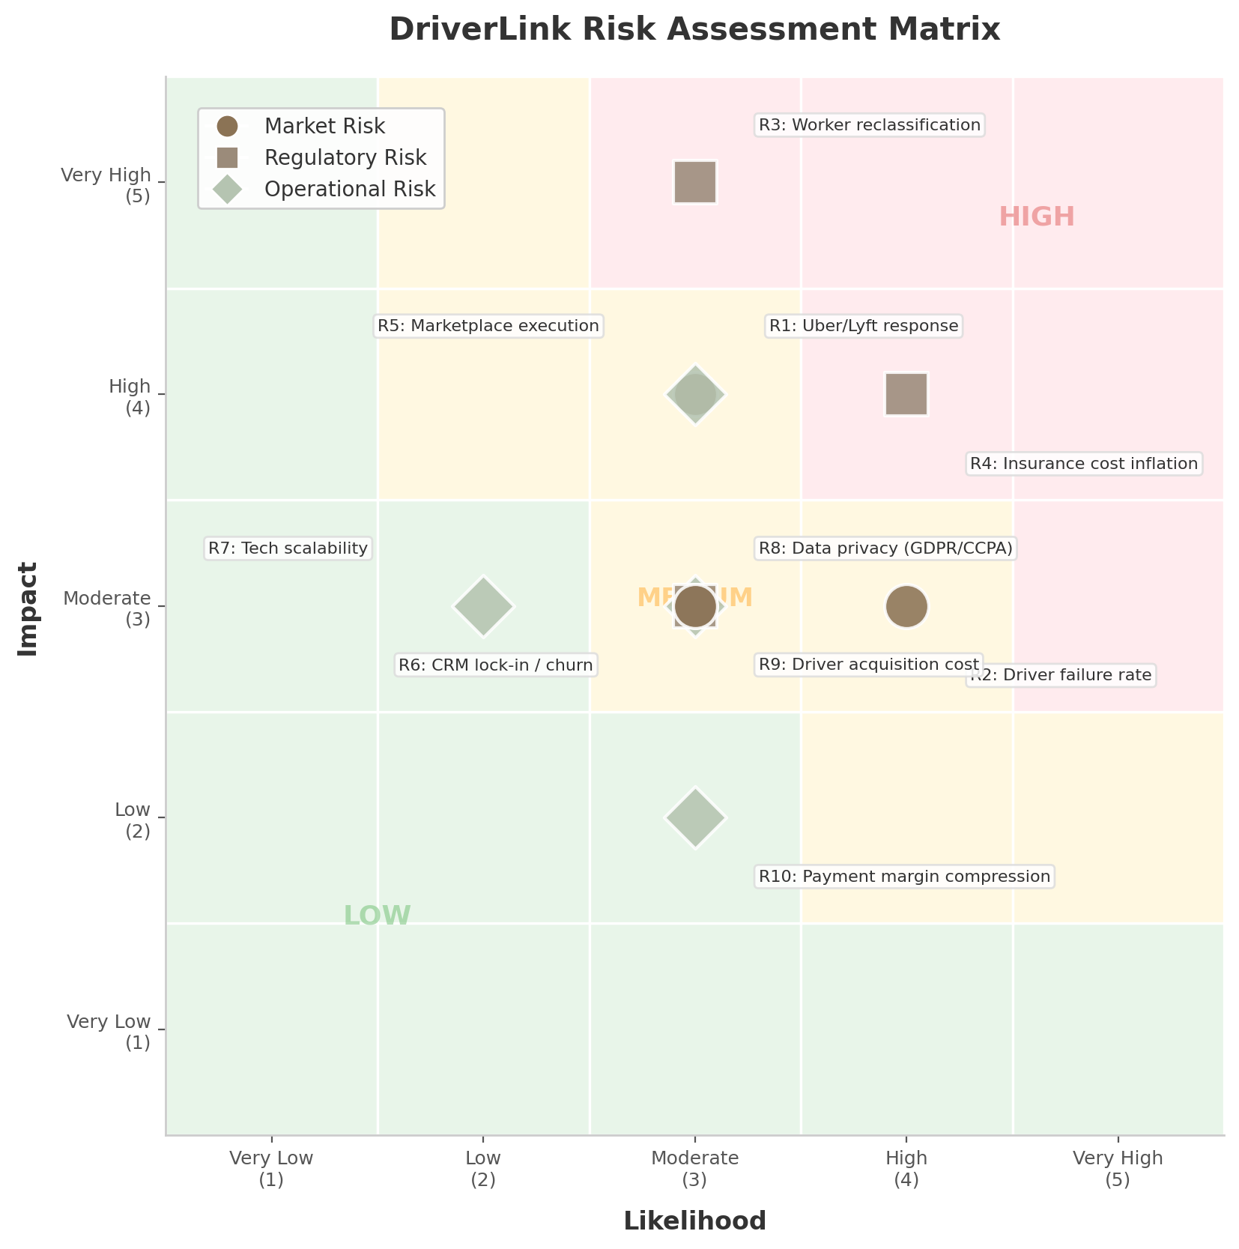
DriverLink Risk Assessment Matrix
The risk landscape reveals a critical insight: regulatory risks (R3, R4) carry the highest combined scores, while market risks (R1, R2) are most probable. Operational risks cluster in the medium zone but become acute if marketplace execution fails. The matrix suggests DriverLink’s risk profile is asymmetric — regulatory missteps could be existential, while market and operational risks are manageable with disciplined execution.

9.1 Market Risks

9.1.1 Uber/Lyft Competitive Response — Mitigated by SaaS-Not-Marketplace Positioning
The most visible competitive threat is a direct response from Uber or Lyft. Uber’s acquisition of Blacklane (March 2026, undisclosed terms) ⁵²and launch of Uber Elite ⁶⁰signal aggressive premium segment expansion. Lyft’s acquisition of TBR Global for £83 million ⁵⁸and Gett’s UK operations for £40 million ⁶²demonstrate similar intent. Either platform could theoretically extend its driver toolset into standalone SaaS offerings or acquire Anolla — the closest existing comparable.
The mitigation, however, is structural. Uber and Lyft are fundamentally marketplace businesses; their entire economics depend on controlling the rider-driver transaction. Uber’s take rate has climbed from 10% to 40%+ ⁴³, and the company’s strategic pivot toward autonomous vehicles (100,000 Waymo robotaxis targeted by 2027) ¹signals reduced long-term reliance on human drivers. A SaaS-tool offering that helps drivers go independent would directly cannibalize Uber’s supply base — creating an internal conflict that makes such a move strategically irrational. Blacklane’s partner model provides “complete schedule control” and “reliable direct payment” ⁵³, but it remains a demand platform, not a business operating system. DriverLink’s positioning as “Squarespace for chauffeurs” rather than “Uber for independents” creates a competitive moat that marketplace incumbents cannot cross without undermining their core business model.

9.1.2 Driver Acquisition: 47.4% Five-Year Failure Rate for Independents
The transportation and warehousing industry exhibits a 20.4% first-year business failure rate, rising to 47.4% by year five and 63.9% by year ten ⁴⁴— placing it in the bottom half of all industries for survival. This statistic represents both a risk and an opportunity: every failed independent driver is a churned customer, but the high failure rate is driven by precisely the pain points DriverLink addresses.
Research identifies the primary failure drivers as cash flow disruption (56% of small businesses wait on unpaid invoices) ⁴⁵, customer acquisition failure (the #1 cited challenge for independents) ¹³², and lack of integrated business tools (70% of small fleets still use manual scheduling) ⁷⁶. The mitigation strategy maps directly onto these causes: embedded payment processing with automated invoicing reduces collection cycles from 30+ days to instant; marketplace demand generation provides a predictable client pipeline; and the all-in-one SaaS tool replaces the fragmented stack of WhatsApp, Google Calendar, and spreadsheets that currently dominates independent operations ²⁹. Targeting recently departed Uber Black/Reserve drivers — a population actively seeking independence as Uber’s take rates rise and AV deployment threatens human driver roles — provides a captured recruitment pipeline that lowers CAC toward the $300–$400 range ⁸⁷.

9.2 Regulatory Risks

9.2.1 Reclassification Risk — SaaS Tool Model Provides Strongest Defense
Worker classification represents the single highest-impact risk on the matrix (R3: score 15). California’s AB5 codified the ABC test, which presumes all workers are employees unless the hiring entity can demonstrate the worker is (A) free from control, (B) outside the usual course of business, and (C) customarily engaged in an independent trade ¹⁹³. Critically, CPUC regulations require all TCP-licensed vehicle operators in California to be classified as W-2 employees of the TCP license holder — independent contractors cannot operate TCP-listed vehicles ¹⁷. At the federal level, the DOL’s 2024 independent contractor rule is no longer being enforced as of May 2025, but remains in effect for private litigation ¹⁷⁷. Internationally, the EU Platform Work Directive (2024/2831) creates a rebuttable employment presumption for “platforms” effective December 2026 ¹⁸.
The defense is architectural. A pure SaaS tool that provides scheduling, invoicing, and client management — without controlling dispatch, pricing, hours, or restricting drivers to the platform — falls outside the statutory definition of a “platform” or “transportation network company.” The DOL’s Fact Sheet #13 framework examines control, integration, and economic dependence as primary factors ¹⁸⁵. By never dispatching rides, never setting prices, and never restricting multi-homing, DriverLink positions itself as a software provider, not an employer or marketplace operator. This distinction, while legally untested in chauffeur-specific contexts, aligns with the seven-factor Texas Administrative Code test for marketplace contractors, which explicitly exempts platforms that do not prescribe hours, control work locations, or restrict use of other platforms ¹⁸³. The “Squarespace for chauffeurs” positioning is not merely a marketing frame — it is a legal firewall.

9.2.2 Insurance Cost Inflation — AB-1807-Type Legislation Spreading
California’s AB-1807, effective July 1, 2025, raised minimum commercial auto liability from $750,000 to $2 million combined single limit per vehicle — driving premium increases of 20–50% for many operators ¹⁶⁵. Commercial limo insurance already averages $904/month nationally, with NYC TLC services at $1,403/month ¹⁷¹. Over half of all rideshare drivers lack proper gap coverage ¹⁹⁴, and the trend toward higher minimums is accelerating: New York State now requires $1.25 million during active rides ¹⁶⁶, and Uber reports insurance costs exceeding 25% of fares in New York and New Jersey ¹⁶⁶.
The mitigation strategy transforms insurance from a cost center into a revenue stream. By aggregating thousands of independent drivers into a collective risk pool, DriverLink can negotiate 20–40% premium reductions through group buying — validated by the National Limousine Association’s existing affinity programs (40% off background checks and fuel cards) ⁷³. Insurance commissions of 15–30% on premiums averaging $5,000–$15,000 annually generate $750–$6,480 per policy in near-pure margin ⁸⁶. At scale, this single feature could add $500–$1,500 in annual revenue per driver — matching or exceeding the SaaS subscription itself. The strategy follows Toast’s embedded finance playbook: use transaction data to underwrite risk, then capture the distribution margin ⁹.

9.3 Operational Risks

9.3.1 Two-Sided Marketplace Execution — CRM Lock-In and Subscription Retention
The chicken-and-egg problem — riders won’t join without drivers, drivers won’t join without riders — is the classic platform execution risk (R5: score 12). Uber solved this by focusing supply-side first, paying drivers $20–$30/hour guarantees during 60–90 day launch periods, and treating each city as its own startup with a 180-step playbook ¹³⁶ ¹⁵⁹. For DriverLink, the sequencing strategy is different but equally deliberate: the “come for the tool, stay for the network” approach, validated by OpenTable’s SaaS-first restaurant reservation system ¹⁹²and Toast’s 118% annual growth from POS-first expansion ¹⁹⁵.
The core insight is that premium chauffeur services are relationship-based, not algorithm-based ¹³⁴. Network effects in this segment are asymptotic — they deliver diminishing returns after approximately 4-minute pickup times, which is irrelevant for pre-booked chauffeur services ¹³⁴. This means CRM lock-in, not marketplace density, is the primary defensibility mechanism. As drivers build customer profiles, booking histories, payment methods, and preference notes on DriverLink, switching costs increase non-linearly. A driver with 200 customer profiles and years of history faces massive friction to migrate to any competitor — even one with superior marketplace liquidity. This “data moat” is reinforced by embedding financial services: BCG/Adyen research shows embedded payment strategies retain customers at 2.5x the rate of traditional providers ⁸⁴. The target NRR of 105–115% ⁹⁴is achievable through tier upgrades ($49 → $99 → $199/month), add-on adoption (SMS marketing, branded apps), and processing volume growth as driver businesses scale.

9.3.2 Technology Scalability — PWA-First De-Risks Mobile
Building native iOS and Android applications simultaneously with the core SaaS platform introduces scope creep, cost inflation, and delayed time-to-market. The PWA-first approach reduces mobile development costs by 40–60% and accelerates launch by 50–70% ⁵⁷, but carries a known limitation: iOS PWAs cannot send push notifications ¹³², which is critical for real-time booking alerts and driver status updates.
The mitigation is staged. Phase 1 deploys a PWA for both rider booking and driver companion functionality — sufficient for the SaaS-first launch where real-time GPS tracking is not yet required. Phase 2 adds a Capacitor native wrapper to enable push notifications without rewriting the application. Phase 3 builds a native driver app only when continuous GPS tracking and background location services become essential — a milestone likely reached at 5,000+ active drivers when dispatch optimization requires real-time position data. This staged approach follows the CloudTrucks model ($141.6M raised, $850M valuation), which built its “business in a box” for truckers using a responsive web-first approach before adding native features ⁷². On the backend, PostgreSQL with Row-Level Security handles multi-tenancy at scale — benchmarks show 94.74% query performance improvement with proper RLS filter optimization ¹⁹— and Stripe Connect Express enables driver onboarding in under two minutes with automatic KYC verification ⁵⁸.
The technology risk is further de-risked by the vertical SaaS precedent. Toast serves ~164,000 restaurant locations with annualized revenue exceeding $2.0 billion ⁷; Shopify powers millions of merchants ⁸; and GlossGenius reached $100M ARR with only $17.6M in funding ⁶⁹. The infrastructure patterns — multi-tenant PostgreSQL, Stripe Connect, serverless deployment on Vercel/AWS — are proven at orders of magnitude beyond DriverLink’s projected scale. The risk is not technical feasibility; it is execution sequencing. Prioritizing standalone SaaS utility over marketplace features in the first 12–18 months aligns product development with the platform’s primary retention mechanism and its most powerful regulatory defense.

10. Conclusion
The global chauffeur market is a $60–85 billion industry growing at 6–15% annually, yet it remains structurally identical to the restaurant industry before Toast or retail before Shopify: 70% of operators run fewer than five vehicles, no single player controls more than 5% nationally, and the vast majority of small fleets still manage bookings with pen and paper, phone calls, or WhatsApp ⁴. This is not a market with a dominant platform to displace — it is a whitespace waiting for its vertical operating system.
DriverLink enters this gap with a sequencing insight that redefines the competitive landscape. Premium chauffeur services are relationship-based, not algorithm-based; network effects are asymptotic and weaker than in ride-hailing ¹³⁴. This means the classic two-sided marketplace chicken-and-egg problem dissolves. Drivers will pay for standalone scheduling, CRM, invoicing, and payment tools even with zero riders on the platform — the “come for the tool, stay for the network” playbook that Toast used to reach $6.15 billion in revenue ⁷and GlossGenius used to hit $100 million ARR on just $17.6 million in capital ⁶⁹. SaaS-first, marketplace-second is not merely a product strategy; it is a regulatory fortress. By never controlling dispatch, never setting prices, and never restricting multi-homing, DriverLink positions itself as a software provider outside the employment nexus that threatens Uber, Lyft, and Blacklane across the EU, California, and an expanding list of jurisdictions ¹⁷ ¹⁸.
The revenue architecture follows the proven vertical SaaS playbook. Subscription fees at $49–$199 per month address an immediate, addressable TAM of $30–95 million across an estimated 25,000–40,000 independent chauffeurs in the United States ⁵ ⁶. But the true engine is embedded fintech. Payment processing spreads, insurance brokerage commissions of 15–30% on premiums averaging $5,000–$21,600 annually, and lending products together expand per-driver revenue 3–5x — the same transformation that shifted Toast to 82% payments-derived revenue and Shopify to 74% merchant solutions ⁸ ⁹. When fully layered, the serviceable TAM reaches $108–500 million.
Unit economics reinforce this trajectory. At target scale, the model projects a 6.4:1 LTV-to-CAC ratio, a 4.5-month payback period, and 55–70% gross margins. The Sun Belt go-to-market strategy — Atlanta first, followed by Dallas, Houston, Charlotte, and Phoenix — targets markets where 80% of US population growth is concentrated, regulatory barriers are lower, and just 20–30 active drivers per city achieves critical mass ³. Three revenue accelerators sit immediately within reach: corporate B2B2C integrations (corporate travel accounts for 49–58% of market revenue and generates 2–3x the profitability of leisure bookings), NEMT vertical specialization (a $4.4–6.6 billion segment with government-guaranteed demand), and insurance group buying (transforming the largest fixed cost burden into a revenue stream).
The Ask. DriverLink is raising pre-seed/seed capital to reach 1,000 paying drivers across 5–8 Sun Belt cities within 18 months — a milestone that translates to $2.2–4.9 million in ARR and puts the platform on a clear path to Series A scale. This is not a concept. The product architecture is specified, the competitive whitespace is verified across eleven direct competitors, the regulatory pathway is mapped, and the unit economics are modeled against directly comparable vertical SaaS benchmarks. The only remaining variable is execution speed. The market is open, the drivers are waiting, and the window for category definition is narrow.

Appendix: Research Methodology

Research Scope
This report was produced through a multi-agent deep research pipeline covering 12 independent research dimensions, with findings cross-verified across 400+ sources.

Dimensions Researched
- Market Sizing & TAM Analysis
- Competitive Landscape & Platform Players
- “Shopify for X” Vertical SaaS Business Model Patterns
- Independent Driver Economics & Pain Points
- Target Customer Segments & Vertical Opportunities
- Technology Stack & Platform Architecture
- Two-Sided Marketplace Dynamics & Growth Strategy
- Regulatory, Insurance & Compliance Landscape
- Go-to-Market Strategy & Customer Acquisition
- Unit Economics, Pricing Models & Revenue Optimization
- Vertical Specialization & Niche Opportunities
- International Expansion & Regional Market Variations

Source Tiers
- T1 (Primary): Government sources (BLS, BTS, FMCSA), SEC filings (Toast, Shopify), court rulings, official regulatory bodies (CPUC, TLC, EU Commission)
- T2 (Secondary): Major market research firms (Dimension Market Research, MAK Data, Dataintelo), industry publications (Chauffeur Driven Magazine, Business Travel News), established media (Business Insider, Bloomberg)
- Rejected: Content farms, anonymous forums (except as anecdotal color), unverified social media

Confidence Framework
- High Confidence: Confirmed by ≥2 agents from independent sources
- Medium Confidence: Single authoritative source or consistent but limited sources
- Low Confidence: Weak sourcing or single unverified claim
- Conflict Zone: Statistical disagreement between sources (documented with analysis)

Research Artifacts
All supporting research files are available in /mnt/agents/output/research/: - 12 dimension reports (driverlink_dim01.md through driverlink_dim12.md) - Cross-verification analysis (driverlink_cross_verification.md) - Insight extraction (driverlink_insight.md) - Prototype analysis (driverlink_prototype.md)

