VICTOR MARTIN KAHIHU
DSE-01-8788/2024
COUMPUTING SYSTEM MODELS
ABSTRACT
This research document highlights various concepts of computing, their meaning, how they work and all advantages and disadvantages.
- CENTRALISED COMPUTING
What is Centralized Computing? Centralized computing refers to a system where all processing and data storage is handled by a single, central device or system. This central device is responsible for processing all requests and managing all data, and all other devices in the system are connected to it and rely on it for their computing needs.
Components
There are several key components of a Centralized Computing System
Central Device or System: The central device or system handles all processing and data storage for the system.
Clients: The clients are devices or systems that request and receive services from the central device or system.
Network: The network connects the central device or system and the clients, allowing them to communicate and exchange data. The architecture of a centralized computing system is typically a client-server architecture, where the central device or system acts as a server and the other devices in the system act as clients.
Characteristics
There are several characteristics that define a Centralized Computing System
Single Central Device or System: All processing and data storage is handled by a single, central device or system.
Client-Server Architecture: The central device or system acts as a server, while other devices in the system act as clients that request and receive services from the server.
Shared Resources: The central device or system manages and controls access to shared resources, such as data storage and processing power.
Vertical Scaling: Scaling a centralized computing system typically involves adding more resources to the central device or system, such as additional memory or processing power. This can be done through hardware upgrades or by adding additional devices to the system.
Advantages and Disadvantages
Advantages
1.Simplicity: Centralized systems are relatively simple, as all processing and data storage is handled by a single device or system.
2. Cost: Centralized systems may be cheaper to set up and maintain, as they require fewer devices or systems.
3.Performance: Centralized systems may offer faster performance, as all processing and data storage is handled by a single, powerful device or system.
Limitations/ Disadvantages
1.Single Point of Failure: If the central device or system fails, the entire system may go down, as all processing and data storage relies on the central device.
2. Limited Scalability: Centralized systems may be limited in their ability to scale, as they are dependent on the capabilities of the central device or system.
3. Limited Flexibility: It may be more difficult to reconfigure or adapt a centralized system to meet changing needs or requirements
meet changing needs or requirements
Applications of Centralized Computing Systems
1.Mainframe Systems: Traditional mainframe systems are a type of centralized computing system that is used in a variety of industries, including finance, healthcare, and government.
2. Client-Server Systems: Client-server systems are a type of centralized computing system that is used in a variety of applications, including business applications, web applications, and more.
3.Network Servers: Network servers are a type of centralized computing system that is used to manage and control access to shared resources, such as data storage and printing, on a network

- GRID COMPUTING

Grid computing is a distributed architecture that combines computer resources from different locations to achieve a basic goal. It can also be defined as a network of computers working together to perform a task that would rather be difficult for a single machine.
IMPORTANCE OF GRID COMPUTING
- Scalability- It can increase or reduce the number of computers based on the amount of workload.
- Resource utilization- it maximizes resource utilization by pooling resources from the multiple computers.
- Complex problem solving- they can handle large scale problems that require significant computation power.
- Collaboration- They facilitate collaboration across geographical boundaries as seen in fields of research.
TYPES OF GRID COMPUTING
- Computation grid- It is a collection of high performance processors.
- Scavenging grid- Similar to computing grid, CPU scavenging grids have a large number of conventional computers.
- Data grid- It refers to a grid of computing network that connects multiple computers together to enable huge amount of data storage.

USE CASES OF GRID COMPUTING
- Genomic research
- Drug discovery
- Cancer research
- Weather forecasting
- Risk analysis
- Computer-Aided design(CAD)
- Animation and visual effects
- Collaborative projects

ADVANTAGES AND DISADVANTAGES OF GRID COMPUTING

ADVANTAGES
- Grid computing provides a high resource utilization. This is because of the number of computers being used.
- Grid computing allows parallel processing of tasks- This means that several tasks can be performed at the same time.
- Scalability- Grid computing is flexible as it can increase the number of computers or reduce the number of computers based on the amount of work being done.

DISADVANTAGES
- Grid computing is still in the evolution stages. This means that it can not be efficient as it still needs to be adapted well.
- It is sometimes complex in the nature it operates on.
- Security- As it uses various devices, the chances of security breaches are high hence it is not secure.
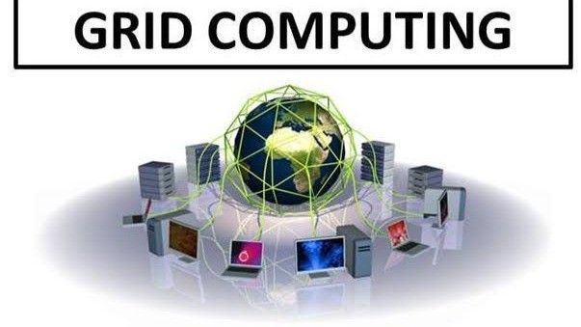

3.CLOUD COMPUTING

This is a technology that allows a user to use data and application over the internet.
It allows movement beyond the limitations of a local computer’s hard drive or a private server.

COMPARISON BETWEEN THE OLD WAY AND THE NEW WAY(CLOUD)

- THE OLD WAY
The companies then had to buy powerful physical servers, storage disks, and networking equipment.
This meant that the amount of investment placed was huge.
Installation of the servers was also a challenge as it would take days or even weeks to be installed.

- THE NEW WAY
This came when cloud was introduced. Here, instead of buying large servers, you just rent computing power from a cloud provider like Google.
This greatly reduced the amount of cost a company had to incur to purchase a server.

ARCHITECTURE OF CLOUD COMPUTING
It entails three different components:
- Front end
- Back end (servers)
- Cloud based delivery and a network

- FRONT-END
The user interface of cloud computing consists of two sections of clients; the thin clients and the fat clients. The thin clients are the ones that use web browsers facilitating portable and lightweight accessibility while the fat clients are the ones who use many functionalities for offering a strong user experience.

- BACK-END
This is the core of the computing. It is made up of several servers for storage and processing computing. This is where management of applications logic is managed through the servers.

- CLOUD-BASED DELIVERY AND NETWORK
On-demand access to the computer and resources is provided over the internet, intranet and intercloud. Internet comes with global accessibility, intranet helps with internal communications of the services within an organization and the intercloud enables interoperability across various cloud services.

CLOUD DEPLOYMENT MODELS
- PRIVATE CLOUD- the cloud is only used by a single organization and not by others.
- PUBLIC CLOUD- the cloud infrastructure is owned and managed by a third party service provider like Google and is made available to the general public over the internet.
- HYBRID CLOUD- it is a combination of both private and public clouds. It offers flexibility, allowing companies to keep sensitive data on a private cloud while leveraging the scalable resources of a public cloud for other applications.

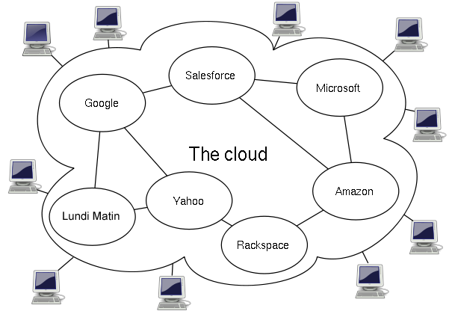
This Photo by Unknown Author is licensed under CC BY-SA

]

4.UBIQUITOUS COMPUTING

It is also referred to pervasive computing.
It refers to the presence of computers in common objects found all around us so that people are unaware of their presence.
These devices communicate with each other over wireless networks without the interaction of the user.
It is a combination of three technologies;
- Micro electronic technology
- Digital communication technology
- The internet standardization
Thus wireless communication, consumer electronic and computer technology were all merged into one to create a new environment called pervasive computing environment.
CHARACTERISTICS OF PERVASIVE COMPUTING
- Many devices can be integrated into one system for multi-purpose uses.
- A huge number of various interfaces can be used to build an optimized user interface.
- Concurrent operation of online and offline supported.
- A large number of specialized computers are integrated through local buses and internet.
- Security elements are added to prevent misuse and unauthorized access.

These type of functions can be extended into network operations for use in workplace, home and mobile environments.

APPLICATIONAREAS OF PERVASIVE COMPUTING
- Retail
- Airline booking and check-in
- Sales force automation
- Healthcare
- Tracking
- Car information system
- Email access via WAP (wireless application protocol) and voice

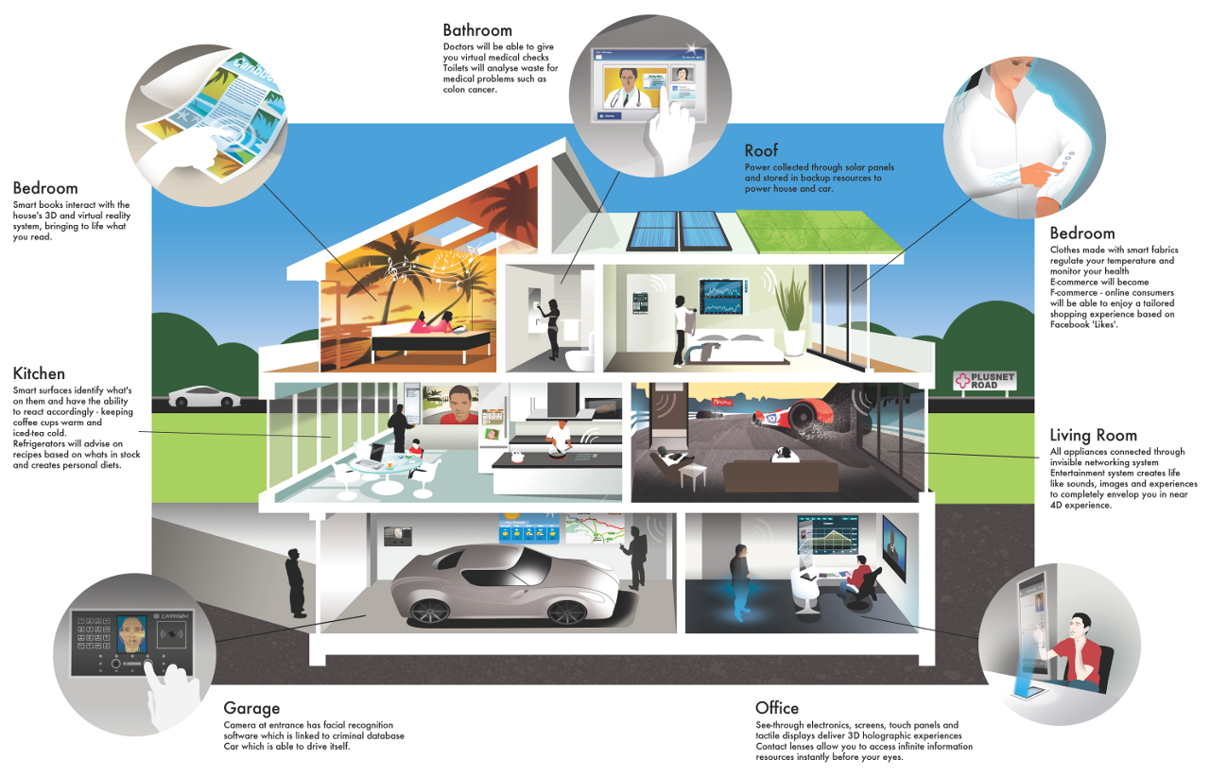
This Photo by Unknown Author is licensed under CC BY-SA-NC

5 DISTRIBUTED COMPUTING

Distributed computing refers to a system where processing and data storage is distributed across multiple devices or systems, rather than being handled by a single central device.
In a distributed system , each device or system has its own processing capabilities and may also store and manage its own data. These devices or systems work together to perform tasks and share resources, with no single device serving as the central hub.

COMPONENTS OF DISTRIBUTED COMPUTING
- Devices or systems- they have their own processing capabilities and may also store and manage data.
- Network- it connects devices in the distributed system, allowing them to communicate and exchange data.
- Resource management- distributed systems often have some type of resource management system in place to allocate and manage shared resources such as computing power, storage and networking.

CHARACTERISTICS OF DISTRIBUTED COMPUTING
- Multiple devices- data processing is done across multiple devices.
- Peer-to-peer architecture- devices in a distributed system act as clients and servers, as they can both request and provide services to other devices.
- Shared resources- resources such as computing power are shared across among devices.
- Horizontal scaling- scaling is done by increasing the number of devices hence increasing the capacity and storage.

ADVANTAGES AND DISADVANTAGES OF DISTRIBUTED COMPUTING
ADVANTAGES
- Scalability- one can easily add new devices increasing the storage capacity.
- Reliability- they are reliable than centralized systems because if one device fails the system is still capable of continuing .
- Flexibility- the system can easily be configured and reconfigured easily in order to meet the changing computing needs.

DISADVANTAGES
- Complexity- they are more complex since they involve various devices that need management.
- Security- it is more difficult to secure a distributed system as security measures have to be implemented to all devices.
- Performance- their performance is unwavering since it uses many devices.

APPLICATIONS
- Cloud computing
- Peer-to-peer networks
- Distributed architectures
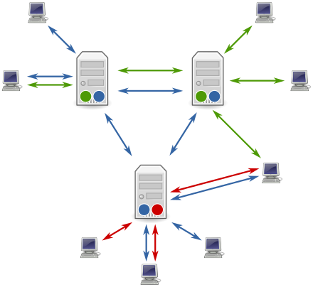
This Photo by Unknown Author is licensed under CC BY-SA

REFERENCES
- https://www.linkedin.com/company/celebsandstyle/ 23 July 2021
- https://www.geeksforgeeks.org/ 19 January 2023
- Vinicius Fulber-Garcia https://www.baeldung.com/ 18 March 2024
- Buyya, Rajkumar University of Melbourne, Melbourne, Australia 2025
- https://www.geeksforgeeks.org/ 12 July 2025
- https://openmetal.io/ 5 October 2025
- Alan Zeichick | Senior Writer |https://www.oracle.com/ April 10, 2025
- https://www.geeksforgeeks.org/ 06 Feb, 2020
- https://www.open.edu/ 2025
- Phill Powell Staff Writer https://www.ibm.com/ 2024
- https://aws.amazon.com/ 2025C

