|  |
| --- |
| Group 26 |
| Project Proposal – Swords of Turing |
| CMP2089M |
| Marlon Gilliam 14471455;  Benjamin Stock 13457465;  Emmanuel Uanseru 13454941;  Stefano Rinaldi 14480397;  Benjamin Rogers 14470874;  Matthew Webster 13466955  18-2-2016 |

Contents

Intro

Project Aims

Literature Review

AI and ‘The Turing Test’

AI in Video Games

Risk Matrix

Project Plan and Timescales

Online Video Pitch

# Intro

For our group project assessment, we have been tasked with developing an AI system that is capable of passing the Turing test. The system would attempt to mislead a user into believing it is interacting with another human in a given scenario. As a group we are developing the two player combat game, Swords of Turing, which pits the user against an AI.

The Turing test, theorised and developed by Alan Turing, is a test of a computer system's ability to act in such a way that it would be indistinguishable from another human. The system would take in input from a human and, using natural language processing (NLP), generate a response that would try and fool the user into thinking that it was human. The aim for this project is to develop such a system.

We have chosen a combat game as a case study for a number of reasons. After extensive discussion as a group, we had a list of skillsets that would be useful in the completion of the assessment. With confident programmers and game students, making a game was seen as a good idea. The group was confident in understanding game AI and systems, as well as being a passionate hobby amongst all members.

Another advantage for the chosen case study was the lack of emphasis on the NLP side of the Turing test. NLP is a very advanced and complex system to get right, with random input from users often garnering stock responses from simple AIs, very easy to be caught out by the Turing test. Focusing more on AI that makes mistakes in the context of a game removes the need to create a database that would be too large to develop within our given timeframe. This increases our chances of developing a system that meets the objective of the assessment.

When discussing the idea for what game to make, many ideas were put forward. Games like Scrabble and Countdown were proposed quite early on. However, an AI that generates words and solves maths problems was deemed too hard to fake. The AI couldn’t really make mistakes and would likely end up generating results that were clearly computerised. This kind of system would fail to meet the aim of the assessment and so was written off.

We then discussed more visual based games like Connect 4 and chess as viable options. Although easier to develop, Connect 4 would not really challenge the group in any way. The mechanics and dynamics of games of this nature would not serve as a complex enough base for our AI system. Chess was deemed almost the opposite, with millions of permutations for any game, the system would be far beyond the scope of the group’s skillset.

Following the decision to develop our own game we decided that designing a system with a limited number of moves would lead to fluid player interaction as well as being manageable for AI programming. Having only a limited number of moves in the game means we can develop at a pace that the group is comfortable with, reducing the risk of running over the allotted time in our project plan.

# Project Aims

We are aiming to create a game that is enjoyable when played with either a friend or versus an AI.

We look to develop an AI that behaves in a mannerism that appears to be human like, and doesn’t pertain to the traditional and inhuman traits found in most common video game AIs.

Furthering this, we will look to craft a system whereby the AI can record the player’s behaviours and devise methods by which it can counteract these actions.

Given the situation where all these aims are met, the final product should be a game where the AI is indistinguishable from another human player. This will be due to its humanised characteristics and its unpredictable, occasionally illogical, actions. It should be developed to a stage where the AI can lose intentionally in order to gain knowledge about the player, which it would then use to win.

# Literature Review

The Turing test is a test developed by British computer scientist Alan Turing in 1950 , Turing proposed the question “Can Machines Think” . The whole experiment comprises on machines thinking like humans and being able to understand skills and knowledge that it can use to imitate a human . Turing experiments this theory using a game called the imitation game . Artificial intelligence (or also known as AI) is defined as a computer or software that shows intelligence. “The ability to acquire, understand and apply knowledge and skills” is the dictionary definition of intelligence and this means that a program has to show this to be an AI (or has an AI in the program). The Turing Test was used as a means to see if a user could be fooled into thinking an AI is actually another human use

2.Artificial intelligence has been around for at least 66 years and the technology only just started to take off. Projects like cleverbot, an “AI” that you talk to which remembers replies received from users and uses them to reply to the same question when a user asks cleverbot the question, fail because of it mixing up conversations and moves onto other things without warning. This is the reason why the human brain is the most powerful “computer” and currently we do not have the technology to recreate this. For example according to Scientific American the human brain can store about 2.5 PB (Petabytes, 1000 TB) of data while the Largest storage hard drive we have at the moment is 16TB. An example of how big that is it could store 300 years of TV So instead of programmers trying to create programs that learn from interaction, they make them look like it is learning when instead it’s just selecting pre made actions and slightly editing them.

An example of AI is drones and robots, which use cameras and sensors to see how close they are to walls and objects. If they find themselves too close to something it will stop (if it’s moving towards the object that’s blocking its path) and back away if it needs to. This is similar to some cars we have today as well, automatically breaking if the programming feels that the driver is going to crash if he leaves it any later. Some can go as far as memorise the layout of the room to know not to go that close to the area.

Turing Test

The Turing test itself never explicitly states any definite way in which it is to be conducted. (W. Rapaport, 2000) States that “Turing says nothing about what the suitably programmed computer is supposed to do” The commonly used internet security test “‘CAPTCHA’ is a “Commonly Automated Public Turing test to tell Computers and Humans Apart” (M. Kouritzin, 2013) This is probably the most frequently used example of a modern turing test. The only exception is that the interrogator is not a human. The paper goes on to discuss how CAPTCHAs are an example of a simple visual understanding test that humans are able to pass but computers are not yet able to devise. Within our project we are aiming to create an AI that is capable of human like behaviour. The test for this will be the visual actions that it makes during the course of the game. To do this the system will have to recognise the actions that the player makes and understand why they undertake these visual actions.

## AI in Video Games

In terms of Artificial Intelligence (A.I.) video games have always had some ongoing research into the area as the more advanced an A.I. in a game can be, the better the quality the computer opponents will be whether that is the difficulty in beating the A.I. opponent or making more believable characters through these processes. With the Turing test in mind the aim of this project is to create an A.I. that a human player can fight against while believing that the A.I. is in fact another human playing against them. To make an A.I. that seems human there would have to be certain aspects of behaviour given to the A.I. which we associate with human beings such as making a mistake or a joke.

One of the games that designs around this area of A.I. is the popular game series The Sims which uses A.I. to simulate human beings in the most realistic way they can, Richard Evans from EA has discussed the building of characters in the Sims through A.I. [2] by discussing his company's attempt at making each of the sims in the game function as if they’re a real human being, they’ve attempted to create a human like A.I. by having each of the characters in their world work based on a set of basic needs, desires and goals which would allow for the computer controlled people seem as if they’re autonomous people, for example Richard Evans stated that through this design the sims are able to be seen as characters rather than just computer players in the game. The project we’re putting forward is going to try to create ways for the A.I. to seem as if it has human goals by simulating the sort of actions that a human would perform without there being a logic purpose for it e.g. Some players may jump around in victory in the game after beating an enemy however a non human like A.I. wouldn’t as performing those actions doesn’t benefit it in any way. In our fencing game we could implement ways for the A.I. to seem more human through illogical actions such as jumping for victory or attacking the air however these actions would have to be kept random in style in order the actions to not seem like part of a routine.

While A.I. autonomy is a trait that may be solved through a list of objectives there is another suggestion to the next step in human A.I. given by Dave Mark from Intrinsic Algorithm, he stated that with the creation of all the different ways an A.I. can think it doesn’t do much in terms of having a human A.I. without being able to express those thoughts in a variety of ways [3] e.g. An advanced A.I. that thinks similarly to a human being with no ways it can act it out will be seen easily as an A.I. however Dave Mark also commented on the fact that acting human is still difficult without the actions being subtle. In the project we would have to consider the subtlety of the actions that we let the A.I. perform as the subtlety of the movements can affect the result of a decision of the Turing test therefore the actions that are intended to emulate a human being will be reduced to smaller actions so that they may be better in terms of human A.I. interactions.

Richard Evans wrote a piece of research around this topic called “Representing Personality Traits as Conditionals” [1] which investigates two different approaches to making an A.I. seem to have a personality therefore making it seem more human. This research compares the approach used by the game “Sims 3” and an alternative approach which represents the traits of the A.I.’s as conditionals which means that instead of the traits being assigned to the A.I. outright, the traits could be in the code and be activated if certain conditions are met. This comparison found that the conditional approach can affect the personality of the A.I. in the ways the Sims approach can it can also result in an indefinite amount of personalities that are given to the A.I. This research will be considered and applied to this project with the use of a more conditional system for the triggering of the personality events which have been discussed before as the seemingly random events that make the A.I. seem much more human compared to the purely logical actions of a non human like A.I.

In conclusion our project is going to take the sum of the ideas from research and designs in products that have allowed for more human A.I. to become a reality therefore our project is going to investigate this field more and create another example of an attempt of creating a human A.I. This project will attempt to advance the area of production of human like A.I. by successfully creating a full game human A.I. that will be adequately convincing if placed in a Turing test. This will be achieved by making using the system of random but subtle events that will be programmed into the A.I. for it to decide when to perform each task as well as it being able to decide the appropriate attacks and defences in order to successfully combat the opponent however the A.I. will not be constructed to be skilful to the level of a computer system meaning that this product will be programmed with the ability to make mistakes much like a human would while still maintaining the overall control that a human may have meaning it will still be aimed at the level of skill that the average human being would possess in order to convince the participant of a Turing test that the game A.I. could very well be a human being.

# Project Plan and Timescales

In order to plan our timescales and that tasks that we needed to perform later on in the project. We decided to use a Gantt chart, as it specifies what task each person in the group is doing, and the timescale that they have for that task. The chart on the right shows each individual task and the category that they fall into. It clearly states the start and end date, as well as who we decided as a group, that the task is allocated to. This means that there should be no excuse for anyone being late on doing their tasks.

The chart below is a timeline of the tasks that we need to do in order to complete our project. We decided to group our tasks into four different categories; Planning, Programming and Design, Testing, and Reports and Findings. We decided to group the tasks as they help to show how well we are on track according to our plans.

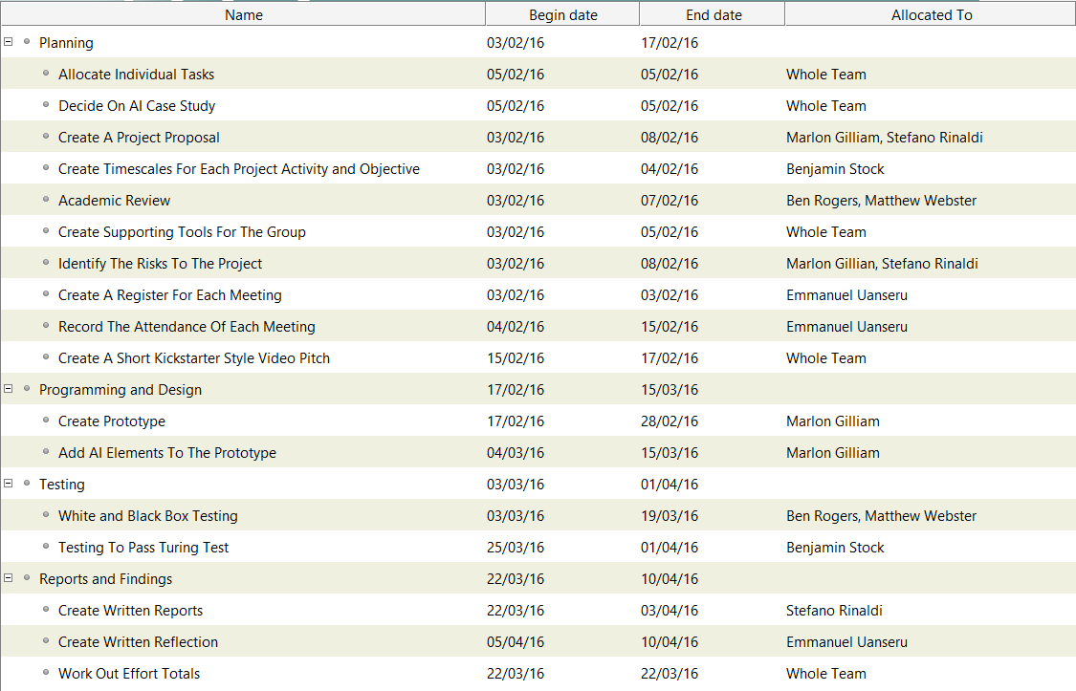

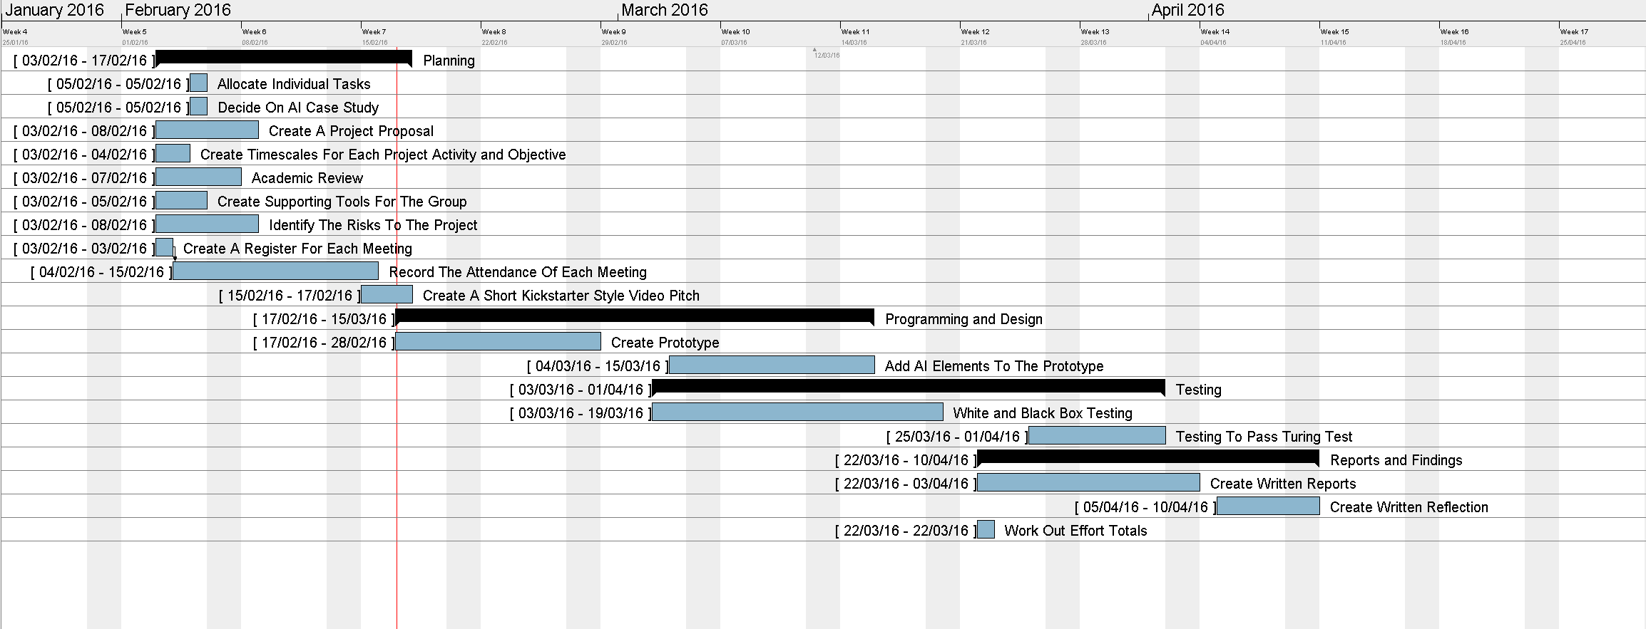

# Risk Matrix

|  |  |  |  |
| --- | --- | --- | --- |
| **Name of Risk** | **Likelihood of Risk Occurrence** | **Impact of Risk on Project** | **Possible Mitigations Methods** |
| Lack of productivity due to long development cycle | High | Medium | Break tasks down into small specific blocks that can be tackled compartmentally  Set small incremental developmental stages to be achieved at each group meet |
| Project requirements inflation | Low | High | Layout all projected requirements at project start and comprehensively cover their specific needs and wants  Dedicate time to finding effective systems that match these requirements and test them to make sure they fit specific development needs |
| Prototype Overruns time limit for development | Low | Low | Simplify prototype move straight to core development  Ignore complex prototype and rely upon design documents |
| Teams development skills don’t match specifics in the development of the project | Low | Low | Make sure throughout development that each member is working on an area that suits their expertise  Divide project development into smaller tasks that require different more specific skills to avoid people feeling over encumbered |
| Team members feel lost or confused with projects current development state | Low | Medium | Make sure to have regular group meetings at which everyone is updated on all aspects of the project  Time is allowed at these meetings for explanation of all development areas so everyone understands the entire project |
| AI code too ambitious | Medium | High | Allow more time for AI development  Have a backup project with less ambitious AI prepared |
| Visuals of project look amateur, causes user to misunderstand interface | Medium | High | Allow more time for development of visuals  Test the visual design with users throughout development  Outsource visuals to professional entity |
| Teams code skill lacking in certain areas | Medium | Medium | Allow time for research and practice in given areas  Try to find methods of production that don’t rely upon these areas  Acquire open-source materials to fill gaps in development |

# References

1. <http://philpapers.org/archive/EVARPT> -Evans, R “Representing Personality Traits as Conditionals” Research Paper (2008)
2. <http://www.gdcvault.com/play/1261/(307)-Breaking-the-Cookie-Cutter> - “Breaking the Cookie-Cutter: Modeling Individual Personality, Mood, and Emotion in Characters”,  Phil Carlisle, Richard Evans, Dave Mark. (2009)
3. <http://www.gdcvault.com/play/1268/(307)-Characters-Welcome-Next-Steps> - “Characters Welcome: Next Steps Towards Human AI”, Phil Carlisle, Richard Evans, Daniel Kline, Dave Mark, Borut Pfeifer, Robert Zubek (2009)
4. Kouritzin, M. Newton, F. Wu, B (2013). *On Random Field Completely Automated Public Turing Test to Tell Computers and Humans Apart Generation*. p1.
5. Rapaport, W (2000). *How to pass a turing test*. p2.

Appendix 1

|  |  |  |  |  |
| --- | --- | --- | --- | --- |
| **Meeting date, time and location** | **Key points** | **Progress** | **Attendees of the meeting** | **Absent members** |
| 03/02/2016  Bashir Office  10:30 – 11:00 AM | * Got to know each other * Discussed the assignment | * Got valued advice on the assignment from Bashir * Highlighted the objectives of the assignment | 1. **Emmanuel Uanseru** 2. **Benjamin Stock** 3. **Marlon Gilliam** 4. **Matthew Webster** 5. **Stefano Rinaldi** 6. **Ben Rogers** |  |
| 04/02/2016  University Library  2:30-3:30 PM | * Getting to know each other * Deciding on AI system * Allocating tasks * Making deadlines * Proposed idea of game being *Scrabble* or *Connect 4* * We had a vote on the game ideas to come to a decision on the game | * Decided on AI system would be a Fencing game where the user will believe they are playing an online game with a player but instead it will be a smart AI system. * To impress Jason and create a buzz with our AI system we decided the game will be UOL vs BGU * Allocated the tasks | 1. **Emmanuel Uanseru** 2. **Benjamin Stock** 3. **Marlon Gilliam** 4. **Matthew Webster** 5. **Stefano Rinaldi** 6. **Ben Rogers** |  |
| 08/02/2016  University Library  8:00-9:30 PM | * We discussed about the progress me made so far * I gave my group a Plan sheet so they can record their role and the aspects they would take to complete the task . | * Managed to get the group motivated * Everyone was on the right track with their task allocation * Managed to get permission to film the stage combat society so we can use them in our video | 1. **Emmanuel Uanseru** 2. **Benjamin Stock** 3. **Marlon Gilliam** 4. **Matthew Webster** 5. **Stefano Rinaldi** | 1. **Ben Rogers** |
| 10/02/2016  Bashir Office  10:30 – 11:00 AM | * Discussed our AI system idea * Discussed how we allocated the tasks | * Discussed the group member’s roles with our group supervisor. | 1. **Emmanuel Uanseru** 2. **Benjamin Stock** 3. **Marlon Gilliam** 4. **Matthew Webster** 5. **Ben Rogers** | **Stefano Rinaldi** |
| 04/02/2016  University Library  2:00-3:30 pm | * In this meeting we discussed and presented our individual tasks * We also discussed what can be improved on what we done so far. * We also talked about the difficulties we faced when working on our tasks and | * Each team member made an significant progress in their tasks and are on track to completing their tasks | 1. **Emmanuel Uanseru** 2. **Benjamin Stock** 3. **Marlon Gilliam** 4. **Matthew Webster** 5. **Ben Rogers** 6. **Stefano Rinaldi** |  |
| 11/02/2016  Jason Bradbury Lecture | * Gained some professional knowledge in the AI Industry * The robot was a very interesting and interactive way to present a lecture | * Was able to ask Jason crucial questions that will benefit our assignment | 1. **Emmanuel Uanseru** 2. **Benjamin Stock** | 1. **Marlon Gilliam** 2. **Matthew Webster** 3. **Ben Rogers** 4. **Stefano Rinaldi** |
| 12/02/2016  Stage Combat Filming session | * Discussed the animation of combat in the game | * Recorded stage combat for B-roll footage in the proposal video | 1. **Ben Rogers** 2. **Matthew Webster** 3. **Marlon Gilliam** 4. **Stefano Rinaldi** | 1. **Emmanuel Uanseru** 2. **Benjamin Stock** |
| 15/02/2016  University library  21:00 – 23:00 | * At this meeting we looked at everyone’s work and made suggestions how to improve it * We also discussed the video for Jason Bradbury and where , when, and what we will film | * After viewing everyone’s work I was very pleased to see the progress we all have made and we were near completion | 1. **Emmanuel Uanseru** 2. **Benjamin Stock** 3. **Marlon Gilliam** 4. **Matthew Webster** | 1. **Stefano Rinaldi** 2. **Ben Rogers** |
| 17/02/2016  Bashir Office  10:30 – 11:00 AM | * At this meeting we discussed our latest improvements * At this meeting we made a storyboard | * We were all motivated here to make a good video to impress Jason at Marlon’s house * We were almost finished and was able to show our supervisor evidence of our work and he was very impressed | 1. **Emmanuel Uanseru** 2. **Benjamin Stock** 3. **Marlon Gilliam** 4. **Matthew Webster** 5. **Ben Rogers** | 1. **Stefano Rinaldi** |
| 17/02/2016  Marlon’s house | * Marlon had all the filming equipment we needed so after our meeting with Bashir (group supervisor)we headed off to Marlon’s house . * At Marlon’s house we discussed more ideas on how we were going to film our video and present it * We finally decided on our Game name * We filmed our proposal video | * So I (Emmanuel) decided on the name of our game to be called swords of Turing because it is a fencing game that trying to challenge the Alan Turing test. * We filmed our group video and it looks good | 1. **Emmanuel Uanseru** 2. **Benjamin Stock** 3. **Marlon Gilliam** 4. **Matthew Webster** 5. **Ben Rogers** | 1. **Stefano Rinaldi** |
| 17/02/2016  Computer Labs | * After filming at Marlon’s house we headed to the labs to complete the work * We also had a discussion on the terms of what we are doing on the deadline day for this part of the assignment | * Peer assessed every team member's work | 1. **Emmanuel Uanseru** 2. **Benjamin Stock** 3. **Marlon Gilliam** 4. **Matthew Webster** 5. **Stefano Rinaldi** 6. **Ben Rogers** |  |
| 18/02/2016  David Chidwick business Building  12:00- 15:00 | * Had a final look at every team member's work * Discussed mark allocations | * Corrected Grammar and spelling mistakes of team members Work | 1. **Emmanuel Uanseru** 2. **Benjamin Stock** 3. **Marlon Gilliam** 4. **Matthew Webster** 5. **Stefano Rinaldi** 6. **Ben Rogers** |  |

|  |  |  |  |  |
| --- | --- | --- | --- | --- |
| **Name** | **Team Roles** | **Task allocation** | **Strengths** | **Weaknesses** |
| Emmanuel Uanseru | Completer Finisher | C5: Maintain a record or log of all group meetings, to include attendance records, tasks allocated and all progress made. | * Kept team motivated * Checked all work and helped all team members | * More concerned in other members work than own |
| Benjamin Stock | Co-ordinator | C3: Devise a plan for the project, allocating work logically and efficiently so that all objectives can be achieved in the project timescale. | * Developed the proposal document * Helped in editing of members work | * More concerned in other members work than own |
| Marlon Gilliam | Implementer | C1: Produce a project proposal which includes an introduction and identifies and justifies the project aim and objectives. A short video (max 60 seconds) can be used to explain this. | * Edited video * Brought in interesting ideas and reliable | * More concerned in other members work than own |
| Matthew Webster | Teamworker | C2: Conduct a review of recent, relevant academic literature on the subject. | * Good attendance and co –operative | * Poor effort and lazy |
| Stefano Rinaldi | Resource Investigator | C4: Analyse the risks associated with the project and identify ways in which those risks may be managed and mitigated. | * Excellent quality of work | * Poor attendance and low enthusiasm |
| Ben Rogers | Specialist | C2: Conduct a review of recent, relevant academic literature on the subject. | * Has good skills and knowledge | * Kept to himself and contributes on a narrow front |

Mark allocation

Marlon Gilliam 14471455; = 17.6

Benjamin Stock 13457465;=17.6

Emmanuel Uanseru 13454941;=17.6

Stefano Rinaldi 14480397; =17.6

Benjamin Rogers 14470874; =17.6

Matthew Webster 13466955 =11.6

# Online Video Pitch

<https://www.youtube.com/watch?v=f1nh2fe1AHA>