Project:BP Mount

Date:21-Mar-2011

Image 1

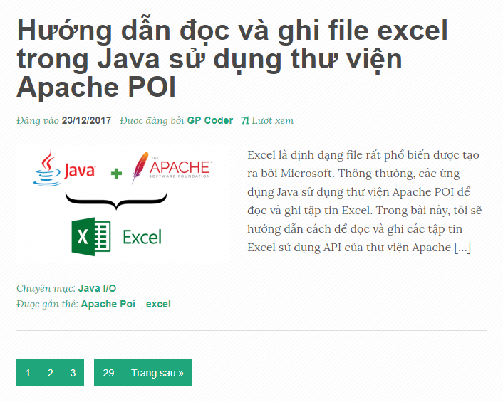

Image 2

