练习2

类图如下

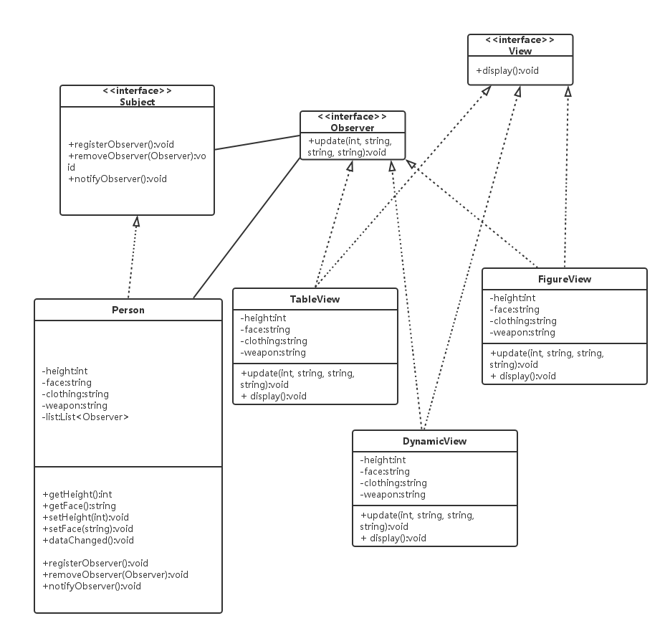

时序图

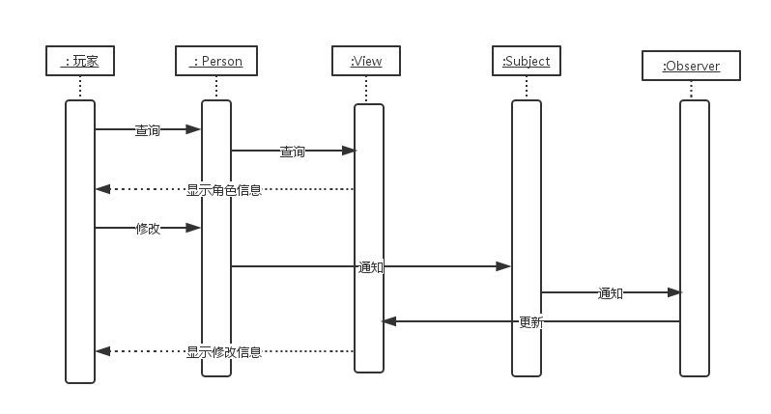

主要函数实现如下

**public** **void** registerObserver(Observer observer) {

list.add(observer);

}

**public** **void** removeObserver(Observer observer) {

list.remove(observer);

}

**public** **void** notifyObserver() {

**for** (Observer observer : list) {

observer.update(height, face, clothing, weapon);

}

}

**public** **void** dataChanged(){

notifyObserver();

}

**public** **void** update(**int** height, String face, String clothing, String weapon) {

**this**.clothing = clothing;

**this**.face = face;

**this**.height = height;

**this**.weapon = weapon;

}

**public** **static** **void** main(String[] args){

Person person = **new** Person();

TableView tv = **new** TableView(person);

tv.display();

person.dataChanged();

tv.display();

}