Creativity is Bold and Visionary
Creativity is the force that drives innovation, progress, and artistic expression. It is a bold pursuit that constantly challenges limits and encourages individuals to think beyond the ordinary. To be creative means embracing curiosity, taking risks, and passionately exploring new ideas.

The Courageous Nature of Creativity
Creativity is inherently bold because it aims to bring fresh and meaningful ideas to life. It does not settle for repetition or mediocrity but thrives on originality and transformation. Whether in art, science, business, or technology, bold creativity leads to breakthroughs and remarkable changes.

The Power of Vision and Persistence
Bold creativity requires vision—the ability to see beyond the present reality. Visionaries like Leonardo da Vinci, Steve Jobs, and Marie Curie exemplified how determined creativity can reshape the world. Their unwavering pursuit of innovation and refusal to accept limitations led to groundbreaking achievements.
Persistence is just as crucial. Creativity often involves challenges and failures, but those who think boldly persist despite setbacks. They view failures as stepping stones, refining their ideas until they reach success.

Creativity as a Driver of Growth
Bold creativity fosters both personal and professional growth. It pushes individuals to learn new skills, adapt to changes, and constantly improve. It also drives innovation in various industries, contributing to economic and technological advancements that shape society.
Additionally, bold creativity inspires others. Witnessing daring creative efforts encourages people to explore their own potential, creating a ripple effect that leads to a more dynamic and forward-thinking world.

Cultivating Bold Creativity
To nurture bold creativity, individuals should:
- Challenge conventional ideas – Question assumptions and explore fresh perspectives.
- Take strategic risks – Experiment with new concepts without fearing failure.
- Stay resilient – Overcome obstacles and refine ideas through persistence.
- Seek inspiration – Learn from creative minds in various fields.
- Collaborate – Share ideas and innovate through teamwork.
in conclusion, creativity is naturally bold. It dreams big, breaks barriers, and redefines possibilities. By adopting this mindset, individuals and societies can make extraordinary progress and leave a lasting impact on the world.
In c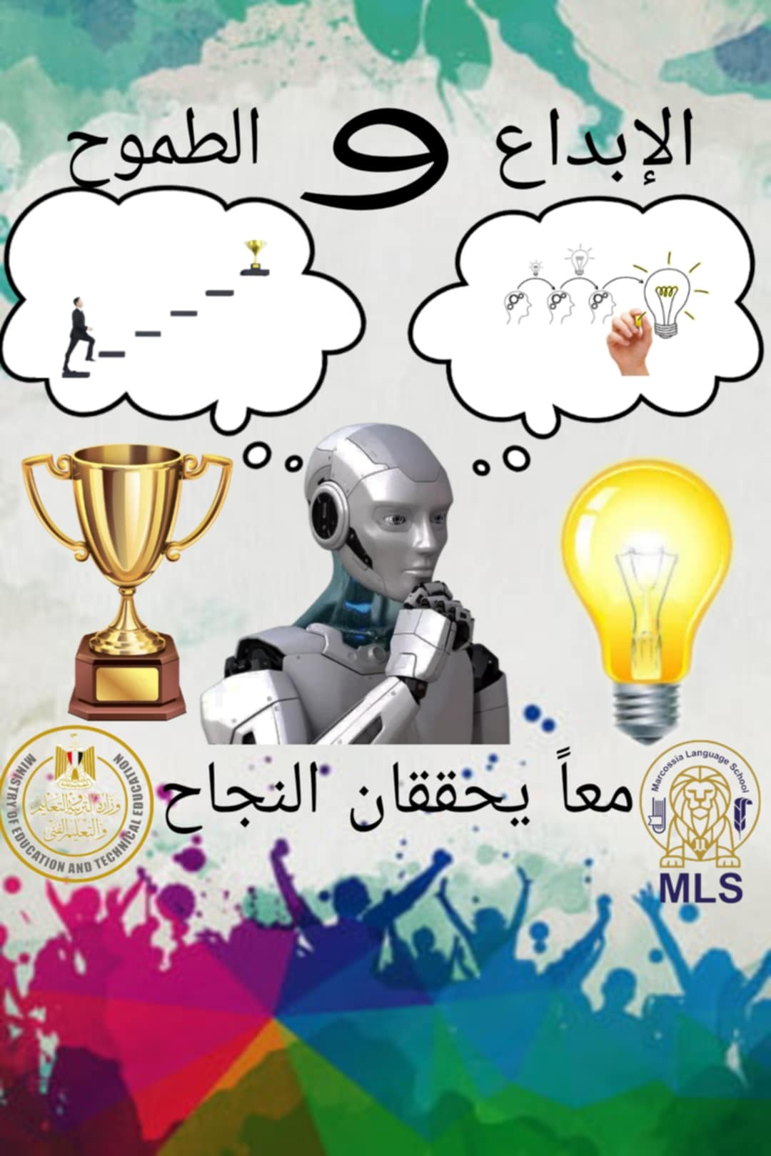 In

