Project 1 Report

ECE 461

Zach Hannum

2017

Contents

Blocking Code Implementation 2

Finite State Machine Implementation 3

Input Data 3

Output Data 3

Control Flow Diagram 3

State Machine Diagram 4

Logic Analyzer 5

Interrupt Service Routine Implementation 6

Input Data 6

Output Data 6

Logic Analyzer 6

Figure 1: Blocking Code I2C message on logic analyzer 2

Figure 2: FSM I2C Control Flow diagram 3

Figure 3: FSM I2C State Diagram 4

Figure 4: FSM I2C message with no delay 5

Figure 5: FSM I2C message with ~17 μs delay 5

Figure 6: FSM I2C message with ~19 μs delay - Missing NAK 5

Figure 7: FSM I2C message with ~21 μs delay - Reading 11 bytes (broken) 5

Figure 8: ISR I2C Full Message 6

Figure 9: ISR I2C Message detail 1 6

Figure 10: ISR I2C Message detail 2 6

Figure 11: ISR I2C Message detail 3 6

# Blocking Code Implementation

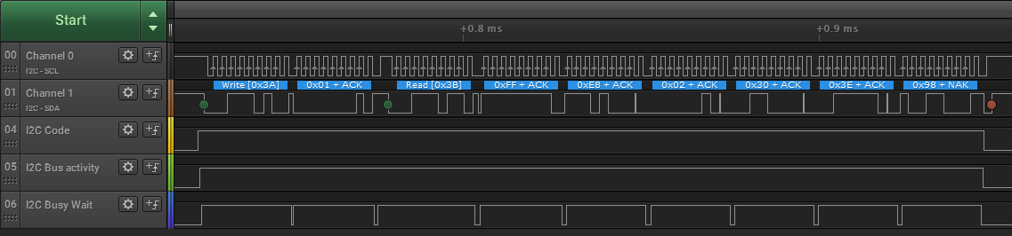

Figure 1: Blocking Code I2C message on logic analyzer

# Finite State Machine Implementation

## Input Data

## Output Data

## Control Flow Diagram



Figure 2: FSM I2C Control Flow diagram

## State Machine Diagram



Figure 3: FSM I2C State Diagram

## Logic Analyzer

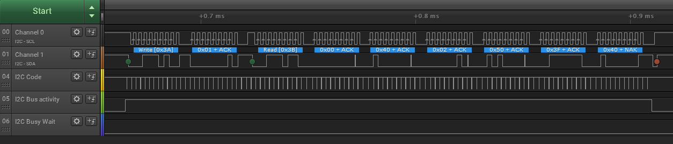

Figure 4: FSM I2C message with no delay

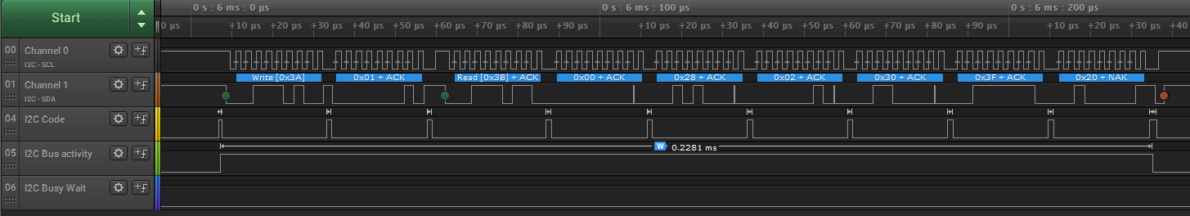

Figure 5: FSM I2C message with ~17 μs delay

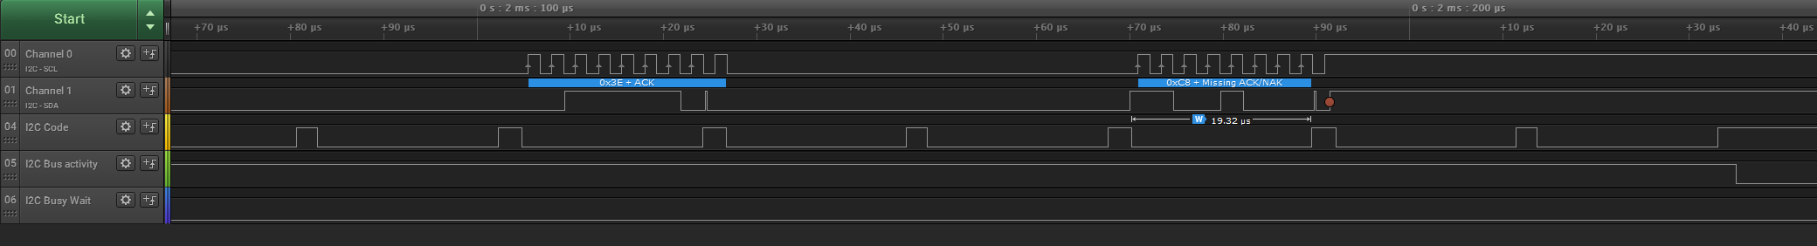

Figure 6: FSM I2C message with ~19 μs delay - Missing NAK

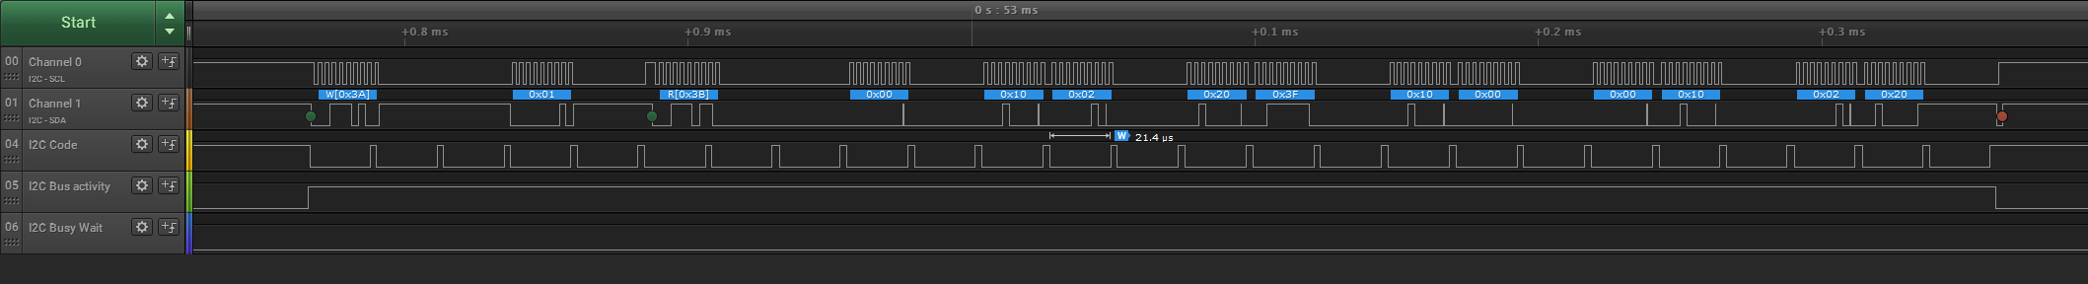

Figure 7: FSM I2C message with ~21 μs delay - Reading 11 bytes (broken)

As seen in Figures 5-7, polling the I2C State Machine at ~17 μs intervals is the largest delay without causing issues with the communications. This corresponds to ShortDelay(8) in code. Increasing the delay to ShortDelay(9) or ~19 μs, The I2C message is missing the NAK at the end of reading all 6 bytes. Interestingly though, the program still seems to function correctly. At ShortDelay(9) or ~21 μs, the program completely breaks, reading out 11 bytes of data. The data[] array changes on every iteration, causing the LED to flash white constantly.

# Interrupt Service Routine Implementation

## Input Data

## Output Data

## Logic Analyzer



Figure 8: ISR I2C Full Message

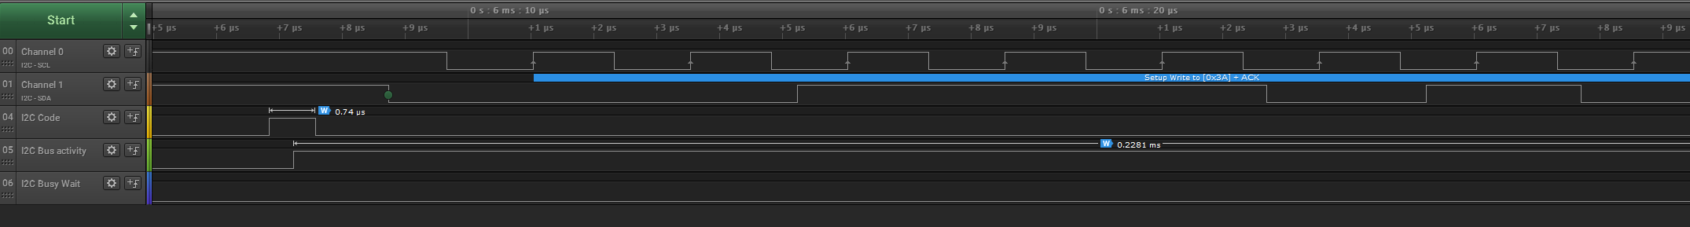

Figure 9: ISR I2C Message detail 1

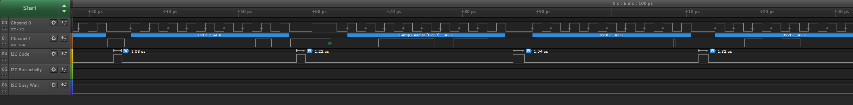

Figure 10: ISR I2C Message detail 2

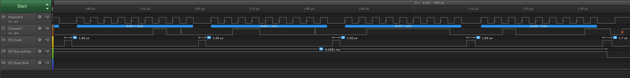

Figure 11: ISR I2C Message detail 3

As seen the detailed I2C message Figures (9-11), the total processor time executing the I2C code is

0.74 μs + 1.08 μs + 1.22 μs + 1.54 μs + 1.32 μs + 1.32 μs + 1.32 μs + 1.32 μs + 1.52 μs + 1.7 μs = **13.08 μs**

Figure 8 shows that the total duration of the message on the bus is **228.1 μs**. So the processor only needed to run ~6% of the time that the message was on the bus. ­