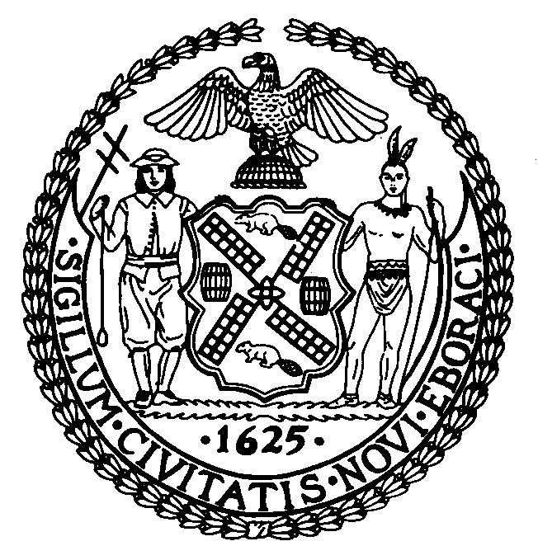
THE COUNCIL OF THE CITY OF NEW YORK

OFFICE OF COMMUNICATIONS

CITY HALL
NEW YORK, NY 10007
(212) 788-7116

**For Immediate Release**

June 15, 2007

Contact: 212-788-7116
Release # 054-2007

Council Passes 59 billion Dollar Budget for FY08, Fiscally Responsible Budget Protects Vital City Programs and Services
Greater detail in budget documents brings increased transparency to budget process

City Hall, June 15, 2007 – The City Council voted in its Stated Meeting today to adopt the City’s 2008 operating budget, totaling $59 billion. The budget incorporates a number of new Council priorities including a 7% property tax reduction, the initiation of six day library service and the reduction of double taxation for small businesses. Additionally, the budget includes initiatives to expand primary health care, expand full-day universal pre-kindergarten, arm District Attorneys with crime fighting tools, combat obesity, protect affordable housing, and promote greenmarkets.

“This budget balances fiscal responsibility with the need to provide vital City services,” said Council Speaker Christine C. Quinn. “Our budget gives property owners needed relief; enables our libraries to be open six days a week so working families can visit them; reduces the tax burden on small businesses; and pushes for more full-day pre-kindergarten slots. We have also prepared for possible economic downturns ahead while making sure we preserve essential services and make our City more livable for all New Yorkers.”

“Through this year's budget, the Council was able to meet both the current and future needs of New Yorkers,” said Finance Committee Chair David Weprin. “With innovative, long-term planning and fiscal responsibility, this year's budget will enhance many city services, while reducing the burden on homeowners. The 7% across the board property tax cut will ensure that people’s tax bills will not be higher than the year before, and in many cases, coupled with the $400 rebate, residents will see a net decrease from last year's bills.”

Budget Transparency Initiative
In addition to passing today’s budget, Speaker Quinn also announced a new web based Budget Transparency Initiative, which will provide ongoing detail about Council spending and agency and program spending and effectiveness. (http://www.nyccouncil.info/budget.)

For the first year ever, initiatives and programs receiving funding will indicate the sponsoring Council member(s). This information will be detailed in the Council’s Schedule C booklet. The booklet, available in hard copy and on the website, will include the name of the organization receiving funding; the description of services provided; the City agency routing the funding; the amount allocated; and the sponsoring Council member(s). As the new fiscal year begins, the public will also be able to view more details on City agencies’ budgets and spending, which will provide more transparency to the delivery of City services.

Speaker Quinn has made reforming the budget process a priority of her tenure and has taken significant steps toward creating a more open and responsive budget process, and ending the budget dance. She successfully base-lined funding for a number of City-wide services, and initiated a Council Budget Negotiating Committee which meets throughout the year rather than at the eleventh hour, and involves Council members in the budget decision process.

Additionally, Speaker Quinn has implemented the first-ever systematic evaluation of Council initiatives. Selected organizations are now required to submit a specific City Council evaluation form along with a copy of the performance reports filed with their City contracting agency, so that funding can be evaluated on the basis of both need and performance. “Our budget also demonstrates continued budget reform, which we initiated in my first year as Speaker. By showing more details about our spending, we shine the light of transparency on our allocations,” said Speaker Quinn.

Budget Highlights
- Provide property tax rate reduction – The 7% property tax rate reduction that was negotiated is larger than the five percent initially proposed in January, which means tax bills will be lower than anticipated
- Reduce double taxation of small businesses – $28 million will increase the credit on New York City’s personal income tax (PIT) for unincorporated small business owners, reducing what is currently a double taxation on many businesses.
- Promote affordable housing – $25 million over two years will be used to maintain, repair and preserve affordability of more than 12,000 units of affordable housing that are currently in financial and physical distress.
- Provide quality childcare – With $200,000, the Low Income Investment Fund will work with childcare centers on facility upgrades and expansions.
- Improve crime-fighting capabilities – $5 million in funding to the District Attorneys’ Offices and Office of the Special Narcotics Prosecutor will step up investigation and prosecution of child abuse, gun violence and Internet crime. Additionally, $12 million in base-lined funding will go towards crime prevention programs, a priority of the Council.
- Combat obesity – $3 million will fund education and fitness programs.
- Prevent high school dropouts – At a cost of $5.6 million, dropout prevention and intervention programs will be targeted at 50 low-performing schools with the lowest attendance rate.
- Develop ten state-of-the-art health clinics – To expand access to quality primary care, ten new health care clinics will be created in neighborhoods with the most severe primary health care shortages. $10 million will be targeted to these communities over the next four years.
- Expand Greenmarkets’ ability to accept food stamps – $295,000 will continue the Council’s effort to provide EBT machines at greenmarkets, which will allow farmers to accept food stamps.

OTHER ITEMS BEING VOTED ON IN THE STATED MEETING

Construction of Health Science Secondary School in Queens
The Land Use Committee voted to authorize the construction of the Queens Gateway to Health Sciences School. The school will get a new 800-seat facility on the campus of Queens Hospital and will include a state-of-the-art science lab, demonstration rooms and a library specializing in health sciences.

“I want to thank the Administration for working with Council member Gennaro and me to address the environmental and traffic concerns regarding this site,” said Landmarks Committee Chair Jessica Lappin. “The young men and women who walk through the doors of this Gateway school will become the people responsible for our health and general welfare. We owe it to them to build the best facility we can provide, and today we've taken the first step to doing just that.”

“It was only two short weeks ago that many unresolved issues associated with the Gateway school project caused the local community and local elected officials to adamantly oppose the school,” said Council member James F. Gennaro. “Today, thanks to the leadership of the City Council, the hard work and cooperation of the community and the willingness of the Administration to accommodate legitimate community concerns, this important project is universally supported. It is my hope that the overwhelmingly successful negotiations on Gateway will become a paradigm for the siting of schools in the future.”

“We are glad to work with Council members Gennaro and Lappin and the community board to ensure that community concerns are adequately addressed,” said Land Use Committee Chair Melinda Katz.

Home Rule Messages
To give the City more authority to act on its own interest, the Council passed several Home Rule messages, requesting the following:
- An act to amend the tax law to exempt clothing and footwear from sales tax.
- An act that would amend the Open Driveways Act and give the city authority to adjudicate disputes concerning the blocking of driveways.
- An omnibus tax package to both streamline and reduce taxes for small business owners.
- A bill to provide a credit against the City’s personal income tax (PIT) for residents who are s-corporation shareholders.
- An act to amend the Hudson River Park Act and authorize a marine transfer station on the Ganesvoort peninsula.

Council Resolutions
The Council will also vote on the following resolutions:
- A resolution (Res. No. 825) commemorating the 350th Anniversary of the Flushing Remonstrance, an event considered essential to the First Amendment.
- A resolution (Res. No. 836-A) calling on the State Legislature to amend the Public Authorities Law to requires the School Construction Authority to provide notice of siting plans for educational facilities.
- A resolution (Res. No. 898) declaring November New York History Month.
- A resolution (Res. No. 899) calling upon the State Legislature to amend the Hudson River Park Act to allow for the construction of and operation of a marine transfer station for the transfer of recyclable materials and an environmental education center at Pier 52 on the Gansevoort peninsula.

All measures were adopted by a vote of 51-0, except for the Home Rule Message and Resolution regarding the Hudson River Act which were both passed by a vote of 48-3.

###

