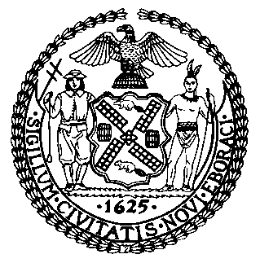 | The Council of the City of New York  Finance Division  Nathan Toth, Director  Fiscal Impact Statement  Int. No: T2026-2600  Committee of the Whole
Title: A Local Law to amend the administrative code of the city of New York, in relation to establishing a private cause of action for certain harms arising from third-party misuse of artificial intelligence models | Sponsor(s): Council Member Maloney and Louis
Summary of Legislation: Int. No. T2026-2600 would create a private right of action against companies that make artificial intelligence models available for commercial or public use when third parties cause harm by misuse or malicious use of artificial intelligence models. A person could bring a claim if the harm was foreseeable and the company failed to implement reasonable safeguards against the misuse or malicious use that caused the harm.
Effective Date: Immediately

City Council Estimate:

 | Effective FY27 | FY Succeeding Effective FY28 | Full Fiscal Impact FY28
Revenues (+) | $0 | $0 | $0
Expenditures (-) | $0 | $0 | $0
Net | $0 | $0 | $0

Fiscal Year in Which Proposed Local Law Would First Become Effective: 2027

Fiscal Year In Which Full Fiscal Impact Anticipated: 2028

Impact on Revenues: It is estimated that there would be no impact on revenues resulting from the enactment of this legislation.

Impact on Expenditures: It is estimated that there would be no impact on expenditures resulting from the enactment of this legislation.

Source of Funds To Cover Estimated Costs: N/A

Source(s) of Information: New York City Council Finance Division
Estimate Prepared By: Owen Kotowski, Senior Financial Analyst

Estimate Reviewed By: Jack Storey, Assistant Director
Eisha Wright, Deputy Director
Jonathan Rosenberg, Managing Deputy Director
Nadia Jean-François, Senior Counsel

Office of Management and Budget Estimate: The Office of Management and Budget provided an estimate, which is attached in full.

Legislative History: https://legistar.council.nyc.gov/LegislationDetail.aspx?ID=8239231&GUID=5C450184-BED1-41D0-AD4F-6A511EFD2D9A&Options=&Search=
Date Prepared: September 29, 2026
Hearing Date: October 5, 2026

