成都信息工程大学

计算机学院

课 程 实 验 报 告

实验课程 | Java高级编程
实验名称 | 实验三JDBC编程
指导教师 | 汤蓉
学生姓名 | 熊术文
学生学号 | 2017051107
班 级 | 计应173
实验地点 | B210
实验日期 | 2019.03.19
实验成绩

- 实验内容

实验三 JDBC编程

实验目的
掌握JDBC编程，能够访问数据库，掌握对数据库的表实现增查删改等操作，并能够将数据库操作应用于系统开发中。

实验内容
- 使用SQL Server数据库管理系统，建立名为“Information”数据库，在该数据库中创建名为“user”的数据表，用于存储才注册界面输入的用户信息，包括：用户名和密码等，为“userInfo”表设置主键。
- 编写User.java类，该类对应于数据库的User表，其成员变量和数据库字段相对应，提供对成员变量操作的方法，比如：成员变量的set方法和get方法等。
//User.java
public class User{

……

}
- 编写类数据库连接类DBUtil.java，该类实现连接数据库的功能，该类模板如下：
//数据库连接类，需要连接数据库时使用该类
public class DBUtil {
//设置数据库参数
private static final String URL = "jdbc:sqlserver://localhost:1433;DatabaseName=factory";
private static final String USER="sa";
private static final String PASSWORD="12345";
private static Connection conn=null;

public DBUtil() {
//补充建立连接的代码
}

//getConnection方法返回所建立的数据库连接，即：Connection对象
public static Connection getConnection(){
return conn;
}
}
- 编写数据访问类UserDao.java(Data Access Object，DAO)，该类负责提供方法对User表进行增查删改等所有操作，其它类需要对User表进行增查删改等操作时直接该使用该类。
- add(User user)方法：添加一个用户的信息到User表中，如果用户已经存在则不重复添加。
- query(String name)方法：按用户姓名查找用户，还可以根据其他字段查询用户。
- delete(String name)方法：删除一个用户记录，比如：根据用户名或编号删除某个用户。
- update()方法：更新用户信息，比如：修改密码。
- queryAll()方法：遍历并显示所有用户信息。
/* UserDao.java, 是专为User类设计的数据访问类，该类使用JDBC编程提供数据的增查删改的服务，所有需要操作数据库的sql语句均包含在该类中。 */
public class UserDao{

//构造方法
……

//方法
……

}

- 编写测试类Test.java，测试以下功能，该类模板如下：：
  - 添加一个新用户
  - 按新用户名查询用户
  - 修改用户密码
  - 删除新用户
  - 查询并显示所有用户
//Test.java
public class Test{
public static void main(String[] args) throws Exception {
UserDao userDao=new UserDao();
//添加用户
User user=new User();
user.setName("张三");
user.setPassword("12345");
userDao.addStudent(user);
……
}
}
- 源代码
//类1.Test.java
package shiyan3;

public class Test {

public static void main(String[] args) {
// TODO Auto-generated method stub

MenuWindow menu = new MenuWindow();
}
}

//类2.User,java
package shiyan3;

public class User {

String username;
String password;

//无参构造方法
User(){}

public void setUsername(String username) {
this.username = username;
}

public String getUsername() {
return this.username;
}

public void setPassword(String password) {
this.password = password;
}

public String getPassword() {
return this.password;
}
}
//类3.UserDao.java
package shiyan3;

import java.sql.*;
import java.util.Scanner;

/**
* *
* @author MR.JOHN
*UserDao.java, 是专为User类设计的数据访问类
*该类使用JDBC编程提供数据的增查删改的服务
*所有需要操作数据库的sql语句均包含在该类中
*/
public class UserDao {

private Connection conn;
private Statement stat;
private ResultSet rs;

UserDao(Connection conn){

this.conn = conn;
try {
stat = conn.createStatement();
} catch (SQLException e) {
// TODO Auto-generated catch block
e.printStackTrace();
}
}

//添加一个用户的信息到User表中，如果用户已经存在则不重复添加
public boolean add(User user){
//flag用来判断用户是否重复
boolean flag = false;
String sql = "select username from users where username='"+user.username+"'";
String sql2 = "insert into users values('"+user.username+"',"+"'"+user.password+"')";
try {
rs = stat.executeQuery(sql);
if(rs.next()) {
flag = false;
}
else {
stat.executeUpdate(sql2);
flag = true;
}
conn.close();
} catch (SQLException e) {
// TODO Auto-generated catch block
e.printStackTrace();
}
return flag;
}

//按用户姓名查找用户，还可以根据其他字段查询用户
public User query(String name) {
//user用来返回查询得到的对象，若不存在则返回null
User user = null;
String sql = "select * from users where username='"+name+"'";
try {
rs = stat.executeQuery(sql);
if(rs.next()) {
user = new User();
user.setUsername(rs.getString("username"));
user.setPassword(rs.getString("password"));
}
conn.close();
} catch (SQLException e) {
// TODO Auto-generated catch block
e.printStackTrace();
}
return user;
}

//删除一个用户记录，比如：根据用户名或编号删除某个用户
public int delete(String name) {
int result=0;
String sql = "delete from users where username ='"+name+"'";
try {
result = stat.executeUpdate(sql); //定义整形变量来存储返回结果，后期利用
conn.close();
} catch (SQLException e) {
// TODO Auto-generated catch block
e.printStackTrace();
}
return result;
}
//更新用户信息，比如：修改密码
public int update(String name, String password) {
//修改指定用户的密码
int result = 0;
String sql = "update users set password='"+password+"'where username='"+name+"'";
try {
result = stat.executeUpdate(sql);
conn.close();
} catch (SQLException e) {
// TODO Auto-generated catch block
e.printStackTrace();
}
return result;
}

//遍历并显示所有用户信息
public ResultSet queryAll() {
String sql = "select * from users";
try {
rs = stat.executeQuery(sql);

} catch (SQLException e) {
// TODO Auto-generated catch block
e.printStackTrace();
}
return rs;
}
}

类4:DBUtil.java
package shiyan3;

import java.sql.*;

public class DBUtil {

private static final String URL="jdbc:sqlserver://localhost:1433;DatabaseName=Information";
private static final String USER="sa";
private static final String PASSWORD="admin";
private static Connection conn=null;

public DBUtil() {

try {
//加载驱动程序
Class.forName("com.microsoft.sqlserver.jdbc.SQLServerDriver");
}
catch(ClassNotFoundException e) {
System.out.print(e);
}

try {
//建立连接
conn = DriverManager.getConnection(URL, USER, PASSWORD);
}
catch(SQLException e) {
System.out.print(e);
}
}

//getConnection方法返回所建立的数据库连接，即：Connection对象
public static Connection getConnection() {
return conn;
}

}

类5:DeleteWindow.java
package shiyan3;

import java.awt.*;
import java.awt.event.*;
import javax.swing.*;

public class DeleteWindow extends JFrame implements ActionListener{

private static final long serialVersionUID = 1L;
JTextField usernameText;
JButton deleteButton;
DBUtil util = new DBUtil();
UserDao userdao = new UserDao(util.getConnection());

DeleteWindow(){
init();
this.setBounds(600, 300, 300, 200);
this.setTitle("删除用户");
this.setVisible(true);
this.setDefaultCloseOperation(JFrame.DISPOSE_ON_CLOSE);
}

void init(){
this.setLayout(new FlowLayout());
Box boxBase,boxV1,boxV2,boxH1,boxH2;
boxV1 = Box.createVerticalBox();
boxV2 = Box.createVerticalBox();
boxBase = Box.createVerticalBox();
boxH1 = Box.createHorizontalBox();
boxH2 = Box.createHorizontalBox();

usernameText = new JTextField(15);
deleteButton = new JButton("删除");

boxV1.add(Box.createVerticalStrut(20));
boxV1.add(new Label("用户名"));

boxV2.add(Box.createVerticalStrut(20));
boxV2.add(usernameText);

boxH1.add(boxV1);
boxH1.add(Box.createHorizontalStrut(8));
boxH1.add(boxV2);

boxH2.add(deleteButton);

boxBase.add(boxH1);
boxBase.add(Box.createVerticalStrut(20));
boxBase.add(boxH2);

this.add(boxBase);

deleteButton.addActionListener(this);
}

@Override
public void actionPerformed(ActionEvent e) {
// TODO Auto-generated method stub
if(usernameText.getText().length()==0) {
JOptionPane.showMessageDialog(null, "请输入要删除的用户", "删除失败", JOptionPane.WARNING_MESSAGE);
}
else {
int result = userdao.delete(usernameText.getText().trim());
if(result==0) {
JOptionPane.showMessageDialog(null, "删除失败\n不存在该用户", "删除失败", JOptionPane.WARNING_MESSAGE);
}
else {
JOptionPane.showMessageDialog(null, "删除成功\n删除用户为:"+usernameText.getText(), "删除成功", JOptionPane.INFORMATION_MESSAGE);
}
}
}

}

类6：MenuWindow.java
package shiyan3;

import java.awt.FlowLayout;
import java.awt.event.*;

import javax.swing.*;

public class MenuWindow extends JFrame implements ActionListener{

private static final long serialVersionUID = 1L;

JButton signUpButton, deleteButton, searchButton, updateButton, queryButton;

MenuWindow(){
init();
this.setBounds(600, 300, 300, 300);
this.setTitle("用户管理系统");
this.setVisible(true);
this.setDefaultCloseOperation(JFrame.EXIT_ON_CLOSE);
}

void init() {
this.setLayout(new FlowLayout());
signUpButton = new JButton("用户注册");
searchButton = new JButton("查询用户");
deleteButton = new JButton("删除用户");
updateButton = new JButton("更新密码");
queryButton = new JButton("遍历用户");
Box boxV = Box.createVerticalBox();
boxV.add(Box.createVerticalStrut(15));
boxV.add(signUpButton);
boxV.add(Box.createVerticalStrut(15));
boxV.add(searchButton);
boxV.add(Box.createVerticalStrut(15));
boxV.add(deleteButton);
boxV.add(Box.createVerticalStrut(15));
boxV.add(updateButton);
boxV.add(Box.createVerticalStrut(15));
boxV.add(queryButton);
this.add(boxV);

signUpButton.addActionListener(this);
searchButton.addActionListener(this);
deleteButton.addActionListener(this);
updateButton.addActionListener(this);
queryButton.addActionListener(this);
}
@Override
public void actionPerformed(ActionEvent e) {
// TODO Auto-generated method stub
//点击用户注册按钮
if(e.getSource()==signUpButton) {
SignUpWindow signUpWindow = new SignUpWindow();
}
else if(e.getSource()==searchButton) {
SearchWindow searchWindow = new SearchWindow();
}
else if(e.getSource()==deleteButton) {
DeleteWindow deleteWindow = new DeleteWindow();
}
else if(e.getSource()==updateButton) {
UpdateWindow updateWindow = new UpdateWindow();
}
else if(e.getSource()==queryButton) {
QueryWindow queryWindow = new QueryWindow();
}
}

}
类7:MyFocusListener.java
package shiyan3;

import java.awt.Color;
import java.awt.event.*;
import javax.swing.*;

public class MyFocusListener implements FocusListener{

JTextField usernameText;
JLabel label;

public void setUsernameText(JTextField usernameText) {
this.usernameText = usernameText;
}

public void setLabel(JLabel label) {
this.label = label;
}

@Override
public void focusGained(FocusEvent e) {
// TODO Auto-generated method stub
if(usernameText.getText().equals("请设置用户名")){
usernameText.setText("");
}
label.setForeground(Color.black);
label.setText("<html><body>用户名的长度<br />不超过14</body></html>");
}

@Override
public void focusLost(FocusEvent e) {
// TODO Auto-generated method stub
if(usernameText.getText().equals("")){
usernameText.setText("请设置用户名");
}
}

}
类8:QueryWindow .java
package shiyan3;

import java.awt.FlowLayout;
import java.awt.event.*;
import java.sql.*;

import javax.swing.*;

public class QueryWindow extends JFrame implements ActionListener{

private static final long serialVersionUID = 1L;

JButton queryButton;
JScrollPane scroll;
JTextArea area;
DBUtil util = new DBUtil();
UserDao userdao = new UserDao(util.getConnection());

QueryWindow(){
init();
this.setBounds(600, 300, 300, 300);
this.setTitle("遍历用户");
this.setVisible(true);
this.setDefaultCloseOperation(JFrame.DISPOSE_ON_CLOSE);
}

void init() {
this.setLayout(new FlowLayout());

Box boxH1, boxH2, boxBase;

boxH1 = Box.createHorizontalBox();
boxH2 = Box.createHorizontalBox();
boxBase = Box.createVerticalBox();

queryButton = new JButton("遍历");
area = new JTextArea(8,20);
scroll = new JScrollPane(area);

boxH1.add(queryButton);
boxH2.add(scroll);
boxBase.add(Box.createVerticalStrut(20));
boxBase.add(boxH1);
boxBase.add(Box.createVerticalStrut(20));
boxBase.add(boxH2);
this.add(boxBase);

queryButton.addActionListener(this);
}
@Override
public void actionPerformed(ActionEvent e) {
// TODO Auto-generated method stub
ResultSet rs = userdao.queryAll();
if(rs != null) {
try {
while(rs.next()) {
area.append(rs.getString("username")+"\t"+rs.getString("password")+"\n");
}
} catch (SQLException e1) {
// TODO Auto-generated catch block
e1.printStackTrace();
}
}
else {
area.setText("数据库为空");
}
}

}
类9:SearchWindow .java
package shiyan3;

import java.awt.FlowLayout;
import java.awt.event.*;
import javax.swing.*;

public class SearchWindow extends JFrame implements ActionListener{

private static final long serialVersionUID = 1L;

JLabel label;
JTextField usernameText;
JButton searchButton;
JScrollPane scroll;
JTextArea area;
DBUtil util = new DBUtil();
UserDao userdao = new UserDao(util.getConnection());

SearchWindow(){
init();
this.setBounds(600, 300, 300, 200);
this.setTitle("查询用户");
this.setVisible(true);
this.setDefaultCloseOperation(JFrame.DISPOSE_ON_CLOSE);
}

void init() {
this.setLayout(new FlowLayout());

Box boxH1, boxH2, boxBase;

boxH1 = Box.createHorizontalBox();
boxH2 = Box.createHorizontalBox();
boxBase = Box.createVerticalBox();

label = new JLabel("用户名");
usernameText = new JTextField(10);
searchButton = new JButton("查询");
area = new JTextArea(4,8);
scroll = new JScrollPane(area);

boxH1.add(label);
boxH1.add(usernameText);
boxH1.add(searchButton);
boxH2.add(scroll);
boxBase.add(Box.createVerticalStrut(20));
boxBase.add(boxH1);
boxBase.add(Box.createVerticalStrut(20));
boxBase.add(boxH2);
this.add(boxBase);

searchButton.addActionListener(this);
}

@Override
public void actionPerformed(ActionEvent e) {
// TODO Auto-generated method stub
User user;
user = userdao.query(usernameText.getText().trim());
if(user == null) {
area.setText("该用户不存在");
}
else {
area.setText("用户名为:"+user.getUsername()+"\n密码为:"+String.valueOf(user.getPassword()));
}
}

}
类10:SignUpWindow .java
package shiyan3;

import java.awt.*;
import java.awt.event.*;

import javax.swing.*;

public class SignUpWindow extends JFrame implements ActionListener{

private static final long serialVersionUID = 1L;
JLabel label;
JTextField usernameText;
JPasswordField passwordField;
JButton signUpButton;
User user;
DBUtil util = new DBUtil();
UserDao userdao = new UserDao(util.getConnection());

SignUpWindow(){
init();
this.setBounds(600, 300, 400, 300);
this.setTitle("新用户注册");
this.setVisible(true);
this.setDefaultCloseOperation(JFrame.DISPOSE_ON_CLOSE);
}

void init(){
this.setLayout(new FlowLayout());
Box boxBase,boxV1,boxV2,boxV3,boxH1,boxH2;
boxV1 = Box.createVerticalBox();
boxV2 = Box.createVerticalBox();
boxV3 = Box.createVerticalBox();
boxBase = Box.createVerticalBox();
boxH1 = Box.createHorizontalBox();
boxH2 = Box.createHorizontalBox();

boxV1.add(Box.createVerticalStrut(50));
boxV1.add(new JLabel("用户名"));
boxV1.add(Box.createVerticalStrut(50));
boxV1.add(new JLabel("密 码"));

usernameText = new JTextField(15);
usernameText.setText("请设置用户名");
boxV2.add(Box.createVerticalStrut(50));
boxV2.add(usernameText);
passwordField = new JPasswordField(15);
boxV2.add(Box.createVerticalStrut(50));
boxV2.add(passwordField);

//用于显示用户名的注册规范
JLabel label = new JLabel();
label.setFont(new Font("宋体",Font.BOLD,10));
label.setText("<html><body>用户名的长度<br />不超过14</body></html>");
boxV3.add(label);
boxV3.add(Box.createVerticalStrut(25));

//将各个组件添加到容器
boxH1.add(boxV1);
boxH1.add(Box.createHorizontalStrut(8));
boxH1.add(boxV2);
boxH1.add(Box.createHorizontalStrut(8));
boxH1.add(boxV3);

//添加注册按钮
signUpButton = new JButton("注册");
boxH2.add(signUpButton);

boxBase.add(boxH1);
boxBase.add(Box.createVerticalStrut(40));
boxBase.add(boxH2);

this.add(boxBase);

//添加焦点事件监听器
MyFocusListener myFocusListener = new MyFocusListener();
myFocusListener.setUsernameText(usernameText);
myFocusListener.setLabel(label);
usernameText.addFocusListener(myFocusListener);

//添加注册事件监视器
signUpButton.addActionListener(this);
}

@Override
public void actionPerformed(ActionEvent e) {
// TODO Auto-generated method stub

//如果用户名的长度大于14，则作出提示
if(usernameText.getText().length()>14) {
label.setForeground(Color.RED);
label.setText("<html><body>用户名长度<br />不能超过14<br />请重新输入</body></html>");
}

//若用户名和密码为空时弹出窗口进行警告
else if(usernameText.getText().length()==0 || passwordField.getPassword().length==0) {
JOptionPane.showMessageDialog(null, "用户名或密码不为空", "警告", JOptionPane.WARNING_MESSAGE);
}

/*
* 用户名和密码符合要求
* 将用户注册信息写到数据库
* 弹出窗口进行提示
*/
else {
user = new User();
user.setUsername(usernameText.getText());
user.setPassword(String.copyValueOf(passwordField.getPassword()));
boolean flag = userdao.add(user);
if(flag) {
//注册成功
String message = "注册成功\n用户名为:"+usernameText.getText()+"\n密码为:"+String.valueOf(passwordField.getPassword());
JOptionPane.showMessageDialog(null, message, "注册成功", JOptionPane.INFORMATION_MESSAGE);
}
else {
//用户已存在，注册失败
String message = "注册失败\n用户:"+usernameText.getText()+"已存在";
JOptionPane.showMessageDialog(null, message, "注册失败", JOptionPane.INFORMATION_MESSAGE);
}

}
}
}
类11:
package shiyan3;

import java.awt.*;
import java.awt.event.*;
import javax.swing.*;

public class UpdateWindow extends JFrame implements ActionListener{

private static final long serialVersionUID = 1L;

JLabel usernameLabel, passwordLabel;
JTextField usernameText;
JPasswordField passwordFiled;
JButton updateButton;
DBUtil util = new DBUtil();
UserDao userdao = new UserDao(util.getConnection());

UpdateWindow(){
init();
this.setBounds(600, 300, 300, 200);
this.setTitle("查询用户");
this.setVisible(true);
this.setDefaultCloseOperation(JFrame.DISPOSE_ON_CLOSE);
}

void init() {
this.setLayout(new FlowLayout());

Box boxV1, boxV2, boxBase, boxH1, boxH2;
boxV1 = Box.createVerticalBox();
boxV2 = Box.createVerticalBox();
boxBase = Box.createVerticalBox();
boxH1 = Box.createHorizontalBox();
boxH2 = Box.createHorizontalBox();

usernameLabel = new JLabel("用户名");
passwordLabel = new JLabel("密码");
usernameText = new JTextField(15);
passwordFiled = new JPasswordField(15);
updateButton = new JButton("更新");

boxV1.add(Box.createVerticalStrut(20));
boxV1.add(usernameLabel);
boxV1.add(Box.createVerticalStrut(20));
boxV1.add(passwordLabel);
boxV2.add(Box.createVerticalStrut(20));
boxV2.add(usernameText);
boxV2.add(Box.createVerticalStrut(20));
boxV2.add(passwordFiled);
boxH1.add(boxV1);
boxH1.add(Box.createHorizontalStrut(8));
boxH1.add(boxV2);
boxH2.add(updateButton);
boxBase.add(boxH1);
boxBase.add(Box.createVerticalStrut(20));
boxBase.add(boxH2);
this.add(boxBase);
updateButton.addActionListener(this);
}

@Override
public void actionPerformed(ActionEvent e) {
// TODO Auto-generated method stub
int result;
String username = usernameText.getText().trim();
String password = String.valueOf(passwordFiled.getPassword());
result = userdao.update(username,password);
if(result == 0) {
JOptionPane.showMessageDialog(this, "更新失败", "更新失败", JOptionPane.WARNING_MESSAGE);
}
else {
String str = "更新成功\n更新后的密码为:"+password;
JOptionPane.showMessageDialog(this, str, "更新成功", JOptionPane.INFORMATION_MESSAGE);
}
}
}

- 测试结果
菜单：
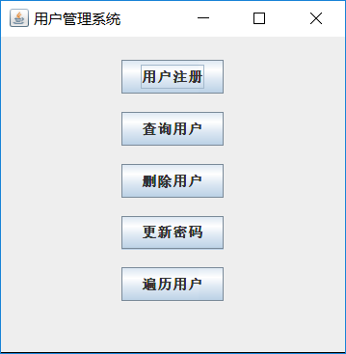
添加新用户：
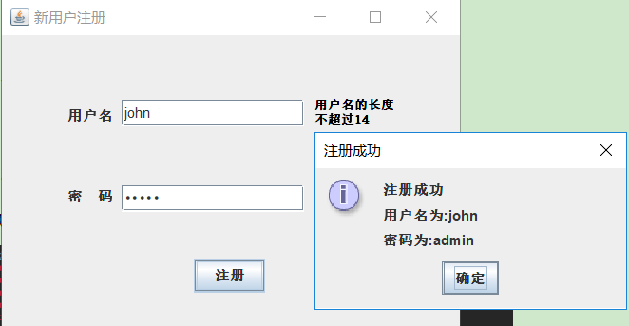
按用户名查询用户：
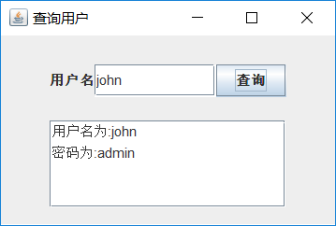
修改用户密码：
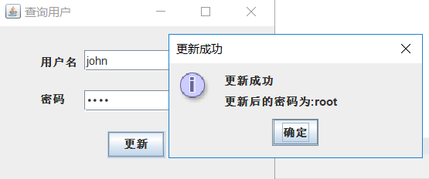
删除用户：
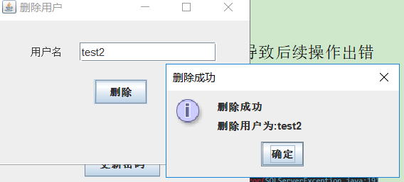
遍历所有用户：
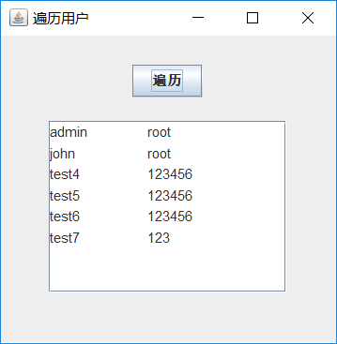
- 实验中的问题及解决方案
问题1：在每执行完一个sql语句后就关闭连接，导致后续操作出错
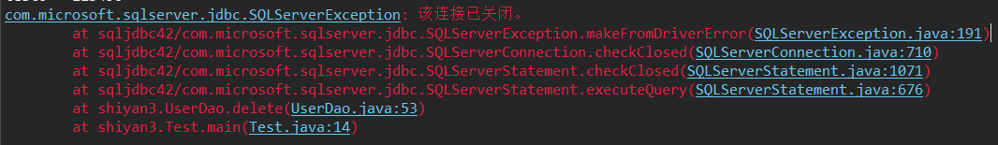
解决方案：每个图形化界面都创建连接，用完后及时关闭
问题2：执行在用executeQuery()方法执行删除语句时出错
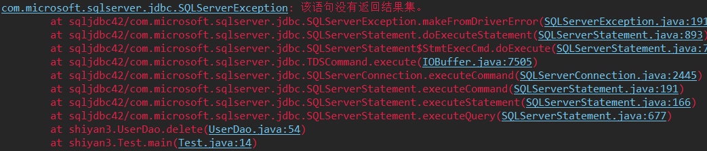
解决方案：查阅api和百度相关资料，了解到在执行UPDATE、DELETE、INSERT语句时并不会返回结果集，所以应该用executeUpdate()方法，而不是executeQuery()
总结：
- JDBC编程主要流程：
加载驱动->建立连接->执行sql语句->处理结果->关闭连接
- 掌握结果集的操作方法
- 掌握预处理相关方法和cachedRowSetImpl相关方法

