成都信息工程大学

需求分析说明书

学院名称 | 计算机学院
专业名称 | 计算机科学与技术
所属学期 | 2019-2020(1)
所属课程 | 工程实践3
项目名称 | 学生出勤管理系统
小组序号
小组名单 | 班级 | 学号 | 姓名
小组名单 | 计应173 | 2017051104 | 于永康
小组名单 | 计应173 | 2017051105 | 宋纪奇
小组名单 | 计应173 | 2017051107 | 熊术文
小组名单 | 计应173 | 2017051109 | 谢莞悦
指导教师 | 汤蓉
提交日期 | 2019年12月27日

目录

1 引言 1
1.1 编制目的 1
1.2 范围 1
1.3 预期的读者和阅读建议 1
1.4 术语和缩略语 1
1.5 参考文件 1
2 项目概述 2
2.1 目标 2
2.2 范围 2
2.3 用户的特点 2
2.4 假定条件和约束限制 2
2.5 运行环境 2
2.5.1 硬件环境 2
2.5.2 软件环境 3
3 需求描述 3
4 功能需求 3
4.1 用例模型 3
4.2 对象模型 3
4.3 动态模型 3
4.4 系统总体功能需求 3
5 非功能需求 4
5.1 性能需求 4
5.2 安全保密需求 4
5.3 扩展性需求 4
5.4 稳定性需求 5
6 项目组成员分工 5

引言

编制目的
本《软件需求说明书》的主要目的是明确所要开发的软件所应具有的功能、性能，使系统分析人员和软件设计人员能清楚地了解用户的需求，并在此基础上进一步提出概要设计和完成后续设计与开发工作，为软件开发范围、业务处理规范提供依据。

范围
- 设计的软件命名为学生出勤管理系统
- 学生出勤管理系统对学校全体学生的资料和考勤情况进行管理，通过每堂课进出教室打卡把出勤信息输入到考勤管理中心，保存学生每每堂课的出勤情况，以便于统计学生的出勤情况。学生可以通过该系统请假，并交给辅导员审批，审批后的结果能传给该课的任课老师，任课老师可以修改学生的出勤情况。
- 方便学生、教师及辅导员查阅，即节省了人力，又省去了中间的很多容易出错的步骤。让学校学生的考勤管理更具有透明性，且方便管理。该系统通过结合学生的实际出勤情况实现对数据的有效管理，满足学习需求，提高学生对学生的管理效率，完善学校的管理制度。

预期的读者和阅读建议
读者分类 | 阅读的重点及目的
项目经理 | 全文，并据此编制/修订项目（软件）开发计划等。
设计与开发工程师 | 需求的完整性、正确性、可行性、优先级、无二义性，为概要设计做准备。
学校的系统管理员 | 需求的必要性、优先级。
测试工程师 | 需求的可验证性，并据此准备（软件）系统测试方案。
文档工程师 | 全文，为编写用户文档做准备。

术语和缩略语
表1术语和缩略语
术语、缩略语 | 解释
SysMan | System Manager系统管理
B/S | Browser/Server浏览器/服务器

参考文件
表2参考资料
文件编号 | 文献名称 | 作者 | 出版单位 | 出版日期
未知 | 学生考勤管理系统需求分析文档 | 秦伟 | 曲阜师范大学
未知 | 四川省企业环境信用评价系统的设计  与实现需求规格说明书 |  | 成都信息工程大学计算机学院

项目概述

目标
通过学习软件工程的设计方法，主要采用 JavaEE，使用者可以使用具备查询功能、登记功能、修改功能、统计功能、请假处理功能的软件，主要用于学生的考勤管理。

范围
本系统主要分为学生考勤、查询学生出勤情况、修改学生出勤情况、请假批假四个功能模块。能对学生出勤的情况进行管理，得知学生的出勤率，利于评定学生的综合学习情况。

用户的特点
- 授课教师：查询、修改学生出勤情况的老师
- 辅导员：查询年级学生的出勤情况、审批学生请假
- 普通用户(学生)：查询记录和进出教室考勤的学生，账号为学生的学号，密码默认为123456

假定条件和约束限制
假定系统的客户为学校，系统的用户为学生、任课教师、年级辅导员。
假定软件环境：ECLIPSE,MYSQL,EXCEL等并配有Windows系统。
假定硬件环境：PC端电脑。
假定系统使用B/S模式。

运行环境

硬件环境
（1）服务器：1核CPU|2GB内存|40GBSSD|
5Mbps限制峰值宽带|1000GB每月流量
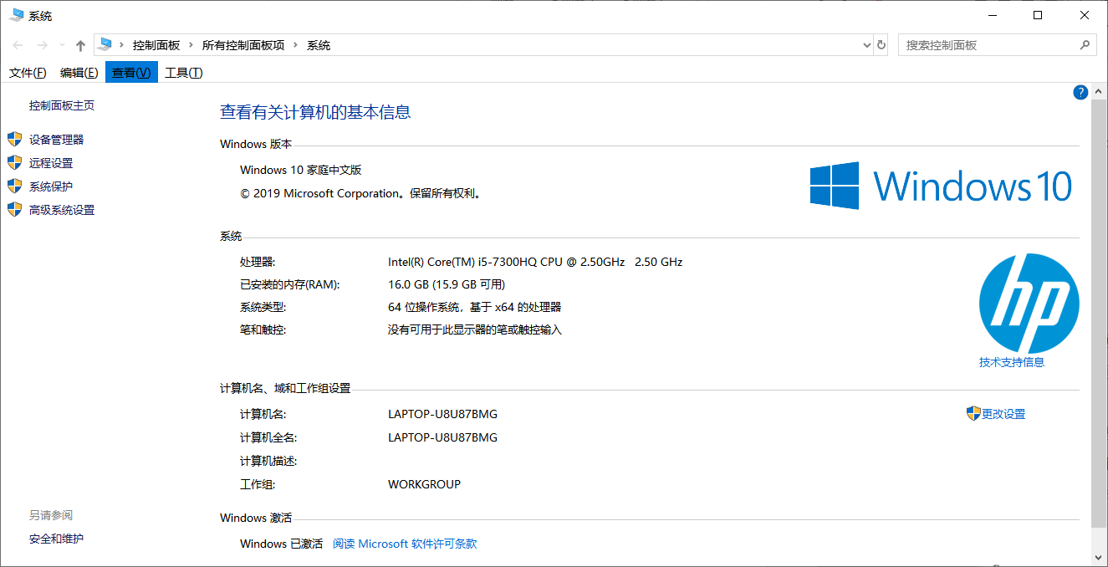

软件环境
- 操作系统：Windows10家庭中文版
- 数据库系统：MySQL
- 开发平台及工具：eclipse
- 通信协议：TCP
- 其他软件：excel

需求描述
学生出勤管理系统的主要功能是通过学生进出教室的打卡记录学生不同情况的出勤情况，并保存学生的出勤情况到后台。学生可通过该系统登录自己的账号查询自己的出勤情况，如有事需要请假可以申请请假；授课教师可通过该系统查询自己所授课程的学生出勤情况，并修改学生的出勤情况；辅导员可通过该系统查询年级学生的出勤情况，并审批学生的假条。

学生出勤管理系统功能描述：
- 学生考勤、请假、查询自己的出勤情况
- 教师查询授课班级学生的出勤情况，修改学生的出勤情况
- 辅导员查询年级学生的出勤情况，审批假条

“学生考勤”用例的主要场景：
1) 课前进入教室刷卡，正常上课
2) 下课后刷卡，为正常下课

“学生考勤”用例的次要场景1—学生上课后15分钟内才到教室打卡：
- 系统记该学生迟到
“学生考勤”用例的次要场景2—学生离开时间若在下课前15分钟内：
- 系统记该学生早退
“学生考勤”用例的次要场景3—不属于以上任何情况：
- 系统记该学生缺勤

前置条件：考勤学生为已经登记在读的学生
后置条件：如果学生考勤成功，出勤管理系统记录学生的出勤情况，否则出勤管理系统记录该学生当堂课考勤记录为缺勤
行为者：学生

“用户查询”用例的主要场景：
- 不同用户登录自己的账号到系统
- 学生查询自己的出勤情况，授课教师查询授课班级学生的出勤情况、请假情况，辅导员查询年级学生的出勤情况、请假情况

“教师修改”用例的主要场景：
- 教师登录自己的账号到系统
- 可修改自己授课班级学生的出勤情况

“学生请假”用例的主要场景：
- 学生登录自己的账号到系统
- 根据自己的需求选择是否请假

“辅导员批假”用例的主要场景：
- 辅导员登录自己的账号到系统
- 根据实际情况选择是否批假

功能需求
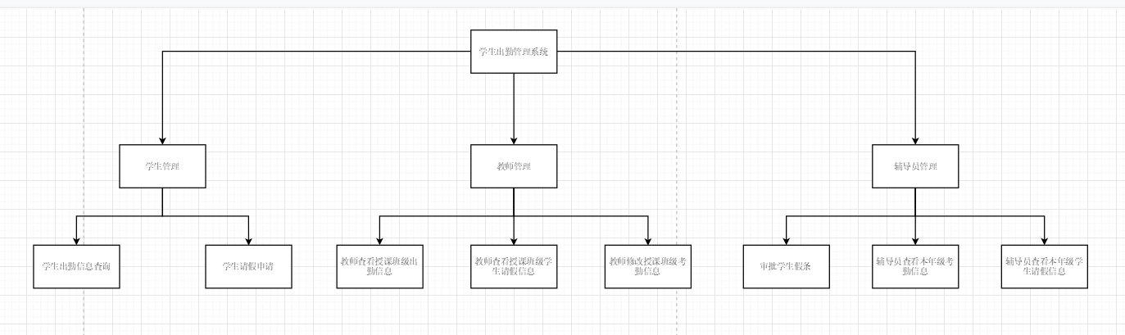%3CmxGraphModel%3E%3Croot%3E%3CmxCell%20id%3D%220%22%2F%3E%3CmxCell%20id%3D%221%22%20parent%3D%220%22%2F%3E%3CmxCell%20id%3D%222%22%20style%3D%22edgeStyle%3DorthogonalEdgeStyle%3Brounded%3D0%3BorthogonalLoop%3D1%3BjettySize%3Dauto%3Bhtml%3D1%3BexitX%3D0%3BexitY%3D0.5%3BexitDx%3D0%3BexitDy%3D0%3BentryX%3D0.5%3BentryY%3D0%3BentryDx%3D0%3BentryDy%3D0%3B%22%20edge%3D%221%22%20source%3D%225%22%20target%3D%228%22%20parent%3D%221%22%3E%3CmxGeometry%20relative%3D%221%22%20as%3D%22geometry%22%2F%3E%3C%2FmxCell%3E%3CmxCell%20id%3D%223%22%20style%3D%22edgeStyle%3DorthogonalEdgeStyle%3Brounded%3D0%3BorthogonalLoop%3D1%3BjettySize%3Dauto%3Bhtml%3D1%3BexitX%3D0.5%3BexitY%3D1%3BexitDx%3D0%3BexitDy%3D0%3BentryX%3D0.5%3BentryY%3D0%3BentryDx%3D0%3BentryDy%3D0%3B%22%20edge%3D%221%22%20source%3D%225%22%20target%3D%2214%22%20parent%3D%221%22%3E%3CmxGeometry%20relative%3D%221%22%20as%3D%22geometry%22%2F%3E%3C%2FmxCell%3E%3CmxCell%20id%3D%224%22%20style%3D%22edgeStyle%3DorthogonalEdgeStyle%3Brounded%3D0%3BorthogonalLoop%3D1%3BjettySize%3Dauto%3Bhtml%3D1%3BexitX%3D1%3BexitY%3D0.5%3BexitDx%3D0%3BexitDy%3D0%3BentryX%3D0.5%3BentryY%3D0%3BentryDx%3D0%3BentryDy%3D0%3B%22%20edge%3D%221%22%20source%3D%225%22%20target%3D%2221%22%20parent%3D%221%22%3E%3CmxGeometry%20relative%3D%221%22%20as%3D%22geometry%22%2F%3E%3C%2FmxCell%3E%3CmxCell%20id%3D%225%22%20value%3D%22%E5%AD%A6%E7%94%9F%E5%87%BA%E5%8B%A4%E7%AE%A1%E7%90%86%E7%B3%BB%E7%BB%9F%22%20style%3D%22rounded%3D0%3BwhiteSpace%3Dwrap%3Bhtml%3D1%3B%22%20vertex%3D%221%22%20parent%3D%221%22%3E%3CmxGeometry%20x%3D%22540%22%20y%3D%2230%22%20width%3D%22120%22%20height%3D%2260%22%20as%3D%22geometry%22%2F%3E%3C%2FmxCell%3E%3CmxCell%20id%3D%226%22%20style%3D%22edgeStyle%3DorthogonalEdgeStyle%3Brounded%3D0%3BorthogonalLoop%3D1%3BjettySize%3Dauto%3Bhtml%3D1%3BexitX%3D0.5%3BexitY%3D1%3BexitDx%3D0%3BexitDy%3D0%3BentryX%3D0.5%3BentryY%3D0%3BentryDx%3D0%3BentryDy%3D0%3B%22%20edge%3D%221%22%20source%3D%228%22%20target%3D%229%22%20parent%3D%221%22%3E%3CmxGeometry%20relative%3D%221%22%20as%3D%22geometry%22%3E%3CmxPoint%20y%3D%22330%22%20as%3D%22targetPoint%22%2F%3E%3C%2FmxGeometry%3E%3C%2FmxCell%3E%3CmxCell%20id%3D%227%22%20style%3D%22edgeStyle%3DorthogonalEdgeStyle%3Brounded%3D0%3BorthogonalLoop%3D1%3BjettySize%3Dauto%3Bhtml%3D1%3BexitX%3D0.5%3BexitY%3D1%3BexitDx%3D0%3BexitDy%3D0%3B%22%20edge%3D%221%22%20source%3D%228%22%20parent%3D%221%22%3E%3CmxGeometry%20relative%3D%221%22%20as%3D%22geometry%22%3E%3CmxPoint%20x%3D%22230%22%20y%3D%22330%22%20as%3D%22targetPoint%22%2F%3E%3C%2FmxGeometry%3E%3C%2FmxCell%3E%3CmxCell%20id%3D%228%22%20value%3D%22%E5%AD%A6%E7%94%9F%E7%AE%A1%E7%90%86%22%20style%3D%22rounded%3D0%3BwhiteSpace%3Dwrap%3Bhtml%3D1%3B%22%20vertex%3D%221%22%20parent%3D%221%22%3E%3CmxGeometry%20x%3D%2250%22%20y%3D%22190%22%20width%3D%22120%22%20height%3D%2260%22%20as%3D%22geometry%22%2F%3E%3C%2FmxCell%3E%3CmxCell%20id%3D%229%22%20value%3D%22%E5%AD%A6%E7%94%9F%E5%87%BA%E5%8B%A4%E4%BF%A1%E6%81%AF%E6%9F%A5%E8%AF%A2%22%20style%3D%22rounded%3D0%3BwhiteSpace%3Dwrap%3Bhtml%3D1%3B%22%20vertex%3D%221%22%20parent%3D%221%22%3E%3CmxGeometry%20x%3D%22-70%22%20y%3D%22330%22%20width%3D%22120%22%20height%3D%2260%22%20as%3D%22geometry%22%2F%3E%3C%2FmxCell%3E%3CmxCell%20id%3D%2210%22%20value%3D%22%E5%AD%A6%E7%94%9F%E8%AF%B7%E5%81%87%E7%94%B3%E8%AF%B7%22%20style%3D%22rounded%3D0%3BwhiteSpace%3Dwrap%3Bhtml%3D1%3B%22%20vertex%3D%221%22%20parent%3D%221%22%3E%3CmxGeometry%20x%3D%22170%22%20y%3D%22330%22%20width%3D%22120%22%20height%3D%2260%22%20as%3D%22geometry%22%2F%3E%3C%2FmxCell%3E%3CmxCell%20id%3D%2211%22%20style%3D%22edgeStyle%3DorthogonalEdgeStyle%3Brounded%3D0%3BorthogonalLoop%3D1%3BjettySize%3Dauto%3Bhtml%3D1%3BexitX%3D0.5%3BexitY%3D1%3BexitDx%3D0%3BexitDy%3D0%3BentryX%3D0.5%3BentryY%3D0%3BentryDx%3D0%3BentryDy%3D0%3B%22%20edge%3D%221%22%20source%3D%2214%22%20target%3D%2215%22%20parent%3D%221%22%3E%3CmxGeometry%20relative%3D%221%22%20as%3D%22geometry%22%2F%3E%3C%2FmxCell%3E%3CmxCell%20id%3D%2212%22%20style%3D%22edgeStyle%3DorthogonalEdgeStyle%3Brounded%3D0%3BorthogonalLoop%3D1%3BjettySize%3Dauto%3Bhtml%3D1%3BexitX%3D0.5%3BexitY%3D1%3BexitDx%3D0%3BexitDy%3D0%3B%22%20edge%3D%221%22%20source%3D%2214%22%20target%3D%2216%22%20parent%3D%221%22%3E%3CmxGeometry%20relative%3D%221%22%20as%3D%22geometry%22%2F%3E%3C%2FmxCell%3E%3CmxCell%20id%3D%2213%22%20style%3D%22edgeStyle%3DorthogonalEdgeStyle%3Brounded%3D0%3BorthogonalLoop%3D1%3BjettySize%3Dauto%3Bhtml%3D1%3BexitX%3D0.5%3BexitY%3D1%3BexitDx%3D0%3BexitDy%3D0%3B%22%20edge%3D%221%22%20source%3D%2214%22%20target%3D%2217%22%20parent%3D%221%22%3E%3CmxGeometry%20relative%3D%221%22%20as%3D%22geometry%22%2F%3E%3C%2FmxCell%3E%3CmxCell%20id%3D%2214%22%20value%3D%22%E6%95%99%E5%B8%88%E7%AE%A1%E7%90%86%22%20style%3D%22rounded%3D0%3BwhiteSpace%3Dwrap%3Bhtml%3D1%3B%22%20vertex%3D%221%22%20parent%3D%221%22%3E%3CmxGeometry%20x%3D%22540%22%20y%3D%22190%22%20width%3D%22120%22%20height%3D%2260%22%20as%3D%22geometry%22%2F%3E%3C%2FmxCell%3E%3CmxCell%20id%3D%2215%22%20value%3D%22%E6%95%99%E5%B8%88%E6%9F%A5%E7%9C%8B%E6%8E%88%E8%AF%BE%E7%8F%AD%E7%BA%A7%E5%87%BA%E5%8B%A4%E4%BF%A1%E6%81%AF%22%20style%3D%22rounded%3D0%3BwhiteSpace%3Dwrap%3Bhtml%3D1%3B%22%20vertex%3D%221%22%20parent%3D%221%22%3E%3CmxGeometry%20x%3D%22353%22%20y%3D%22330%22%20width%3D%22120%22%20height%3D%2260%22%20as%3D%22geometry%22%2F%3E%3C%2FmxCell%3E%3CmxCell%20id%3D%2216%22%20value%3D%22%E6%95%99%E5%B8%88%E6%9F%A5%E7%9C%8B%E6%8E%88%E8%AF%BE%E7%8F%AD%E7%BA%A7%E5%AD%A6%E7%94%9F%E8%AF%B7%E5%81%87%E4%BF%A1%E6%81%AF%22%20style%3D%22rounded%3D0%3BwhiteSpace%3Dwrap%3Bhtml%3D1%3B%22%20vertex%3D%221%22%20parent%3D%221%22%3E%3CmxGeometry%20x%3D%22540%22%20y%3D%22330%22%20width%3D%22120%22%20height%3D%2260%22%20as%3D%22geometry%22%2F%3E%3C%2FmxCell%3E%3CmxCell%20id%3D%2217%22%20value%3D%22%E6%95%99%E5%B8%88%E4%BF%AE%E6%94%B9%E6%8E%88%E8%AF%BE%E7%8F%AD%E7%BA%A7%E8%80%83%E5%8B%A4%E4%BF%A1%E6%81%AF%22%20style%3D%22rounded%3D0%3BwhiteSpace%3Dwrap%3Bhtml%3D1%3B%22%20vertex%3D%221%22%20parent%3D%221%22%3E%3CmxGeometry%20x%3D%22727%22%20y%3D%22330%22%20width%3D%22120%22%20height%3D%2260%22%20as%3D%22geometry%22%2F%3E%3C%2FmxCell%3E%3CmxCell%20id%3D%2218%22%20style%3D%22edgeStyle%3DorthogonalEdgeStyle%3Brounded%3D0%3BorthogonalLoop%3D1%3BjettySize%3Dauto%3Bhtml%3D1%3BexitX%3D0.5%3BexitY%3D1%3BexitDx%3D0%3BexitDy%3D0%3BentryX%3D0.5%3BentryY%3D0%3BentryDx%3D0%3BentryDy%3D0%3B%22%20edge%3D%221%22%20source%3D%2221%22%20target%3D%2222%22%20parent%3D%221%22%3E%3CmxGeometry%20relative%3D%221%22%20as%3D%22geometry%22%2F%3E%3C%2FmxCell%3E%3CmxCell%20id%3D%2219%22%20style%3D%22edgeStyle%3DorthogonalEdgeStyle%3Brounded%3D0%3BorthogonalLoop%3D1%3BjettySize%3Dauto%3Bhtml%3D1%3BexitX%3D0.5%3BexitY%3D1%3BexitDx%3D0%3BexitDy%3D0%3BentryX%3D0.5%3BentryY%3D0%3BentryDx%3D0%3BentryDy%3D0%3B%22%20edge%3D%221%22%20source%3D%2221%22%20target%3D%2223%22%20parent%3D%221%22%3E%3CmxGeometry%20relative%3D%221%22%20as%3D%22geometry%22%2F%3E%3C%2FmxCell%3E%3CmxCell%20id%3D%2220%22%20style%3D%22edgeStyle%3DorthogonalEdgeStyle%3Brounded%3D0%3BorthogonalLoop%3D1%3BjettySize%3Dauto%3Bhtml%3D1%3BexitX%3D0.5%3BexitY%3D1%3BexitDx%3D0%3BexitDy%3D0%3BentryX%3D0.5%3BentryY%3D0%3BentryDx%3D0%3BentryDy%3D0%3B%22%20edge%3D%221%22%20source%3D%2221%22%20target%3D%2224%22%20parent%3D%221%22%3E%3CmxGeometry%20relative%3D%221%22%20as%3D%22geometry%22%2F%3E%3C%2FmxCell%3E%3CmxCell%20id%3D%2221%22%20value%3D%22%E8%BE%85%E5%AF%BC%E5%91%98%E7%AE%A1%E7%90%86%22%20style%3D%22rounded%3D0%3BwhiteSpace%3Dwrap%3Bhtml%3D1%3B%22%20vertex%3D%221%22%20parent%3D%221%22%3E%3CmxGeometry%20x%3D%221100%22%20y%3D%22190%22%20width%3D%22120%22%20height%3D%2260%22%20as%3D%22geometry%22%2F%3E%3C%2FmxCell%3E%3CmxCell%20id%3D%2222%22%20value%3D%22%E5%AE%A1%E6%89%B9%E5%AD%A6%E7%94%9F%E5%81%87%E6%9D%A1%22%20style%3D%22rounded%3D0%3BwhiteSpace%3Dwrap%3Bhtml%3D1%3B%22%20vertex%3D%221%22%20parent%3D%221%22%3E%3CmxGeometry%20x%3D%22920%22%20y%3D%22330%22%20width%3D%22120%22%20height%3D%2260%22%20as%3D%22geometry%22%2F%3E%3C%2FmxCell%3E%3CmxCell%20id%3D%2223%22%20value%3D%22%E8%BE%85%E5%AF%BC%E5%91%98%E6%9F%A5%E7%9C%8B%E6%9C%AC%E5%B9%B4%E7%BA%A7%E8%80%83%E5%8B%A4%E4%BF%A1%E6%81%AF%22%20style%3D%22rounded%3D0%3BwhiteSpace%3Dwrap%3Bhtml%3D1%3B%22%20vertex%3D%221%22%20parent%3D%221%22%3E%3CmxGeometry%20x%3D%221100%22%20y%3D%22330%22%20width%3D%22120%22%20height%3D%2260%22%20as%3D%22geometry%22%2F%3E%3C%2FmxCell%3E%3CmxCell%20id%3D%2224%22%20value%3D%22%E8%BE%85%E5%AF%BC%E5%91%98%E6%9F%A5%E7%9C%8B%E6%9C%AC%E5%B9%B4%E7%BA%A7%E5%AD%A6%E7%94%9F%E8%AF%B7%E5%81%87%E4%BF%A1%E6%81%AF%22%20style%3D%22rounded%3D0%3BwhiteSpace%3Dwrap%3Bhtml%3D1%3B%22%20vertex%3D%221%22%20parent%3D%221%22%3E%3CmxGeometry%20x%3D%221280%22%20y%3D%22330%22%20width%3D%22120%22%20height%3D%2260%22%20as%3D%22geometry%22%2F%3E%3C%2FmxCell%3E%3C%2Froot%3E%3C%2FmxGraphModel%3E%3CmxGraphModel%3E%3Croot%3E%3CmxCell%20id%3D%220%22%2F%3E%3CmxCell%20id%3D%221%22%20parent%3D%220%22%2F%3E%3CmxCell%20id%3D%222%22%20style%3D%22edgeStyle%3DorthogonalEdgeStyle%3Brounded%3D0%3BorthogonalLoop%3D1%3BjettySize%3Dauto%3Bhtml%3D1%3BexitX%3D0%3BexitY%3D0.5%3BexitDx%3D0%3BexitDy%3D0%3BentryX%3D0.5%3BentryY%3D0%3BentryDx%3D0%3BentryDy%3D0%3B%22%20edge%3D%221%22%20source%3D%225%22%20target%3D%228%22%20parent%3D%221%22%3E%3CmxGeometry%20relative%3D%221%22%20as%3D%22geometry%22%2F%3E%3C%2FmxCell%3E%3CmxCell%20id%3D%223%22%20style%3D%22edgeStyle%3DorthogonalEdgeStyle%3Brounded%3D0%3BorthogonalLoop%3D1%3BjettySize%3Dauto%3Bhtml%3D1%3BexitX%3D0.5%3BexitY%3D1%3BexitDx%3D0%3BexitDy%3D0%3BentryX%3D0.5%3BentryY%3D0%3BentryDx%3D0%3BentryDy%3D0%3B%22%20edge%3D%221%22%20source%3D%225%22%20target%3D%2214%22%20parent%3D%221%22%3E%3CmxGeometry%20relative%3D%221%22%20as%3D%22geometry%22%2F%3E%3C%2FmxCell%3E%3CmxCell%20id%3D%224%22%20style%3D%22edgeStyle%3DorthogonalEdgeStyle%3Brounded%3D0%3BorthogonalLoop%3D1%3BjettySize%3Dauto%3Bhtml%3D1%3BexitX%3D1%3BexitY%3D0.5%3BexitDx%3D0%3BexitDy%3D0%3BentryX%3D0.5%3BentryY%3D0%3BentryDx%3D0%3BentryDy%3D0%3B%22%20edge%3D%221%22%20source%3D%225%22%20target%3D%2221%22%20parent%3D%221%22%3E%3CmxGeometry%20relative%3D%221%22%20as%3D%22geometry%22%2F%3E%3C%2FmxCell%3E%3CmxCell%20id%3D%225%22%20value%3D%22%E5%AD%A6%E7%94%9F%E5%87%BA%E5%8B%A4%E7%AE%A1%E7%90%86%E7%B3%BB%E7%BB%9F%22%20style%3D%22rounded%3D0%3BwhiteSpace%3Dwrap%3Bhtml%3D1%3B%22%20vertex%3D%221%22%20parent%3D%221%22%3E%3CmxGeometry%20x%3D%22540%22%20y%3D%2230%22%20width%3D%22120%22%20height%3D%2260%22%20as%3D%22geometry%22%2F%3E%3C%2FmxCell%3E%3CmxCell%20id%3D%226%22%20style%3D%22edgeStyle%3DorthogonalEdgeStyle%3Brounded%3D0%3BorthogonalLoop%3D1%3BjettySize%3Dauto%3Bhtml%3D1%3BexitX%3D0.5%3BexitY%3D1%3BexitDx%3D0%3BexitDy%3D0%3BentryX%3D0.5%3BentryY%3D0%3BentryDx%3D0%3BentryDy%3D0%3B%22%20edge%3D%221%22%20source%3D%228%22%20target%3D%229%22%20parent%3D%221%22%3E%3CmxGeometry%20relative%3D%221%22%20as%3D%22geometry%22%3E%3CmxPoint%20y%3D%22330%22%20as%3D%22targetPoint%22%2F%3E%3C%2FmxGeometry%3E%3C%2FmxCell%3E%3CmxCell%20id%3D%227%22%20style%3D%22edgeStyle%3DorthogonalEdgeStyle%3Brounded%3D0%3BorthogonalLoop%3D1%3BjettySize%3Dauto%3Bhtml%3D1%3BexitX%3D0.5%3BexitY%3D1%3BexitDx%3D0%3BexitDy%3D0%3B%22%20edge%3D%221%22%20source%3D%228%22%20parent%3D%221%22%3E%3CmxGeometry%20relative%3D%221%22%20as%3D%22geometry%22%3E%3CmxPoint%20x%3D%22230%22%20y%3D%22330%22%20as%3D%22targetPoint%22%2F%3E%3C%2FmxGeometry%3E%3C%2FmxCell%3E%3CmxCell%20id%3D%228%22%20value%3D%22%E5%AD%A6%E7%94%9F%E7%AE%A1%E7%90%86%22%20style%3D%22rounded%3D0%3BwhiteSpace%3Dwrap%3Bhtml%3D1%3B%22%20vertex%3D%221%22%20parent%3D%221%22%3E%3CmxGeometry%20x%3D%2250%22%20y%3D%22190%22%20width%3D%22120%22%20height%3D%2260%22%20as%3D%22geometry%22%2F%3E%3C%2FmxCell%3E%3CmxCell%20id%3D%229%22%20value%3D%22%E5%AD%A6%E7%94%9F%E5%87%BA%E5%8B%A4%E4%BF%A1%E6%81%AF%E6%9F%A5%E8%AF%A2%22%20style%3D%22rounded%3D0%3BwhiteSpace%3Dwrap%3Bhtml%3D1%3B%22%20vertex%3D%221%22%20parent%3D%221%22%3E%3CmxGeometry%20x%3D%22-70%22%20y%3D%22330%22%20width%3D%22120%22%20height%3D%2260%22%20as%3D%22geometry%22%2F%3E%3C%2FmxCell%3E%3CmxCell%20id%3D%2210%22%20value%3D%22%E5%AD%A6%E7%94%9F%E8%AF%B7%E5%81%87%E7%94%B3%E8%AF%B7%22%20style%3D%22rounded%3D0%3BwhiteSpace%3Dwrap%3Bhtml%3D1%3B%22%20vertex%3D%221%22%20parent%3D%221%22%3E%3CmxGeometry%20x%3D%22170%22%20y%3D%22330%22%20width%3D%22120%22%20height%3D%2260%22%20as%3D%22geometry%22%2F%3E%3C%2FmxCell%3E%3CmxCell%20id%3D%2211%22%20style%3D%22edgeStyle%3DorthogonalEdgeStyle%3Brounded%3D0%3BorthogonalLoop%3D1%3BjettySize%3Dauto%3Bhtml%3D1%3BexitX%3D0.5%3BexitY%3D1%3BexitDx%3D0%3BexitDy%3D0%3BentryX%3D0.5%3BentryY%3D0%3BentryDx%3D0%3BentryDy%3D0%3B%22%20edge%3D%221%22%20source%3D%2214%22%20target%3D%2215%22%20parent%3D%221%22%3E%3CmxGeometry%20relative%3D%221%22%20as%3D%22geometry%22%2F%3E%3C%2FmxCell%3E%3CmxCell%20id%3D%2212%22%20style%3D%22edgeStyle%3DorthogonalEdgeStyle%3Brounded%3D0%3BorthogonalLoop%3D1%3BjettySize%3Dauto%3Bhtml%3D1%3BexitX%3D0.5%3BexitY%3D1%3BexitDx%3D0%3BexitDy%3D0%3B%22%20edge%3D%221%22%20source%3D%2214%22%20target%3D%2216%22%20parent%3D%221%22%3E%3CmxGeometry%20relative%3D%221%22%20as%3D%22geometry%22%2F%3E%3C%2FmxCell%3E%3CmxCell%20id%3D%2213%22%20style%3D%22edgeStyle%3DorthogonalEdgeStyle%3Brounded%3D0%3BorthogonalLoop%3D1%3BjettySize%3Dauto%3Bhtml%3D1%3BexitX%3D0.5%3BexitY%3D1%3BexitDx%3D0%3BexitDy%3D0%3B%22%20edge%3D%221%22%20source%3D%2214%22%20target%3D%2217%22%20parent%3D%221%22%3E%3CmxGeometry%20relative%3D%221%22%20as%3D%22geometry%22%2F%3E%3C%2FmxCell%3E%3CmxCell%20id%3D%2214%22%20value%3D%22%E6%95%99%E5%B8%88%E7%AE%A1%E7%90%86%22%20style%3D%22rounded%3D0%3BwhiteSpace%3Dwrap%3Bhtml%3D1%3B%22%20vertex%3D%221%22%20parent%3D%221%22%3E%3CmxGeometry%20x%3D%22540%22%20y%3D%22190%22%20width%3D%22120%22%20height%3D%2260%22%20as%3D%22geometry%22%2F%3E%3C%2FmxCell%3E%3CmxCell%20id%3D%2215%22%20value%3D%22%E6%95%99%E5%B8%88%E6%9F%A5%E7%9C%8B%E6%8E%88%E8%AF%BE%E7%8F%AD%E7%BA%A7%E5%87%BA%E5%8B%A4%E4%BF%A1%E6%81%AF%22%20style%3D%22rounded%3D0%3BwhiteSpace%3Dwrap%3Bhtml%3D1%3B%22%20vertex%3D%221%22%20parent%3D%221%22%3E%3CmxGeometry%20x%3D%22353%22%20y%3D%22330%22%20width%3D%22120%22%20height%3D%2260%22%20as%3D%22geometry%22%2F%3E%3C%2FmxCell%3E%3CmxCell%20id%3D%2216%22%20value%3D%22%E6%95%99%E5%B8%88%E6%9F%A5%E7%9C%8B%E6%8E%88%E8%AF%BE%E7%8F%AD%E7%BA%A7%E5%AD%A6%E7%94%9F%E8%AF%B7%E5%81%87%E4%BF%A1%E6%81%AF%22%20style%3D%22rounded%3D0%3BwhiteSpace%3Dwrap%3Bhtml%3D1%3B%22%20vertex%3D%221%22%20parent%3D%221%22%3E%3CmxGeometry%20x%3D%22540%22%20y%3D%22330%22%20width%3D%22120%22%20height%3D%2260%22%20as%3D%22geometry%22%2F%3E%3C%2FmxCell%3E%3CmxCell%20id%3D%2217%22%20value%3D%22%E6%95%99%E5%B8%88%E4%BF%AE%E6%94%B9%E6%8E%88%E8%AF%BE%E7%8F%AD%E7%BA%A7%E8%80%83%E5%8B%A4%E4%BF%A1%E6%81%AF%22%20style%3D%22rounded%3D0%3BwhiteSpace%3Dwrap%3Bhtml%3D1%3B%22%20vertex%3D%221%22%20parent%3D%221%22%3E%3CmxGeometry%20x%3D%22727%22%20y%3D%22330%22%20width%3D%22120%22%20height%3D%2260%22%20as%3D%22geometry%22%2F%3E%3C%2FmxCell%3E%3CmxCell%20id%3D%2218%22%20style%3D%22edgeStyle%3DorthogonalEdgeStyle%3Brounded%3D0%3BorthogonalLoop%3D1%3BjettySize%3Dauto%3Bhtml%3D1%3BexitX%3D0.5%3BexitY%3D1%3BexitDx%3D0%3BexitDy%3D0%3BentryX%3D0.5%3BentryY%3D0%3BentryDx%3D0%3BentryDy%3D0%3B%22%20edge%3D%221%22%20source%3D%2221%22%20target%3D%2222%22%20parent%3D%221%22%3E%3CmxGeometry%20relative%3D%221%22%20as%3D%22geometry%22%2F%3E%3C%2FmxCell%3E%3CmxCell%20id%3D%2219%22%20style%3D%22edgeStyle%3DorthogonalEdgeStyle%3Brounded%3D0%3BorthogonalLoop%3D1%3BjettySize%3Dauto%3Bhtml%3D1%3BexitX%3D0.5%3BexitY%3D1%3BexitDx%3D0%3BexitDy%3D0%3BentryX%3D0.5%3BentryY%3D0%3BentryDx%3D0%3BentryDy%3D0%3B%22%20edge%3D%221%22%20source%3D%2221%22%20target%3D%2223%22%20parent%3D%221%22%3E%3CmxGeometry%20relative%3D%221%22%20as%3D%22geometry%22%2F%3E%3C%2FmxCell%3E%3CmxCell%20id%3D%2220%22%20style%3D%22edgeStyle%3DorthogonalEdgeStyle%3Brounded%3D0%3BorthogonalLoop%3D1%3BjettySize%3Dauto%3Bhtml%3D1%3BexitX%3D0.5%3BexitY%3D1%3BexitDx%3D0%3BexitDy%3D0%3BentryX%3D0.5%3BentryY%3D0%3BentryDx%3D0%3BentryDy%3D0%3B%22%20edge%3D%221%22%20source%3D%2221%22%20target%3D%2224%22%20parent%3D%221%22%3E%3CmxGeometry%20relative%3D%221%22%20as%3D%22geometry%22%2F%3E%3C%2FmxCell%3E%3CmxCell%20id%3D%2221%22%20value%3D%22%E8%BE%85%E5%AF%BC%E5%91%98%E7%AE%A1%E7%90%86%22%20style%3D%22rounded%3D0%3BwhiteSpace%3Dwrap%3Bhtml%3D1%3B%22%20vertex%3D%221%22%20parent%3D%221%22%3E%3CmxGeometry%20x%3D%221100%22%20y%3D%22190%22%20width%3D%22120%22%20height%3D%2260%22%20as%3D%22geometry%22%2F%3E%3C%2FmxCell%3E%3CmxCell%20id%3D%2222%22%20value%3D%22%E5%AE%A1%E6%89%B9%E5%AD%A6%E7%94%9F%E5%81%87%E6%9D%A1%22%20style%3D%22rounded%3D0%3BwhiteSpace%3Dwrap%3Bhtml%3D1%3B%22%20vertex%3D%221%22%20parent%3D%221%22%3E%3CmxGeometry%20x%3D%22920%22%20y%3D%22330%22%20width%3D%22120%22%20height%3D%2260%22%20as%3D%22geometry%22%2F%3E%3C%2FmxCell%3E%3CmxCell%20id%3D%2223%22%20value%3D%22%E8%BE%85%E5%AF%BC%E5%91%98%E6%9F%A5%E7%9C%8B%E6%9C%AC%E5%B9%B4%E7%BA%A7%E8%80%83%E5%8B%A4%E4%BF%A1%E6%81%AF%22%20style%3D%22rounded%3D0%3BwhiteSpace%3Dwrap%3Bhtml%3D1%3B%22%20vertex%3D%221%22%20parent%3D%221%22%3E%3CmxGeometry%20x%3D%221100%22%20y%3D%22330%22%20width%3D%22120%22%20height%3D%2260%22%20as%3D%22geometry%22%2F%3E%3C%2FmxCell%3E%3CmxCell%20id%3D%2224%22%20value%3D%22%E8%BE%85%E5%AF%BC%E5%91%98%E6%9F%A5%E7%9C%8B%E6%9C%AC%E5%B9%B4%E7%BA%A7%E5%AD%A6%E7%94%9F%E8%AF%B7%E5%81%87%E4%BF%A1%E6%81%AF%22%20style%3D%22rounded%3D0%3BwhiteSpace%3Dwrap%3Bhtml%3D1%3B%22%20vertex%3D%221%22%20parent%3D%221%22%3E%3CmxGeometry%20x%3D%221280%22%20y%3D%22330%22%20width%3D%22120%22%20height%3D%2260%22%20as%3D%22geometry%22%2F%3E%3C%2FmxCell%3E%3C%2Froot%3E%3C%2FmxGraphModel%3E%3CmxGraphModel%3E%3Croot%3E%3CmxCell%20id%3D%220%22%2F%3E%3CmxCell%20id%3D%221%22%20parent%3D%220%22%2F%3E%3CmxCell%20id%3D%222%22%20style%3D%22edgeStyle%3DorthogonalEdgeStyle%3Brounded%3D0%3BorthogonalLoop%3D1%3BjettySize%3Dauto%3Bhtml%3D1%3BexitX%3D0%3BexitY%3D0.5%3BexitDx%3D0%3BexitDy%3D0%3BentryX%3D0.5%3BentryY%3D0%3BentryDx%3D0%3BentryDy%3D0%3B%22%20edge%3D%221%22%20source%3D%225%22%20target%3D%228%22%20parent%3D%221%22%3E%3CmxGeometry%20relative%3D%221%22%20as%3D%22geometry%22%2F%3E%3C%2FmxCell%3E%3CmxCell%20id%3D%223%22%20style%3D%22edgeStyle%3DorthogonalEdgeStyle%3Brounded%3D0%3BorthogonalLoop%3D1%3BjettySize%3Dauto%3Bhtml%3D1%3BexitX%3D0.5%3BexitY%3D1%3BexitDx%3D0%3BexitDy%3D0%3BentryX%3D0.5%3BentryY%3D0%3BentryDx%3D0%3BentryDy%3D0%3B%22%20edge%3D%221%22%20source%3D%225%22%20target%3D%2214%22%20parent%3D%221%22%3E%3CmxGeometry%20relative%3D%221%22%20as%3D%22geometry%22%2F%3E%3C%2FmxCell%3E%3CmxCell%20id%3D%224%22%20style%3D%22edgeStyle%3DorthogonalEdgeStyle%3Brounded%3D0%3BorthogonalLoop%3D1%3BjettySize%3Dauto%3Bhtml%3D1%3BexitX%3D1%3BexitY%3D0.5%3BexitDx%3D0%3BexitDy%3D0%3BentryX%3D0.5%3BentryY%3D0%3BentryDx%3D0%3BentryDy%3D0%3B%22%20edge%3D%221%22%20source%3D%225%22%20target%3D%2221%22%20parent%3D%221%22%3E%3CmxGeometry%20relative%3D%221%22%20as%3D%22geometry%22%2F%3E%3C%2FmxCell%3E%3CmxCell%20id%3D%225%22%20value%3D%22%E5%AD%A6%E7%94%9F%E5%87%BA%E5%8B%A4%E7%AE%A1%E7%90%86%E7%B3%BB%E7%BB%9F%22%20style%3D%22rounded%3D0%3BwhiteSpace%3Dwrap%3Bhtml%3D1%3B%22%20vertex%3D%221%22%20parent%3D%221%22%3E%3CmxGeometry%20x%3D%22540%22%20y%3D%2230%22%20width%3D%22120%22%20height%3D%2260%22%20as%3D%22geometry%22%2F%3E%3C%2FmxCell%3E%3CmxCell%20id%3D%226%22%20style%3D%22edgeStyle%3DorthogonalEdgeStyle%3Brounded%3D0%3BorthogonalLoop%3D1%3BjettySize%3Dauto%3Bhtml%3D1%3BexitX%3D0.5%3BexitY%3D1%3BexitDx%3D0%3BexitDy%3D0%3BentryX%3D0.5%3BentryY%3D0%3BentryDx%3D0%3BentryDy%3D0%3B%22%20edge%3D%221%22%20source%3D%228%22%20target%3D%229%22%20parent%3D%221%22%3E%3CmxGeometry%20relative%3D%221%22%20as%3D%22geometry%22%3E%3CmxPoint%20y%3D%22330%22%20as%3D%22targetPoint%22%2F%3E%3C%2FmxGeometry%3E%3C%2FmxCell%3E%3CmxCell%20id%3D%227%22%20style%3D%22edgeStyle%3DorthogonalEdgeStyle%3Brounded%3D0%3BorthogonalLoop%3D1%3BjettySize%3Dauto%3Bhtml%3D1%3BexitX%3D0.5%3BexitY%3D1%3BexitDx%3D0%3BexitDy%3D0%3B%22%20edge%3D%221%22%20source%3D%228%22%20parent%3D%221%22%3E%3CmxGeometry%20relative%3D%221%22%20as%3D%22geometry%22%3E%3CmxPoint%20x%3D%22230%22%20y%3D%22330%22%20as%3D%22targetPoint%22%2F%3E%3C%2FmxGeometry%3E%3C%2FmxCell%3E%3CmxCell%20id%3D%228%22%20value%3D%22%E5%AD%A6%E7%94%9F%E7%AE%A1%E7%90%86%22%20style%3D%22rounded%3D0%3BwhiteSpace%3Dwrap%3Bhtml%3D1%3B%22%20vertex%3D%221%22%20parent%3D%221%22%3E%3CmxGeometry%20x%3D%2250%22%20y%3D%22190%22%20width%3D%22120%22%20height%3D%2260%22%20as%3D%22geometry%22%2F%3E%3C%2FmxCell%3E%3CmxCell%20id%3D%229%22%20value%3D%22%E5%AD%A6%E7%94%9F%E5%87%BA%E5%8B%A4%E4%BF%A1%E6%81%AF%E6%9F%A5%E8%AF%A2%22%20style%3D%22rounded%3D0%3BwhiteSpace%3Dwrap%3Bhtml%3D1%3B%22%20vertex%3D%221%22%20parent%3D%221%22%3E%3CmxGeometry%20x%3D%22-70%22%20y%3D%22330%22%20width%3D%22120%22%20height%3D%2260%22%20as%3D%22geometry%22%2F%3E%3C%2FmxCell%3E%3CmxCell%20id%3D%2210%22%20value%3D%22%E5%AD%A6%E7%94%9F%E8%AF%B7%E5%81%87%E7%94%B3%E8%AF%B7%22%20style%3D%22rounded%3D0%3BwhiteSpace%3Dwrap%3Bhtml%3D1%3B%22%20vertex%3D%221%22%20parent%3D%221%22%3E%3CmxGeometry%20x%3D%22170%22%20y%3D%22330%22%20width%3D%22120%22%20height%3D%2260%22%20as%3D%22geometry%22%2F%3E%3C%2FmxCell%3E%3CmxCell%20id%3D%2211%22%20style%3D%22edgeStyle%3DorthogonalEdgeStyle%3Brounded%3D0%3BorthogonalLoop%3D1%3BjettySize%3Dauto%3Bhtml%3D1%3BexitX%3D0.5%3BexitY%3D1%3BexitDx%3D0%3BexitDy%3D0%3BentryX%3D0.5%3BentryY%3D0%3BentryDx%3D0%3BentryDy%3D0%3B%22%20edge%3D%221%22%20source%3D%2214%22%20target%3D%2215%22%20parent%3D%221%22%3E%3CmxGeometry%20relative%3D%221%22%20as%3D%22geometry%22%2F%3E%3C%2FmxCell%3E%3CmxCell%20id%3D%2212%22%20style%3D%22edgeStyle%3DorthogonalEdgeStyle%3Brounded%3D0%3BorthogonalLoop%3D1%3BjettySize%3Dauto%3Bhtml%3D1%3BexitX%3D0.5%3BexitY%3D1%3BexitDx%3D0%3BexitDy%3D0%3B%22%20edge%3D%221%22%20source%3D%2214%22%20target%3D%2216%22%20parent%3D%221%22%3E%3CmxGeometry%20relative%3D%221%22%20as%3D%22geometry%22%2F%3E%3C%2FmxCell%3E%3CmxCell%20id%3D%2213%22%20style%3D%22edgeStyle%3DorthogonalEdgeStyle%3Brounded%3D0%3BorthogonalLoop%3D1%3BjettySize%3Dauto%3Bhtml%3D1%3BexitX%3D0.5%3BexitY%3D1%3BexitDx%3D0%3BexitDy%3D0%3B%22%20edge%3D%221%22%20source%3D%2214%22%20target%3D%2217%22%20parent%3D%221%22%3E%3CmxGeometry%20relative%3D%221%22%20as%3D%22geometry%22%2F%3E%3C%2FmxCell%3E%3CmxCell%20id%3D%2214%22%20value%3D%22%E6%95%99%E5%B8%88%E7%AE%A1%E7%90%86%22%20style%3D%22rounded%3D0%3BwhiteSpace%3Dwrap%3Bhtml%3D1%3B%22%20vertex%3D%221%22%20parent%3D%221%22%3E%3CmxGeometry%20x%3D%22540%22%20y%3D%22190%22%20width%3D%22120%22%20height%3D%2260%22%20as%3D%22geometry%22%2F%3E%3C%2FmxCell%3E%3CmxCell%20id%3D%2215%22%20value%3D%22%E6%95%99%E5%B8%88%E6%9F%A5%E7%9C%8B%E6%8E%88%E8%AF%BE%E7%8F%AD%E7%BA%A7%E5%87%BA%E5%8B%A4%E4%BF%A1%E6%81%AF%22%20style%3D%22rounded%3D0%3BwhiteSpace%3Dwrap%3Bhtml%3D1%3B%22%20vertex%3D%221%22%20parent%3D%221%22%3E%3CmxGeometry%20x%3D%22353%22%20y%3D%22330%22%20width%3D%22120%22%20height%3D%2260%22%20as%3D%22geometry%22%2F%3E%3C%2FmxCell%3E%3CmxCell%20id%3D%2216%22%20value%3D%22%E6%95%99%E5%B8%88%E6%9F%A5%E7%9C%8B%E6%8E%88%E8%AF%BE%E7%8F%AD%E7%BA%A7%E5%AD%A6%E7%94%9F%E8%AF%B7%E5%81%87%E4%BF%A1%E6%81%AF%22%20style%3D%22rounded%3D0%3BwhiteSpace%3Dwrap%3Bhtml%3D1%3B%22%20vertex%3D%221%22%20parent%3D%221%22%3E%3CmxGeometry%20x%3D%22540%22%20y%3D%22330%22%20width%3D%22120%22%20height%3D%2260%22%20as%3D%22geometry%22%2F%3E%3C%2FmxCell%3E%3CmxCell%20id%3D%2217%22%20value%3D%22%E6%95%99%E5%B8%88%E4%BF%AE%E6%94%B9%E6%8E%88%E8%AF%BE%E7%8F%AD%E7%BA%A7%E8%80%83%E5%8B%A4%E4%BF%A1%E6%81%AF%22%20style%3D%22rounded%3D0%3BwhiteSpace%3Dwrap%3Bhtml%3D1%3B%22%20vertex%3D%221%22%20parent%3D%221%22%3E%3CmxGeometry%20x%3D%22727%22%20y%3D%22330%22%20width%3D%22120%22%20height%3D%2260%22%20as%3D%22geometry%22%2F%3E%3C%2FmxCell%3E%3CmxCell%20id%3D%2218%22%20style%3D%22edgeStyle%3DorthogonalEdgeStyle%3Brounded%3D0%3BorthogonalLoop%3D1%3BjettySize%3Dauto%3Bhtml%3D1%3BexitX%3D0.5%3BexitY%3D1%3BexitDx%3D0%3BexitDy%3D0%3BentryX%3D0.5%3BentryY%3D0%3BentryDx%3D0%3BentryDy%3D0%3B%22%20edge%3D%221%22%20source%3D%2221%22%20target%3D%2222%22%20parent%3D%221%22%3E%3CmxGeometry%20relative%3D%221%22%20as%3D%22geometry%22%2F%3E%3C%2FmxCell%3E%3CmxCell%20id%3D%2219%22%20style%3D%22edgeStyle%3DorthogonalEdgeStyle%3Brounded%3D0%3BorthogonalLoop%3D1%3BjettySize%3Dauto%3Bhtml%3D1%3BexitX%3D0.5%3BexitY%3D1%3BexitDx%3D0%3BexitDy%3D0%3BentryX%3D0.5%3BentryY%3D0%3BentryDx%3D0%3BentryDy%3D0%3B%22%20edge%3D%221%22%20source%3D%2221%22%20target%3D%2223%22%20parent%3D%221%22%3E%3CmxGeometry%20relative%3D%221%22%20as%3D%22geometry%22%2F%3E%3C%2FmxCell%3E%3CmxCell%20id%3D%2220%22%20style%3D%22edgeStyle%3DorthogonalEdgeStyle%3Brounded%3D0%3BorthogonalLoop%3D1%3BjettySize%3Dauto%3Bhtml%3D1%3BexitX%3D0.5%3BexitY%3D1%3BexitDx%3D0%3BexitDy%3D0%3BentryX%3D0.5%3BentryY%3D0%3BentryDx%3D0%3BentryDy%3D0%3B%22%20edge%3D%221%22%20source%3D%2221%22%20target%3D%2224%22%20parent%3D%221%22%3E%3CmxGeometry%20relative%3D%221%22%20as%3D%22geometry%22%2F%3E%3C%2FmxCell%3E%3CmxCell%20id%3D%2221%22%20value%3D%22%E8%BE%85%E5%AF%BC%E5%91%98%E7%AE%A1%E7%90%86%22%20style%3D%22rounded%3D0%3BwhiteSpace%3Dwrap%3Bhtml%3D1%3B%22%20vertex%3D%221%22%20parent%3D%221%22%3E%3CmxGeometry%20x%3D%221100%22%20y%3D%22190%22%20width%3D%22120%22%20height%3D%2260%22%20as%3D%22geometry%22%2F%3E%3C%2FmxCell%3E%3CmxCell%20id%3D%2222%22%20value%3D%22%E5%AE%A1%E6%89%B9%E5%AD%A6%E7%94%9F%E5%81%87%E6%9D%A1%22%20style%3D%22rounded%3D0%3BwhiteSpace%3Dwrap%3Bhtml%3D1%3B%22%20vertex%3D%221%22%20parent%3D%221%22%3E%3CmxGeometry%20x%3D%22920%22%20y%3D%22330%22%20width%3D%22120%22%20height%3D%2260%22%20as%3D%22geometry%22%2F%3E%3C%2FmxCell%3E%3CmxCell%20id%3D%2223%22%20value%3D%22%E8%BE%85%E5%AF%BC%E5%91%98%E6%9F%A5%E7%9C%8B%E6%9C%AC%E5%B9%B4%E7%BA%A7%E8%80%83%E5%8B%A4%E4%BF%A1%E6%81%AF%22%20style%3D%22rounded%3D0%3BwhiteSpace%3Dwrap%3Bhtml%3D1%3B%22%20vertex%3D%221%22%20parent%3D%221%22%3E%3CmxGeometry%20x%3D%221100%22%20y%3D%22330%22%20width%3D%22120%22%20height%3D%2260%22%20as%3D%22geometry%22%2F%3E%3C%2FmxCell%3E%3CmxCell%20id%3D%2224%22%20value%3D%22%E8%BE%85%E5%AF%BC%E5%91%98%E6%9F%A5%E7%9C%8B%E6%9C%AC%E5%B9%B4%E7%BA%A7%E5%AD%A6%E7%94%9F%E8%AF%B7%E5%81%87%E4%BF%A1%E6%81%AF%22%20style%3D%22rounded%3D0%3BwhiteSpace%3Dwrap%3Bhtml%3D1%3B%22%20vertex%3D%221%22%20parent%3D%221%22%3E%3CmxGeometry%20x%3D%221280%22%20y%3D%22330%22%20width%3D%22120%22%20height%3D%2260%22%20as%3D%22geometry%22%2F%3E%3C%2FmxCell%3E%3C%2Froot%3E%3C%2FmxGraphModel%3E

用例模型
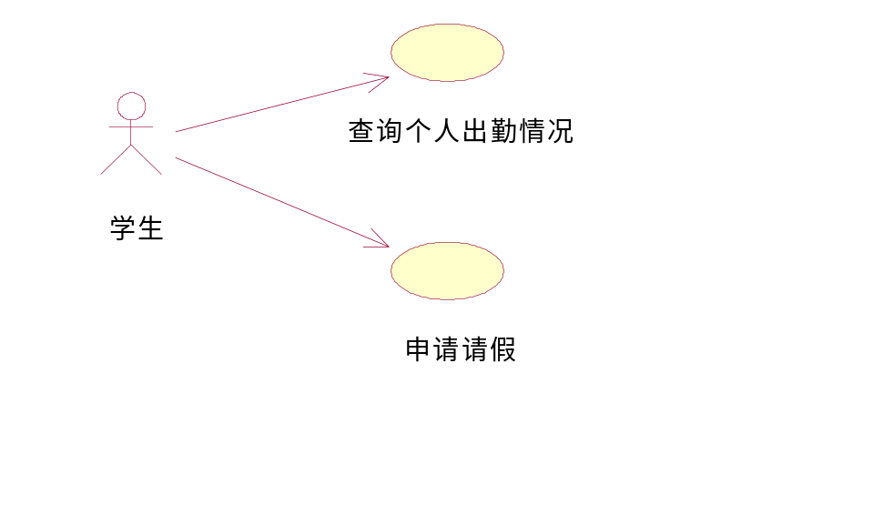
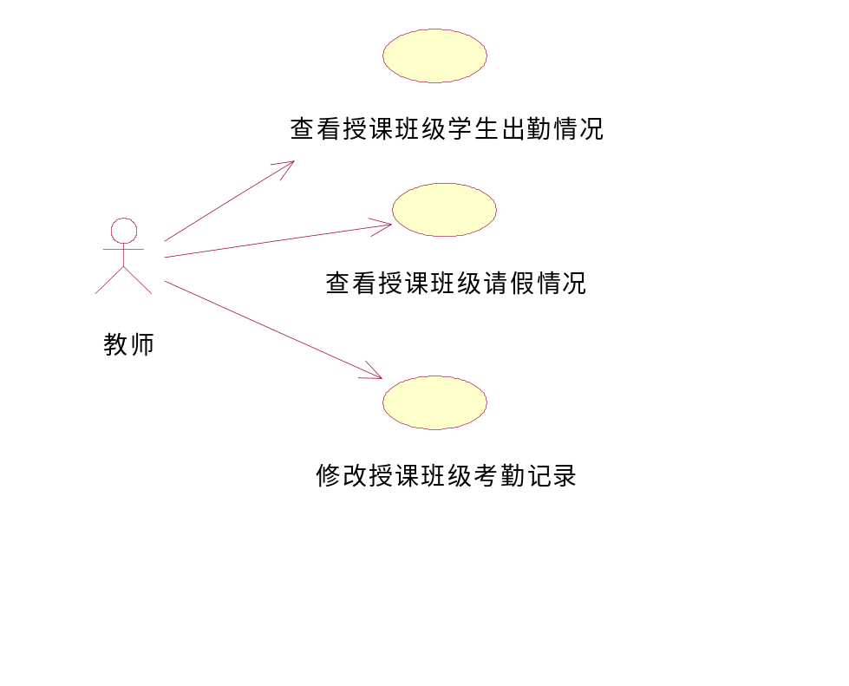
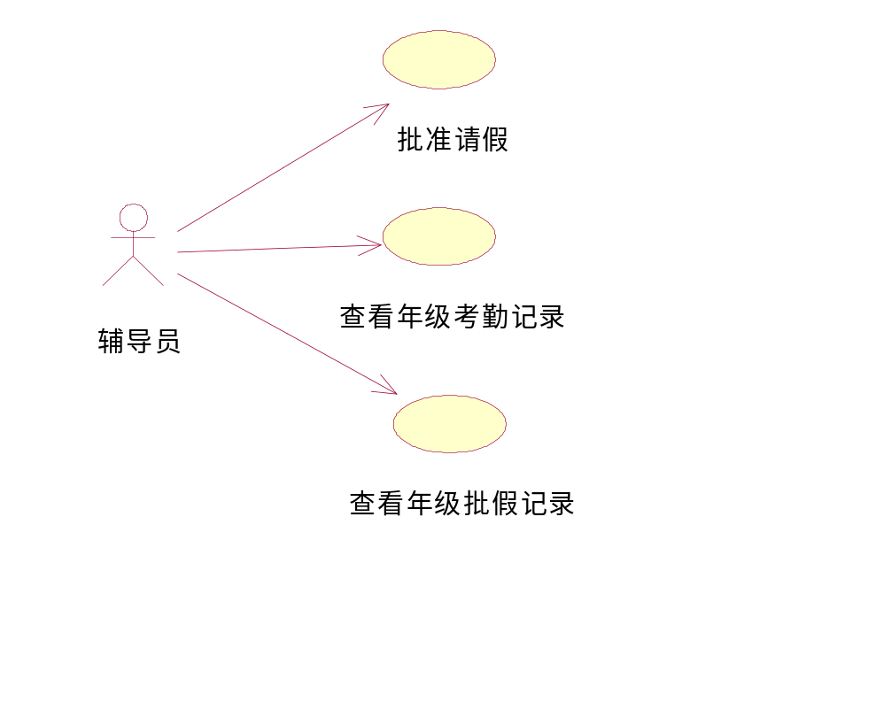

对象模型
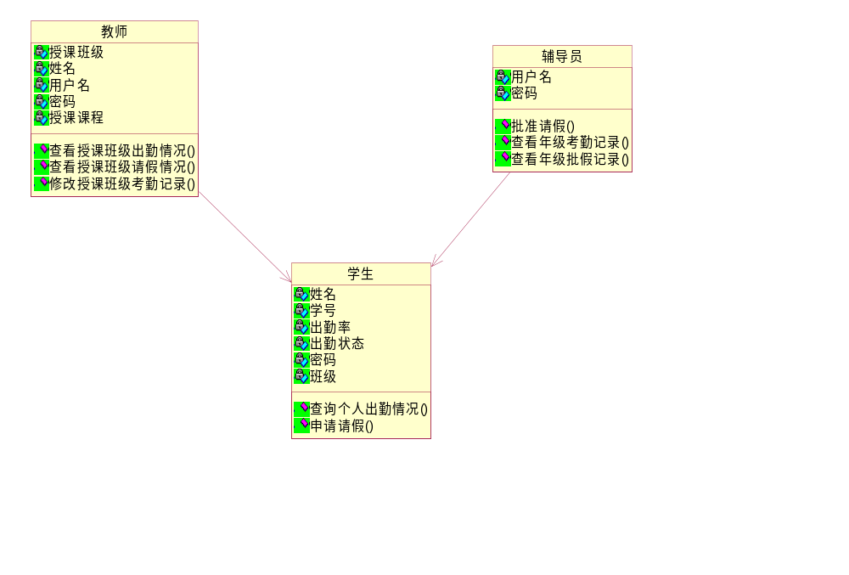

动态模型

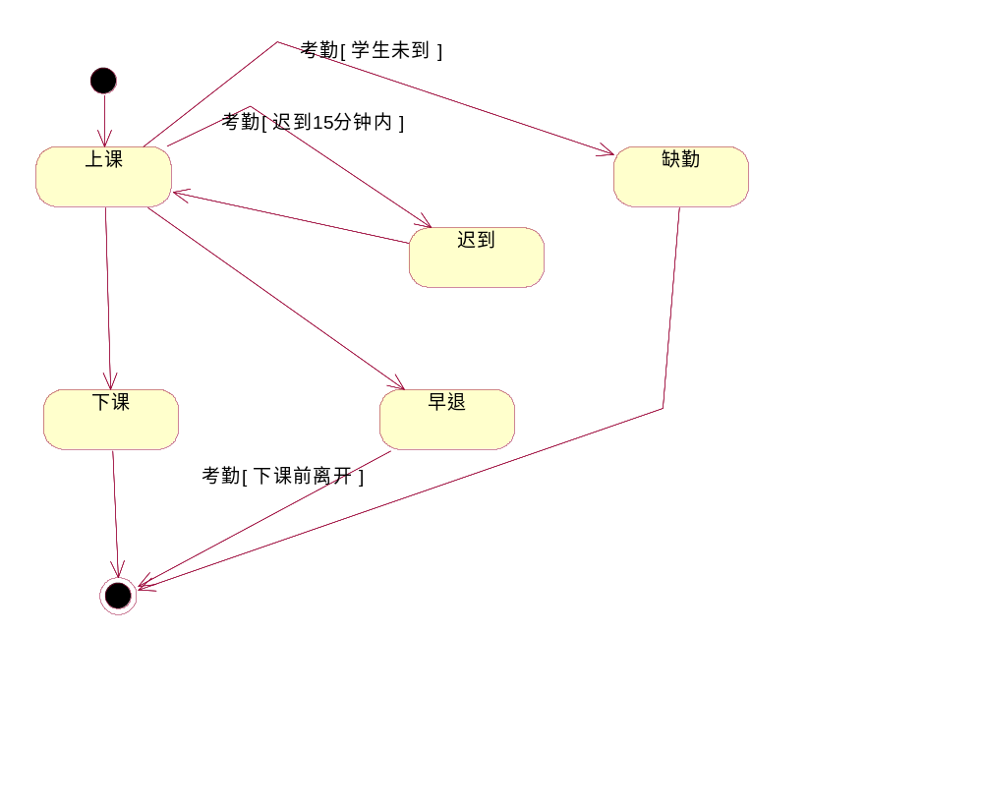

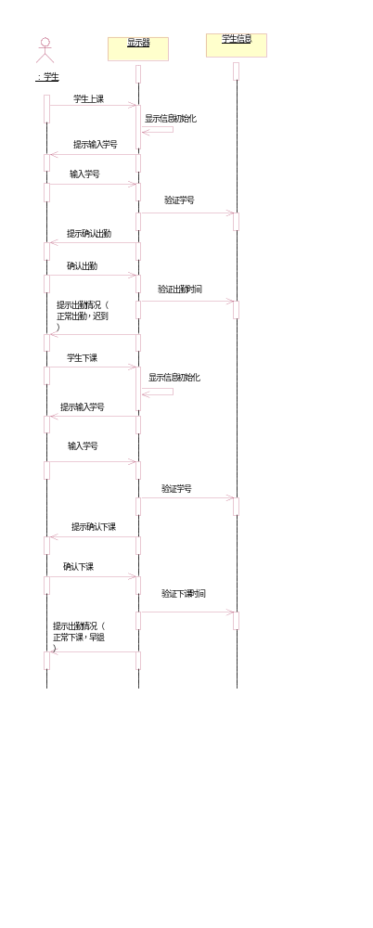

系统总体功能需求
表2功能需求表

编号 | 功能需求名称 | 优先级别
SRS_SJGL01 | 数据管理 | 高
SRS_SJGL01.01 | 数据导入 | 高
SRS_SJGL01.02 | 数据导出 | 高
SRS_STUGL02 | 学生信息管理 | 高
SRS_STUL02.01 | 学生用户登录 | 高
SRS_STUL02.02 | 学生用户考勤 | 高
SRS_STUL02.03 | 学生用户查询 | 高
SRS_STUL02.04 | 学生用户请假 | 高
SRS_TCHGL03 | 教师信息管理 | 高
SRS_TCHGL03.01 | 教师用户登录 | 高
SRS_TCHGL03.02 | 教师用户查询 | 高
SRS_TCHGL03.03 | 教师用户修改 | 高
SRS_FDYGL03 | 辅导员信息管理 | 高
SRS_FDYGL03.01 | 辅导员用户登录 | 高
SRS_FDYGL03.02 | 辅导员用户查询 | 高
SRS_FDYGL03.03 | 辅导员用户批假 | 高

非功能需求
对软件的非功能需求的描述，应包括性能、安全性、可扩展性、稳定性等方面的需求界定。

性能需求
数据处理能力：
支持的终端数：50
支持并行操作的用户数：50
处理的文件和记录数：1000
表和文件的大小：1M
时间特性需求：
响应时间：1s
更新处理时间：1s
数据的转换和传送时间：1s
运行时间：长期运行

安全保密需求
防止非授权用户登录：通过校验账号和密码是否匹配。
防止非法数据侵入：根据用户不同权限可以执行不同操作。
密码存储及乱码传输：采用简单加密，如凯撒密码等。
数据安全：建立日志。

扩展性需求
能够进行功能扩展，可灵活地增减学生、教师、辅导员。

稳定性需求
学生出勤时间在上下课时间，期间为考勤登记的高峰时间，尤其是上下课的前后5分钟，可能会存在大量并发式访问系统，系统应当尽量保证在此高并发访问下不出现崩溃的情况，如果出现，维护人员应及时处理。

项目组成员分工
表3项目组成员分工
姓名 | 主要工作内容 | 组内评分
熊术文
于永康
宋纪奇
谢莞悦

