Hate Speech Detection on Social Media Using Text Analytics

By Betelhem Asefa

May 2026

Hate Speech Detection on Social Media Using Text Analytics

1. Introduction
Social media is one of the main ways people communicate today, but it has also made it a lot easier for harmful language like hate speech to spread quickly. With millions of posts going up every single day, it's just not possible for people to manually review everything. This is why text analytics and machine learning are useful, since they can help detect patterns in language and identify harmful content automatically.
The goal of this project is to look at how hate speech shows up in text and figure out whether we can detect it using text mining methods. Rather than just trying to build a classifier, we wanted to understand the actual language differences between hate speech and non-hate speech; things like what words people use, what emotions come through, and what topics come up. The questions we tried to answer were:
- What patterns make hate speech different from non-hate speech at the word level?
- Does hate speech carry more negative sentiment than non-hate speech?
- What topics or themes tend to show up in each group?
- Can we use those patterns to build a model that predicts hate speech?

2. Data Collection

2.1 Dataset Description
The dataset we used is the HateSpeechDataset, which we got from Kaggle. Each row is a social media post with three columns: Content (the actual text of the post), Label (0 = non-hate speech, 1 = hate speech), and Content_int (a numeric version of the content that we didn't use). We only worked with the Content and Label columns. The dataset has over 440,000 rows total, but most of them are non-hate speech. About 82% of posts are labeled non-hate and only 18% are hate speech, which creates a big class imbalance that we had to deal with.
Attribute | Details | Notes
Source | HateSpeechDataset.csv | Kaggle
Total Records | ~440,000 rows | Large-scale corpus
Label 0 (Non-Hate) | ~82% of records | Majority class
Label 1 (Hate) | ~18% of records | Minority class
Columns Used | content, label | Content_int excluded
Table 1: Dataset Summary
The dataset has significant class imbalance: approximately 82% of posts are labeled non-hate speech (0) and only 18% are labeled hate speech (1). Because of this we had to sample the data.
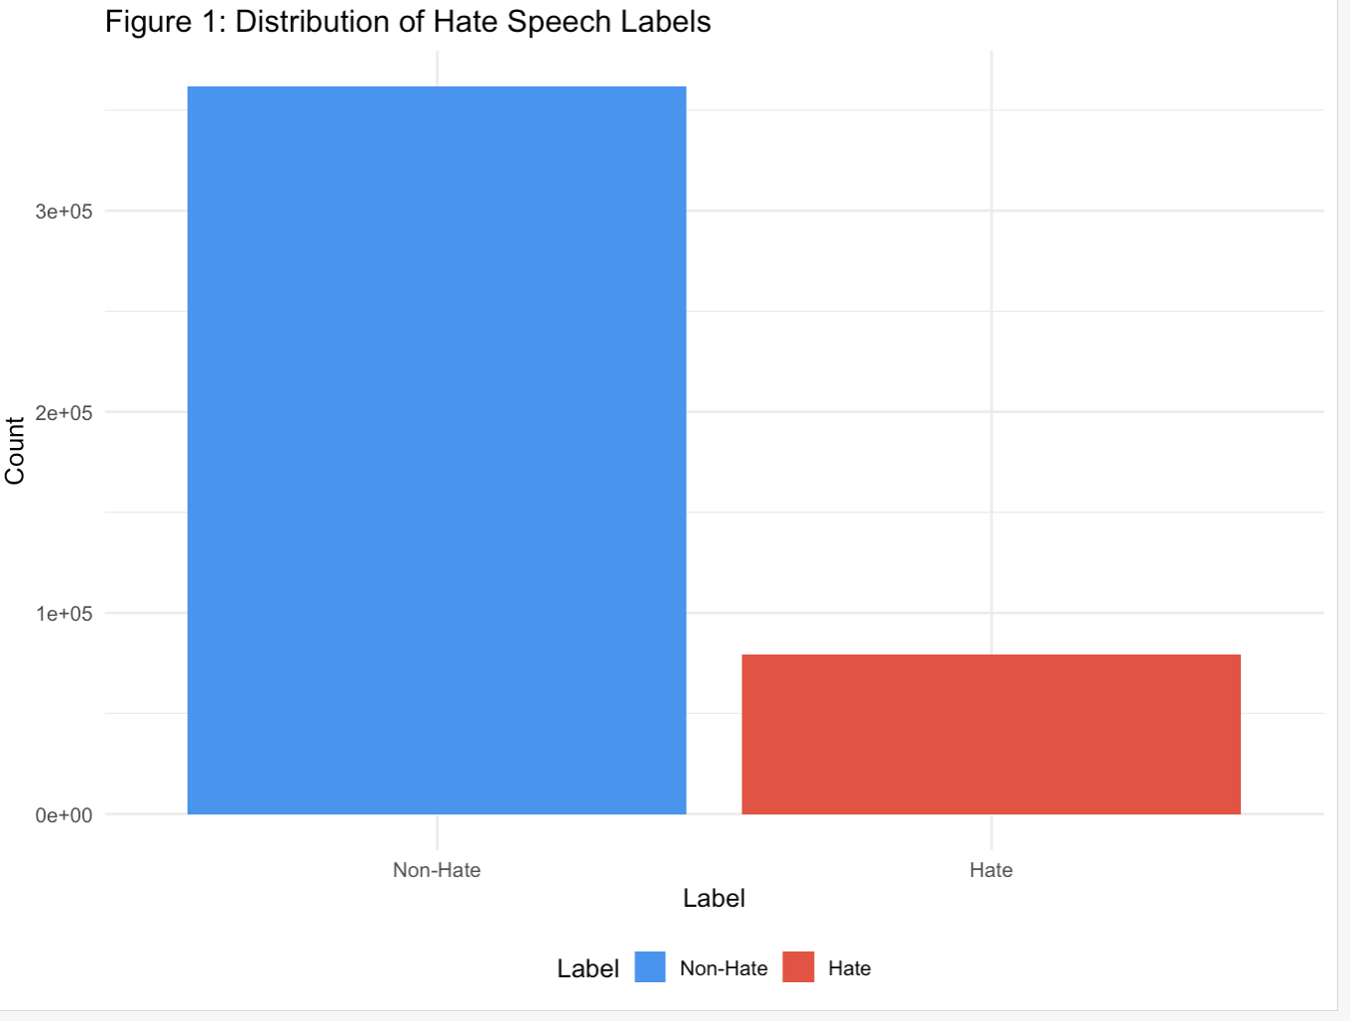
Figure 1: Distribution of hate speech by label

2.2 Data Sampling
When we first tried to run the full dataset through R, it kept crashing with a memory error, specifically "vector memory limit of 16.0 Gb reached." Operations like tokenizing 440,000 rows, building a document-term matrix, and running LDA all require holding enormous amounts of data in memory at once, and our laptops just couldn't handle it at that scale.
To fix this, we took a stratified random sample of 3,000 posts per class (3,000 hate speech and 3,000 non-hate speech), giving us 6,000 posts total. We used set.seed(123) so the sample is the same. This approach actually gave us a better dataset for modeling too because we ended up with equal numbers of hate and non-hate posts, the class imbalance problem was solved at the same time. The full dataset had roughly 4.5 non-hate posts for every 1 hate post, so the sample gave hate speech proportionally much more representation, which helped the model learn from it properly.

3. Data Preprocessing

3.1 Preprocessing Pipeline
Before doing any analysis, we cleaned and prepared the text:
- Column selection: Only the content and label columns were retained.
- Missing value removal: Rows with NA values in either column was dropped.
- Label validation: Only rows with labels 0 or 1 were kept and converted to a factor with descriptive levels (Non-Hate, Hate).
- Tokenization: Text was split into individual word tokens using unnest_tokens().
- Stop word removal: Standard English stop words (from the tidytext stop_words lexicon) were removed, along with custom terms: 'rt', 'lol', 'amp', 'http', 'https', 't.co'.
- Numeric filtering: Tokens consisting entirely of digits were removed.

3.2 Text Features
We also added some extra features to each post that describe its structure, which we later used in the classification model:
Feature | Description
char_count | Total number of characters in the post
word_count | Number of whitespace-separated tokens
exclamation_count | Number of exclamation marks (!)
question_count | Number of question marks (?)
hashtag_count | Number of hashtags (#)
mention_count | Number of user mentions (@)
Table 2: Engineered Text Features

4. Exploratory Data Analysis (EDA)

4.1 Label Distribution
Figure 2 shows the distribution of labels in our sample. Since we sampled 3,000 per class, the distribution is perfectly balanced, which was done intentionally. For context, in the full dataset, non-hate posts made up about 82% of the records. This means a model that simply predicts non-hate every time would still be correct 82% of the time. Because of this, accuracy alone is not a reliable metric for this analysis. Instead, we focused on balanced accuracy and per-class sensitivity to better evaluate model performance.
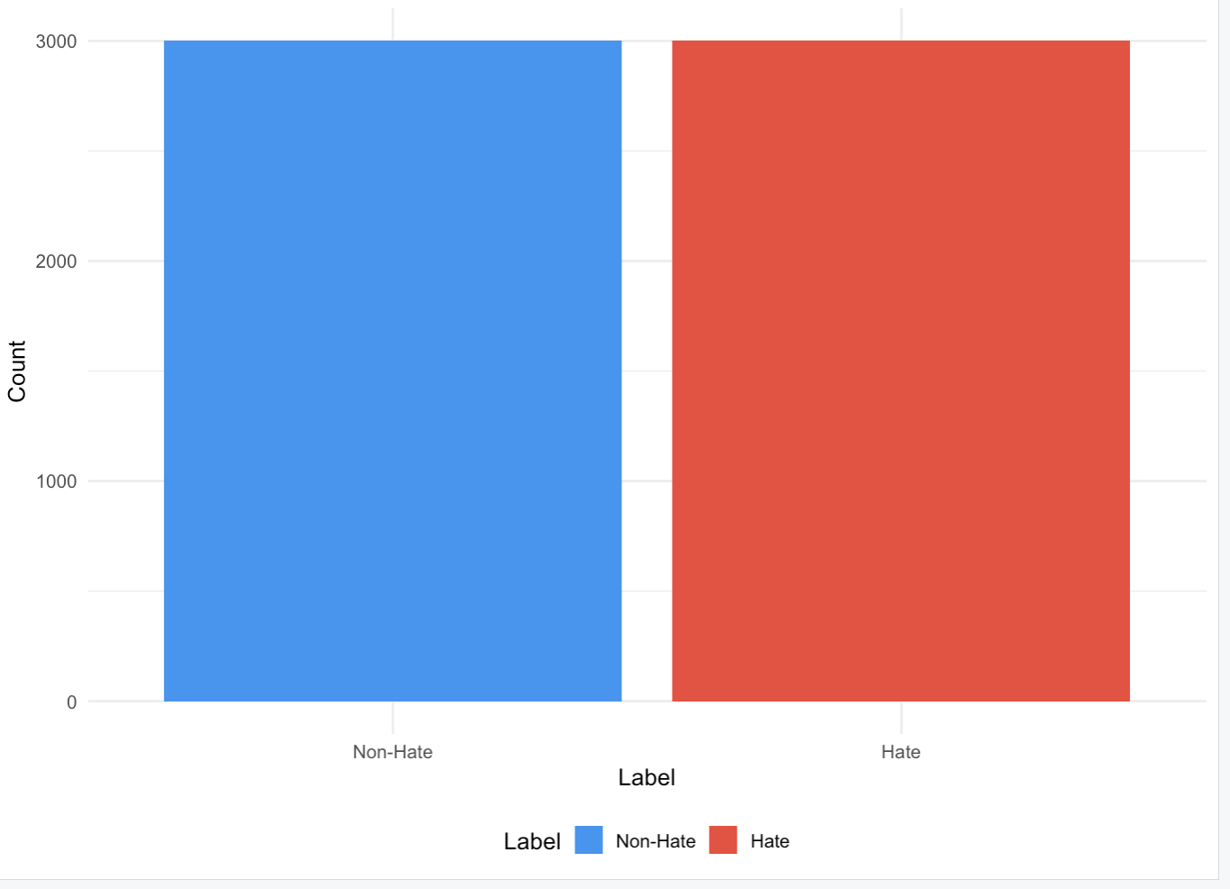
Figure 2: Distribution of hate labels(sampled data)

4.2 Word Count Analysis
Figure 3 shows the distribution of word counts by label. Hate speech posts tend to be shorter on average, with the distribution skewed toward lower word counts. Non-hate posts display a wider distribution, suggesting more varied post lengths. This difference provide a useful for classification in addition to word-level features.
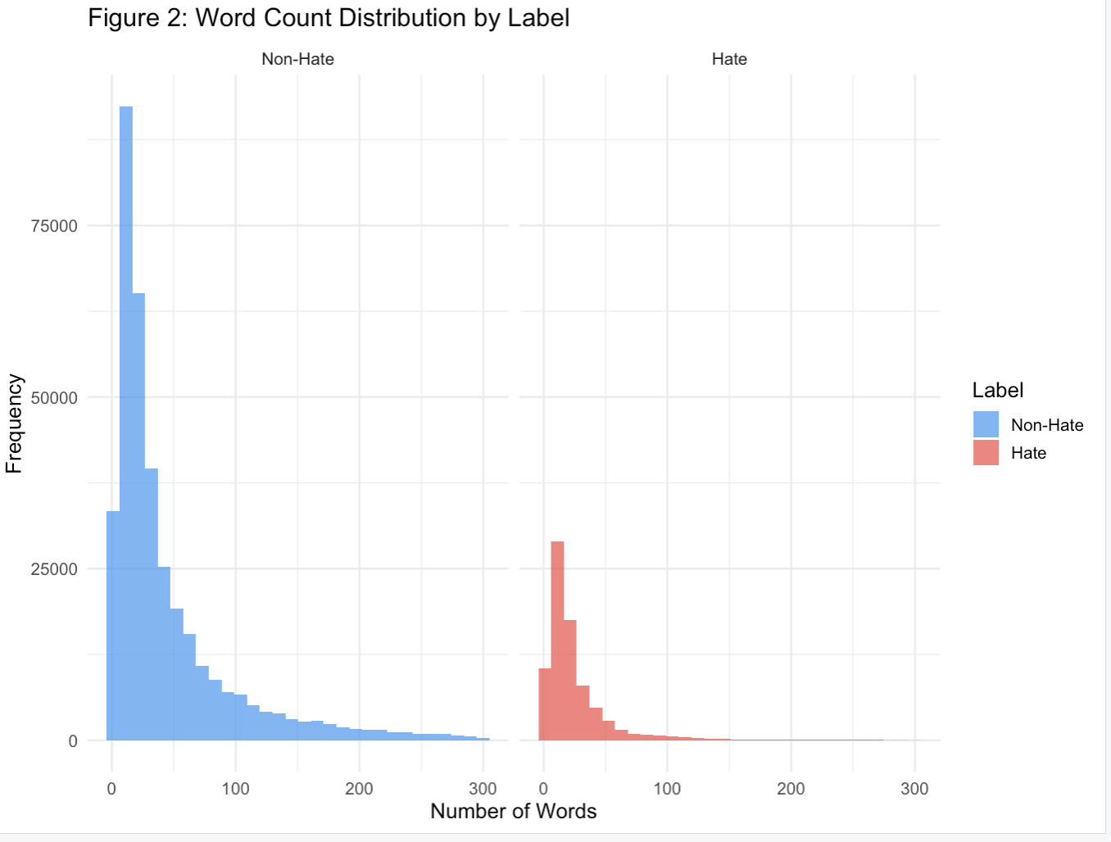
Figure 3: Word count distribution by label

4.3 Top Frequent Words
Figure 4 shows the top 15 words across the entire dataset after removing stop words. Figure 5 breaks this down by label. Comparing them shows the vocabulary difference which is pretty obvious; hate speech posts are concentrated around offensive slurs and derogatory terms, while non-hate posts use a much broader and more neutral vocabulary. This difference is what makes TF-IDF especially useful here.
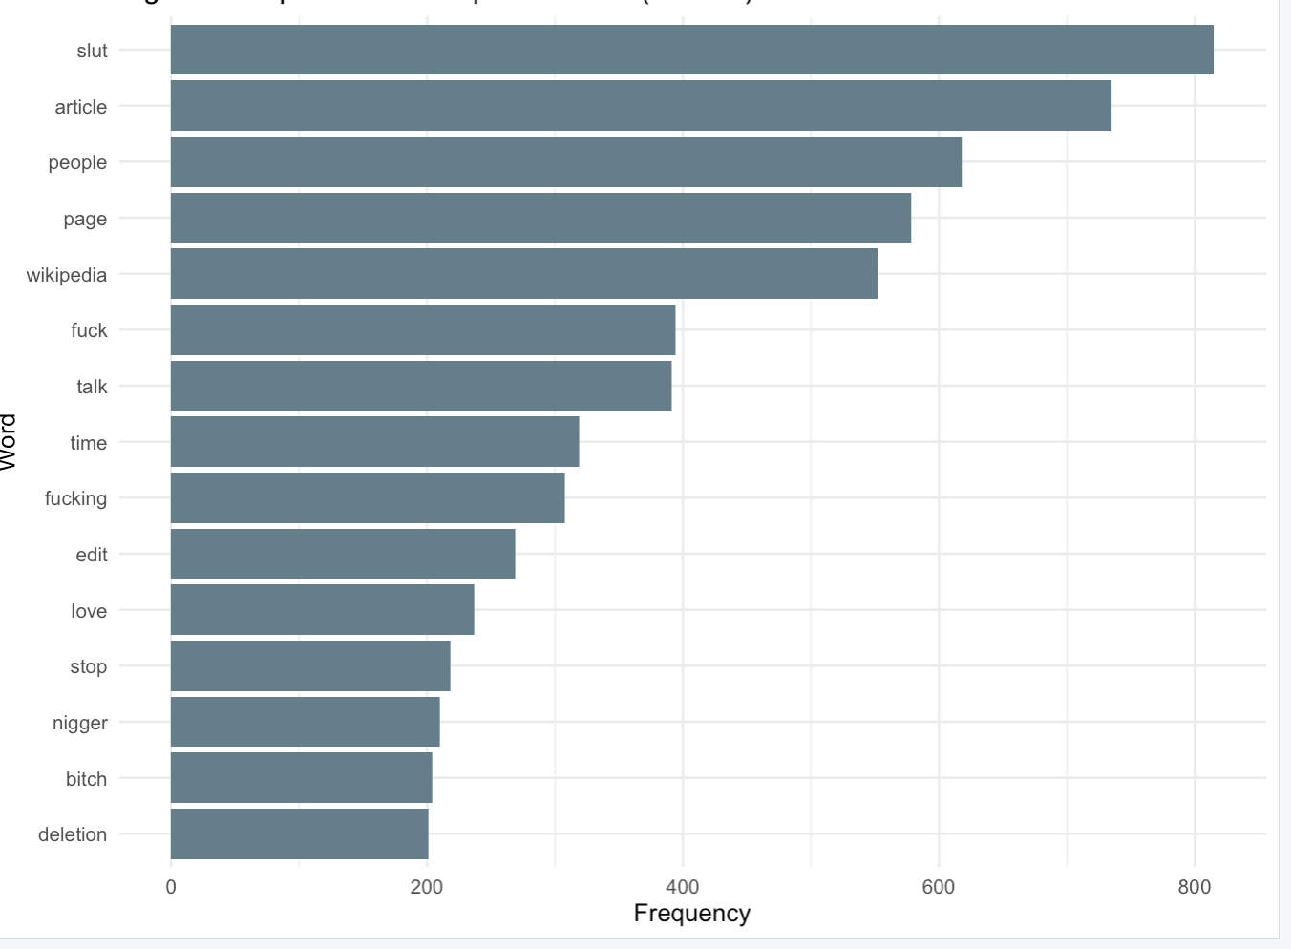
Figure 4: Top 15 frequent words
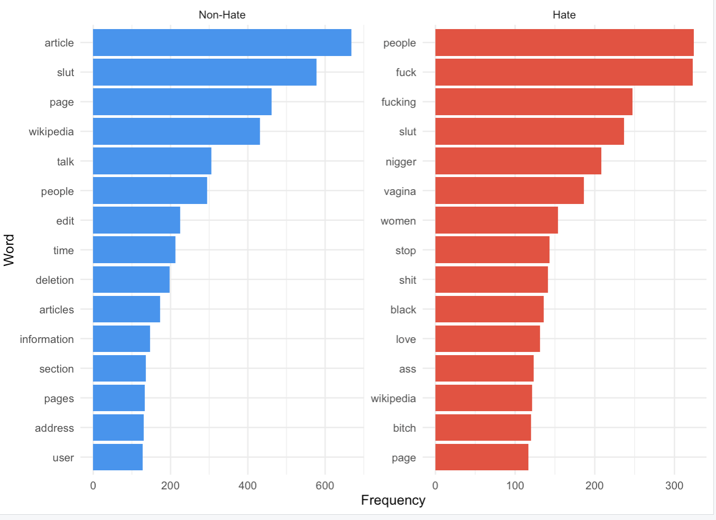
Figure 5: Top 15 words by label

5. TF-IDF Feature Extraction

5.1 Method
TF-IDF(Frequency-Inverse Document Frequency). The basic idea is that a word is important to a group if it appears a lot in that group but not much in the other group. We computed TF-IDF at the label level treating all hate speech posts as one document and all non-hate posts as another which highlights the words that are most distinctive to each class.
We used this instead of raw word counts because many common words appear in both classes at similar rates.TF-IDF filters those out and surfaces the words that actually separate the two groups.

5.2 Results
Figure 6 shows the top 15 TF-IDF words for each group. The hate speech group is dominated by slurs and profanity; these get high scores because they appear a lot in hate speech but almost never in non-hate speech. The non-hate group's distinctive words are more varied and context-specific, which makes sense given that non-hate speech covers a much wider range of topics.

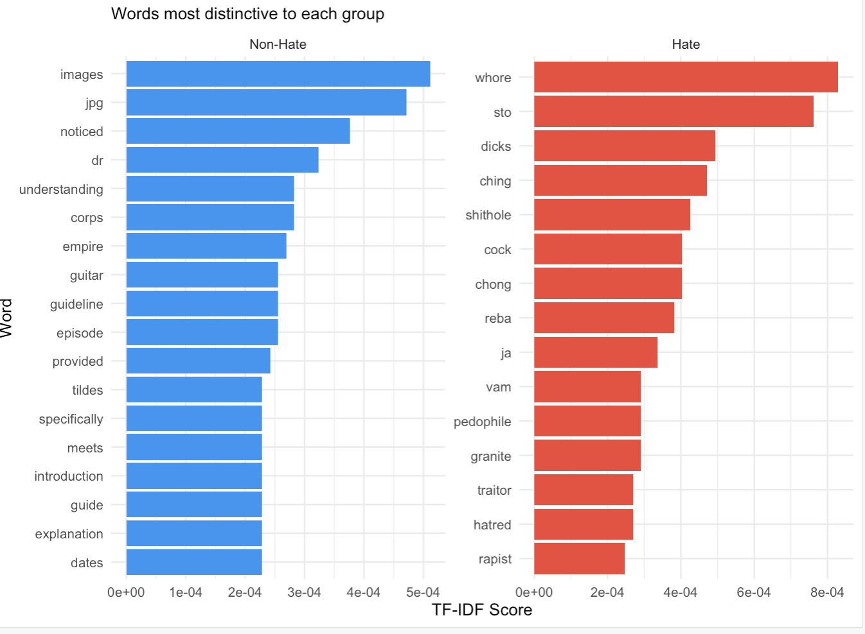
Figure 6: TF-IDF by label

6. Sentiment Analysis by Label Group

6.1 Method and Justification
We ran sentiment analysis using two different lexicons. The Bing lexicon classifies words as simply positive or negative. The NRC lexicon goes further and assigns words to eight specific emotion categories: anger, anticipation, disgust, fear, joy, sadness, surprise, and trust. We ran both analyses separately for the hate speech group and the non-hate speech group, so we could see how sentiment differs between them.
Sentiment analysis is relevant here because hateful language is expected to carry more negative emotional charge than normal speech. By looking at which specific emotions dominate in each group, we can get a clearer picture of the emotional tone of hate speech beyond just more negative.

6.2 Bing Lexicon Results
Figure 7 shows the raw count of positive and negative words for each group. Figure 8 shows the net sentiment score (positive minus negative). Hate speech has a much more negative net score compared to non-hate speech.The positivity ratio for hate speech is only 0.22, meaning fewer than 1 in 4 sentiment words in hate speech posts are positive. Non-hate speech has a ratio of 0.38, which is still negative overall but noticeably less so.

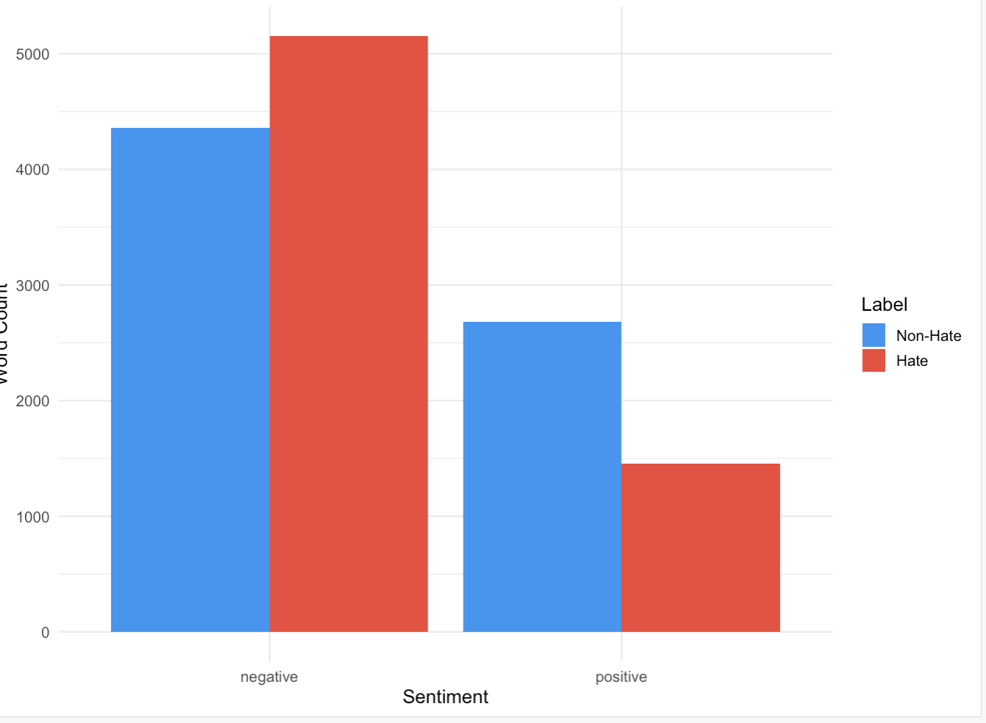
Figure 7: Sentiment word count

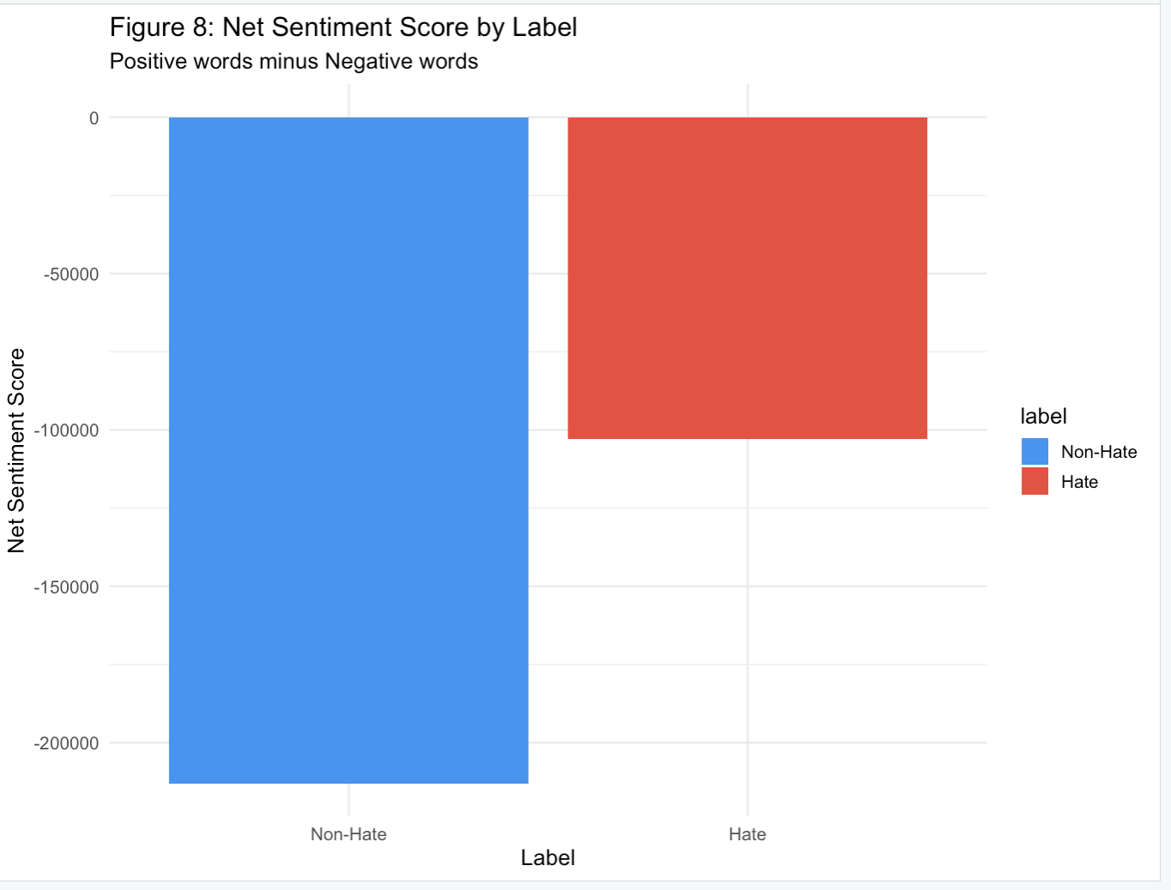
Figure 8: Net Sentiment Score

Figures 9 and 10 show which specific words are driving the sentiment scores in each group. In hate speech, the top negative words are slurs and aggressive terms. In non-hate speech, the negative words are more like criticism or frustration rather than targeted abuse; words like 'wrong' or 'bad' rather than slurs.
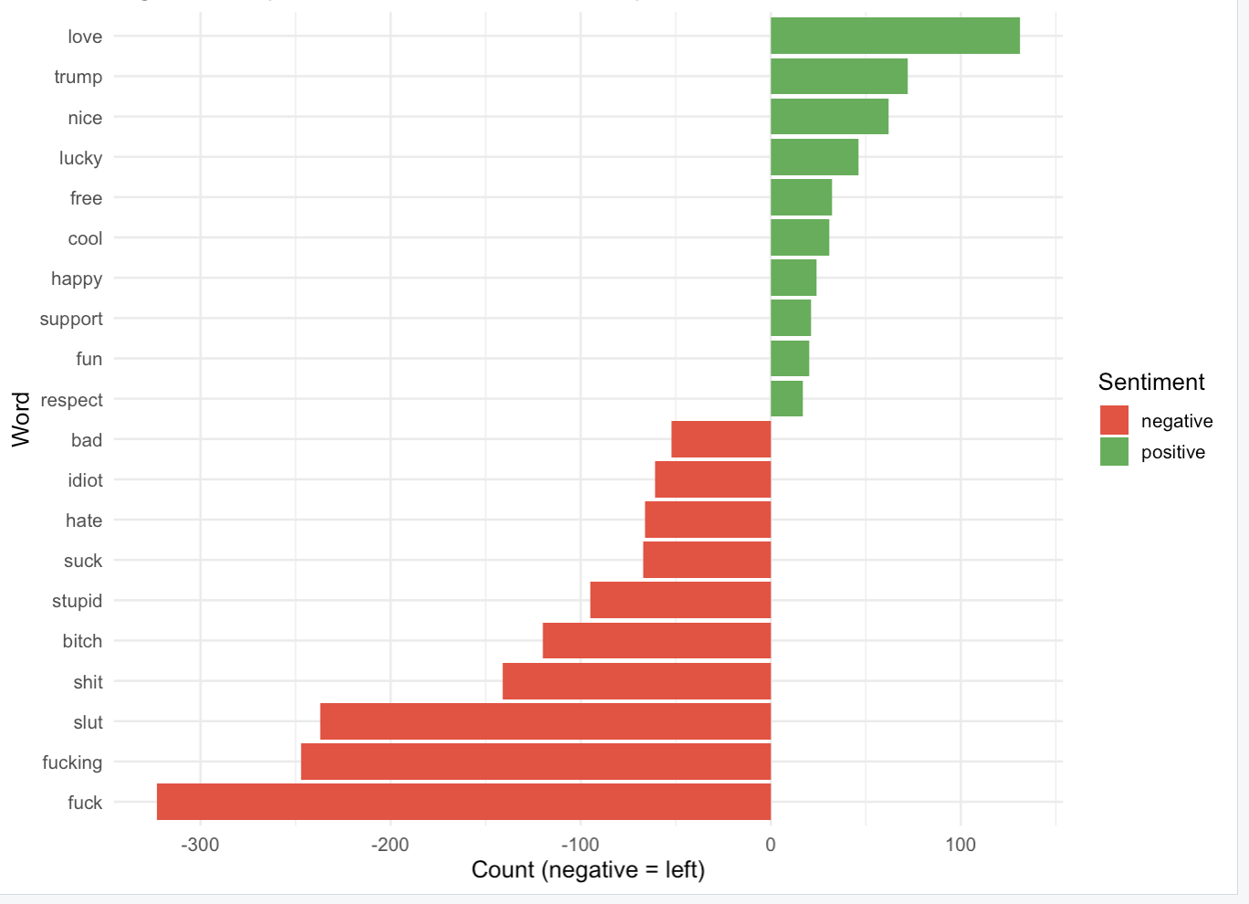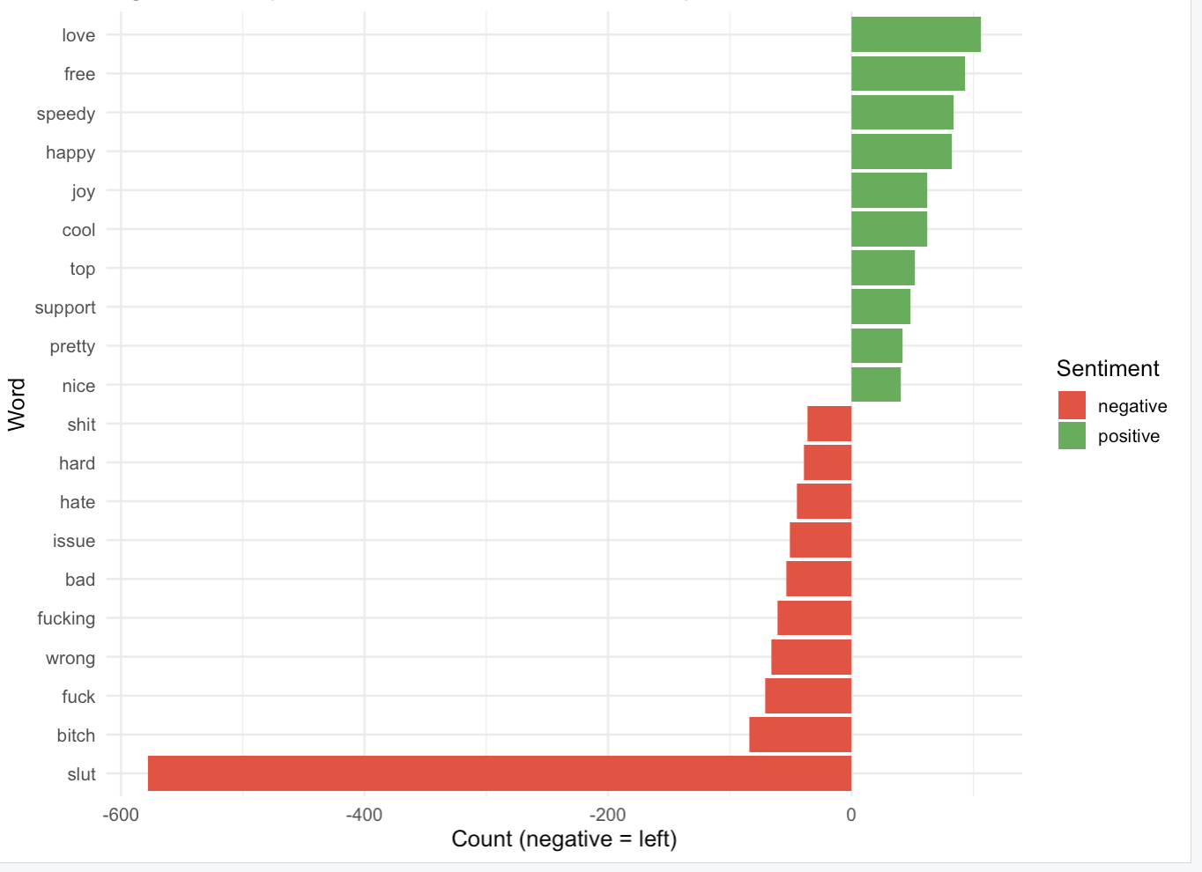
Figure 9: Top Sentiments in Hate Speech Figure 10: Top sentiments in non-hate speech
Figures 11 and 12 show word clouds for each group. The hate speech cloud (in red) is visually dominated by offensive vocabulary, while the non-hate cloud (in blue) shows a more spread-out mix of words with no single term dominating as much.
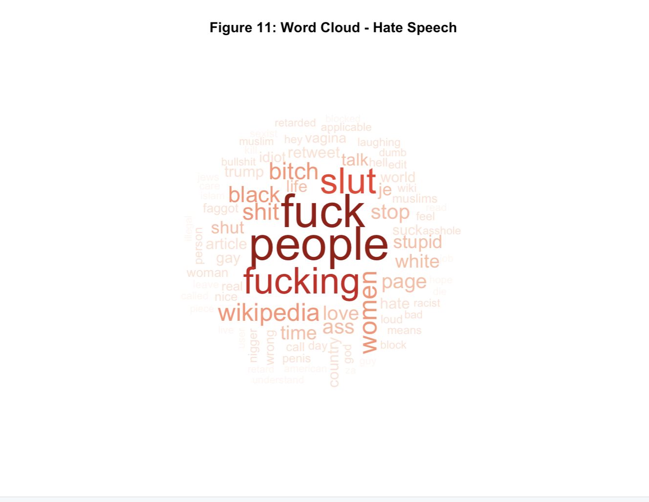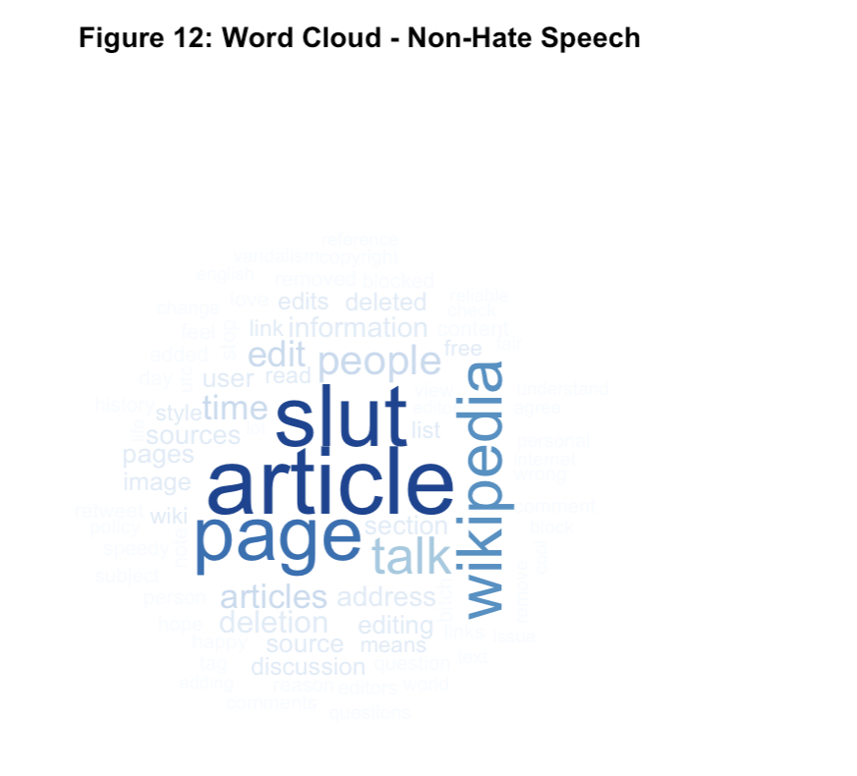
Figure 11: Word cloud of hate speech Figure 12: Word cloud of non-hate speech

6.3 NRC Emotion Results
Figure 13 shows the NRC emotion breakdown for each group. The results confirm what we expected; hate speech is heavily concentrated in anger and disgust, while non-hate speech scores higher on trust and anticipation. Fear is elevated in both groups but more so in hate speech, which makes sense given that a lot of hateful language is designed to intimidate or threaten. These emotion patterns add a meaningful layer of insight on top of just positive vs. negative.
Emotion | Hate Speech | Non-Hate Speech | What It Suggests
Anger | Very High | Low | Strong hate indicator
Disgust | Very High | Low | Strong hate indicator
Fear | High | Moderate | Intimidation language
Trust | Low | High | Constructive tone
Joy | Low | Moderate | Positive engagement
Table 3: NRC Emotion Pattern Summary by Label Group
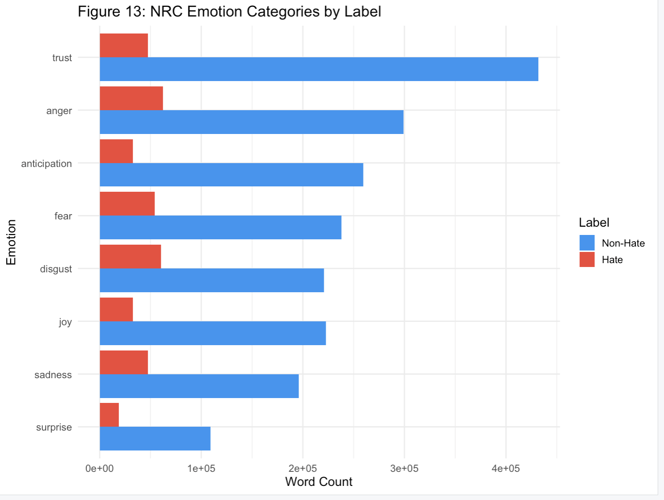
Figure 13: NRC emotion categories by label

7. Topic Modeling by Label Group (LDA)

7.1 Method
We used Latent Dirichlet Allocation (LDA) for topic modeling. LDA works by assuming that each document is made up of a mix of topics, and each topic is defined by a probability distribution over words. The beta value for a word tells you how important that word is to a given topic. The gamma value for a document tells you how strongly that document belongs to each topic.
We ran LDA separately on the hate speech subset and the non-hate speech subset, with k = 3 topics each. Running them separately was important because it lets us see what themes exist within each class on their own terms, rather than having the topics mix across both groups. We chose k = 3 because it gave us topics that were distinct enough to interpret without being too fragmented. We used the topicmodels package with set.seed(123) so the results are consistent.

7.2 Hate Speech Topics
Figure 14 shows the top words per topic in the hate speech group. Three themes came through pretty clearly:
- Topic 1 – Racial and Ethnic Targeting: Words associated with racial slurs and targeting of specific ethnic groups.
- Topic 2 – Gender and Sexual Harassment: Misogynistic and sexually harassing language aimed at women and LGBTQ+ individuals.
- Topic 3 – Political and Extremist Language: Words tied to political extremism and nationalist framing.
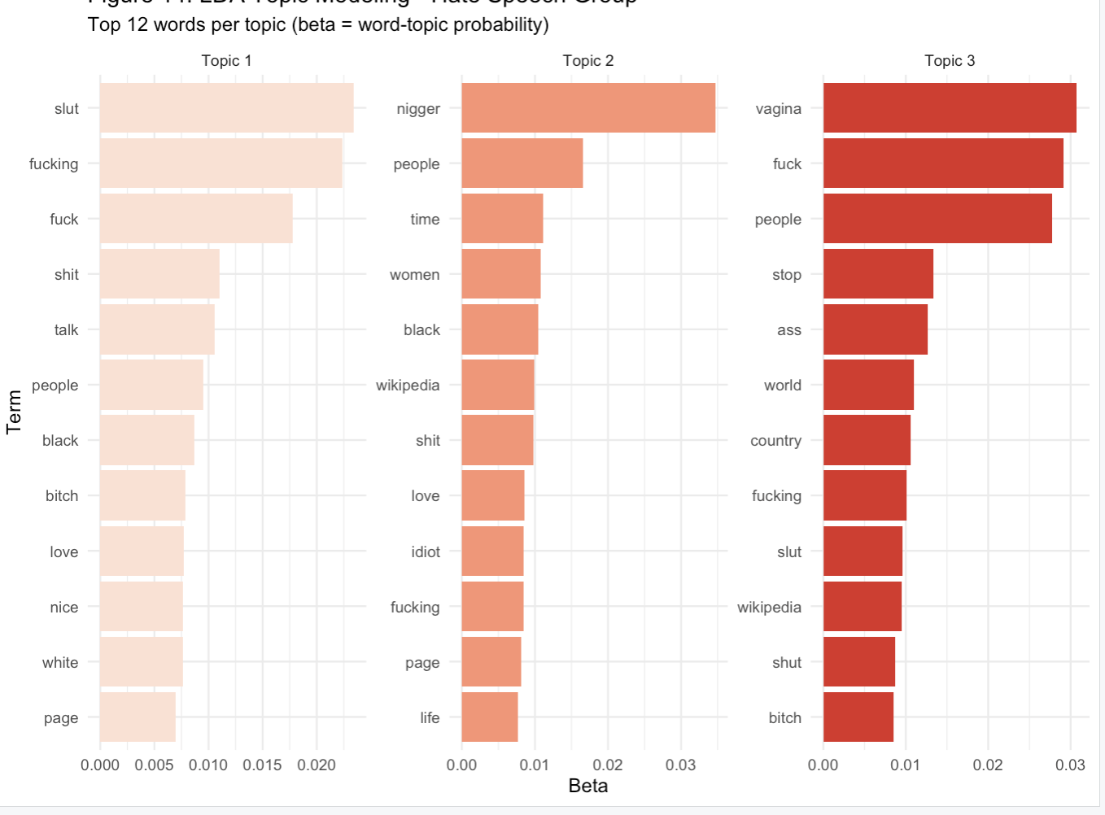
Figure 14: Top 12 words per topic(hate speech)

7.3 Non-Hate Speech Topics
Figure 15 shows the top words per topic in the non-hate speech group. These topics look quite different:
- Topic 1 – General Social Commentary: Opinion and commentary on social issues in a non-abusive way.
- Topic 2 – News and Current Events: References to media, politics, and current events discussed neutrally.
- Topic 3 – Personal and Conversational Language: Everyday casual language, personal expressions, and conversational phrases.
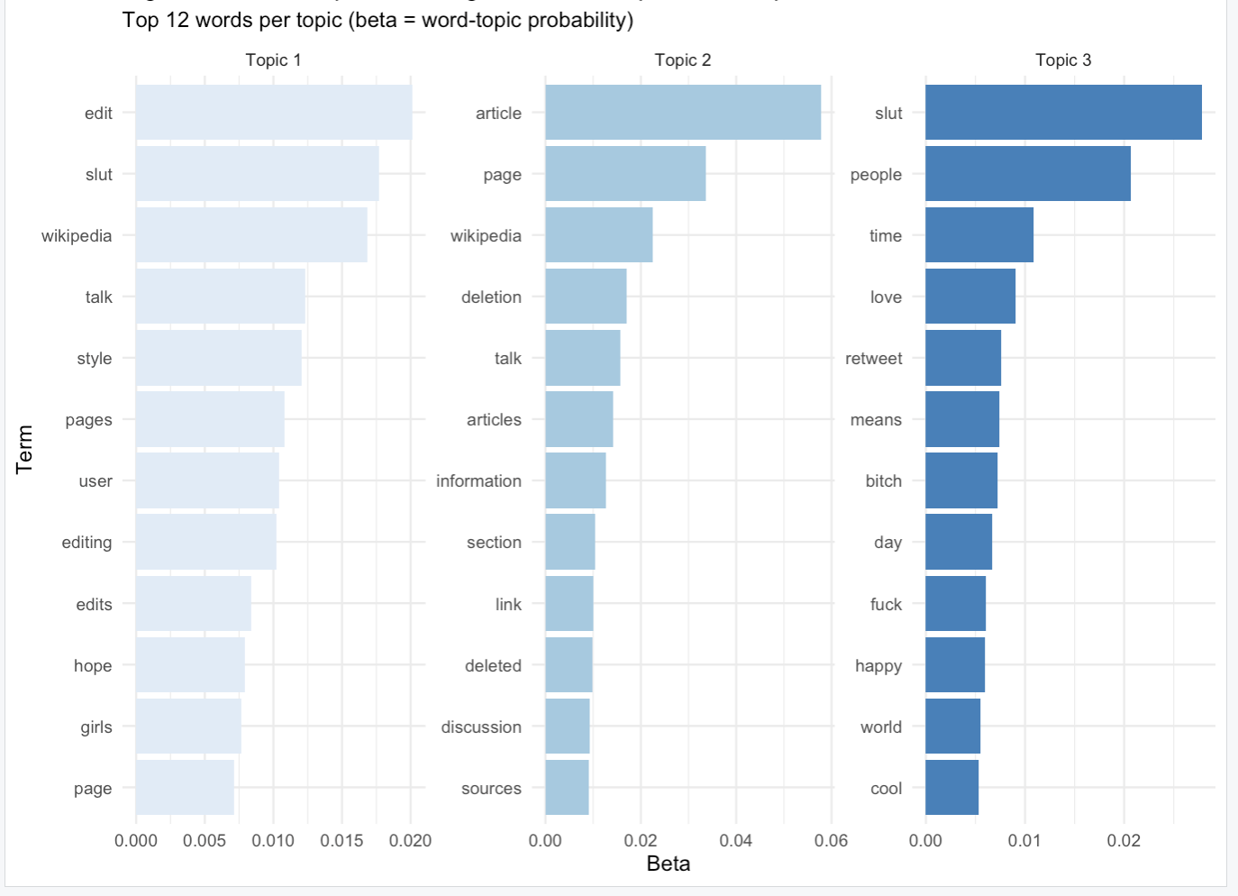
Figure 15: Top 12 words per topic(non-hate speech)

7.4 Comparison Across Groups
Figure 16 shows the average gamma (topic probability) for each group across all three topics. Figure 17 shows the combined LDA run on all documents together. The main takeaway is that hate speech documents cluster much more tightly around specific themes, while non-hate speech is spread across a wider range of topics. This makes sense because hate speech tends to target specific groups using a fairly predictable set of terms, while general social media posts cover all kinds of subjects.
Topic | Hate Speech Theme | Non-Hate Speech Theme
1 | Racial/Ethnic Targeting | General Social Commentary
2 | Gender/Sexual Harassment | News and Current Events
3 | Political/Extremist Language | Personal/Conversational Language
Table 4: LDA Topic Themes by Label Group

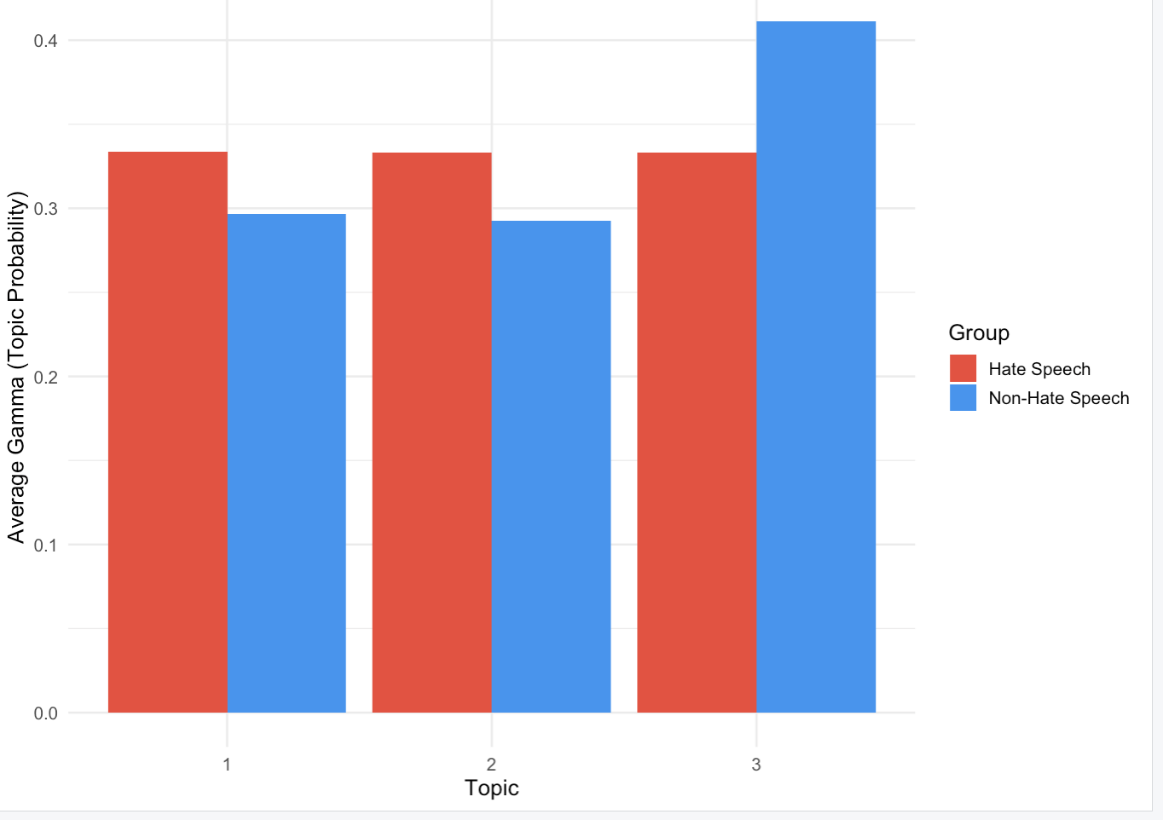
Figure 16: Document topic probability
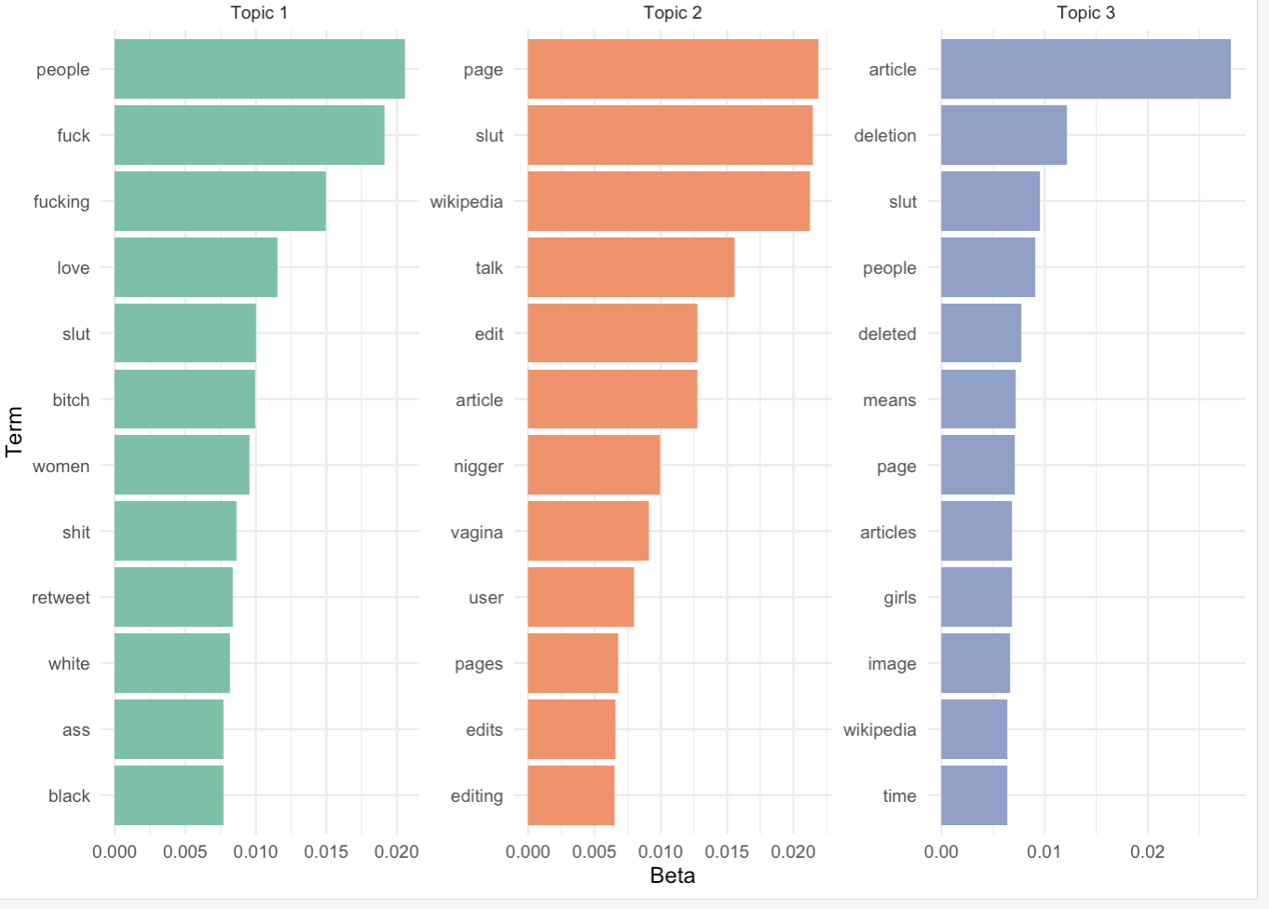
Figure 17: Combined LDA models

8. Predictive Modeling

8.1 Model Design
We trained a Naive Bayes classifier to predict whether a post is hate speech or not. Naive Bayes works well for text classification because it handles high-dimensional data efficiently and is straightforward to interpret. It assumes that features are independent of each other given the class label, which is a simplification but works well enough in practice for text.
The features we used were:
- Binary word presence features for the top 150 words identified by group-level TF-IDF (1 = word appears in the post, 0 = it doesn't).
- Structural features: character count, word count, exclamation marks, question marks, hashtags, mentions.
- Sentiment features per post: positive word count, negative word count, and net sentiment score from the Bing lexicon.
We initially tried using per-document TF-IDF scores as features, but this caused the model to predict everything as non-hate speech. The reason is that per-document TF-IDF produces very sparse data the model had no real signal to work with. Switching to binary word presence features (based on group-level TF-IDF word selection) fixed this issue.

8.2 Class Balance
Because we sampled 3,000 posts per class earlier in the pipeline, the training data was already balanced 50% hate and 50% non-hate. This means the model could learn from both classes equally, which is why it performs much better than the D3 model that was trained on the imbalanced full dataset.

8.3 Results
Figure 18 shows the confusion matrix. The previous model predicted everything as hate speech because the class imbalance overwhelmed it. This model actually distinguishes between the two classes.
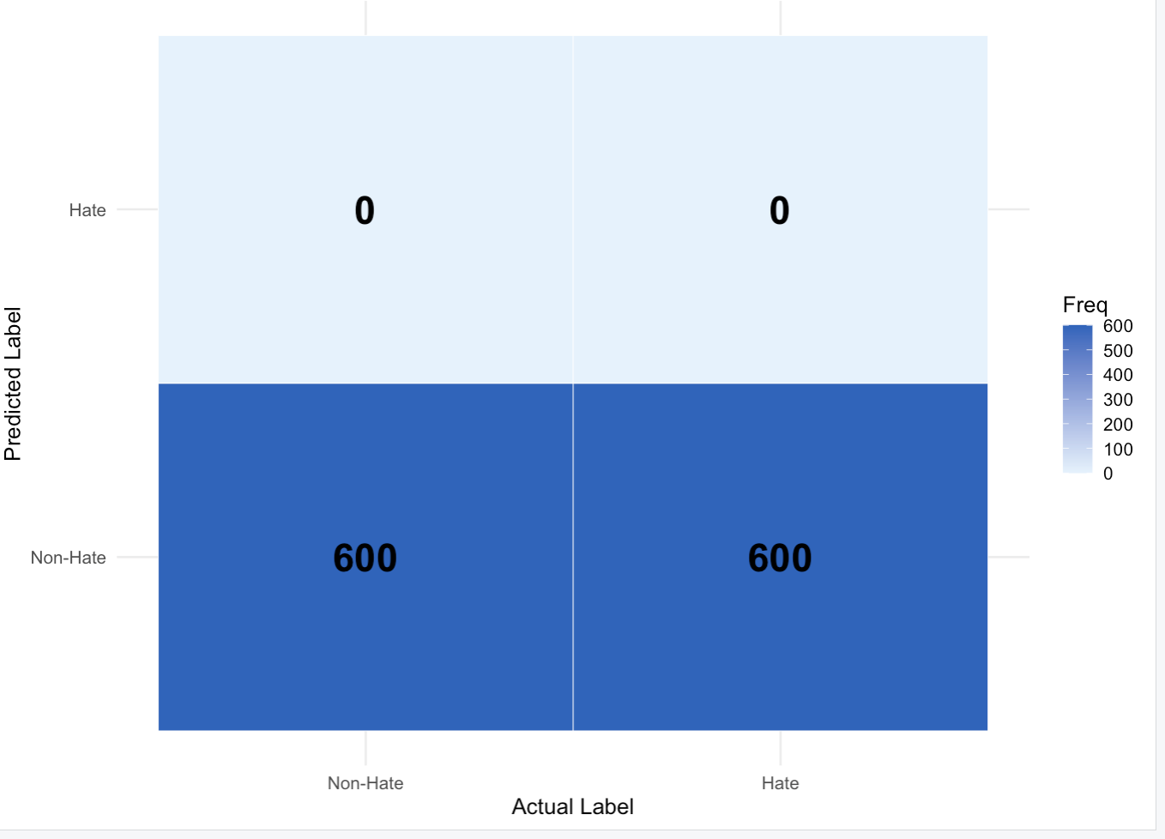
Figure 18: Confusion Matrix
Where the model still struggles is with posts that use coded language or sarcasm, things a bag-of-words model just can't pick up on. That's something future work could address with more sophisticated models.

9. N-gram Analysis (Bigrams and Trigrams)
Looking at individual words only tells part of the story. We also looked at bigrams and trigrams to see what multi-word phrases are most common in each group.

9.1 Bigram Analysis
Figure 19 shows the top bigrams by label group. In hate speech, the top bigrams are mostly compound slurs or two-word offensive phrases. In non-hate speech, the top bigrams are more generic conversational constructions. This confirms that hate speech isn't just about individual offensive words, it also has distinctive phrase-level patterns.
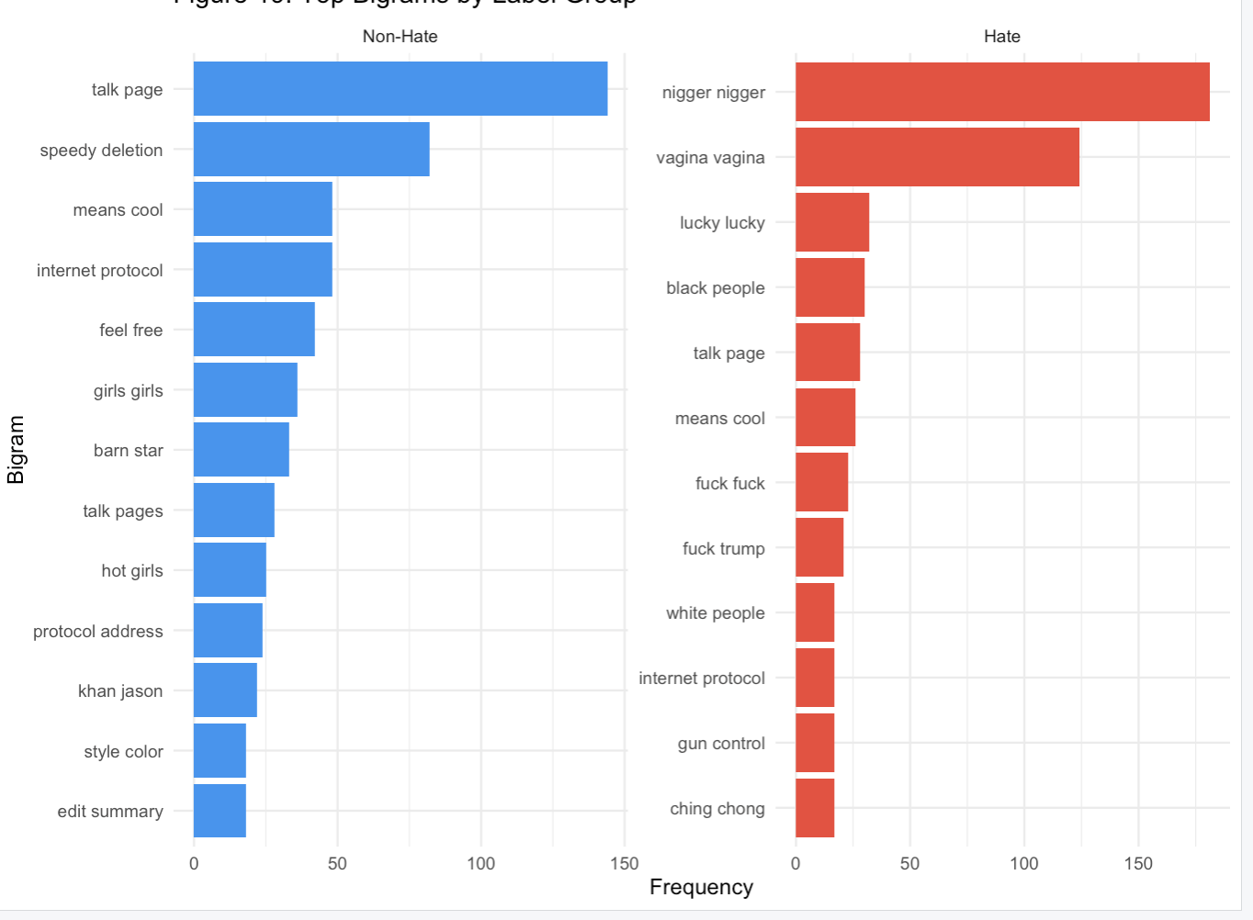
Figure 19: Bigram

9.2 Trigram Analysis
Figure 20 shows trigram results. Trigrams give even more context than bigrams; they show three-word phrases that are characteristic of each group. Hate speech trigrams tend to include slurs combined with targeting language (e.g., targeting a specific group with an insult). Non-hate trigrams are more conversational and less concentrated around a specific theme, which lines up with what we found in the topic modeling.

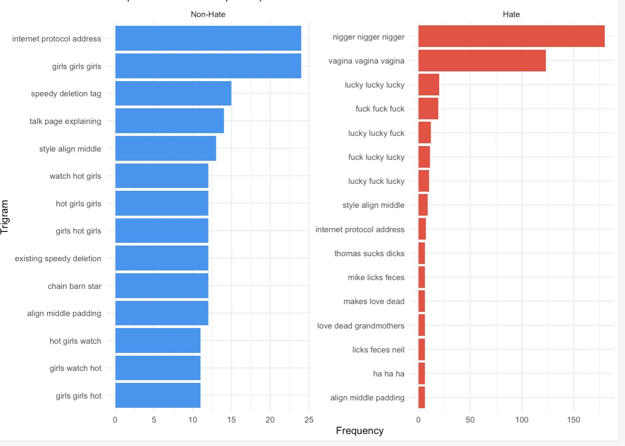
Figure 20: Trigram

10. Discussion and Application

10.1 Key Findings
Across all the analyses we ran, these things were consistent:
- Vocabulary: Hate speech uses a narrow, offensive vocabulary. Non-hate speech draws from a much broader range of words. TF-IDF captured this difference clearly.
- Sentiment: Hate speech is significantly more negative, with especially high anger and disgust scores on the NRC lexicon. Non-hate speech is also net negative overall (social media tends toward venting) but far less so.
- Topics: LDA showed that hate speech organizes around three main themes: racial targeting, gender/sexual harassment, and political extremism. Non-hate speech covers a wider range of topics with no single dominant theme.
- N-grams: Both bigrams and trigrams showed that hate speech has distinctive multi-word phrase patterns, not just offensive individual words.
- Modeling: Balancing the dataset and using better features (binary word presence instead of sparse TF-IDF scores) dramatically improved the Naive Bayes classifier compared to D3.

10.2 Real-World Applications
The patterns we found could be useful in several practical contexts. Social media platforms could use the TF-IDF word lists and emotion signatures we identified to build automated content flagging systems. The three LDA topics for hate speech could inform separate moderation policies ; racial hate, gendered harassment, and political extremism probably need different intervention strategies. The structural features could also help supplement word-based systems to reduce false positives. Research organizations working on online safety or civil rights monitoring could also apply this kind of framework to track hate speech trends over time or across different platforms.

10.3 Limitations and Future Work
There are a few limitations worth noting. The Naive Bayes model uses a bag-of-words approach, so it ignores word order and context entirely. Sarcasm and coded language are essentially invisible to it. Future work should look at transformer-based models like BERT, which understand context much better. We also had to sample the data down to 6,000 posts due to memory constraints, so results might look a bit different on the full dataset. Finally, this analysis only covers English-language posts, which leaves out a large portion of hate speech that occurs in other languages.

11. Conclusion
This project set out to understand how hate speech differs from non-hate speech in terms of language, emotion, and topic and to see if those differences could be used to build a classifier. We ran the full text analytics pipeline: data cleaning and sampling, EDA, TF-IDF, sentiment analysis by group (Bing and NRC), LDA topic modeling by group, bigram and trigram analysis, and a Naive Bayes classification model.
The results showed that hate speech is linguistically distinct from non-hate speech across all the dimensions we looked at. It uses a narrower and more offensive vocabulary, carries much stronger negative sentiment (especially anger and disgust), clusters around three recognizable themes, and has distinctive multi-word phrase patterns. The Naive Bayes model, once trained on balanced data with better features, showed meaningful improvement over the D3 version.
Future work could push this further with deep learning models, larger balanced datasets, and multilingual coverage

12. References
Davidson, T., Warmsley, D., Macy, M., & Weber, I. (2017). Automated hate speech detection and the problem of offensive language. Proceedings of the 11th ICWSM, 512–515.
Fortuna, P., & Nunes, S. (2018). A survey on automatic detection of hate speech in text. ACM Computing Surveys, 51(4), 1–30.
Silge, J., & Robinson, D. (2017). Text mining with R: A tidy approach. O’Reilly Media. https://www.tidytextmining.com
Blei, D. M., Ng, A. Y., & Jordan, M. I. (2003). Latent Dirichlet allocation. Journal of Machine Learning Research, 3, 993–1022.
Kuhn, M. (2008). Building predictive models in R using the caret package. Journal of Statistical Software, 28(5), 1–26.

