Project Ideas: User Interaction Design

Contents

2 Organisational Structure / Site Map 2

3 Wireframe Design 2

3.1 Form Design 2

3.2 Output design 3

4 Use Case 4

4.1 Use Case Diagram 4

4.2 Use Cases 4

# Organisational Structure / Site Map

The organisational structure will focus around the creation, update and retrieval of the User, Idea and Organisational entities.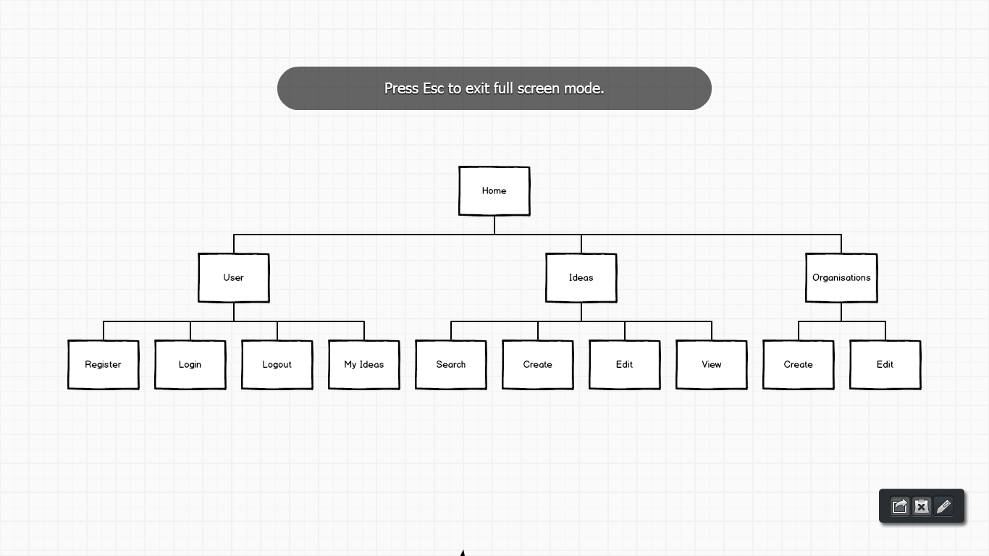

# Wireframe Design

## Form Design

|  |  |
| --- | --- |
| Register User Form | Login User Form |
|  |  |
| Create/Edit Idea Form | Create/Edit Organisation Form |
|  |  |

## Output design

|  |  |
| --- | --- |
| Output | Design |
| Search ideas   * Provides a method of searching via tag |  |
| View ideas   * Outputs idea information and information about the organisation the idea relates to * Allows a user to select an idea |  |

# Use Case

## Use Case Diagram

The use case diagram below shows student and staff interactions with the system.

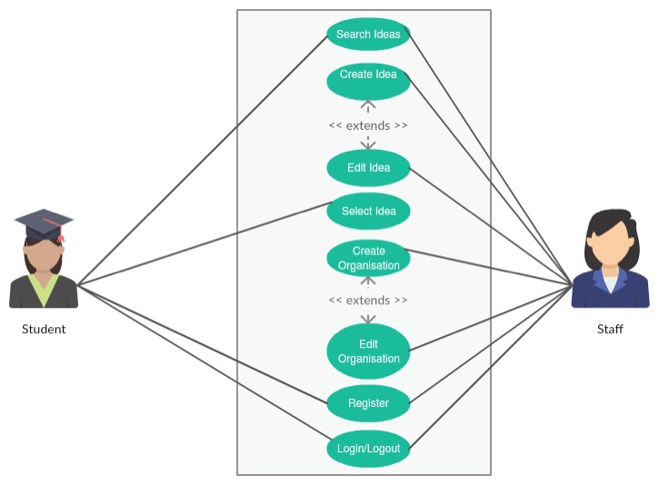

## Use Cases

|  |  |  |
| --- | --- | --- |
| **Use Case** | **User Type** | **Steps** |
| Registering | Staff,  Student | 1. Click register from home page 2. Complete register form |
| Login | Staff,  Student | 1. Click login form home page 2. User will be taken to search idea page |
| Create a new idea | Staff | 1. Navigate to create idea page 2. Complete create idea form 3. Assign idea to an existing organisation |
| Create a new organisation | Staff | 1. Navigate to create organisation form 2. Complete create organisation form |
| Search for an idea | Staff, Student | 1. Navigate to the search ideas page 2. Specify a tag to search by 3. System will output all ideas with that tag |
| Select an idea | Student | 1. Navigate to the idea 2. Click ‘Select idea’   (Note: only one idea per student, selecting a second will overwrite the original selection) |