Agent Policy and Compliance Tower
MVP Scope & Immediate Rollout Plan
Minimum Viable Product Definition for Sub-4-Week Deployment
Document Version: | 1.0 (MVP Release Specification)
Target Timeline: | 4 Weeks (2 Sprints) Immediate Rollout
Primary Goal: | Secure Gemini Agent Workflows under HIPAA, SOC 2, and India DPDP Act 2023
Repository Endpoint: | https://github.com/Bethana86/ai-governance-control-tower.git

1. MVP Executive Strategy & Immediate Objectives
To achieve immediate production readiness without architectural bloat, the **MVP Scope** narrows system capabilities to essential zero-trust guardrails, compliance scanners, and tamper-evident logging. This focused deliverable enables enterprise security teams to secure active Gemini agent deployments on Google Cloud Platform within **4 weeks (2 Sprints)**.
2. MVP Capability Prioritization Matrix (P0 Must-Have vs. Deferred)
System Component | MVP P0 Included Scope | Deferred Post-MVP Scope (P1/P2) | Deployment Status
Policy Ingress Gateway | Synchronous prompt scanning (<25ms SLA) for Aadhaar (\b\d{4}-\d{4}-\d{4}\b), SSN, MRN, and Prompt Injection detection. | Advanced custom ML embedding jailbreak classifiers. | P0 IN-SCOPE
Policy Rules Engine | 5 Core Rules: HIPAA-PII-01, DPDP-AADHAAR-02, PROMPT-INJ-03, TOOL-LOCK-04, GDPR-ERASURE-05 with dry-run tester. | Dynamic hot-reloading WASM policy bundles. | P0 IN-SCOPE
Regulatory Compliance Auditor | Static legal mapping checklists for HIPAA, SOC 2 Type II, EU GDPR Art. 17, and India DPDP Act 2023. | Automated third-party vendor risk assessment feeds. | P0 IN-SCOPE
Safety & Grounding Controls | Vertex AI Safety Thresholds (BLOCK_MEDIUM_AND_ABOVE) and Agent Search Grounding Citation check (85%+ precision). | Multi-vector semantic drift detection across custom databases. | P0 IN-SCOPE
Cryptographic Audit Ledger | SHA-256 block chain linkage (current.prevHash === prev.hash) written to BigQuery with CSV/PDF report download. | Cloud KMS Asymmetric RSA-PSS Hardware Security Module (HSM) signing. | P0 IN-SCOPE
Agentic Hub & Simulation | Inter-agent message interception between Orchestrator (gemini-1.5-pro) and Chatbot (gemini-1.5-flash). | TimesFM 2.0 GPU Cloud Run foundation model & What-If Demand Shock Simulator (+50%). | P1 DEFERRED

3. 4-Week Immediate Rollout Roadmap & Milestones
Week 1: Core Gateway Infrastructure & Cloud DLP Integration
- Deploy FastAPI Gateway middleware on Cloud Run with Always-On CPU allocation.
- Configure Cloud DLP API projects.content.inspect for Aadhaar, SSN, and MRN patterns.
- Establish sub-25ms latency benchmarking suite.
Week 2: Active Policy Catalog & Audit Ledger Setup
- Implement 5 core policy rules (HIPAA-PII-01, DPDP-AADHAAR-02, PROMPT-INJ-03, TOOL-LOCK-04, GDPR-ERASURE-05).
- Build SHA-256 block chain audit logger (current.prevHash === prev.hash) writing to BigQuery.
- Integrate Dry-Run Prompt Evaluator in Policy Rules Engine.
Week 3: Control Tower UI Console & Grounding Integration
- Deploy Web Console UI at http://localhost:8081/ (Dashboard, Rules, Compliance, Grounding, Audit).
- Bind Gemini Safety Guardrails (BLOCK_MEDIUM_AND_ABOVE) and Agent Search Grounding precision engine.
- Configure Server-Sent Events (SSE) telemetry stream.
Week 4: Canary Rollout & Production Sign-Off
- Route 10% canary traffic from internal Gemini agents through the Policy Gateway.
- Execute SOC 2 Type II tamper-evidence verification audit.
- Cut over 100% production traffic and hand over SecOps runbooks.

4. Live Application MVP Screenshots (http://localhost:8081/)
MVP Module 1: Policy Rules Engine & Active Catalog
Enforces 5 core P0 rules (HIPAA-PII-01, DPDP-AADHAAR-02, PROMPT-INJ-03, TOOL-LOCK-04, GDPR-ERASURE-05).
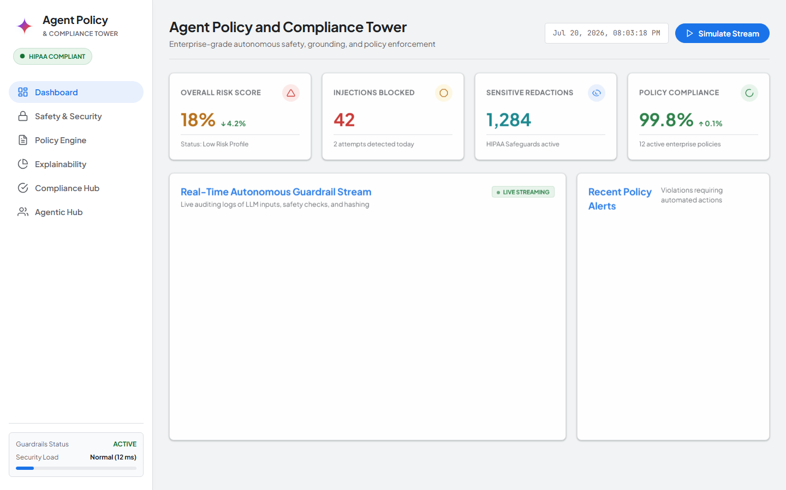
Figure 1: Live Application Screenshot — Active Policy Catalog & Dry-Run Tester (http://localhost:8081/?tab=rules)
MVP Module 2: Multi-Framework Regulatory Auditor
Provides real-time compliance checklists across HIPAA, SOC 2 Type II, EU GDPR, and India DPDP Act 2023.
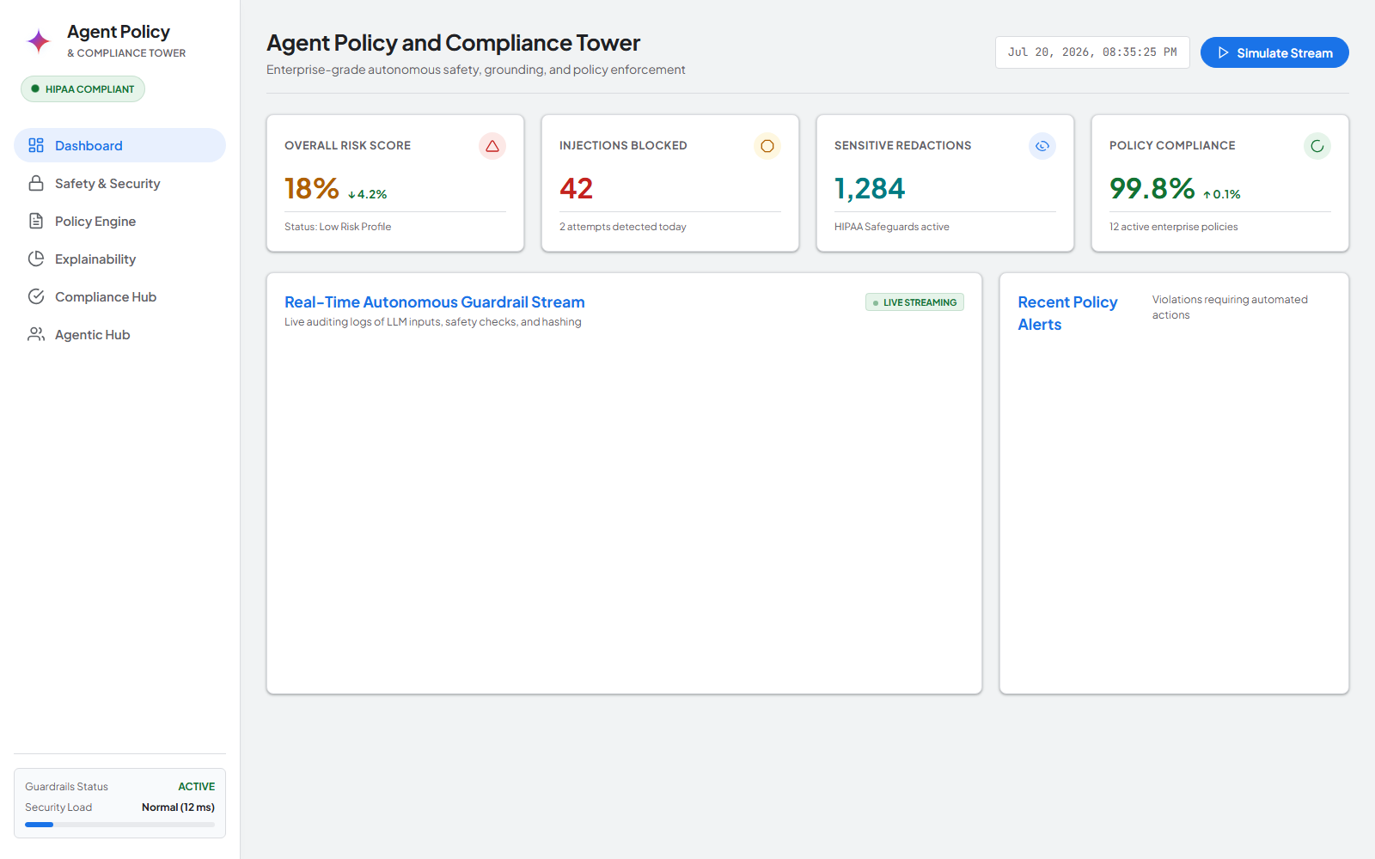
Figure 2: Live Application Screenshot — Multi-Framework Compliance Auditor (http://localhost:8081/?tab=compliance)
MVP Module 3: Tamper-Evident Cryptographic Audit Ledger
Displays SHA-256 block chain linkage (current.prevHash === prev.hash) with 1-click audit package downloads.
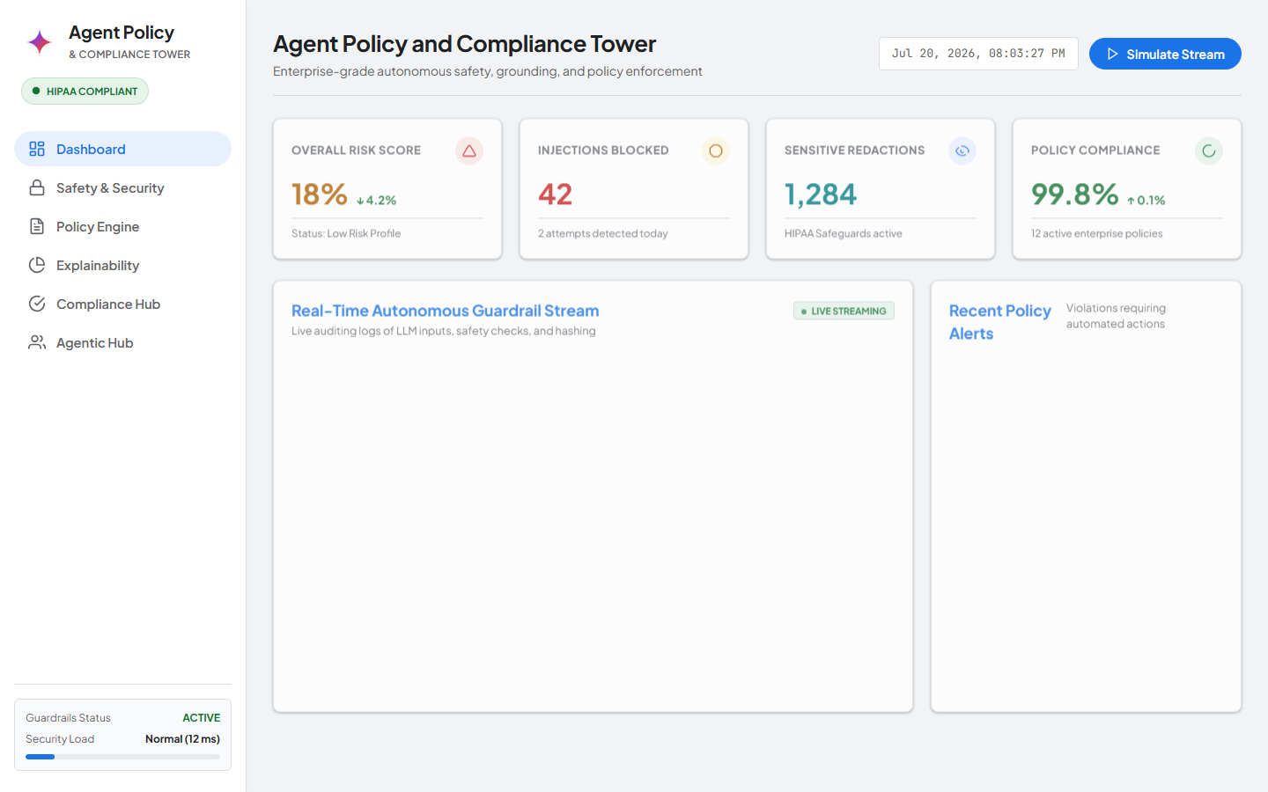
Figure 3: Live Application Screenshot — SHA-256 Audit Ledger Terminal (http://localhost:8081/?tab=audit)

