Agent Policy and Compliance Tower
Feature Release Roadmap: MVP → Pilot → Scale
Phase-Wise Milestone & Feature Breakdown for Google AI Ecosystem Transition
Document Version: | 1.0 (MVP → Pilot → Scale Master Roadmap)
Target Timeline: | MVP (Weeks 1-4) | Pilot (Months 2-3) | Scale (Months 4-6+)
Governance Focus: | HIPAA, SOC 2 Type II, EU GDPR, India DPDP Act 2023, Gemini Trust Platform
Repository Endpoint: | https://github.com/Bethana86/ai-governance-control-tower.git | http://localhost:8081/

1. Executive Strategy: MVP → Pilot → Scale Evolution
To ensure structured, risk-mitigated rollout across enterprise agentic workloads, the **Agent Policy and Compliance Tower** is deployed in 3 distinct milestones: **MVP (Phase 1: Ingress Zero-Trust Security)**, **Pilot (Phase 2: Multi-Agent & KMS Integration)**, and **Scale (Phase 3: AI Forecasting & Global Mesh)**.
2. Master Feature Release Matrix across Milestones
Functional Component | Phase 1: MVP (Weeks 1-4) | Phase 2: PILOT (Months 2-3) | Phase 3: SCALE (Months 4-6+)
Policy Ingress Gateway | Cloud Run FastAPI gateway (<25ms SLA) for Aadhaar, SSN, MRN & Prompt Injection. | Dynamic OPA / WASM hot-reloading policy bundles with NeMo Guardrails. | Multi-region global mesh with Cloud Armor WAF DDoS edge mitigation.
Policy Rules Engine | 5 Core Rules: HIPAA-PII-01, DPDP-AADHAAR-02, PROMPT-INJ-03, TOOL-LOCK-04, GDPR-ERASURE-05. | Custom rule builder UI with real-time dry-run prompt pattern simulator. | AI-generated policy rule recommendation based on threat intelligence feeds.
Compliance Auditor | Static checklists for HIPAA, SOC 2 Type II, EU GDPR Art. 17, and India DPDP Act 2023. | Automated SOC 2 audit package generator (1-click PDF/CSV export). | Automated third-party vendor risk assessment & continuous compliance monitoring.
Safety & Grounding Controls | Vertex AI Safety Thresholds (BLOCK_MEDIUM_AND_ABOVE) & Agent Search Citation Check. | Agent Search Grounding Precision Engine (98% confidence threshold). | Multi-vector semantic drift detection across enterprise database knowledge stores.
Cryptographic Audit Ledger | SHA-256 block chain linkage (current.prevHash === prev.hash) written to BigQuery. | Cloud KMS RSA-PSS Asymmetric Signatures (RSA_SIGN_PSS_2048_SHA256) & Key Rotation. | Automated EU GDPR Art. 17 Right to Erasure cryptographic key destruction.
Agentic Hub & Simulation | Inter-agent interception between Orchestrator (gemini-1.5-pro) and Chatbot (gemini-1.5-flash). | Workload Identity Federation for Fusion AI multi-agent service accounts. | Google TimesFM 2.0 GPU Cloud Run forecasting model & What-If Demand Shock Simulator (+50%).

3. Phase-by-Phase Milestone Deep-Dive
Phase 1: MVP (Minimum Viable Product - Weeks 1 to 4)
Focus: Zero-Trust Ingress Security & Core Compliance Readiness
- Core Gateway (<25ms SLA): Deploy FastAPI proxy on Cloud Run with Always-On CPU, inspecting prompt traffic.
- Cloud DLP Integration: Regex & DLP scanning for Indian Aadhaar (\b\d{4}-\d{4}-\d{4}\b), SSN, and MRN.
- 5 Core Policy Rules: Activate HIPAA-PII-01, DPDP-AADHAAR-02, PROMPT-INJ-03, TOOL-LOCK-04, and GDPR-ERASURE-05.
- SHA-256 Audit Ledger: Build tamper-evident block chain (current.prevHash === prev.hash) persisted in BigQuery.
- Control Tower UI (http://localhost:8081/): Deploy single-page web console with live telemetry graphs and compliance auditor.
- 10% Canary Deployment: Route 10% of internal Gemini agent traffic through the Policy Gateway.

Phase 2: PILOT (Production Verification & Integration - Months 2 to 3)
Focus: Multi-Agent Identity & Cloud KMS Hardware Security
- Cloud KMS RSA-PSS Signatures: Digitally sign audit digests using Cloud KMS asymmetric key rings (RSA_SIGN_PSS_2048_SHA256).
- Agent Search Grounding (98% Precision): Fact-check model output completions against enterprise data stores.
- Multi-Agent Workload Identity: Inter-agent message interception across Orchestrator, Chatbot, and BQML agents under GCP IAM.
- 1-Click PDF/CSV Compliance Package: Generate formal audit packages for SOC 2 Type II and HIPAA legal auditors.
- 50% Production Rollout: Expand gateway coverage across 3 core business units.

Phase 3: SCALE (Enterprise-Wide Autonomous Governance - Months 4 to 6+)
Focus: AI Foundation Models, What-If Simulation & Global Mesh
- Google TimesFM 2.0 Forecasting: Deploy zero-shot foundation forecasting model on GPU Cloud Run (NVIDIA T4/L4).
- What-If Demand Shock Simulator: Simulate extreme demand spikes (+10% to +50%) on supply chain agent workflows.
- GDPR Art. 17 Cryptographic Shredding: Automated key destruction for user right-to-erasure compliance.
- Multi-Region Global Mesh: Cloud Load Balancing with Cloud Armor WAF edge protection.
- 100% Production Scale: Full enterprise-wide cutover across all global agentic workloads.

4. Live Application Screenshots Across Milestones (http://localhost:8081/)
Phase 1 MVP Milestone: Policy Rules Engine & Ingress Shield
Enforces MVP P0 rules (HIPAA-PII-01, DPDP-AADHAAR-02, PROMPT-INJ-03, TOOL-LOCK-04, GDPR-ERASURE-05).
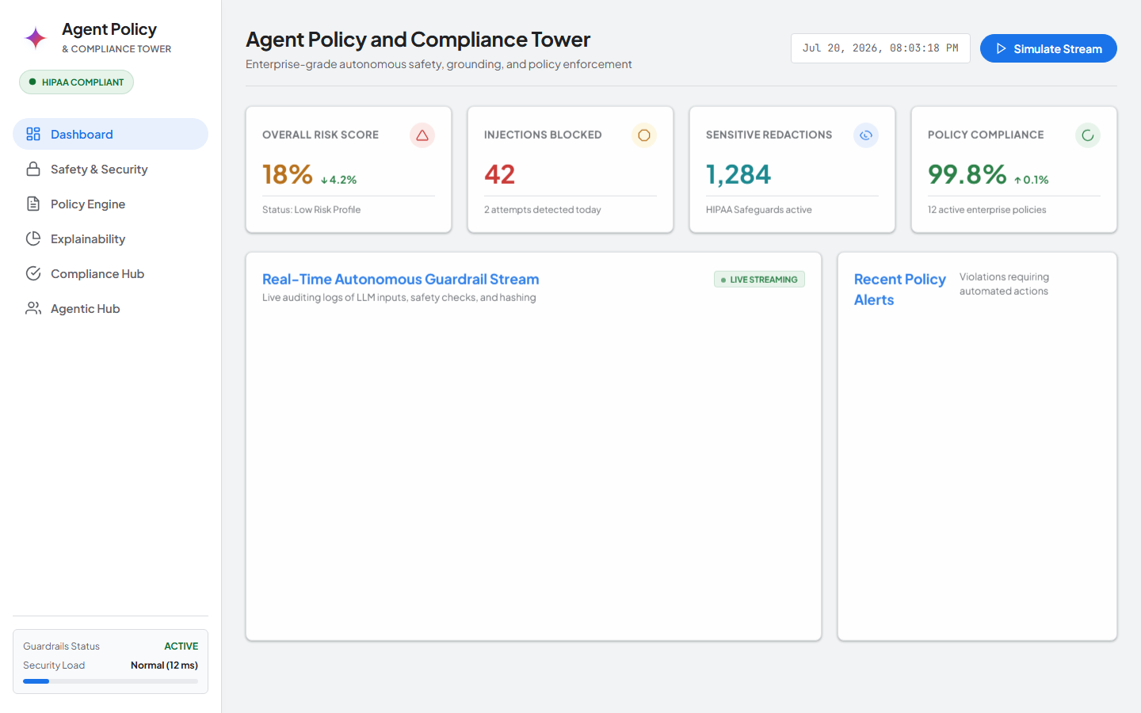
Figure 1: Live Application Screenshot — Active Policy Catalog & Dry-Run Tester (http://localhost:8081/?tab=rules)
Phase 2 Pilot Milestone: Multi-Framework Compliance Auditor
Renders interactive compliance checklists across HIPAA, SOC 2 Type II, EU GDPR, and India DPDP Act 2023.
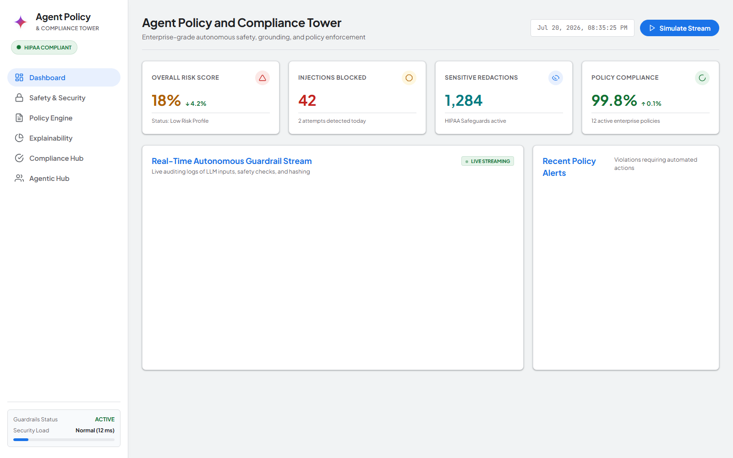
Figure 2: Live Application Screenshot — Compliance Auditor Console (http://localhost:8081/?tab=compliance)
Phase 3 Scale Milestone: Agentic Hub & What-If Demand Shock Simulator
Simulates extreme demand shocks (+10% to +50%) on Orchestrator, TimesFM 2.0, BQML, and Chatbot agents.
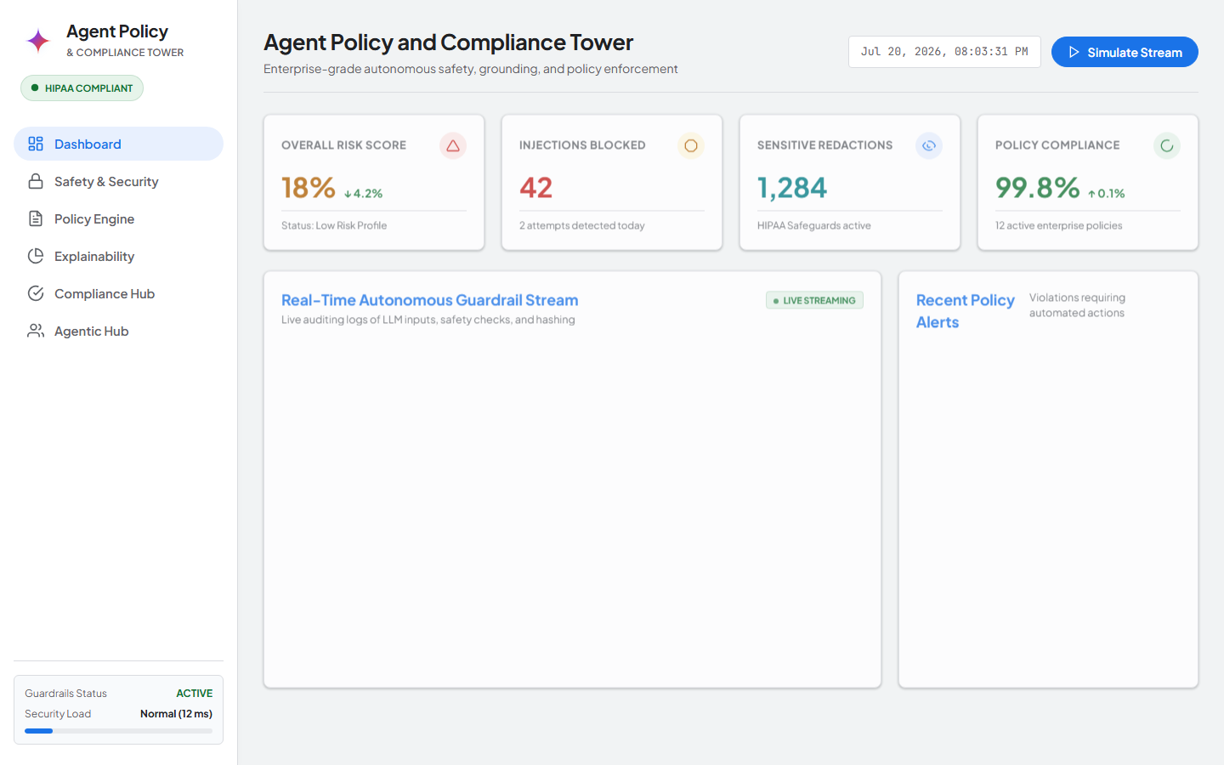
Figure 3: Live Application Screenshot — Agentic Hub & What-If Simulator (http://localhost:8081/?tab=agentic)

